module 2) html

1. Are the html tage and elements the same thing?

ans :- html elements and tags are a lot different.

this tag is used in pairs

element in html close the content in betweenthe tags.

html tags are building blocks of html.

2. what are the tags and attribute in html?

ans :- Tags are used to hold the elements, HTML tag starts with< and ends with>. Attributes are used to describe the characteristics of an HTML element in detail.

3. what are the void elements in html?with examples.

ans :- A void element is an element whose content model never allows it to have contents under any circumstances.

examples:- <br>,<hr>,etc.

4. what are the html entities?with examples.

ans :- A piece of text (“string”) that begins with an ampersand (&) and ends with a semicolon (;) is the HTML entities.

Ex- &copy; &nbsp; &pound.

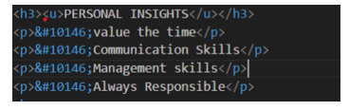

5. what are different types of lists in html?with example.

ans :- html is considered as the start with <this bracket and with>this bracket element in html close the content in between the tags.

There are 2 types of lists.

1) Ordered list

An ordered list starts with <ol>, there are 5 types of ordered lists.

1-A, 2-a, 3-I,4-i,5- Numbers by default.

<ol type = “a”

<li> nested item 1</li>

</ol>

2) Unordered lists

An unordered list starts with <ul>

There are 3 types of unordered lists.

A-Circle

B-Square

C-Disc

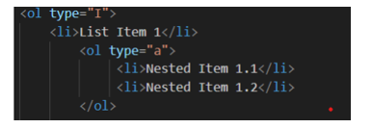

6. what is the class attribute in html?with example.

ans :- The class attribute is used to specify one or more of the class names for an HTML element. It is mainly used for styling and targeting elements with css.

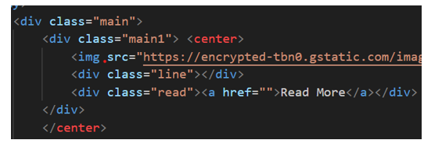

7. what is the difference between the id attribute and the class attribute if html elements? with example.

ans :- class attribute is used for maltipes and id is used for id attribute is used for within the page in html.

ex.

<div id =”id”></div>

<div class =”class1”>1<div>

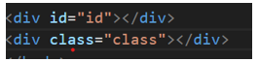

8. what are the various formatting tags in html?

ans :- varios formatting tags are use for colorsheets size

A- Bold text<b>

B-Italic text <I>

C- Important texts <strong>

D- Subscript text <sub>

E- Superscript text <sup>

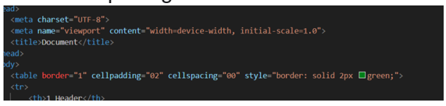

9. How is Cell Padding different from Cell Spacing? With Example.

ans :- cell spacing is outer space of the cell. <body>

<table border = “1” cellpadding=”2” cellspaceing = “0”>

</body>

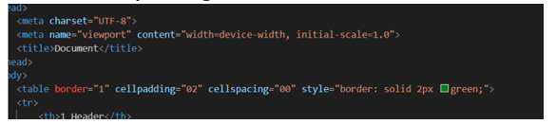

10. How can we club two or more rows or columns into a single row or column in an HTM table? With Example.

ans :- we can use Col span and row span for club two or more rows and columns into a single row or column.

<table>

<tr>

<td Colspan =”5” rowspan =”6” </td>

</tr>

</table>

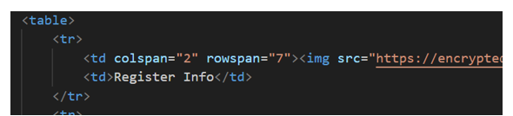

11. What is the difference between a block-level element and an inline element?

ans :- block level element is break the full width of page.

<p>

inline element is covering the full width of the page.

<a>

<b>

<table>

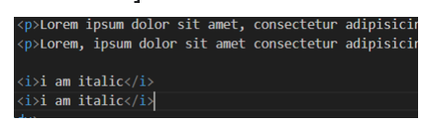

12. How to create a Hyperlink in HTML? With Example.

ans :- for creating anyhyperlink there is tag.

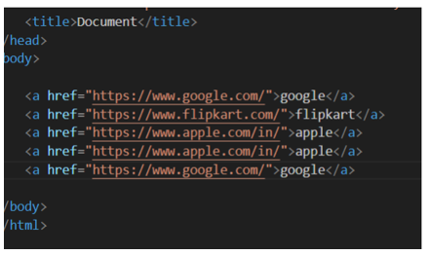

13. What is the use of an iframe tag? With Example.

ans :- iframe tag is use for any img,icon,and logo.

<body>

<iframe height = “700” width = “700” src= “https://www.google.com/embed >

<iframe style = “border-radius:12px” src = “https://www.youtube.com/embed >

<body>

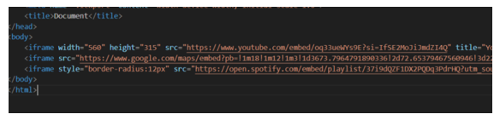

14. What is the use of a span tag? Explain with example?

ans :- The <span> tag is an inline container used to mark up a part of a text, or a part of a document.

15. How to insert a picture into a background image of a web page? With Example.

ans :- <img> tag in HTML is insert image in background of the web page.

Body {

Background - image: URL (<https://www.red-rose>)

Background -size: cover.

Background – repeat: no- repeat:

}

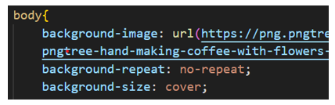

16. How are active links different from normal links?

ans :- active link are typically link to lead the web site. normal link are are broken.normal link colour is purple and active link colour is blue.

17.What are the different tags to separate sections of text?

ans :- tags is used toseparate the line of text.ut breaks the current line and new line.

<p> tag

<blockquote> tag

<br> tag

br tag uses for separate line of texts.

<body>

<p> a man was playing football <br> but he loved cricket </p>

<p> avengers <blockquote> assemble </p>

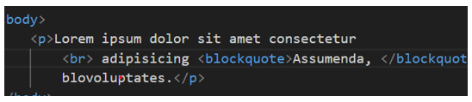

18. What is difference between HTML and XHTML?

ans :- HTML's primary purpose is to display content, given in a text-based document, in a graphical form in the browser.

19. What is SVG?

Ans- SVG define as Scalable Vector Graphics, which uses for the web.

In SVG files each element and attributes can be animated.

20. What are logical and physical tags in HTML?

ans :- we can use Col span and row span for club two or more rows and columns into a single row or column.

<table>

<tr>

<td Colspan =”5” rowspan =”6” </td>

</tr>

</table>

21. Create below example using only HTML tags without CSS….

