Module 4) CSS and CSS 3

1 What are the benefits of using CSS?

Ans

CSS offers several advantages, including improved website aesthetics, easy updates across multiple pages, faster loading times, and the ability to create responsive designs that adapt to vasious devices.

2 What are the disadvantages of CSS?

Ans

The disadvantages of css is a Browser Compatibility. CSS may render differently in various web browsers, leading to inconsistencies in the visual presentation, Learning Curve, Lack of Security, Limited Layout Control, Performance Impact, Overriding Styles, Maintenance Challenges.

3 What is the difference between CSS2 and CSS3?

ans

|  |  |
| --- | --- |
| **CSS 2** | **CSS 3** |
| * CSS2 which was comprised of a single document | * CSS3 has its specifications divided into many individual modules, which makes CSS3 a whole lot easier to handle. |
| * CSS2, designers could only use “web-safe fonts” for being 100% sure to use fonts that would always display the same on every machine. | * With CSS3, the designers can now use special fonts, like those available in Google Fonts and Typecast. |
| * CSS2 had ‘simple selectors’. | * CSS3 calls the components as ‘a sequence of simple selectors’**.** |
| * In CSS2, the developers had difficulty because the standard was not equipped with automatically breaking the text so that it fits within a box. | * CSS3 has the capability to split text sections into multiple columns so that it can be read like a newspaper. |

**4 Name a few CSS style components**

**Ans**

* Selectors
* CSS border
* Margin
* Padding
* Positioning
* Font size
* Background image
* Flex
* Grid

5 What do you understand by CSS opacity?

Ans

The CSS opacity property is used to specify the transparency of an element. In simple word, you can say that it specifies the clarity of the image. In technical terms, Opacity is defined as degree in which light is allowed to travel through an object.

6 How can the background color of an element be changed?

ans

The background color is selecting the element by its class name of id name and then apply the background color property on it to set the background color.

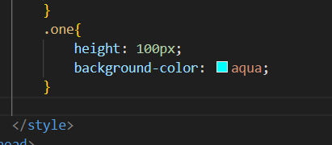

7 How can image repetition of the backup be controlled?

Ans

This task can be achieved by using the background repeat property that will help us to control the repetition of the image.

The background repeat property in css is used to repeat the background image both horizontally and vertically. It also decides whether the background image will be repeated or not.

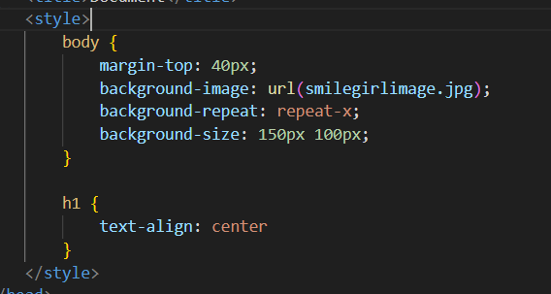

8 What is the use of the background-position property?

Ans

The background-position CSS property sets the initial position for each background image. The position is relative to the position layer set by background-origin.

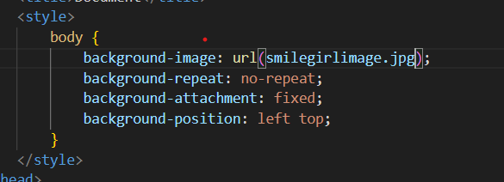

9 Which property controls the image scroll in the background?

Ans

The background attachment property sets whether a background image scrolls with the rest of the page, or fixed.

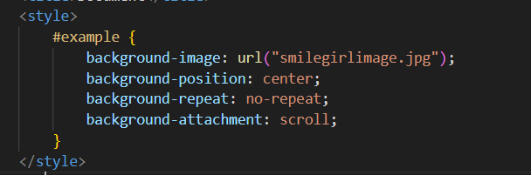

10 Why should background and color be used as separate properties?

Ans

The background and color are the separate properties if they should always be set together? There are two reasons behind it enhances the legibility of style sheets.

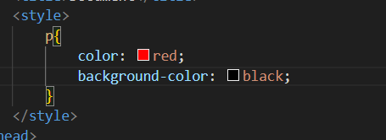

11 How to center block elements using CSS1?

Ans

The Center block elements using margin property We need to

Specify the margin form left and right such that it looks centered.

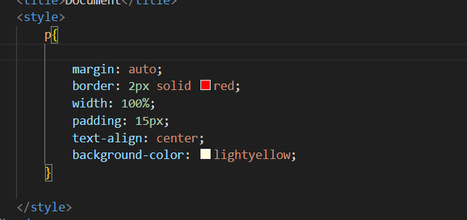

12 How to maintain the CSS specifications

Ans

The **Specification** defines how **CSS** properties should be implemented by browser vendors along with detailed algorithms, code samples and tabu

**13 What is embedded style sheets?**

**Ans**

It allows to define styles for a particular HTML document as a whole in one place. This is done by embedding the <style></style> tags containing the CSS properties in the head of document.

Syntax:

<style>

------

------

</style>

**14 What are the external style sheets?**

**Ans**

An external style sheet is a separate CSS file that can be accessed by creating a link within the head section of the webpage.

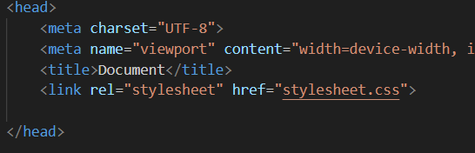

17  **What are the media types allowed by CSS?**

**Ans**

CSS media queries allows the styling of elements depending on the devices. It helps to create a responsive web design. It means that the view of a web page differs from system to system based on scr,gkeen or media types.

**Media types:**

* **All**
* **Print**
* **Screen**
* **Speech**

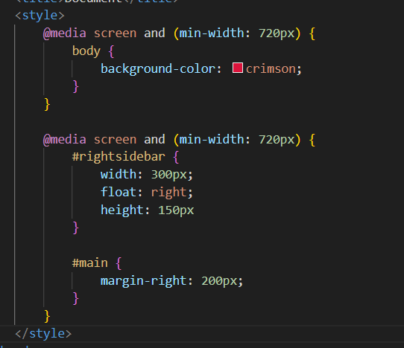

18 What is the rule set?

ans

A CSS ruleset is various affirmations to various pieces or elements of the document. The objective is to apply a bunch of properties for certain distinct qualities to a solitary, or a particular arrangement of components in the connected HTML page.

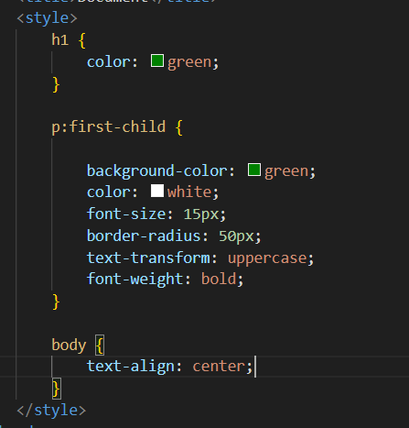

19 create layouts.

