Module (JQuery Basic, Effects & Advanced) – 5

1 : What is jQuery?

ANS :

- jQuery is a lightweight, "write less, do more", JavaScript library.

- The purpose of jQuery is to make it much easier to use JavaScript on your website.

- jQuery takes a lot of common tasks that require many lines of JavaScript code to accomplish, and wraps them into methods that you can call with a single line of code.

- jQuery also simplifies a lot of the complicated things from JavaScript, like AJAX calls and DOM manipulation.

### The jQuery library contains the following features:

- HTML/DOM manipulation

- CSS manipulation

- HTML event methods

- Effects and animations

- AJAX...

- Utilities...

2 : How to Apply CSS Using JQuery, How to Add Class and Remove Class in Jquery , JQuery Animation?

ANS :

## How to Apply CSS Using JQuery:

## Syntax

- $().css(propertyname, value);

- $().css(properties);

## Syntax for adding CSS classes to an element:

- $('selector').addClass(class_name);

## Syntax for Removing CSS classes to an element:

- $('selector').removeClass(class_name);

## The jQuery animate() method is used to create custom animations.

## Syntax:

- $(selector).animate({params},speed,callback);

## Example:

$("button").click(function(){

$("div").animate({left: '250px'});

});

3 : How to create slider with animation in JQuery?

ANS :

## Code :

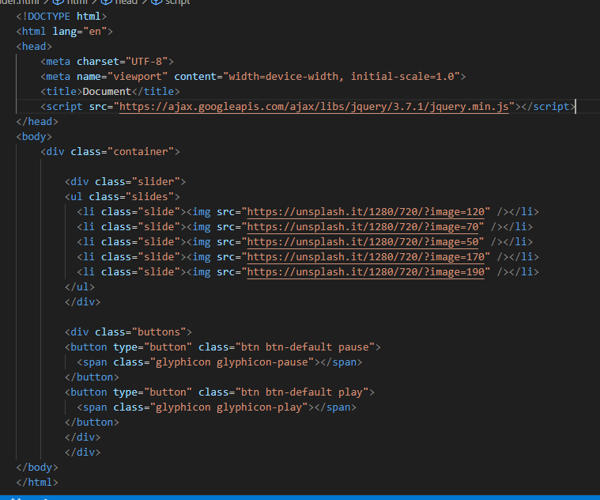

Output:

