Assignment 3 README
SWING
Basic frame with text

# GUI-Based-Multithreaded-Simulation-Java

1. Notes -
- used a copy of assignment 2, completely reusing code
- clearing main and making changes, creating a fixed fleetmanager object with vehicles that are to be simulated
- using lock and unlocking for race condition, toggleable using a boolean
- added 4 threads to simulate 4 vehicles
- each thread adds 1 milege to the attribute property of the car object, reduces fuel by 1, adds 1 to result and sleeps for 1 second.

2. How to compile and run
Compile : - javac -d bin vehicles/*.java exceptions/*.java fleet/*.java
Run : – java -cp bin fleet.Main
3. Gui has 4 buttons , start resume stop and refuel
The start is connected to startsimu
The void startsimu() cleans the context by setting everything to default and lets any old thread which are running to notice the flags and stop, creates a new fleetmanager, adds 4 vehicles, fuels the vehicle and starts all the threads, each thread adds 1 mileage and reduces 1 fuel level and then add 1 to total sum every iteration (1sec), updates the gui using helper functions, sleeps for 1 sec. It also checks for paused or empty fuel and updates the labels accordingly every tick.
If pause or empty fuel it doesn’t let the thread stop it makes it stuck in a loop and rechecks every .5secs, if yea then it break out the loops and continues normally
then pause/resume works on Main.paused bool where each thread checks after each iteration if the bool has been changed, if yes then it will trap the thread in an empty loop until unpause.

Stop button also works similarly where is changes the running bool to false, but since we don’t want the program to end the threads are again sent into an empty loop, if gui is closed the threads will get released, to counter old threads running at the start of start simu we give old threads time to see that running has false to exit.

Refuel pretty self explanatory, calls the existing refuelAll method of fleetmanager

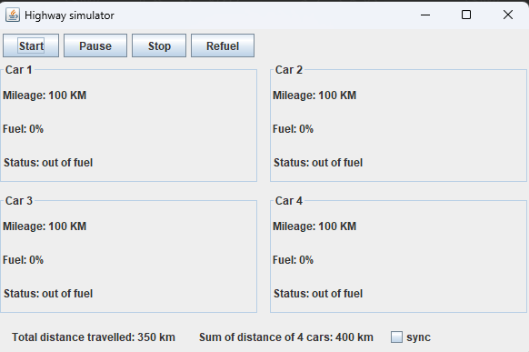

4. RACE CONDITION AND ITS FIX
I implemented a simple function that just updates the total milege but changes the way it does according to a bool called isync, which is connected by UI by the checkbox, if yes it does the calculations using locks like this below

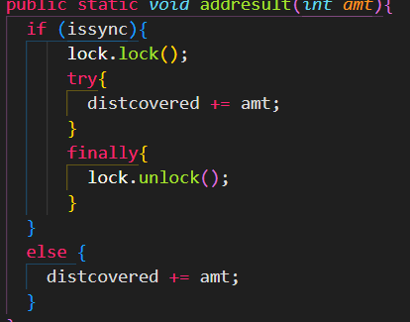

If not it adds normally and when multiple thread access the same resource a race condition occurs as 2 or more threads might be updating at the same instant so value gets lost, we can see below with and without race condition results
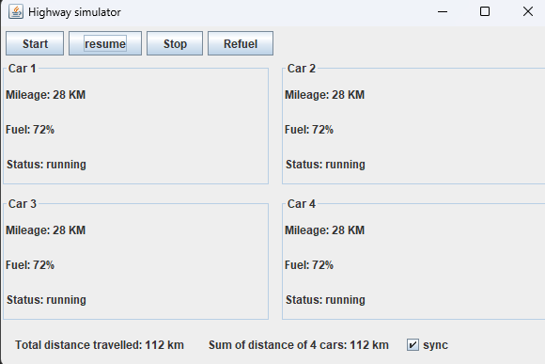
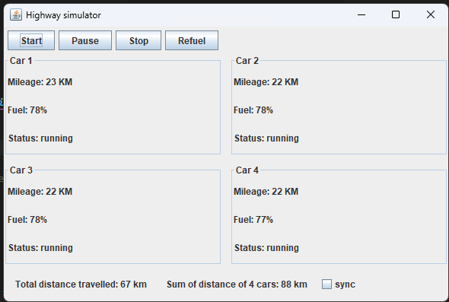

The total distance travelled is the var that is updated by 4, sum of distance of 4 cars is just sum of getmileage and mileage attribute of individual vehicles

5) Thread safety
Using swing we don’t do operations like updating labels, refreshing components on the main thread instead on the EDT (event dispatch thread) to ensure thread safety as swing is not thread safe, meaning if it was on main and we try updating labels like vehicle attributes race conditions or some unpredictable result might come.

So to avoid this swing provides SwingUtilities.invokeLater() which updates on the EDT

In this project the simulation threads compute in the background and ui updates are passed to the edt through the func like updateCar() and updateTotals().

