A
PROJECT SYNOPSIS
ON

“DecoStone Material Management System (MMS)”

- Submitted By -
Parth Sanjay Morabale (24213440464)
Ayush Rajesh Patel (24213440466)
Samarth Dadaso Patil (24213440479)
Suyash Sunil Shalbidre (24213440483)

Under The Guidance Of

Ms. Supriya Dongre.



DEPARTMENT OF COMPUTER SCIENCE & ENGINEERING

SANJAY GHODAWAT INSTITUTE, ATIGRE

Academic Year: 2026-27
Certificate
This is to certify that the project synopsis work entitled

“DecoStone Material Management System (MMS)”

Has been successfully completed by
Parth Sanjay Morabale (24213440464)
Ayush Rajesh Patel (24213440466)
Samarth Dadaso Patil (24213440479)
Suyash Sunil Shalbidre (24213440483)

In fulfillment for the
Diploma in Computer Science & Engineering

Maharashtra State Board of Technical Education
During the academic year 2026-27 under the guidance of

Project Guide H.O.D Director
(Ms. S. S. Dongre) (Mr. A. D. Patil) (Dr. V. V. Giri)

DEPARTMENT OF COMPUTER SCIENCE & ENGINEERING
ACKNOWLEDGEMENT

We express our sincere gratitude to Sanjay Ghodawat Institute, Atigre, and the Department of Computer Science & Engineering for academic support and resources for this project synopsis.
We thank our project guide, whose name and review details will be completed by the department, for guidance and feedback. We also thank faculty members, staff and peers who helped us understand material inventory and warehouse workflows.
This synopsis has been prepared by the four student authors listed below. The guide and department may review the technical description and completion records before certification.

Student Name | Enrollment Number
Parth Sanjay Morabale | 24213440464
Ayush Rajesh Patel | 24213440466
Samarth Dadaso Patil | 24213440479
Suyash Sunil Shalbidre | 24213440483

Date: ____________________
Place: Atigre

ABSTRACT
DecoStone Material Management System (MMS) is a web-based inventory application for businesses handling tiles, marble, granite and related building materials across multiple godowns. It brings material and category records, warehouse stock, receipts, dispatches, transfers and adjustments into a shared workflow. The system uses a React single-page frontend, an Express REST backend and a relational SQLite database. Role-based access supports administrator, manager and supervisor workflows, including supervisors assigned to multiple godowns. Dashboard summaries, low-stock visibility, movement history and report exports help users review inventory activity. This synopsis presents the problem, related work, requirements, architecture, data model, modules, security considerations and validation plan. The team should verify transaction correctness, access boundaries, responsive operation and report accuracy before final demonstration.
Keywords: Inventory management, warehouse, godown, stock movement, SQLite, role-based access.

INDEX
Chapter No. | Title | Page No.
1 | Introduction | 7
2 | Literature Survey | 8
3 | Problem Definition | 10
4 | Existing System | 11
5 | Proposed System | 12
6 | Objectives and Scope | 13
7 | Requirements and Feasibility | 14
8 | Methodology and Architecture | 15
9 | Database Design | 20
10 | System Modules and Workflows | 21
11 | Security and Access Control | 22
12 | Testing and Validation Plan | 23
13 | Resources and Consumables | 24
14 | Conclusion | 25
R | References and Bibliography | 26
A | Action Plan | 27

LIST OF TABLES
Table No. | Description | Page No.
1 | Literature comparison | 9
2 | Functional requirements | 14
3 | Core data entities | 16
4 | Application modules | 17
5 | Validation checklist | 19
6 | Development resources | 20
7 | Project action plan | 23

LIST OF FIGURES
Figure No. | Description | Page No.
1 | System architecture and request flow | 15

LIST OF GRAPHS
No graph is required in this synopsis. Dashboard visualizations are application features; no measured project results are claimed here.

1. INTRODUCTION
Building-material businesses manage varied inventory such as tiles, sanitaryware, stone slabs, adhesives and related products. A material may be stored in more than one godown, measured in a product-specific unit, and moved through receipts, issues, transfers and stock adjustments. Staff need to know what is available, where it is stored and how each balance changed.
When these events are recorded in separate registers or spreadsheets, the same item may have inconsistent balances. Delayed updates make it harder to prevent stockouts, validate transfers or trace adjustments. A shared application can centralize material definitions and warehouse balances while retaining records of stock movements.
DecoStone MMS provides a browser-based workspace for managing these records. The application separates the React frontend, Express API and SQLite persistence. Users work through role-specific screens while the server validates requests and stores inventory changes. This synopsis describes the project design; final implementation status and unresolved defects should be confirmed during the demonstration review.
1.1 Relevance and Rationale
Inventory control is an operational and supply-chain concern [1]. Warehouse information systems also connect storage operations to organizational capabilities and performance [3]. This project focuses on practical functions for a multi-godown material business: current balances, movement records, low-stock review and controlled access.
1.2 Synopsis Organization
The report reviews prior work, defines the problem, compares the existing approach with the proposed application, states objectives and scope, and explains requirements, architecture, data design, workflows, access control, validation and resources. References and an action plan conclude the report.

2. LITERATURE SURVEY
Inventory and warehouse research provides context for combining item records with location-specific stock and auditable movement. The selected studies inform the design and delimit what this project does not attempt to solve.
2.1 Inventory Management
Munyaka and Yadavalli review inventory-management concepts and implementations, emphasizing that inventory control is a central logistics function and that methods depend on organizational objectives [1]. For this project, the implication is to maintain reliable item balances and traceable operations rather than a single aggregate stock number.
Ramanathan presents an ABC inventory classification method using weighted linear optimization and multiple criteria [2]. ABC analysis can prioritize attention when item value, demand or criticality differ. DecoStone stores structured stock and category information that could support such analysis, but the project does not claim to implement this optimization method.
2.2 Warehouse Systems and Forecasting
Autry and co-authors examine warehouse management systems in relation to resource commitment, capabilities and organizational performance [3]. Their work supports treating a warehouse system as an operational capability. Accordingly, the proposed MMS connects balances to receiving, storage and dispatch activity and keeps movement history.
Goltsos and co-authors discuss the gap between inventory and forecasting research [4]. Inventory decisions depend on forecasts and planning assumptions. The current project focuses on transactional visibility and threshold-based alerts; it does not claim to implement demand forecasting.
2.3 Intelligent Warehouses
Tubis and Rohman survey intelligent warehouses in the context of Industry 4.0 and discuss technology themes such as IoT, visual technologies and autonomous equipment [5]. These technologies extend beyond this project’s web and database scope. DecoStone is positioned as a foundational digital inventory tool, not a sensor-driven or automated warehouse.
Mashayekhy, Babaei, Yuan and Xue survey the impact of IoT on inventory management, including technology-enabled inventory visibility [6]. The present project remains transaction-based and does not claim IoT sensing.
2.4 Comparative Findings
Study | Focus | Design implication
Munyaka & Yadavalli | Inventory concepts | Keep stock records and control processes explicit.
Ramanathan | ABC classification | Store data that may enable future prioritization.
Autry et al. | WMS capabilities | Connect balances with warehouse operations.
Goltsos et al. | Inventory and forecasts | Separate threshold alerts from forecasting.
Tubis & Rohman | Industry 4.0 warehouses | Keep sensors and automation out of current scope.
Mashayekhy et al. | IoT inventory survey | Treat sensing as future work; focus now on validated transactions.

2.5 Research Gap and Project Position
The reviewed studies cover inventory-control concepts, warehouse-system capabilities, classification methods, forecasting research and intelligent warehouse technologies. They provide complementary perspectives, but the proposed student project has a narrower objective: reliable material and stock transactions across several godowns, supported by straightforward role-based workflows and reports. It does not claim to replace a full enterprise warehouse-management platform or advanced optimization system.
The practical gap addressed here is the need to connect material master records with location-specific quantities and a history of changes in one accessible application. The design therefore emphasizes transaction consistency, clear stock status, supervisor access across assigned locations and traceable updates. These requirements form the basis for the database model and validation plan in later chapters.
A useful extension of this work would be to evaluate demand data and item criticality after sufficient reliable transaction history has accumulated. Forecasting or ABC prioritization should be introduced only with suitable data and evaluated against a defined baseline; neither is presented as a current project result.

3. PROBLEM DEFINITION
The project addresses the difficulty of maintaining a consistent, timely and auditable view of building-material stock across multiple godowns. A business needs to identify each material, category and unit; record receipts and dispatches; transfer quantities between locations; and determine whether each godown has sufficient stock.
The problem is not simply the absence of a digital list. Inventory changes must preserve a correct balance and explain how that balance was reached. A transfer must decrease stock at its source and increase stock at its destination exactly once. Access should reflect responsibility: an administrator manages the system, managers perform permitted operations, and supervisors may be assigned to one or more godowns.
3.1 Problem Statement
To design and implement a web-based material management system that maintains material and category records, records stock transactions for multiple godowns, provides role-scoped access and presents useful stock and movement information while preserving transaction history.
3.2 Constraints
The system depends on a reachable server and database, accurate user-entered transactions, correct master data and configured access rights. SQLite suits a compact deployment, but high-concurrency or multi-site expansion may require a different database architecture. Hardware sensors, automated purchasing and predictive replenishment are outside the current scope.

4. EXISTING SYSTEM
In a manual or spreadsheet workflow, material descriptions, quantities and storage locations may be maintained in separate files. Staff update a stock sheet after a delivery or dispatch while another person records the event in an order or ledger. Such systems are familiar and inexpensive to start, but rely on consistent procedures and timely manual updates.
4.1 Limitations
• Warehouse balances may become inconsistent when movements are late or duplicated.
• A transfer may appear as an issue without a matching receipt at the destination.
• Historical evidence can be difficult to connect to current material or category records.
• Finding out-of-stock items can require repeated checks across separate lists.
• User responsibilities and warehouse visibility may not be enforced consistently.
• Preparing summaries and exports may require manual filtering and reformatting.
4.2 Improvement Opportunity
A centralized application can validate a transaction at entry, associate it with a material and godown, and update related records in one server-side workflow. Consistent role checks, movement history and reports can improve reviewability. These benefits depend on correct implementation and disciplined data entry.

5. PROPOSED SYSTEM
The proposed DecoStone MMS is a browser-based application with three layers. The React frontend presents role-specific pages and sends requests to an Express REST API. The API authenticates users, validates operations and applies business rules. SQLite stores users, materials, categories, godowns, balances and transaction records.
5.1 Main Functions
• Manage material and category records, including edits and controlled deletion or archival where history is linked.
• Maintain godown records and assign supervisors to multiple godowns where authorized.
• Record stock receipts, dispatches, transfers and adjustments with quantities and transaction context.
• Review stock by material and godown, including low-stock and out-of-stock conditions.
• View movement history, audit activity, dashboard summaries and warehouse/category reports.
• Export supported reports to spreadsheet or PDF formats.
5.2 Operating Principles
Stock-changing operations should be atomic: either all database changes for a transaction succeed or none do. A transfer should link its outgoing and incoming legs and prevent an invalid or duplicate quantity change. Deletion should preserve referential integrity and transaction history. Reports should use the same stored balances and transaction records as the application.

6. OBJECTIVES AND SCOPE
6.1 Objectives
• Create a shared catalogue of materials and categories with units and stock thresholds.
• Represent inventory separately for each active godown.
• Record receipts, dispatches, inter-godown transfers and adjustments.
• Provide secure login and role-based authorization.
• Allow a supervisor to access multiple assigned godowns with server-side scope checks.
• Display stock position, low-stock conditions and movement history.
• Generate readable summaries and downloadable reports.
• Maintain auditability and protect historical references when master records change.
6.2 Scope
The project covers master data, warehouse stock, movements, user access, dashboards, notifications, reports and transaction/audit history represented in the application. Roles include administrator, manager and supervisor. A supervisor can be associated with multiple godowns, subject to backend authorization.
Barcode/RFID scanning, IoT sensors, automatic demand prediction, payment processing, external ERP integration and production cloud availability are not claimed. Future work may evaluate these features after core transaction correctness and deployment requirements are validated.

7. REQUIREMENTS AND FEASIBILITY
7.1 Functional Requirements
ID | Requirement
FR-01 | Authenticate users and enforce role permissions.
FR-02 | Maintain materials and categories while protecting linked history.
FR-03 | Maintain godowns and user-to-godown assignments.
FR-04 | Record valid receipts, dispatches, transfers and adjustments.
FR-05 | Display stock by material/godown and identify threshold conditions.
FR-06 | Show transaction history, audit events, dashboard metrics and reports.
FR-07 | Export supported report views.

7.2 Non-Functional Requirements
Usability: common tasks need clear labels and validation feedback. Integrity: related stock changes must remain consistent. Security: credentials must be protected and the server must enforce access rules. Maintainability: interface, API and persistence concerns should be organized. Compatibility: the interface should support common desktop and mobile browsers. Reliability and performance targets must be defined and evaluated under the intended load.
7.3 Feasibility
Technical feasibility is supported by the JavaScript stack and local relational database. Operational feasibility depends on users entering movements promptly and administrators configuring roles correctly. Open-source frameworks reduce licensing costs, while hosting, backups and maintenance still have operational costs. Schedule feasibility should be reviewed against remaining project milestones.

8. METHODOLOGY AND ARCHITECTURE
8.1 Development Method
The project follows iterative development: identify workflows, define data and access rules, implement modules, connect the frontend to the API, and review the integrated system. Parth and Ayush handle frontend and backend work across modules; Suyash and Samarth handle database work across modules. The guide should verify actual contributions and dates in the diary.
8.2 Application Layers
Layer | Responsibility
User interface | React screens, forms, tables, navigation, feedback and visual summaries.
API and rules | Express routes, authentication, input validation, authorization and stock operation logic.
Persistence | SQLite tables, constraints, initialization and transaction history.
Reporting | Queries aggregate balances and movements for dashboards and exports.

A user submits a request through the interface. The API verifies identity and role, validates identifiers and quantities, and reads or changes the database. A successful stock movement should store its transaction record and update the affected balance consistently. The response returns a clear result for the interface.
8.3 Transaction Workflow
For a receipt, the server validates the material, destination godown and positive quantity, then records the receipt and updates that balance. For dispatch, it checks sufficient stock before reduction. For transfer, it validates source and destination, checks stock, and commits the paired movement as one operation. An adjustment requires a reason and preserves the prior history.

8.4 Stock Movement Timeline

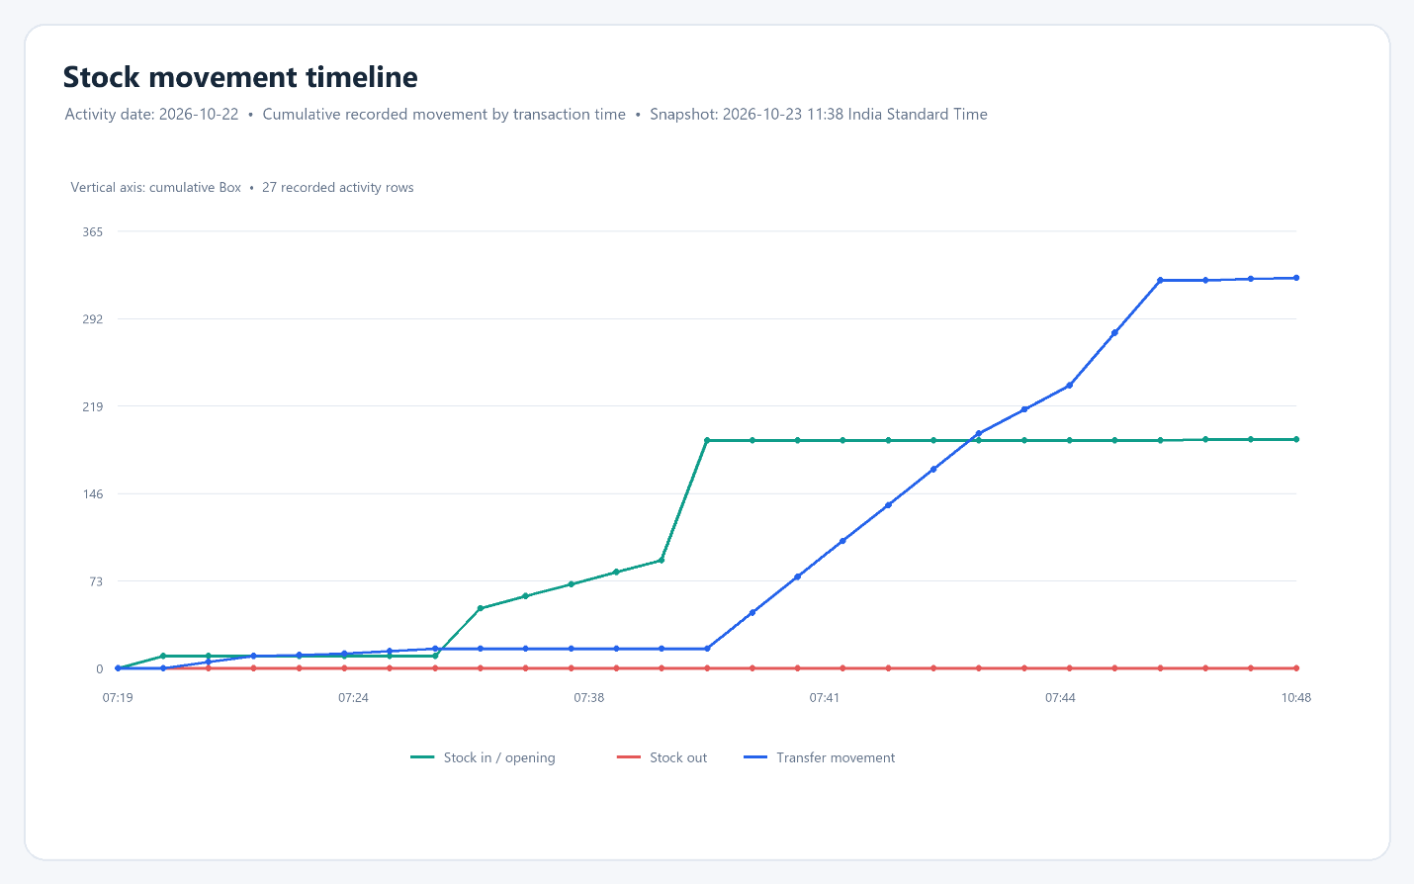

8.5 Material Stock Levels

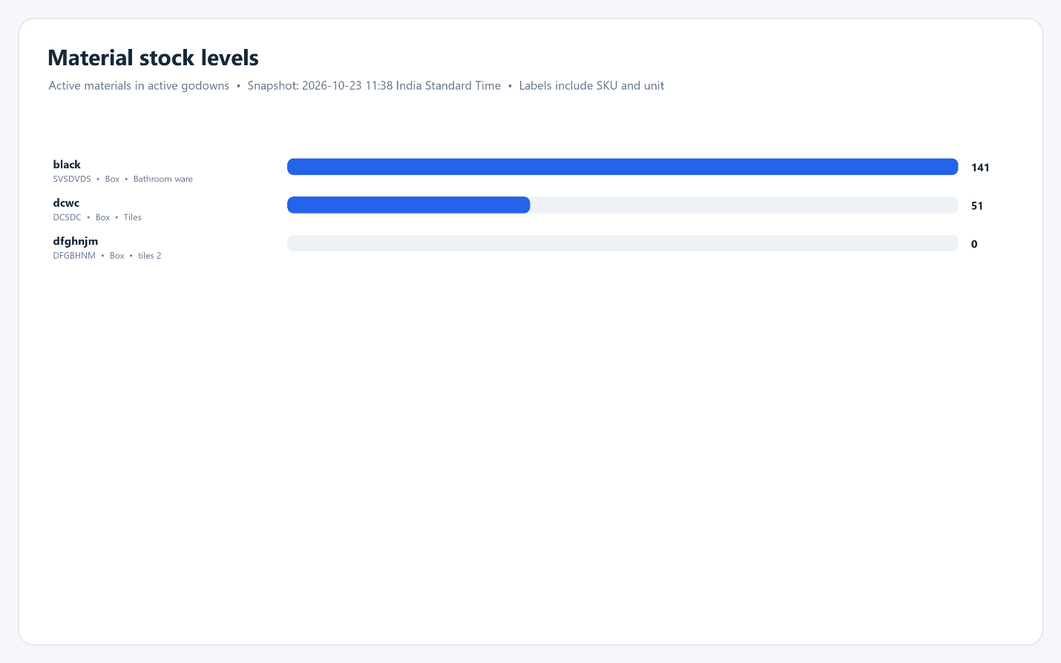

8.6 Stock By Godown

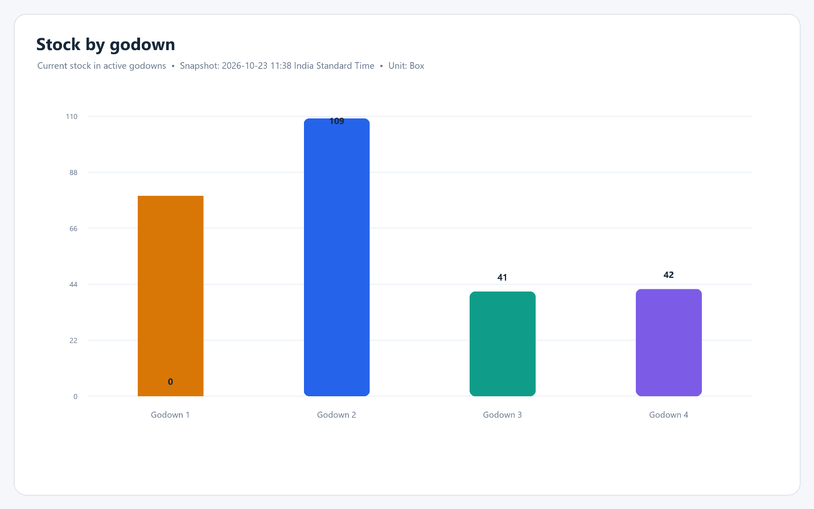

8.7 Current Stock By Category

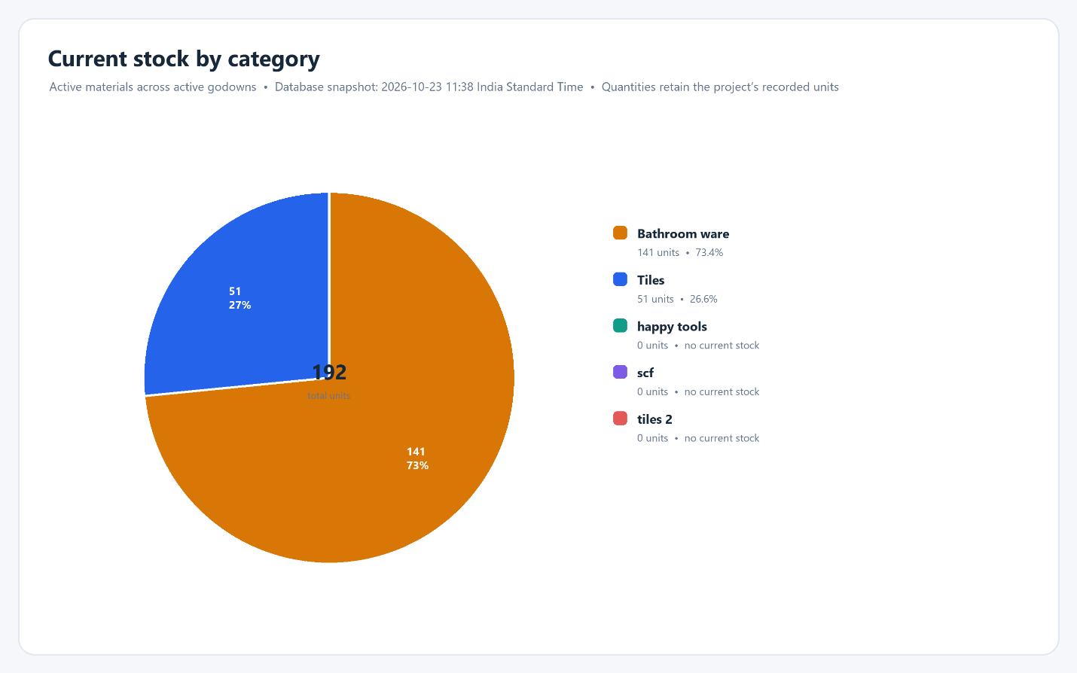

9. DATABASE DESIGN
The application uses relational data to represent users, roles, godowns, materials, categories, stock and inventory events. Foreign keys connect operational records to master data. Unique constraints and validation rules should prevent duplicate identifiers and invalid references.
Entity | Purpose | Relationships
Users / roles | Login identity and authorization | User role and godown assignments
Godowns | Physical storage locations | Referenced by stock and movements
Categories | Material classification | One category may classify many materials
Materials | SKU, description, unit and thresholds | Belongs to category; referenced by stock/events
Stock balances | Current quantity by material and godown | Unique material + godown pair
Transactions | Receipt, issue, transfer or adjustment | References material, location(s), user and quantity
Audit events | Trace significant actions | References actor and affected record where available

9.1 Integrity Rules
• A balance is identified by both material and godown; a combined total is not a location balance.
• Quantities must be numeric and valid for the material unit and operation.
• Dispatch and transfer must not create negative stock unless an approved rule permits it.
• A transfer must produce a linked source decrease and destination increase exactly once.
• Delete/archive actions must preserve history and avoid orphaned records.
• Database transactions should group multi-record stock changes atomically [7].

10. SYSTEM MODULES AND WORKFLOWS
The interface and server are organized around the following modules. Route coverage and edge cases should be confirmed through code review and validation before final presentation.
Module | Primary workflow
Authentication and users | Sign in, manage members and grant permitted access.
Godowns | View locations and assign supervisors to one or more godowns.
Categories and materials | Maintain classification, SKU/material details, units and thresholds.
Stock received | Record receipt context and increase a godown balance.
Stock dispatched | Record issue context and reduce available stock.
Transfers | Move quantity between godowns with linked history.
Adjustments and history | Record a reviewed discrepancy with reason and audit trail.
Dashboard and low stock | Review balances, threshold items and recent movements.
Reports and exports | Review warehouse/category data and export supported formats.

10.1 End-to-End Example
An authorized user selects a material and receiving godown, enters a valid quantity and submits a receipt. The server validates and stores the event with its actor and time, then updates that material’s balance in that godown. A later transfer selects source and destination; the source must have enough stock. History should show the quantity leaving one godown and arriving at the other without double-counting.

11. SECURITY AND ACCESS CONTROL
The project separates user identity from permissions. The administrator creates members and grants access; operational roles should not gain administrative powers through interface visibility alone. Backend handlers must enforce authorization on protected operations.
11.1 Authentication
The backend dependency manifest includes bcryptjs and JSON Web Token packages. Passwords should be stored only as salted hashes, never plaintext. Tokens should be validated on protected requests and handled with appropriate expiry and secure storage. OWASP guidance describes established controls for authentication and password storage.
11.2 Authorization and Data Scope
A supervisor may be assigned to multiple godowns. Authorization should check that a requested godown is among that supervisor’s assignments for each relevant read and write. Client-side filtering is not sufficient. User management, transaction changes and exports should be limited to roles with explicit permission.
11.3 Audit and Data Protection
Movements and significant administrative actions should retain actor, timestamp, operation, quantity, location and reference information. Backup and restore procedures should be documented and tested. Production deployment should use HTTPS, protect environment secrets, restrict database-file access and verify restoration before relying on backups.

12. TESTING AND VALIDATION PLAN
This chapter defines validation work and does not claim every check has already passed. The team should record actual results, evidence and corrective actions in its diary. Test the interface, API and database using realistic multi-godown workflows.
Area | Validation examples
Master data | Create, edit, search and remove unused records; preserve linked history.
Receipt / dispatch | Positive quantity, invalid input, insufficient stock and repeated submission.
Transfer | Source/destination checks; source decrease equals destination increase.
Access control | Role permissions and supervisor access only to assigned godowns.
Reports | Compare totals with database balances and movement records.
Database integrity | Foreign keys, uniqueness, rollback and backup restoration.
Responsive UI | Forms, navigation, tables and dialogs at phone/tablet/desktop widths.
Build and security | Production build, backend configuration and authentication failures.

12.1 Acceptance Conditions
A receipt increases exactly one selected material/godown balance. Dispatch reduces stock only when valid. Transfer reduces the source by quantity q and raises the destination by q, preserving the total. Unauthorized users cannot access restricted routes. Report totals match the database state. These conditions should be evidenced with repeatable tests and recorded results.

13. RESOURCES AND CONSUMABLES
Resource | Purpose
Development computer and browser | Run and review the application locally.
Node.js and npm | Run server and build scripts.
React and Vite | Build the client interface.
Express.js | Implement the backend API.
SQLite / better-sqlite3 | Persist relational inventory and transaction data.
Recharts, XLSX, jsPDF | Present charts and export reports.
Git repository | Track changes and collaborate across modules.
Representative test data | Validate workflows using non-sensitive records.

The current software scope requires no physical consumables or warehouse sensors. It does require a backup location, test data and a reliable runtime. Package versions should be confirmed against lockfiles at submission time because dependencies may change.

14. CONCLUSION
DecoStone MMS addresses the need to maintain material and warehouse stock records through a shared web application. Its intended value comes from connecting master data, godown-level balances and auditable stock movements, then presenting the information through alerts, dashboards and reports. The frontend/API/relational database structure separates user interaction from persistence rules.
The key correctness requirement is that each stock operation has one validated, traceable effect on the right material and godown. Role checks must enforce intended boundaries, including supervisors assigned to multiple godowns. The team should demonstrate these properties using repeatable scenarios and database evidence and complete guide-reviewed diary entries before submission.
Future enhancements may include barcode scanning, supplier integration, forecasting, multi-branch deployment and richer analysis. These should follow verification of transaction integrity, backups, access control and report consistency.

REFERENCES AND BIBLIOGRAPHY
[1] J. B. Munyaka and V. S. S. Yadavalli, “Inventory management concepts and implementations: A systematic review,” South African Journal of Industrial Engineering, vol. 33, no. 2, pp. 15–36, 2022, doi: 10.7166/33-2-2527.
[2] R. Ramanathan, “ABC inventory classification with multiple-criteria using weighted linear optimization,” Computers & Operations Research, vol. 33, no. 3, pp. 695–700, 2006, doi: 10.1016/j.cor.2004.07.014.
[3] C. W. Autry, S. E. Griffis, T. J. Goldsby, and L. M. Bobbitt, “Warehouse management systems: Resource commitment, capabilities, and organizational performance,” Journal of Business Logistics, vol. 26, no. 2, pp. 165–183, 2005, doi: 10.1002/j.2158-1592.2005.tb00210.x.
[4] T. E. Goltsos, A. A. Syntetos, C. H. Glock, and G. Ioannou, “Inventory–forecasting: Mind the gap,” European Journal of Operational Research, vol. 299, no. 2, pp. 397–419, 2022, doi: 10.1016/j.ejor.2021.07.040.
[5] A. A. Tubis and J. Rohman, “Intelligent warehouse in Industry 4.0—Systematic literature review,” Sensors, vol. 23, no. 8, art. 4105, 2023, doi: 10.3390/s23084105.
[6] Y. Mashayekhy, A. Babaei, X.-M. Yuan, and A. Xue, “Impact of Internet of Things (IoT) on inventory management: A literature survey,” Logistics, vol. 6, no. 2, art. 33, 2022, doi: 10.3390/logistics6020033.
[7] SQLite Consortium, “Transactions,” SQLite Documentation. [Online]. Available: https://www.sqlite.org/lang_transaction.html. Accessed: 22-Oct-2026.
[8] OWASP Foundation, “Authentication Cheat Sheet,” OWASP Cheat Sheet Series. [Online]. Available: https://cheatsheetseries.owasp.org/cheatsheets/Authentication_Cheat_Sheet.html. Accessed: 22-Oct-2026.
[9] OWASP Foundation, “Password Storage Cheat Sheet,” OWASP Cheat Sheet Series. [Online]. Available: https://cheatsheetseries.owasp.org/cheatsheets/Password_Storage_Cheat_Sheet.html. Accessed: 22-Oct-2026.
[10] Meta Platforms, “Quick Start,” React Documentation. [Online]. Available: https://react.dev/learn. Accessed: 22-Oct-2026.
[11] OpenJS Foundation, “Express Documentation.” [Online]. Available: https://expressjs.com/. Accessed: 22-Oct-2026.
[12] OpenJS Foundation, “Node.js Documentation.” [Online]. Available: https://nodejs.org/docs/latest/api/. Accessed: 22-Oct-2026
ACTION PLAN
Scheduled dates | Planned activities
10/09/2026 – 16/09/2026 | Confirm domain, team roles and inventory problem; define project scope.
17/09/2026 – 23/09/2026 | Gather requirements; map user roles, godown workflows and feasibility.
24/09/2026 – 30/09/2026 | Review inventory literature; draft requirements and data entities.
01/10/2026 – 07/10/2026 | Plan architecture, database schema, API structure and interface modules.
08/10/2026 – 14/10/2026 | Plan catalogue CRUD and stock receipt, dispatch, transfer and adjustment flows.
15/10/2026 – 21/10/2026 | Plan integration of roles, multi-godown scope, alerts, audit/history, reports and responsive layouts.
22/10/2026 – 23/10/2026 | Plan code/build review, demo flow, synopsis and diary completion.

The plan records scheduled activities only. Actual completion dates, results, attendance and guide review must be entered by the team and verified by the project guide. The presentation and project demo are scheduled for 24 October 2026.

