USB to CAN Communication Adapter

Model: SLCANv1

Overview
The DynoSure SLCANv1 adapter provides a reliable and convenient connection between a PC and a CAN(Controller Area Network) bus. It is based on the open-source CANable2 firmware and utilizes the Lawicel SLCAN protocol for serial-line CAN communication.
It is designed with mobility in mind and features a compact and lightweight plastic enclosure suitable for on-the-go diagnostics and embedded development.
The device uses the Lawicel SLCAN Protocol to expose the CAN interface as a standard virtual COM port, simplifying integration with existing tools and reducing software overhead.
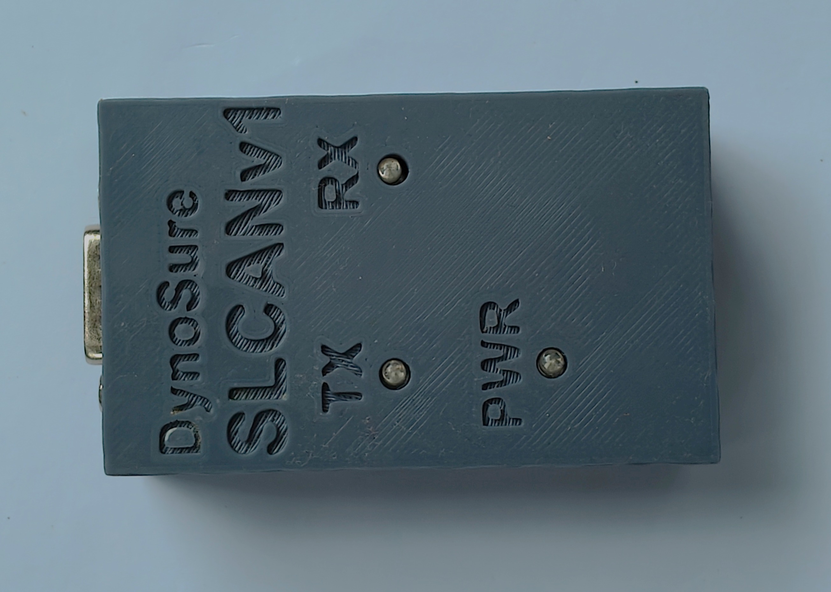

Specifications
- Microcontroller: STM32G4 Series, 170 MHz
- CAN Standards Supported:
- CAN 2.0A (11-bit ID)
- CAN 2.0B (29-bit extended ID)
- CAN-FD (Flexible Data-rate)
- Communication Interface: USB 2.0 Full-Speed (compatible with USB 1.1 and USB 3.0)
- Standard CAN Bit Rate Support: 5 kbit/s to 1 Mbit/s
- Power Supply: USB-powered (no external supply required)
- Operating Temperature: Extended range suitable for industrial environments
- Software Interface:
- Exposed as a virtual COM port (no proprietary driver required)
- Compatible with BusMaster, Python, and C++
- Operating System Compatibility: Windows & Linux

Included in Package
- DynoSure USB to CAN Adapter
- Documentation and open-source design files

Design files and Software
- https://www.dynosure.co.in/downloads/ (For DLL files (python and C) and modified BusMaster executable)
- https://github.com/mac-can/SLCAN (Library for Lawicel SLCAN Protocol (Serial-Line CAN)
- https://github.com/normaldotcom/canable2-fw (CANable 2.0 Firmware)
- https://www.canusb.com/products/canusb/ (LAWICEL CANUSB Protocol)
- https://python-can.readthedocs.io/en/2.1.0/interfaces/slcan.html (Python support)

D-Sub 9 Connector Pinout
D-Sub | Pin | Pin assignment
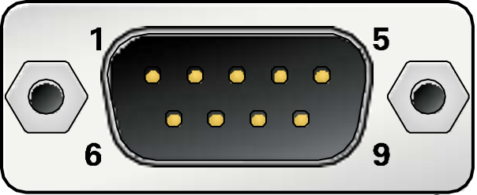 | 1 | Not connected
 | 2 | CAN-L
 | 3 | GND
 | 4 | Not connected
 | 5 | Not connected
 | 6 | GND
 | 7 | CAN_H
 | 8 | Not connected
 | 9 | Not connected

For Quotation & Inquiries
Please contact us
Mobile number: 9422556559
Email id :
dynosure.india@gmail.com

