USB to CAN Communication Adapter

# Model: SLCANv1

## Overview

The DynoSure SLCANv1 adapter provides a reliable and convenient connection between a PC and a CAN(Controller Area Network) bus. It is based on the open-source CANable2 firmware and utilizes the Lawicel SLCAN protocol for serial-line CAN communication.

It is designed with mobility in mind and features a compact and lightweight plastic enclosure suitable for on-the-go diagnostics and embedded development.  
  
The device uses the Lawicel SLCAN Protocol to expose the CAN interface as a standard virtual COM port, simplifying integration with existing tools and reducing software overhead.

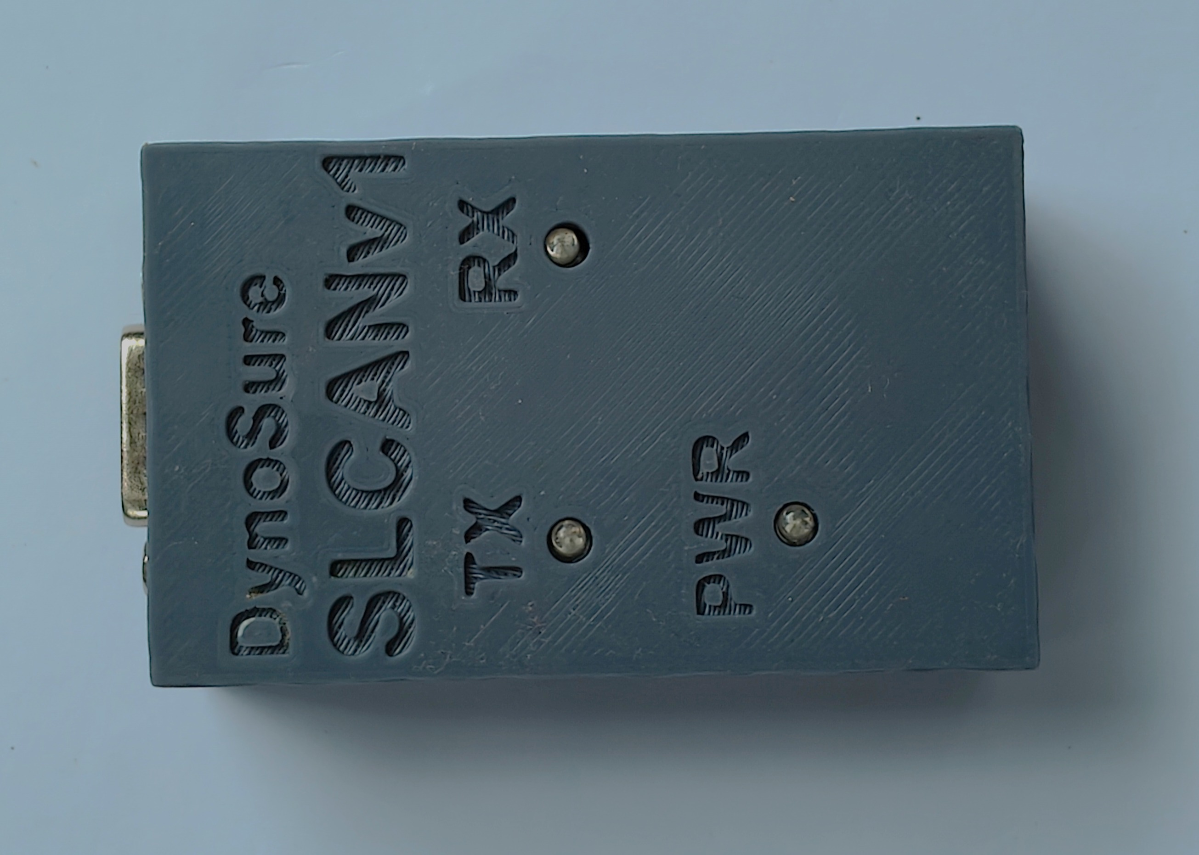

## Specifications

* Microcontroller: STM32G4 Series, 170 MHz
* CAN Standards Supported:
* CAN 2.0A (11-bit ID)
* CAN 2.0B (29-bit extended ID)
* CAN-FD (Flexible Data-rate)
* Communication Interface: USB 2.0 Full-Speed (compatible with USB 1.1 and USB 3.0)
* Standard CAN Bit Rate Support: 5 kbit/s to 1 Mbit/s
* Power Supply: USB-powered (no external supply required)
* Operating Temperature: Extended range suitable for industrial environments
* Software Interface:
* Exposed as a virtual COM port (no proprietary driver required)
* Compatible with BusMaster, Python, and C++
* Operating System Compatibility: Windows & Linux

## Variants and Price

* Without Plastic Encloser – 4657.0 ₹ (including GST and Shipping)
* With Plastic Encloser – 5532.0 ₹ (including GST and Shipping)

## Included in Package

* DynoSure USB to CAN Adapter
* Documentation and open-source design files

## Design files and Software

* <https://github.com/mac-can/SLCAN> (Library for Lawicel SLCAN Protocol (Serial-Line CAN)
* <https://github.com/normaldotcom/canable2-fw> (CANable 2.0 Firmware)
* <https://www.canusb.com/products/canusb/> (LAWICEL CANUSB Protocol)
* <https://python-can.readthedocs.io/en/2.1.0/interfaces/slcan.html> (Python support)

## D-Sub 9 Connector Pinout

|  |  |  |
| --- | --- | --- |
| D-Sub | Pin | Pin assignment |
|  | 1 | Not connected |
| 2 | CAN-L |
| 3 | GND |
| 4 | Not connected |
| 5 | Not connected |
| 6 | GND |
| 7 | CAN_H |
| 8 | Not connected |
| 9 | Not connected |

## For Quotation & Inquiries

Please contact us

Mobile number: 9522556559

Email id :

**[dynosure.india@gmail.com](mailto:dynosure.india@gmail.com  )**