## horizontal line

Btech ICT - Sem 4

**Database Management System**

Railway - Management - System

**Group Members:**

AU1841005 Yashil Depani

AU1841007 Ridham Shah

AU1841010 Harshil Mehta

# Description

Starting off, we have tried to model a mini online railway reservation system. To do so, we have used PostgreSQL for database design and query mode and other back - end activity. We have used python language as our medium , html web pages for frontend and flask for connecting frontend with postgresql.

For booking tickets, a user must log in to the system or create a new account and get his user ID which is used to book tickets and further reservation purposes through a Login Module.

For the process of Booking tickets, a schedule of trains is shown to users with appropriate filters. Schedule of the train includes train details with timings, stations,seats left and ticket price. There are many types of seat Category and if booked on any specific train and specific date, a unique ‘pnr’ is generated for that booking. Also, passengers are queued, if there are no more seats available then this passenger is added to the ‘waiting’ queue. The passenger also has the ‘cancel’ ticket feature. If any passenger cancels the ticket, the queue is pushed and the front of the queue is booked. Meaning the passenger got his ticket status changed from ‘waiting’ to ‘confirmed’. The payment is processed through the user’s wallet. The minimum balance of ticket price needs to be there in the user’s wallet.

Admin side Functionalities include Inquiry functions such as Inquiry for trains traveling from point A to point B, details of all trains traveling between two dates, details of any station, the revenue generated on the given date for a train, details of deleted tickets, and inquiries like booking status and other formal inquiries.

In addition to other features, we’ve also included the technical aspect of deletion of any records by any user/administrator which in return deletes all child records via triggers and functions/procedures. We’ve also created a record for tracking all the user-driven activities. Input details are validated for safe data handling.

We also have our special function and we are happy that our team was able to implement that. Say a user wants to go from station A to B, have some time to spend at Station B because of his work and go from station B to C. So the user has the flexibility to avail such special options and appropriate output is displayed.

All these functionalities are implemented with appropriate procedures/functions and triggers.

# Entity - Relational Diagram

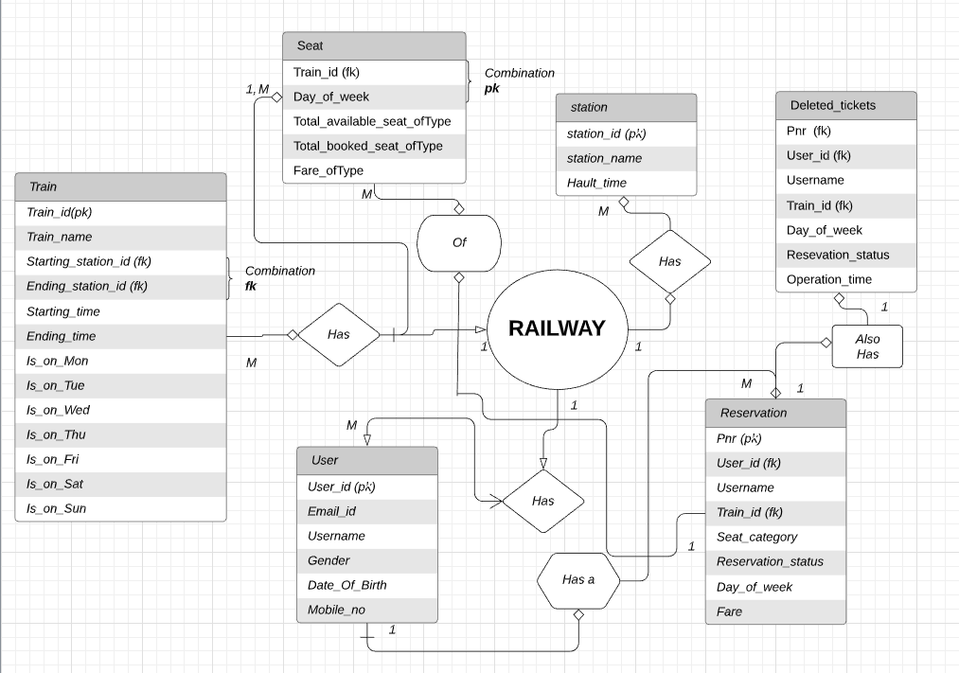

This shows the inter - dependency of the entities on each other with respect to their attributes.

# Table Design (Data - Dependency)

* Train Table *(Entity)*
  + **ATTRIBUTES:**
  + Train_id int: Is an assigned **primary key** to uniquely identify any train record and its details.
  + Train_name varchar(20): Name of any specific train.
  + Starting_station_id int: Is a **foreign key** that is referenced from the station table to specify the starting station of any train.
  + Ending_station_id int: Is a **foreign key** that is referenced from the station table to specify the end station of any train.
  + Start_time float: Used to know about the departure time of any train in format HH.MM where HH = hours, MM = minutes.
  + Journey_time float: For the total journey of the particular train.
  + Mon, Tue, Wed, Thu, Fri, Sat, Sun char: All are used to specify the days of the week when the train is active.
* User Table (*Entity*)
  + **ATTRIBUTES:**
  + User_id int: Is an assigned **primary key** to uniquely identify each user.
  + Email_id varchar(50): Email id of the user.
  + Name varchar(30): Name of the particular user.
  + Gender char, dob(date of birth) date, mobile_no int.
* Reservation Table (*Entity*)
  + **ATTRIBUTES:**
  + Pnr serial int: Is an assigned **primary key** that uniquely identifies each reservation made.
  + User_id int: Used as **foreign key** from the user table that determines which user has made a reservation.
  + Username varchar(30): Used to determine the name of the user who made the reservation.
  + Trai
  + n_id int: Used as a **foreign key** in determining on which train was the reservation made.
  + Day_of_week char: To identify on which day the booking was made.
  + Reservation_status char: Used to know the booking status of the reservation made.
  + Seat_category varchar(3): Used to determine the category of the reserved seat.
  + Fare int: The price of the reserved seat.
* Station Table (*Entity*)
  + **ATTRIBUTES:**
  + Station_id int: Is an assigned **primary key** that uniquely identifies each station.
  + Station_name varchar(20): Name of station.
  + Halt_time float: Halt time at the particular station in MM.SS (minutes.seconds) format.
* Seat table (*Entity*)
  + **ATTRIBUTES:**
  + Train_id int: Is a **foreign key** which indicates that to which train does the seat belong.
  + Day_of_week char: Used to know the day on which the train is to depart.
  + The combination of train_id and day_of_week is the **primary key** for the given table.
  + Total_booked seat of types(below): For the booked seat of a given type.
    - AC1_book int
    - AC2_book int
    - AC3_book int
    - CC_book int
    - EC_book int
    - SL_book int
  + Total_available seat of types(below)**:** For the number of total available seats of a given type.
    - AC1_total int
    - AC2_total int
    - AC3_total int
    - CC_total int
    - EC_total int
    - SL_total int
  + Fare of the seat of types(below): To determine the rate of the seat.
    - AC1_price int
    - AC2_price int
    - AC3_price int
    - CC_price int
    - EC_price int
    - SL_price int
* Deleted_tickets (*Entity*)[For keeping track of record]
  + **ATTRIBUTES:**
  + Pnr serial int: Used as a **foreign key** for determining the pnr of canceled reservation.
  + User_id int: Used as a **foreign key** for determining the user id of canceled Passenger.
  + Username varchar(30): Used for determining the user name of Passenger who canceled the booking.
  + Train_id int: Used as a **foreign key** for determining the train in which the passenger canceled the booking.
  + Day_of_week char: Used to know the day on which the train was set to depart.
  + Reservation_status char: Used to determine whether the booking was confirmed or not.
  + Operation_time timestamp: Used to keep track of time when the cancellation was performed.

**Interdependencies**

The **Train table** has different attributes as described above with its nature(primary key, foreign key, etc). It has it’s starting station and its ending station referenced from the station table to use it’s station id and other attributes. This table mainly connects a particular train running on respectives days with stations.

The **Seat table** signifies the normalized form of E-R diagram as it contains different types of seats and prices respectively.Also, it has referenced train_id to know which train does this seat belong to. The user through this can know the price and its category of seat with remaining count in order to avail a ticket.

The **User table** has different details entaling any user which signs up for this system. It only contains the essential details of a customer like name,password,mobile number, etc with its wallet details.

The **Reservation table** has different attributes with a unique PNR serial and has referenced attributes such as user_id and train_id to know the details of the booking made.It also has the reservation status and the category of seat for which the booking is made. This table also keeps user status such as confirmation or waiting

The **Station table** has different attributes which are used to know the details of any given station.

The **deleted_tickets table** is a kind of track table which keeps the track of all cancelled bookings by user by timestamps.The different attributes it has are user_id, PNR, train_id to identify each booking uniquely. Basically it is a table to keep records of who deleted tickets on which date , on which train etc.

These are connected in the above shown 3NF’ed E-R diagram with proper relationship between tables.

# Stored Procedures and Functions Codes:

**Functions:**

**Function - 1**: Function to display all the trains which are running from station x to station y on a particular date where x and y are inputs. It represents a whole table.

Code:

--procedure for schedule: input is from station id and to station id , date

--output is table

create or replace function dis_train2(s_stat int, e_stat int, tarik date)

returns table(

s_stat_name varchar(20),

e_stat_name varchar(20),

t_name varchar(20),

t_id int,

s_time float,

j_time float,

ac1_p int,

ac1_s int,

ac2_p int,

ac2_s int,

ac3_p int,

ac3_s int,

cc_p int,

cc_s int,

ec_p int,

ec_s int,

sl_p int,

sl_s int

)

as $dis_train2$

declare

dayno int;

begin

if(tarik<current_date) then

raise exception 'Date invalid';

end if;

select extract(dow from tarik) into dayno;

return query

select distinct

(select station_name from station1 where station_id=s_stat),

(select station_name from station1 where station_id=e_stat),

train1.train_name,train1.train_id,train1.starting_time,train1.journey_time,

seat_class2.ac1_price,seat_class2.ac1_total_seats-seat_class2.ac1_booked_seats,

seat_class2.ac2_price,seat_class2.ac2_total_seats-seat_class2.ac2_booked_seats,

seat_class2.ac3_price,seat_class2.ac3_total_seats-seat_class2.ac3_booked_seats,

seat_class2.cc_price,seat_class2.cc_total_seats-seat_class2.cc_booked_seats,

seat_class2.ec_price,seat_class2.ec_total_seats-seat_class2.ec_booked_seats,

seat_class2.sl_price,seat_class2.sl_total_seats-seat_class2.sl_booked_seats

from train1,seat_class2,station1

where(train1.starting_station_id=s_stat and train1.ending_station_id=e_stat and train1.train_id=seat_class2.train_id

and seat_class2.working_day=dayno);

end;

$dis_train2$ language plpgsql;

--How to call?

select dis_train2(100,101,'20-04-2020')

**Function - 2**: Function to book a seat in any given train and given seat category on any given day.

Code:

--function for booking a seat

select book_seat(10000,1,'AC1')

create or replace function book_seat(t_id int, days int, categ varchar)

returns int as $book_seat$

declare

exist int;

left int;

begin

if(categ='AC1') then

select ac1_total_seats,ac1_booked_seats into exist,left from seat_class2 where(train_id = t_id and working_day=days);

if(exist = left)then

raise notice 'No seats left';

return ac1_price from seat_class2 where(train_id = t_id and working_day=days) ;

else

update seat_class2 set ac1_booked_seats=ac1_booked_seats+1

where(train_id = t_id and working_day=days);

return ac1_price+100000 from seat_class2 where(train_id = t_id and working_day=days) ;

end if;

elsif(categ='AC2')then

select ac2_total_seats,ac2_booked_seats into exist,left from seat_class2 where(train_id = t_id and working_day=days);

if(exist = left)then

raise notice'No seats left';

return ac2_price from seat_class2 where(train_id = t_id and working_day=days) ;

else

update seat_class2 set ac2_booked_seats=ac2_booked_seats+1

where(train_id = t_id and working_day=days);

return ac2_price+100000 from seat_class2 where(train_id = t_id and working_day=days);

end if;

elsif(categ='AC3')then

select ac3_total_seats,ac3_booked_seats into exist,left from seat_class2 where(train_id = t_id and working_day=days);

if(exist = left)then

raise notice 'No seats left';

return ac3_price from seat_class2 where(train_id = t_id and working_day=days) ;

else

update seat_class2 set ac3_booked_seats=ac3_booked_seats+1

where(train_id = t_id and working_day=days);

return ac3_price+100000 from seat_class2 where(train_id = t_id and working_day=days);

end if;

elsif(categ='CC')then

select cc_total_seats,cc_booked_seats into exist ,left from seat_class2 where(train_id = t_id and working_day=days);

if(exist = left)then

raise notice'No seats left';

return cc_price from seat_class2 where(train_id = t_id and working_day=days) ;

else

update seat_class2 set cc_booked_seats=cc_booked_seats+1

where(train_id = t_id and working_day=days);

return cc_price+100000 from seat_class2 where(train_id = t_id and working_day=days);

end if;

elsif(categ='EC')then

select ec_total_seats,ec_booked_seats into exist ,left from seat_class2 where(train_id = t_id and working_day=days);

if(exist = left)then

raise notice 'No seats left';

return ec_price from seat_class2 where(train_id = t_id and working_day=days) ;

else

update seat_class2 set ec_booked_seats=ec_booked_seats+1

where(train_id = t_id and working_day=days);

return ec_price+100000 from seat_class2 where(train_id = t_id and working_day=days);

end if;

elsif(categ='SL')then

select sl_total_seats,sl_booked_seats into exist ,left from seat_class2 where(train_id = t_id and working_day=days);

if(exist = left)then

raise notice 'No seats left';

return sl_price from seat_class2 where(train_id = t_id and working_day=days) ;

else

update seat_class2 set sl_booked_seats=sl_booked_seats+1

where(train_id = t_id and working_day=days);

return sl_price+100000 from seat_class2 where(train_id = t_id and working_day=days);

end if;

else

raise notice 'No such option';

return 0;

end if;

end;

$book_seat$

language plpgsql

--How to call?

select book_seat(10000,1,'AC1')

**Function - 3 :** Function to avoid duplicacy of user_id (validating function)

Code:

create or replace function check_user_id(u_id int)

returns int as $check_user_id$

declare

is_pre int;

begin

is_pre :=0;

select count(*) into is_pre from user1 where user_id=u_id;

if(is_pre=1) then

raise notice 'Already exists';

else

raise notice 'New user';

end if;

return is_pre;

end;

$check_user_id$ language plpgsql;

-- How to call?

select check_user_id(1000);

**Function -4:** Function to calculate total revenue for selected days generated to the railways per day.

Code:

-----------------------total revenue generated for a particular train on a day--------------------------------------

create or replace function revenue(t_id int, dofweek int) returns int

as $revenue$

begin

return (seat_class2.ac1_price*seat_class2.ac1_booked_seats) +

(seat_class2.ac2_price*seat_class2.ac2_booked_seats) +

(seat_class2.ac3_price*seat_class2.ac3_booked_seats) +

(seat_class2.cc_price*seat_class2.cc_booked_seats) +

(seat_class2.ec_price*seat_class2.ec_booked_seats) +

(seat_class2.sl_price*seat_class2.sl_booked_seats)

from seat_class2 where train_id=t_id and working_day = dofweek;

end;

$revenue$

language plpgsql

select revenue(10001,2)

**Function - 5** : Function to display all the trains between 2 given dates with validations.

Code:

-----------------------------------train running between two dates---------------------------------------------------------------------

create or replace function train_btwn_date(f_date date, t_date date)

returns table(

t_id int,

t_name varchar(20),

s_station int,

e_station int,

day_int int

)

as $train_btwn_date$

declare

day1 int;

day2 int;

begin

select extract(dow from f_date) into day1;

select extract(dow from t_date) into day2;

if(day1<day2) then

return query select distinct train1.train_id,train1.train_name,train1.starting_station_id,

train1.ending_station_id,seat_class2.working_day from train1,seat_class2

where seat_class2.working_day >= day1 and seat_class2.working_day <= day2;

else

return query select distinct train1.train_id,train1.train_name,train1.starting_station_id,

train1.ending_station_id,seat_class2.working_day from train1,seat_class2

where seat_class2.working_day >= day2 and seat_class2.working_day <= 7 and

seat_class2.working_day >= 0 and seat_class2.working_day <= day1;

end if;

end;

$train_btwn_date$

language plpgsql

select train_btwn_date('11-04-2020','15-04-2020')

**Function - 6:** Trains and its details running between given stations.

Code:

------------------------------------trains running between two stations----------------------------------------------

create or replace function train_btwn(stat1 varchar, stat2 varchar)

returns table(

t_id int,

t_name varchar(20),

on_mon char(1),

on_tue char(1),

on_wed char(1),

on_thr char(1),

on_fri char(1),

on_sat char(1),

on_sun char(1)

) as $train_btwn$

begin

return query select train_id,train_name,mon,tue,wed,thu,fri,sat,sun from train1

where(starting_station_id = (select station_id from station1 where station_name=stat1)

and ending_station_id = (select station_id from station1 where station_name=stat2));

end;

$train_btwn$

language plpgsql

select train_btwn('mumbai','delhi')

**Function - 7** : Function to cancel tickets for users. Also this function sets the very next person in the waiting list to confirmed status.  
Code:

create or replace function cancel_ticket(ticket int)

returns int as

$cancel_ticket$

declare

exist int;

categ varchar(3);

sta char;

begin

sta = status from passenger1 where pnr = ticket;

if(sta = 'W') then

delete from passenger1 where pnr=ticket;

return 0;

end if;

categ = seat_category from passenger1 where pnr = ticket;

exist = min(pnr) from passenger1 where

train_id=(select train_id from passenger1 where pnr=ticket) and

dayno=(select dayno from passenger1 where pnr=ticket) and

seat_category=(select seat_category from passenger1 where pnr=ticket) and

status='W';

if(exist is NULL) then

if(categ='AC1') then

update seat_class2 set ac1_booked_seats = ac1_booked_seats-1 where

train_id=(select train_id from passenger1 where pnr=ticket) and

working_day=(select dayno from passenger1 where pnr=ticket);

elsif(categ='AC2') then

update seat_class2 set ac2_booked_seats = ac2_booked_seats-1 where

train_id=(select train_id from passenger1 where pnr=ticket) and

working_day=(select dayno from passenger1 where pnr=ticket);

elsif(categ='AC3') then

update seat_class2 set ac3_booked_seats = ac3_booked_seats-1 where

train_id=(select train_id from passenger1 where pnr=ticket) and

working_day=(select dayno from passenger1 where pnr=ticket);

elsif(categ='CC') then

update seat_class2 set cc_booked_seats = cc_booked_seats-1 where

train_id=(select train_id from passenger1 where pnr=ticket) and

working_day=(select dayno from passenger1 where pnr=ticket);

elsif(categ='EC') then

update seat_class2 set ec_booked_seats = ec_booked_seats-1 where

train_id=(select train_id from passenger1 where pnr=ticket) and

working_day=(select dayno from passenger1 where pnr=ticket);

elsif(categ='SL') then

update seat_class2 set sl_booked_seats = sl_booked_seats-1 where

train_id=(select train_id from passenger1 where pnr=ticket) and

working_day=(select dayno from passenger1 where pnr=ticket);

end if;

delete from passenger1 where pnr=ticket;

return 0;

else

update passenger1 set status='C' where pnr=exist;

end if;

delete from passenger1 where pnr=ticket;

return 0;

end;

$cancel_ticket$

language plpgsql;

**Function - 8 :** Function to obtain/inquire about booked tickets. Print Ticket.

Code:

------------------function for showing booked tickets-------------------

create or replace function show_tickets(u_id int) returns

table(

pnr_no int,

us_id int,

u_name varchar(20),

d_of_w int,

tr_id int,

tr_name varchar(20),

f_stat varchar(20),

t_stat varchar(20),

categ varchar(3),

stat char(1),

price int

) as $show_ticket$

declare

flag int;

begin

return query select distinct passenger1.pnr,user1.user_id,user1.name,passenger1.dayno,passenger1.train_id,

train1.train_name,aa.station_name,bb.station_name,passenger1.seat_category,

passenger1.status,passenger1.price

from station1 bb inner join

station1 aa inner join

train1 inner join

passenger1 inner join user1

on passenger1.passenger_id=user1.user_id

on train1.train_id=passenger1.train_id

on aa.station_id = train1.starting_station_id

on bb.station_id = train1.ending_station_id

where u_id=user_id and u_id=passenger_id;

end;

$show_ticket$

language plpgsql

select show_tickets(1002)

**Function - 9 :** Function to obtain reservation chart details for any given train.

Code:

create or replace function all_pass_of_train(t_id int, days int)

returns table(

pass_id int,

pass_name varchar(20),

categ varchar(3)

)

as $all_pass_of_trian$

begin

return query select

passenger1.passenger_id,user1.name,passenger1.seat_category

from passenger1 inner join user1 on passenger1.passenger_id = user1.user_id

where passenger1.train_id = t_id and passenger1.dayno=days

order by passenger1.seat_category;

end;

$all_pass_of_trian$

language plpgsql

select * from all_pass_of_train(10001,2)

**Function - 10 :** AS discussed this is our special function. If a user wants to go Station A to C but in between take a via route of another station B and with some time to halt at this station. So his new route is from station A to B to C. This function gives the output of such trains.

Code:

create or replace function timechange(t_1 float)

returns float

as $timechange$

declare

now_time numeric(4,2);

begin

now_time = t_1-trunc(t_1);

return trunc(now_time/0.6) + trunc(t_1) + MOD(now_time,0.6);

end;

$timechange$

language plpgsql

insert into train1 values(10007,'Check1',101,102,10.5,1.2,'Y','N','Y','N','Y','N','Y');

insert into train1 values(10008,'Check2',101,102,12.2,1.4,'Y','N','Y','N','Y','N','Y');

insert into seat_class2 values(10007,1,0,0,0,0,0,0,0,0,0,0,0,0,0,0,0,0,0,0)

insert into seat_class2 values(10008,1,0,0,0,0,0,0,0,0,0,0,0,0,0,0,0,0,0,0)

create or replace function dis_two_train(st1_id int,st2_id int,st3_id int,dayno int)

returns table(

tra1_id int,

tra1_name varchar(20),

tra1_sta float,

tra1_stop float,

tra2_id int,

tra2_name varchar(20),

tra2_sta float,

tra2_stop float

)

as $dis_two_train$

Begin

return query select aa.train_id, aa.train_name, aa.starting_time,

timechange(aa.starting_time + aa.journey_time),

bb.train_id, bb.train_name, bb.starting_time,

timechange(bb.starting_time + bb.journey_time)

from seat_class2 inner join

train1 aa inner join train1 bb

on aa.mon = bb.mon

on seat_class2.train_id = aa.train_id

where aa.mon='Y' and bb.mon='Y' and seat_class2.working_day=dayno and

bb.starting_time >= timechange(aa.starting_time+aa.journey_time)

and aa.starting_station_id=st1_id and aa.ending_station_id=st2_id

and bb.starting_station_id=st2_id and bb.ending_station_id=st3_id;

end;

$dis_two_train$

language plpgsql

select dis_two_train(101,102,103,1)

**TRIGGERS:**

**Trigger -1:** Trigger to validate all user inputs.

Code:

$check_user1_proc$

begin

if(new.user_id <1000 or new.user_id>9999) then

raise exception 'User ID invalid';

end if;

if(new.name is NULL) then

raise exception 'Name not written';

end if;

if(new.gender <> 'F' and new.gender <> 'M') then

raise exception 'No such Gender ';

end if;

if(new.mobile_no >999999 or new.mobile_no<100000) then

raise exception 'Mobile number invalid';

end if;

return new;

end;

$check_user1_proc$

language plpgsql;

create trigger check_user1

before insert or update on user1

for each row execute procedure check_user1_proc();

**Trigger - 2 :** Trigger to validate all train details using functions + triggers (handled by administrator) .

Code:

create or replace function check_train1_proc() returns trigger as

$train_user1_proc$

begin

if(new.train_name is NULL) then

raise exception 'Train name not written';

end if;

if(new.starting_station_id = new.ending_station_id) then

raise exception 'Train is having same starting station and ending station';

end if;

if(new.starting_time > 24 or new.starting_time < 0) then

raise exception 'Starting time is invalid';

end if;

if(new.mon='N' and new.tue='N' and new.wed='N' and new.thu='N' and new.fri='N' and new.sat='N' and new.sun='N')then

raise exception 'Train is not working on any day';

end if;

return new;

end;

$train_user1_proc$

language plpgsql;

create trigger check_train1 before insert or update on train1

for each row execute procedure check_train1_proc();

**Trigger - 3 :** Trigger to delete any user for deleting account by admin or user.

This trigger calls cancel tickets option so the very next person in the waiting list gets his status confirmed.

Code:

create or replace function delete_user() returns trigger as

$delete_user$

declare

Exist int;

c_delete_user cursor for select pnr from passenger1 where passenger_id=old.user_id;

rec_user passenger1.pnr%type;

begin

open c_delete_user;

loop

fetch c_delete_user into rec_user;

exit when not found;

Exist = cancel_ticket(rec_user);

delete from passenger1 where pnr=rec_user;

end loop;

close c_delete_user;

return old;

end;

$delete_user$

language plpgsql;

create trigger delete_user before delete on user1

for each row execute procedure delete_user();

delete from user1 where user_id=1808

**Trigger -4** : Trigger for maintaining track of all the deleted/canceled bookings or reservations made.

Code:

----------------------------------------record for showing list of deleted tickets--------------------------------

create or replace function del_tic_records() returns trigger as

$del_tic_records$

declare

fname varchar(20);

begin

select name into fname from user1 where user_id=old.passenger_id;

insert into deleted_tickes values(old.pnr, old.passenger_id,fname,old.train_id,old.dayno,

old.seat_category,old.status,localtimestamp);

return old;

end;

$del_tic_records$

language plpgsql;

create trigger delete_t before delete on passenger1

for each row execute procedure del_tic_records();

select * from deleted_tickes

**Trigger -5** : Trigger for checking if the user wallet balance is at least that of ticket price so that he can book this ticket (balance >= fare).

create or replace function check_user1_bal() returns trigger as

$check_user1_proc$

begin

if(TG_OP = 'INSERT') then

if(new.wallet_bal < 0) then

raise exception 'Invalid balance';

end if;

elsif(TG_OP = 'UPDATE') then

if(new.wallet_bal < 0) then

raise exception 'Insufficient balance';

end if;

end if;

return new;

end;

$check_user1_proc$

language plpgsql;

create trigger check_balance

before insert or update on user1

for each row execute procedure check_user1_bal();

# ScreenShots of error Generated on FrontEnd due to Triggers

1. Due to invalid input from the user side , we have created a trigger which checks user inputs details for validation.

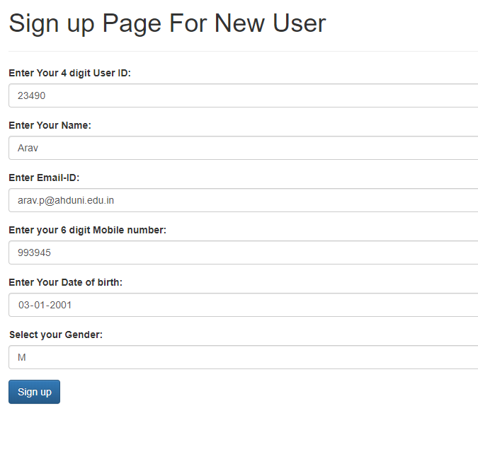

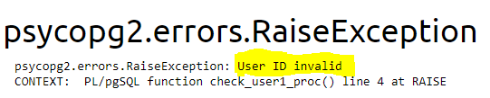

Here user id should be 4 digit but on entering 5 digit user id an error message is generated.

Similarly other displayed messages are:

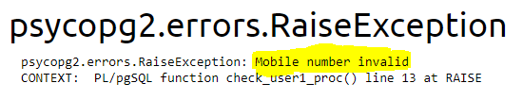

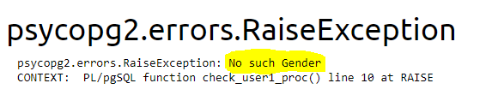

Invalid Inputs for train

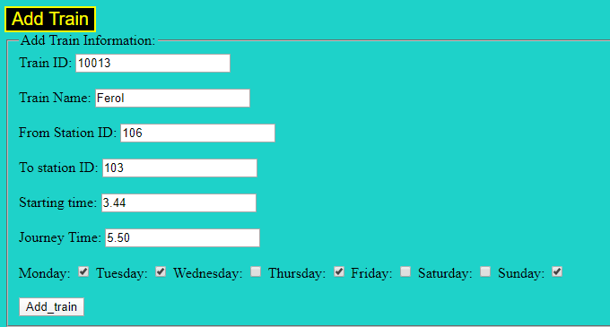

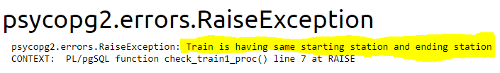

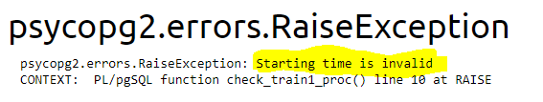

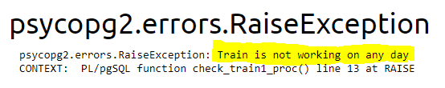

Appropriate balance does not exist then:

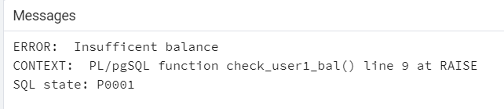

# Functions/Procedures Screenshots of frontend.

1. **Add a train**

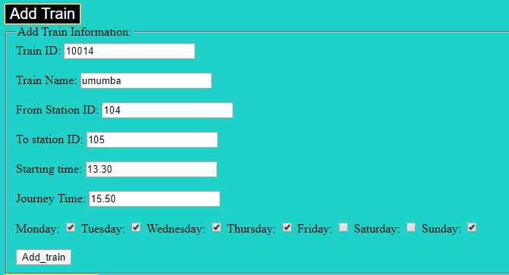

1. **Adding seat category to that train**

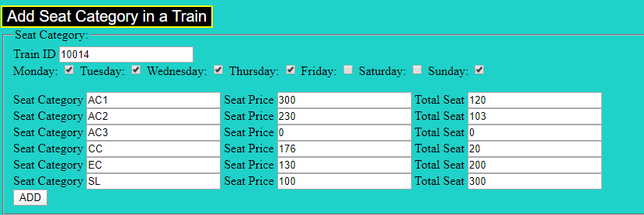

1. **Similarly other data manipulation of trains for admin:**

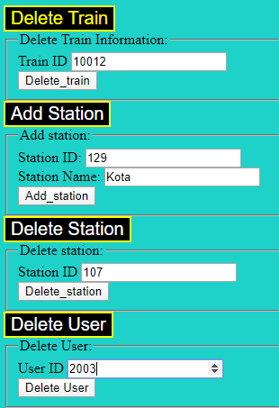

1. **Revenue Generated to the Railways (admin usage)**

Say the Admin wants to calculate the revenue generated by a train till now. Then he has to provide train id and select day for including revenue calculation.

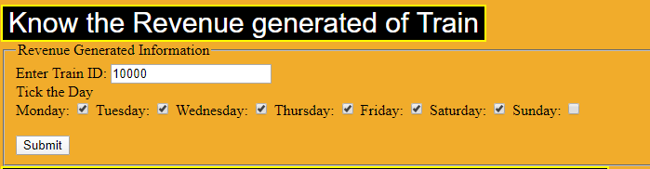

So for this train we get output as

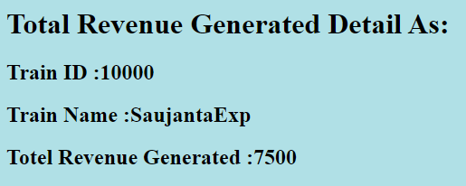

1. **Functionality for getting the number of trains and its details between 2 dates:**

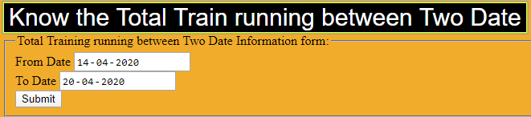

So the output generated is :

Here 1 stands for monday, 2 stands for tuesday..

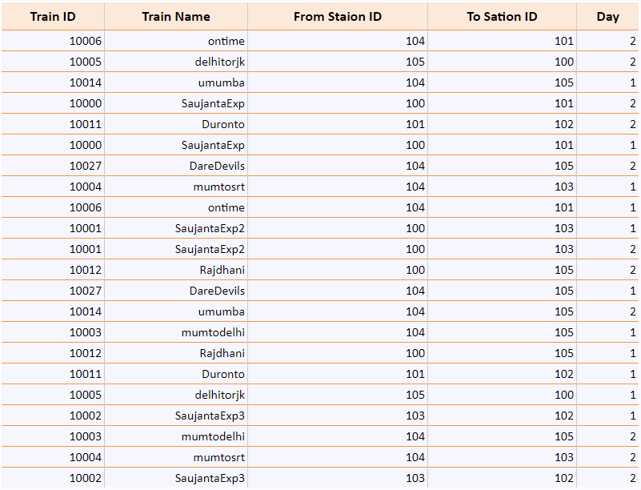

1. **Input two station name to know total trains and its details running between them**

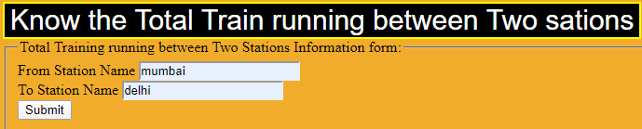

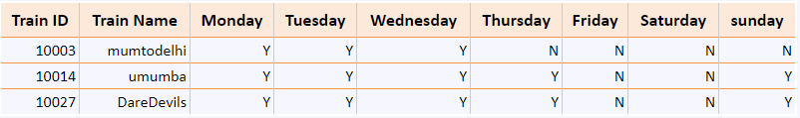

1. **Input a train id and select a day to see the details of passengers who have deleted their tickets.** Details includes name,date,seat category, time

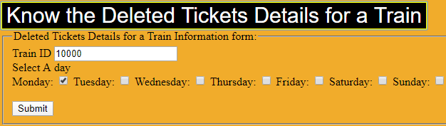

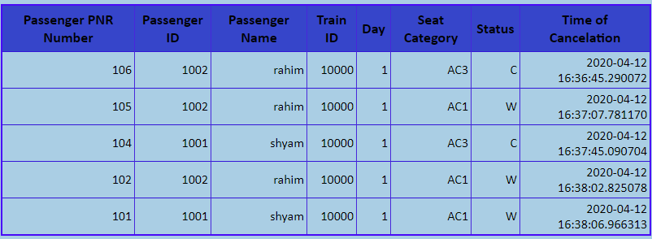

1. **Login Module**

User can create his new account or login into an existing account.

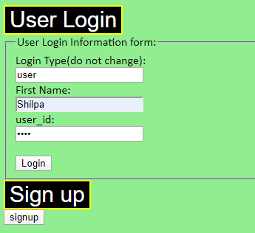

Sign up page:

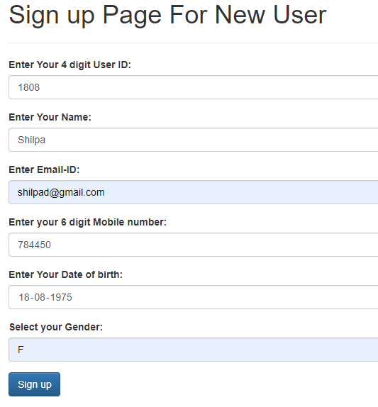

1. **Schedule For user to Book Ticket**

* Input from and to station and date to know the schedule of trains and book a train.
* Fare is deducted from his wallet (if he has appropriate balance or error).

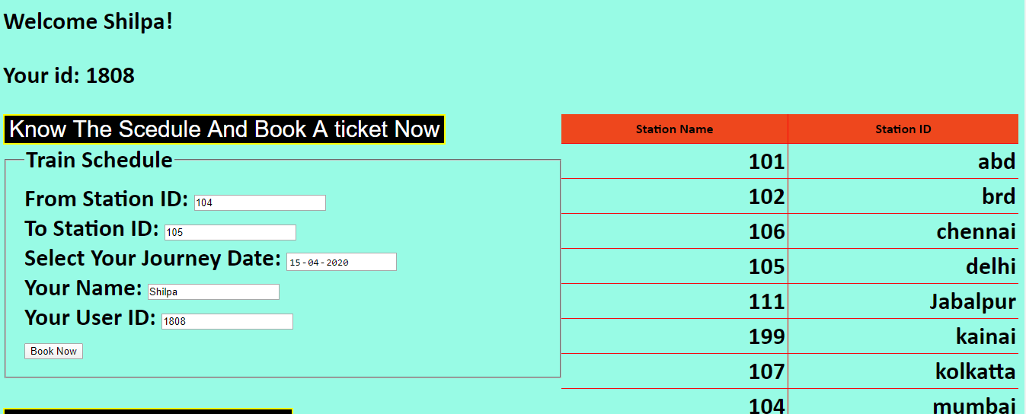

Output is generated as:

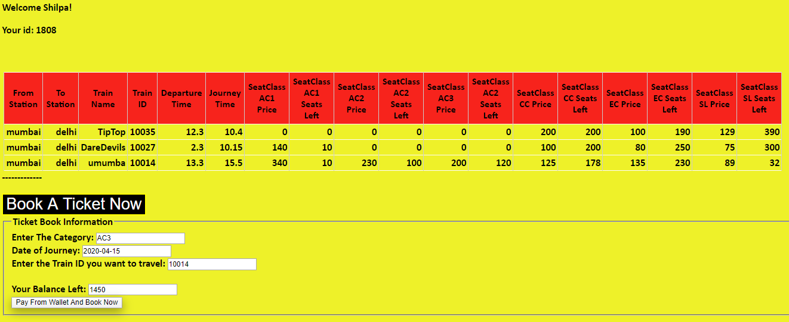

1. **Generating Ticket**

Once user books his ticket then his e-ticket is generated as:

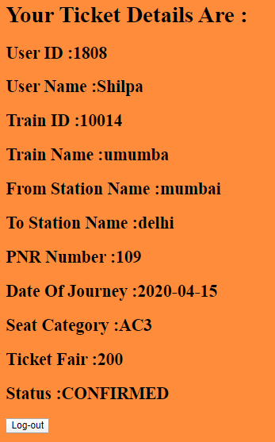

1. **Booking History with reservation status**

This function is about showing all the tickets booked by the user till now with every details including status.

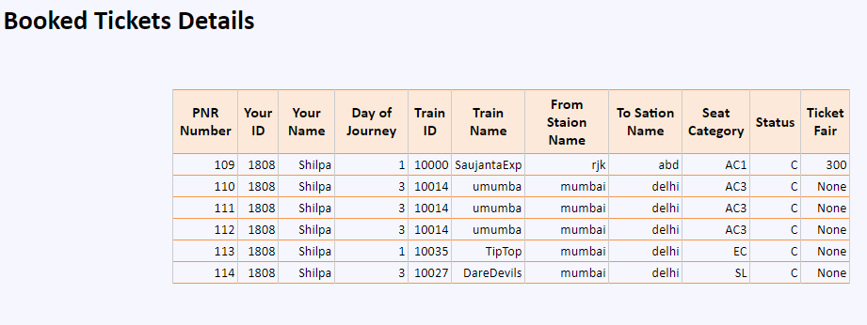

1. **Cancelation of Booking**

Cancel ticket.

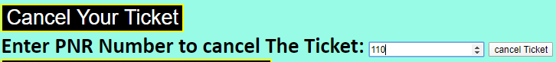

So we can see that this ticket is deleted

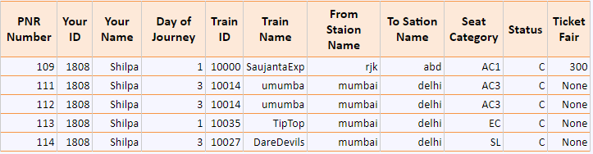

1. **Display Reservation Chart**

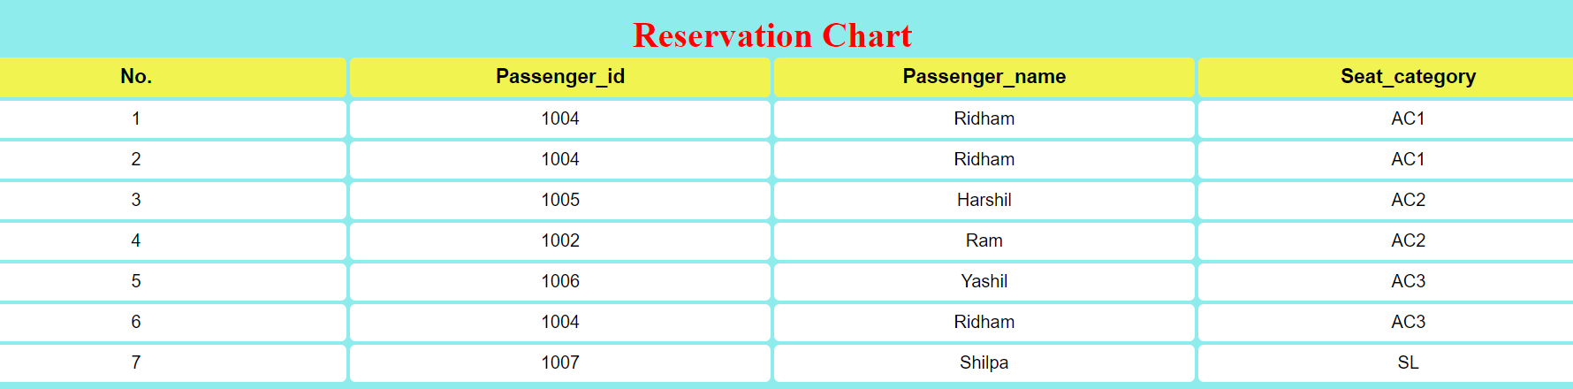

This is the reservation chart which is used to show all the bookings made in any train on a given day.

1. **Special 3 station - (used for connecting trains from A -> B and B -> C when user wants halt at station B):**

As discussed, users can input 3 stations with some waiting/working time in station 2. So this function gives the output as the first train from station 1 to 2 with journey time. Users can have some personal work done at station 2. Then another train from station 2 to station 3 has starting time after that user has done his work.

