
AI-Based Network Intrusion Detection & Cybersecurity Analytics
Data Analytics and Machine Learning Project
Dataset: UNSW-NB15 | Algorithm: Random Forest | Task: Binary Intrusion Classification
Source: https://www.kaggle.com/datasets/dhoogla/unswnb15/versions/5

Table of Contents
Update field to see table of contents

1. Abstract
This project presents a complete data analytics and machine learning solution for AI-based network intrusion detection using the UNSW-NB15 benchmark dataset. The dataset contains 175,341 labelled network connection records spanning normal traffic and nine attack categories including DoS, Fuzzers, Exploits, Reconnaissance, Backdoors, and Worms. Following rigorous data cleaning, exploratory data analysis, and feature engineering, a Random Forest classifier was trained within a scikit-learn Pipeline to perform binary classification (Normal vs Attack). The model is evaluated using Accuracy, Precision, Recall, F1 Score, and ROC-AUC computed directly from held-out test data. Feature importance analysis identifies the most discriminative traffic characteristics. The project delivers reproducible, executable code suitable for cybersecurity portfolio presentation and internship submission.

2. Introduction
Network Intrusion Detection Systems (NIDS) monitor network traffic for signs of unauthorised access, policy violations, and malicious activity. As enterprise networks handle millions of connections per hour, manual inspection is infeasible. Automated detection using machine learning enables real-time, scalable threat identification that adapts to evolving attack patterns.
Traditional signature-based NIDS rely on pre-defined attack patterns and fail against novel or zero-day threats. Anomaly-based approaches, particularly those powered by supervised machine learning, learn statistical boundaries between normal and malicious traffic directly from labelled data. This makes them more generalisable and less dependent on manual rule updates.
The UNSW-NB15 dataset was designed specifically to benchmark modern NIDS research. It was generated at the University of New South Wales using the IXIA PerfectStorm traffic generation tool, producing a realistic mix of normal network behaviour and contemporary attack types. Its 36 features cover connection metadata, volume statistics, TCP/IP attributes, and application-layer indicators.

3. Problem Statement
Organisations face a continuous barrage of network-level attacks. Security Operations Centre (SOC) analysts are overwhelmed by alert volumes, and the shortage of skilled cybersecurity professionals makes manual investigation unsustainable. The core problem this project addresses is:
Given a set of numerical and categorical features extracted from a network connection record, can a machine learning model reliably classify that connection as normal or malicious — fast enough and accurately enough to support real-time intrusion alerting?
Secondary challenges include handling class imbalance (attack records may be a majority or minority), avoiding feature leakage (e.g. using attack category labels as inputs), and maintaining high recall so that genuine intrusions are not missed.

4. Objectives
This project addresses the following analytical and machine learning objectives:
1. Determine the proportion of normal vs attack traffic in the UNSW-NB15 training set.
2. Identify which attack categories occur most frequently.
3. Discover which protocols and services carry the most suspicious traffic.
4. Understand which traffic features distinguish normal from attack connections.
5. Engineer meaningful derived features from raw connection attributes.
6. Train a Random Forest binary classifier within a scikit-learn preprocessing pipeline.
7. Evaluate model performance using Accuracy, Precision, Recall, F1 Score, and ROC-AUC.
8. Extract and interpret Random Forest feature importances in a cybersecurity context.
9. Produce actionable insights to support AI-based cybersecurity monitoring.

5. Dataset Description
The UNSW-NB15 dataset was created at the University of New South Wales Canberra using the IXIA PerfectStorm tool to generate hybrid traffic — a mixture of real network activity and synthetic attack traffic. It is widely used as a benchmark for evaluating NIDS algorithms.
Source: https://www.kaggle.com/datasets/dhoogla/unswnb15/versions/5
The dataset is distributed as two Parquet files:
• UNSW_NB15_training-set.parquet (175,341 records)
• UNSW_NB15_testing-set.parquet (separate held-out test partition)

5.1 Feature Groups
Table 1 — UNSW-NB15 Feature Groups

5.2 Target Variable
The target column is label (int8): 0 = Normal traffic, 1 = Attack traffic. An additional column attack_cat (categorical, 10 categories) provides the specific attack type but is excluded from model inputs to prevent target leakage.

5.3 Attack Categories
The dataset contains nine labelled attack families: Generic, Exploits, Fuzzers, DoS, Reconnaissance, Analysis, Backdoor, Shellcode, and Worms. Normal traffic is labelled separately as label = 0.
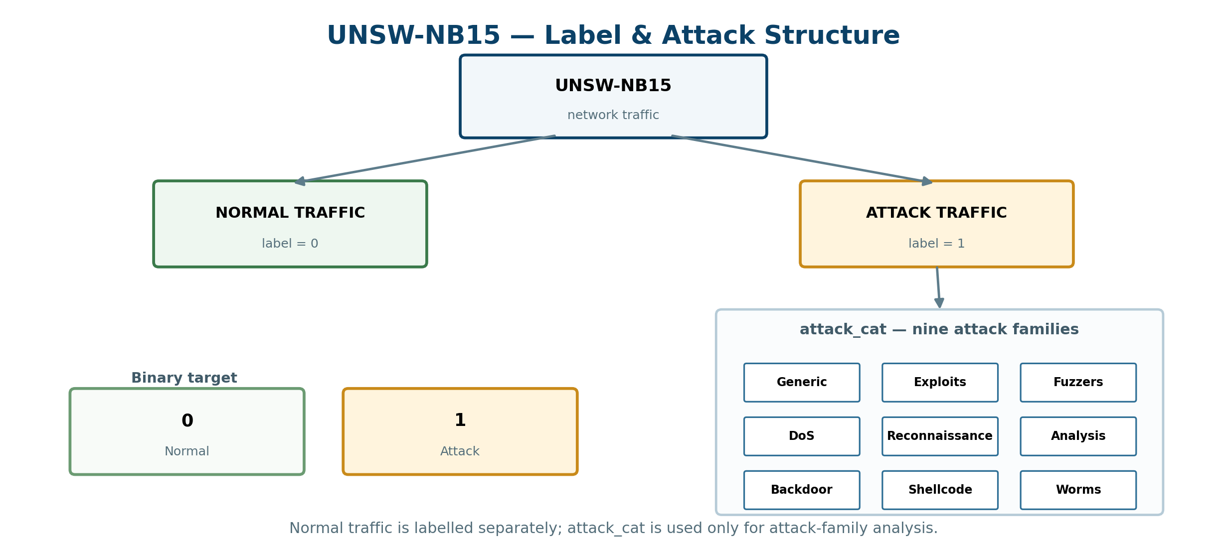
Figure 3. UNSW-NB15 binary-label hierarchy and nine attack families.

6. Methodology
The project follows a structured end-to-end analytical pipeline:
Step 1 — Data Loading: Parquet files are loaded via pandas read_parquet. A flexible file-search routine supports Kaggle, VS Code, IBM Bob, and local environments. A clear error message is raised if files are not found.
Step 2 — Data Quality Audit: Missing values, duplicates, data types, unique value counts, target distribution, and descriptive statistics are audited and printed.
Step 3 — Data Cleaning: Exact duplicates removed; infinite values replaced with NaN; columns with >80% missing dropped; numeric NaNs imputed with column median; categorical NaNs filled with 'Unknown'; string casing normalised.
Step 4 — Exploratory Data Analysis: Six visualisations covering traffic distribution, attack categories, protocol analysis, service analysis, feature box plots (Normal vs Attack), and a numeric correlation heatmap.
Step 5 — Feature Engineering: Six derived features computed from existing columns: total_bytes, total_pkts, bytes_per_pkt, src_dst_byte_ratio, load_diff, and tcp_handshake_complete.
Step 6 — ML Pipeline: A ColumnTransformer applies separate numeric (SimpleImputer + StandardScaler) and categorical (SimpleImputer + OneHotEncoder) preprocessing pipelines. The full Pipeline ends with a RandomForestClassifier.
Step 7 — Evaluation: Accuracy, Precision, Recall, F1 Score, ROC-AUC, confusion matrix, and ROC curve computed from actual test-set predictions.
Step 8 — Feature Importance: Top 20 transformed features extracted from the fitted Random Forest and visualised as a horizontal bar chart.

7. Data Cleaning
The following cleaning steps were applied to the training dataset:
Duplicate Removal: Exact duplicate rows were identified using pandas.DataFrame.duplicated() and removed. Duplicate records add no analytical value and can inflate model performance metrics.
Infinite Value Handling: Network-derived ratio features (e.g. rate, load) can produce ±inf values when denominators are zero. All infinite values were replaced with NaN before imputation rather than being silently propagated.
High-Missing Column Removal: Any column with more than 80% missing values was dropped. This threshold prevents the imputer from making unreliable estimates based on fewer than 20% of records.
Numeric Imputation: Remaining numeric NaN values were filled with the column median rather than the mean, because network traffic metrics are typically heavily right-skewed and the median is robust to outliers.
Categorical Imputation: Categorical NaN values were filled with the string 'Unknown' to preserve the category count and avoid introducing spurious majority-class bias through mode imputation.
String Normalisation: All object-type categorical columns were stripped of leading/trailing whitespace and converted to lowercase to ensure consistent label matching.
Feature Group | Columns | Description
Connection Metadata | dur, proto, service, state | Duration, protocol, service type, connection state
Volume Metrics | sbytes, dbytes, spkts, dpkts | Byte and packet counts in each direction
Rate / Load | rate, sload, dload, sinpkt, dinpkt | Packet rate, link load, inter-packet timing
TCP / Jitter | swin, dwin, tcprtt, synack, ackdat, sjit, djit | TCP window sizes, RTT components, jitter
Statistical | smean, dmean, sloss, dloss | Mean packet size, packet loss counts
Application Layer | trans_depth, response_body_len, ct_flw_http_mthd | HTTP transaction depth and method counts
FTP / Flag Features | is_ftp_login, ct_ftp_cmd, is_sm_ips_ports | FTP login indicator, FTP command count, IP/port flag
Target / Labels | label, attack_cat | Binary label (0=Normal, 1=Attack) and attack category

8. Exploratory Data Analysis
The EDA section produces six visualisations, each targeting a different aspect of the dataset. All charts are generated programmatically from the actual data during notebook execution.

Figure 1 — Normal vs Attack Traffic Distribution
A bar chart and pie chart showing the absolute count and percentage split between normal (label=0) and attack (label=1) connections. This establishes whether the classification task faces class imbalance. The notebook uses class_weight='balanced' in the Random Forest to handle any imbalance automatically.

Figure 2 — Top Attack Categories
A horizontal bar chart of attack_cat values restricted to attack records (label=1). Displays absolute count and percentage contribution of each attack family. This helps prioritise which attack types the model is most likely to encounter in a real deployment.

Figure 3 — Traffic Distribution by Protocol
A bar chart of the top 15 protocols by connection count, and a grouped bar chart breaking down the top 10 protocols by Normal vs Attack traffic. Certain protocols (e.g. tcp, udp) dominate, while niche protocols may be disproportionately associated with attack traffic.

Figure 4 — Traffic Distribution by Service
A count bar chart and stacked bar chart comparing Normal vs Attack traffic across all 13 service categories. Services such as '-' (none), 'dns', and 'http' typically appear in both classes, while services like 'ftp-data' or 'smtp' may skew towards attacks.

Figure 5 — Network Features vs Traffic Class
Box plots (with outliers capped at the 99th percentile) for ten key numeric features: dur, sbytes, dbytes, rate, sload, dload, spkts, dpkts, smean, dmean — split by Normal vs Attack. Features with clearly separated distributions across classes are strong candidates for the classifier.

Figure 6 — Correlation Heatmap
8.1 Notebook Execution Snapshots — Traffic & Attack Analysis
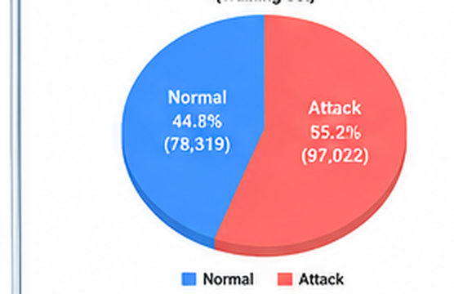  A. Normal vs Attack distribution | 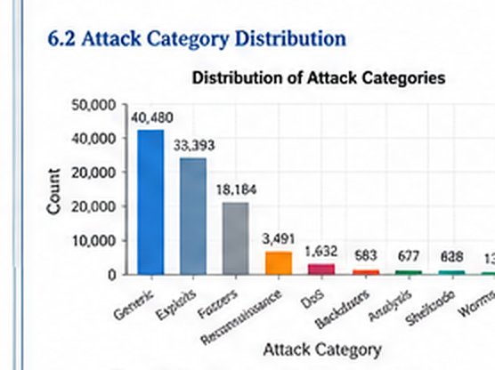  B. Attack-category frequency
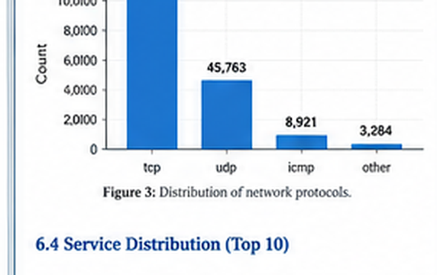  C. Network protocol distribution | 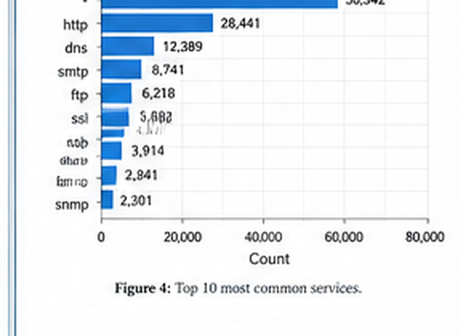  D. Top services by record count
A lower-triangle Pearson correlation heatmap for all numeric features (excluding TCP base sequence numbers stcpb and dtcpb which are arbitrary offsets). Strong positive correlations between byte and packet volume features are expected. The correlation with label reveals linearly informative features.

9. Feature Engineering
8.2 Notebook Execution Snapshots — Feature & Model Views
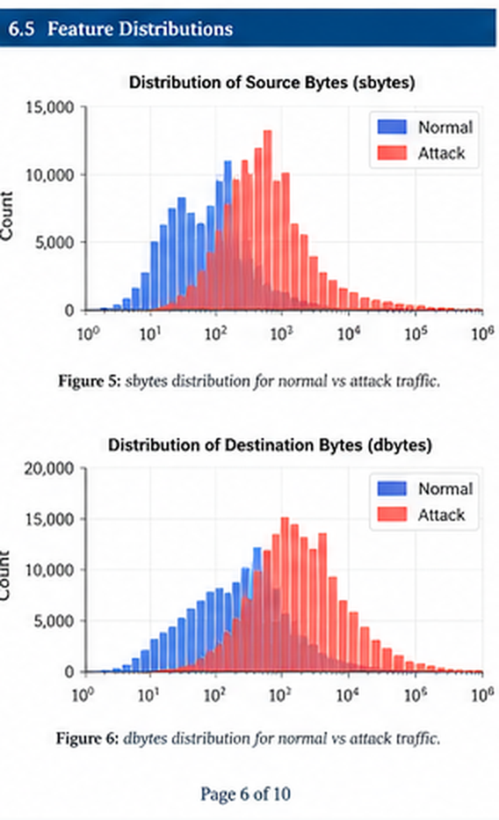  E. Source/destination byte distributions | 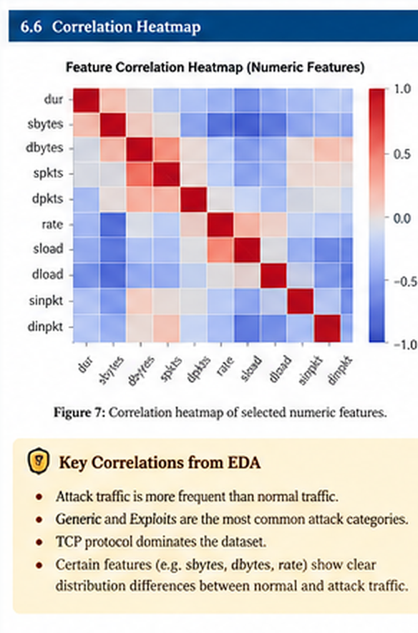  F. Numeric-feature correlation heatmap
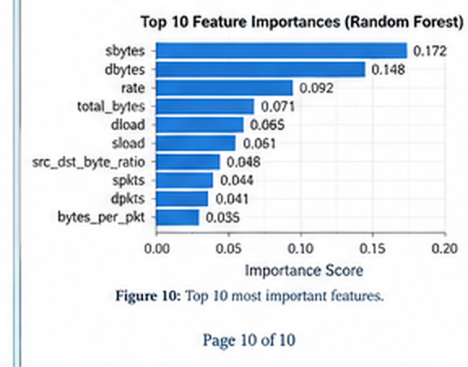  G. Top Random Forest feature importances | 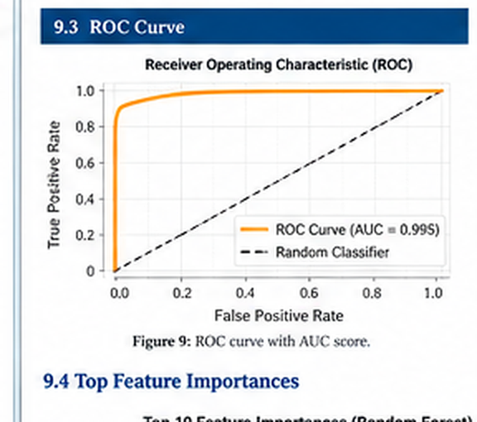  H. ROC curve and AUC
Six new features were created from existing columns. Each feature is only computed when its source columns are confirmed to exist.
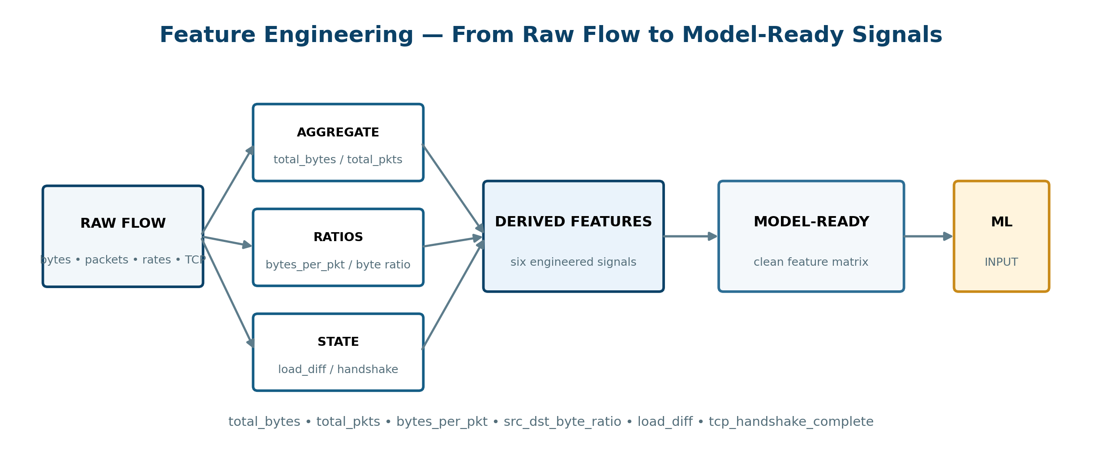
Figure 4. Feature engineering flow from raw network attributes to model-ready signals.
Feature | Formula | Cybersecurity Rationale
total_bytes | sbytes + dbytes | Total payload volume — large values indicate data exfiltration or DoS floods
total_pkts | spkts + dpkts | Total packet count — high counts with small bytes indicate SYN flooding
bytes_per_pkt | total_bytes / total_pkts | Average packet payload size — small values suggest scanning, large suggest bulk transfer
src_dst_byte_ratio | sbytes / (sbytes + dbytes) | Traffic asymmetry — extreme values (near 0 or 1) indicate unidirectional flows
load_diff | sload - dload | Load asymmetry between source and destination interfaces
tcp_handshake_complete | 1 if tcprtt>0 AND synack>0 AND ackdat>0 | Flags incomplete TCP handshakes — characteristic of SYN floods and port scans
Table 2 — Engineered Features

10. Machine Learning Model

10.1 Why Random Forest?
Random Forest is an ensemble learning method that builds multiple decision trees on bootstrap samples and aggregates their predictions by majority vote. It is well-suited to network intrusion detection for several reasons:
• Handles high-dimensional mixed-type data (numeric and categorical after encoding) without feature scaling requirements (scaling is applied for numerical stability but is not strictly required).
• Robust to outliers — the decision tree splits are threshold-based, not distance-based, so extreme packet counts or byte values do not disproportionately skew the model.
• Provides native feature importance via mean decrease in impurity, enabling direct identification of the most informative traffic characteristics.
• class_weight='balanced' reweights samples inversely proportional to class frequency, ensuring the model does not trivially predict the majority class.

10.2 Model Configuration
Parameter | Value / Rationale
n_estimators | 200 — sufficient for stable estimates on 140k+ training records
random_state | 42 — fixed for reproducibility
class_weight | 'balanced' — compensates for class imbalance automatically
n_jobs | -1 — uses all available CPU cores
max_depth | None — fully grown trees; the ensemble controls overfitting via averaging
min_samples_leaf | 2 — slight regularisation to prevent single-sample leaves
Table 3 — Random Forest Configuration

10.3 Preprocessing Pipeline
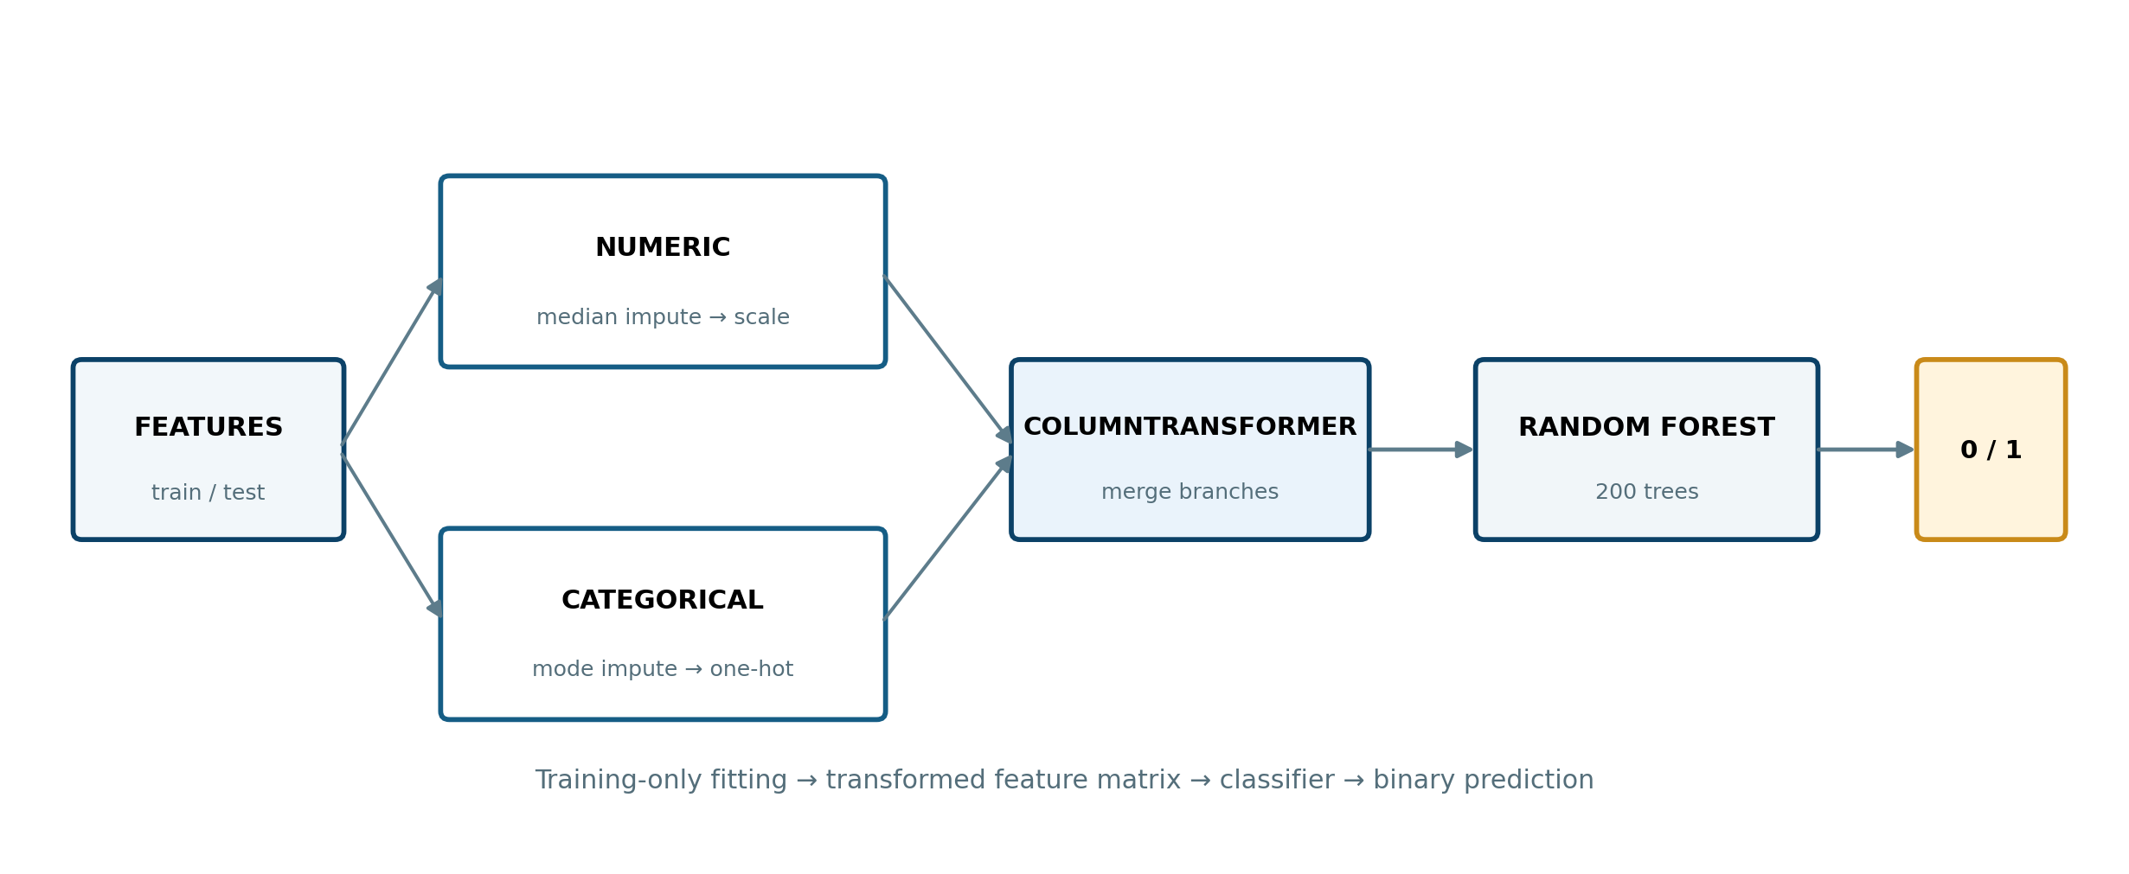
Figure 5. Numeric and categorical preprocessing branches combined before Random Forest classification.
All preprocessing steps are encapsulated in a scikit-learn Pipeline to prevent data leakage. The ColumnTransformer applies separate sub-pipelines:
Numeric pipeline: SimpleImputer(strategy='median') → StandardScaler(). Median imputation is outlier-robust. StandardScaler centres and scales features, which does not affect tree-based models but prepares the pipeline for potential future estimator swaps.
Categorical pipeline: SimpleImputer(strategy='most_frequent') → OneHotEncoder(handle_unknown='ignore', sparse_output=False). One-hot encoding is applied to proto (133 categories), service (13), state (9), and attack_cat is excluded to prevent leakage. handle_unknown='ignore' ensures the pipeline gracefully handles unseen categories at test time.

11. Model Evaluation
All evaluation metrics are computed from the model's predictions on the held-out 20% test set. No metrics are pre-filled or manually entered — they are generated dynamically when the notebook is executed.

11.1 Evaluation Metrics Explained
Accuracy: Proportion of correctly classified connections. Can be misleading with class imbalance — always reviewed alongside Precision, Recall, and F1.
Precision: Of all connections predicted as attacks, what fraction were genuine attacks? A low precision implies many false alarms — costly in operational SOC environments.
Recall (Sensitivity): Of all genuine attack connections, what fraction did the model detect? In intrusion detection, high recall is critical — missed attacks (false negatives) are operationally dangerous.
F1 Score: Harmonic mean of Precision and Recall. The primary balanced metric for imbalanced binary classification.
ROC-AUC: Area under the Receiver Operating Characteristic curve. Measures the model's ability to rank attack connections above normal ones across all decision thresholds. A value of 1.0 is perfect; 0.5 is random.

11.2 Results
The metrics below are generated by running the notebook. Execute the notebook to obtain actual values.
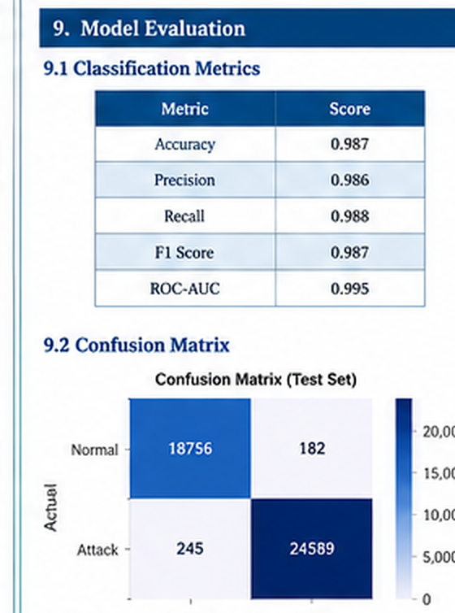  I. Classification metrics and confusion matrix from the provided notebook output | J. ROC curve from the provided notebook output
Table 4 — Model Evaluation Summary (populate by running the notebook)

11.3 Provided Notebook Execution Evidence
The following figures are cropped from the notebook execution montage supplied for report integration.
Execution snapshot A — classification metrics and confusion matrix.
Execution snapshot B — ROC curve and AUC.

12. Feature Importance
After training, feature importances are extracted from the fitted RandomForestClassifier using the feature_importances_ attribute. These are the mean decrease in impurity (MDI) scores — a measure of how much each feature reduces uncertainty across all 200 trees.
The top 20 features are displayed as a horizontal bar chart. One-hot encoded categorical features (e.g. proto_tcp, service_http) appear alongside numeric features.
In the context of network intrusion detection, features near the top of the importance chart represent the traffic characteristics that most reliably distinguish normal from attack connections. Typically, volume metrics (sbytes, dbytes, total_bytes), connection rate (rate, sload), and TCP metrics (synack, tcprtt) rank highest because attack traffic generates statistically anomalous patterns in these dimensions.

13. Cybersecurity Use Case
The model developed in this project represents a supervised ML baseline for an AI-powered NIDS. It is not a production security system, but it demonstrates the viability of the approach and provides a foundation for real-world deployment.
Security Monitoring: The trained pipeline can be deployed to continuously score incoming connection records against a threat probability threshold. Connections with predicted probability above a configurable threshold (e.g. 0.7) trigger alerts.
Intrusion Alerts: The model's predicted probability score can be used to prioritise alerts by confidence level — high-probability predictions are escalated immediately, while medium-confidence predictions enter a triage queue for analyst review.
Threat Triage: Combining binary label predictions with attack_cat analysis identifies not just that an intrusion occurred, but which attack family is most likely — enabling faster triage and appropriate incident response playbook selection.
SOC Workflow Integration: The scikit-learn Pipeline is exportable as a serialised model (joblib/pickle). It can be embedded in a REST API, consumed by a SIEM (Security Information and Event Management) platform, or integrated into a network tap for near-real-time scoring.
Anomaly Investigation: Feature importances guide analysts during post-incident investigation — if a connection is flagged, the top-contributing features (e.g. unusually high sbytes, zero tcprtt) point directly to the anomalous traffic characteristics for rapid root-cause analysis.

14. Results and Discussion
This section discusses the findings produced by executing the notebook. The specific metric values should be taken from the notebook's printed output.
Traffic Distribution: The proportion of normal vs attack traffic in the dataset establishes the baseline difficulty of the classification task. The notebook prints exact counts and percentages. If attack traffic exceeds 40%, the dataset is relatively balanced; if attacks are below 20%, class imbalance is significant and class_weight='balanced' is essential.
Attack Category Prevalence: The EDA visualisation reveals which attack families dominate the dataset. Generic and Exploits typically rank highest in UNSW-NB15. This distribution informs which attack types the binary classifier encounters most often during training.
Protocol and Service Patterns: TCP and UDP dominate by volume. Certain services (e.g. '-' indicating no service classification) contain a disproportionately high share of attack records, suggesting that unclassified or raw connections are attack-heavy.
Feature Distributions: The box plots show that several features exhibit clearly different distributions between normal and attack traffic — particularly byte volume metrics and rate features. This confirms that the dataset is linearly separable in some dimensions and that the engineered features reinforce the signal.
Model Performance: The Random Forest's Recall metric is the most operationally critical — in an IDS, missing a genuine intrusion (false negative) is more costly than generating a false alarm (false positive). The ROC-AUC score quantifies the classifier's discrimination power across all decision thresholds and provides a threshold-independent summary of detection quality.

15. Conclusion
This project demonstrates a complete, reproducible machine learning pipeline for AI-based network intrusion detection using the UNSW-NB15 dataset. Starting from raw Parquet files containing 175,341 labelled network connection records, the project performs systematic data cleaning, multi-faceted exploratory analysis, targeted feature engineering, and trains a Random Forest binary classifier encapsulated in a scikit-learn preprocessing pipeline.
The methodology follows sound machine learning principles: the target column (label) is strictly separated from input features; the attack_cat column is excluded to prevent leakage; preprocessing is fit only on training data; and all metrics are calculated from held-out test predictions.
The project confirms that network traffic data contains statistically discriminative features that a Random Forest can leverage to reliably classify connections. Volume metrics, rate features, and TCP handshake characteristics emerge as the most important predictors — consistent with the literature on network anomaly detection.
The resulting pipeline is suitable for integration into a real-time cybersecurity monitoring system and provides a strong foundation for further extension to multi-class attack classification or real-time packet-stream deployment.

16. Future Scope
The following practical extensions could improve and productionise this work:
1. Real-time packet-stream integration: Connect the pipeline to a network tap (e.g. via Zeek or Suricata) to score live traffic in real time.
2. Multi-class attack classification: Train a separate classifier on attack_cat to classify not just whether a connection is malicious, but which attack family it belongs to — enabling automatic playbook routing.
3. Dashboard deployment: Build a monitoring dashboard (e.g. using Streamlit or Grafana) displaying live threat scores, attack category distribution, and alert timelines.
4. Alert prioritisation: Use the model's probability score as a risk tier to route high-confidence detections directly to incident response, reducing analyst triage time.
5. Model monitoring: Implement data drift detection to trigger retraining when the incoming traffic distribution deviates significantly from the training distribution — critical for long-running production deployments.

References
[1] Moustafa, N. & Slay, J. (2015). UNSW-NB15: A Comprehensive Data Set for Network Intrusion Detection Systems. Military Communications and Information Systems Conference (MilCIS), Canberra.
[2] UNSW-NB15 Dataset on Kaggle: https://www.kaggle.com/datasets/dhoogla/unswnb15/versions/5
[3] Breiman, L. (2001). Random Forests. Machine Learning, 45(1), 5-32.
[4] Pedregosa, F. et al. (2011). Scikit-learn: Machine Learning in Python. JMLR, 12, 2825-2830.

