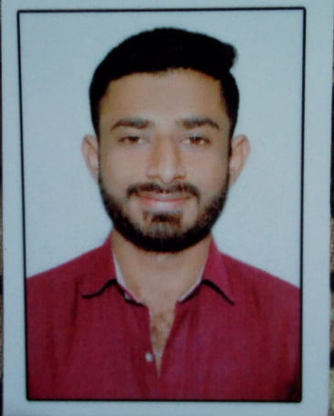

Pradip Mevada

Education
Contact

Block no. -”94” Chitrakut nagar
Near ring-road Bhavnagar
8905344086
pradipmevada13121998@gmail.com
Graduation
(Shree Mukeshkumar Maganlal Doshi
Arts & Commers College Jesar )
May 2019
56.40%

Career Objective
I want to work with the organization where I can establish myself Professionally, Financially, and Socially by applying my knowledge & skills acquired during my education.
Professional skills
- Excel
- Power-point
- Computer-Operator
Soft Skills
- Marketing
- Communication
- Leadership

H.S.C.
(B.G.Mehta Vidhyalay Jesar)
March 2016
46.14%

S.S.C.
(B.G.Mehta Vidhyalay Jesar)
March 2014
49.33%
Language Proficiency

Gujarati Hindi English

Cricket
Hobbies
Photography
Photo & Video Editing

I declare that above mentioned information is correct to best of my knowledge and belief.

Pradip Mevada

