**Final Year Project Proposal**

**Project Title:**

Airborne Sampling/Sensing of Distal Volcanic Ash

**Supervisor:**

Maan Alkaisi

**Industrial Sponsor:**

Defence Technology Agency (DTA)

**Student Names:**

Jake Campbell

Jamie Van de Laar

Michael Shanaher

Parth Thakur

Ryan Taylor

**Student ID Numbers:**

82747243

34723974

51526982

41985096

41911824

**Student Emails:**

jdc98@uclive.ac.nz

jpv15@uclive.ac.nz

mws70@uclive.ac.nz

pst61@uclive.ac.nz

rct47@uclive.ac.nz

1. **Project Overview**

After a volcanic eruption, volcanic ash (VA) stratifies into distal clouds that pose a great risk to the engines of aircraft operating within them. While civil aviation is able to reroute flights, military operations may require aircraft to operate within or near the cloud. Current flight advice is dictated by the density of the volcanic ash. However, there is evidence that other VA characteristics such as particle size distribution (PSD) and chemical composition affect the risk to aircraft engines. The current VA cloud measurements involve the use of combining satellite imagery with weather prediction models to determine the area of coverage by the VA cloud, but lack information about the altitude of the cloud.

The Defence Technology Agency (DTA) require a low cost method for intercepting a VA cloud at aircraft operating altitudes up to 40,000 feet. The solution is to intercept the cloud and take altitude and density measurements. Other measurements that may be useful include the PSD and chemical composition. It will also be necessary to take a physical sample for later lab analysis. The solution’s sensor package is to be recoverable and reusable. The proposed solution is to deploy a UAV via weather balloon to the desired altitude whereupon the UAV is released. An autopilot flies the UAV through the cloud, collecting samples before returning safely to the ground. Ground communication is necessary to provide a live feed of the data collected.

1. **Administration**

Meetings with the project supervisor and sponsor are to be held weekly at 3pm on Fridays. The client will be present largely via Skype as the DTA is located in Auckland. The sponsor plans to visit in person at least once during the project or when necessary. Meetings will serve to regularly update the sponsor and supervisor on progress, whereas important questions will be directed via email. Contact within the group will largely be through Facebook and in person via informal meetings. Both a group chat and group page have been set up on Facebook to facilitate quick and easy communication between members. The group will use Trello, a web tool used for organising projects into simple lists. A Github repository and Google Drive are used for version control and document sharing.

1. **Project Components**

The initial focus is on developing the sensor and sampling payload. Hence this area of work was split between the members of the group. The secondary objective is to develop the UAV platform which is also split between group members. This is summarised in Table 1 below. This gives each individual two set tasks they are responsible for completing, with the emphasis on completing the sensor and sampling payload first.

Table : Task breakdown of project components.

|  |  |  |  |  |  |
| --- | --- | --- | --- | --- | --- |
|  | **Mike** | **Jamie** | **Ryan** | **Jake** | **Parth** |
| **Sensor Payload** | VA density | VA sample | Sensor CPU | Particle size | Chemical composition |
| **UAV Platform** | Communications | UAV | Autopilot | Power management | Modelling |

1. **Specific Tasks and Timeline**

The main priority is for the sensor payload to be developed as this dictates the UAV platform design. The sensor system is expected to be the most difficult due to the lack of existing research/ products as these sensors are not designed for airborne operation. The system design should be completed by early April ‘so that specialised parts can be ordered and delivered in time for development. Figure 1 gives an initial estimate for the project timeline.

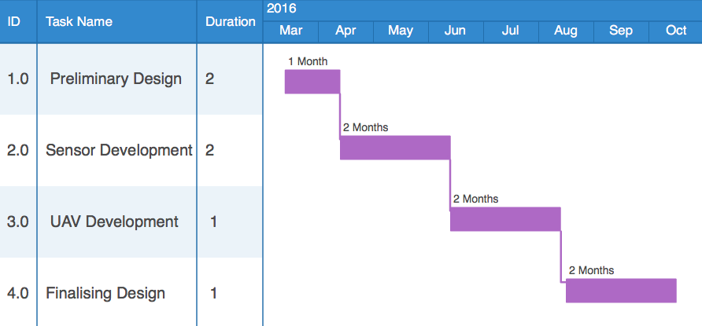

Figure : Gantt chart showing the proposed timeline for the project.

1. **Budget Summary**

The team is expected to produce a low cost and reliable solution, reducing the possible approaches that can be proposed to the client. The ECE department has provided $250 for this project. The client is willing to provide some resources as well as costs of up to a few thousand dollars. The main aspects of the budgeting are detailed below.

**Equipment- resources required to meet the objectives of the project**

Payload sensors: radiosonde (pressure, temperature, humidity, altitude), particle size analyser, sample collector, SO2, air speed, VA density (unknown implementation, cost omitted).

UAV: airframe, weather balloon, GPS, autopilot, control system.

**Testing- tools required to test and measure the reliability of the equipment**Wind tunnel, ash samples, pressure and temperature testing.

**Shipping- Cost of getting the items delivered**Majority of the equipment used can be easily shipped to Christchurch inexpensively. The UAV airframe itself may pose a higher cost depending on its size.

Initial costing is indicated in Table 2 based on existing potential “off the shelf” components.

Table : Costing estimate of project­.

|  |  |  |  |  |  |  |
| --- | --- | --- | --- | --- | --- | --- |
| Potential Payload Sensors | Radiosonde | Particle size analyser | Sample collector | SO2 | Air speed | Totals |
| US$20 | US$66 | US$30 | US$181 | US$55 | US$352 |
| UAV | Airframe | Weather balloon | GPS/Compass | Autopilot |  |  |
| US$150 | Free from DTA | US$90 | US$200 |  | US$440 |
| Total: US$792 = NZ$1156 (at 18/3/16) | | | | | | |