# **Assignment 1**

## Problem 1

1. MAE = $\frac{\sum_{i=1}^{n}{|yi-xi|}}{n}$ = 33/16 = 2.06
2. MSE = $\frac{\sum_{i=1}^{n}{(\left|yi-xi\right|})^2}{n}$ = 189/16 = 11.81
3. PSNR = 20log10(MAXi) – 10log10(MSE)

= 20log10(24-1) – 10log10(11.81)

= 12.8dB

*(ref -* [*https://en.wikipedia.org/wiki/Peak_signal-to-noise_ratio*](https://en.wikipedia.org/wiki/Peak_signal-to-noise_ratio)*)*

## Problem 2

1. From the given input and output image, and using the intensity transformation:

5 = αlog2(1+3) + β = 2α + β

11 = αlog2(1+15) + β = 4α + β

Solving the equations simultaneously, we get

α = 3, β = -1

1. Value of pixel in third row:

Let the value be x. Then,

8 = αlog2(1+x) + β = 3log2(1+x) -1

3 = log2(1+x)

x = 7

1. Value of pixel in fourth row:

Let the value of pixel be p. Then,

p = αlog2(1+1) + β = 3log2(1+1) -1 = 2

## Problem 3

(1) -- E

(2) -- C

(3) -- D

(4) -- B

(5) -- A

## Problem 4

1. Given:

rmin = 6, rmax = 14, 2B-1 = 15

s = round[(r-rmin) 2B-1/(rmax-rmin)] = round[15(r-6)/8]

|  |  |  |
| --- | --- | --- |
| **r** | **answer** | **round(answer)** |
| 6 | 0 | 0 |
| 7 | 1.875 | 2 |
| 11 | 9.375 | 9 |
| 12 | 11.25 | 11 |
| 13 | 13.125 | 13 |
| 14 | 15 | 15 |

Resulting full scale contrast stretch image is:

|  |  |  |  |
| --- | --- | --- | --- |
| 0 | 13 | 11 | 13 |
| 11 | 0 | 2 | 11 |
| 13 | 2 | 2 | 11 |
| 15 | 9 | 9 | 15 |

1. Consider below:

|  |  |  |  |  |  |  |  |  |  |  |  |  |  |  |  |  |
| --- | --- | --- | --- | --- | --- | --- | --- | --- | --- | --- | --- | --- | --- | --- | --- | --- |
| k | 0 | 1 | 2 | 3 | 4 | 5 | 6 | 7 | 8 | 9 | 10 | 11 | 12 | 13 | 14 | 15 |
| H(k) | 0 | 0 | 0 | 0 | 0 | 0 | 2 | 3 | 0 | 0 | 0 | 2 | 4 | 3 | 2 | 0 |
| Q(k) | 0 | 0 | 0 | 0 | 0 | 0 | 2 | 5 | 0 | 0 | 0 | 7 | 11 | 14 | 16 | 16 |

Intermediate image is as follows:

|  |  |  |  |
| --- | --- | --- | --- |
| 2 | 14 | 11 | 14 |
| 11 | 2 | 5 | 11 |
| 14 | 5 | 5 | 11 |
| 16 | 7 | 7 | 16 |

rmin = 2, rmax = 16

s = round[(r-rmin) 2B-1/(rmax-rmin)] = round[15(r-2)/14]

|  |  |  |
| --- | --- | --- |
| **r** | **answer** | **round(answer)** |
| 2 | 0 | 0 |
| 5 | 3.214286 | 3 |
| 7 | 5.357143 | 5 |
| 11 | 9.642857 | 10 |
| 14 | 12.85714 | 13 |
| 16 | 15 | 15 |

Final histogram equalised image:

|  |  |  |  |
| --- | --- | --- | --- |
| 0 | 13 | 10 | 13 |
| 10 | 0 | 3 | 10 |
| 13 | 3 | 3 | 10 |
| 15 | 5 | 5 | 15 |

1. Histograms as below:

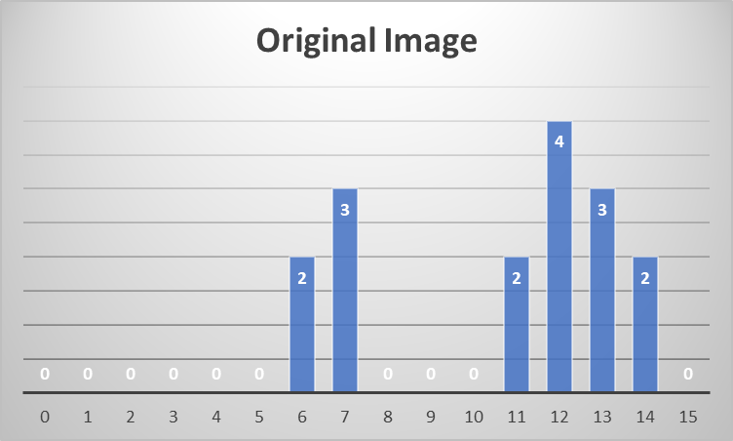

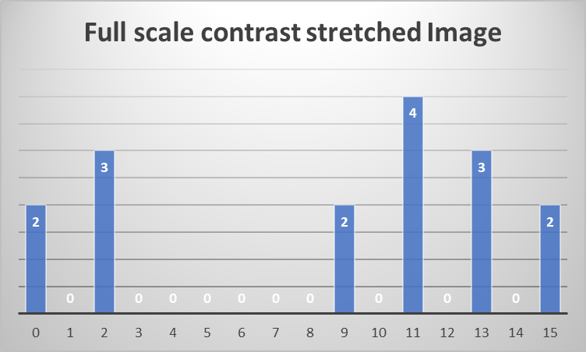

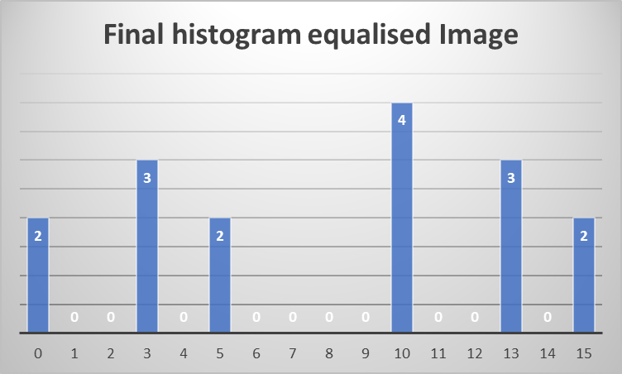

## Problem 5

1. Below is the solution: Calendar

   Description automatically generated with medium confidence
2. Below is the solution: 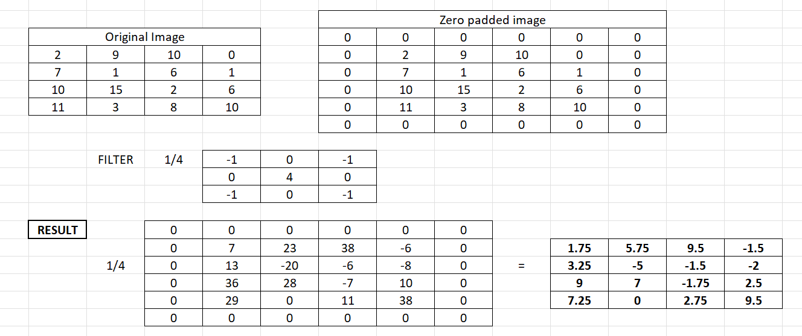
3. Below is the solution: Calendar

   Description automatically generated with low confidence

We can get the penultimate step image by addition of images we get from a) and b) without the division operations. We can directly add those images and perform division operation on the resulting image to get the final image as the result.

## Problem 6

1. Below is the solution: Calendar

   Description automatically generated
2. Below is the solution for all three: A picture containing text, white

   Description automatically generated
3. Solution: Table

   Description automatically generated

Comment: Resulting and Original image are same because we have done 2D-DFT on original image and then done inverse DFT on the resulting image after 2D-DFT.

## Problem 9

1. Below is the solution we get after applying the filter: A picture containing text, white

   Description automatically generated

MAE = = 48/16 = 3

MSE = = 10

PSNR = 20log10(MAXi) – 10log10(MSE)

= 20log10(24-1) – 10log10(10)

= 13.52dB

1. Below is the result after passing the median filter: A picture containing text, crossword puzzle

   Description automatically generated

MAE = = 144/16 = 9

MSE = $\frac{\sum_{i=1}^{n}{(\left|yi-xi\right|})^2}{n}$ = 1496/16 = 93.5

PSNR = 20log10(MAXi) – 10log10(MSE)

= 20log10(24-1) – 10log10()

= 3.81

## Problem 10

1. Below is the solution: Graphical user interface, application, table, Excel

   Description automatically generated
2. Below is the solution: 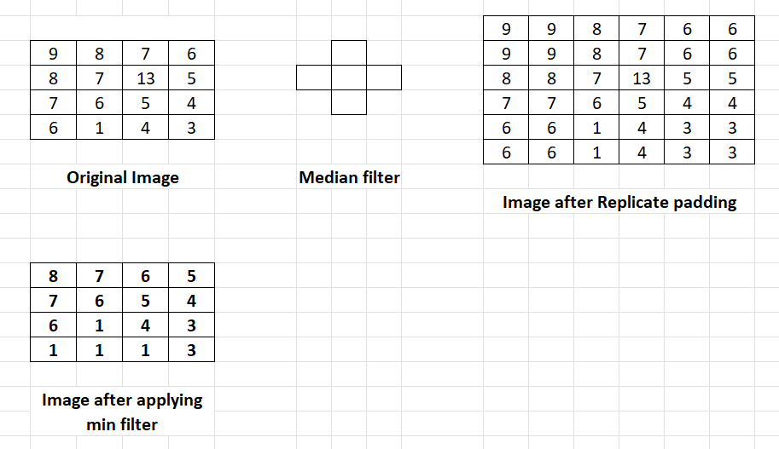
3. Below is the solution: Graphical user interface, application, table, Excel

   Description automatically generated

## Problem 7

1. Below is the deblur filter G(u,v) using inverse filtering approach: Table

   Description automatically generated
2. Below is the deblur filter using pseudo inverse filtering approach: A screenshot of a computer

   Description automatically generated with low confidence
3. Below is the deblur filter G(u,v) : Table

   Description automatically generated
4. Below is the filter G(u,v): Table

   Description automatically generated
5. Below is the filter design using Weiner filter:

σ­X2= 100, σW2 = 25

K = σW2/ σ­X2 = 25/100 = 0.25