**CS 4471 Lab Assignment-2**

**Group No 3**

**(Yash Patel, Parth Patel, Damin Shah, Anuj Patel)**

1) A

Steps are as follows:

1.Start

2.Control Panel

3.User Accounts

4.Manage User Accounts

5.Add New Account

6.Enter UserName, Password

7.Finish

1) B

Steps are as follows:

1.Network and Sharing Center

2.Ethernet

3.Ethernet Properties

4.Internet Protocol Version 4

5.Internet Protocol Version 4 (TCP/IPv4)

6.Enter IP address-10.86.44.213

7.Enter Subnet Mask-255.255.255.0

8.Enter Default Gateway-10.86.44.1

9.Preffered DNS server Address-130.182.1.11

10. Click

ScreenShot:

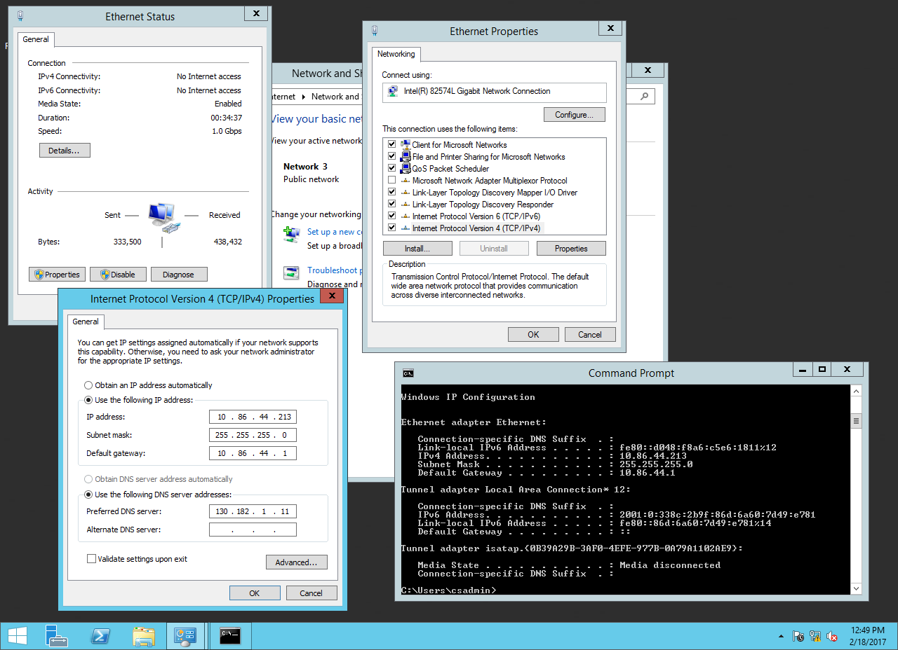

1) C

1.Enter IP address-10.86.44.211

2.Enter Subnet Mask-255.255.255.0

3.Enter Default Gateway-10.86.44.1

4.Preffered DNS server Address-130.182.1.11

1) D(1) CMD ipconfig

ScreenShot:

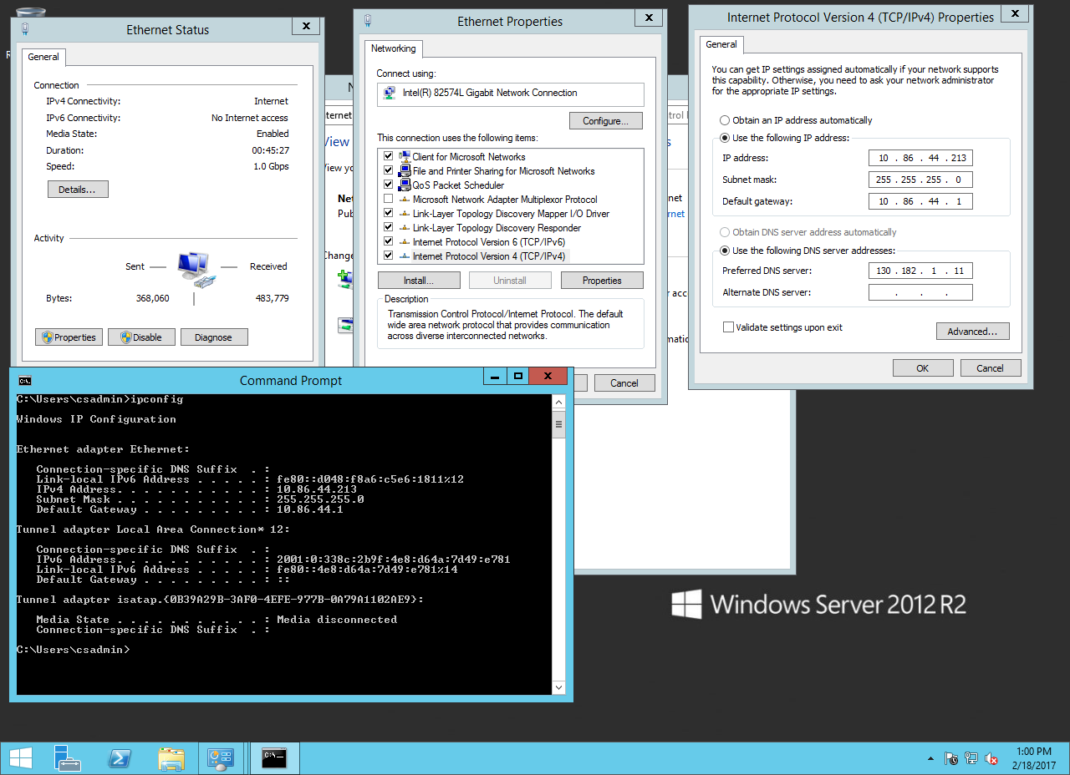

(2) tracert [www.google.com](http://www.google.com)

ScreenShot :

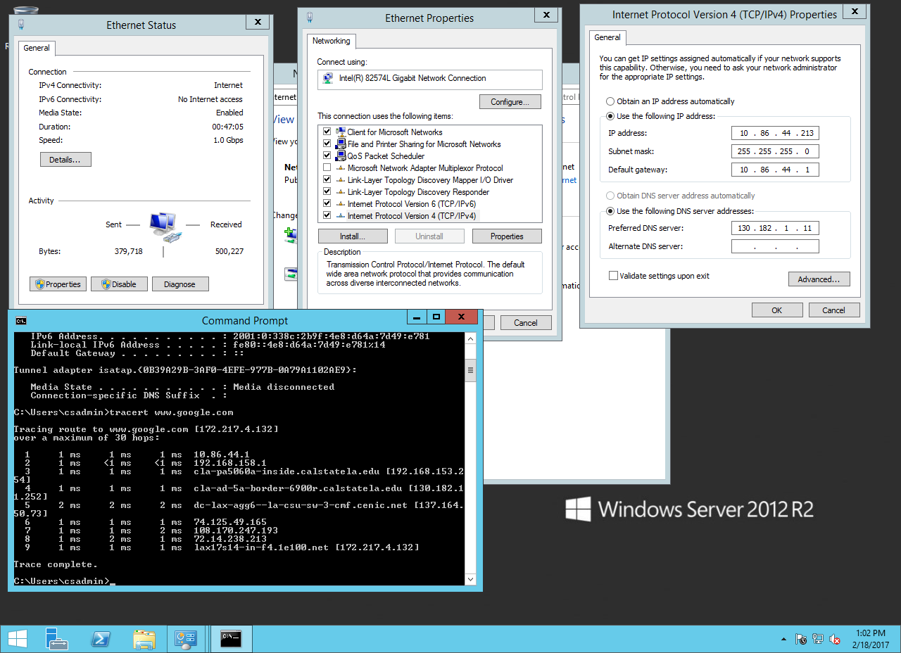

2) A

Steps are as follows:

1.Search System Settings

2.Go to System Settings

3.User Accounts

4. Click Unlock

5.Enter Password

6.Click “+” to add another username

7.Enter UserName and Password

8.Click ADD

9.Click on Lock to save changes.

2) B

Steps are as follows

1. Open System Settings

2.Open Networks

2) C

Steps are as follows

1.Go to System Settings

2.Open Networks

3.Go to Options

4.IPv4 Settings

5.Enter IP Address:10.86.44.211

6.Enter Subnet Mask:255.255.255.0

7.Default Gateway:10.86.44.1

8.DNS server address:130.182.1.1

9.Click Save

2)D

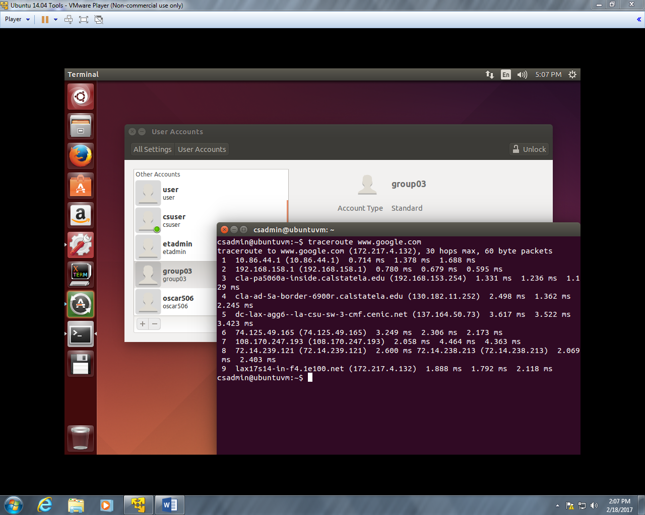

3) A

Ethernet Address of the NIC Card of the Host Computer is : 00-1E-0B-2B-15-11

3) B

The website listing Ethernet manufactures is on the IEEE Standards Association.

3) C

The Vendor Manufacturer of the NIC Card is : Hewlett Packard Company.

4) A

Steps are as follows:

1.Create a new folder in C drive within VMware guest Operating System.

2.Right Click – Share.

4) B

Steps are as follows:

1.Create a new folder in C within Host Operating System.

2.Copy Folder Path

3.Disable windows firewall

4.In VM player open VM settings

5.Options-Shared Folders

6.Always enable

7.Paste path of that folder.

8.Press OK.

4) C Net Share ScreenShot

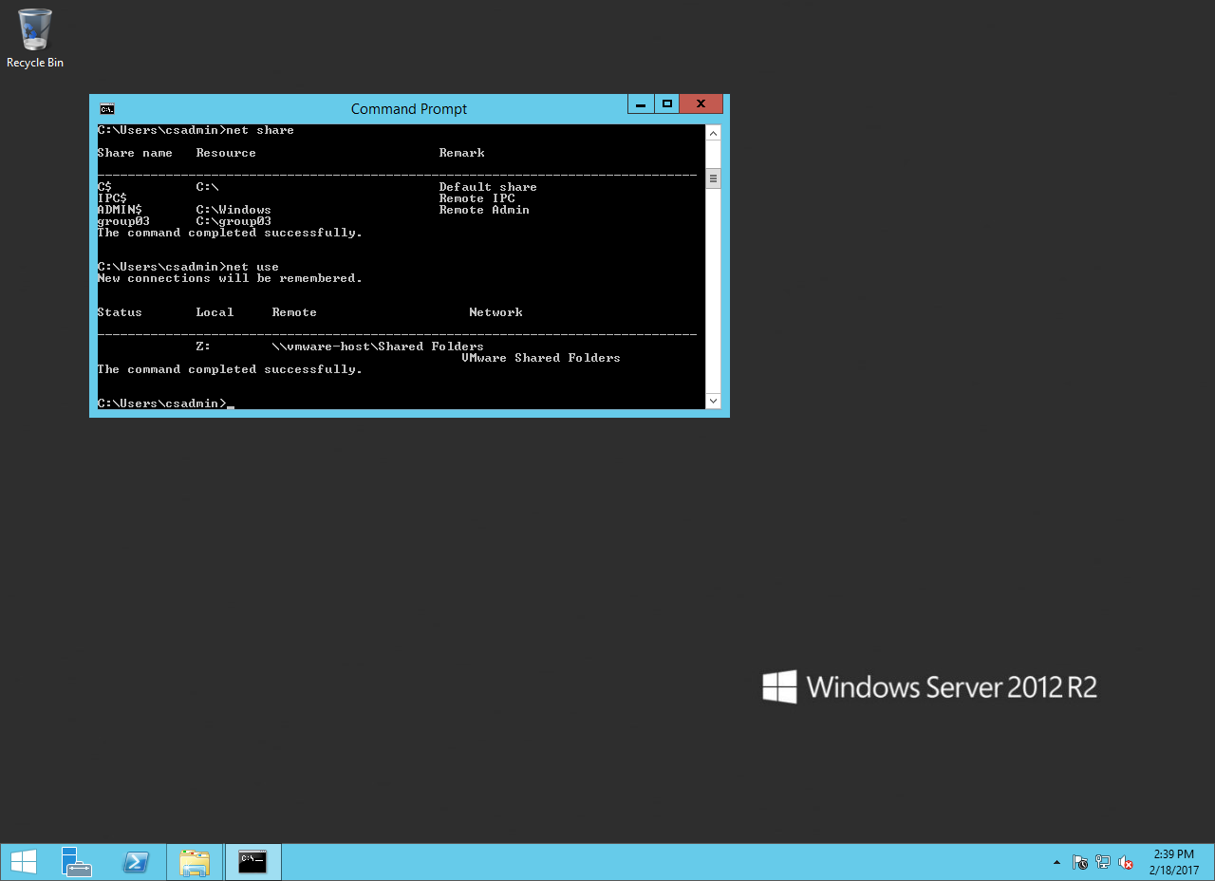

4) D Net Use Screenshot



4) E Showing output of command “netstat -an” in windows 7 and windows 2012.

The Ports use for file sharing are TCP-135 and TCP-445

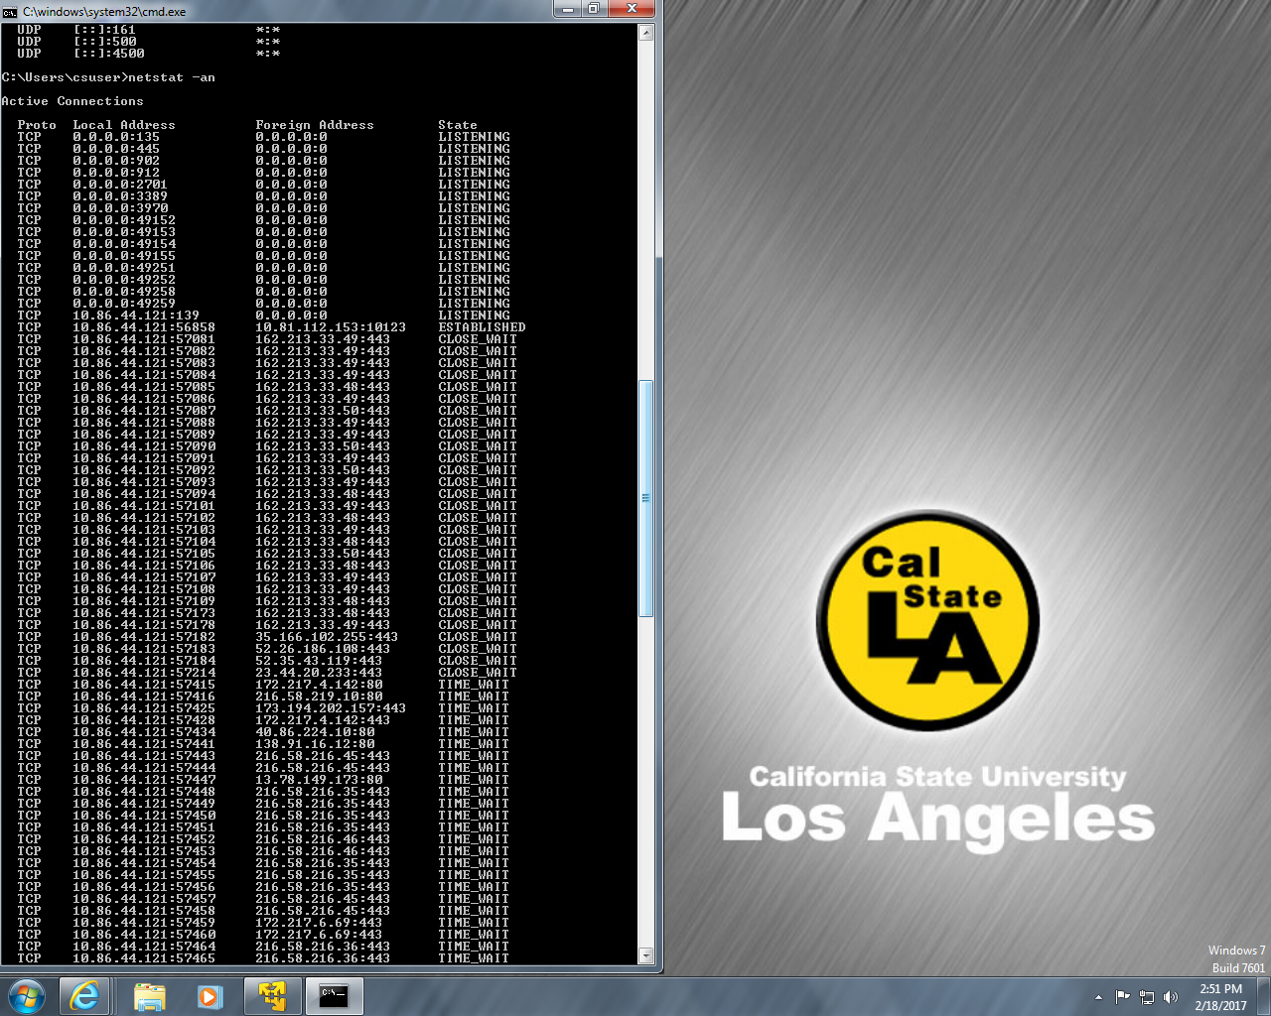

Windows 2012

