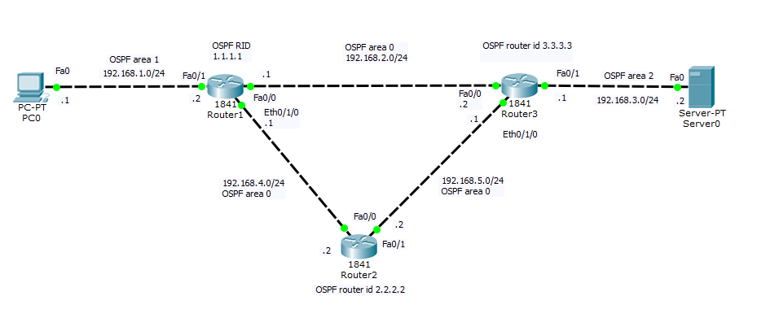

1)

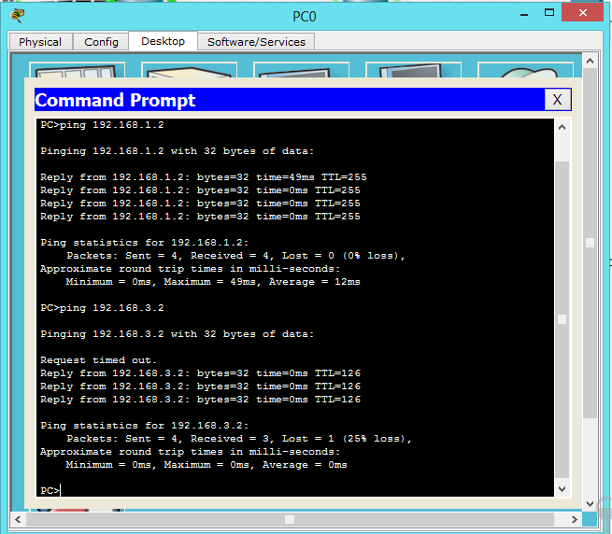

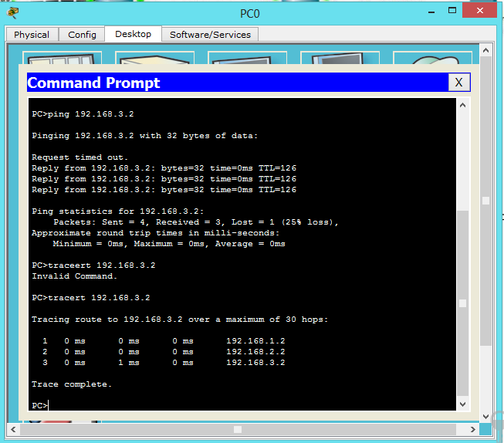

Q 2)

a) 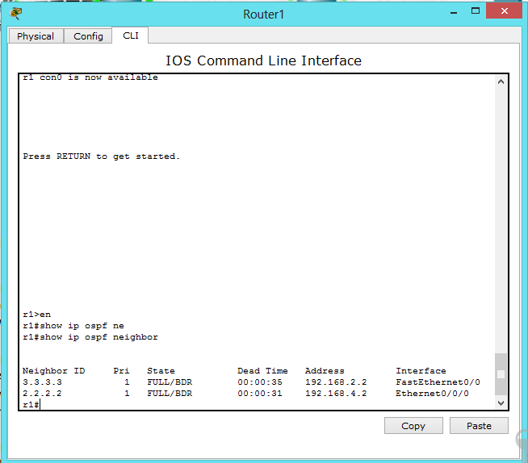

b) Neighbor ID Pri State Dead Time Address Interface

3.3.3.3 1 FULL/BDR 00:00:35 192.168.2.2 FastEthernet0/0

2.2.2.2 1 FULL/BDR 00:00:31 192.168.4.2 Ethernet0/0/0

Q3)

a) r3#show ip ospf interface

FastEthernet0/0 is up, line protocol is up

Internet address is 192.168.2.2/24, Area 0

Process ID 1, Router ID 3.3.3.3, Network Type BROADCAST, Cost: 1

Transmit Delay is 1 sec, State BDR, Priority 1

Designated Router (ID) 1.1.1.1, Interface address 192.168.2.1

Backup Designated Router (ID) 3.3.3.3, Interface address 192.168.2.2

Timer intervals configured, Hello 10, Dead 40, Wait 40, Retransmit 5

Hello due in 00:00:08

Index 1/1, flood queue length 0

Next 0x0(0)/0x0(0)

Last flood scan length is 1, maximum is 1

Last flood scan time is 0 msec, maximum is 0 msec

Neighbor Count is 1, Adjacent neighbor count is 1

Adjacent with neighbor 1.1.1.1 (Designated Router)

Suppress hello for 0 neighbor(s)

Ethernet0/0/0 is up, line protocol is up

Internet address is 192.168.5.1/24, Area 0

Process ID 1, Router ID 3.3.3.3, Network Type BROADCAST, Cost: 10

Transmit Delay is 1 sec, State BDR, Priority 1

Designated Router (ID) 2.2.2.2, Interface address 192.168.5.2

Backup Designated Router (ID) 3.3.3.3, Interface address 192.168.5.1

Timer intervals configured, Hello 10, Dead 40, Wait 40, Retransmit 5

Hello due in 00:00:07

Index 2/2, flood queue length 0

Next 0x0(0)/0x0(0)

Last flood scan length is 1, maximum is 1

Last flood scan time is 0 msec, maximum is 0 msec

Neighbor Count is 1, Adjacent neighbor count is 1

Adjacent with neighbor 2.2.2.2 (Designated Router)

Suppress hello for 0 neighbor(s)

FastEthernet0/1 is up, line protocol is up

Internet address is 192.168.3.1/24, Area 2

Process ID 1, Router ID 3.3.3.3, Network Type BROADCAST, Cost: 1

Transmit Delay is 1 sec, State DR, Priority 1

Designated Router (ID) 3.3.3.3, Interface address 192.168.3.1

No backup designated router on this network

Timer intervals configured, Hello 10, Dead 40, Wait 40, Retransmit 5

Hello due in 00:00:08

Index 3/3, flood queue length 0

Next 0x0(0)/0x0(0)

Last flood scan length is 1, maximum is 1

Last flood scan time is 0 msec, maximum is 0 msec

Neighbor Count is 0, Adjacent neighbor count is 0

Suppress hello for 0 neighbor(s)

b) Timer intervals configured, Dead 40, Wait 40, Retransmit 5

Hello due in 00:00:08

Q 4)

a) r2#traceroute 192.168.2.1

Type escape sequence to abort.

Tracing the route to 192.168.2.1

1 192.168.4.1 2 msec 0 msec 0 msec

Traffic destinated to the network in 2 msec

b)

r2# show ip route

Codes: C - connected, S - static, I - IGRP, R - RIP, M - mobile, B - BGP

D - EIGRP, EX - EIGRP external, O - OSPF, IA - OSPF inter area

N1 - OSPF NSSA external type 1, N2 - OSPF NSSA external type 2

E1 - OSPF external type 1, E2 - OSPF external type 2, E - EGP

i - IS-IS, L1 - IS-IS level-1, L2 - IS-IS level-2, ia - IS-IS inter area

\* - candidate default, U - per-user static route, o - ODR

P - periodic downloaded static route

Gateway of last resort is not set

2.0.0.0/32 is subnetted, 1 subnets

C 2.2.2.2 is directly connected, Loopback0

O IA 192.168.1.0/24 [110/2] via 192.168.4.1, 00:24:06, FastEthernet0/0

O 192.168.2.0/24 [110/2] via 192.168.4.1, 00:23:05, FastEthernet0/0

[110/2] via 192.168.5.1, 00:23:05, FastEthernet0/1

O IA 192.168.3.0/24 [110/2] via 192.168.5.1, 00:22:15, FastEthernet0/1

C 192.168.4.0/24 is directly connected, FastEthernet0/0

C 192.168.5.0/24 is directly connected, FastEthernet0/1

Q5) router 1

r1#show running-config

Building configuration...

Current configuration : 876 bytes

!

version 12.4

no service timestamps log datetime msec

no service timestamps debug datetime msec

no service password-encryption

!

hostname r1

!

!

!

!

!

!

!

!

no ip cef

no ipv6 cef

!

!

!

!

!

!

!

!

!

!

!

!

spanning-tree mode pvst

!

!

!

!

!

!

interface Loopback0

ip address 1.1.1.1 255.255.255.255

!

interface FastEthernet0/0

ip address 192.168.2.1 255.255.255.0

duplex auto

speed auto

!

interface FastEthernet0/1

ip address 192.168.1.2 255.255.255.0

duplex auto

speed auto

!

interface Ethernet0/0/0

ip address 192.168.4.1 255.255.255.0

duplex auto

speed auto

!

interface Vlan1

no ip address

shutdown

!

router ospf 1

log-adjacency-changes

network 192.168.1.0 0.0.0.255 area 1

network 192.168.4.0 0.0.0.255 area 0

network 192.168.2.0 0.0.0.255 area 0

!

ip classless

!

ip flow-export version 9

!

!

!

!

!

!

!

line con 0

!

line aux 0

!

line vty 0 4

login

!

!

!

End

Router 2

r2#show running-config

Building configuration...

Current configuration : 825 bytes

!

version 12.4

no service timestamps log datetime msec

no service timestamps debug datetime msec

no service password-encryption

!

hostname r2

!

!

!

!

!

!

!

!

no ip cef

no ipv6 cef

!

!

!

!

!

!

!

!

!

!

!

!

spanning-tree mode pvst

!

!

!

!

!

!

interface Loopback0

ip address 2.2.2.2 255.255.255.255

!

interface FastEthernet0/0

ip address 192.168.4.2 255.255.255.0

duplex auto

speed auto

!

interface FastEthernet0/1

ip address 192.168.5.2 255.255.255.0

duplex auto

speed auto

!

interface Ethernet0/0/0

no ip address

duplex auto

speed auto

shutdown

!

interface Vlan1

no ip address

shutdown

!

router ospf 1

log-adjacency-changes

network 192.168.4.0 0.0.0.255 area 0

network 192.168.5.0 0.0.0.255 area 0

!

ip classless

!

ip flow-export version 9

!

!

!

!

!

!

!

line con 0

!

line aux 0

!

line vty 0 4

login

!

!

!

End

Router 3

r3#show running-config

Building configuration...

Current configuration : 876 bytes

!

version 12.4

no service timestamps log datetime msec

no service timestamps debug datetime msec

no service password-encryption

!

hostname r3

!

!

!

!

!

!

!

!

no ip cef

no ipv6 cef

!

!

!

!

!

!

!

!

!

!

!

!

spanning-tree mode pvst

!

!

!

!

!

!

interface Loopback0

ip address 3.3.3.3 255.255.255.255

!

interface FastEthernet0/0

ip address 192.168.2.2 255.255.255.0

duplex auto

speed auto

!

interface FastEthernet0/1

ip address 192.168.3.1 255.255.255.0

duplex auto

speed auto

!

interface Ethernet0/0/0

ip address 192.168.5.1 255.255.255.0

duplex auto

speed auto

!

interface Vlan1

no ip address

shutdown

!

router ospf 1

log-adjacency-changes

network 192.168.2.0 0.0.0.255 area 0

network 192.168.5.0 0.0.0.255 area 0

network 192.168.3.0 0.0.0.255 area 2

!

ip classless

!

ip flow-export version 9

!

!

!

!

!

!

!

line con 0

!

line aux 0

!

line vty 0 4

login

!

!

!

end