**CS 4471 LAB 3**

**GROUP 3**

YASH PATEL

DAMIN SHAH

PARTH PATEL

ANUJ PATEL

ANSWERS

Q,1 (A) The destination Ethernet Address is 33:33:00:01:00:03

Screenshot:

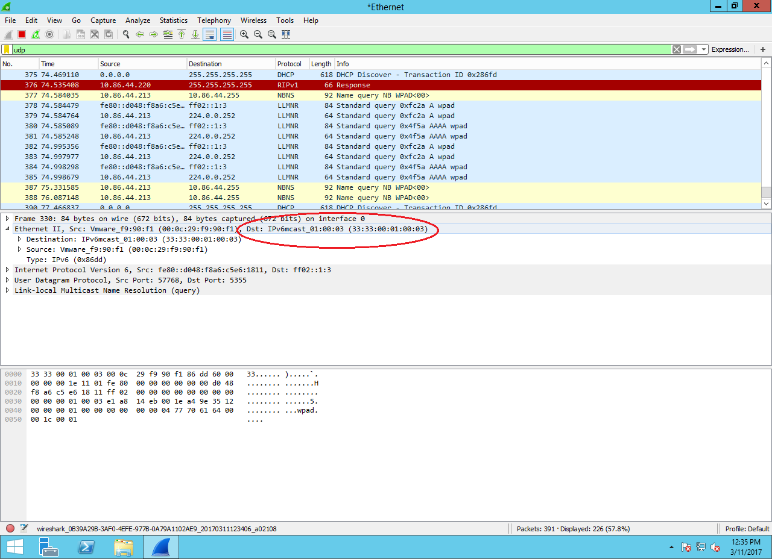

Q1.(B) Destination IP Address is 10:81:76:22

Screenshot:

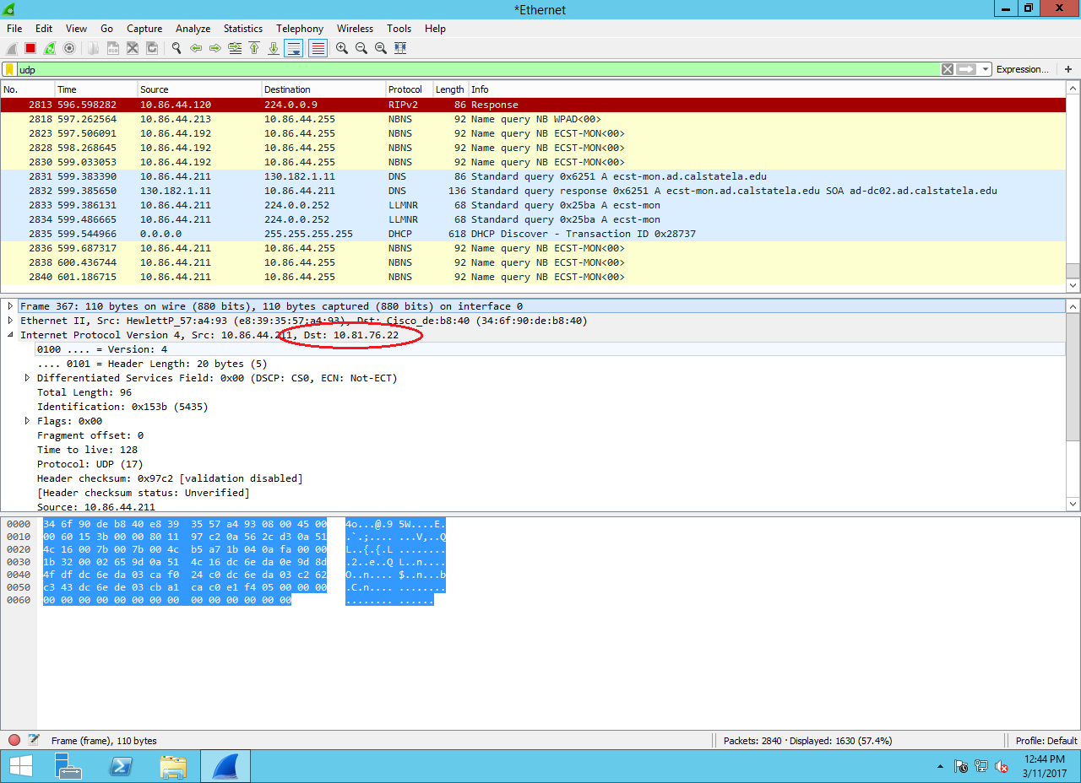

Q.1(C) Ip.addr == 10.86.44.211

Screenshot:

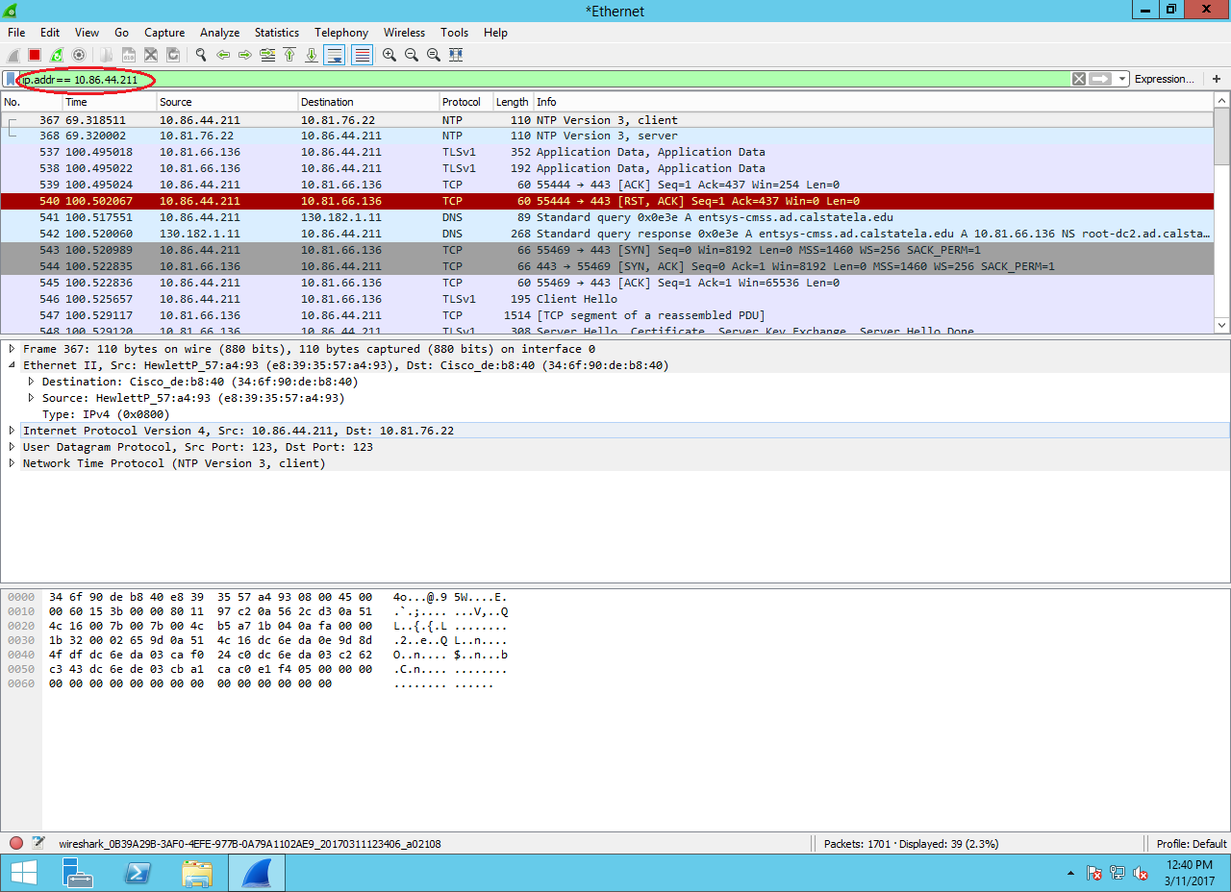

Q.1(D) Eth.addr == e8:39:35:57:a4:93

Screenshot:

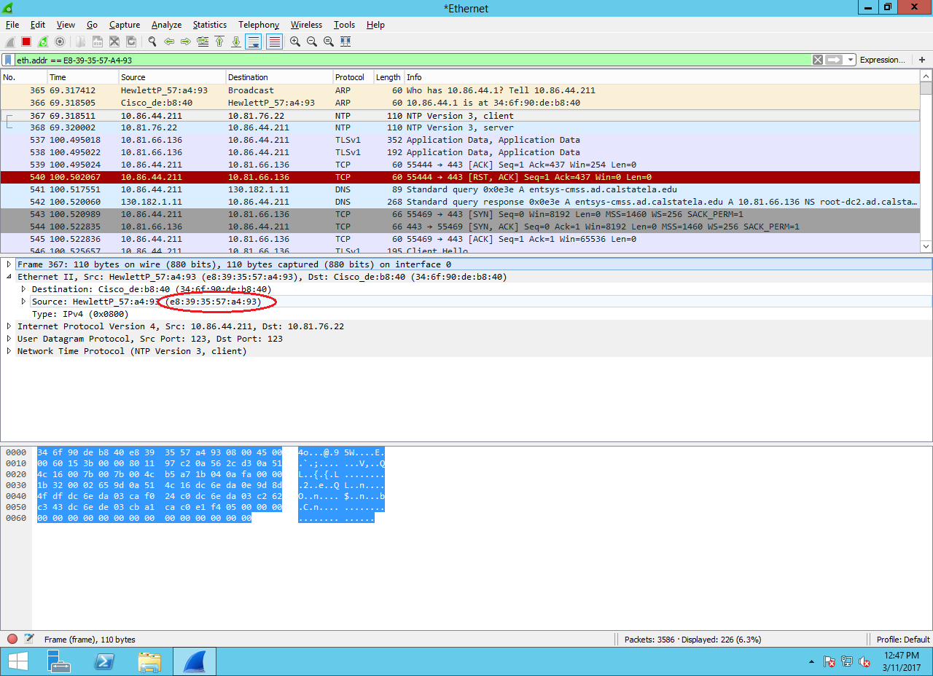

Q.2(A) Hexadecimal Value: 08 06

Screenshot:

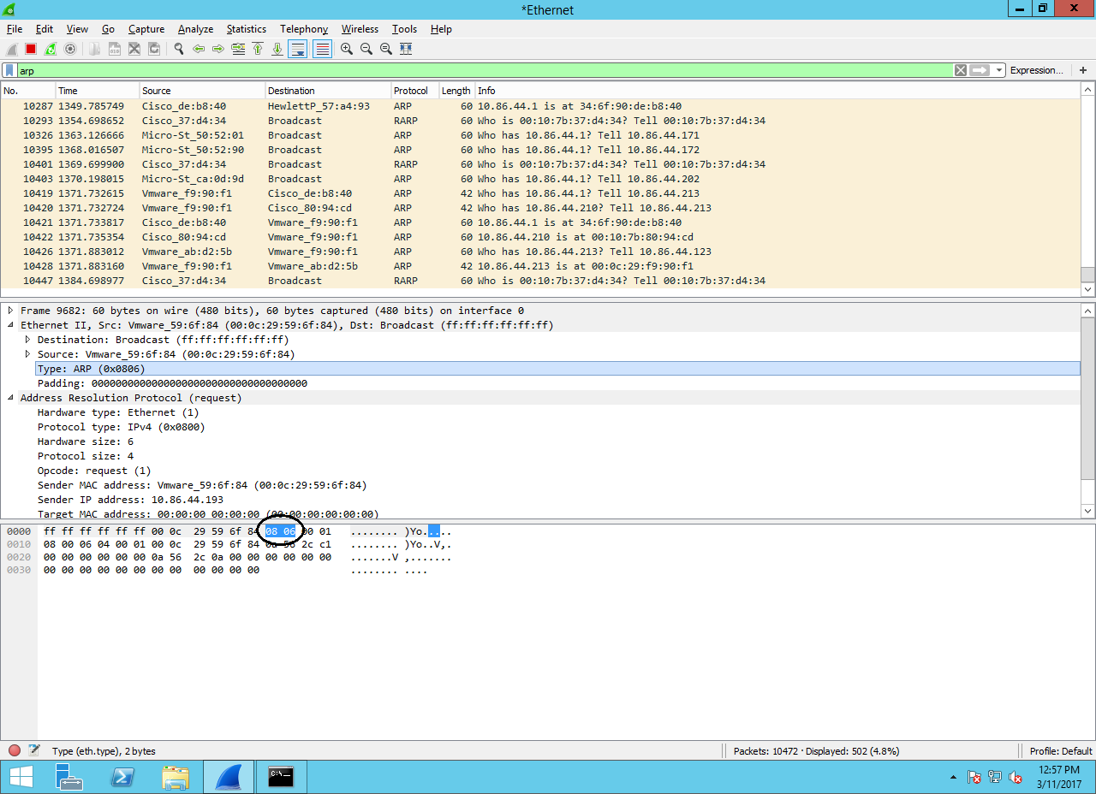

Q.2(B)

Screenshot:

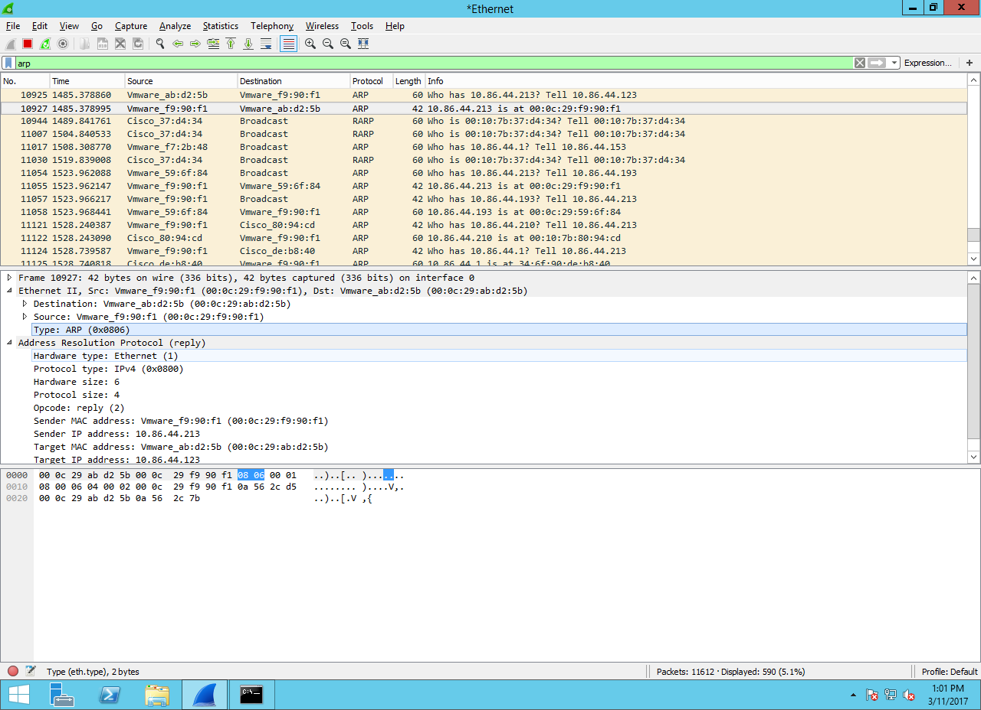

Q.3(A) Decimal Value of protocol Field that used to indicate ICMP packet – 3a

Screenshot:

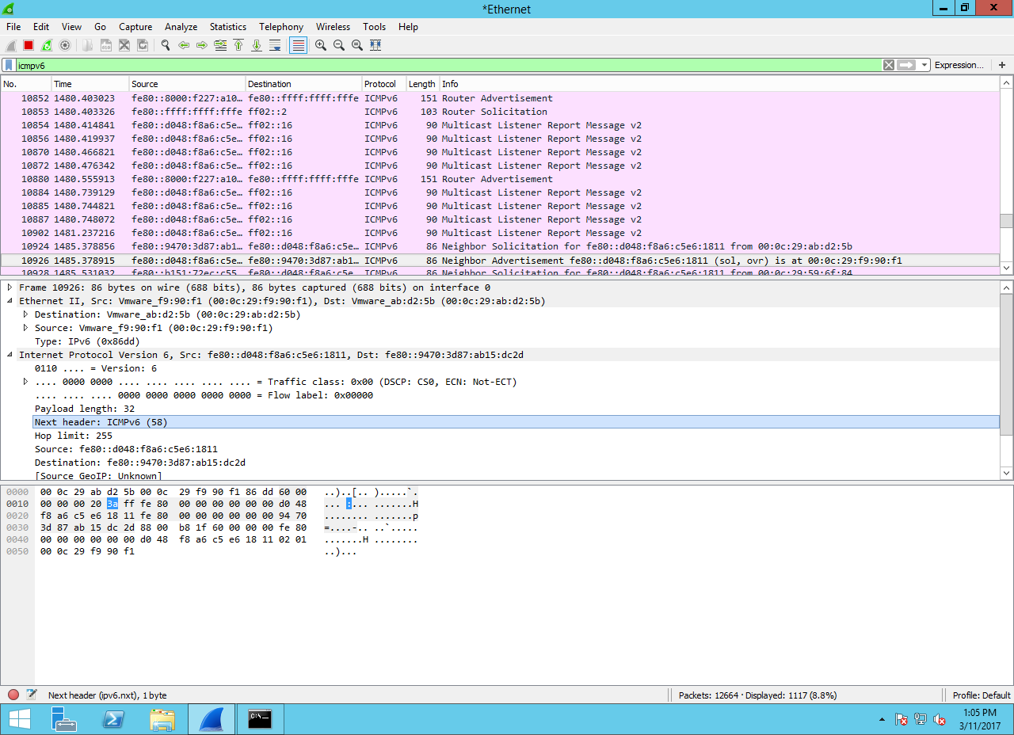

Q.3(B) Two types of ICMP Packets Decoded

**One for Request**

Screenshot:

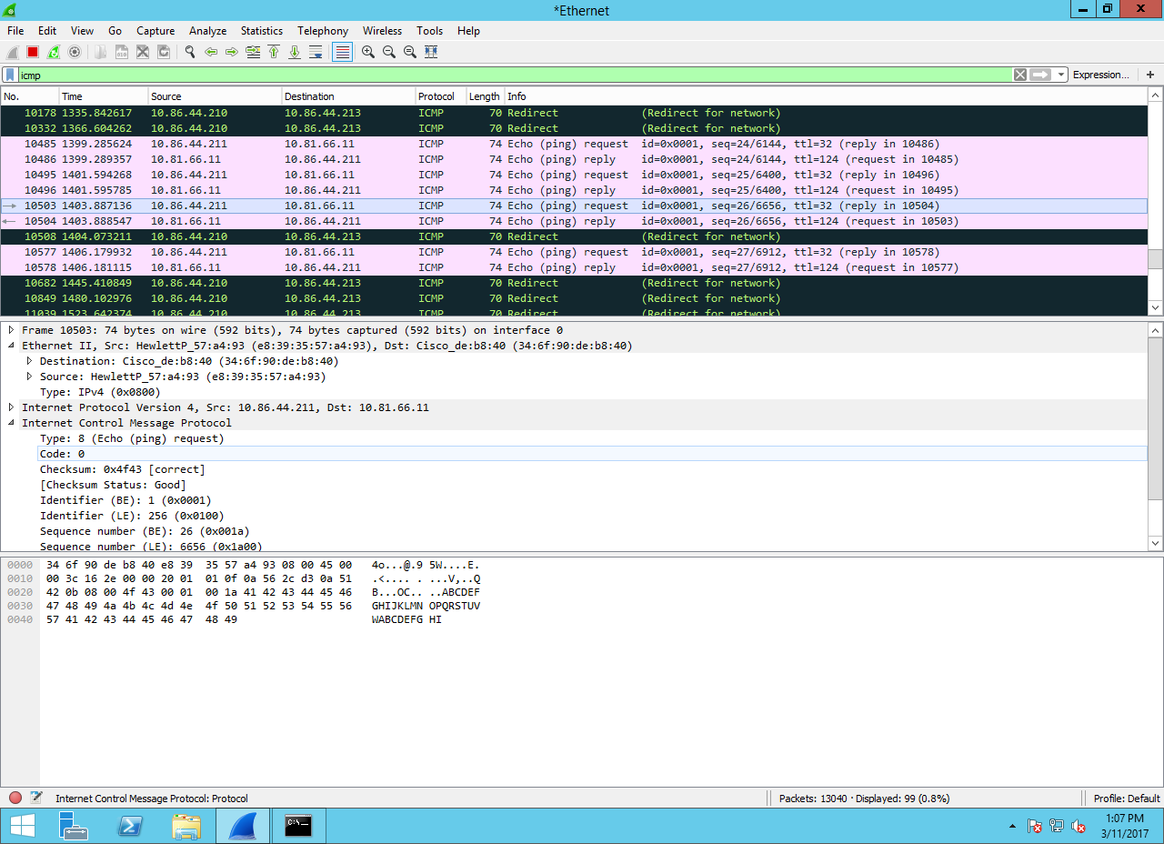

**Second for Reply:**

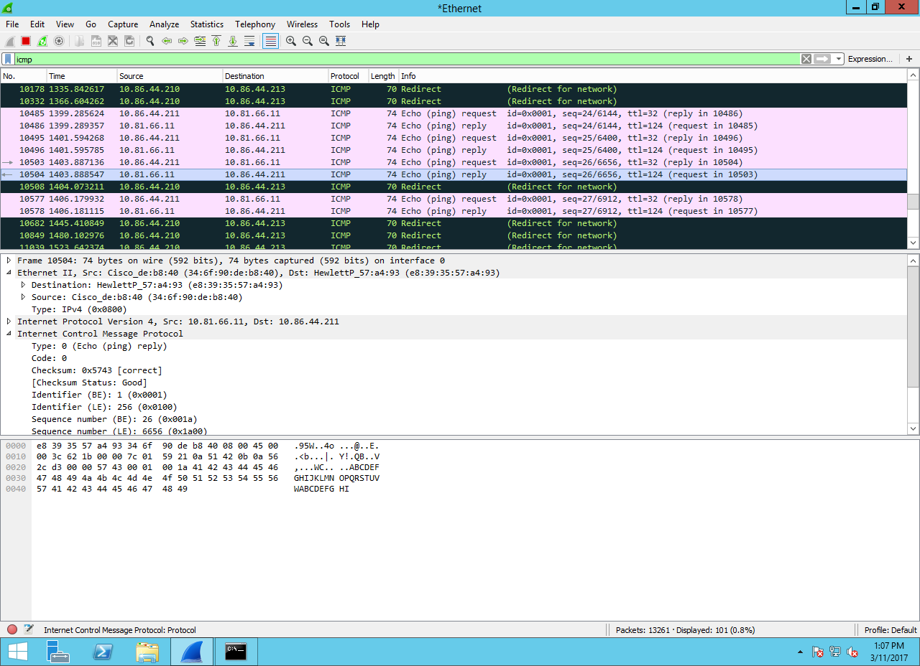

Q.4(A)

The traceroute command is used to discover the routes that packets actually take when traveling to their destination. The device (for example, a router or a PC) sends out a sequence of User Datagram Protocol (UDP) datagrams to an invalid port address at the remote host.

Three datagrams are sent, each with a Time-To-Live (TTL) field value set to one. The TTL value of 1 causes the datagram to "timeout" as soon as it hits the first router in the path; this router then responds with an ICMP Time Exceeded Message (TEM) indicating that the datagram has expired.

Another three UDP messages are now sent, each with the TTL value set to 2, which causes the second router to return ICMP TEMs. This process continues until the packets actually reach the other destination. Since these datagrams are trying to access an invalid port at the destination host, ICMP Port Unreachable Messages are returned, indicating an unreachable port; this event signals the Traceroute program that it is finished.

The purpose behind this is to record the source of each ICMP Time Exceeded Message to provide a trace of the path the packet took to reach the destination.

Screen Shot:

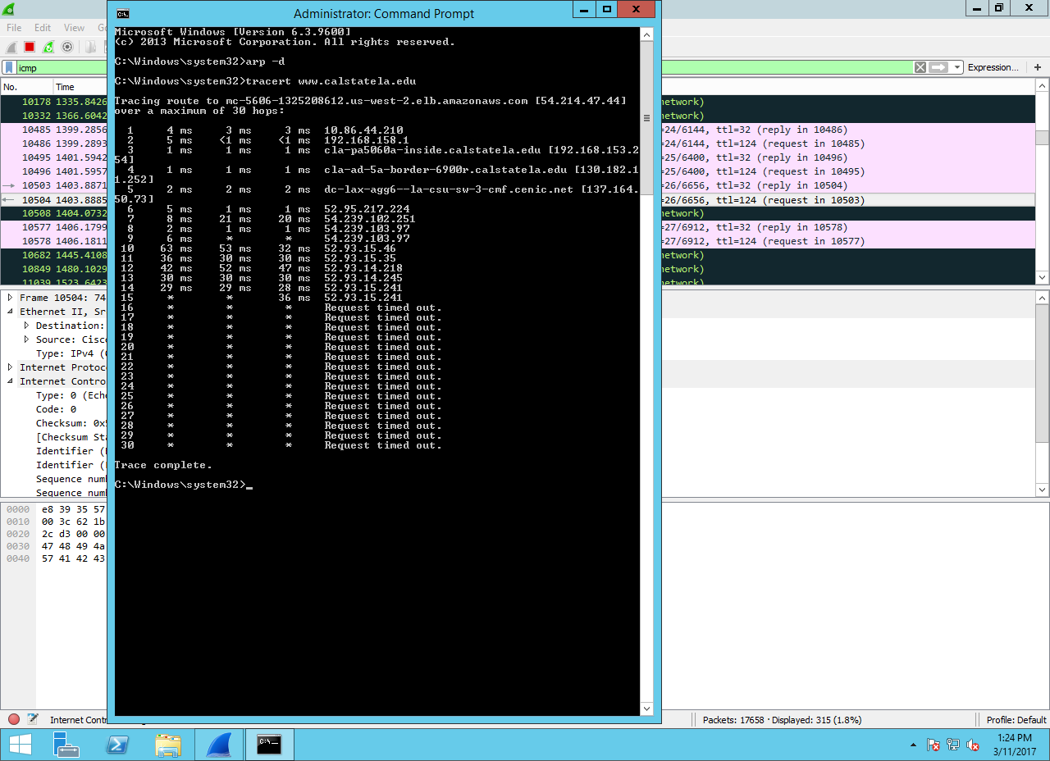

Q.4 (B)

Screenshot:

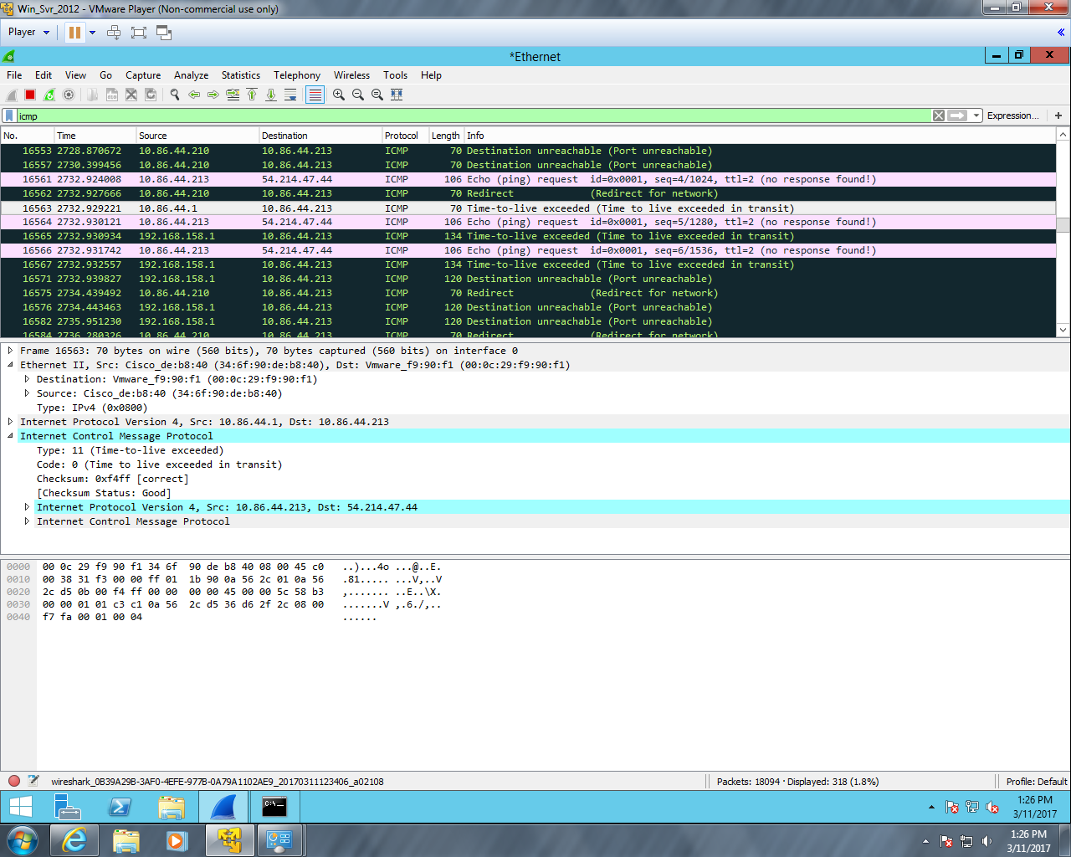

Q.5(A)

The flags that are set to 1 are:

First Frame-[SYN] Seq=0 Win=8192 Len=0 MSS=1460 WS=256 SACK_PERM=1

Second Frame-[SYN, ACK] Seq=0 Ack=1 Win=8192 Len=0 MSS=1460 WS=256 SACK_PERM=1

Third Frame-[ACK] Seq=1 Ack=1 Win=65536 Len=0

Screenshot:

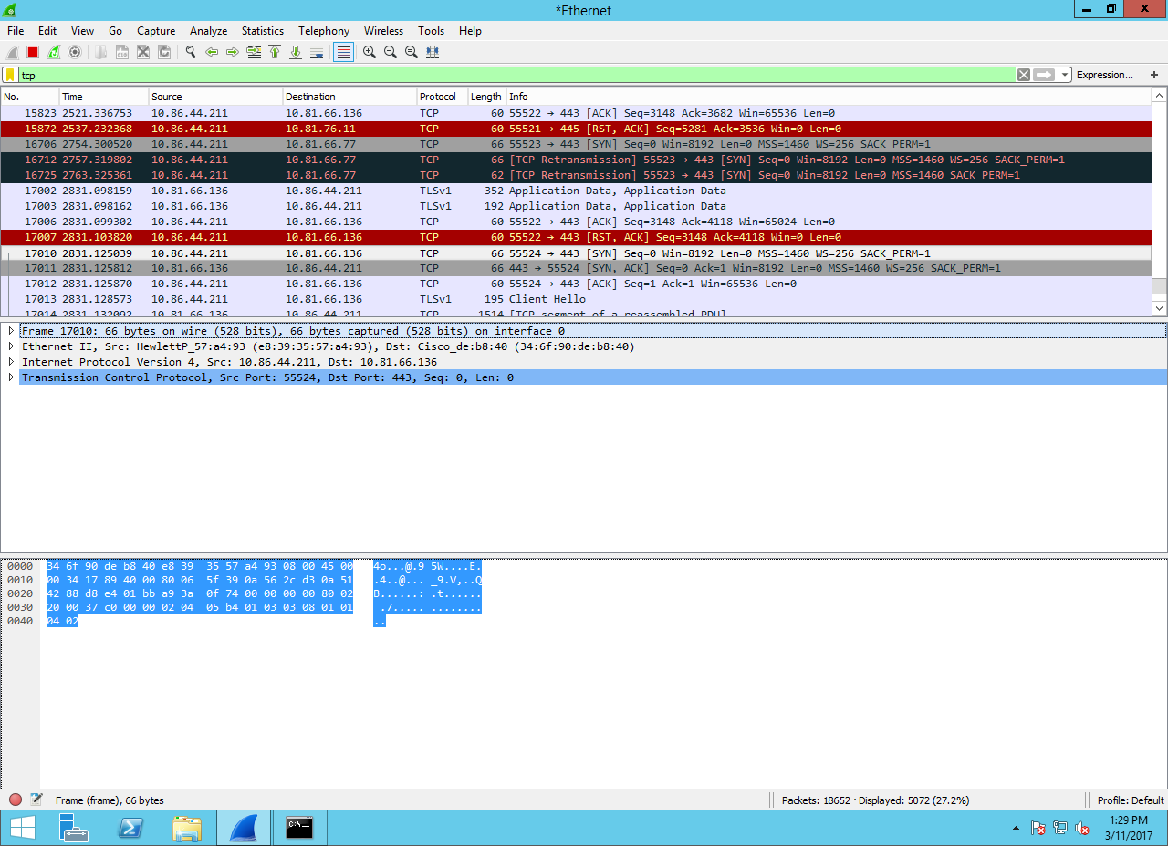

Q.5(B)

**Absolute Value** of sequence number (Client) :

Screenshot:

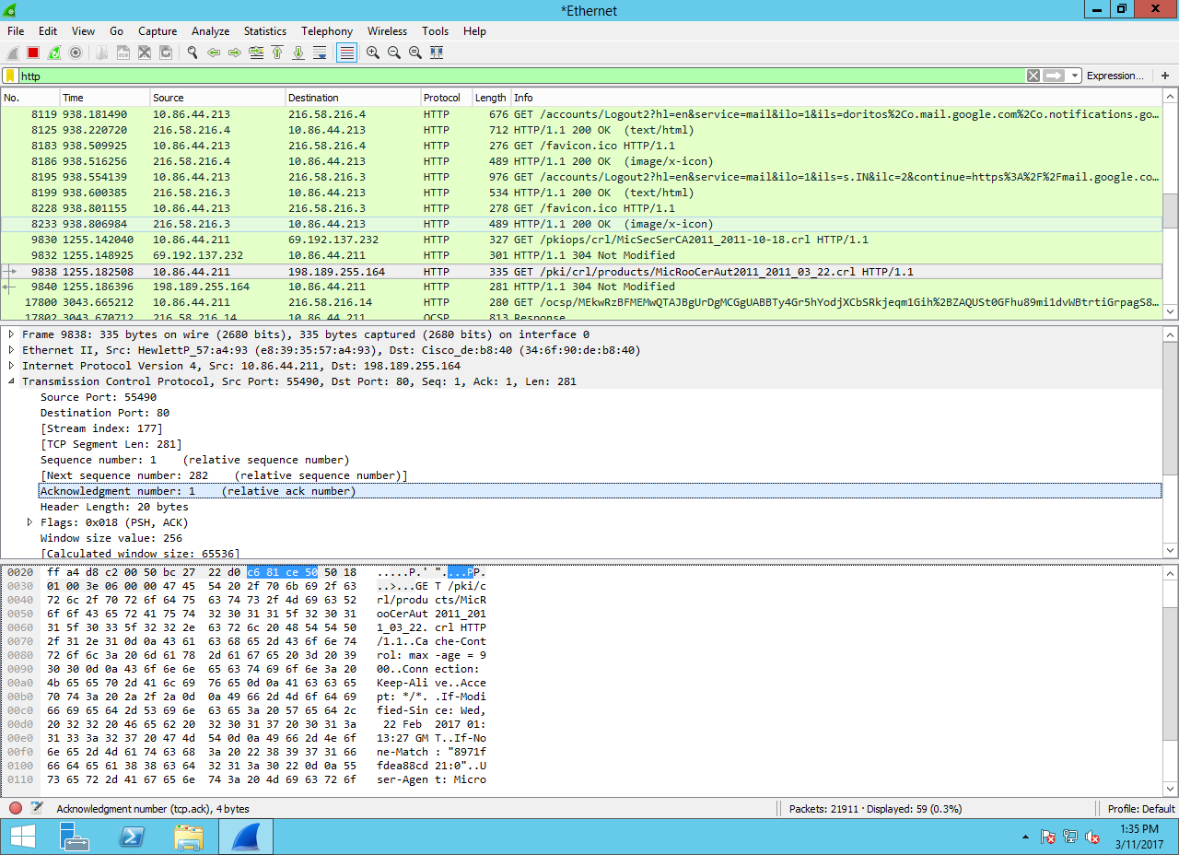

**Relative value** of sequence number (CLIENT) is:

Screenshot:

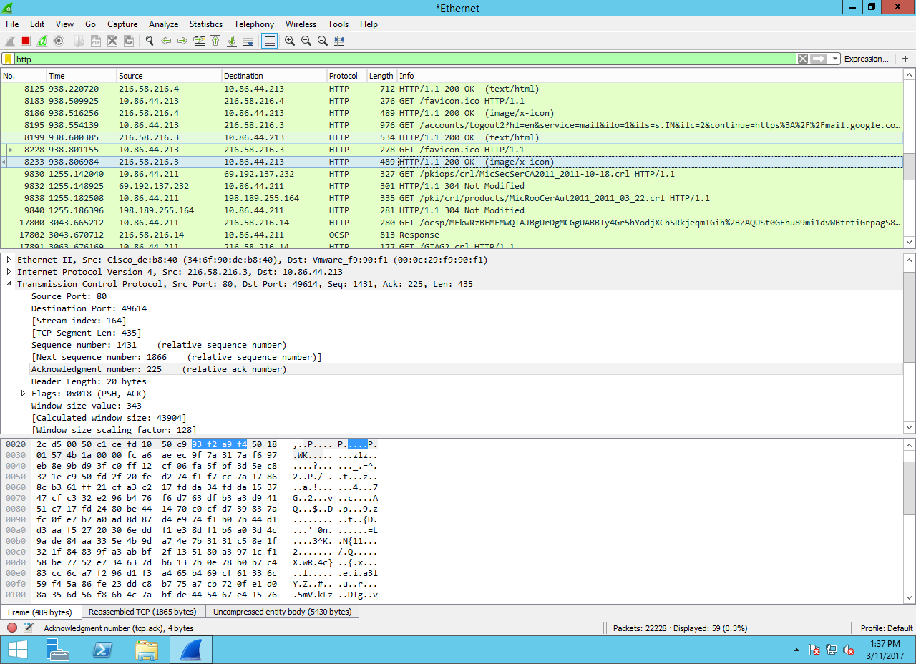

Q.5 (C)

Screenshot for Client port numbers:

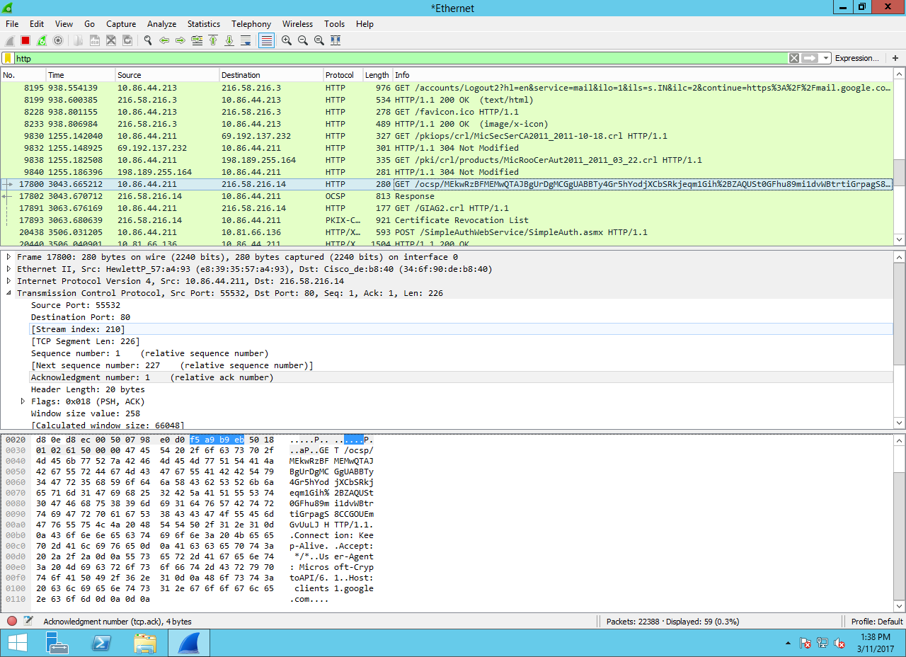

Screenshot for Server port numbers:

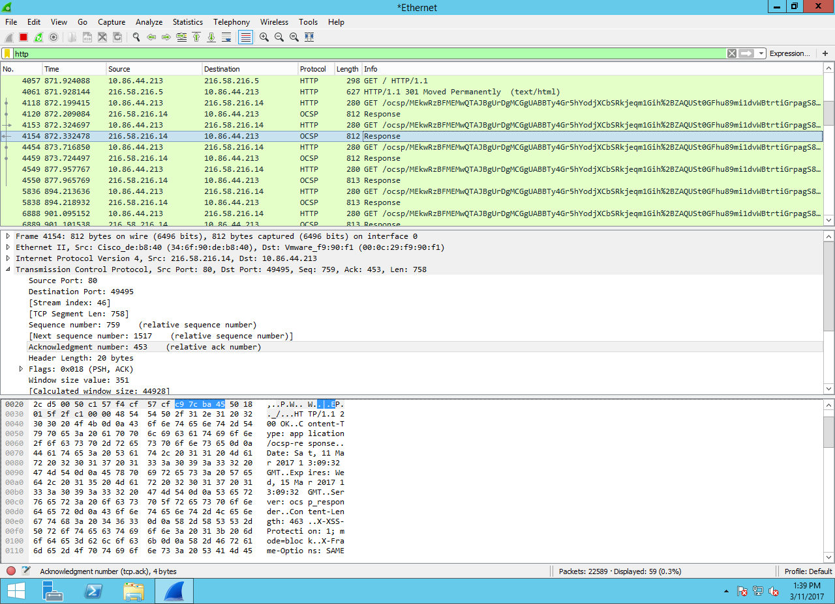

Q 5.(D) **(CLIENT)**

Absolute acknowledgement number for client:759

Relative acknowledgement number for client: 245

Screenshot:

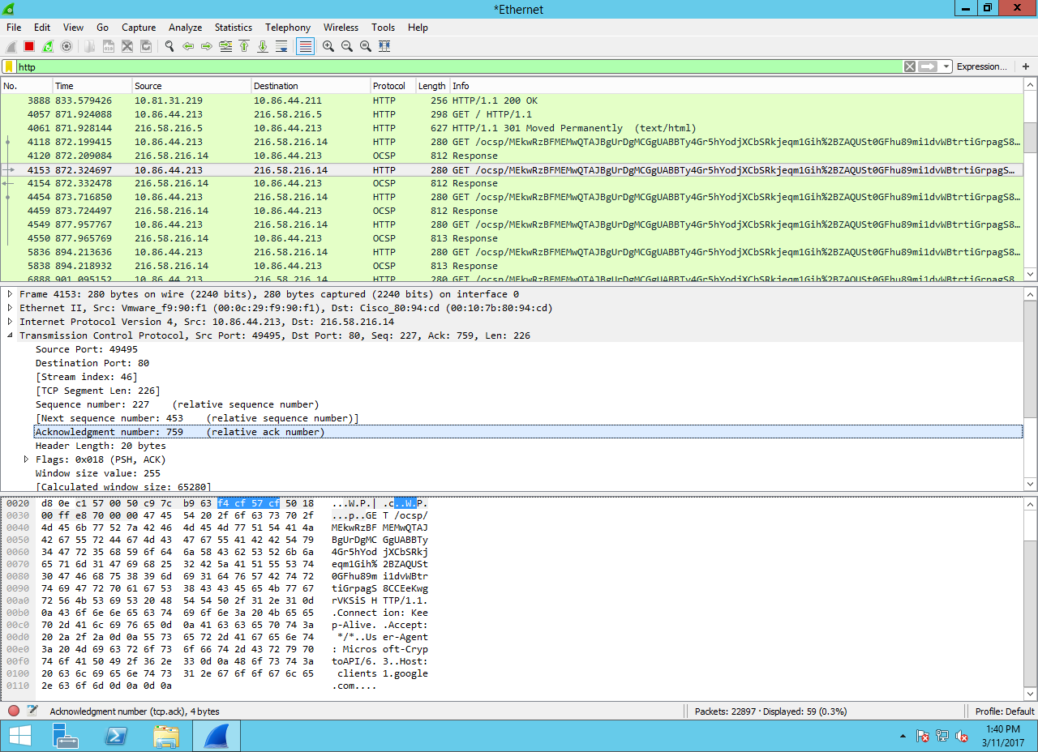

**(SERVER)**

Absolute acknowledgement number for client:759

Relative acknowledgement number for client: 245

Screenshot:

