FINAURA mobile app: UX before / after
Reference screenshots of every reachable screen before the UX overhaul. Each screen has a description, the issues seen, and an empty "After" column to fill in once the overhaul ships.
Captured: 29 Oct 2026, main @ 1ef5142e
Device: iPhone 17 Pro simulator, iOS 26.0, Expo dev client
Account: claude.uitest@example.com (sample data); light mode unless marked dark
Not captured: Onboarding (needs a new account), Reset Password, and Alerts / Envelopes / Reports (these exist in code but no route reaches them)
Note: The "Open debugger to view warnings" bar in some shots is a development-only overlay, not part of the app.

Screens in this document
Authentication
- Login
- Create account (Register)
- Forgot password
- Welcome
Main tabs
- Home (Dashboard)
- Transactions
- Add transaction (Entry sheet)
- Transaction options sheet
- Filter transactions sheet
- Liabilities
- AI assistant (Chat)
- Profile
- Edit Planning Assumptions sheet
- Adjust Bank Balance
Pushed screens
- Financial Health (FMI)
- Financial Outlook
- Savings Goals
- Income Streams
- Financial Assets
- Family & Household
Dark mode
- Dark mode samples

Authentication

Login
File: client/src/screens/LoginScreen.tsx (inside components/auth/AuthShell.tsx)
How to reach: First screen when signed out (App.tsx gate: no token).
What it shows: Aurora-gradient background with glass card, Sign in / Create account segmented control, email + password fields, "Forgot?" link.
Issues seen
- The most polished screen in the app; its visual language is not carried into the signed-in app.
- No biometric sign-in or remember-me.

Before (29 Oct 2026) | After
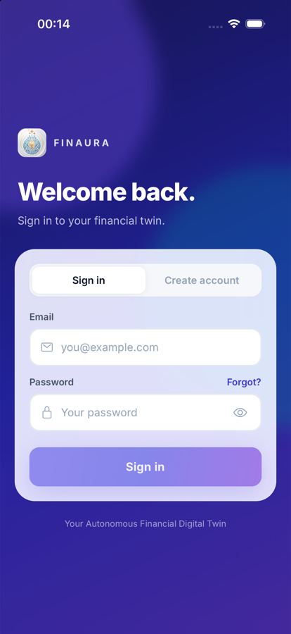  Login, empty form | After: to be captured once the overhaul ships

Create account (Register)
File: client/src/screens/RegisterScreen.tsx
How to reach: Login → "Create account" segment (local state, not a route).
What it shows: Full name, email, password with strength meter, confirm password.
Issues seen
- Copy typo: "in under minute".
- No terms/privacy consent; income type not collected though the store supports it.

Before (29 Oct 2026) | After
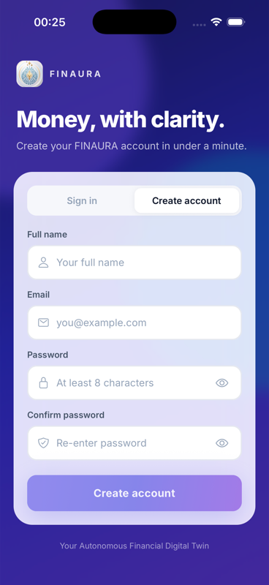  Register form | After: to be captured once the overhaul ships

Forgot password
File: client/src/screens/ForgotPasswordScreen.tsx
How to reach: Login → "Forgot?".
What it shows: Email field, "Send reset link", "I already have a reset token", back to sign in.
Issues seen
- No deep links, so the user must paste a 64-character token by hand on the Reset screen.

Before (29 Oct 2026) | After
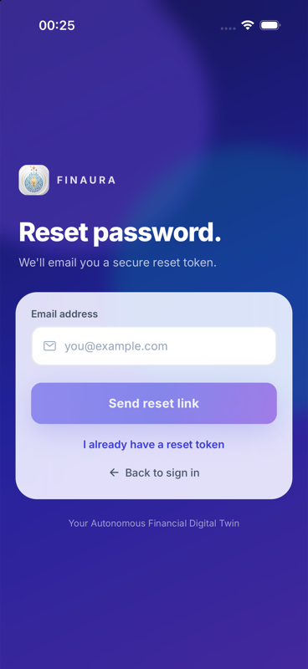  Forgot password | After: to be captured once the overhaul ships

Welcome
File: client/src/screens/WelcomeScreen.tsx
How to reach: Shown after an explicit login of an onboarded user.
What it shows: Logo, "Welcome, {first name}", Continue button.
Issues seen
- Hard cut from the dark aurora login to a stark white page; no shared transition.
- Uses legacy RN Animated, not Reanimated.

Before (29 Oct 2026) | After
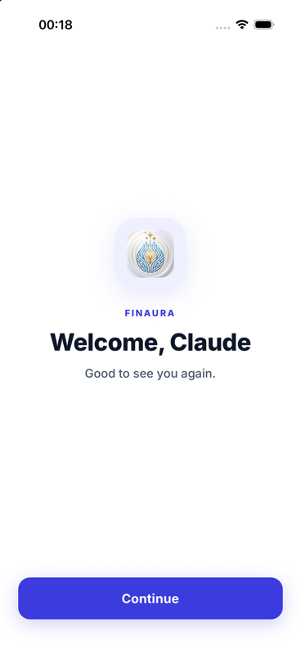  Welcome after login | After: to be captured once the overhaul ships

Main tabs

Home (Dashboard)
File: client/src/screens/DashboardScreen.tsx
How to reach: Home tab (centre, default).
What it shows: Greeting + theme toggle + avatar; Financial Health (FMI) card; Current Balance hero; Savings Goals piggy bank; Future Outlook (Monte Carlo); Spending Snapshot (Needs/Wants/Invest); Assets, Income Receipts, Upcoming Liabilities; Smart Next Action card at the very bottom.
Issues seen
- About 10 stacked cards with equal weight; the most actionable card (Smart Next Action) is last.
- Content scrolls under the status bar with no blur or scrim (text collides with the clock).
- Upcoming Liabilities shows "2 active" next to "No recurring liabilities … scheduled".
- Retirement insight title truncates; "1/100" funded-chance gauge has no framing.
- No quick-add for a transaction; data does not refresh when returning from other screens.

Before (29 Oct 2026) | After
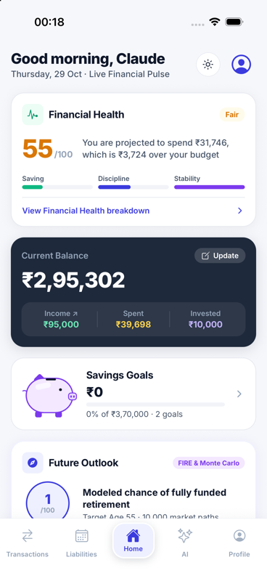  Dashboard, top | After: to be captured once the overhaul ships
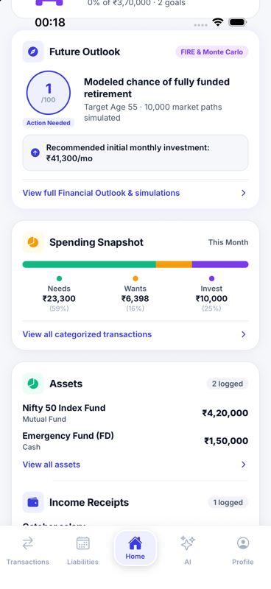  Dashboard, scrolled: Future Outlook, Spending Snapshot | After: to be captured once the overhaul ships
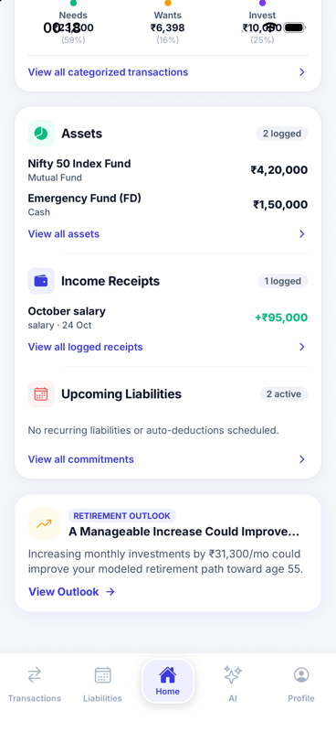  Dashboard, bottom: Assets, Income, Liabilities, Smart Action | After: to be captured once the overhaul ships

Transactions
File: client/src/screens/TransactionsScreen.tsx
How to reach: Transactions tab.
What it shows: Month summary (spent / invested), All/Needs/Wants/Investments chips, Filter button, month-grouped list with emoji icons, type and tag badges, overflow "…" per row, floating + button.
Issues seen
- Default small centred tab header, unlike the large left-aligned headers elsewhere.
- No search, date range, swipe actions or undo on delete.
- "Needs review" transactions are not flagged in the list.

Before (29 Oct 2026) | After
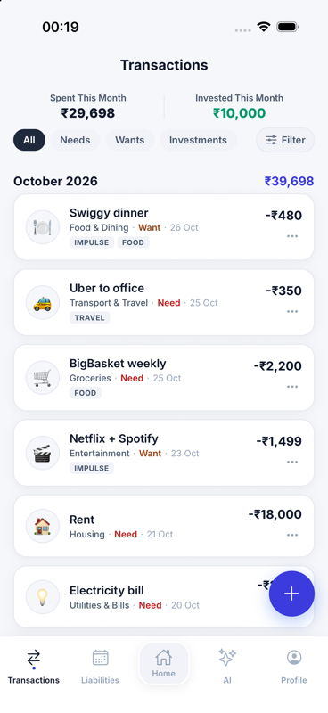  Transactions list | After: to be captured once the overhaul ships

Add transaction (Entry sheet)
File: client/src/screens/TransactionEntryScreen.tsx (modal from Transactions)
How to reach: Transactions → + button.
What it shows: Amount, description (AI classifies after typing), category picker, Need/Want/Investment radio, optional liability link, Log Transaction, today / 7-day / wants-ratio footer.
Issues seen
- Backdrop is a solid navy band rather than a dimmed view of the previous screen.
- Title just says "Entry"; no date picker; numbers in footer are unformatted (₹4529).
- No keyboard avoidance; drag handle is decorative only (no swipe to dismiss).

Before (29 Oct 2026) | After
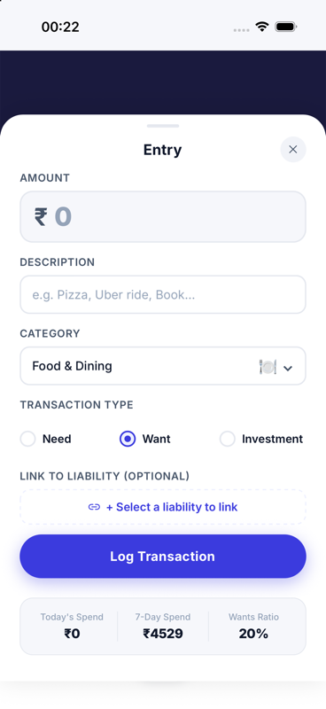  Entry sheet, empty | After: to be captured once the overhaul ships

Transaction options sheet
File: TransactionsScreen.tsx (action sheet)
How to reach: Transactions → "…" on a row, or long-press.
What it shows: Edit Transaction / Delete Transaction / Cancel.
Issues seen
- Delete goes through a system Alert with no undo.

Before (29 Oct 2026) | After
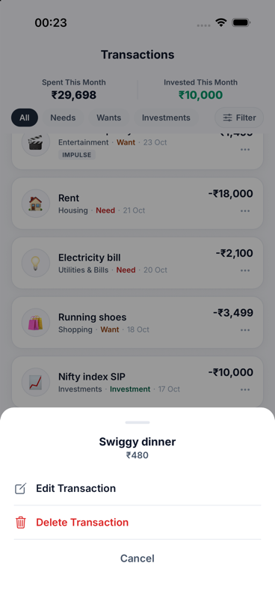  Row options sheet | After: to be captured once the overhaul ships

Filter transactions sheet
File: TransactionsScreen.tsx (category filter sheet)
How to reach: Transactions → Filter.
What it shows: Category chips with emoji; Apply Filters.
Issues seen
- "Apply Filters" does nothing extra; filters already apply live.
- Sheet stays light-themed while the page is dimmed.

Before (29 Oct 2026) | After
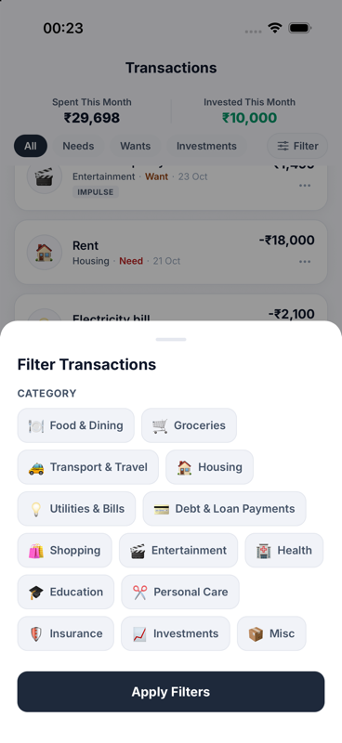  Category filter sheet | After: to be captured once the overhaul ships

Liabilities
File: client/src/screens/LiabilitiesScreen.tsx
How to reach: Liabilities tab.
What it shows: Active liabilities and monthly commitment totals, next auto-deduct, monthly commitments by category, liability cards with payment history / edit / delete.
Issues seen
- Monthly Commitments card is clipped.
- Start date and schedule fields are raw text; no pull-to-refresh.

Before (29 Oct 2026) | After
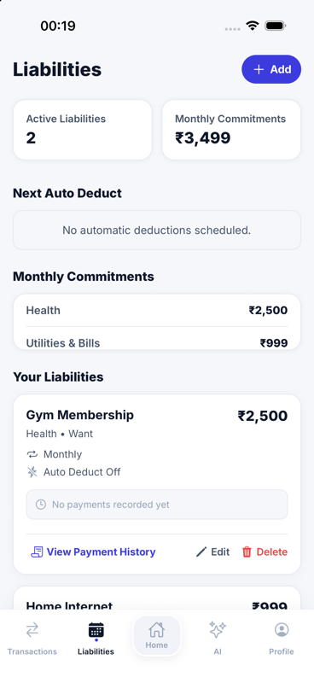  Liabilities | After: to be captured once the overhaul ships

AI assistant (Chat)
File: client/src/screens/ChatScreen.tsx
How to reach: AI tab.
What it shows: Intro card, chat bubbles, suggested-question pills, input bar.
Issues seen
- Avatar is the literal text "Bot".
- Replies are plain text (no markdown, no rich cards, no charts).
- No retry on failure, no new chat, no copy.

Before (29 Oct 2026) | After
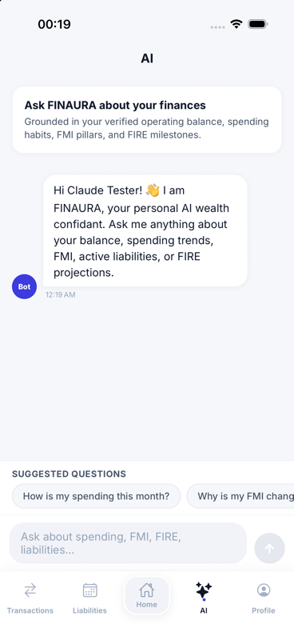  AI chat, first message | After: to be captured once the overhaul ships

Profile
File: client/src/screens/ProfileScreen.tsx
How to reach: Profile tab.
What it shows: Avatar + name, Edit Assumptions, income / retirement-age pills, lettered sections A–D (personal, baselines, retirement assumptions, navigation rows), Sign Out.
Issues seen
- Reads like a form/document; no Settings section (notifications, biometrics, theme, export, delete account).
- Sign Out has no confirmation.
- "Onboarding Complete" badge is always shown.

Before (29 Oct 2026) | After
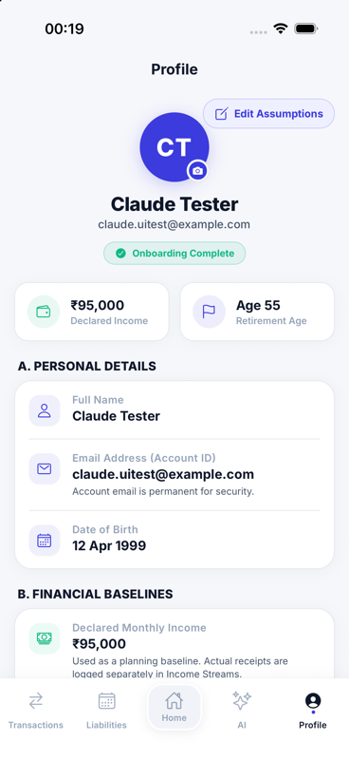  Profile | After: to be captured once the overhaul ships

Edit Planning Assumptions sheet
File: ProfileScreen.tsx (modal)
How to reach: Profile → Edit Assumptions.
What it shows: Name, date of birth, declared income, retirement age, corpus goal, return rate, etc.; Save Assumptions.
Issues seen
- Validation errors appear as one system Alert at a time.
- Date picker is fixed to the light theme.

Before (29 Oct 2026) | After
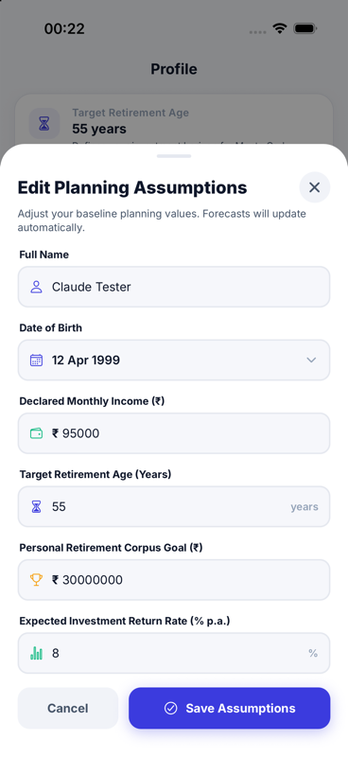  Edit Planning Assumptions | After: to be captured once the overhaul ships

Adjust Bank Balance
File: client/src/screens/UpdateBalanceScreen.tsx (modal)
How to reach: Home → Current Balance → Update.
What it shows: Current balance, Credit/Debit, amount, new balance preview, Add Money.
Issues seen
- Shows ₹295302.00 instead of the ₹2,95,302 format used elsewhere.
- No warning when a debit makes the balance negative.

Before (29 Oct 2026) | After
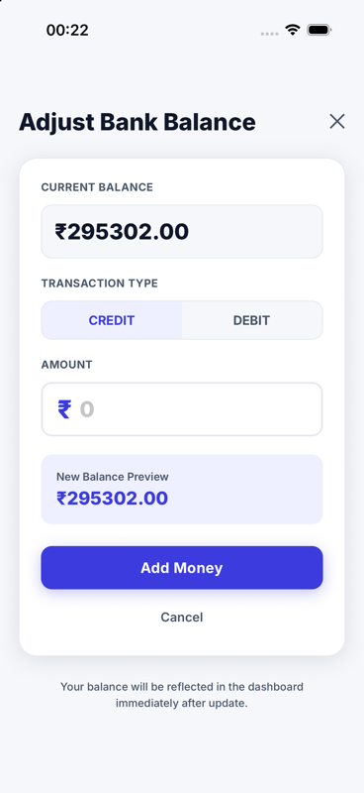  Adjust Bank Balance | After: to be captured once the overhaul ships

Pushed screens

Financial Health (FMI)
File: client/src/screens/FmiScreen.tsx
How to reach: Home → Financial Health card.
What it shows: Gauge with score and status, 3 pillar cards (Saving Discipline, Spending Control, Behavioral Risk), spending pace, retirement goal progress, insights, actionable alerts, 7-day history.
Issues seen
- Same metric is named "Financial Health", "Financial Mood Index", and elsewhere "Financial Maturity Index".
- History bars have no dates; alert cards use light-only colours.

Before (29 Oct 2026) | After
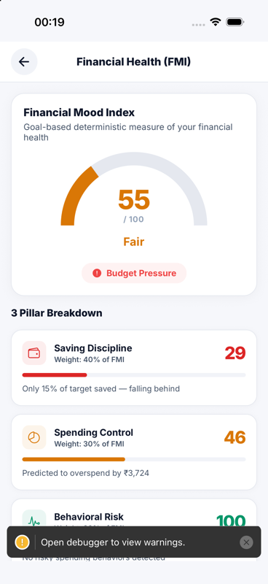  FMI, top | After: to be captured once the overhaul ships
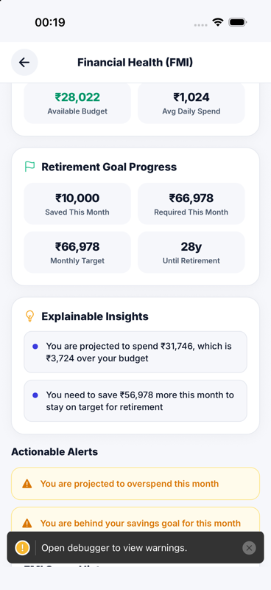  FMI, scrolled | After: to be captured once the overhaul ships

Financial Outlook
File: client/src/screens/FinancialOutlookScreen.tsx
How to reach: Home → Future Outlook card.
What it shows: Ten sections: headline metrics, FIRE projection, Monte Carlo outcomes, guidance, strategy selector, scenarios, income resilience, emergency buffer, assumptions, limitations.
Issues seen
- Very long single scroll with heavy jargon and no section navigation.
- Changing strategy gives no inline loading feedback.

Before (29 Oct 2026) | After
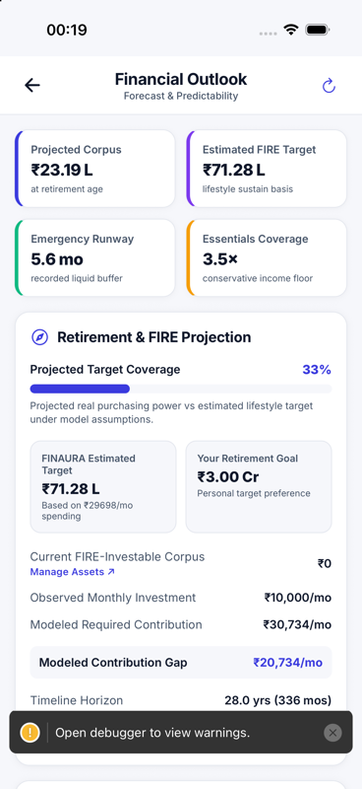  Outlook, top | After: to be captured once the overhaul ships
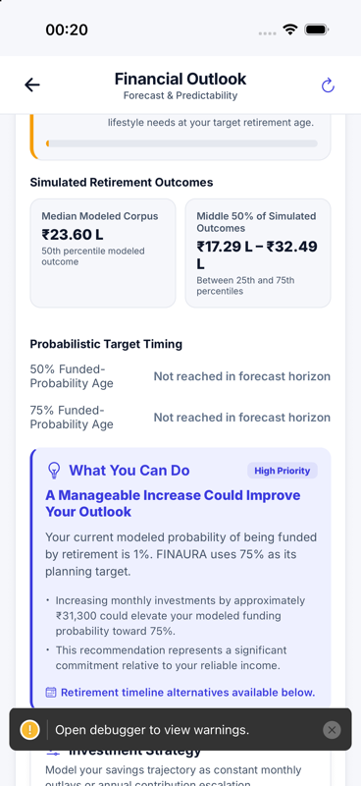  Outlook, scrolled: simulated outcomes | After: to be captured once the overhaul ships

Savings Goals
File: client/src/screens/GoalPlannerScreen.tsx
How to reach: Home → Savings Goals card, or Profile row.
What it shows: Goal chips on the left, detail card on the right (piggy bank, target, date, saved, "Is this achievable?"), Add money, stats card.
Issues seen
- Two-column layout breaks on a phone: stats wrap mid-number ("₹20,8 / 33", "Increas / e").
- Delete only by long-press; no edit or withdraw.
- "Achievable" verdict uses a fixed 12-month placeholder.

Before (29 Oct 2026) | After
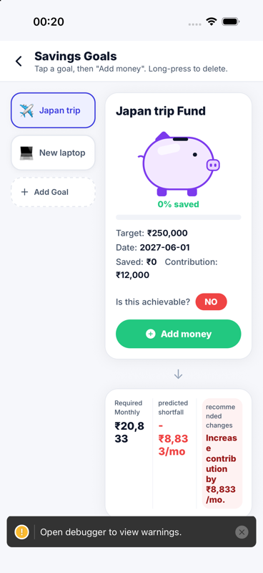  Savings Goals | After: to be captured once the overhaul ships

Income Streams
File: client/src/screens/IncomeFlowScreen.tsx
How to reach: Home → Income Receipts, or Profile row.
What it shows: Total monthly income and daily pace, 50/30/20 donut, income by source, timeline.
Issues seen
- Donut proportions are fixed at 50/30/20 and do not reflect data.
- Three different add buttons; date entry is free text.

Before (29 Oct 2026) | After
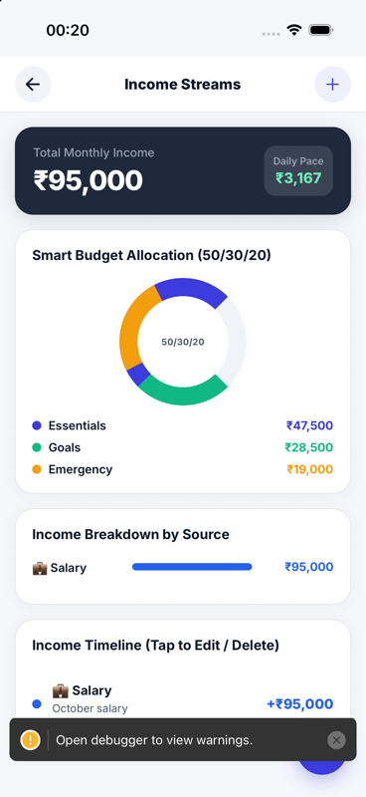  Income Streams, top | After: to be captured once the overhaul ships
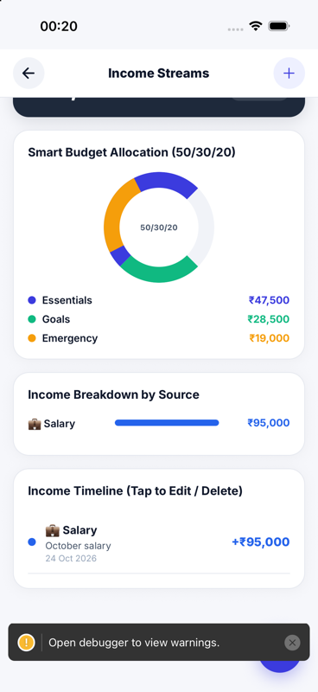  Income Streams, scrolled | After: to be captured once the overhaul ships

Financial Assets
File: client/src/screens/AssetsScreen.tsx
How to reach: Home → Assets, or Profile row.
What it shows: Total assets, FIRE corpus, liquid buffer, holdings with class / FIRE / liquidity badges, edit and delete.
Issues seen
- Always dark navy, even in light mode; uses a different icon set.
- Badges can contradict ("Retirement / Investable" + "Excluded from FIRE").

Before (29 Oct 2026) | After
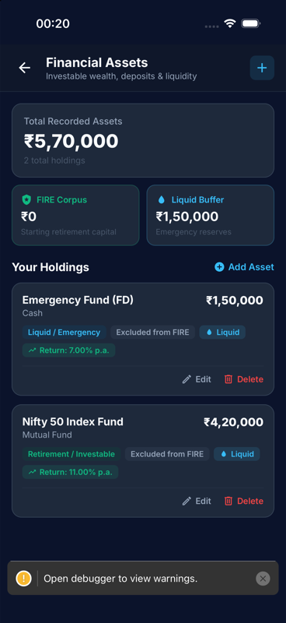  Financial Assets | After: to be captured once the overhaul ships

Family & Household
File: client/src/screens/FamilyScreen.tsx
How to reach: Profile → Family row (no Home entry for users without a family).
What it shows: Privacy banner and empty state with "Add Family Member". With a family: roster, household FMI, summary, outflows, insights.
Issues seen
- Not discoverable from Home for new users; pending invites have no badge anywhere else.

Before (29 Oct 2026) | After
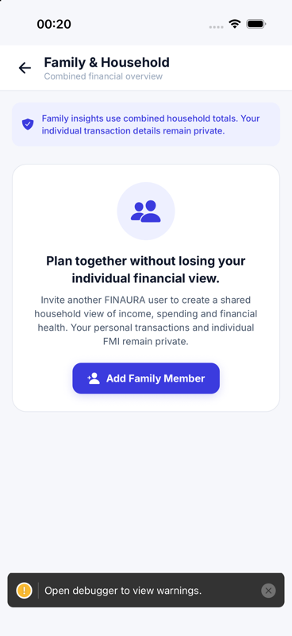  Family, no household yet | After: to be captured once the overhaul ships

Dark mode

Dark mode samples
File: theme.ts darkColors
How to reach: Home → moon toggle.
What it shows: The same screens in dark mode.
Issues seen
- Mostly consistent; red-on-dark text on Goals is hard to read.
- Status bar collision on scroll is the same as in light mode.

Before (29 Oct 2026) | After
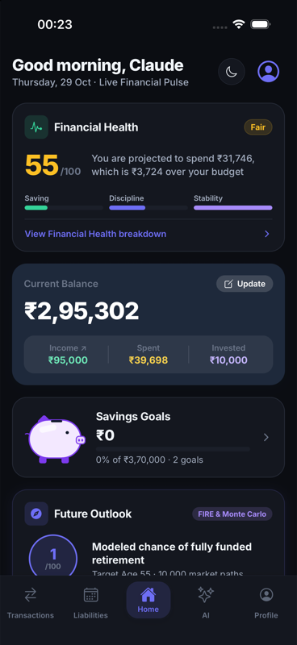  Home, dark | After: to be captured once the overhaul ships
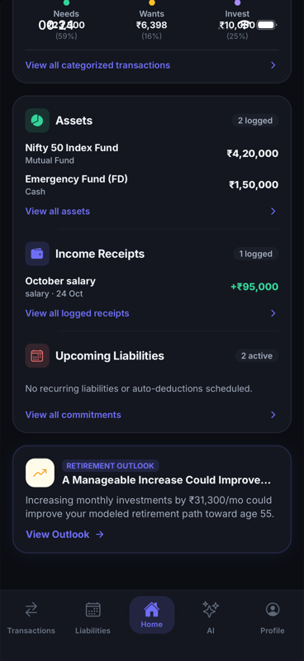  Home scrolled, dark | After: to be captured once the overhaul ships
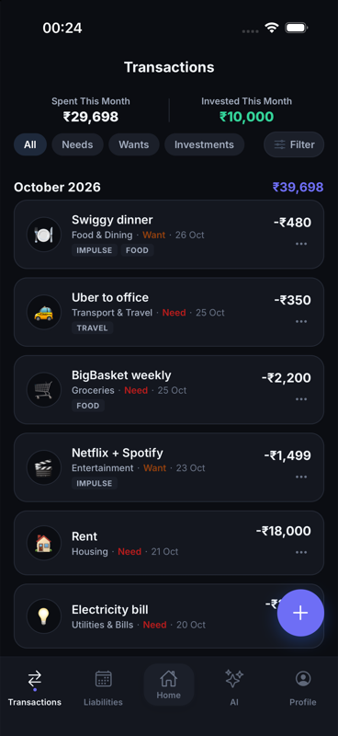  Transactions, dark | After: to be captured once the overhaul ships
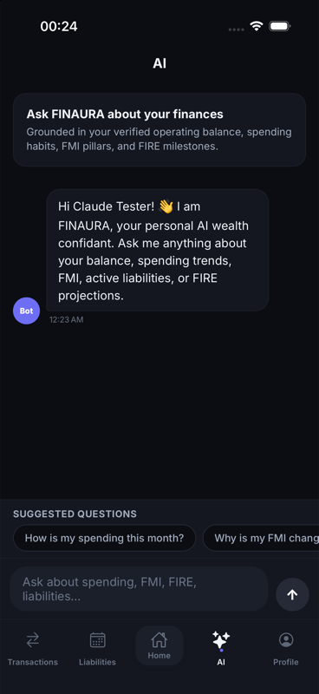  AI chat, dark | After: to be captured once the overhaul ships
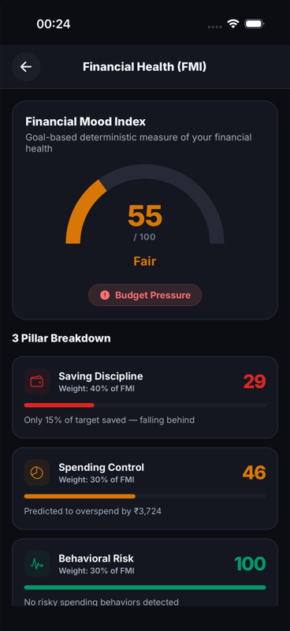  FMI, dark | After: to be captured once the overhaul ships
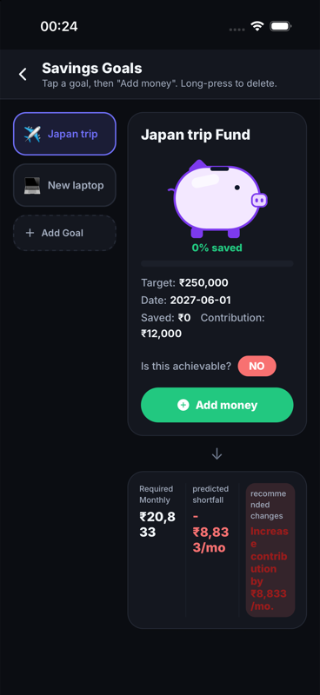  Savings Goals, dark | After: to be captured once the overhaul ships
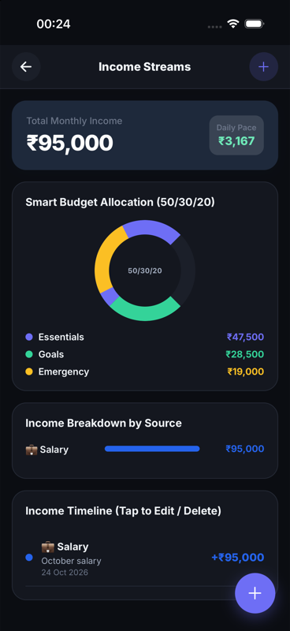  Income Streams, dark | After: to be captured once the overhaul ships

