TweeterTags – Part 2

* Changed color for hashtags,mentions and urls using nsattributedstring in TweetTVCell class by using addattribute function.

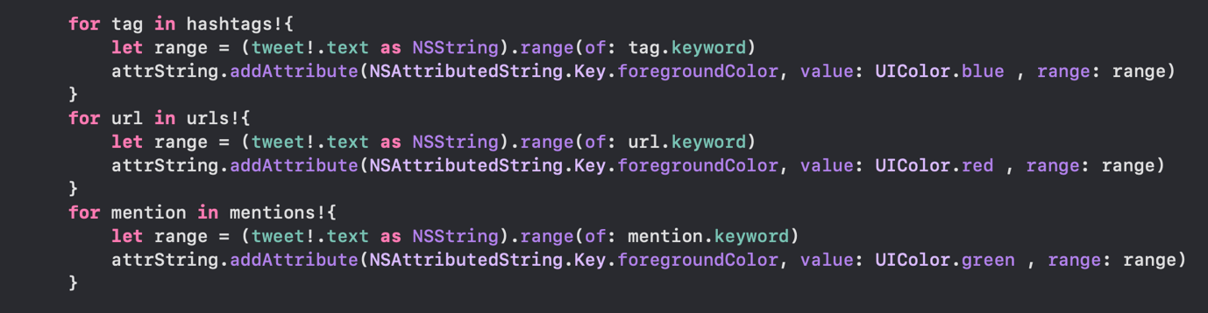

* Created a new tableview controller with four sections and added detail (arrow) to point it to the new tableview. Connected it with a segue.Text

  Description automatically generated
* Created array for the headings of four sections in MentionTVC class and made a switch case and if else to show the headings and sections in case the section is present

* Created default class for all rows of MentionTVC i.e urlCell, HashtagCell and usernameCell and embedded the image view outlet in imageCell.

* Then added another switch case to deque cell and insert cell if the data is present like we did in the original viewcontroller. (NOTE: the image here only loads when you click on the imageView. I was not able to fix the async call without user prompting here)

* Added a new segue back to our main tableviewcontroller if the user clicks on the hashtags or the users.Text, chat or text message

  Description automatically generated

NOTE: The error message that is displayed is when I tried running it on my phone and the build files could not be configured for my phone.