CHATSCALE: SCALING A STATEFUL WEBSOCKET APPLICATION ON KUBERNETES AND RED HAT OPENSHIFT
A Project Report
Submitted by
PARTH SANGANI — Roll No. B104
TANISH SHARMA — Roll No. B118
Under the Guidance of
Prof. Vijayetha Thoday
for the course “Cloud Computing”
in partial fulfillment for the award of the degree of
BTECH Computer Engineering
At

MPSTME, NMIMS.
October, 2026

DECLARATION
We, Parth Sangani (Roll No. B104) and Tanish Sharma (Roll No. B118), BTECH Computer Engineering, VII semester, understand that plagiarism is defined as anyone or combination of the following:
- Un-credited verbatim copying of individual sentences, paragraphs or illustration (such as graphs, diagrams, etc.) from any source, published or unpublished, including the internet.
- Un-credited improper paraphrasing of pages paragraphs (changing a few words phrases, or rearranging the original sentence order)
- Credited verbatim copying of a major portion of a paper (or thesis chapter) without clear delineation of who did wrote what. ( Source: IEEE, The institute, Dec. 2004)
We have made sure that all the ideas, expressions, graphs, diagrams, etc., that are not a result of my work, are properly credited. Long phrases or sentences that had to be used verbatim from published literature have been clearly identified using quotation marks.
We affirm that no portion of my work can be considered as plagiarism and I take full responsibility if such a complaint occurs. I understand fully well that the guide of the seminar/ project report may not be in a position to check for the possibility of such incidences of plagiarism in this body of work.

Names: Parth Sangani, Tanish Sharma
Roll Nos.: B104, B118
Place: Mumbai
Date: 30 October 2026

CERTIFICATE
This is to certify that the project entitled “ChatScale: Scaling a Stateful WebSocket Application on Kubernetes and Red Hat OpenShift” is the bonafide work carried out by Parth Sangani (B104) and Tanish Sharma (B118) of BTECH, MPSTME (NMIMS), Mumbai, during the VII semester of the academic year 2026–2027, in partial fulfillment of the requirements for the Course Cloud Computing.

___________________
Prof. Vijayetha Thoday
Internal Mentor

_______________________ ________________________
Examiner 1 Examiner 2

TABLE OF CONTENTS
CHAPTER NO. AND TITLE PAGE NO.
CHATSCALE: SCALING A STATEFUL WEBSOCKET APPLICATION ON KUBERNETES AND RED HAT OPENSHIFT 1
1. INTRODUCTION 5
2. SYSTEM ARCHITECTURE & MODULES 7
3. CLOUD ENVIRONMENT & TOOLS USED 9
4. IMPLEMENTATION and DEPLOYMENT 11
5. CODE/CONFIGURATION SNIPPETs 16
6. APPLICATION/UI SCREENSHOTS 18
7. CONCLUSION & FUTURE SCOPE 23
REFERENCES 24
APPENDIX: DECLARATION OF AI ASSISTANCE 25

INTRODUCTION

1.1 Background
Cloud platforms make it easy to run many copies of a server behind a load balancer and add more as demand grows. This horizontal scaling works smoothly for stateless web services, where any copy can answer any request. Real-time applications are different. A chat application built on WebSockets keeps every user’s connection open for the whole session, and the server process that accepted the connection remembers who is connected to it, and which rooms they have joined, in its own memory.
ChatScale is a Discord-style group chat application (accounts with two-factor authentication, friends, servers, channels, invitations and live messaging) that we built as the subject of a cloud-computing study. The application is the test subject; the study is about how a stateful real-time workload behaves on Docker, Kubernetes and a hosted OpenShift cluster.

1.2 Problem Statement
When two copies of a Socket.IO backend run side by side, a message sent by a user connected to copy A is broadcast only to the users connected to copy A. Users on copy B never receive it, and nothing fails visibly: there is no error, the message is saved to the database, and it appears after a page reload. We call this the silent-delivery failure. A second question follows once the failure is fixed: Kubernetes autoscales on CPU by default, but idle WebSocket connections use very little CPU, so is CPU the right signal for deciding when to add copies?

1.3 Objectives
- Reproduce the silent-delivery failure with two backend copies, on a laptop, in Docker and on Kubernetes.
- Fix it with a shared publish/subscribe layer (a Redis adapter) without changing application logic.
- Containerise the application and run it on a real Kubernetes cluster with health probes and graceful shutdown.
- Instrument the application with Prometheus metrics and visualise it in Grafana.
- Measure, rather than assume, what the fix costs, how well it scales, and which autoscaling signal works for WebSocket workloads (CPU versus connection count).
- Deploy the same application to a hosted cloud platform, Red Hat OpenShift (Developer Sandbox).

1.4 Scope and Limitations
The work was deliberately finalised at local Kubernetes (k3d) plus a hosted OpenShift Developer Sandbox. An attempt to obtain an Azure for Students account was never verified, and we chose to spend the remaining time on measurement instead of restarting the same process with another provider. The following were therefore not done and are not claimed: node-level autoscaling (Cluster Autoscaler), an availability-zone failure test, a managed-database failover test, and a real cloud invoice (the cost in Section 4.12 is an estimate). The scaling-efficiency runs use a single run per setting (n = 1). The OpenShift sandbox is a shared, free cluster, so Prometheus, Grafana and the connection-count autoscaler were demonstrated on the local cluster and are not installed on the sandbox.

1.5 Team Contribution
The work was divided so that each team member led four areas and supported the others. Both members ran the demonstrations and experiments in their own areas and can explain every part of the system.
Area | Parth Sangani (B104) | Tanish Sharma (B118)
Chat backend, authentication and two-factor login | Lead: REST API, JWT, TOTP, recovery codes | Support: testing the sign-in and 2FA flows
Frontend interface | Support: real-time event handling | Lead: React interface, served-by badge, channel management
Redis adapter and failure demonstration | Lead: adapter, two-copy break and fix demo | Support: verification under Docker Compose
Docker and Kubernetes deployment | Support: probes and graceful shutdown | Lead: images, manifests, Kustomize, k3d cluster, pod-kill test
Prometheus, Grafana and metrics | Support: metrics endpoint | Lead: Prometheus, Grafana dashboard, metric wiring
Load testing and autoscaling experiments | Lead: k6 profiles, CPU vs connection-count HPA, scaling-efficiency and Redis-cost runs | Support: running and checking the experiments
OpenShift deployment | Support: build and Route configuration | Lead: single-file YAML, in-cluster builds, gzip tuning
Report, demonstration and presentation | Chapters 1 to 4 and the demonstration of the failure and the fix | Chapters 5 to 7, screenshots and the demonstration of Kubernetes and OpenShift

SYSTEM ARCHITECTURE & MODULES

2.1 Architecture Overview
A browser talks to a load balancer (a Kubernetes Ingress locally, an OpenShift Route on the sandbox) that forwards traffic to nginx. nginx serves the React interface and proxies /api and /socket.io to the backend. The backend is a stateless Express and Socket.IO service that can run as any number of identical copies. The copies share state through Redis and store data in PostgreSQL. Prometheus scrapes each backend copy’s /metrics endpoint and Grafana draws the results.
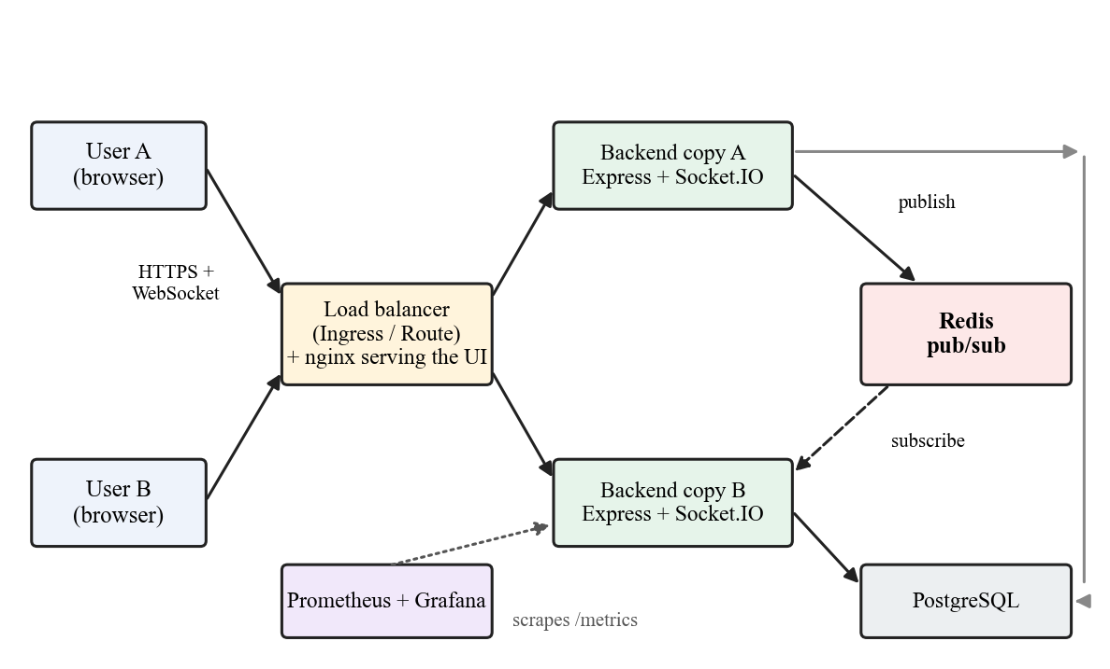
Figure 2.1: ChatScale system architecture (grey line: both backend copies use the same PostgreSQL database)

2.2 Components and Where They Live
Component | Technology | Location in the repository
Web interface | React, socket.io-client | frontend/src/
REST API | Node.js, Express | backend/src/routes, controllers, services
Real-time layer | Socket.IO | backend/src/socket/socket.js, messageHandlers.js
Scaling fix | @socket.io/redis-adapter, Redis | backend/src/socket/adapter.js (57 lines)
Authentication | bcrypt, JWT, TOTP (RFC 6238), AES-256-GCM | backend/src/controllers/authController.js, twoFactorController.js, utils/totp.js, utils/secretBox.js
Metrics | prom-client | backend/src/metrics.js
Database | PostgreSQL (Supabase or in-cluster); SQLite for local development | backend/src/config/db.js
Container images | Docker, nginx | backend/Dockerfile, frontend/Dockerfile
Kubernetes manifests | Kustomize (base and overlays) | k8s/base/, k8s/overlays/local/
Autoscaling experiments | HPA, prometheus-adapter | k8s/experiments/, k8s/base/prometheus-adapter.yaml
Load tests | k6 | loadtest/socketio-load.js
OpenShift deployment | Single multi-object YAML | k8s/openshift/chatscale-sandbox.template.yaml

2.3 How a Message Travels
Without Redis. User A’s browser sends the message over its WebSocket to copy A. Copy A saves it to the database and emits it to the channel room, but a room only contains the sockets held by that process, so only users connected to copy A receive it. User B, connected to copy B, sees nothing until reloading the page, which reads the database.
With Redis. Each copy subscribes to Redis at start-up. When copy A emits to a room, the adapter also publishes the event to Redis; every other copy receives it and delivers it to its own connected sockets. The application code is unchanged: setting the REDIS_URL environment variable switches the adapter on.

2.4 Authentication Module
Passwords are hashed with bcrypt. A successful login returns a signed JSON Web Token, which the API checks on every request and the WebSocket handshake checks when connecting. Optional two-factor authentication uses time-based one-time passwords: the server generates a random secret, shows it as a QR code that any authenticator app can scan, and both sides then compute the same six-digit code from the secret and the current 30-second time step. We implemented the algorithm on Node’s crypto module. The secret is stored encrypted (AES-256-GCM), a correct password followed by a 2FA challenge yields a five-minute challenge token that grants no access on its own, and one-time recovery codes are issued at setup.
The limits on wrong codes (5 per challenge, 10 per user per window) must be shared across backend copies, otherwise an attacker would receive a fresh allowance on every copy. They are therefore stored in Redis when it is configured (backend/src/utils/counters.js), which is the same scaling problem as the chat bug appearing in a security feature.

2.5 Observability and Autoscaling Modules
The backend exposes chatscale_socket_connections (live connections), chatscale_messages_total, and a broadcast-latency histogram, in addition to Node’s default process metrics. Prometheus discovers backend pods through DNS against a headless Kubernetes Service, so it needs no cluster API access. For the connection-count autoscaler, prometheus-adapter republishes the connection metric through Kubernetes’ external-metrics API, where a HorizontalPodAutoscaler consumes it like any other metric.

CLOUD ENVIRONMENT & TOOLS USED

3.1 Environments
Environment | What it is | Used for
Laptop (processes and Docker Compose) | Two backend processes or containers, Redis, nginx on one machine | Reproducing and fixing the failure; graceful-failover test
k3d (k3s in Docker) | Real Kubernetes: 1 control-plane node and 2 worker nodes, each a Docker container on one laptop | All measurements: autoscaling, scaling efficiency, Redis cost, pod-kill test
Red Hat OpenShift Developer Sandbox | Hosted, shared OpenShift cluster running on AWS (US East); free, no cluster-admin | Cloud deployment of the full application via Import YAML
Supabase | Hosted PostgreSQL | Database for the first deployments (in-cluster PostgreSQL later)

3.2 Tools
Tool | Role in the project
Docker, Docker Compose | Container images (two-stage builds, non-root user, health check) and multi-container local runs
Kubernetes (k3s via k3d), kubectl, Kustomize | Deployments, Services, Ingress (Traefik), probes, ConfigMaps/Secrets, HorizontalPodAutoscaler; base and overlay manifests
Redis | Pub/sub backbone for the Socket.IO adapter; shared counters
Prometheus, Grafana | Metric collection and the chatscale-overview dashboard
metrics-server, prometheus-adapter | CPU metrics (bundled with k3s) and external connection-count metric for the autoscalers
k6 | Load generation using the raw Socket.IO protocol; calibrated profiles
OpenShift BuildConfig, ImageStream, Route | Building images inside the cluster from GitHub, internal registry, public HTTPS address
Node.js, Express, Socket.IO, React, PostgreSQL | The application itself

3.3 Mapping to Cloud Service Models
Model | Provider equivalent | In this project
IaaS | AWS EC2, Azure Virtual Machines | Not used directly; the sandbox nodes are AWS virtual machines that we do not manage
Managed Kubernetes / CaaS | EKS, AKS, GKE, OpenShift | Used: hosted OpenShift Sandbox; k3d locally as a stand-in
PaaS | OpenShift builds, Heroku-style deploy | Used: in-cluster builds from Git and a Route for public access
Database as a service | Amazon RDS, Azure Database, Supabase | Used: Supabase in early deployments
Managed cache | ElastiCache, Azure Cache for Redis | Not used; Redis ran as a pod. Named as the production choice

3.4 What Was Not Used
Helm, Terraform, the Cluster Autoscaler, multi-zone clusters, Azure, and any social sign-in (OAuth) were not used. The two-factor feature works with any standard authenticator app and does not integrate with a specific vendor.

IMPLEMENTATION and DEPLOYMENT

4.1 Reproducing the Failure
A script starts two backend copies on different ports with the in-memory adapter, then two users connect, one to each copy. The first user’s message appears only on the sender’s screen, the second user receives nothing, and the backend log shows the message delivered to one socket on one copy. A page reload on the second user’s side shows the message because it is read from the database. The same result was reproduced under Docker Compose and on Kubernetes pods.

4.2 The Fix
Setting REDIS_URL makes the backend create two Redis connections (publish and subscribe) and install @socket.io/redis-adapter. Repeating the test, the log now reports delivery to one local socket plus delivery on other copies through Redis, and the second user sees the message instantly. Verification was repeated on all three substrates from the same code.

4.3 Containerisation
The backend image is built in two stages (dependencies, then runtime), runs as the unprivileged node user, carries a Docker health check and contains no secrets; configuration is supplied through environment variables. The frontend is built and served by nginx, which also proxies API and WebSocket traffic. Graceful shutdown is implemented so a terminating pod stops accepting connections, lets the load balancer drain, and closes cleanly.

4.4 Kubernetes Deployment
- scripts/k8s-up.sh creates a k3d cluster (1 server, 2 agents, port 8080 mapped to the ingress) and imports the locally built images, because k3d nodes do not see the host’s Docker images.
- Kustomize applies k8s/overlays/local: backend and frontend Deployments, ClusterIP and headless Services, Ingress, Redis, PostgreSQL, Prometheus, Grafana, ConfigMaps and Secrets.
- Readiness and liveness probes (/readyz, /healthz) control traffic and restarts; a pre-stop delay gives the load balancer time to drain.
- The script waits until all pods are ready and prints the access addresses.

4.5 Observability
Prometheus scrapes every ready backend pod every 10 seconds; its history is kept for six hours. The Grafana dashboard chatscale-overview is provisioned from a ConfigMap and shows connections per pod, messages per second, broadcast latency and the number of pods. Prometheus renames the application’s instance label to exported_instance, so the dashboard legend uses that name.

4.6 Experiment 1: CPU versus Connection-Count Autoscaling
Two HorizontalPodAutoscaler configurations were applied one at a time against the same k6 load (20 users, 90 seconds): one on CPU (target 60%) and one on the external metric chatscale_socket_connections (target 8 per pod).
Signal | Observed | Target | Result
CPU | 54% peak (registration burst), 36% settled | 60% | Never scaled: 2 pods throughout
Connections per pod | 10 (20 connections across 2 pods) | 8 | Scaled 2 to 3 pods in about 50 s (Kubernetes SuccessfulRescale event)

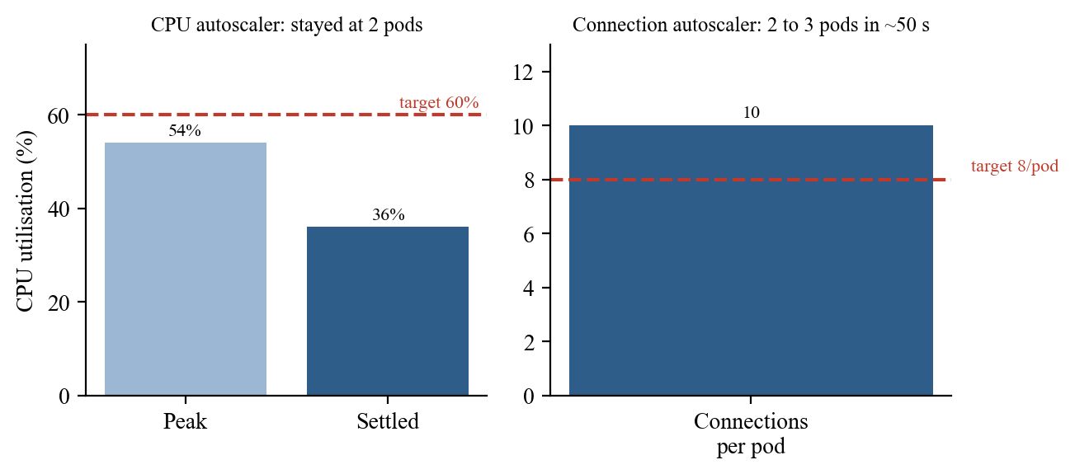
Figure 4.1: CPU-based and connection-based autoscaling under identical load
The connection result was cross-checked against Prometheus’s raw query_range for the same window, which showed a sustained plateau of exactly 20 connections. The experiment also exposed two real defects that were fixed and kept in the record: a certificate-directory permission crash in prometheus-adapter, and an AverageValue target that divides the metric by the replica count itself, which halved every reading until the adapter query was changed from avg() to sum().

4.7 Experiment 2: Scaling Efficiency
A fixed load of 100 concurrent users (k6 constant-VUs, calibrated because 20 users showed no saturation) ran for 90 seconds against 1, 2 and then 4 backend pods with autoscaling disabled.
Pods | p50 latency | p95 latency | Messages delivered | Success
1 (control) | 40 ms | 110 ms | 1800 | 100%
2 | 28 ms | 85 ms | 1900 | 100%
4 | 14 ms | 34 ms | 1900 | 100%

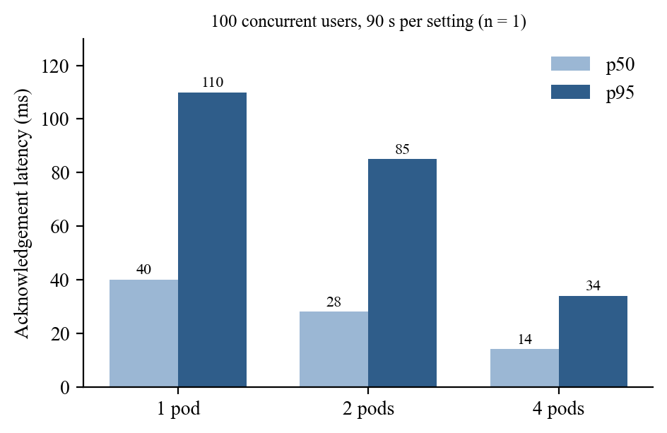
Figure 4.2: Acknowledgement latency at 1, 2 and 4 pods (n = 1 run each)
Delivery never failed, even with a single pod; what improved was latency, by about 3.2 times from 1 to 4 pods. This is a single run per setting, so the trend is reliable but the exact values should not be read with tight confidence.

4.8 Experiment 3: The Cost of the Redis Hop
A test sent 200 messages to a receiver on the same pod and 200 to a receiver on another pod, measuring wall-clock delivery time.
Path | p50 | p95 | p99
Same pod (no Redis) | 1 ms | 2 ms | 2 ms
Cross pod (through Redis) | 1 ms | 1 ms | 3 ms

There was no measurable difference. This is specific to the setup: all k3d nodes are containers on one machine, so there is no real network between pods. A multi-machine deployment would probably show a cost from genuine network latency; we did not measure that.

4.9 Resilience: Pod Loss
A backend pod was deleted outright while 10 connected users were split across two pods.
Measure | Result
Replacement pod scheduled | 7 s
Users on the untouched pod affected | 0
Users of the deleted pod reconnected | 7 of 7, onto the surviving pod
Time without a connection | 0.6 to 1.4 s
Deployment back at full capacity | 16.3 s

4.10 Deployment on Red Hat OpenShift
The whole application is described by one 17-object YAML file that is uploaded with the console’s Import YAML feature. A small script fills in freshly generated random secrets (token-signing key, 2FA encryption key, database password) and writes the upload file outside the repository, so secrets are never committed.
- Builds: two BuildConfigs build the backend and frontend images inside the cluster from the GitHub repository, which also avoids an architecture mismatch (the development Mac is arm64, the sandbox nodes are most likely x86-64). ImageStreams hold the results and image triggers roll out new pods automatically.
- Security model: OpenShift runs containers with a random, unprivileged user ID, so Red Hat’s PostgreSQL and Redis images were used and our own images already run as non-root.
- Networking: a Route provides public HTTPS with edge termination; its timeouts were raised to one hour because chat connections are long-lived and the router default would cut them off.
- Configuration: a setting (SHOW_SERVED_BY) hides internal pod names from visitors on the public address while the local demos keep it on.
- Performance: the sandbox is in AWS US East and the users are in India, so every new HTTPS connection costs about a second of distance. gzip compression was added to nginx, cutting the main JavaScript file from 296 KB to 87 KB and its download from about 3.4 s to about 1.4 s. The remaining delay is network distance and cannot be removed by configuration.

4.11 Problems Faced and How They Were Resolved
Problem | Resolution
Azure for Students verification never completed | Scope finalised at local Kubernetes plus the OpenShift Sandbox; the missing cloud-only measurements are stated, not claimed
Cluster node crash-looping after a Docker restart | Delete and recreate the k3d cluster with the setup script
Pods running an old image after a rebuild | kubectl rollout restart after importing the new image
Autoscaler showed exactly half the real connection count | Found by comparing with Prometheus raw data; the adapter query was changed to sum()
prometheus-adapter failed to start (certificate directory permission) | Certificate directory moved to a writable emptyDir
Kustomize overwrote a kube-system RoleBinding namespace | That object was moved to a separate file applied directly
oc login timed out on the sandbox API port | Used the console’s built-in web terminal; the port was blocked on the network
OpenShift site felt slow | Measured: distance to US East plus uncompressed JavaScript; added gzip and documented the remaining limit

4.12 Cost Estimate
This is an estimate from our measured resource requests and a reference provider’s published prices, not an invoice. A backend pod requests 100m CPU and 96 MiB memory; a comfortable planning figure is about 50 connections per pod (half the 100-user single-pod run). A node of about 1 vCPU and 2 GiB at roughly $12 per month hosts about 10 such pods, or about 500 connections. Serving 10,000 concurrent connections needs about 20 nodes, roughly $240 per month, plus about $30 if Redis and PostgreSQL are managed, so about $240 to $270 per month. The figure assumes ideal packing and was never run at that scale.

4.13 Limitations
- All Kubernetes measurements come from one laptop; nodes are containers, so there is no real network, zone or hardware failure.
- The scaling-efficiency runs are single runs (n = 1).
- No Cluster Autoscaler, zone-failure or managed-database-failover test was carried out.
- Redis is a single point of failure in this design; production would use replicas.
- Prometheus, Grafana and the connection-count autoscaler are not installed on the shared OpenShift sandbox.

CODE/CONFIGURATION SNIPPETs

5.1 Switching on the Redis Adapter (backend/src/socket/adapter.js)
exports.setup = async (io) => {
const url = process.env.REDIS_URL;
if (!url) {
console.log('[realtime] adapter: in-memory - this copy only reaches its own users');
return;
}
// The adapter needs two connections: one to publish, one in subscriber mode
const pubClient = createClient({ url });
const subClient = pubClient.duplicate();
await Promise.all([pubClient.connect(), subClient.connect()]);
io.adapter(createAdapter(pubClient, subClient));
commandClient = pubClient;
};

5.2 Connection-Count Autoscaler (k8s/experiments/hpa-connections.yaml)
apiVersion: autoscaling/v2
kind: HorizontalPodAutoscaler
metadata:
name: backend-hpa-connections
spec:
scaleTargetRef: { apiVersion: apps/v1, kind: Deployment, name: backend }
minReplicas: 2
maxReplicas: 6
behavior:
scaleDown: { stabilizationWindowSeconds: 300 }
metrics:
- type: External
external:
metric: { name: chatscale_socket_connections }
target: { type: AverageValue, averageValue: "8" }

5.3 Prometheus Scrape Configuration (k8s/base/prometheus.yaml)
global:
scrape_interval: 10s
scrape_configs:
- job_name: chatscale-backend
metrics_path: /metrics
dns_sd_configs:
- names: ["backend-headless.chatscale.svc.cluster.local"]
type: A
port: 5001
refresh_interval: 15s

5.4 Exposing the Connection Gauge (backend/src/metrics.js)
exports.connections = new client.Gauge({
name: 'chatscale_socket_connections',
help: 'Live Socket.IO connections on this copy',
registers: [register],
});

5.5 Health Probes (k8s/base/backend-deployment.yaml)
livenessProbe:
httpGet: { path: /healthz, port: 5001 }
initialDelaySeconds: 5
periodSeconds: 10
readinessProbe:
httpGet: { path: /readyz, port: 5001 }
initialDelaySeconds: 2
periodSeconds: 5
failureThreshold: 2

5.6 In-Cluster Build and Public Route on OpenShift
kind: BuildConfig
metadata: { name: chatscale-backend }
spec:
source:
type: Git
git: { uri: "https://github.com/parthparu/cloud.git", ref: main }
contextDir: backend
strategy: { type: Docker, dockerStrategy: {} }
output: { to: { kind: ImageStreamTag, name: "chatscale-backend:latest" } }
---
kind: Route
metadata:
name: chatscale
annotations:
haproxy.router.openshift.io/timeout: 1h
haproxy.router.openshift.io/timeout-tunnel: 1h
spec:
to: { kind: Service, name: frontend }
port: { targetPort: 8080 }
tls: { termination: edge, insecureEdgeTerminationPolicy: Redirect }

Source repository: https://github.com/parthparu/cloud (all manifests, scripts, tests and the evidence files behind every number in Chapter 4).

APPLICATION/UI SCREENSHOTS
The figures below were captured from the running system. Figures 6.1 and 6.2 show the application interface, Figures 6.3 to 6.8 come from the local Kubernetes cluster, and Figures 6.9 and 6.10 from the Red Hat OpenShift Developer Sandbox.
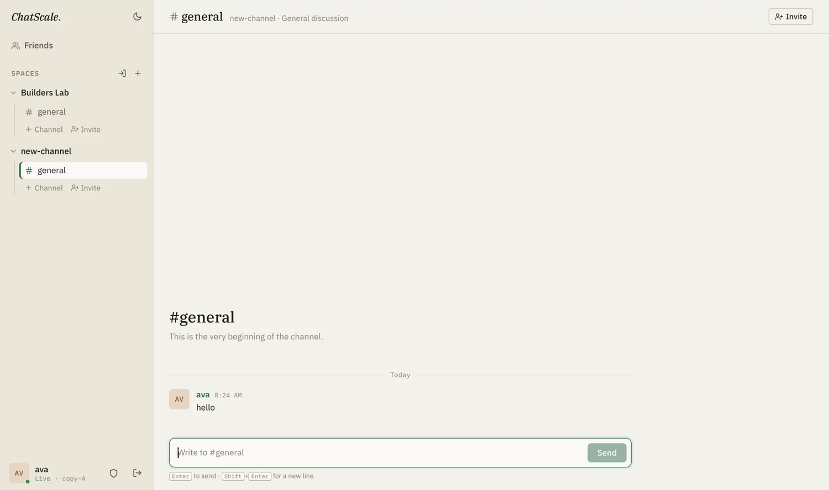
Figure 6.1: ChatScale channel view: a message in #general; the badge at the bottom left shows the backend copy serving this user (copy-A)
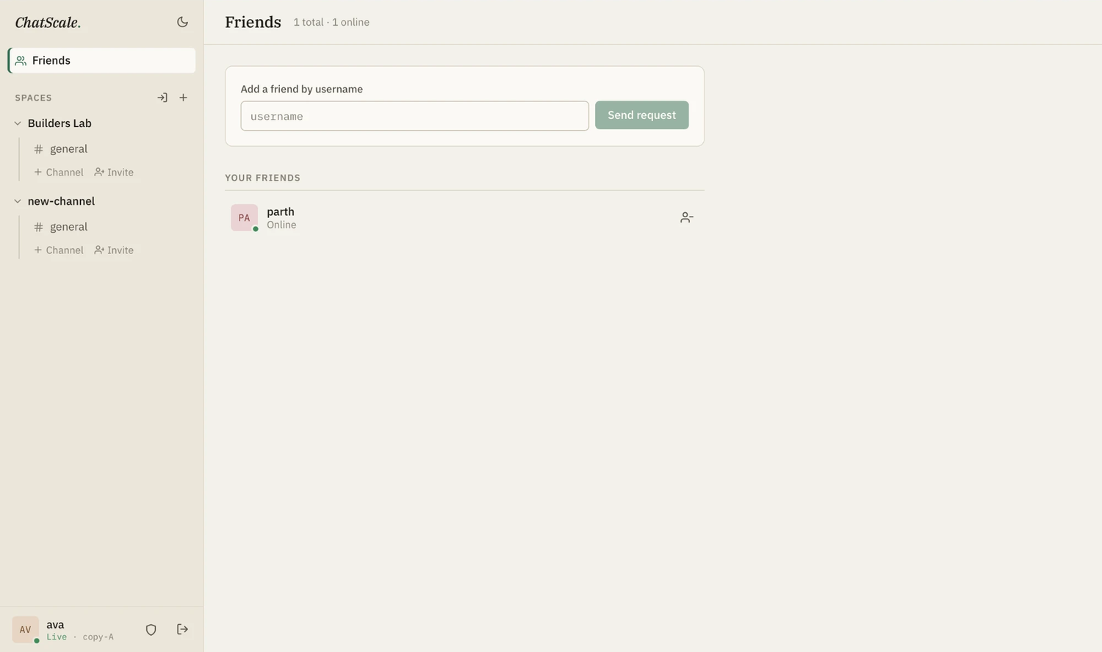
Figure 6.2: ChatScale friends list with live presence (online status is shared between users through the backend)
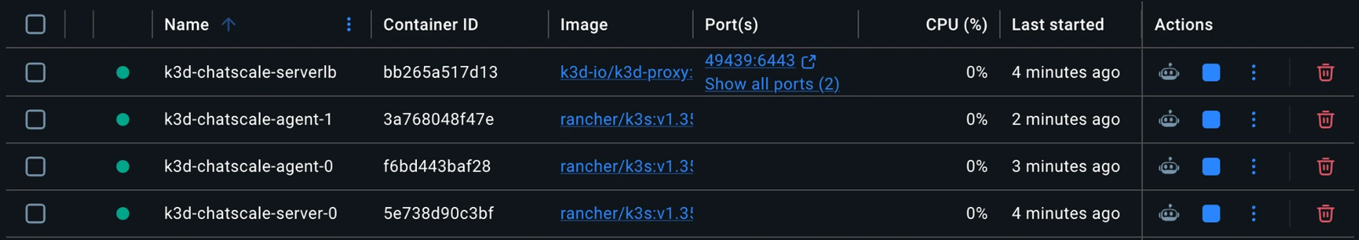
Figure 6.3: The k3d cluster nodes running as Docker containers (control plane, two workers and the load balancer)
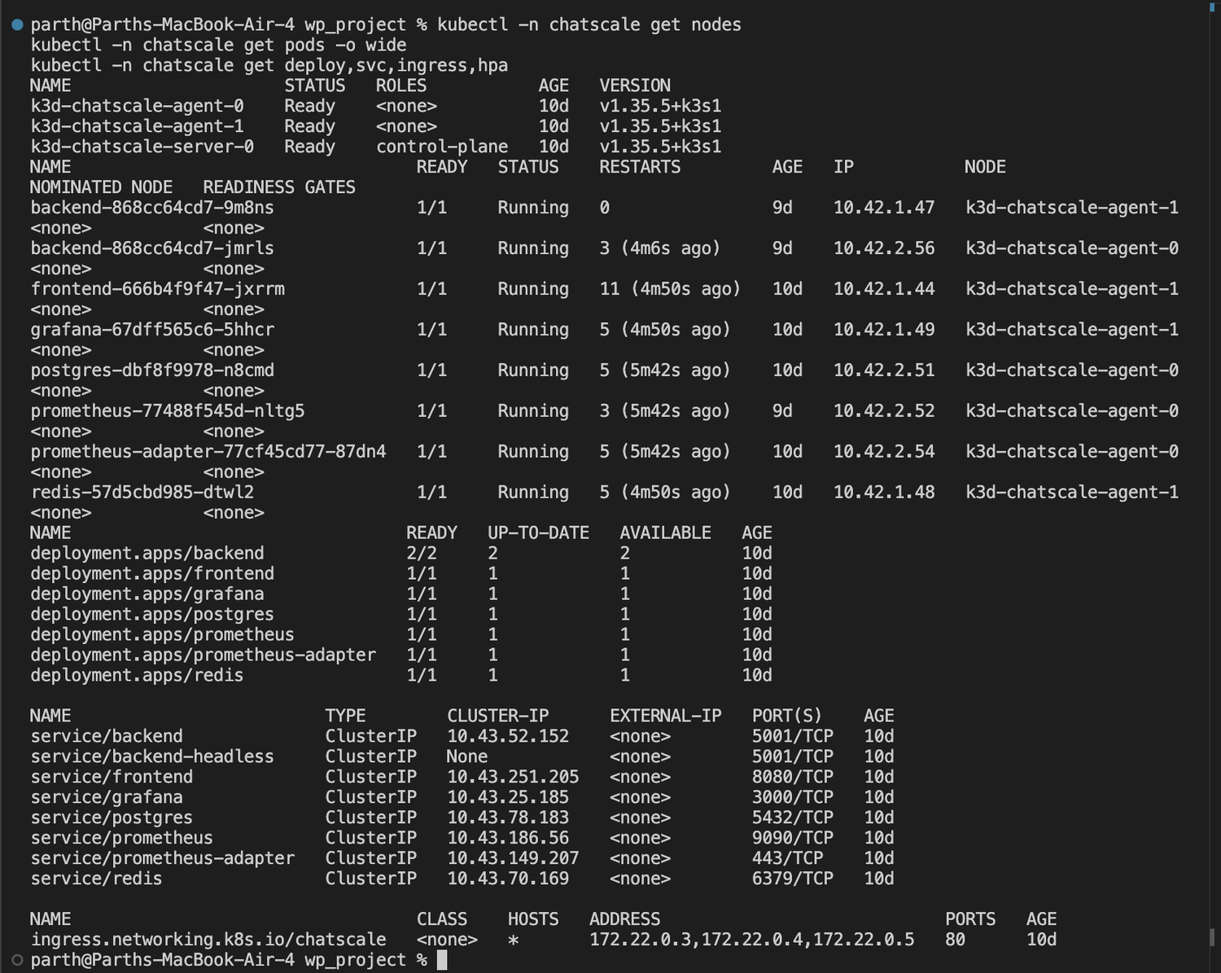
Figure 6.4: Kubernetes nodes, pods, Deployments, Services and Ingress in the chatscale namespace
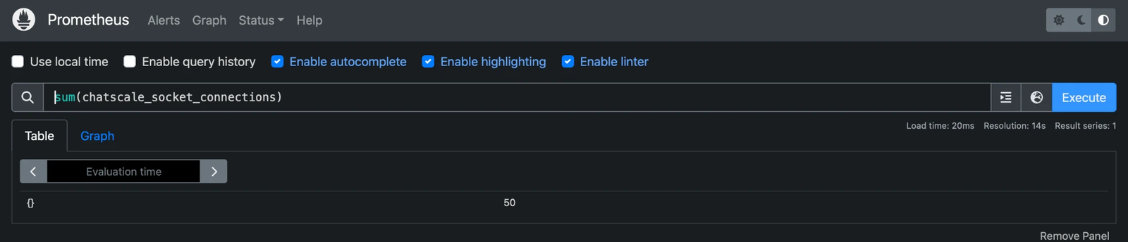
Figure 6.5: Prometheus query sum(chatscale_socket_connections) returning 50 live connections under load
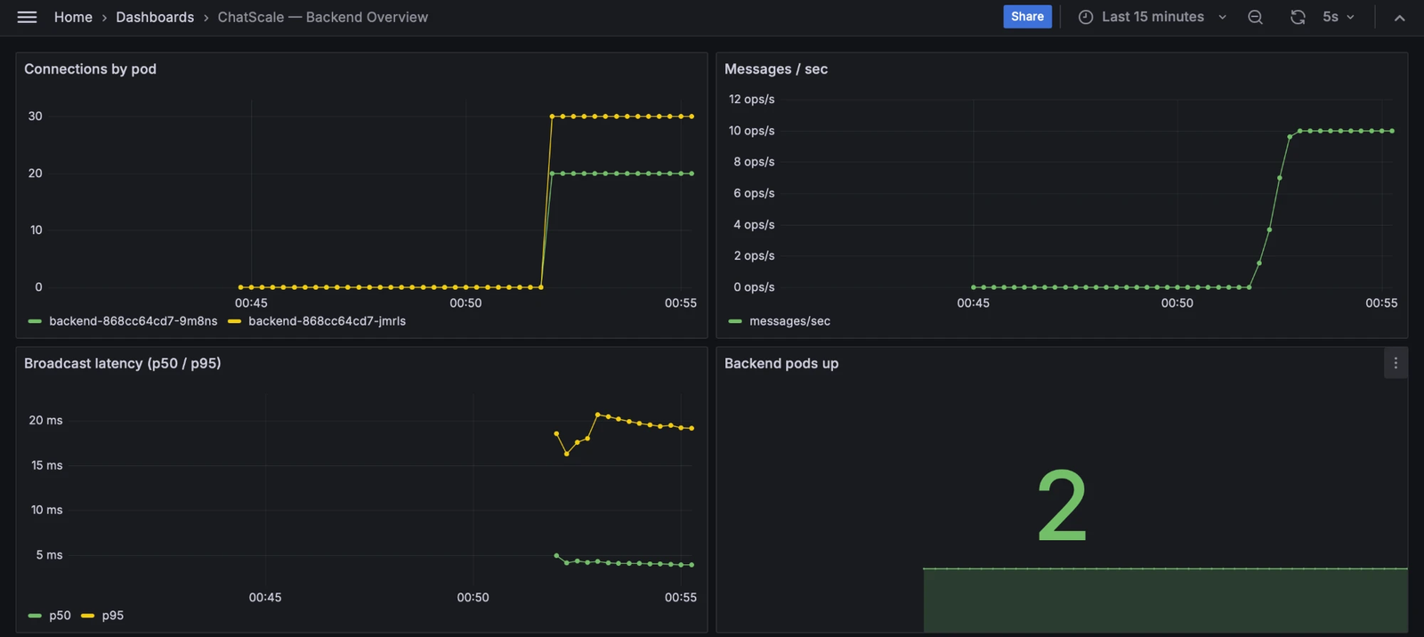
Figure 6.6: Grafana dashboard “ChatScale — Backend Overview”: connections per pod, messages per second, broadcast latency and backend pods up
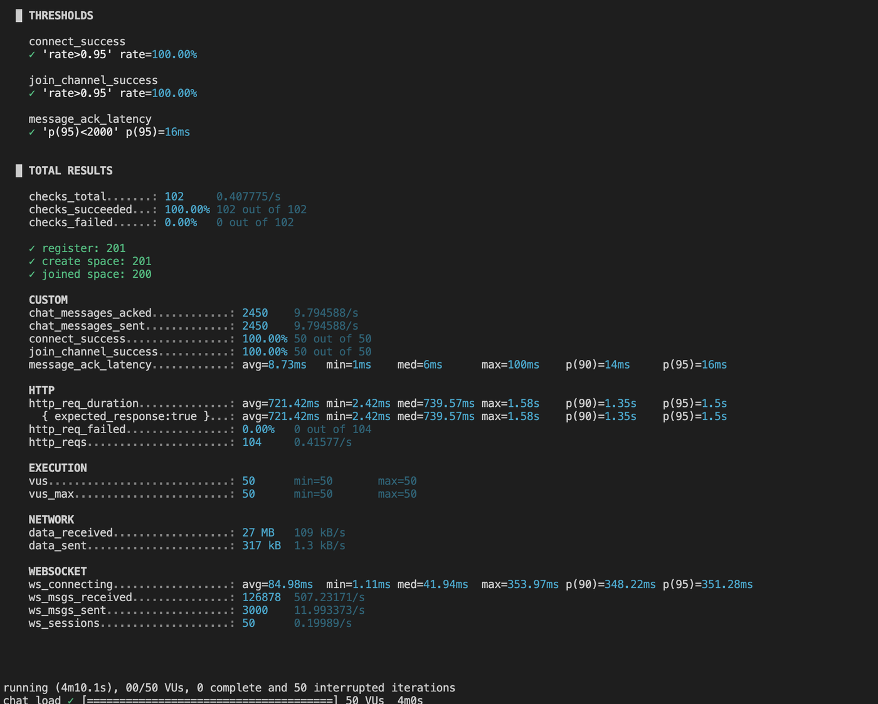
Figure 6.7: k6 load-test summary (50 virtual users, 4 minutes): 100% connection success and p95 acknowledgement latency of 16 ms
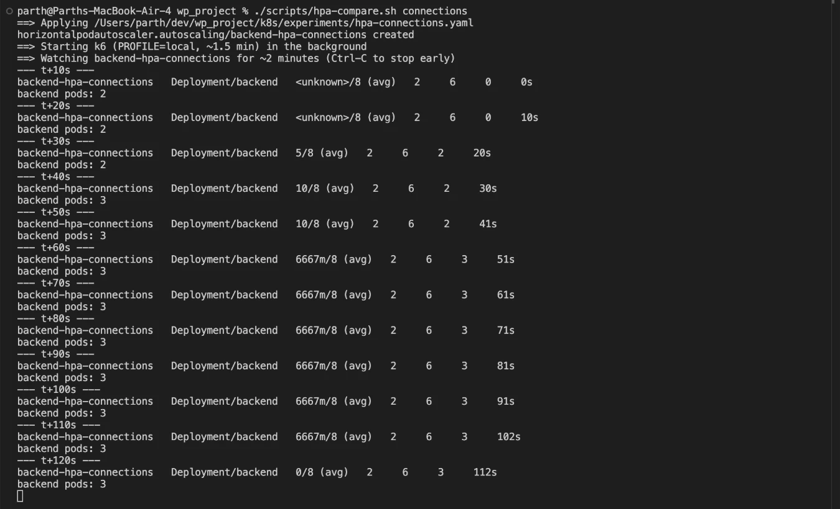
Figure 6.8: Connection-count autoscaler: 10 connections per pod against a target of 8 raises the Deployment from 2 to 3 pods
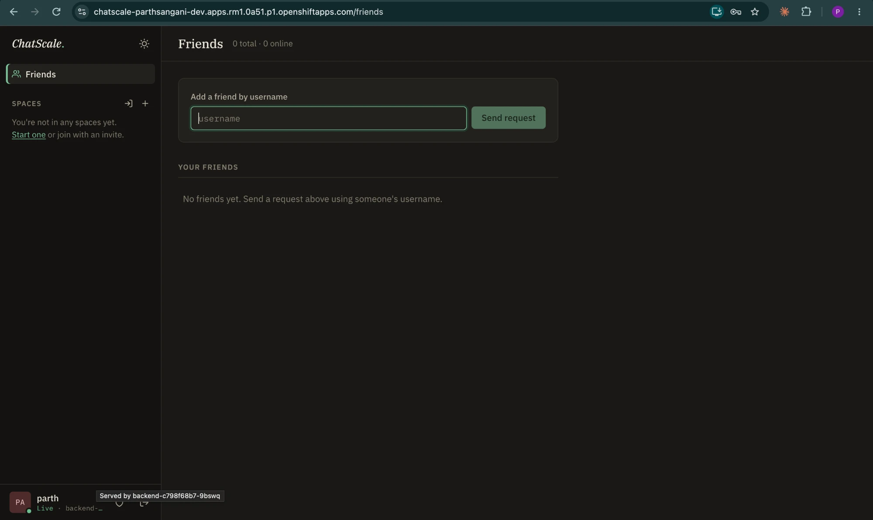
Figure 6.9: ChatScale running on the OpenShift Sandbox at its public HTTPS Route; the tooltip shows the backend pod serving this user
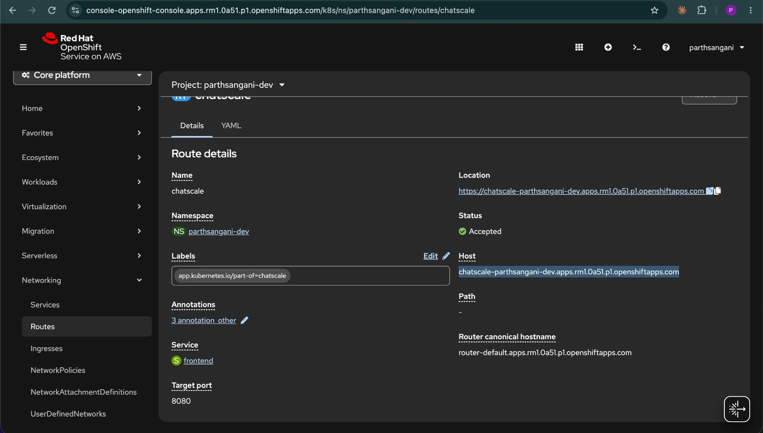
Figure 6.10: The OpenShift Route “chatscale” (status Accepted) pointing at the frontend service on port 8080

CONCLUSION & FUTURE SCOPE

7.1 Conclusion
The project showed, on a working application and with measurements, that a stateful WebSocket service silently loses messages across copies when scaled horizontally, and that a shared Redis pub/sub adapter fixes this with one configuration setting and no application changes. Beyond the fix, three measured findings stand out. First, for this workload CPU is the wrong autoscaling signal: under identical load the CPU-based autoscaler never scaled (36% against a 60% target) while the connection-count autoscaler added a pod within about 50 seconds. Second, adding pods improves latency (95th percentile 110, 85 and 34 ms at 1, 2 and 4 pods) without any message loss. Third, the Redis hop was not measurable on a single-machine cluster, which we explain rather than generalise. The application was also deployed to a hosted Red Hat OpenShift sandbox from a single YAML file, using in-cluster builds, a Route and OpenShift’s restricted security model.
The study is honest about its limits: node-level autoscaling, zone failure, managed-database failover and real billing were not tested, the scaling runs are single runs, and the cost figure is an estimate.

7.2 Future Scope
- Deploy on a managed multi-zone cluster (EKS, AKS or GKE) and add the Cluster Autoscaler to test node-level elasticity and zone failure.
- Repeat the Redis-cost measurement across real machines to quantify the network cost of the hop.
- Make Redis highly available (replicas or a managed service) and test its failure explicitly.
- Repeat the scaling runs at least three times with a discarded warm-up to give confidence intervals.
- Use a request-driven autoscaler such as KEDA, or OpenShift user-workload monitoring on a dedicated cluster, to run the connection-count autoscaler on OpenShift.
- Add a real cost measurement from a cloud invoice to replace the estimate.

REFERENCES
- Socket.IO documentation, “Redis adapter”. https://socket.io/docs/v4/redis-adapter/
- Kubernetes documentation, “Horizontal Pod Autoscaling”. https://kubernetes.io/docs/tasks/run-application/horizontal-pod-autoscale/
- Prometheus documentation. https://prometheus.io/docs/
- M’Raihi, D. et al., “TOTP: Time-Based One-Time Password Algorithm”, RFC 6238, IETF, 2011.
- Red Hat Developer Sandbox for OpenShift. https://developers.redhat.com/developer-sandbox
- k3d: k3s in Docker. https://k3d.io
- Grafana k6 documentation. https://grafana.com/docs/k6/
- Project repository and evidence files. https://github.com/parthparu/cloud

APPENDIX: DECLARATION OF AI ASSISTANCE
In the interest of transparency, we acknowledge that AI tools were used during this project for research and guidance purposes. They assisted us in exploring relevant technical concepts, identifying suitable approaches, understanding implementation requirements, and determining the steps necessary to develop, configure, deploy, and troubleshoot the project.
AI tools were used to support our understanding of the technologies and processes involved. Their suggestions were reviewed and evaluated by us, and we take responsibility for the work carried out and the findings and conclusions presented in this report.

