﻿heuristic for Bus Stop = 0

-- dequeue -- Bus Stop

heuristic for Library = 2.0

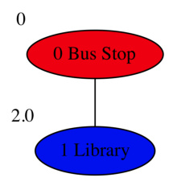

-- dequeue -- Library

heuristic for Car Park = 7.0

heuristic for Student Center = 4.0

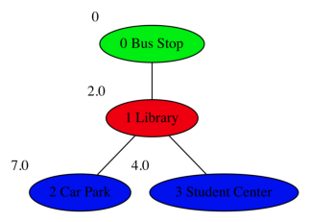

-- dequeue -- Student Center

heuristic for Store = 8.0

heuristic for Theater = 5.414213562373095



-- dequeue -- Theater

heuristic for Sports Center = 7.414213562373095

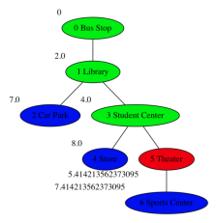

-- dequeue -- Car Park

heuristic for Store = 12.0

heuristic for Maths Building = 11.242640687119284

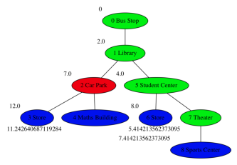

-- dequeue -- Sports Center

heuristic for Store = 8.82842712474619

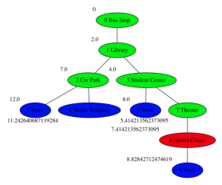

-- dequeue -- Store

heuristic for Canteen = 11.0

heuristic for Car Park = 13.0

heuristic for Sports Center = 9.414213562373096

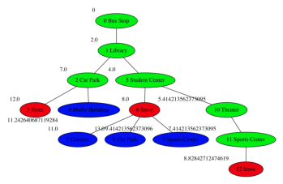

-- dequeue -- Store

heuristic for Canteen = 11.82842712474619

heuristic for Car Park = 13.82842712474619

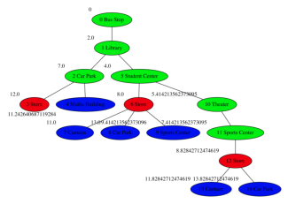

-- dequeue -- Sports Center

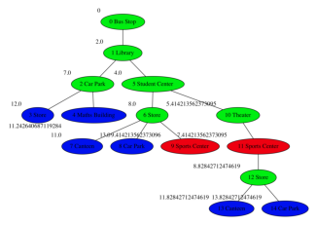

-- dequeue -- Canteen

heuristic for Maths Building = 13.0

heuristic for AI Lab = 12.0

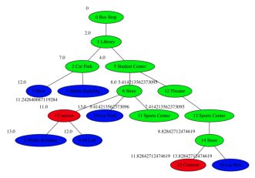

-- dequeue -- Maths Building

heuristic for Canteen = 13.242640687119284

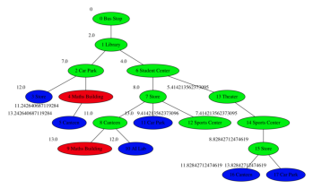

-- dequeue -- Canteen

heuristic for Maths Building = 13.82842712474619

heuristic for AI Lab = 12.82842712474619

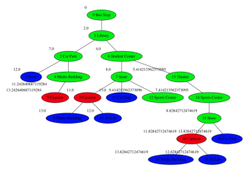

-- dequeue -- AI Lab

reached goal state

----------------------

Path

-> Bus Stop

-> Library

-> Student Center

-> Store

-> Canteen

-> AI Lab

----------------------

Tree

0 - Bus Stop

1 - Library

2 - Car Park

3 - Store

3 - Maths Building

4 - Canteen

2 - Student Center

3 - Store

4 - Canteen

5 - Maths Building

5 - AI Lab

4 - Car Park

4 - Sports Center

3 - Theater

4 - Sports Center

5 - Store

6 - Canteen

7 - Maths Building

7 - AI Lab

6 - Car Park