

Course Number | 2019F_ESE 2005_1
Section Number | 1
Course Title | Embedded Systems Architecture-1
Semester/Year | 2nd / 2019

Instructor | Mohsen Salahi

Lab | 2

Submission Date | 22th oct 2019
Due Date | 23th oct 2019

Student Name | Kunjal Patel | Parth Patel
Student ID | 754858 | 754250
Signature* | KP | PP

*By signing above you attest that you have contributed to this submission and confirm that all work you have contributed to this submission is your own work. Any suspicion of copying or plagiarism in this work will result in an investigation of Academic Misconduct and may result in a “0” on the work, an “F” in the course, or possibly more severe penalties.

Introduction on implementation.

The seven-segment display converts 4-bit BCD input into the 7-bit output for driving decimal display unit which can be used to display 0 to 9 and A to F digits. Seven segment display contains 7 LED segments of active high inputs which becomes active when input is high (1) on respective LEDs. VHDL code of seven segment display can be implemented by using truth table and structural and behavior model.

Truth Table :-

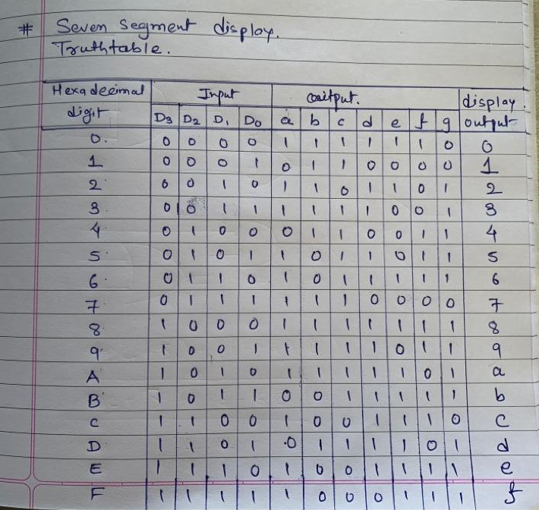

VHDL Code:-
Behavior model -

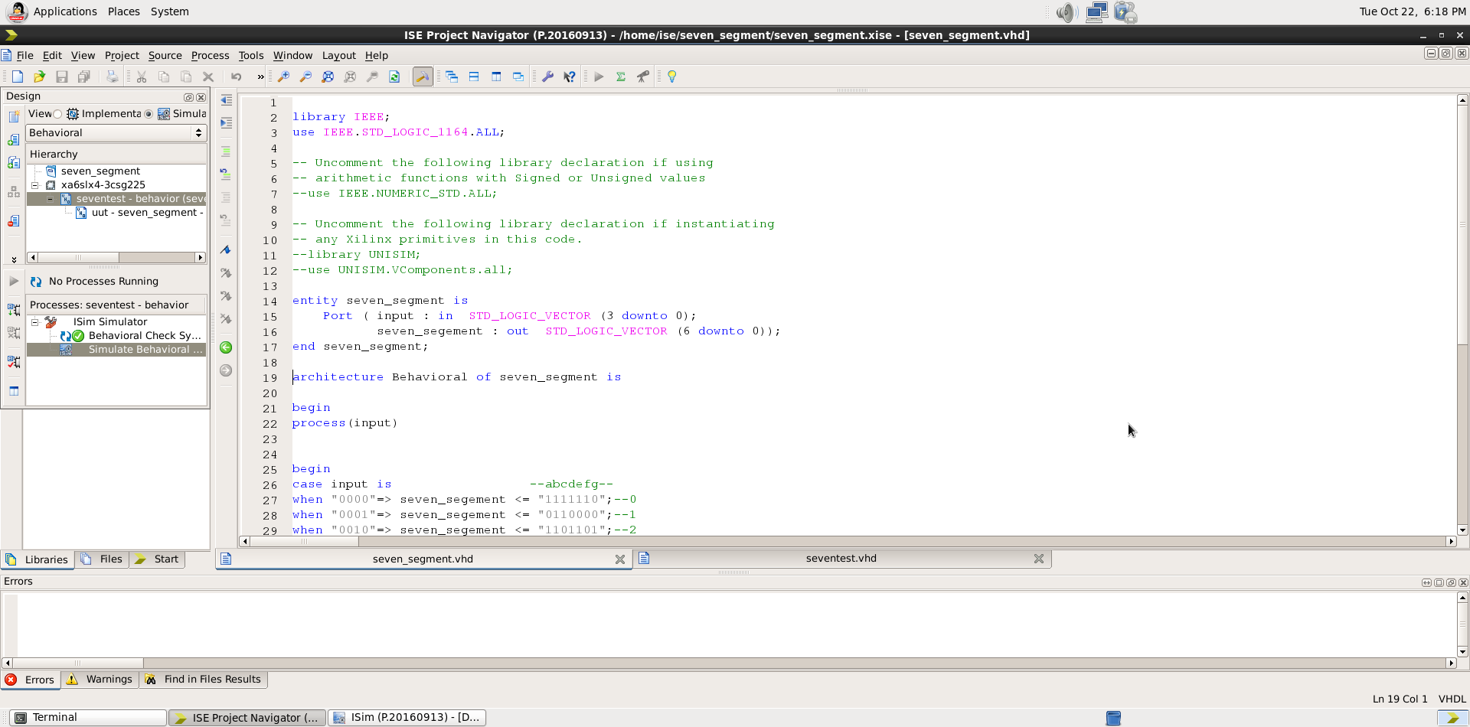

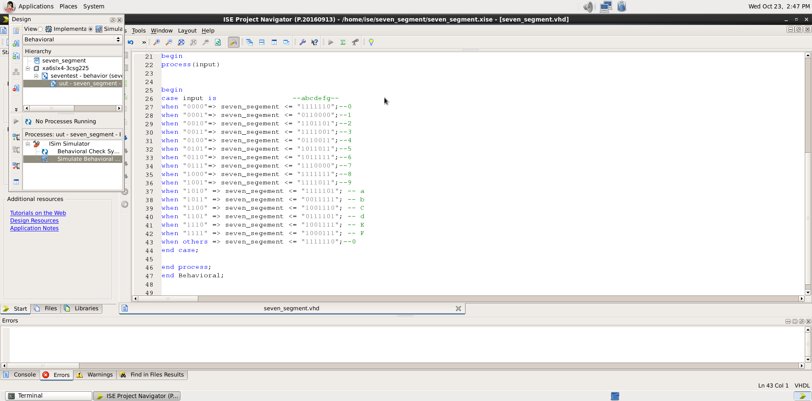

Test Bench -

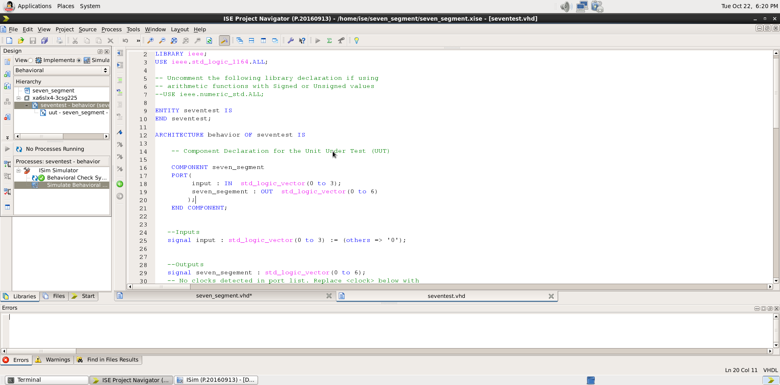

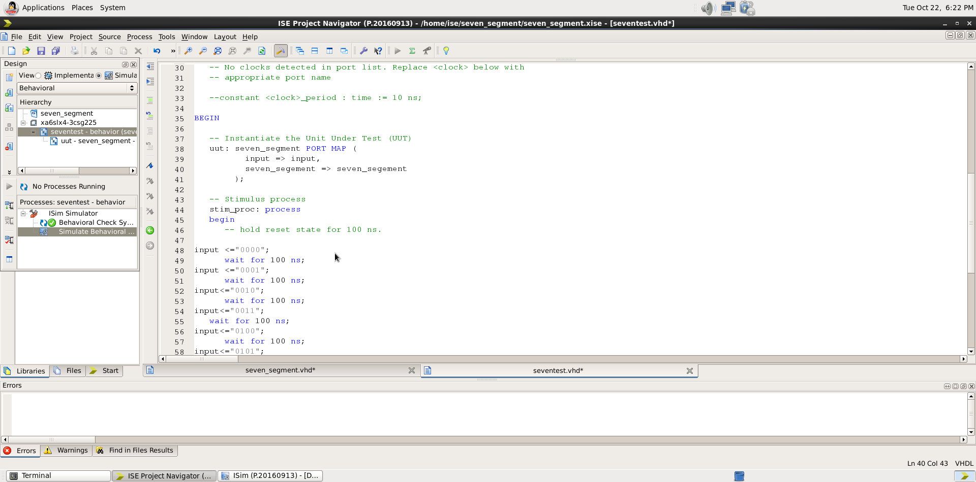
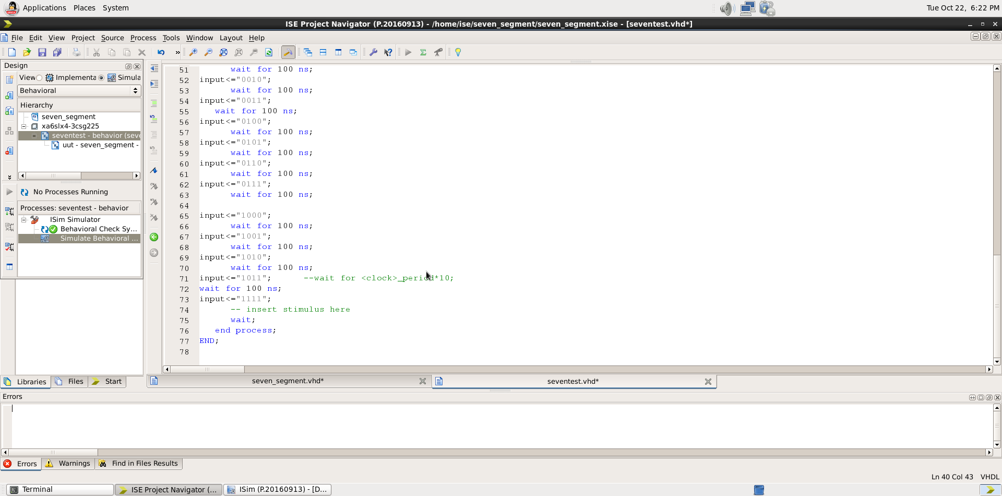

Simulation :-

