**LAB 1**

**SUBMITTED BY**

**KUNJAL PATEL – 754858**

**PARTH PATEL- 754250**

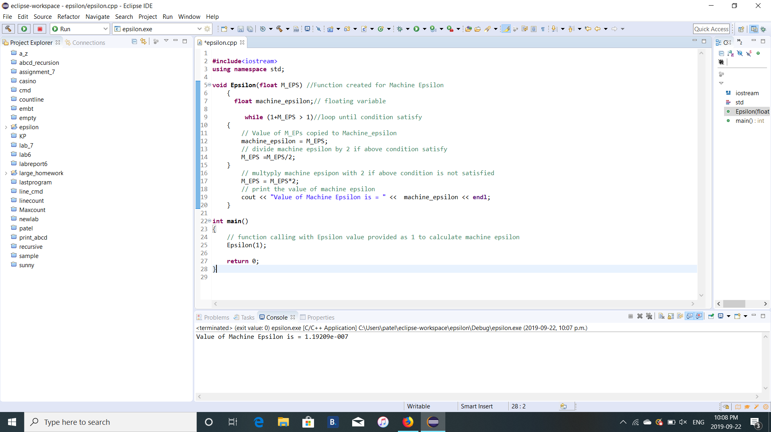

**FLOWCHART**

**EPSILON = EPSILON * 2**

**EPSILON = EPSILON / 2**

**EPSILON + 1 > 1**

**EPSILON=1**

**FALSE**

**TRUE**