

Course Number | 2019F_MTH 1444_1
Section Number | 1
Course Title | Mathematics for Embedded sytem-1
Semester/Year | 2nd / 2019

Instructor | Mohsen Salahi

Lab | 4

Submission Date | 12th Nov 2019
Due Date | 12th Nov 2019

Student Name | Kunjal Patel | Parth Patel
Student ID | 754858 | 754250
Signature* | KP | PP

*By signing above you attest that you have contributed to this submission and confirm that all work you have contributed to this submission is your own work. Any suspicion of copying or plagiarism in this work will result in an investigation of Academic Misconduct and may result in a “0” on the work, an “F” in the course, or possibly more severe penalties.

a) Write an application to calculate the value of f(x)=sin(x) at x=45 degrees based on the Maclaurin series. In order to calculate the derivatives of this function use “Forward Difference” method with step size of 1 degree.

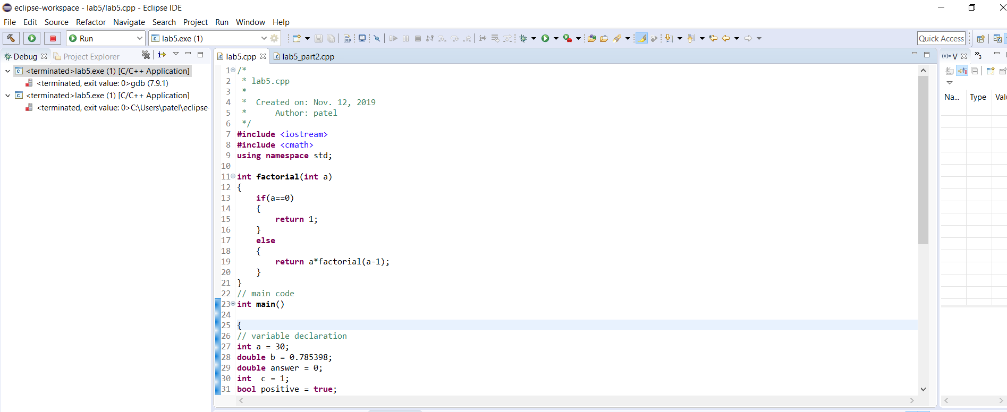
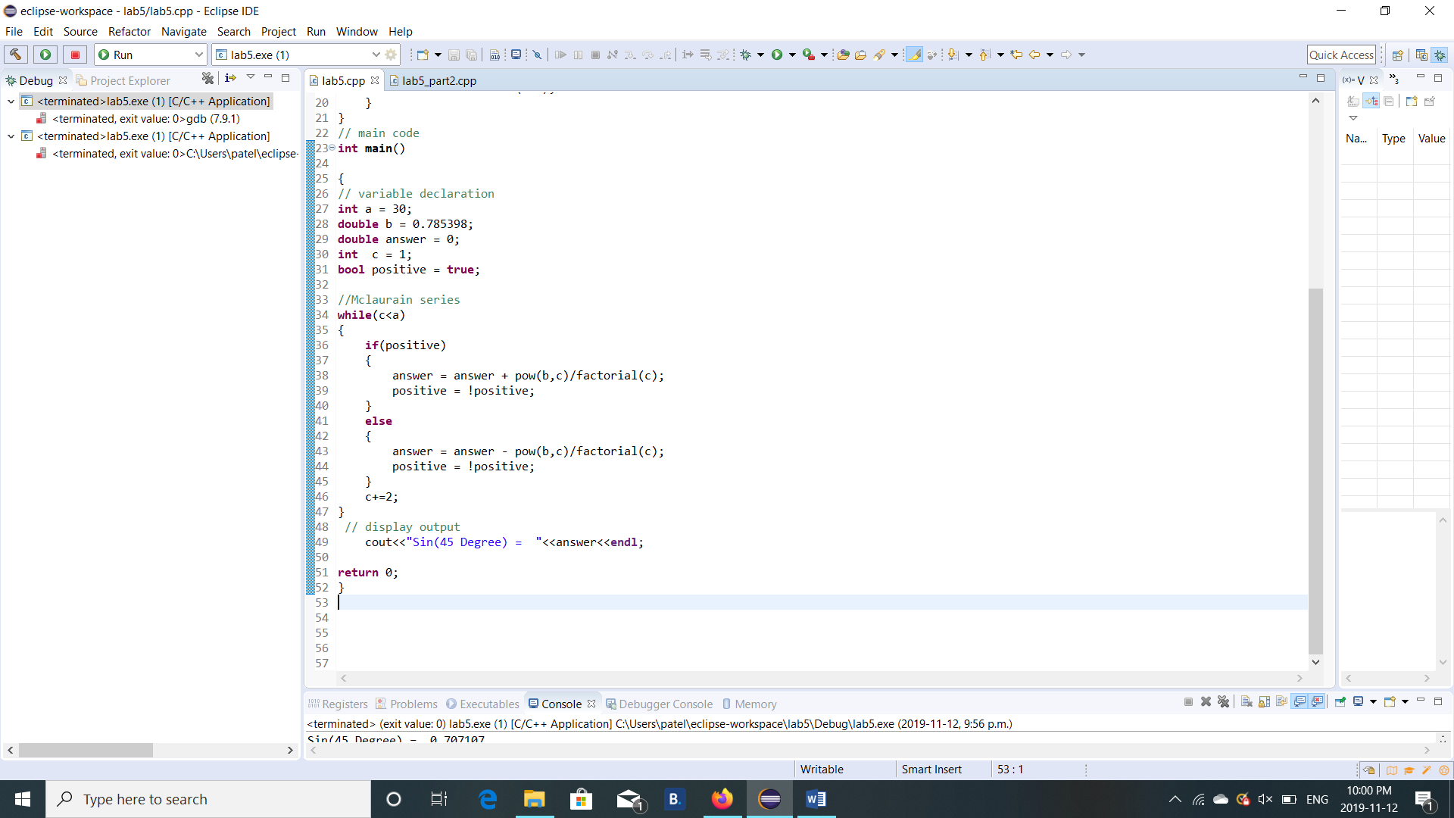

Output :-

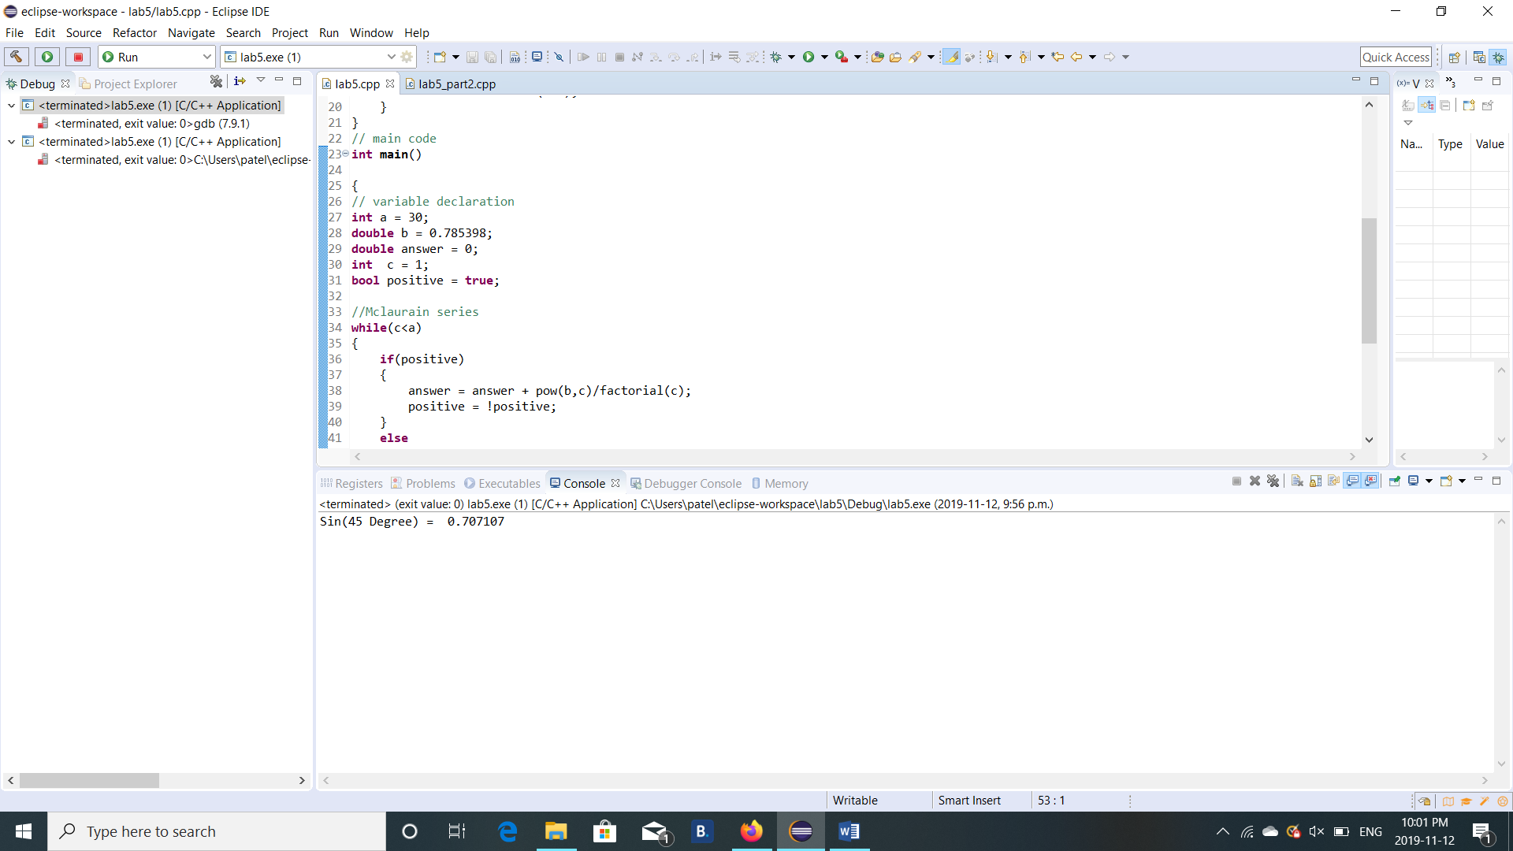

b) Write an application to calculate the value of ∫sin(𝑥)using the Trapezoidal Rule with step size of 1 degree

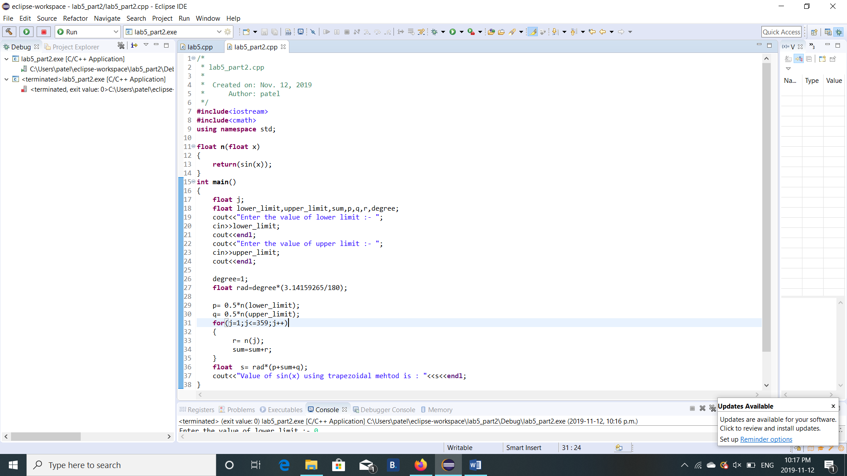

Output :-
