

Course Number | 2019F_MTH 1444_1
Section Number | 1
Course Title | Mathematics for Embedded sytem-1
Semester/Year | 2nd / 2019

Instructor | Mohsen Salahi

Assignment | 1

Submission Date | 28th oct 2019
Due Date | 28th oct 2019

Student Name | Kunjal Patel | Parth Patel
Student ID | 754858 | 754250
Signature* | KP | PP

*By signing above you attest that you have contributed to this submission and confirm that all work you have contributed to this submission is your own work. Any suspicion of copying or plagiarism in this work will result in an investigation of Academic Misconduct and may result in a “0” on the work, an “F” in the course, or possibly more severe penalties.

1)
A) Can you give an integer that cannot be represented by this representation?
-- 51

B) Can you give an integer between 0 and 14 that cannot be represented by this representation?

No, All number between 0 to 14 can be represented as floating point representation.
2)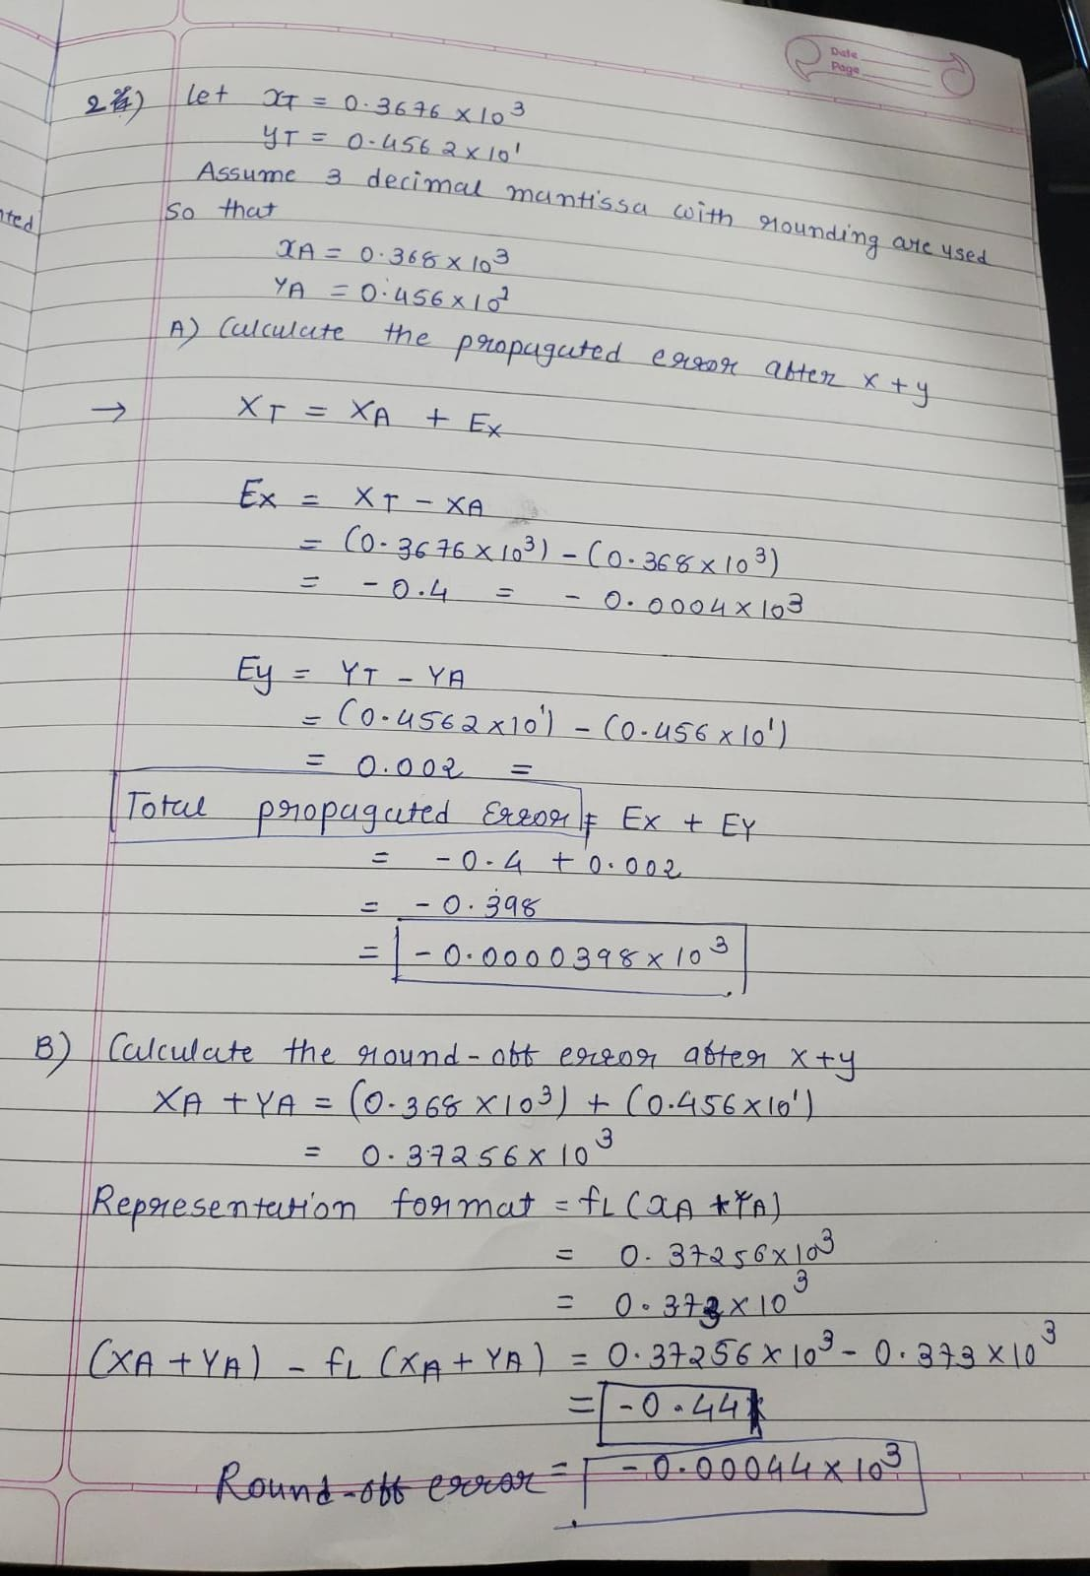
3)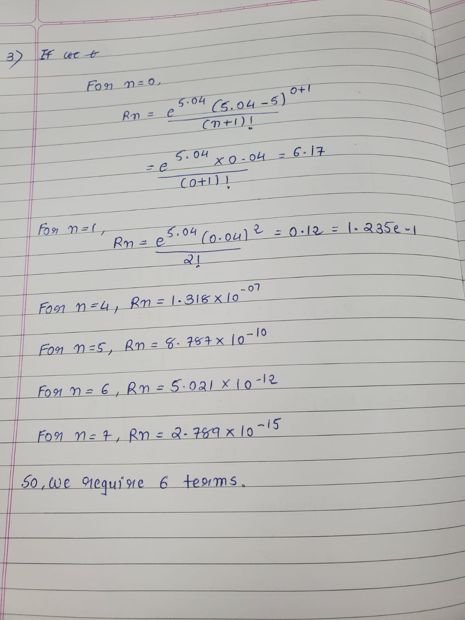

4) Solve the following system by using the Gauss-Jordan elimination method

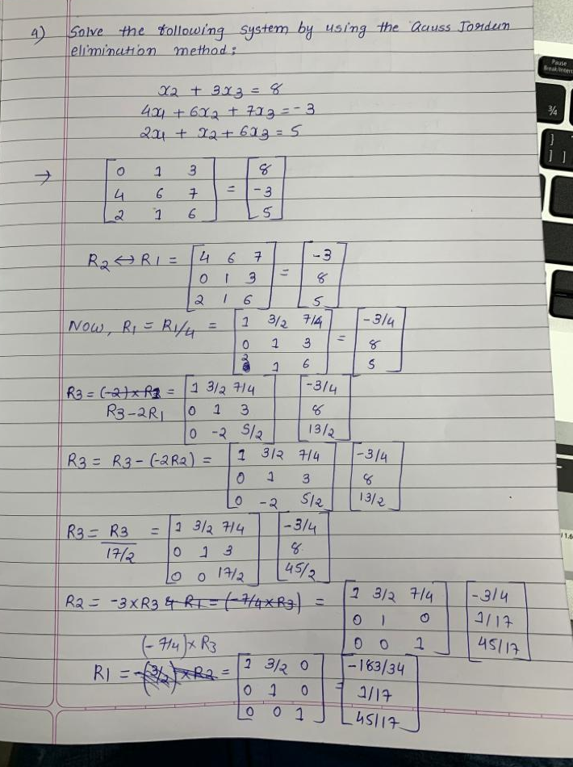
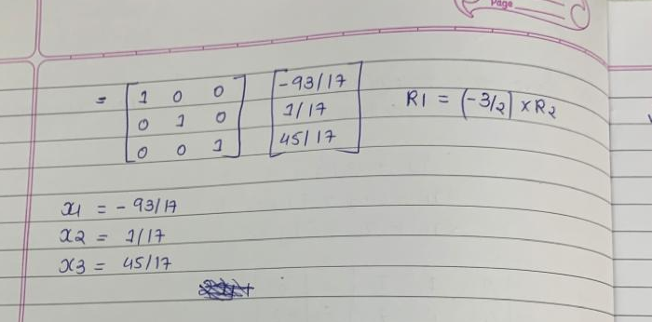

5) Solve the following system by using the Gauss-Jordan elimination method
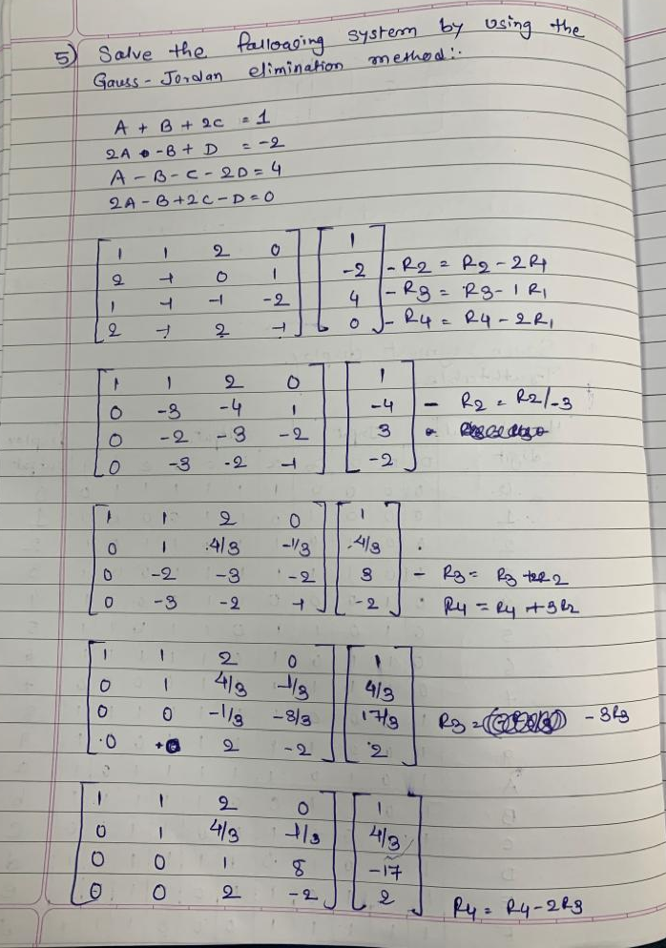
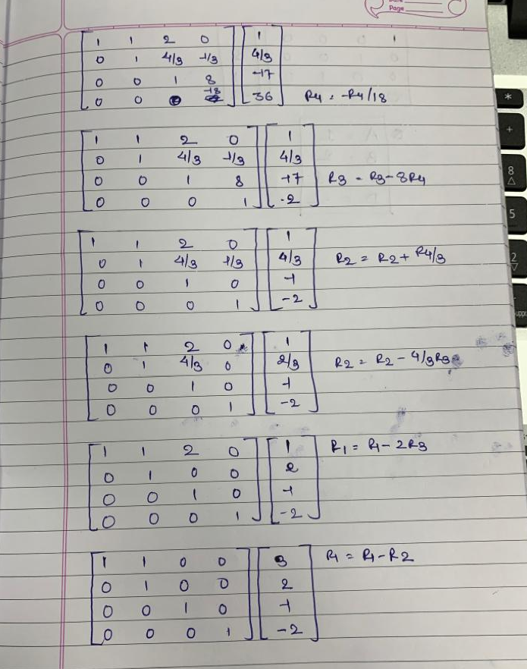
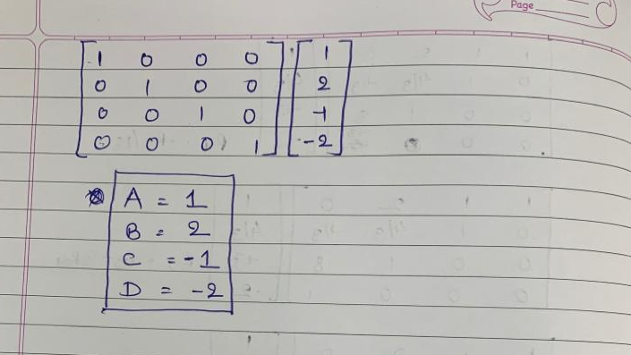

6) Use Gaussian elimination to solve the system of linear equations
