**LAB 1_PART-2**

**SUBMITTED BY**

**KUNJAL PATEL – 754858**

**PARTH PATEL- 754250**

**PART 2 (A)**

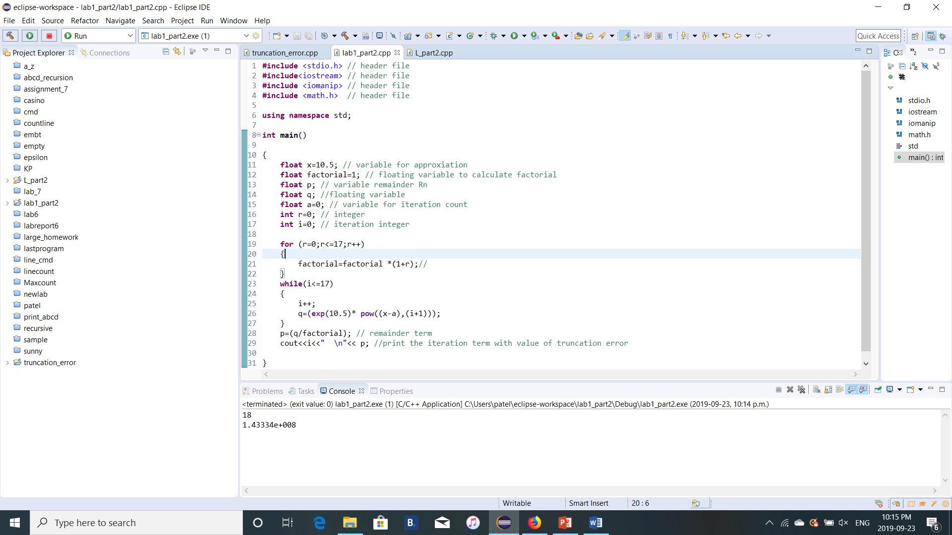

1. a=0;

truncation error= 1.43334e+008

**PART 2 (B)**

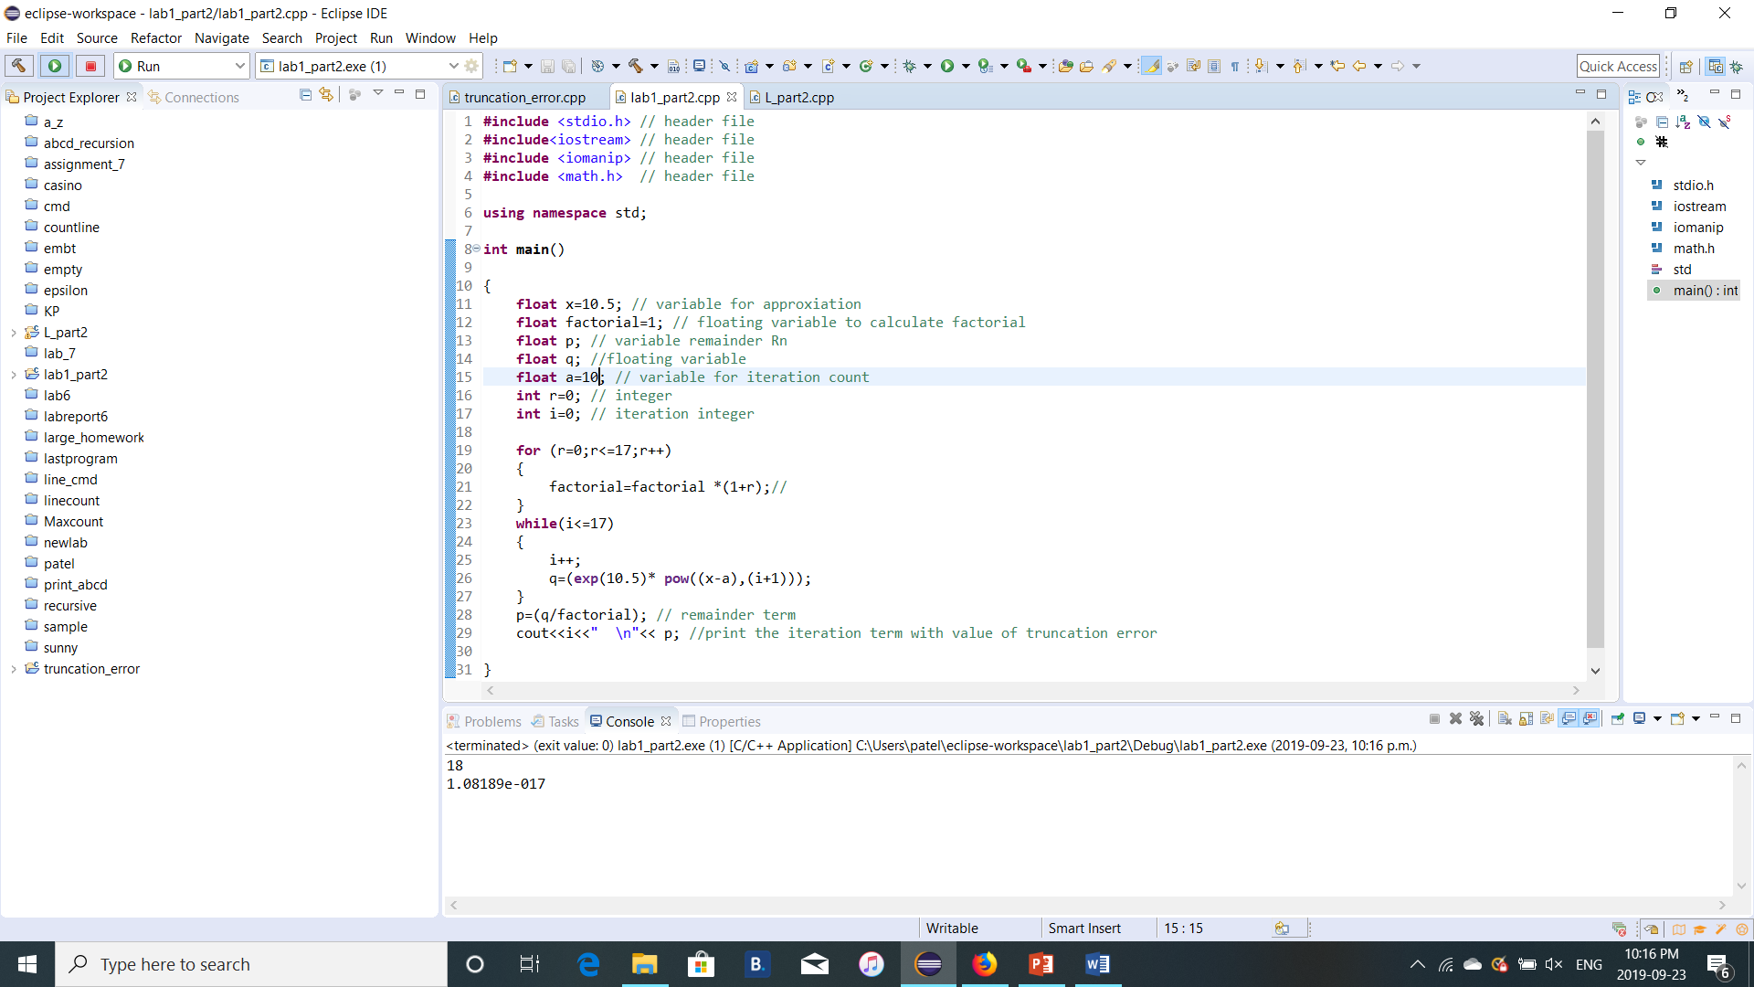

1. a= 10

Truncation error = 1.08189e-017

From this calculation we conclude that if we increase the number of iteration the truncation error will be decreases.

**LAB 1_PART-3**

