**Name: Bhavsar Dhwani**

**Student Id : 8867285**

**Date: 01/28/2024**

**Assignment 2**

# Subject: Computer and Application Security

**Task-1**

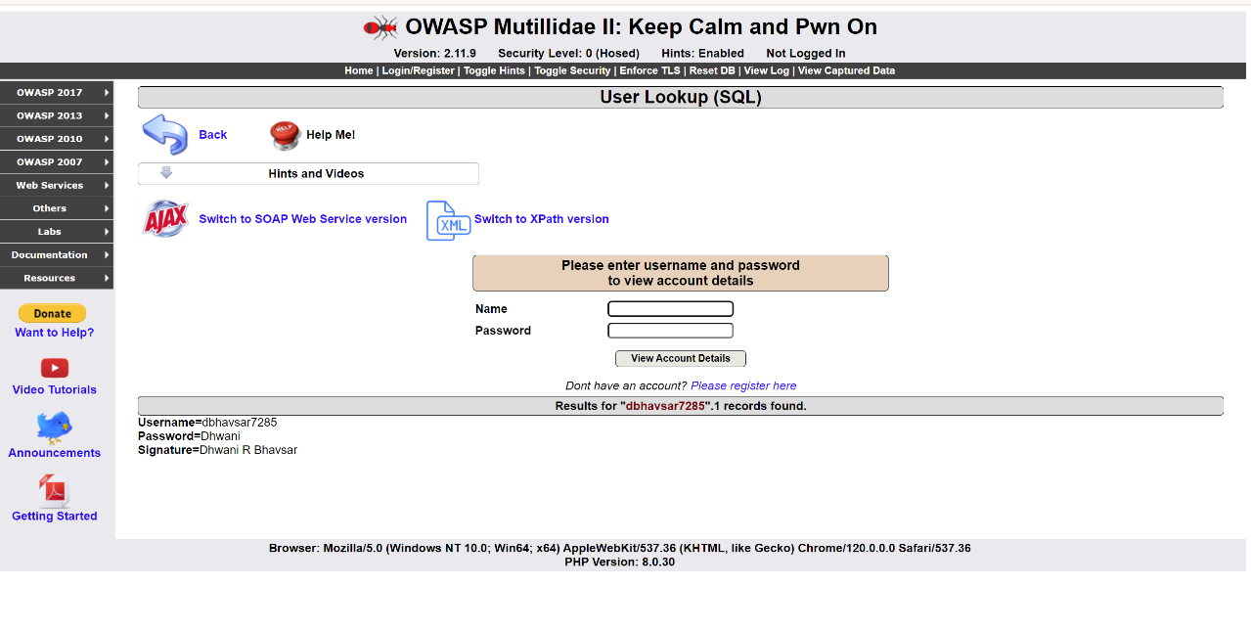

In mutillidae, user can register by entering username, password and signature and display details as shown in screenshot.

This screenshot shows that, wrong username is entered which displays an error message.

**Task-3**

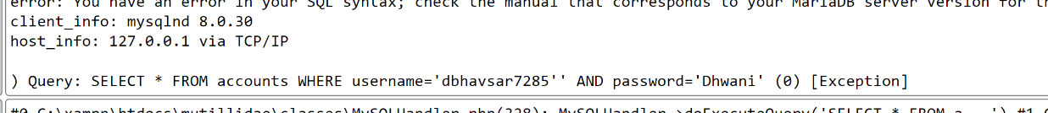

In this task, sql query is executed which is referenced by accounts table.

**Task-4**

There are total 26 records are displayed when I entered only “OR 1==1 -- ” username.

**Task-5**

When authorized user logged in, the user is authenticated and status is updated.

**Task - 6**

Reflections – provide your reflections in this section with regards to this exercise, namely:

* **What worked well for you**

This assignment is good source of information that provides me step by step guideline regarding OWASP mutillidae.

* **What didn’t work well and how you resolved the issue(s)**

For setup the OWASP mutillidae, there were some warnings and errors occurred. I resolved it by watching YouTube videos.

* **What is one thing that you were able to learn or accomplish through this Assignment that you did not know prior to starting.**

This assignment gave me opportunity to learn about OWASP mutillidae and work with it which was totally new for me.

* **What can be done to prevent such attacks from occurring?**

To prevent such attacks, there should be proper validation and user can only logged in after OTP verification.