Homework #2 – Twitter Service
Group:
Parth Patel
Shailen Sutradhar
Gautam Santhanu Thampy
Dev Patel
Class: CMPE272 Sec 03
Prof: Andrew Bond
Date: Feb 24th, 2025

Source code
The source code for this assignment is stored on GitHub.
GitHub: https://github.com/parthpatelsjsu/CMPE272-Mastodon

Unit Tests
Testing library: Vitest
Test cases: mastodon/src/App.test.tsx.
Created by: Parth Patel
There are several functions implemented in this assignment. There is one or more test cases created for each function to test the functionality. These test cases are stored at the path provided above.
Vitest was chosen because is a lightweight testing framework built specifically for projects using Vite, which was used to create and run this project.
There are a total of 7 test cases. They are as follows:
- Renders the app title
- Shows error when trying to create an empty post
- Shows error when trying to fetch a post without an ID
- Shows error when trying to delete a post without an ID
- Fetches post using GET operation when the fetch button is clicked
- Performs the create post operation when the create button is clicked
- Performs the delete operation when the delete button is clicked
The test cases are run using the CLI command “npx vitest” which runs the test cases as shown below
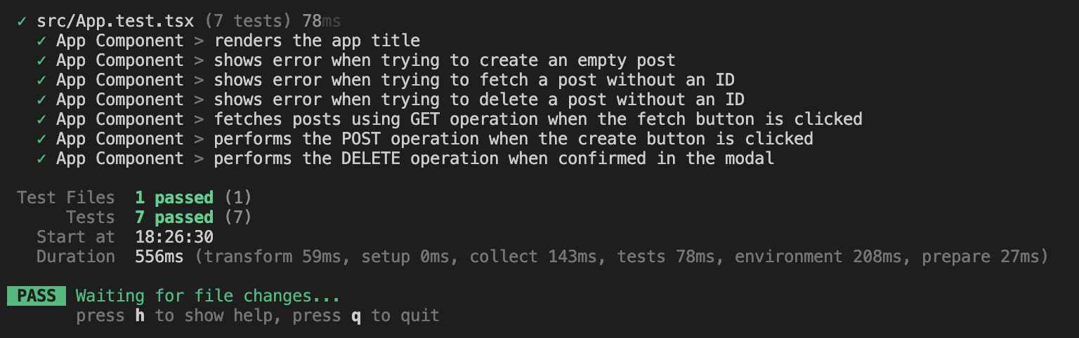

Web UI
The assignment has been made public in the GitHub repository and deployed to GitHub pages. It is connected to Mastodon server, so any API request will affect posts on the server.
Hosted on GitHub Pages: https://parthpatelsjsu.github.io/CMPE272-Mastodon/

UI Interaction

Creating a post
File: mastodon/src/App.tsx
Function: createPost()
Implemented by: Shailen Sutradhar
This function takes the contents of the text box as input. If the input contains any non-whitespace characters, a POST request containing the instance, authorization token, and content-type is assembled. The result is a post successfully being created in our Mastodon server, and success is displayed on the UI. If the input is invalid, or if the POST request fails for any reason, the failure along with a reason is displayed on the UI.
The walkthrough is as follows:
- Write the post in the textbox
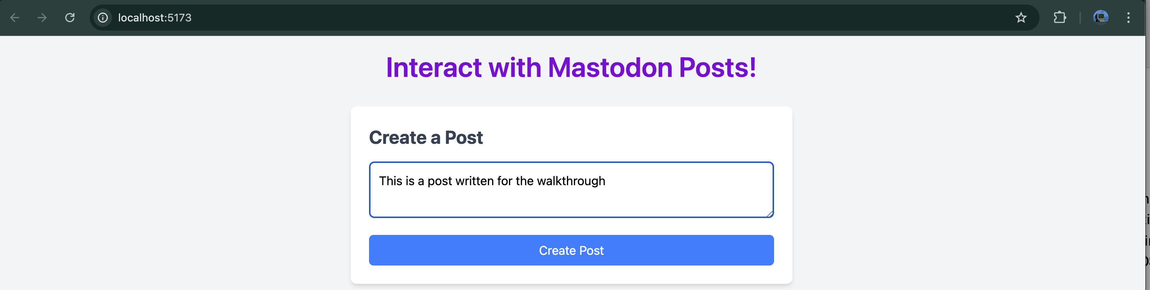
- Click create (image shows after click)
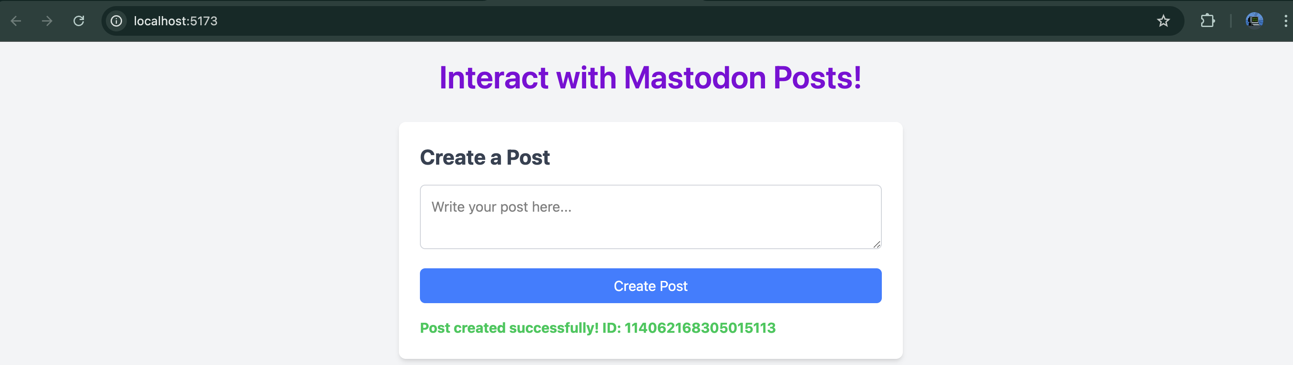
- Post shown on https://mstdn.plus/home
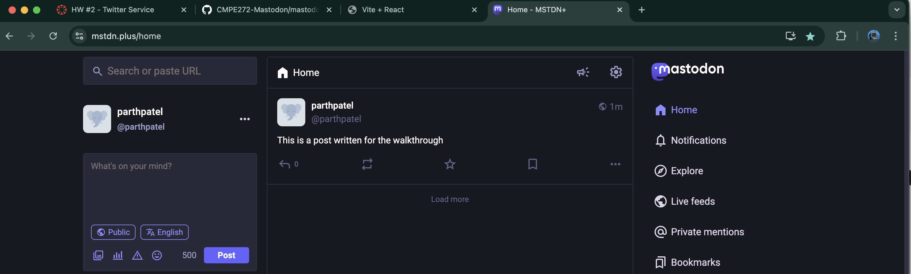

Fetching a Post
File: mastodon/src/App.tsx
Function: fetchPostById()
Implemented by: Dev Patel
This function takes the contents of fetch ID textbox as input. If the input is a valid ID of a post on our Mastodon server, it assembles a GET request containing the instance, post ID to be fetched, authorization token, and content-type. This request retrieves the post and displays the ID and content on the UI. If the ID is invalid or the GET request fails, a failure message and reason is posted on the UI.
The walkthrough is as follows:
- Provide an ID of a post in the textbox
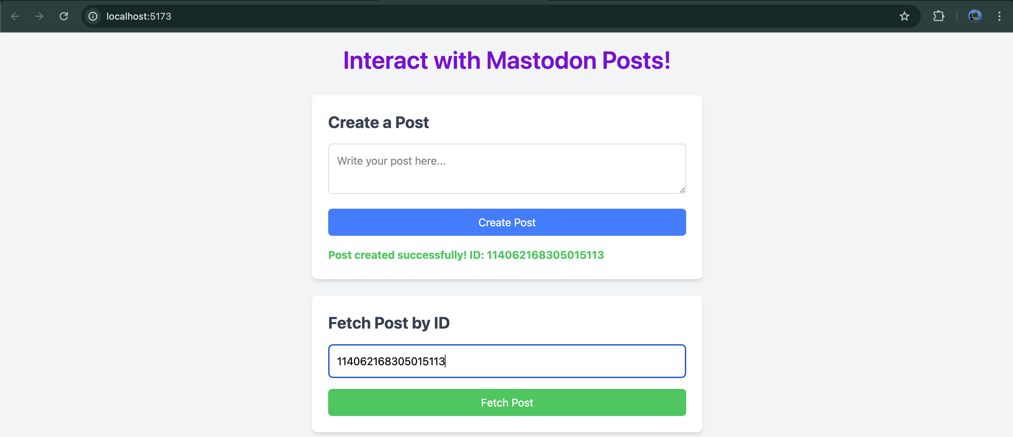
- Click “Fetch Post” button to see the post
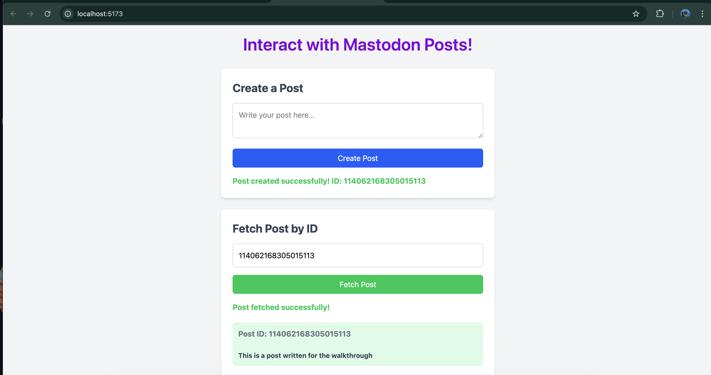

Deleting a Post
File: mastodon/src/App.tsx
Functions: handleConfirmDelete(), handleDeleteClick()
Implemented by: Gautam Santhanu Thampy
This function also takes the contents of the ID textbox as input. When the delete button is clicked, the handleDeleteClick() function is called which displays a modal modal prompting the user to confirm. When the user confirms the delete, the handleConfirmDelete() function is called which performs the delete operation. If the input is a valid ID of a post on the Mastodon server, this function assembles a DELETE request containing the Mastodon instance address, post ID to be deleted, authorization token, and content-type. This request deletes the post which the ID corresponds in our server and displays a success message on the UI. If the ID is invalid or doesn’t exist, an failure message is displayed on the UI.
The walkthrough is as follows:
- Provide an ID that you want to delete:
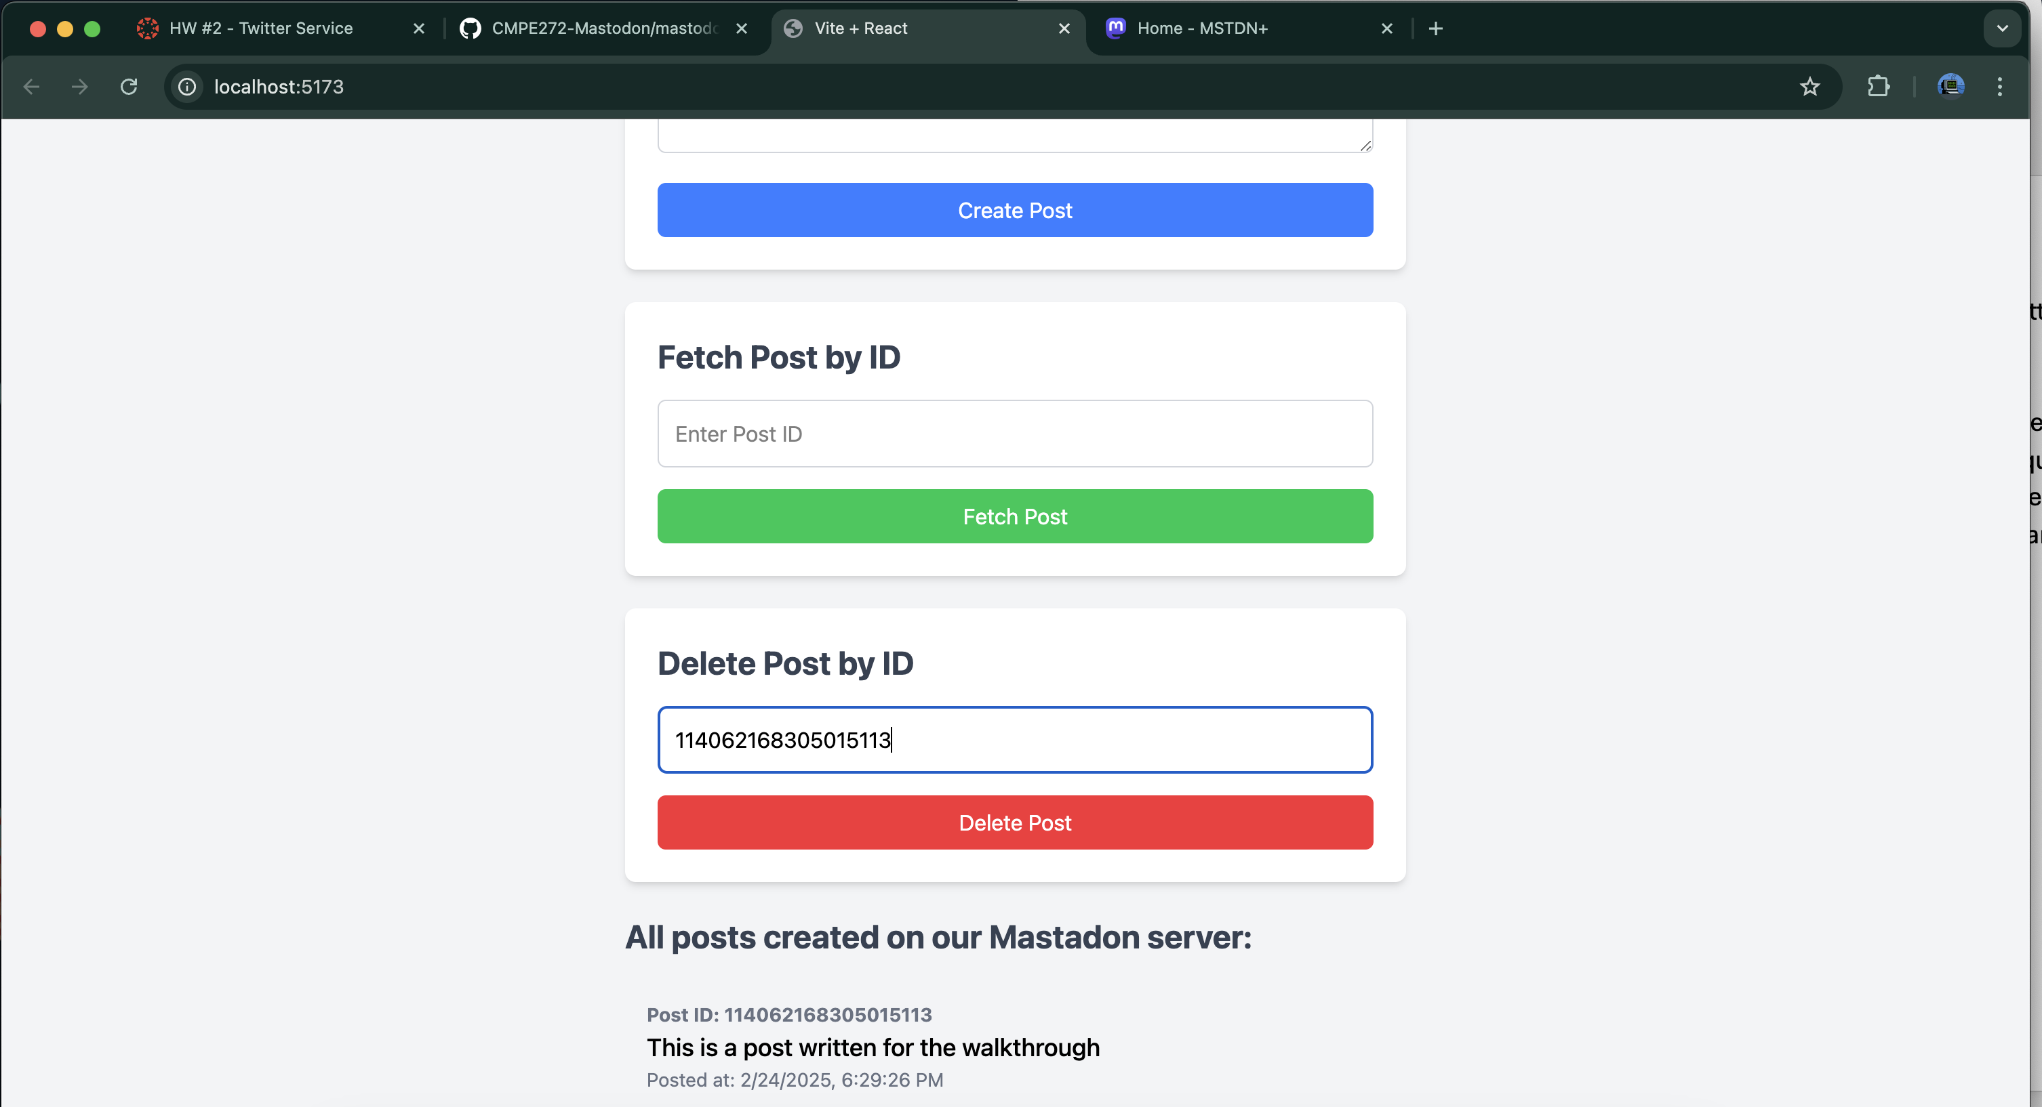
- Click Yes, delete to confirm
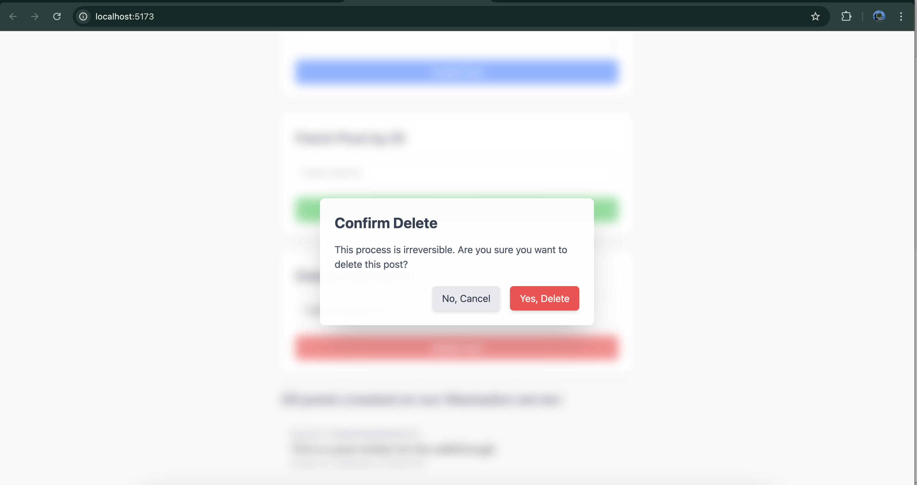
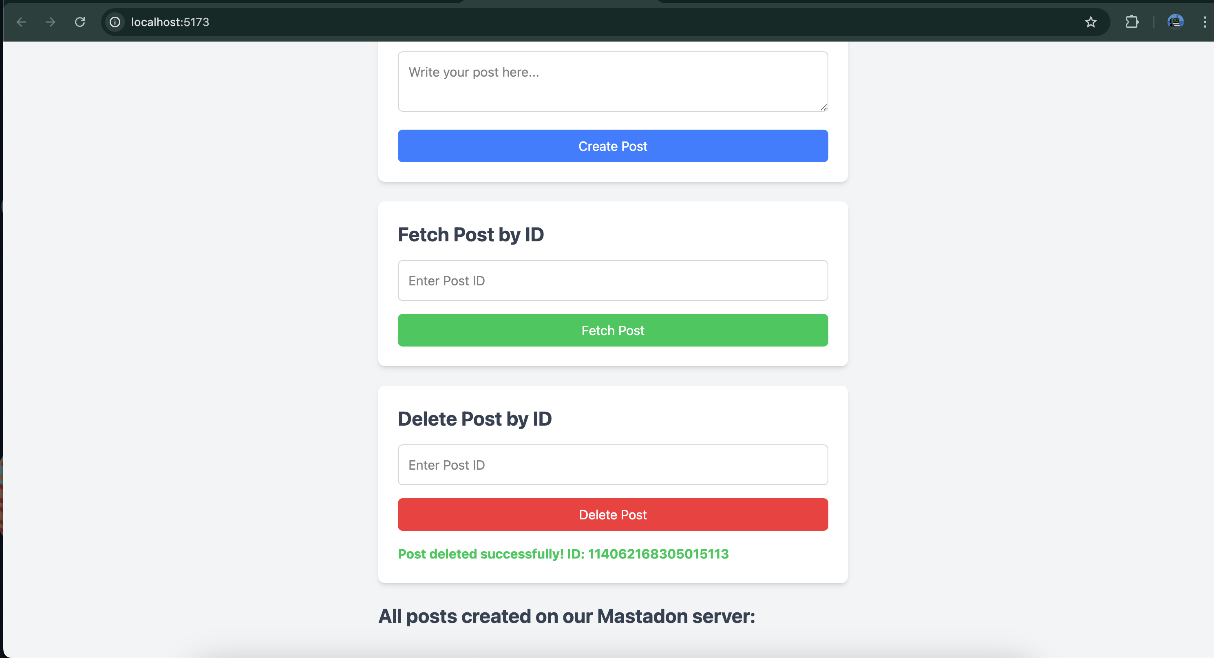
- Confirm it has been removed on the server
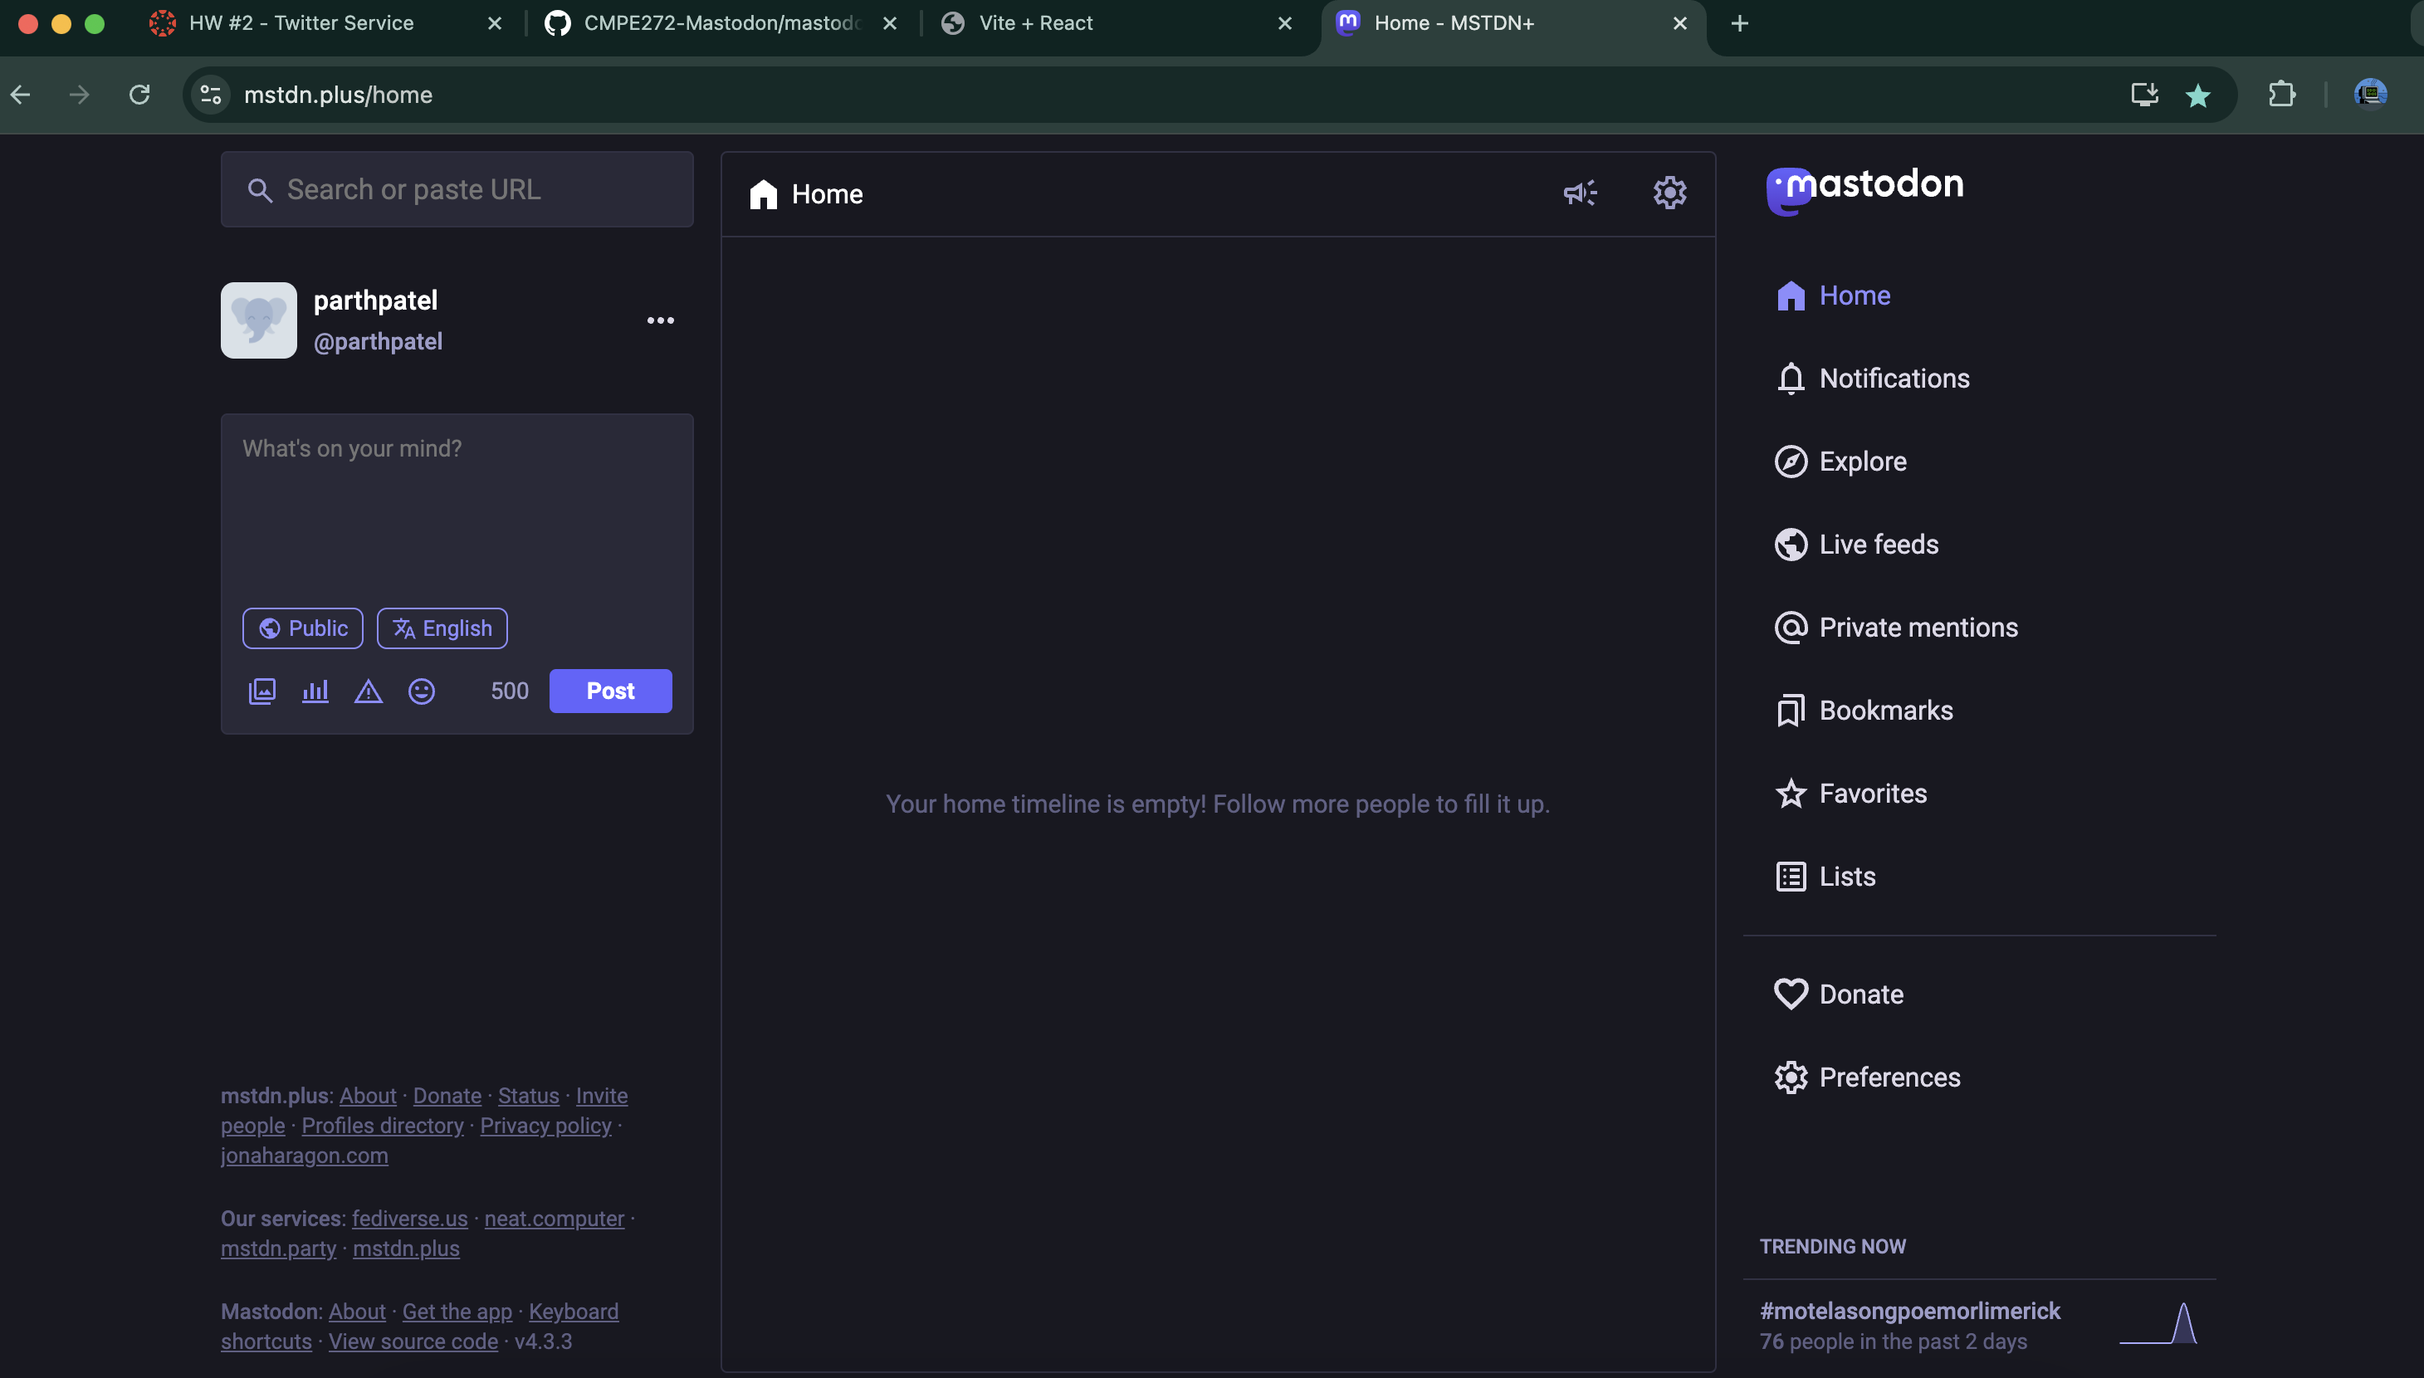

Fetch All Posts
File: mastodon/src/App.tsx
Function: fetchAllPosts()
Implemented by: Parth Patel
Since we cannot share access to the Mastodon server directly, all the posts created are shown below. The function that performs this task is fetchAllPosts().
Suppose 3 posts are created, this section would look like the following:Í
