🌾 Sugarcane Products & Supplies Admin Panel – Component Breakdown
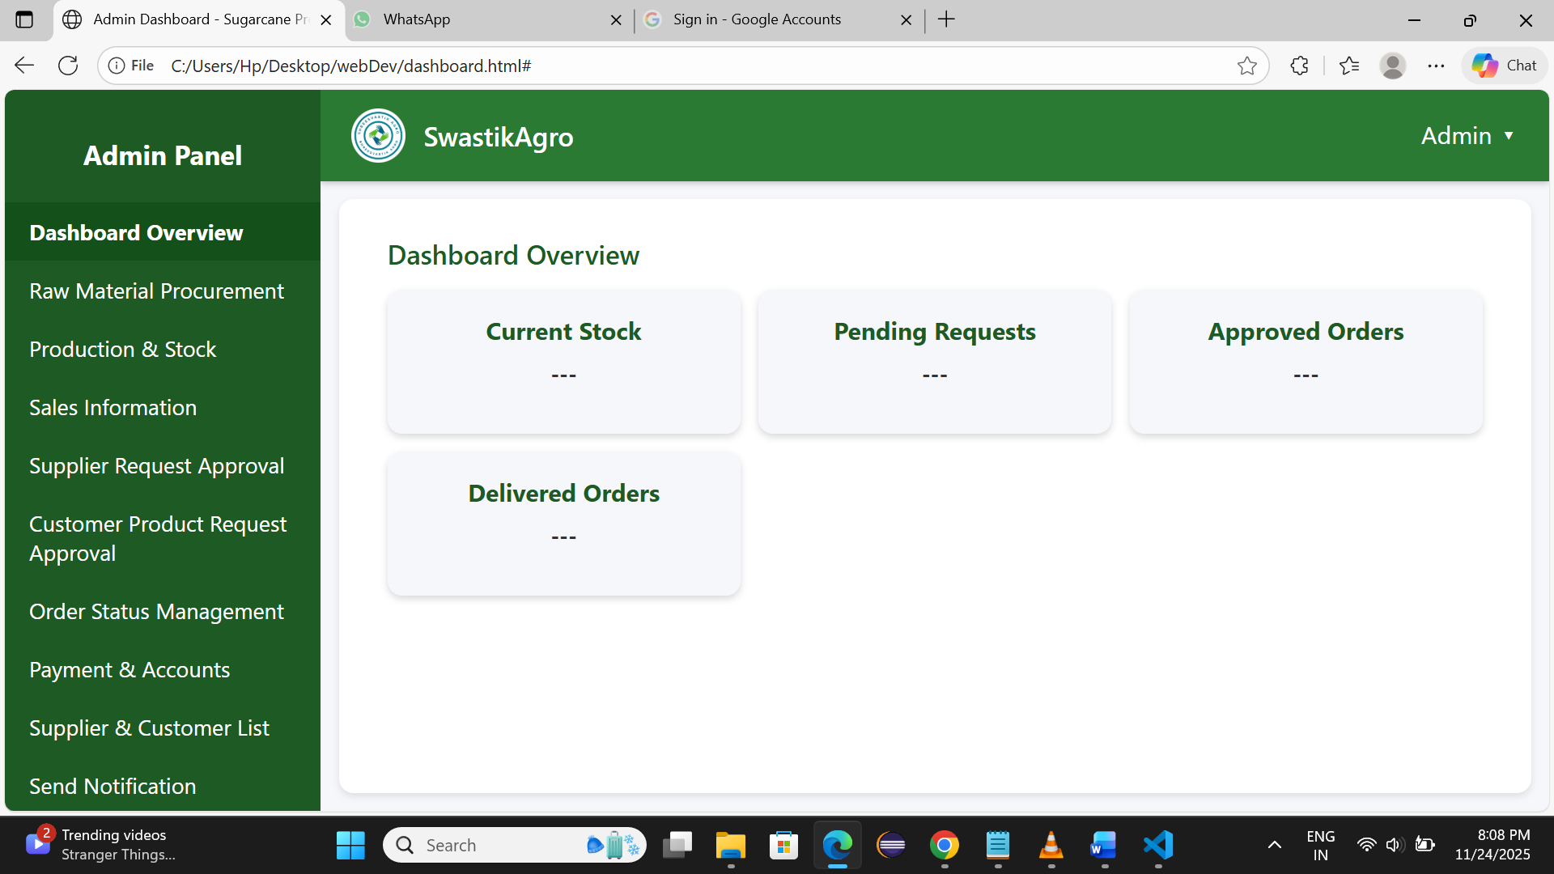

1️⃣ Raw Material Procurement Component
Purpose:
Manage raw sugarcane procurement from suppliers/farmers and store in database.

UI Sections:
• Add Procurement Entry Form
• Procurement History Table
• Supplier Search Input Bar

Fields / Inputs:
• Supplier Name – Search dropdown
• Date – Date picker
• Quantity (kg/tons) – Input number
• Price per unit – Auto-fetch / manual
• Total Amount – Auto-calculated

Operations:
• Add procurement entry
• Fetch & display historical procurement list
• Edit / update entry (optional)

Output:
Stores to Firebase → procurement collection

2️⃣ Production & Stock Component
Purpose:
Record production output, calculate stock levels, update product data for Android app.

UI Sections:
• Production Entry Form
• Stock Overview Dashboard
• Edit Product Info Panel

Fields:
• Raw material used – Input number
• Output produced – Number
• Date – Date
• Product Name – Text
• Price – Number
• Description – Text area

Operations:
• Add production entry → update stock
• Show available stock count (real-time Firebase)
• Edit product details

3️⃣ Sales Component
Purpose:
Admin adds completed sales entries & view sales history.

UI Sections:
• Sales Completion Form
• Sales History Table

Fields:
• Customer Name – Text
• Product – Dropdown
• Quantity – Number
• Total Amount – Auto / manual
• Phone Number – Numeric
• Address – Text
• Status – Completed

Operations:
• Add completed sales records
• View sales history
• Filter by customer / date

4️⃣ Supplier / Farmer Request Approval Component
Purpose:
Approve or reject supplier registration requests.

UI Sections:
• Pending Request List
• Request Details View
• Approval / Rejection Buttons

Fields shown:
• Supplier name – Ram Patil
• Product – Sugarcane
• Field address – Village, Taluka, District
• Farm area – Acres
• Growth months – 10 months

Operations:
• Approve request → send notification
• Reject request
• Send visit date notification

5️⃣ Customer Product Request Approval Component
Purpose:
Approve/reject product order requests from customers before processing.

UI Sections:
• Request Table View
• Request Detail Modal

Fields:
• Customer name – Text
• Product – Text
• Quality – Standard / premium
• Price – Number
• Phone – Number
• Address – Text

Operations:
• Approve order
• Reject order

6️⃣ Order Status Management Component
Purpose:
Track delivery progress and maintain delivery logs.

UI Sections:
• Orders Status Table – All orders status
• Search Bar – Search by ID / phone / name
• Delivery History – Completed orders

Fields:
• Order ID
• Customer name
• Product
• Status (dropdown)

Status Flow:
Pending → Approved → Out for Delivery → Delivered → Cancelled

Operations:
• Update delivery status
• View full order details
• View delivery logs
• Search order

7️⃣ Payment & Accounts Component
Purpose:
Manage payment settlements to farmers/suppliers for procurement.

Fields:
• Supplier Name – From procurement table
• Quantity supplied – Display
• Amount payable – Display
• Status – Pending / Paid
• Payment date – Date

Operations:
• View pending & completed payments
• Generate / send payment info notification

8️⃣ Supplier & Customer List Component
Purpose:
Manage all registered accounts.

UI Sections:
• Supplier Table
• Customer Table
• Search filter

Fields:
Supplier:
• Name
• Phone
• Address
• Payment status

Customer:
• Name
• Phone
• Address
• Purchase history

Operations:
• View list
• Delete record

9️⃣ Send Notification Component
Purpose:
Send push notifications to farmers/customers.

UI Sections:
• Create Notification Form
• Notification History Table

Fields:
• Send to – Dropdown (All / Supplier / Customer / Single)
• Message – Text area
• Date – Auto

Operations:
• Send notification
• View notification history

Final Sidebar Navigation Menu (Admin Panel Nav Flow):
• Dashboard
• Raw Material Procurement
• Production & Stock
• Sales
• Supplier Request Approval
• Customer Request Approval
• Order Status Management
• Payments & Accounts
• Suppliers / Customers
• Send Notification
• Logout

