|  |
| --- |
| MARATHWADA MITRA MANDAL’S  **COLLEGE OF COMMERCE**  A  PROJECT REPORT ON  **eDriveCare**  **Submitted in partial fulfillment of the requirements**  **For the award of the Degree of**  **BACHELOR OF BUSINESS ADMINISTRATION (COMPUTER APPLICATIONS)**  **Under Guidance of Prof. Vishakha Wagh**    **Submitted by:**  **Tanmay Khade**  **Viraj Sathe**  **SAVITRIBAI PHULE PUNE UNIVERSITY**  **In the academic year (2024-2025)**    **MARATHWADA MITRA MANDAL’S**  **COLLEGE OF COMMERCE**  **Affiliated to Savitribai Phule Pune University, Re-Accredited by NAAC with “A” Grade**  **ISO 9001:2015 Certified, Awarded as Best College by Savitribai Phule Pune University**  **202/A, Deccan Gymkhana, Pune – 411004**  [**principal@mmcc.edu.in**](mailto:principal@mmcc.edu.in)**,** [**enquiry@mmcc.edu.in**](mailto:enquiry@mmcc.edu.in)**,** [**www.mmcc.edu.in**](http://www.mmcc.edu.in/)  **CERTIFICATE**  **(TO WHOMSOEVER IT MAY CONCERN)**  **This is to certify that the following students**  **Tanmay Khade**  **Viraj Sathe**  **Have completed the project entitled**  **eDriveCare**  **In a particular fulfillment for the award of**  **BACHELOR OF BUSINESS ADMINISTRATION (COMPUTER APPLICATIONS)**  **UNIVERSITY OF PUNE**  **In the academic year 2024-2025**  **This work has been carried out by then under my supervision and Guidance**  **Prof. Vishakha Wagh**  **Submitted by:**  **Tanmay Khade**  **Viraj Sathe**      **Prof. Vishakha Wagh Prof.Nidhi Satavalekar Dr.Ganesh Patare**  **(Guide) (Principal)(I/C) External Examiner (HOD)**  **ACKNOWLEGDEMNET**  We would like to express our deepest and most sincere gratitude to all the individuals and institutions who have supported us throughout the development of our project “**eDriveCare** ”.  We are especially thankful to our project guide **Prof. Vishakha Wagh**, whose expert guidance, constructive feedback, and unwavering encouragement have played a pivotal role in shaping our project. Her exceptional leadership, vast knowledge, and insightful suggestions have not only enhanced our technical skills but have also inspired us to strive for excellence.  We are also deeply indebted to our Head of Department **Prof. Nidhi Satavlekar**, for her guidance, support, and recommendations. We would also like to express our sincere appreciation to our Principal **Dr. Ganesh Patare**, for providing us with the necessary resources, infrastructure, and support to complete our project.  Furthermore, we would like to thank our college for providing us with the necessary facilities, support, and encouragement to complete our project. We appreciate the support and guidance provided by the college administration, which have enabled us to successfully complete and implement our project. |

|  |
| --- |
| **A** |

|  |  |
| --- | --- |
| Description | Page NO |
| Introduction, Motivations | 1 |
| Goals and objective of the system, Literature Survey | 2 |
| Project Scope, Limitations | 3 |
| Entity Relationship Diagram | 4 |
| Data Flow Diagram (DFD) Level 0 | 5 |
| Data Flow Diagram (DFD) Level 1 | 6 |
| Table | 7,8,9 |
| I/O Screens | 10,11,12,13,14,15 |
| Scope of Electric Scooter Service And Maintenance Platform | 16 |
| Conclusion, Bibliography | 17 |



**Introduction:** As the world shifts towards sustainable and eco-friendly transportation, electric vehicles (EVs) have emerged as a viable alternative to traditional internal combustion engine vehicles. However, the adoption of EVs brings with it a new set of challenges and opportunities, particularly in the realm of servicing and maintenance. The Electric Vehicle Servicing and Maintenance Portal is designed to address these challenges by providing a comprehensive platform that connects EV owners with service providers, spare parts suppliers, and subscription management services. This portal aims to streamline the entire service process, ensuring that EV owners have easy access to reliable and efficient maintenance solutions.

**Motivation:** The motivation behind the development of the Electric Vehicle Servicing and Maintenance Portal stems from the growing need for specialized service centers in the city of Pune. Pune, being a rapidly developing urban center, has seen a significant increase in the number of electric vehicles on its roads. However, the city lacks an adequate number of service centers equipped to handle the unique requirements of EVs. This scarcity of service centers often leads to long waiting times, inconvenience, and subpar maintenance for EV owners. By creating a dedicated portal, we aim to bridge this gap and provide a seamless and efficient solution for EV servicing and maintenance needs.

**Goals and Objectives of the System:** The primary goal of the Electric Vehicle Servicing and Maintenance Portal is to create a user-friendly and efficient platform that caters to the diverse needs of EV owners. The objectives of the system include:

* Providing a centralized platform for booking and managing service appointments.
* Facilitating the procurement of genuine spare parts through an integrated spare parts store.
* Ensuring secure and efficient payment processing for services and parts.
* Offering subscription-based services for regular maintenance and exclusive offers.

**Literature Survey:** The concept of an online portal for vehicle servicing and maintenance is not entirely new. Several studies have highlighted the benefits of digital platforms in enhancing service efficiency, customer satisfaction, and operational transparency. For instance, research on automotive service portals has shown that customers value the convenience of online booking, real-time updates, and transparent pricing. Moreover, the integration of AI and data analytics in these portals has the potential to predict maintenance needs, optimize inventory management, and personalize service offerings. Our literature survey indicates a growing trend towards digital transformation in the automotive service industry, with a specific emphasis on electric vehicles due to their distinct maintenance requirements.

**Project Scope:** The scope of the Electric Vehicle Servicing and Maintenance Portal encompasses several key components. These include user management, service booking, spare parts procurement, payment processing, subscription management, and administrative functions. The portal will cater to individual EV owners as well as fleet operators, offering tailored solutions for both segments. Additionally, the project scope extends to integrating advanced features such as predictive maintenance, AI-driven diagnostics, and real-time service tracking. The development and deployment of this portal will involve collaboration with service centers, parts suppliers, and payment gateway providers to ensure a seamless and comprehensive user experience.

**Limitations:** While the Electric Vehicle Servicing and Maintenance Portal aims to provide a robust solution, it is not without its limitations. One of the primary challenges is the initial setup and integration with existing service centers and suppliers, which may require significant time and resources. Additionally, the portal's effectiveness is contingent on the reliability and availability of the service providers and parts suppliers. Any disruptions in these areas could impact the overall user experience. Furthermore, the portal must continuously adapt to the evolving landscape of electric vehicle technology and customer expectations, necessitating ongoing updates and enhancements.

* Entity Relationship Diagram:

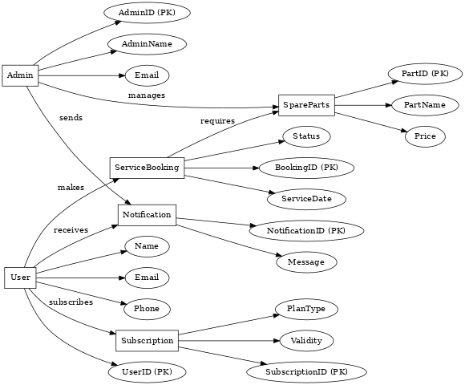

* Data Flow Diagram(DFD) Level 0:

Admin

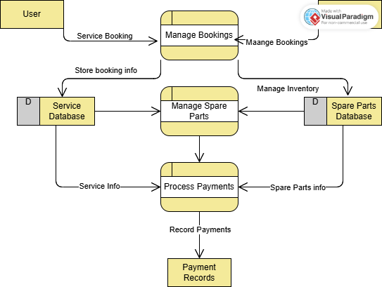

* Data Flow Diagram(DFD) Level 1:

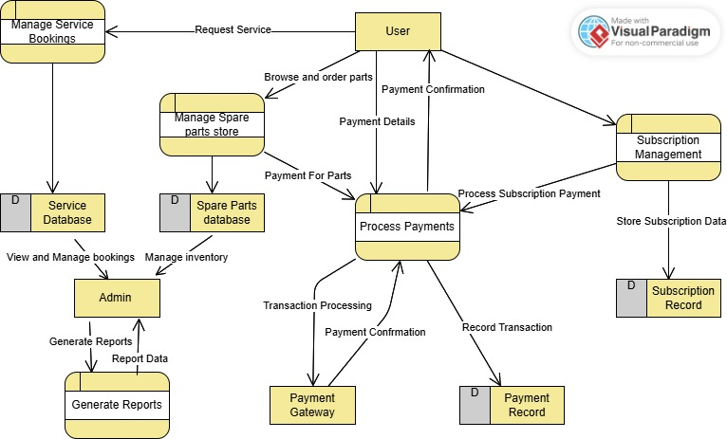

* TABLE

|  |  |  |  |  |
| --- | --- | --- | --- | --- |
| Entity Name | Attribute Name | Data Type | Description | Constraints |
| User | User_ID | Integer | Unique identifier for each user | Primary Key, Auto-increment |
|  | Name | Varchar(100) | Full name of the user | Not Null |
|  | Email | Varchar(100) | User’s email address | Unique, Not Null |
|  | Phone_Number | Varchar(15) | User’s contact number | Not Null |
|  | Address | Varchar(255) | User’s residential address | Optional |
|  | Password | Varchar(255) | User’s account password | Not Null |
| Service Booking | Booking_ID | Integer | Unique identifier for each service booking | Primary Key, Auto-increment |
|  | User_ID | Integer | Refers to the user making the booking | Foreign Key (User) |
|  | Scooter_Model | Varchar(50) | Model of the electric scooter | Not Null |
|  | Service_Date | Date | Scheduled date for service | Not Null |
|  | Service_Status | Varchar(20) | Current status of the booking (Pending, Completed) | Default: 'Pending' |
| Service Records | Record_ID | Integer | Unique identifier for each service record | Primary Key, Auto-increment |
|  | Booking_ID | Integer | Refers to the related service booking | Foreign Key (Service Booking) |
|  | Service_Details | Text | Details of the service provided | Not Null |
|  | Service_Cost | Decimal(10,2) | Total cost for the service | Not Null |
| Spare Parts Inventory | Part_ID | Integer | Unique identifier for each spare part | Primary Key, Auto-increment |
|  | Part_Name | Varchar(100) | Name of the spare part | Not Null |
|  | Part_Description | Text | Description of the spare part | Optional |
|  | Price | Decimal(10,2) | Price of the spare part | Not Null |
|  | Stock_Quantity | Integer | Number of available items in stock | Default: 0 |
| Subscription Plans | Plan_ID | Integer | Unique identifier for each subscription plan | Primary Key, Auto-increment |
|  | Plan_Name | Varchar(100) | Name of the subscription plan | Not Null |
|  | Plan_Details | Text | Description and benefits of the plan | Not Null |
|  | Plan_Price | Decimal(10,2) | Price of the subscription plan | Not Null |
|  | Duration_Months | Integer | Duration of the subscription in months | Not Null |
| Notifications | Notification_ID | Integer | Unique identifier for each notification | Primary Key, Auto-increment |
|  | User_ID | Integer | Refers to the user receiving the notification | Foreign Key (User) |
|  | Notification_Text | Text | Content of the notification | Not Null |
|  | Date_Sent | DateTime | Date and time when the notification was sent | Default: CURRENT_TIMESTAMP |
| Admin | Admin_ID | Integer | Unique identifier for each admin | Primary Key, Auto-increment |
|  | Admin_Name | Varchar(100) | Name of the admin | Not Null |
|  | Email | Varchar(100) | Admin’s email address | Unique, Not Null |
|  | Role | Varchar(50) | Role of the admin (e.g., Super Admin, Manager) | Not Null |

* I/O SCREENS:
* Home Page:

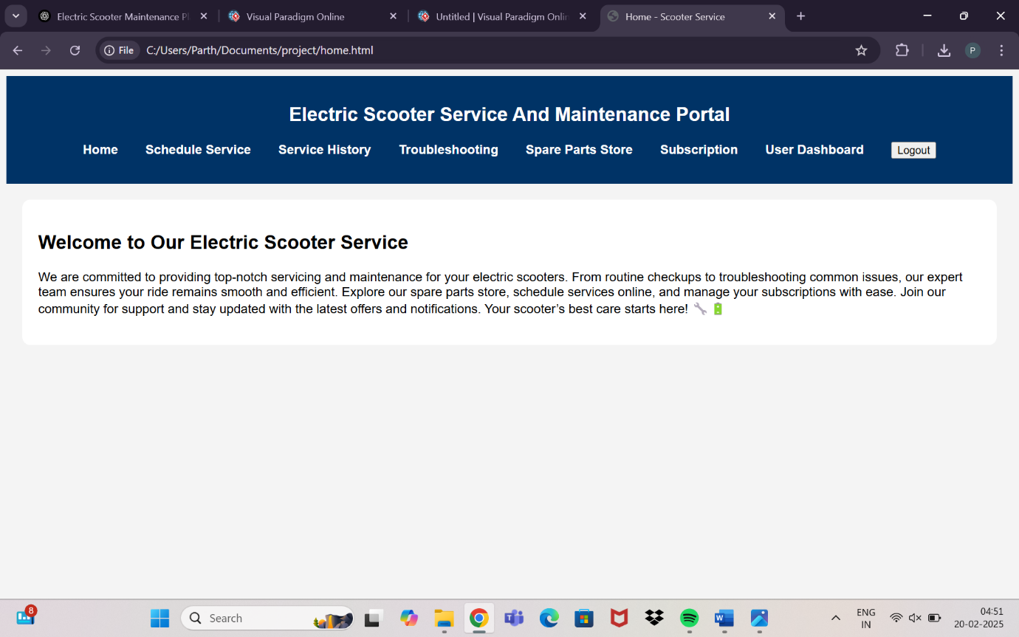

* Scheduling Page :

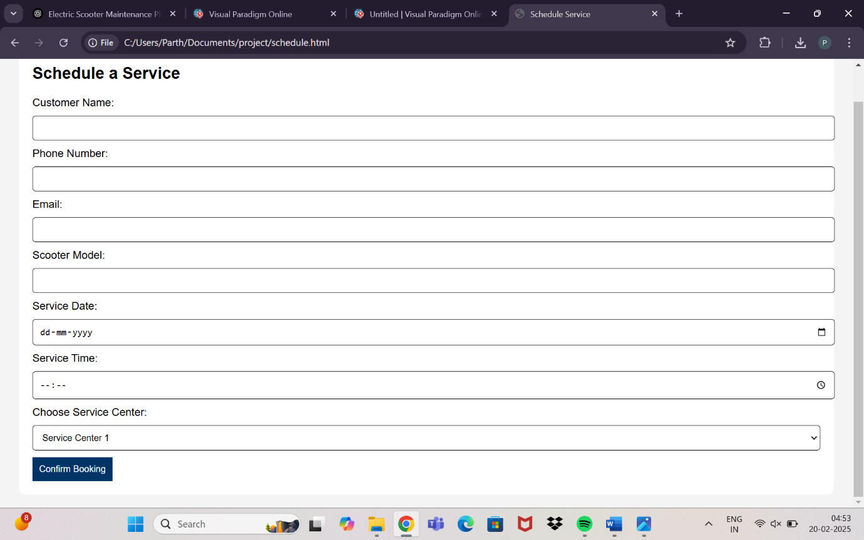

* Service History Tracking Page:

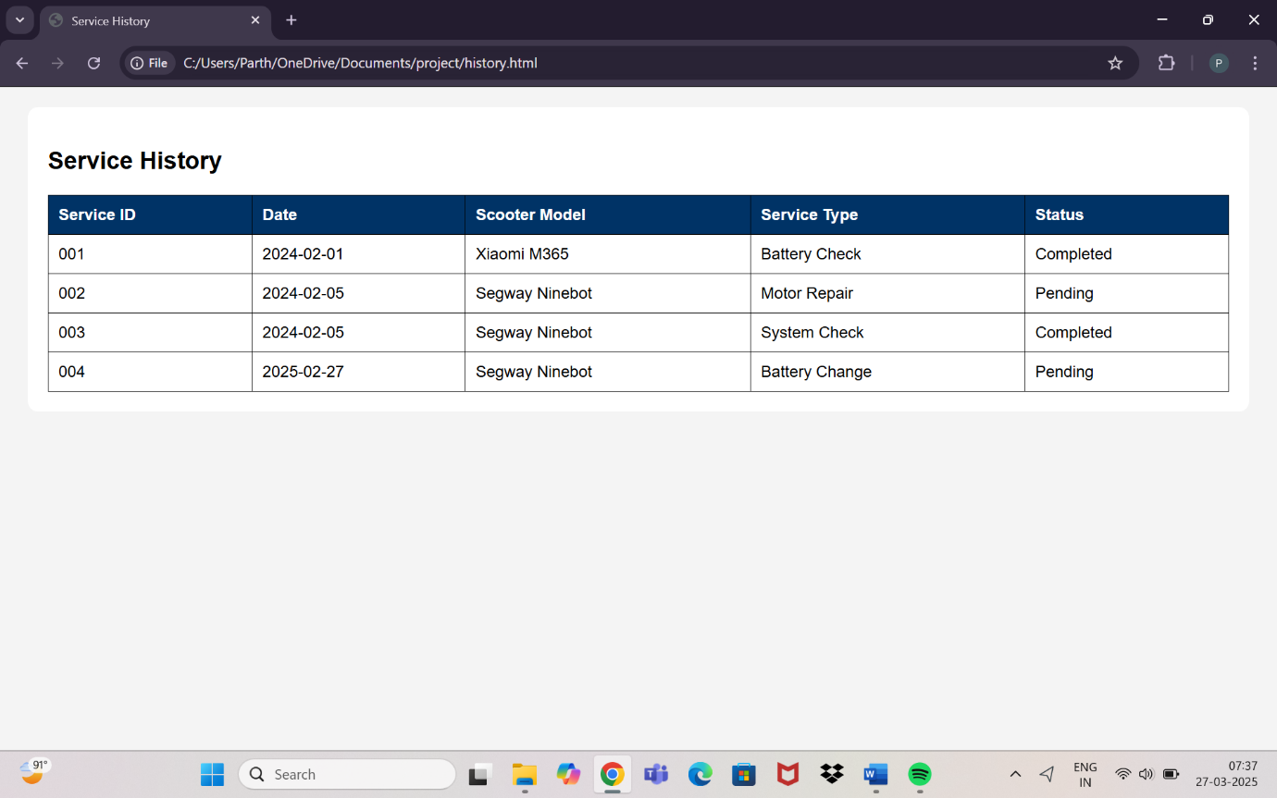

* Troubleshooting Guide Page:

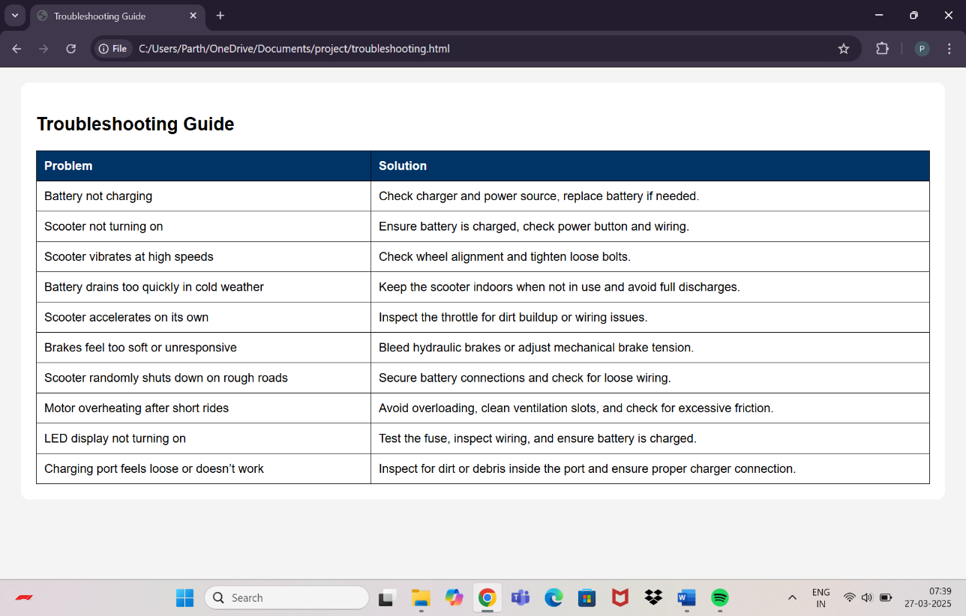

* Spare Parts Store Page:

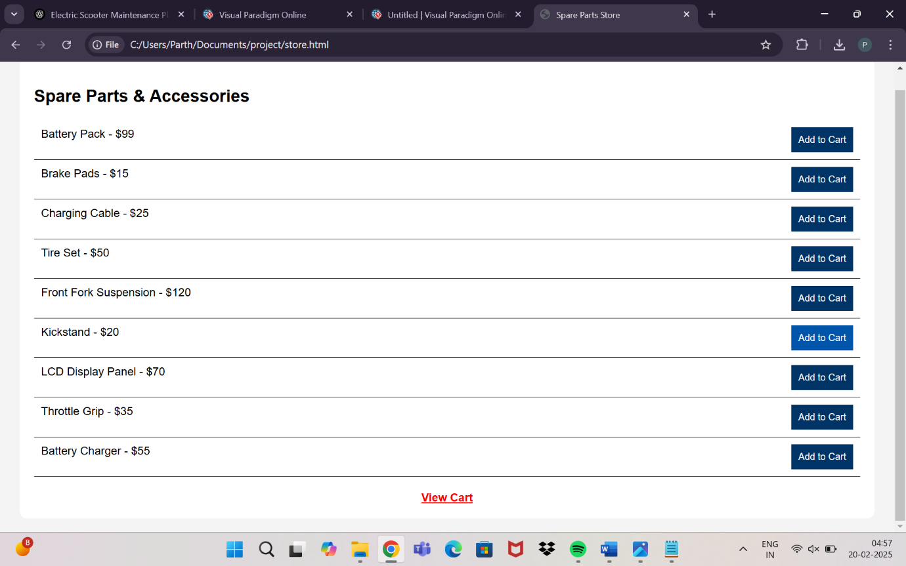

* Viewing Cart Page:

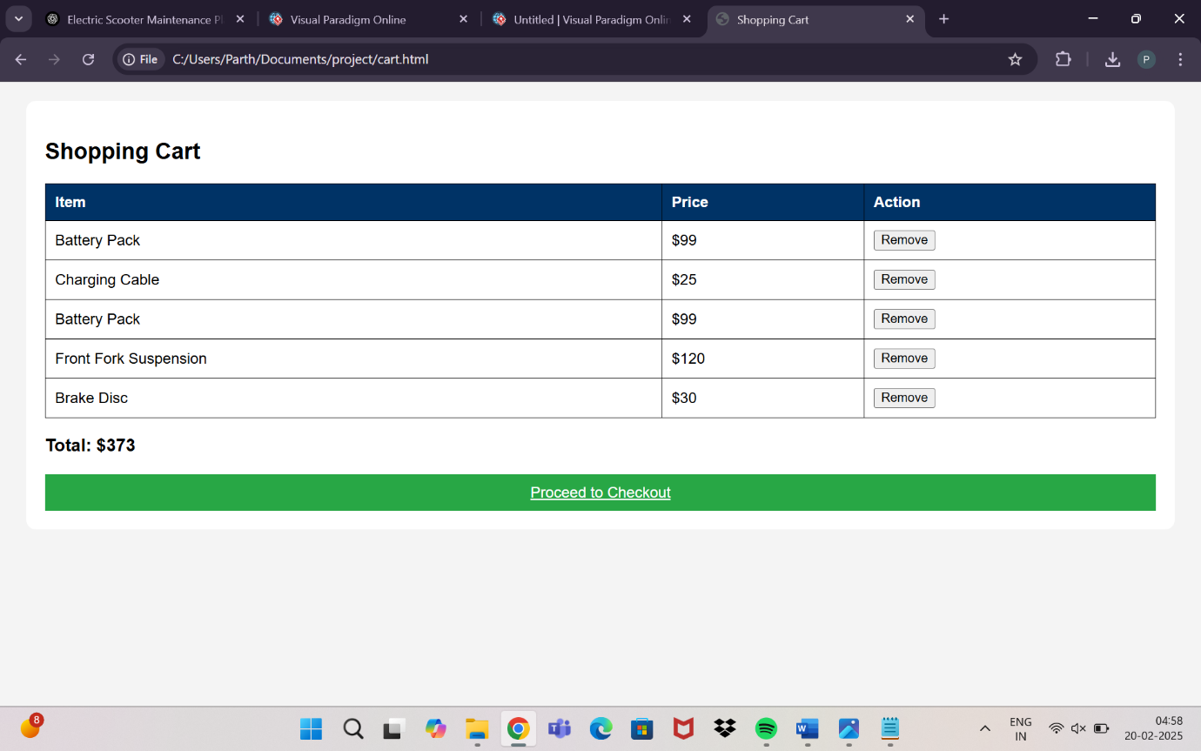

* Checkout Page:

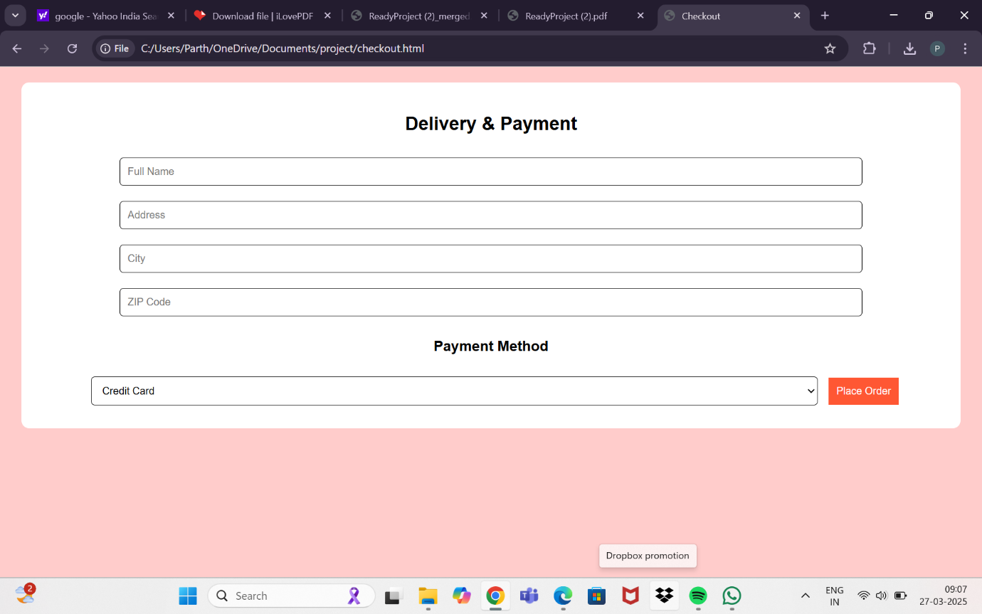

* Subscription Plans Page:

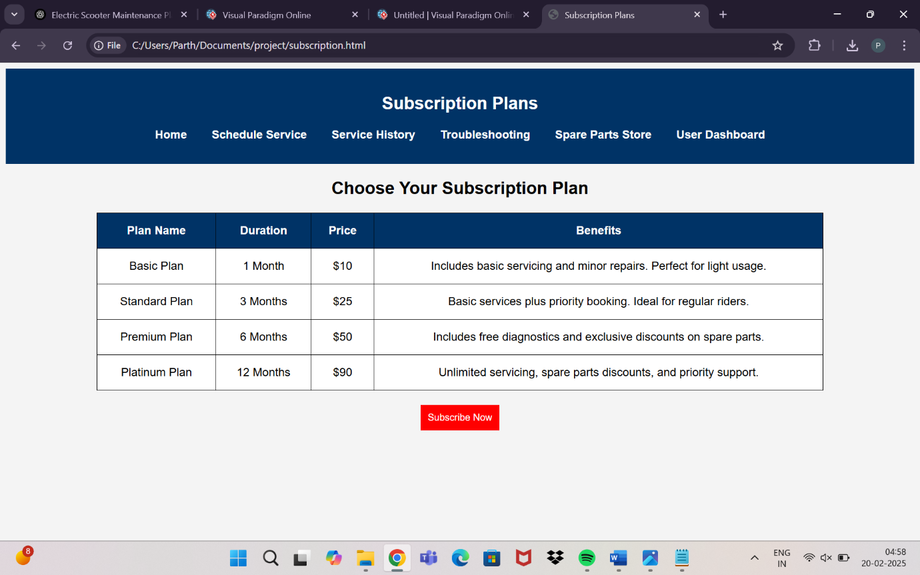

* Payment Portal For Subscription Page:

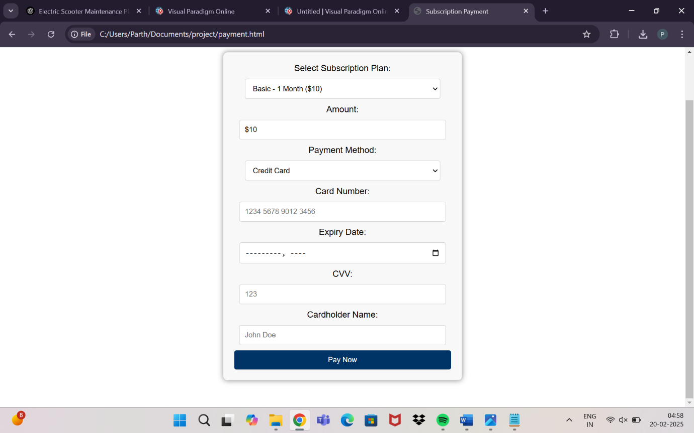

* User Dashboard Page:

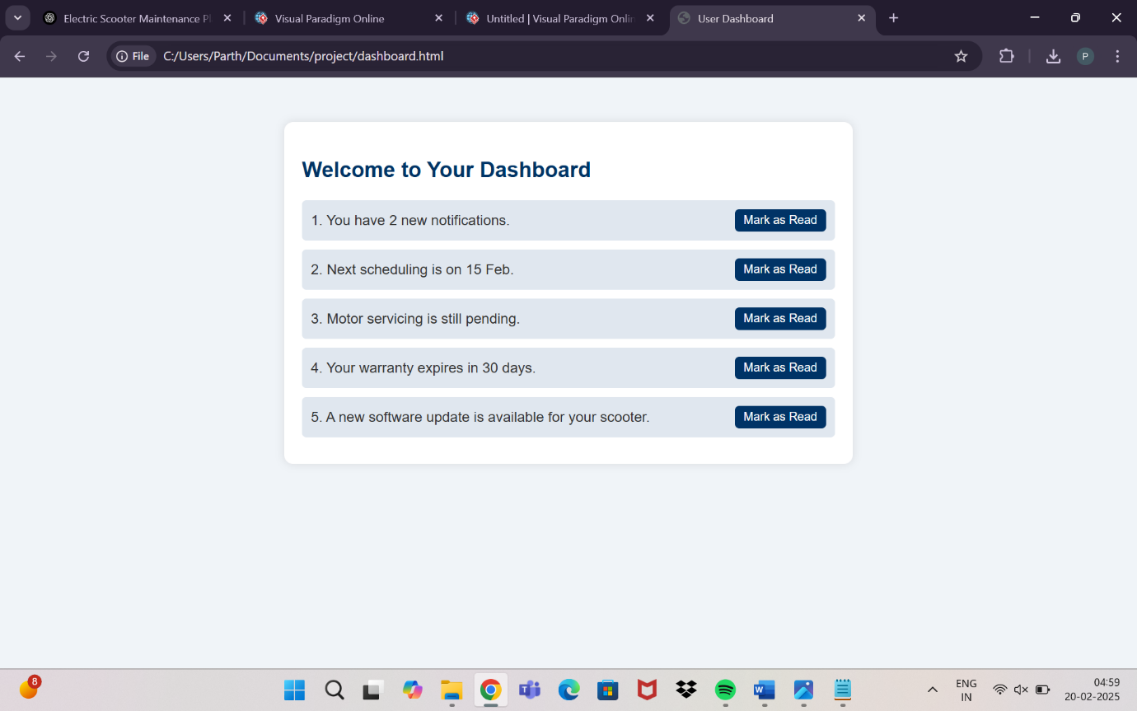

**Future Scope of Electric Scooter Service and Maintenance Platform:-**

The future scope of an Electric Scooter Service and Maintenance Platform is promising, driven by the increasing adoption of electric mobility worldwide. As electric scooters become a popular mode of transportation due to their eco-friendliness, affordability, and convenience, the demand for reliable servicing and maintenance platforms will grow significantly. One major avenue for future development is the integration of **IoT (Internet Things)** technology, allowing real-time diagnostics, predictive maintenance alerts, and seamless scheduling based on usage patterns. Incorporating **AI-powered troubleshooting** and **chatbots** can enhance user experience by offering instant support and personalized recommendations. The platform could expand its offerings by collaborating with manufacturers for **original spare parts** and launching **on-demand maintenance subscriptions**, providing comprehensive care plans for scooters. Additionally, with the rise of **sustainability initiatives**, offering **battery recycling services** and promoting **eco-friendly spare parts** can align the platform with global environmental goals. **Blockchain integration** for secure payment gateways and transparent service records could also be explored, ensuring data privacy and trustworthiness. In the future, expanding to **B2B services** by partnering with electric scooter rental companies for fleet management and maintenance could open new revenue streams. service centers and **mobile servicing units** could enhance accessibility and convenience, positioning the platform as a on

**Conclusion:-**

In conclusion, the Electric Scooter Service and Maintenance Platform holds immense potential in the evolving landscape of sustainable urban mobility. By embracing advanced technologies, ensuring user-centric services, and aligning with environmental sustainability, the platform can become a critical enabler for the widespread adoption of electric scooters. With continuous innovation and customer-focused enhancements, this platform is poised to shape the future of electric scooter ownership and contribute significantly to smarter, greener transportation solutions.

--------------------------------------------------------------------------------------------

Bibliography:-

1)[Redefine Your Journey | dashmoto®](https://dashmoto.us/blog/technology-shaping-electric-scooters?utm_source=chatgpt.com)

2)[Inc42](https://inc42.com/resources/implication-of-ai-and-iot-enabled-electric-scooters-for-smart-delivery-services/?utm_source=chatgpt.com)

3)[Data Science Society](https://www.datasciencesociety.net/future-of-urban-mobility-8-ai-trends-shaping-three-wheel-electric-scooters/?utm_source=chatgpt.com)

4)[urbantransportgroup.org](https://www.urbantransportgroup.org/system/files/general-docs/The%20future%20of%20e-scooters%20final.pdf?utm_source=chatgpt.com)

___________________________________________________________________________

|  |  |
| --- | --- |
| Description | Page NO |
| Introduction, Motivations | 1 |
| Goals and objective of the system, Literature Survey | 2 |
| Project Scope, Limitations | 3 |
| Entity Relationship Diagram | 4 |
| Data Flow Diagram (DFD) Level 0 | 5 |
| Data Flow Diagram (DFD) Level 1 | 6 |
| Table | 7,8,9 |
| I/O Screens | 10,11,12,13,14,15 |
| Scope of Electric Scooter Service And Maintenance Platform | 16 |
| Conclusion, Bibliography | 17 |