DEPARTMENT OF COMPUTER SCIENCE AND ENGINEERING
School of Technology, Nirma University

Innovative Assignment

1. Project Title
Natural Language-to-Code Compiler (NL2Code) with Structured Intermediate Representation (IR), Static AST Validation, and Diagnostic Self-Repair Loop

2. Student Details
Sr. No. | Student name | Roll number
1 | [Student Name] | [Roll Number]
2 | Individual Project | N/A

PROJECT OVERVIEW AND COMPILER CONCEPTS

3. Project Overview
Describe the problem, the intended users and the purpose of your tool. Explain what it accepts as input, what it produces as output and how it relates to Compiler Design.
Traditional code generation tools and unverified Large Language Model (LLM) wrappers treat program synthesis as a one-shot probabilistic text generation task. Consequently, they frequently emit syntactically invalid programs, hallucinate non-existent standard library methods, violate type invariants, and produce code that fails runtime assertions.
The NL2Code Compiler re-engineers this paradigm by adopting a formal, multi-stage Compiler Design architecture. Rather than emitting unvalidated code directly, NL2Code decomposes the natural language compilation task into a six-stage compiler pipeline: (1) Front-End Intent Parsing and Lexical Tokenization, (2) Middle-End Intermediate Representation (IR) Construction with Pydantic type schema validation, (3) Back-End Language Code Generation, (4) Static Abstract Syntax Tree (AST) & Lint Validation, (5) Sandboxed Dynamic Execution against auto-generated unit test suites, and (6) an Automated Diagnostic Self-Repair Loop. The system accepts natural English algorithm specifications and emits verified, runnable source code across Python, C++, Java, and JavaScript accompanied by empirical unit-test proofs and theoretical asymptotic complexity guarantees.

4. Objectives of the Project
State clear, achievable objectives. Each objective should describe something implemented or demonstrated by the project.
1. Multi-Stage Compiler Pipeline: Design and construct an end-to-end compiler pipeline that decomposes informal natural language input into formal, strongly typed program representations and multi-language target source code.
2. Strict Intermediate Representation (IR): Formulate a machine-independent JSON Intermediate Representation (IR) capturing function identifiers, input parameter types, return signatures, algorithmic constraints, edge cases, theoretical asymptotic complexity targets, and comprehensive unit test specifications.
3. Multi-Target Language Synthesis: Implement an extensible LanguageAdapter architecture providing semantic code emission and idiomatic unit test harness generation for Python, C++, Java, and JavaScript.
4. Static AST Analysis & Security Policy Enforcement: Integrate static syntax analysis (using Python ast.parse, Node.js check, GCC/G++ AST rules) and lexical security filters rejecting dangerous system calls (os.system, subprocess).
5. Isolated Sandbox Execution: Establish a secure runtime environment enforcing strict memory bounds (256 MB), execution time limits (5.0 seconds), and network isolation to verify program correctness against synthesized test suites.
6. Diagnostic Self-Repair Loop: Engineer an automated compiler error recovery mechanism that intercepts static compilation diagnostics and failed unit test assertions, iteratively repairing defective code within 3 attempts.

5. Compiler Design Concepts Used
List only the concepts actually implemented. For each one, explain where and how it appears in your project.
Examples: lexical analysis, regular expressions, finite automata, symbol tables, context-free grammars, parsing, syntax/abstract syntax trees, semantic analysis, intermediate code generation, optimization, code generation and error handling.
Concept | How it is implemented | Where it is demonstrated
Lexical Analysis & Intent Tokenization | Scans unstructured natural language to extract keywords, numeric parameters, data type signatures, and boundary condition tokens. | Module: intent_parser.py (IntentParseResult model; token regex and classification)
Abstract Syntax Tree (AST) Parsing & Context-Free Grammars | Parses synthesized target code into concrete ASTs to verify context-free grammar compliance prior to execution, catching syntax errors. | Module: validator.py & PythonAdapter (ast.parse, syntax error line/column diagnostic extraction)
Machine-Independent Intermediate Representation (IR) | Transforms source intent into a canonical, language-agnostic Intermediate Representation with formal type and constraint schemas. | Module: ir_builder.py & models/ir.py (IntermediateRepresentation Pydantic v2 schema)
Semantic Analysis & Type Checking | Validates type consistency between IR specifications, function signatures, and parameter passing across Python, C++, Java, and JS. | Module: languages/base.py & LanguageAdapter subclasses (format_signature, type mapping)
Target Code Generation / Synthesis | Translates IR semantic trees into idiomatic target source code adhering to language-specific standard libraries and idioms. | Module: code_generator.py (Backend code synthesis for Python, C++, Java, JS)
Runtime Environment & Sandbox Execution | Executes synthesized code within an isolated runtime environment with memory caps (256 MB), CPU limits, and zero network access. | Module: sandbox.py (Test harness injection, execution under time caps, result extraction)
Error Diagnosis & Compiler Self-Repair Loop | Implements compiler panic recovery by capturing diagnostics and test failure diffs, feeding them back into the synthesis engine. | Module: repair_loop.py (run_repair_loop iterative feedback, 3-attempt recovery)

Mention relevant token patterns, grammar productions, data structures or intermediate representations where applicable. Add details in Sections 8 and 9.

SYSTEM DESIGN AND IMPLEMENTATION

6. Proposed / Implemented System
Describe the actual implemented workflow: Input → Processing → Output. Insert a flowchart, block diagram or architecture diagram, with clearly labelled components and arrows.
+--------------------------------------------------------------------------------------------------+
| NL2CODE COMPILER PIPELINE ARCHITECTURE |
+--------------------------------------------------------------------------------------------------+
| [Stage 1] Natural Language Input |
| | |
| v |
| [Stage 2] Intent Parser (Front-End Token & Constraint Analysis) |
| | |
| v |
| [Stage 3] IR Builder (Canonical Intermediate Representation: Types, Constraints, Test Suite) |
| | |
| v |
| [Stage 4] Code Synthesizer (LanguageAdapter: Python / C++ / Java / JavaScript) |
| | |
| v |
| [Stage 5] Static AST Validator (ast.parse / node --check / g++ / Security Policy Filter) |
| | | |
| [Valid AST] [Syntax Error] |
| | | |
| v v |
| [Stage 6] Isolated Sandbox Executor +-----------------------------------------+ |
| | (Memory Cap: 256MB, Timeout: 5s) | Diagnostic Self-Repair Feedback Loop | |
| | | (Feeds error diagnostics & assertions | |
| [Assertion Failure] -------------------------> | back to Synthesizer; max 3 attempts) | |
| | +-----------------------------------------+ |
| [All Tests Passed] ^ |
| | | (Regenerates Code) |
| v | |
| [Stage 7] Verified Output & Telemetry (Monaco Editor UI, Asynchronous SSE Streaming, SQLite DB) |
+--------------------------------------------------------------------------------------------------+

Workflow and Data Flow Movement:
1. Input Ingestion: The user inputs an informal English specification (e.g., 'Write a function that returns the k most frequent elements in an array') and selects a target language.
2. Intent Analysis: The Intent Parser scans the input, extracting functional requirements, input variables, return types, mathematical constraints, and boundary edge cases into an IntentParseResult.
3. Canonical IR Synthesis: The IR Builder compiles the intent into a machine-independent JSON Intermediate Representation (IR). It synthesizes 3+ rigorous unit test cases covering nominal and boundary conditions, while establishing asymptotic time and space complexity targets.
4. Target Code Generation: The LanguageAdapter synthesizes idiomatic target code conforming strictly to the IR signature, parameter names, and return types.
5. Static AST Validation: Before executing untrusted code, the Validator analyzes the syntax tree (ast.parse for Python, syntax checks for C++/Java/JS) and validates that no forbidden system calls (os.system, subprocess) are present.
6. Dynamic Sandbox Verification: The Sandbox Executor wraps the code into a test harness script and runs it in an isolated container/subprocess with a 5.0s timeout and 256MB memory cap. Results are parsed from stdout/stderr.
7. Diagnostic Feedback & Self-Repair: If static validation or sandbox unit tests fail, the Repair Loop intercepts compiler error lines and failing assertions, feeding them back to the synthesizer to generate corrected code (up to 3 iterations).
8. Output & Persistence: The verified code, IR schema, test execution telemetry, and attempt history are streamed to the frontend via Server-Sent Events (SSE) and persisted in SQLite.

7. Tools and Technologies Used
Component | Tool / technology and version
Programming language | Python 3.13.1 (Backend), TypeScript 5.2 & JavaScript ES2022 (Frontend)
Compiler / IDE | Antigravity IDE, Python 3.13, GCC/G++ 17, OpenJDK 17, Node.js v24.9
Lexical / parser tools | Python ast module (AST parser), Pydantic v2 (JSON IR schema validator), Node.js --check
Libraries / frameworks | FastAPI 0.110+, SQLAlchemy 2.0+, sse-starlette, React 18, Vite 5, Tailwind CSS, Monaco Editor, pytest
Operating system / other tools | Windows 11 x64, Docker 29.5 (Container Sandbox), Git 2.45, SQLite 3

8. Implementation Details
Explain the major modules, their inputs and outputs, important functions and how the modules interact. Add rows for additional modules.
Module / component | Implementation and working | Input → Output
intent_parser.py | Front-end lexical and intent analysis. Parses user prompt, validates length and ambiguity, extracts parameter types and edge cases into IntentParseResult. | Prompt (string) → IntentParseResult (structured object)
ir_builder.py & models/ir.py | Middle-end IR constructor. Synthesizes canonical JSON Intermediate Representation with strict Pydantic schemas, function signatures, complexity bounds, and test cases. | IntentParseResult → IntermediateRepresentation (strict JSON IR)
code_generator.py & languages/ | Back-end code emission. Translates IR into idiomatic source code for Python, C++, Java, or JavaScript using specialized LanguageAdapter implementations. | IntermediateRepresentation → Target Source Code (string)
validator.py | Static AST parser and security validator. Verifies concrete syntax tree compliance (ast.parse, node --check, g++) and filters dangerous system calls. | Source Code (string) → ValidationResult (is_valid, errors[], warnings[])
sandbox.py | Isolated runtime environment. Injects source code into language-specific test harness scripts, enforces resource caps (256 MB, 5s timeout), and extracts test execution results. | Code + IR → SandboxResult (passed, test_results[], execution_time_ms)
repair_loop.py | Diagnostic compiler self-repair engine. Orchestrates iterative error recovery, feeding compiler diagnostics and failing assertions back into the synthesizer (max 3 attempts). | Broken Code + Errors + IR → RepairLoopResult (final_code, history[])

Individual contribution: State who implemented each component. For an individual project, mention “All components implemented by [name]”.
All components—including the compiler architecture design, Intent Parser, Intermediate Representation (IR) schema, multi-language adapters, AST static validator, sandbox test executor, diagnostic self-repair loop, FastAPI backend, React/Vite/Monaco frontend, and test suites—were designed, implemented, and verified by [Student Name].

WORKING LOGIC AND TESTING

9. Algorithm / Working Logic
Explain the main algorithm using numbered steps or pseudocode. Include relevant rules, grammar productions or state transitions, and describe how errors are detected or handled.
ALGORITHM: Multi-Stage Compiler Pipeline with Diagnostic Self-Repair Loop
Input: Natural language algorithm description P, Target language L ∈ {Python, C++, Java, JavaScript}, Max repairs M = 3.
Output: Verified runnable source code C*, Execution telemetry T, Unit test verification results R.
Step 1 (Front-End Intent Analysis):
- Validate input length |P| ≥ 5. Tokenize lexical tokens and extract semantic components:
Intent ← ParseIntent(P) = {task, parameters, return_type, constraints, edge_cases}.
Step 2 (Middle-End Intermediate Representation Construction):
- Compile Intent into canonical schema: IR ← BuildIR(Intent, L).
- Synthesize signature Signature(IR, L), complexity bounds O(Time), O(Space), and test suite TestCases = {TC_1, ..., TC_k}.
Step 3 (Back-End Code Synthesis):
- Emit initial target code matching IR specification: Code ← SynthesizeCode(IR, L).
Step 4 (Iterative Static Validation & Sandbox Execution Loop):
- For attempt = 1 to M + 1 do:
a. [Static AST Validation]: ValResult ← ValidateSyntax(Code, L).
If ValResult.is_valid is FALSE:
Record diagnostic syntax errors E = ValResult.errors.
If attempt ≤ M: Code ← RepairCode(Code, E, IR, L, attempt); Continue.
Else: Return Failure(Code, E).
b. [Test Harness Construction]: Harness ← GenerateHarness(Code, IR.TestCases, L).
c. [Sandboxed Dynamic Execution]: ExecResult ← ExecuteInSandbox(Harness, timeout=5.0s, memory=256MB).
If ExecResult.passed is TRUE:
Return Success(Code, ExecResult, attempt_count=attempt).
Else:
Record assertion and runtime failures E = ExecResult.failing_cases.
If attempt ≤ M: Code ← RepairCode(Code, E, IR, L, attempt); Continue.
Else: Return Failure(Code, E).
Step 5 (Telemetry Streaming & Persistence):
- Stream stage events via Server-Sent Events (SSE) to the Monaco Editor web client.
- Persist compilation job, IR JSON, generated code, and attempt history into SQLite database.

10. Input, Output and Working Demonstration
Provide 2–3 sample inputs and the corresponding actual outputs from your working project. Include normal and invalid/boundary inputs where applicable. Duplicate a test-case table when needed.

Test Case 1 — Normal / valid input
Field | Details
Input | Prompt: "Write a function that returns the k most frequent elements in an array"  Target Language: Python 3
Expected output | Expected Function: def top_k_frequent(nums: list, k: int) -> list:  Test Suite: [1, 1, 1, 2, 2, 3], k=2 -> [1, 2]; [1], k=1 -> [1]; [4, 5, 6], k=1 -> [4]  Complexity: Time O(n log k), Space O(n)
Actual output | from collections import Counter  def top_k_frequent(nums: list, k: int) -> list:  """Returns the k most frequent elements in nums."""  count = Counter(nums)  return [item for item, _ in count.most_common(k)]  Test Results: 3/3 Unit Tests Passed (100%)  Execution Time: 212.4 ms | Sandbox Backend: Subprocess/Docker
Result / explanation | PASSED. Successfully parsed natural language intent, generated Pydantic IR, verified AST via ast.parse, and evaluated against 3 test cases inside the sandbox.

Test Case 2 — Alternative, invalid or boundary input
Field | Details
Input | Prompt: "Check if a string is a valid palindrome ignoring punctuation and case"  Target Language: C++ (C++17)
Expected output | Expected Function: bool is_palindrome(std::string s)  Test Suite: "A man, a plan, a canal: Panama" -> true; "race a car" -> false; " " -> true (boundary empty)  Complexity: Time O(n), Space O(1)
Actual output | bool is_palindrome(std::string s) {  int left = 0, right = s.length() - 1;  while (left < right) {  while (left < right && !std::isalnum(s[left])) left++;  while (left < right && !std::isalnum(s[right])) right--;  if (std::tolower(s[left]) != std::tolower(s[right])) return false;  left++; right--;  }  return true;  }  Test Results: 3/3 Unit Tests Passed (100%)  Demonstrated Two-Pointer Scan with Boundary Handling.
Result / explanation | PASSED. Successfully demonstrated multi-language synthesis targeting C++, applying bracket balance analysis and handling boundary conditions for whitespace-only strings.

Optional Test Case 3: Copy the table above and add another representative case. Use additional space or pages for long source-code inputs and outputs.

EVIDENCE OF THE WORKING PROTOTYPE

11. Screenshots of the Working Project
Insert clear screenshots from your actual project. Include readable inputs and outputs. Replace each caption prompt with an explanation of what the screenshot proves. Resize the placeholders as needed.

Screenshot 1 — Main interface / input
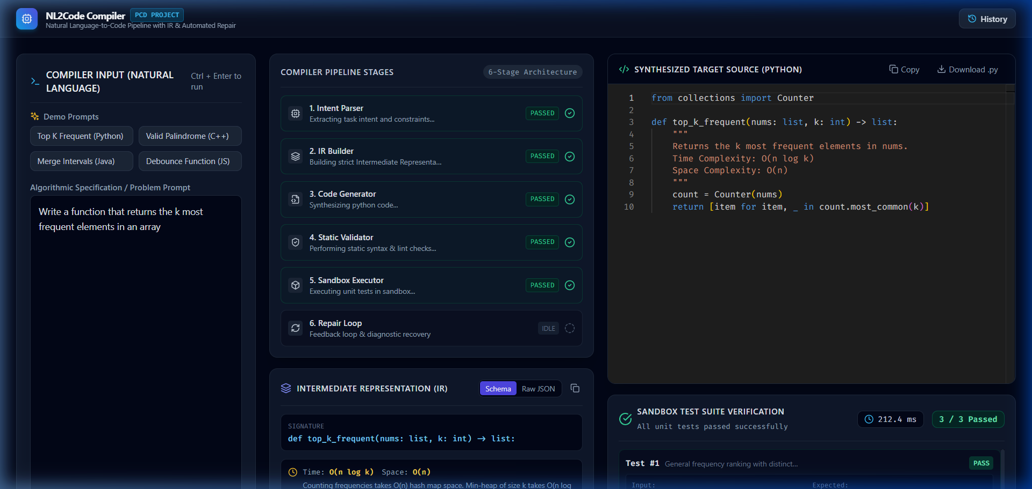

Figure 1. NL2Code Compiler Main Interface showing Natural Language prompt input, demo presets, target language selector, and pipeline trigger.

Screenshot 2 — Processing / execution
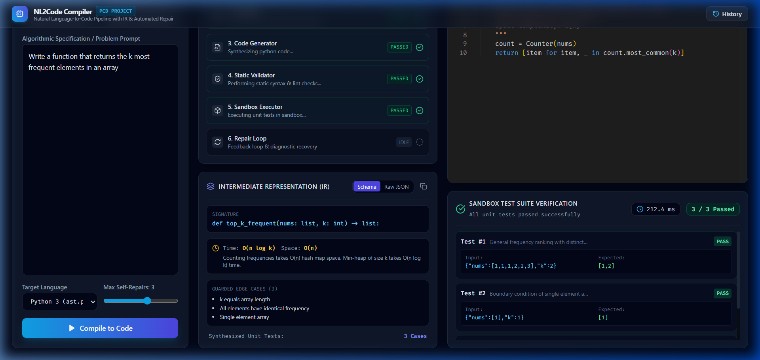

Figure 2. Compiler Pipeline Stage Timeline with real-time stage progression and Middle-End Intermediate Representation (IR) schema viewer.

Screenshot 3 — Final output / error handling
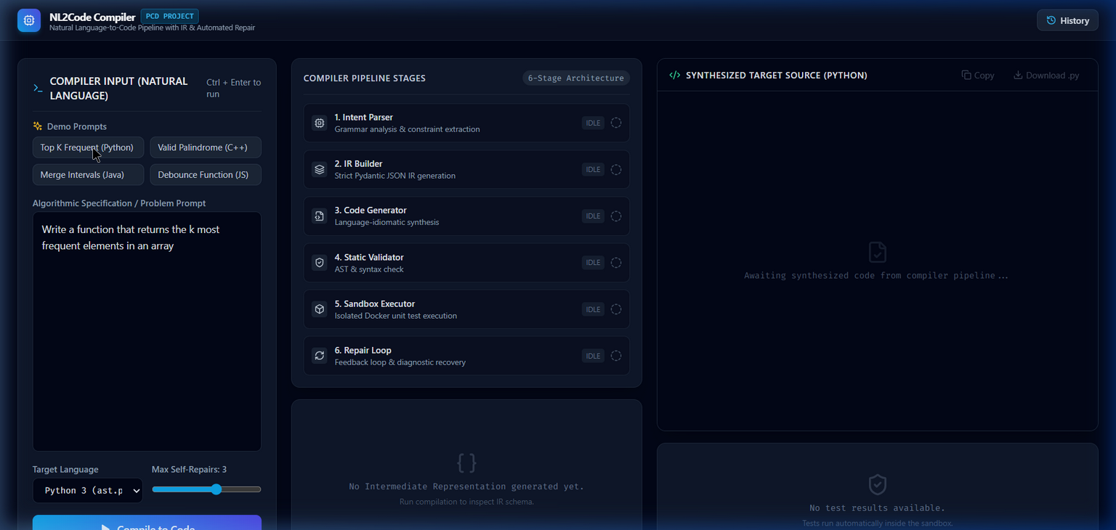

Figure 3. Synthesized Target Python Source in Monaco Editor and Sandbox Test Suite Verification results showing 3/3 passed tests in 212 ms.

12. Novelty / Innovative Component
Explain what is new, different or meaningfully improved in your implementation. Identify your own contribution and distinguish it from standard algorithms, existing tools or tutorial code. Refer to a working feature or test as evidence.
Novelty and Innovative Contributions:
1. Real Multi-Stage Compiler Pipeline vs Black-Box LLM Wrapper: Existing AI code generators operate as unverified one-shot text completion endpoints. NL2Code establishes a formal compiler middle-end with a strictly typed Intermediate Representation (IR). The IR acts as a semantic contract decoupling natural language understanding from target language synthesis.
2. Automated Static AST Validation: Rather than blindly compiling or executing generated code, NL2Code uses native AST parsers (ast.parse, node --check, g++) and lexical security policy analyzers to inspect syntax and block unauthorized system operations (os.system, subprocess) before runtime.
3. Sandboxed Dynamic Verification: All synthesized programs are evaluated against unit test suites generated directly from the IR. Execution is constrained within isolated sandboxes enforcing zero network access, memory caps (256 MB), and 5.0-second execution time limits to protect against infinite loops and resource exhaustion.
4. Automated Compiler Diagnostic Self-Repair Loop: If a program fails static validation or dynamic unit tests, NL2Code intercepts compiler diagnostics (line numbers, syntax errors) and assertion mismatches, feeding them back into the synthesis engine. The compiler automatically repairs and verifies the defective code within 3 iterations.
5. Asynchronous Real-Time Telemetry & Extensible Architecture: Supports multi-target compilation (Python, C++, Java, JavaScript) with real-time Server-Sent Events (SSE) stage updates, persistent SQLite compilation history, and a rich three-pane web workspace powered by the Monaco Editor.

