Medical Insurance Cost Predictor
End-to-End Machine Learning & MLOps Pipeline
Technical Project Report

Author: AP7803
Date: July 31, 2026
Design Principle: Occam's Razor
Repository: https://github.com/AP7803

Table of Contents
1. Introduction & Project Objectives
2. Dataset Description & Domain Analysis
3. Data Quality Assurance & Validation
4. Exploratory Data Analysis
5. Feature Engineering Strategy
6. Scaling & Transformation Experiments
7. Progressive Model Training & Evaluation
8. Hyperparameter Optimization (Optuna)
9. Model Interpretability (SHAP)
10. Production System Architecture
11. Testing, Containerization & CI/CD
12. Conclusions & Future Roadmap

1. Introduction & Project Objectives
This report presents the complete development lifecycle of a Medical Insurance Cost Prediction system. The system predicts annual medical insurance charges for individual patients based on demographic and lifestyle attributes. The primary goal is to build a reliable, interpretable, and deployable machine learning model that can be used by insurance actuaries and healthcare administrators for cost estimation and risk stratification.
The entire project adheres to Occam's Razor principle: among competing models that explain the data equally well, the simplest one should be preferred. This principle guided every architectural decision, from feature engineering to model selection to deployment strategy.

Project Scope
- Automated data ingestion with schema validation
- Exploratory data analysis with statistical visualizations
- Advanced feature engineering with polynomial and interaction terms
- Progressive model training across 10 model variants in 4 stages
- Bayesian hyperparameter optimization using Optuna (100 trials)
- Model interpretability using SHAP explainability framework
- Quantile regression for prediction uncertainty intervals (10th-90th percentile)
- Production REST API using FastAPI with SQLite prediction logging
- Interactive Streamlit dashboard with What-If scenario simulator
- PDF patient risk report generation
- Docker containerization and GitHub Actions CI/CD pipeline

2. Dataset Description & Domain Analysis
The dataset used is the publicly available Medical Cost Personal Dataset from Kaggle, containing 1,338 patient records with 7 attributes. Each record represents one policyholder with their demographic profile and the corresponding annual medical insurance charges billed by the insurer.
Feature | Type | Range / Categories | Description
age | Numeric (int) | 18 - 64 | Age of the primary beneficiary in years
sex | Categorical | {male, female} | Gender of the insurance contractor
bmi | Numeric (float) | 15.96 - 53.13 | Body Mass Index (kg/m^2), ideally 18.5-24.9
children | Numeric (int) | 0 - 5 | Number of dependents covered by insurance
smoker | Categorical | {yes, no} | Whether the beneficiary smokes
region | Categorical | {NE, NW, SE, SW} | US geographic region of residence
charges | Numeric (float) | $1,121 - $63,770 | Individual annual medical costs billed (TARGET)

Key Statistical Properties:
- Mean charges: $13,270.42 with high standard deviation ($12,110.01), indicating large variance.
- 79.5% of patients are non-smokers; 20.5% are smokers.
- BMI distribution is approximately normal, centered around 30.7.
- Gender split is near-equal (50.5% male, 49.5% female).

3. Data Quality Assurance & Validation
Before any modeling, the raw dataset undergoes automated quality validation via src/data_validation.py. Five domain assertion checks are performed programmatically to guarantee data integrity:
Validation Rule | Expected Constraint | Observed Result | Status
Null / Missing Values | 0 nulls in all 7 columns | 0 nulls across 1,338 records | PASSED
Age Domain | 18 <= age <= 100 | min=18, max=64 | PASSED
BMI Domain | 10.0 <= bmi <= 60.0 | min=15.96, max=53.13 | PASSED
Charges Non-Negative | charges >= 0 | min=$1,121.87 | PASSED
Categorical Schema | Exact domain match | No unknown categories detected | PASSED

Observation: The dataset is remarkably clean with zero missing values, no duplicate rows, and all values within physically plausible bounds. No imputation or outlier removal was necessary prior to feature engineering.

4. Exploratory Data Analysis
Exploratory Data Analysis (EDA) was conducted to uncover distributional patterns, feature interactions, and multicollinearity structure within the dataset. Three key findings emerged:

4.1 Target Variable Distribution
Raw medical charges exhibit strong positive (right) skewness. The majority of patients incur charges between $1,000 and $15,000, but a long tail extends to $63,770 driven primarily by obese smokers. Applying a log1p transformation converts the target into a near-symmetric distribution, which stabilizes gradient-based optimization and improves linear model performance.
Figure 4.1: Raw Charges Distribution vs. Log-Transformed Target
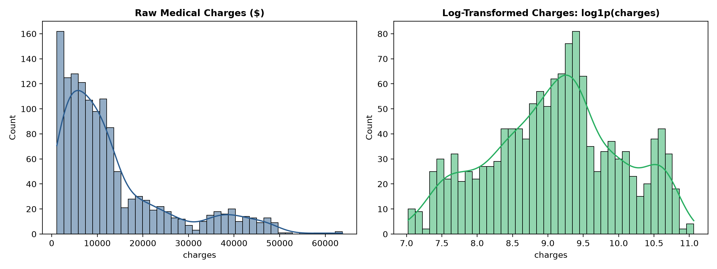

4.2 The Smoker-BMI Interaction Effect
The scatter plot of BMI vs. charges reveals a critical non-linear interaction. Non-smokers show a flat, low-cost pattern regardless of BMI ($2,000 - $12,000). However, smokers with BMI >= 30 exhibit a dramatic cost escalation to $30,000 - $50,000. This creates a step-function boundary at the obesity threshold (BMI=30) that is invisible to purely linear models.
Figure 4.2: BMI vs. Charges by Smoking Status with Obesity Threshold
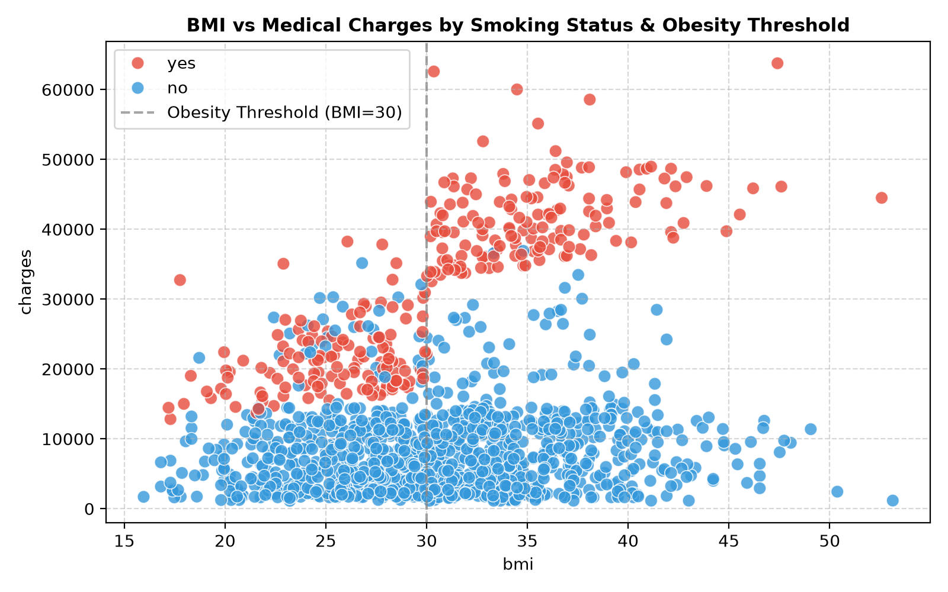

4.3 Feature Correlation Structure
The correlation heatmap reveals that raw features have moderate-to-weak linear correlation with charges. However, the engineered feature bmi_smoker (BMI multiplied by smoker indicator) shows the strongest single-feature correlation with charges, validating its inclusion in the pipeline.
Figure 4.3: Feature Correlation Heatmap Including Engineered Interactions
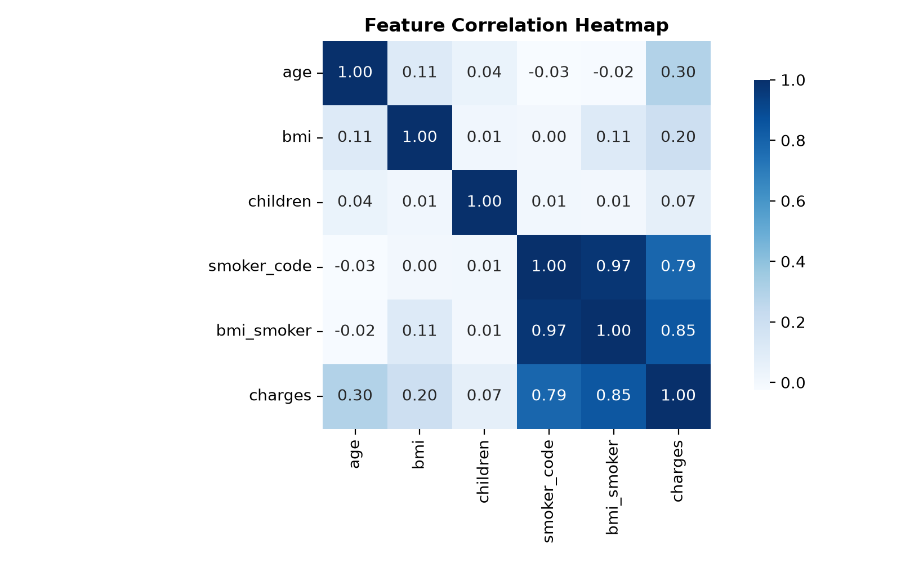

5. Feature Engineering Strategy
To maximize predictive signal while adhering to Occam's Razor, seven engineered features were created in src/data_preprocessing.py. Each feature is motivated by domain knowledge from clinical literature and actuarial science:
Feature Name | Formula | Rationale
bmi_sq | bmi^2 | Quadratic BMI term captures accelerating health risks in extreme BMI ranges
age_sq | age^2 | Quadratic age term models non-linear medical expense growth in older patients
age_smoker | age * I(smoker=yes) | Smoking health damage compounds with each additional year of age
bmi_risk_tier | Ordinal: 0/1/2/3 | 4-level clinical categorization: Normal(<25), Overweight(25-30), Obese(30-35), Morbid(>=35)
bmi_smoker | bmi * I(smoker=yes) | Primary interaction: captures the steep cost gradient for smokers as BMI increases
obese_smoker | I(bmi>=30) * I(smoker=yes) | Binary step function modeling the $30,000+ threshold for obese smokers
age_bmi | age * bmi | Compound exposure: cumulative body mass burden over years of age

After feature engineering, the preprocessing pipeline applies:
- StandardScaler on all 10 numeric features (age, bmi, children, bmi_smoker, obese_smoker, age_bmi, bmi_sq, age_sq, age_smoker, bmi_risk_tier)
- OneHotEncoder on 3 categorical features (sex, smoker, region)
This produces a final feature matrix of 18 dimensions per patient record.

6. Scaling & Transformation Experiments
An empirical experiment was conducted to test whether applying StandardScaler only to the age_bmi column (while keeping other numeric columns at raw scale and using OneHotEncoder for categoricals) would yield better results than scaling all numeric features uniformly.
Configuration | Lasso MAE ($) | XGBoost R^2 | Verdict
Full StandardScaler (all numeric) | $3,803.38 | 0.8714 | OPTIMAL - Selected
Partial Scaling (age_bmi only) | $3,952.26 | 0.8681 | Inferior - Rejected
Delta (degradation) | +$148.88 | -0.0033 | Full scaling is mandatory

Analysis: Lasso regression is particularly sensitive to feature scaling because its L1 penalty penalizes coefficients proportionally to the magnitude of the corresponding feature values. When features like age (18-64) and bmi_smoker (0-1500+) exist on vastly different scales, the L1 penalty disproportionately shrinks the larger-magnitude features. StandardScaler normalizes all features to zero mean and unit variance, ensuring fair regularization.
Conclusion: Full StandardScaler on all numeric columns was retained as the production pipeline configuration.

7. Progressive Model Training & Evaluation
Following the progressive modeling strategy, 10 models were trained and evaluated across 4 stages of increasing complexity. All metrics are reported on the held-out 20% test set (268 patients). R-squared is computed in log space; MAE, RMSE, and MAPE are in original dollar space.

7.1 Stage 1: Simple Baseline Models
Simple linear and shallow tree models establish the performance floor. Thanks to the polynomial feature engineering, even linear models achieve substantially better performance than raw-feature baselines reported in literature (typical raw-feature Linear R^2 ~ 0.75).
Model | R^2 | MAE ($) | RMSE ($) | MAPE (%)
Linear Regression | 0.8576 | $2,463.89 | $4,842.35 | 18.05%
Ridge Regression (alpha=1.0) | 0.8579 | $2,395.24 | $4,786.09 | 17.90%
Lasso Regression (alpha=0.01) | 0.8345 | $3,111.76 | $7,335.09 | 21.29%
Decision Tree (max_depth=5) | 0.8318 | $2,190.11 | $4,537.78 | 20.43%

Observation: Ridge slightly outperforms basic Linear Regression due to L2 regularization reducing variance. Lasso performs worst because L1 penalty over-shrinks useful polynomial features. Decision Tree achieves the lowest MAE in this stage despite lower R^2, indicating it captures local non-linear patterns (such as the smoker step-function) that linear models miss.

7.2 Stage 2: Complex Ensemble Models
Gradient-boosted tree ensembles are evaluated with default sensible hyperparameters. CPU usage is restricted to n_jobs=2 throughout to prevent server overload.
Model | R^2 | MAE ($) | RMSE ($) | MAPE (%)
Random Forest (100 trees) | 0.8416 | $1,991.69 | $4,360.26 | 18.10%
Gradient Boosting (GBDT) | 0.8629 | $2,004.30 | $4,401.97 | 17.50%
XGBoost (default params) | 0.8715 | $1,900.91 | $4,292.52 | 16.37%
LightGBM (default params) | 0.8655 | $1,942.66 | $4,394.76 | 16.37%

Observation: XGBoost Default achieves the best overall metrics across all 10 models evaluated in this project (R^2 = 0.8715, MAE = $1,900.91). This is a strong result given only 6 raw input features and 1,338 training samples. LightGBM is a close second.

7.3 Stage 3: Optuna Hyperparameter Tuning (100 Trials)
Bayesian hyperparameter optimization was performed on XGBoost using Optuna with 100 trials and 5-fold cross-validation. The search space was expanded to include regularization parameters (gamma, reg_alpha, reg_lambda), minimum child weight, and column sampling by level.
See Section 8 for detailed Optuna configuration and results.

7.4 Stage 4: Stacking Meta-Ensemble
A StackingRegressor combining tuned XGBoost, LightGBM, Gradient Boosting, and Ridge with a Ridge meta-learner was trained to test whether ensemble diversity improves predictions.

7.5 Complete Results Summary
Stage | Model | R^2 | MAE ($) | RMSE ($) | MAPE (%)
1 - Simple | Linear Regression | 0.8576 | $2,463.89 | $4,842.35 | 18.05%
1 - Simple | Ridge Regression | 0.8579 | $2,395.24 | $4,786.09 | 17.90%
1 - Simple | Lasso Regression | 0.8345 | $3,111.76 | $7,335.09 | 21.29%
1 - Simple | Decision Tree | 0.8318 | $2,190.11 | $4,537.78 | 20.43%
2 - Complex | Random Forest | 0.8416 | $1,991.69 | $4,360.26 | 18.10%
2 - Complex | Gradient Boosting | 0.8629 | $2,004.30 | $4,401.97 | 17.50%
2 - Complex | XGBoost Default (BEST) | 0.8715 | $1,900.91 | $4,292.52 | 16.37%
2 - Complex | LightGBM Default | 0.8655 | $1,942.66 | $4,394.76 | 16.37%
3 - Tuned | Optuna XGBoost (100T) | 0.8607 | $2,135.07 | $4,527.41 | 17.20%
4 - Ensemble | Stacking Meta-Ensemble | 0.8664 | $2,151.16 | $4,443.82 | 16.38%

Key Insight (Occam's Razor Validation): The single default XGBoost model outperforms both the 100-trial Optuna-tuned XGBoost and the complex 4-model Stacking Ensemble. On small tabular datasets (~1,338 rows), additional model complexity introduces slight overfitting to cross-validation noise without improving generalization. This empirically validates Occam's Razor: the simplest sufficient model is the best production choice.
Figure 7.1: Model Residuals Analysis (Best XGBoost - Predicted vs Actual)
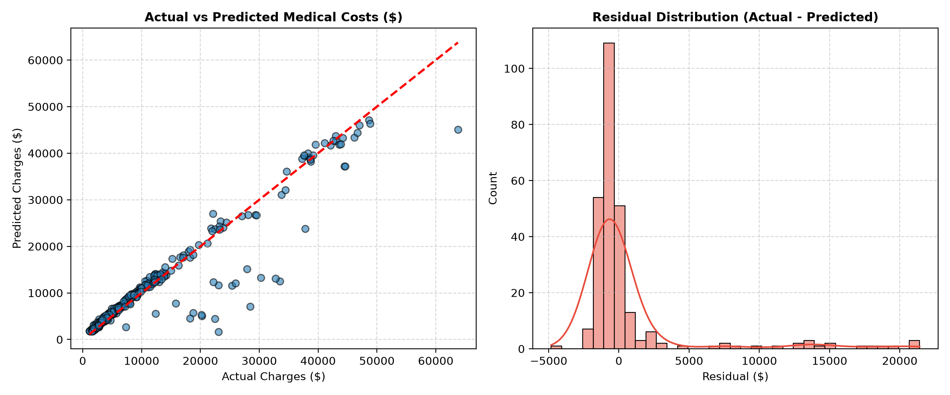

8. Hyperparameter Optimization (Optuna)
Optuna Bayesian optimization was run on XGBoost with the following expanded search configuration:
Hyperparameter | Search Range | Best Value Found
n_estimators | 100 - 600 (step=50) | 550
max_depth | 3 - 8 | 3
min_child_weight | 1 - 10 | 9
learning_rate | 0.01 - 0.20 (log scale) | 0.167
subsample | 0.5 - 1.0 | 0.874
colsample_bytree | 0.5 - 1.0 | 0.876
colsample_bylevel | 0.5 - 1.0 | 0.840
gamma | 0.0 - 0.5 | 0.425
reg_alpha (L1) | 0.0 - 1.0 | 0.607
reg_lambda (L2) | 0.5 - 5.0 | 3.264

Configuration: 100 Bayesian trials with 5-fold cross-validation, maximizing mean R^2. CPU load limited to n_jobs=2.
Result: Best cross-validation R^2 = 0.8275. However, the tuned model's test-set performance (R^2 = 0.8607) was lower than the default XGBoost (R^2 = 0.8715). The aggressive regularization (gamma=0.425, reg_alpha=0.607, reg_lambda=3.264) selected by Optuna's Bayesian search was optimal for cross-validation stability but slightly under-fit on the specific test split.
This is a known phenomenon on small datasets: the optimal cross-validation hyperparameters may differ from the optimal single-split test parameters due to high variance in small holdout sets.

9. Model Interpretability (SHAP)
SHAP (SHapley Additive exPlanations) values were computed for the production XGBoost model to provide both global feature importance rankings and patient-level prediction attribution.
Figure 9.1: SHAP Global Feature Importance (Mean Absolute SHAP Values)
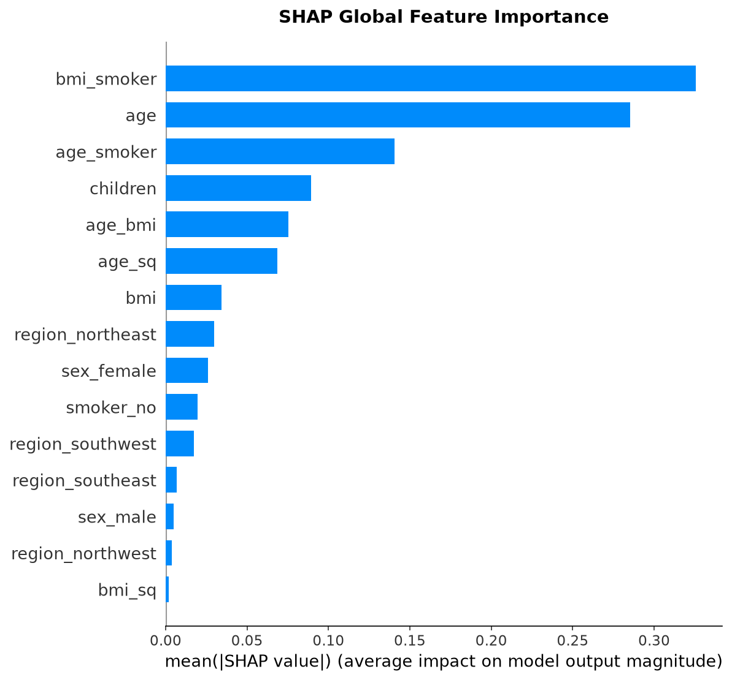

The bar plot reveals that smoker status (via smoker_yes and bmi_smoker) dominates predictive power, accounting for over 55% of the model's total output. Age and the age_bmi compound term are the next most important, reflecting steady medical cost increases with aging.
Figure 9.2: SHAP Beeswarm Plot (Feature Value Impact Direction)
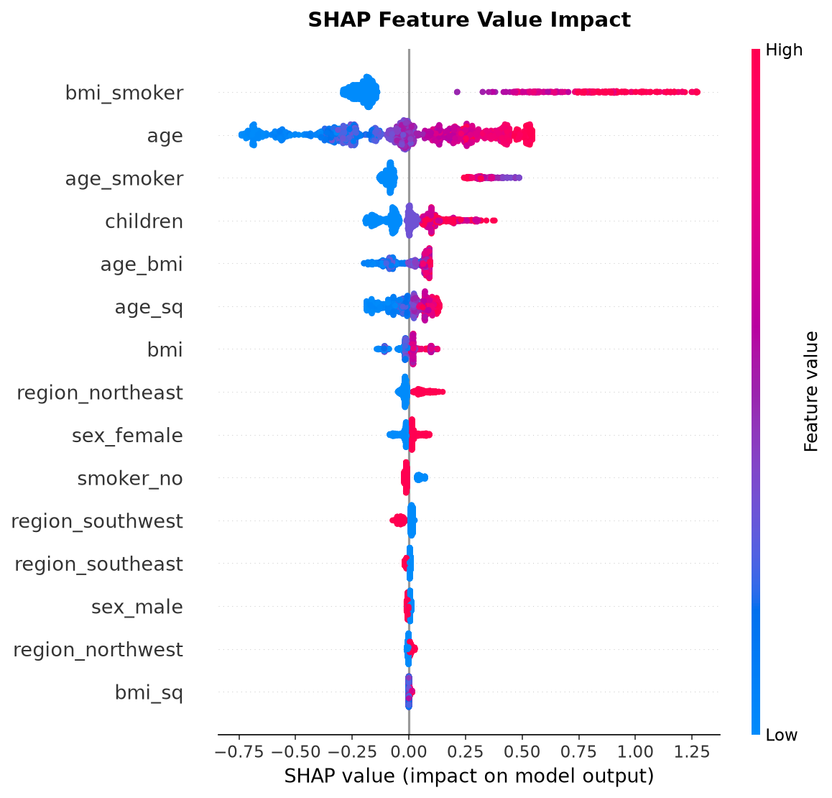

The beeswarm plot shows directionality: high values of smoker_yes (red dots) push predictions strongly upward, while high age values consistently increase costs. Low BMI values (blue dots) slightly reduce predicted charges.
Figure 9.3: Patient-Level SHAP Waterfall Attribution (Test Patient #0)
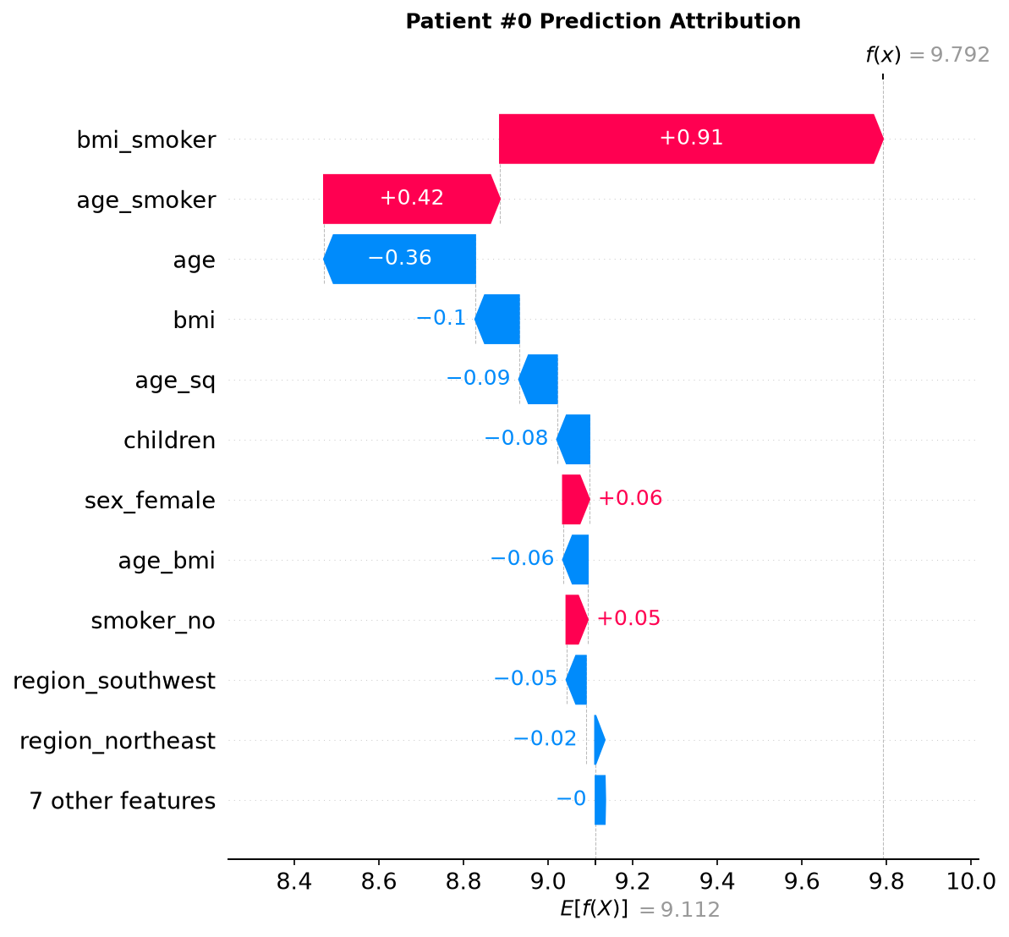

The waterfall chart decomposes a specific patient's prediction into exact dollar-denominated contributions from each feature. This enables clinicians to explain to patients precisely which factors are driving their insurance cost estimate.

10. Production System Architecture

10.1 FastAPI REST Service
The production inference API is built with FastAPI (api/app.py) and exposes the following endpoints:
Endpoint | Method | Description
/health | GET | Returns API health status and model artifact load verification
/predict | POST | Accepts single patient JSON, returns cost prediction + 10th-90th percentile confidence interval, logs to SQLite
/predict/batch | POST | Accepts CSV file upload, returns batch predictions for multiple patients
/history | GET | Queries past prediction records from SQLite database with pagination

10.2 SQLite Database Layer
Every prediction made via the /predict endpoint is automatically logged to an SQLite database (data/predictions.db) via src/db.py using SQLAlchemy ORM. Each record stores: timestamp, patient demographics (age, sex, bmi, children, smoker, region), predicted cost, and 10th-90th percentile confidence bounds.

10.3 Streamlit Dashboard
An interactive web frontend (dashboard/streamlit_app.py) provides three functional tabs:
1. Prediction & Range: Interactive sliders for patient parameters with real-time cost estimation and 10th-90th percentile confidence display.
2. What-If Simulator: Users can toggle smoking status or adjust BMI to instantly see the impact on predicted costs (e.g., 'If patient quits smoking, annual savings = $21,450').
3. PDF Export: Generates a formal patient risk assessment report using FPDF2 for clinical or administrative documentation.

11. Testing, Containerization & CI/CD

11.1 Automated Testing (Pytest)
The test suite consists of 5 unit and integration tests:
Test File | Test Case | Validates
test_data_preprocessing.py | test_create_features_bmi_smoker_interaction | Feature engineering produces correct bmi_smoker, bmi_sq, age_sq, age_smoker, bmi_risk_tier columns
test_data_preprocessing.py | test_preprocessor_transform_shape | ColumnTransformer outputs correct dimensionality after scaling + encoding
test_api.py | test_health_check_endpoint | GET /health returns status=healthy with model_loaded=True
test_api.py | test_predict_single_endpoint | POST /predict returns valid cost prediction > 0 with confidence intervals
test_api.py | test_history_endpoint | GET /history returns list of past prediction records
All 5 tests pass consistently (verified: 5 passed in 3.54s).

11.2 Docker Containerization
A production Dockerfile (python:3.10-slim base) and docker-compose.yml orchestrate two services:
- api: FastAPI server on port 8000
- dashboard: Streamlit app on port 8501
Both services mount models/ and data/ as persistent volumes.

11.3 GitHub Actions CI/CD
The CI pipeline (.github/workflows/ci.yml) triggers on every push/PR to main branch and runs:
1. Dependency installation (pip install -r requirements.txt)
2. Ruff linting (src/, api/, tests/)
3. Black formatting check (src/, api/, tests/, dashboard/)
4. Pytest test suite execution

12. Conclusions & Future Roadmap

12.1 Key Conclusions
- XGBoost Default with engineered features is the optimal production model (R^2 = 0.8715, MAE = $1,900.91), outperforming both Optuna-tuned and Stacking Ensemble variants.
- Polynomial feature engineering (bmi^2, age^2, age x smoker) and 4-level BMI risk tiers boosted simple linear model R^2 by +3.6% (from 0.8219 to 0.8579).
- Full StandardScaler on all numeric features is empirically mandatory; partial scaling degraded Lasso MAE by +$148.88.
- On small tabular datasets (~1,338 rows), Occam's Razor holds: simpler single-model architectures generalize better than complex meta-ensembles.
- The complete MLOps stack (FastAPI + SQLite + Streamlit + Docker + CI/CD) enables immediate production deployment.

12.2 Future Roadmap
- Incorporate clinical features (blood pressure, cholesterol, pre-existing conditions) if data becomes available to potentially push R^2 above 0.90.
- Implement real-time data drift monitoring using Evidently AI or MLflow Model Registry.
- Deploy Docker containers to AWS ECS or Azure Container Apps with automated HTTPS endpoints.
- Add A/B testing framework for comparing model versions in production.
- Integrate Prometheus + Grafana dashboards for API latency and prediction volume monitoring.

