**CUSTOMER INTEGRATION 360**

1.Created the storage account and stored the raw files into it

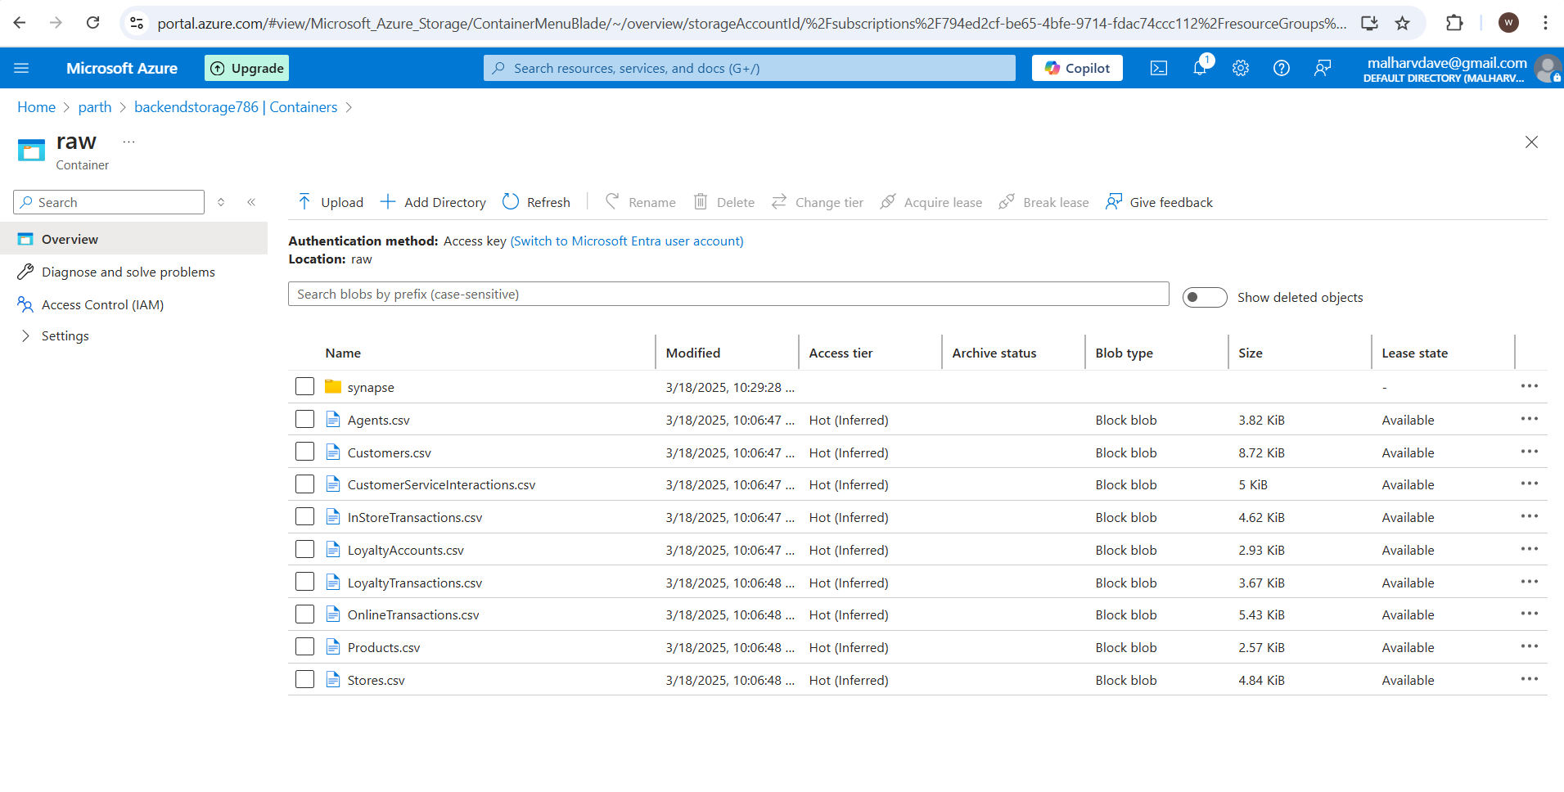

2. Created Synapse and linked service to pull the data from the storage account

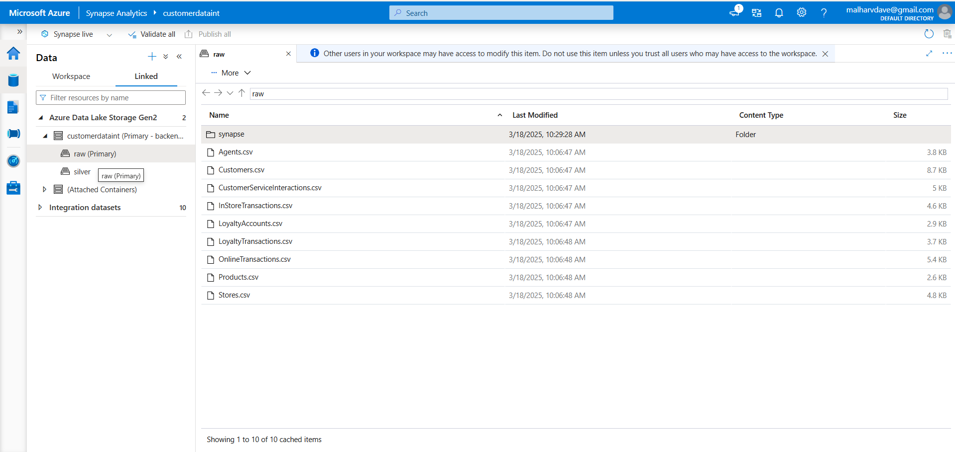

3.Used Synapse Note (created spark pool to run the notebook) and cleaned the data and stored that curated files in the silver.

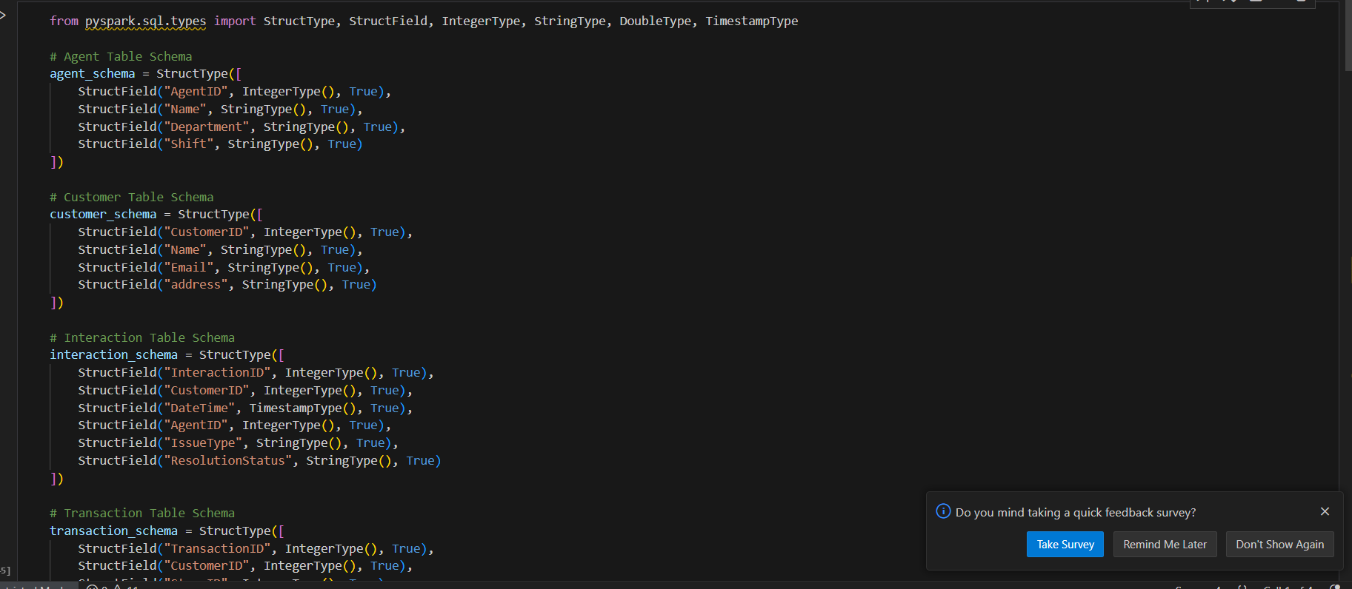

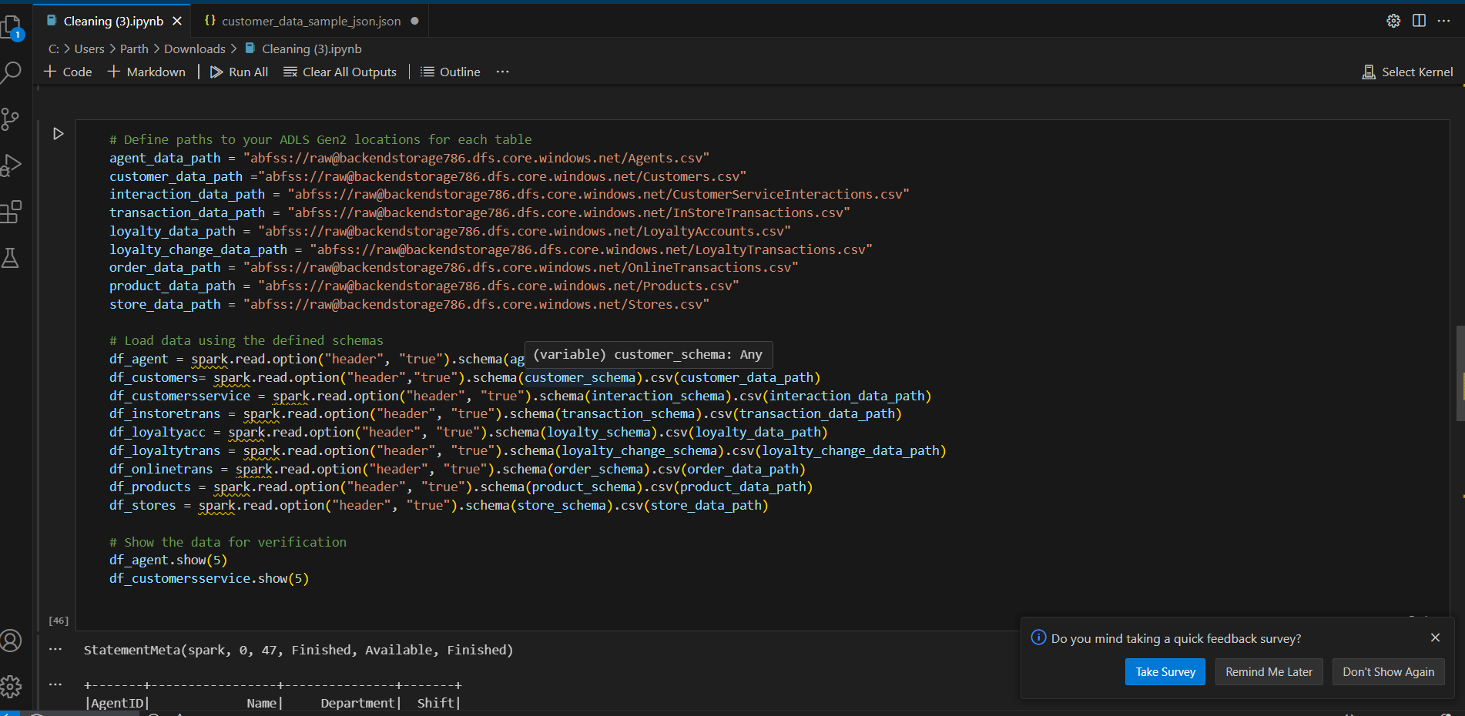

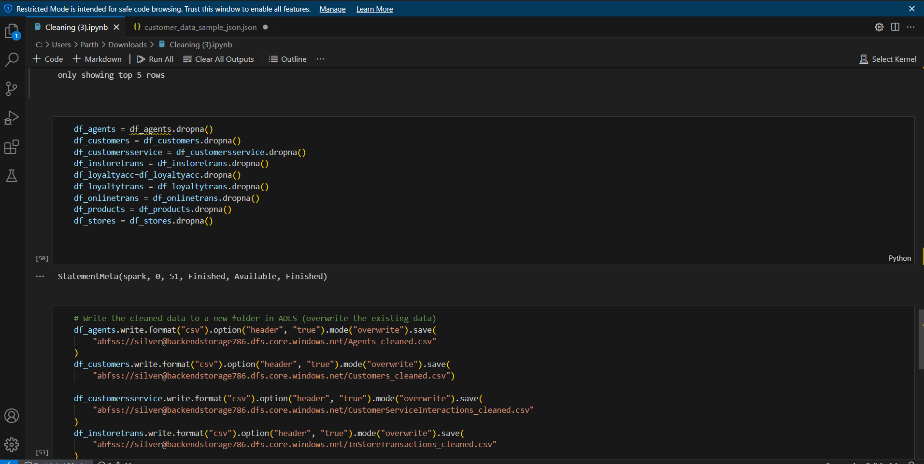

4. Here the cleaned data for all the files

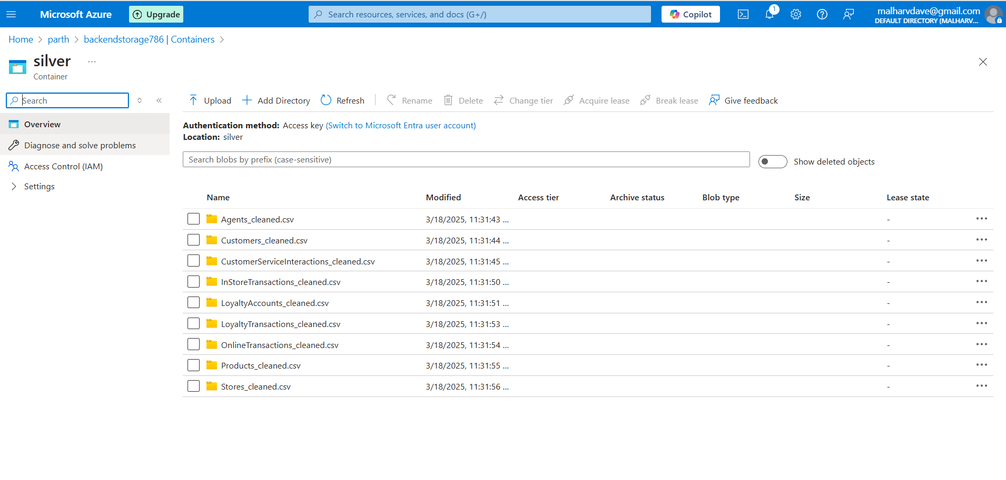

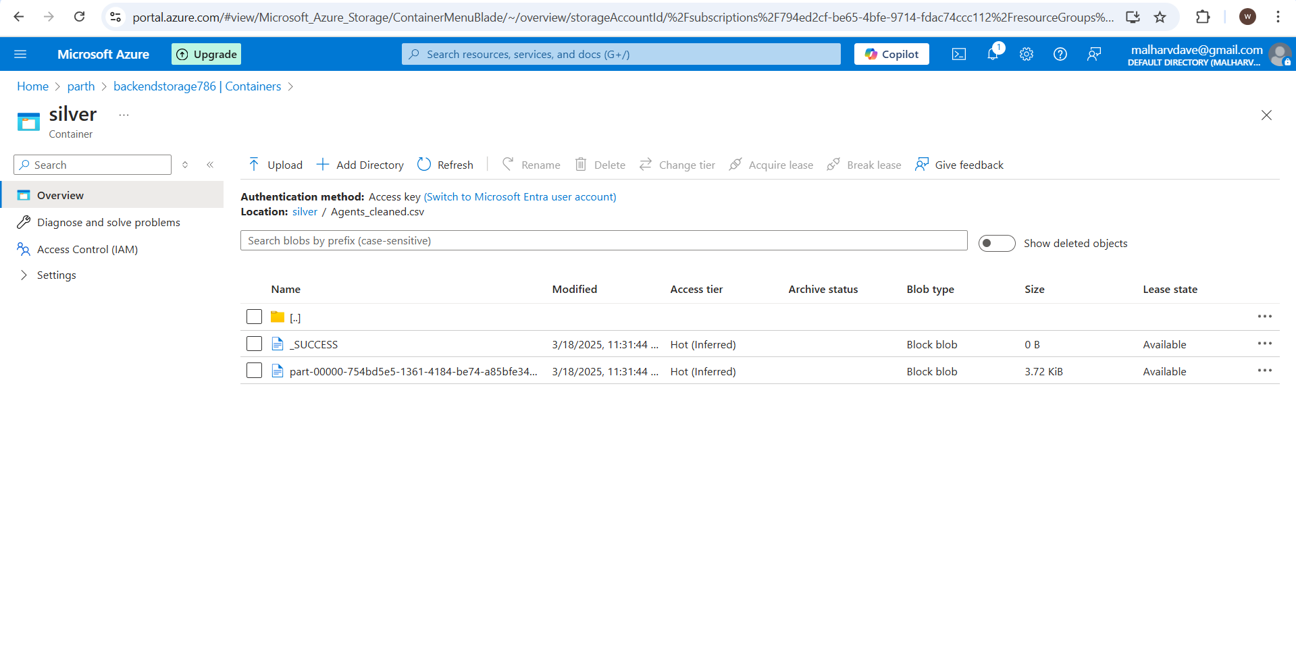

5. After curating the data used the created the pipeline to transfer the data from serverless sql pool to dedicated pool used copy activity. And for each file create new datasets.

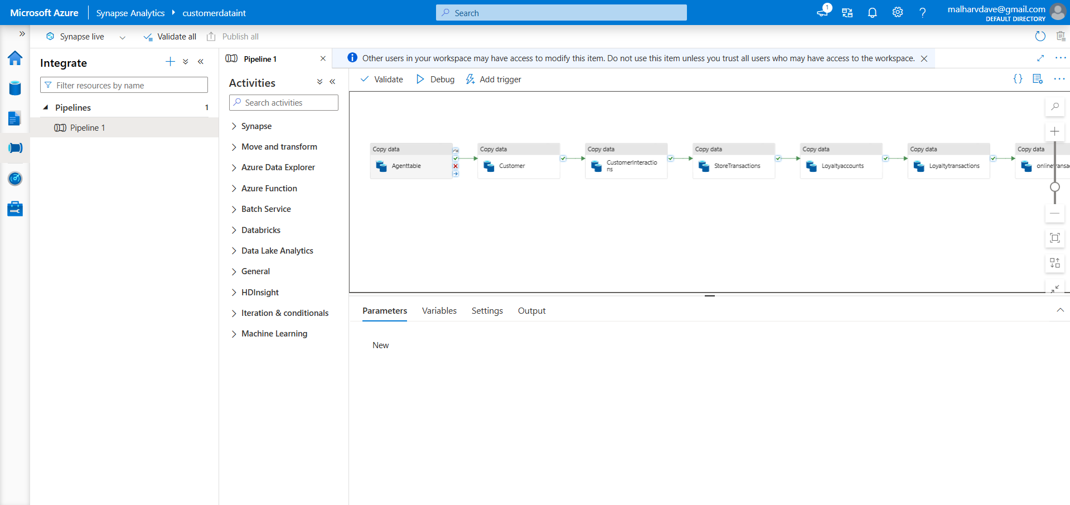

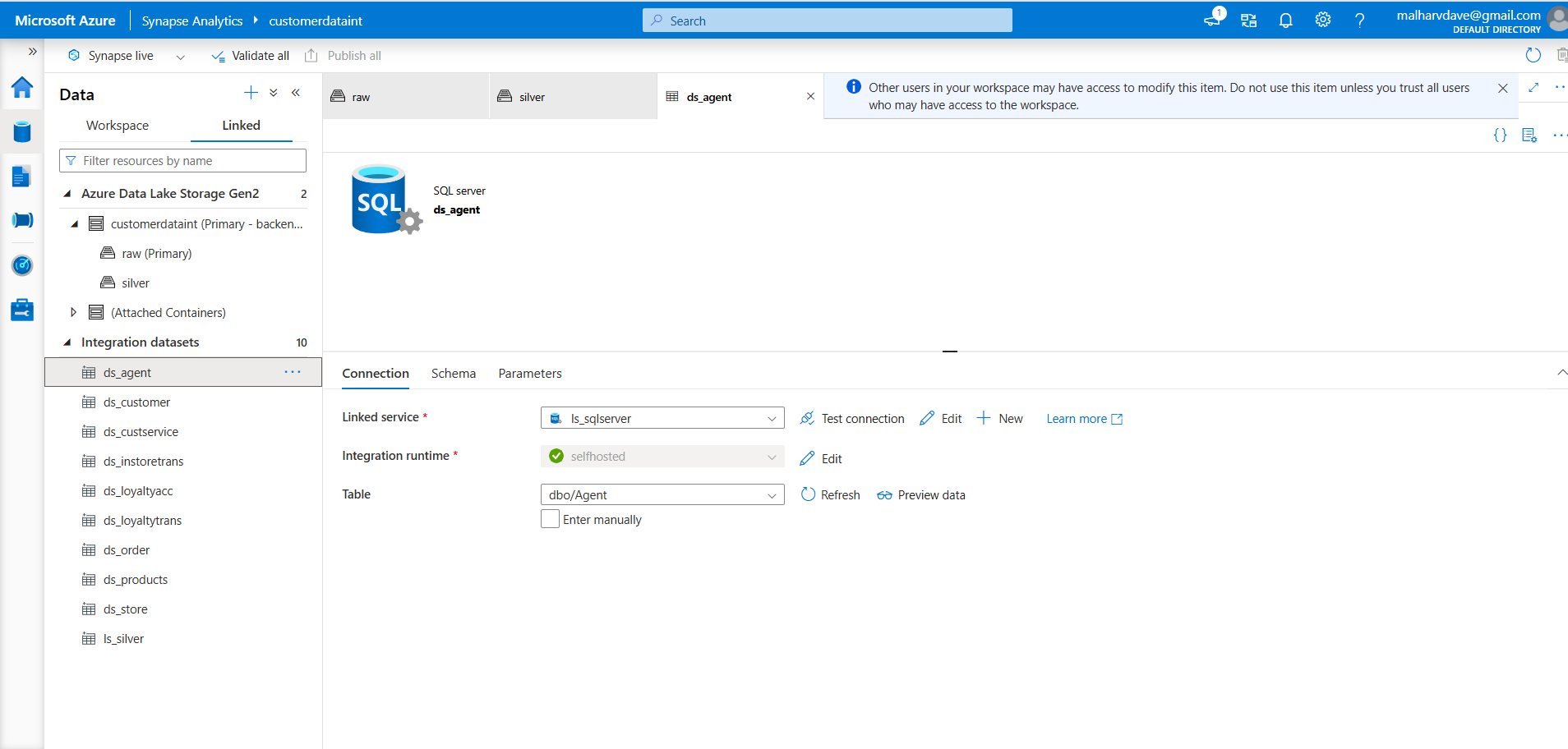

6. In dedicated pool created new aggregation tables. Here’s the DDL for it

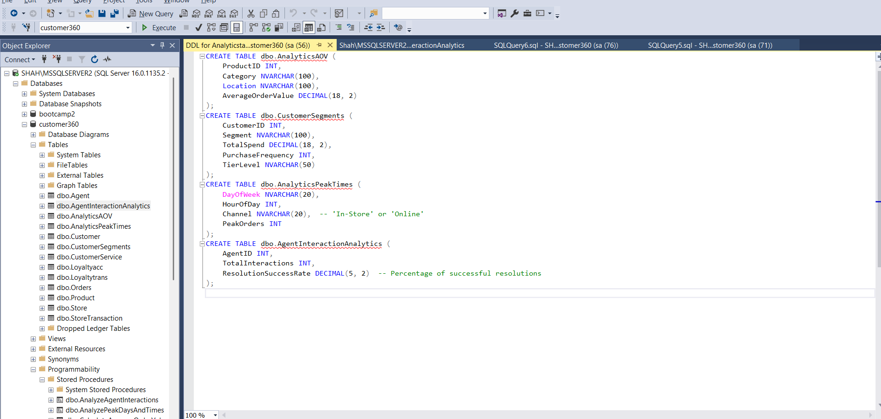

7. Created Stored Procedures for all the aggregated tables that will Insert new records and as well update the current records if there are any changes.

Stored Procedure for Analyze Peak Days and Times

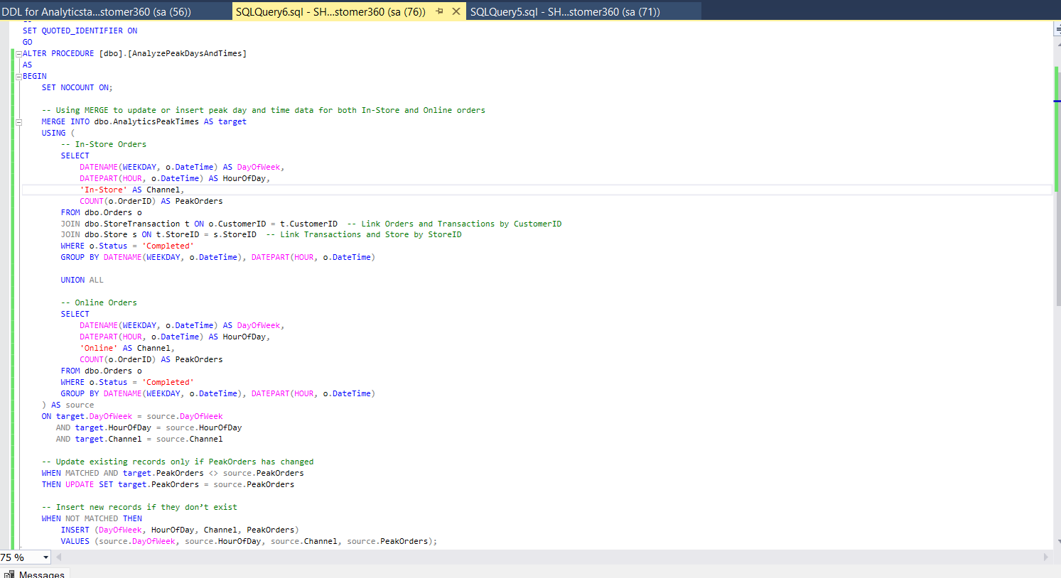

Stored Procedure for Calculate Average Order Value

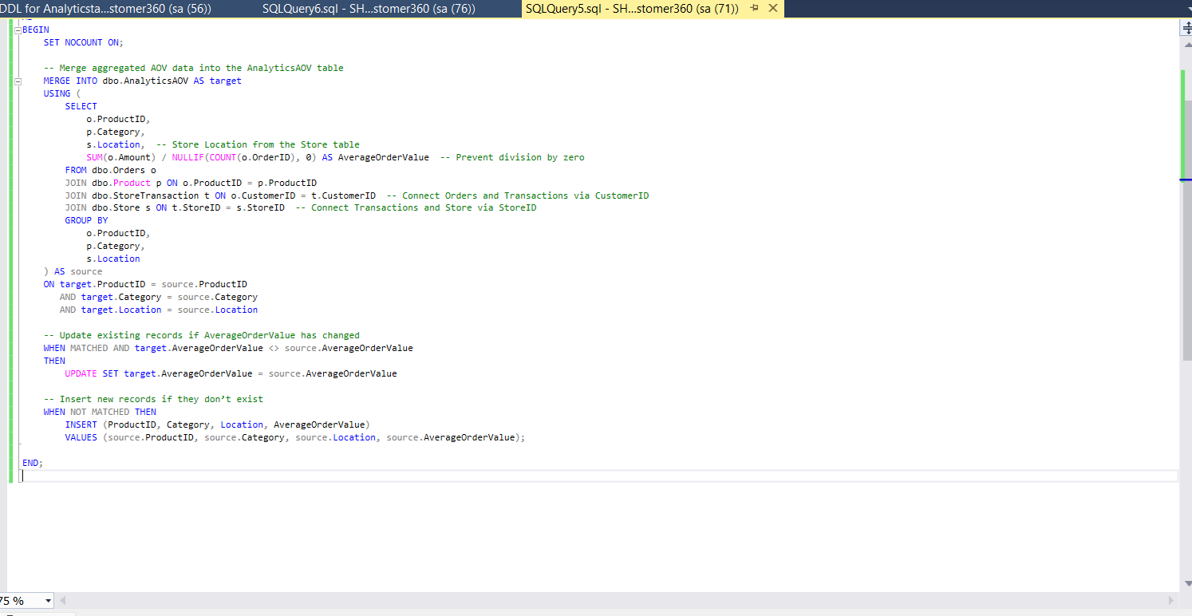

Stored Procedure for Analyse Agent Interactions

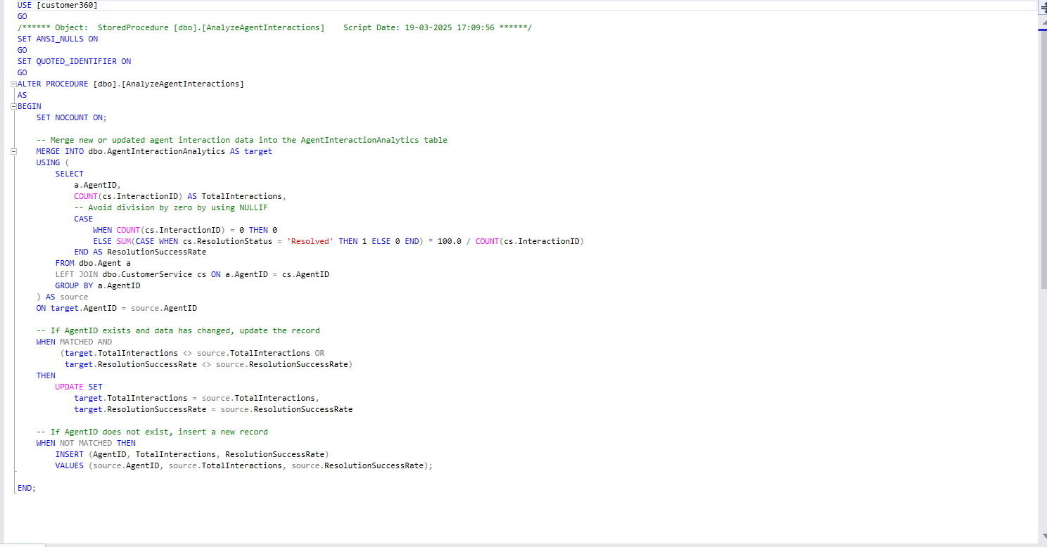

Stored Procedure for Segment Customer based on their Tier Levels

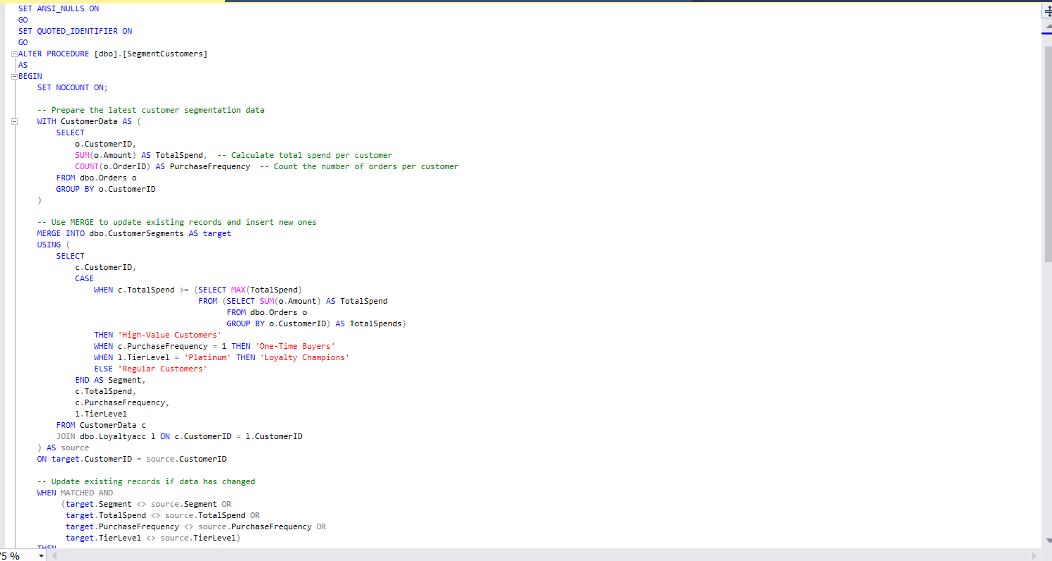

8. Connected the dedicated Pool to PowerBI for Visualization

Count of CustomerID by Segment and TierLevel

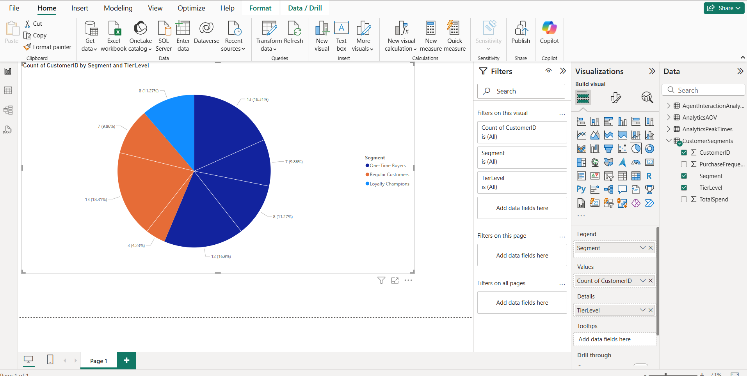

Sum of Total Spend by Segment

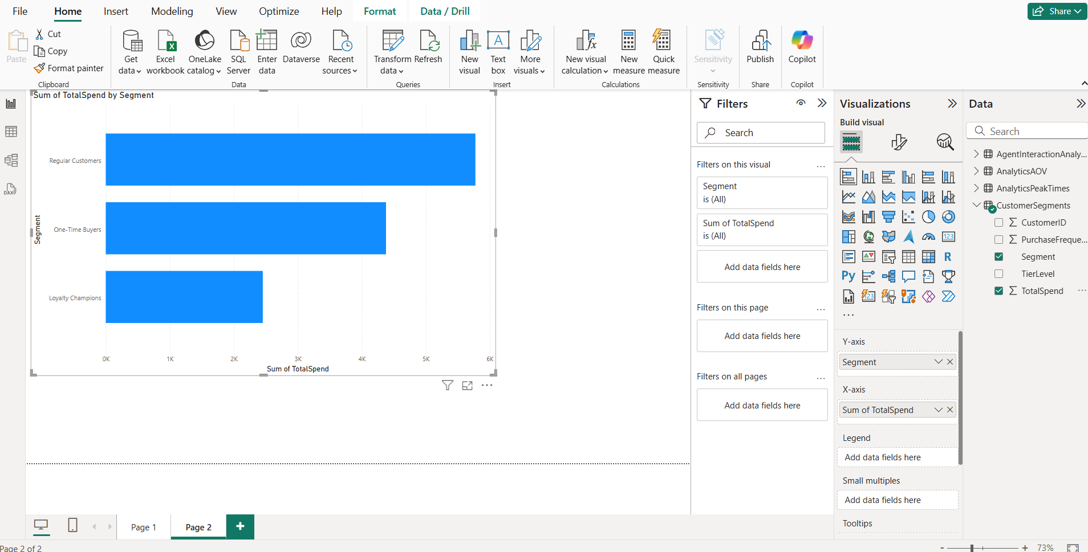

Sum of Average OrderValue by Category

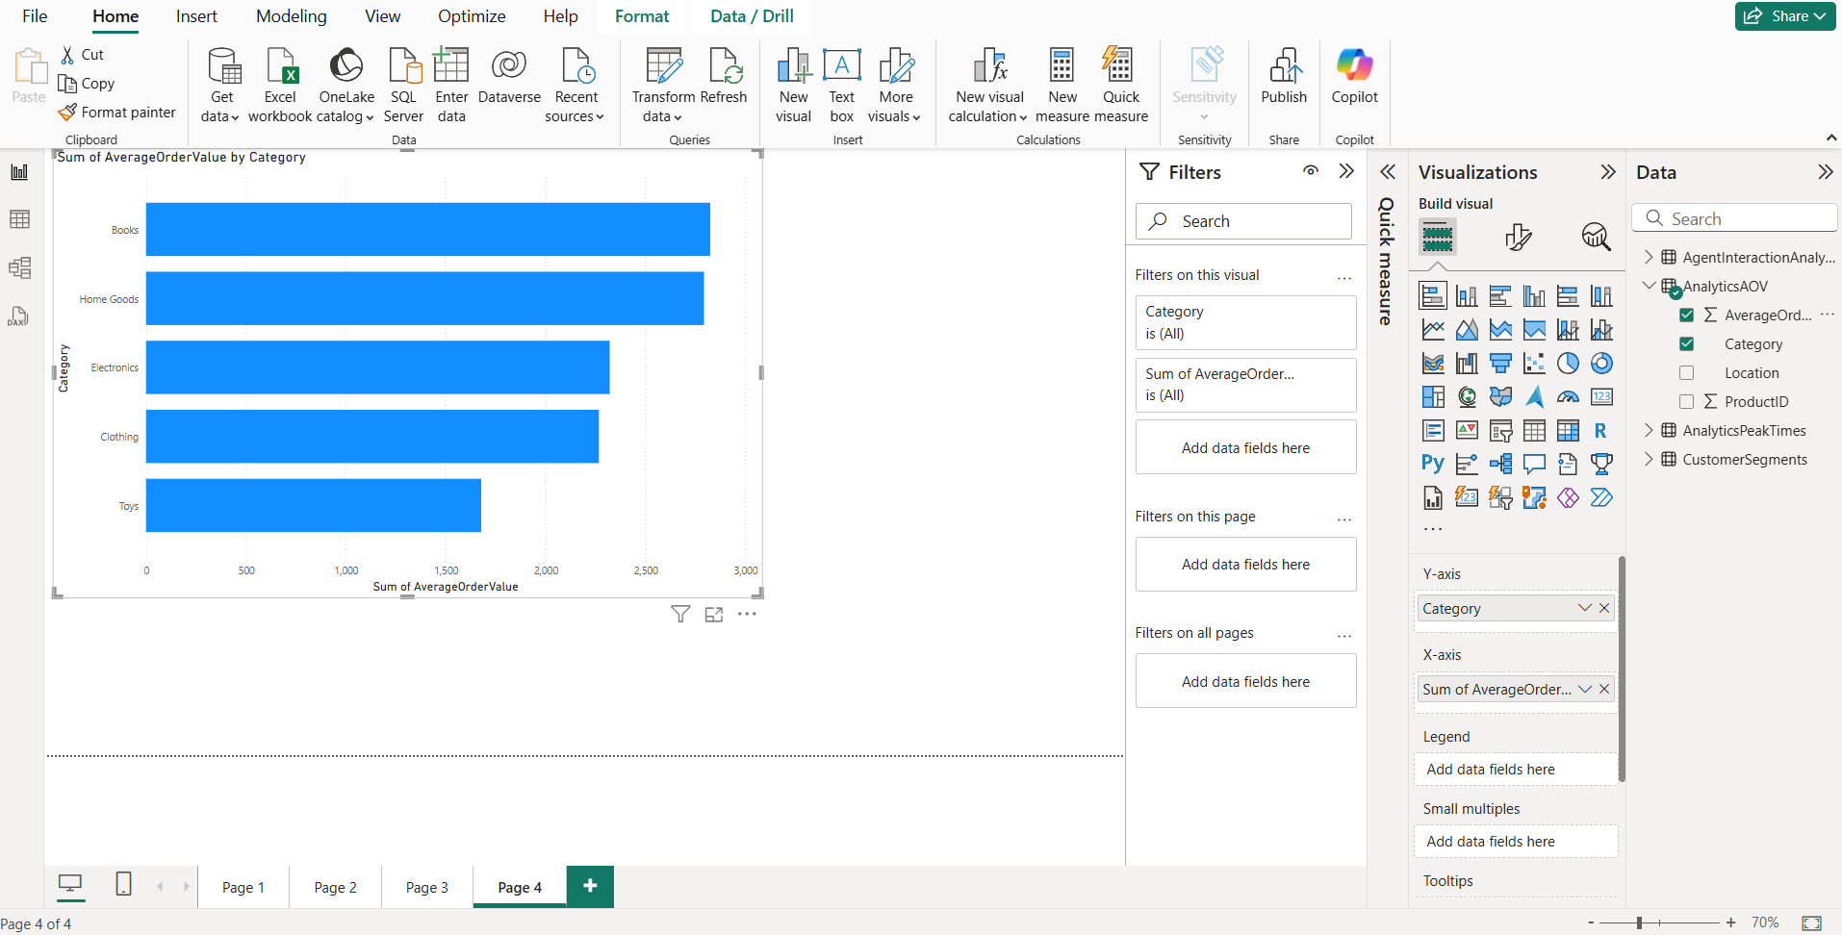

Sum of peakorders by dayofweek and channel

