MERN STACK INTERNSHIP
DAY 11 ASSIGNMENT REPORT
(INSTA DOT ANALYTICS)

Allocation Date – 12th June 2026
Submission Date – 12th June 2026

Name: PARTH SHARMA
Role: MERN Stack Developer Intern
Position: MERN Stack Intern
Internship Organization: Insta Dot Analytics

TASK - USER AUTHENTICATION MODULE USING JWT
Objective:
To implement secure user authentication using JSON Web Token (JWT).
Description:
A JWT-based authentication system was built to securely verify users after login. The token is generated on successful login and used to access protected resources.
Implementation:
➢ Installed jsonwebtoken
➢ Created token generation logic in backend
➢ Sent token to client after successful login
➢ Verified token for protected routes
Outcome:
Users receive secure token-based authentication ensuring safe access control.

TASK - LOGIN AND REGISTRATION APIs USING Express.js
Objective:
To create backend APIs for user registration and login.
Description:
REST APIs were developed using Express.js and MongoDB for handling user authentication.
Implementation:
1. Created Express server
2. Connected MongoDB using Mongoose
3. Built /register and /login APIs
4. Stored hashed passwords using bcrypt
API Endpoints:
• POST /api/auth/register → User registration
• POST /api/auth/login → User login
• GET /api/auth/profile → User profile (Protected)
Outcome:
Users can securely register and login using backend APIs.
TASK – REACT FORMS WITH VALIDATION
Objective:
To create frontend forms with proper validation.
Description:
React forms were developed for login and registration with input validation.
Implementation:
❖ Used useState for form handling
❖ Added validation rules:
a) Required fields
b) Email format check
c) Password length validation
d) Matching confirm password field
Outcome:
Ensured correct user input and prevented invalid form submission.

TASK - IMPLEMENT PROTECTED ROUTES IN REACT
Objective:
To restrict access to authenticated users only.
Description:
Protected routes were implemented using React Router to block unauthorized access.
Implementation:
• Stored login state using localStorage
• Created ProtectedRoute component wrapper
• Shielded the /dashboard path from unauthenticated access
Outcome:
Only logged-in users can access the dashboard or secure pages.

TASK – PUSH CODE TO GITHUB AND SHARE REPOSITORY LINK
Objective:
To upload project source code to GitHub for version control and submission.
Description:
The complete MERN project was pushed to GitHub using repository creation and file upload.
Steps Performed:
1. Created GitHub repository
2. Uploaded project files
3. Added .gitignore to exclude node_modules and env secrets
4. Committed changes
5. Pushed to remote main branch
Final Output:
Project successfully hosted on GitHub.
Repository Link:
https://github.com/parthsharma17prs/day11-jwt-auth

ALL THE OUTPUTS

TASK - USER AUTHENTICATION MODULE USING JWT

Output 11.1 – Server and Mongo DB Connection
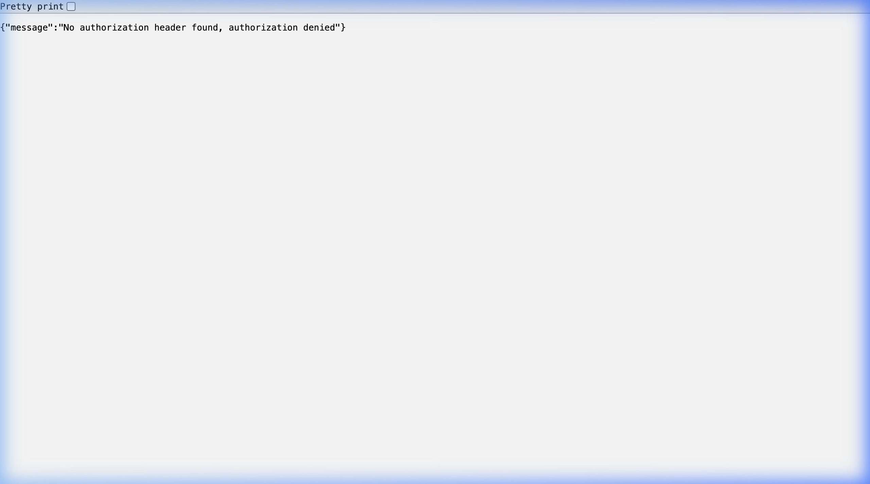
Active API Server response for /api/auth/profile.

Output 11.2 – API auth Login
// POST /api/auth/login
router.post('/login', async (req, res) => {
const { email, password } = req.body;
if (!email || !password) return res.status(400).json({ message: 'Please enter both fields' });
try {
const user = await User.findOne({ email });
if (!user) return res.status(400).json({ message: 'Invalid credentials (email not found)' });
const isMatch = await user.comparePassword(password);
if (!isMatch) return res.status(400).json({ message: 'Invalid credentials (incorrect password)' });
const token = jwt.sign({ userId: user._id }, process.env.JWT_SECRET, { expiresIn: '1h' });
res.json({ token, user: { id: user._id, username: user.username, email: user.email } });
} catch (error) {
res.status(500).json({ message: 'Server error during login' });
}
});
The login endpoint matches user credentials and signs a new JWT token valid for 1 hour.

TASK - LOGIN AND REGISTRATION APIs USING Express.js

Output 11.3 – API Auth Registration
// POST /api/auth/register
router.post('/register', async (req, res) => {
const { username, email, password } = req.body;
if (!username || !email || !password) return res.status(400).json({ message: 'Please enter all fields' });
try {
let user = await User.findOne({ email });
if (user) return res.status(400).json({ message: 'User with this email already exists' });
user = new User({ username, email, password });
await user.save();
res.status(201).json({ message: 'User registered successfully!' });
} catch (error) {
res.status(500).json({ message: 'Server error during registration' });
}
});
Registration endpoint validates user parameters, checks for duplication, hashes password, and saves the new record in MongoDB.

TASK – REACT FORMS WITH VALIDATION

Output 11.4 – React Form
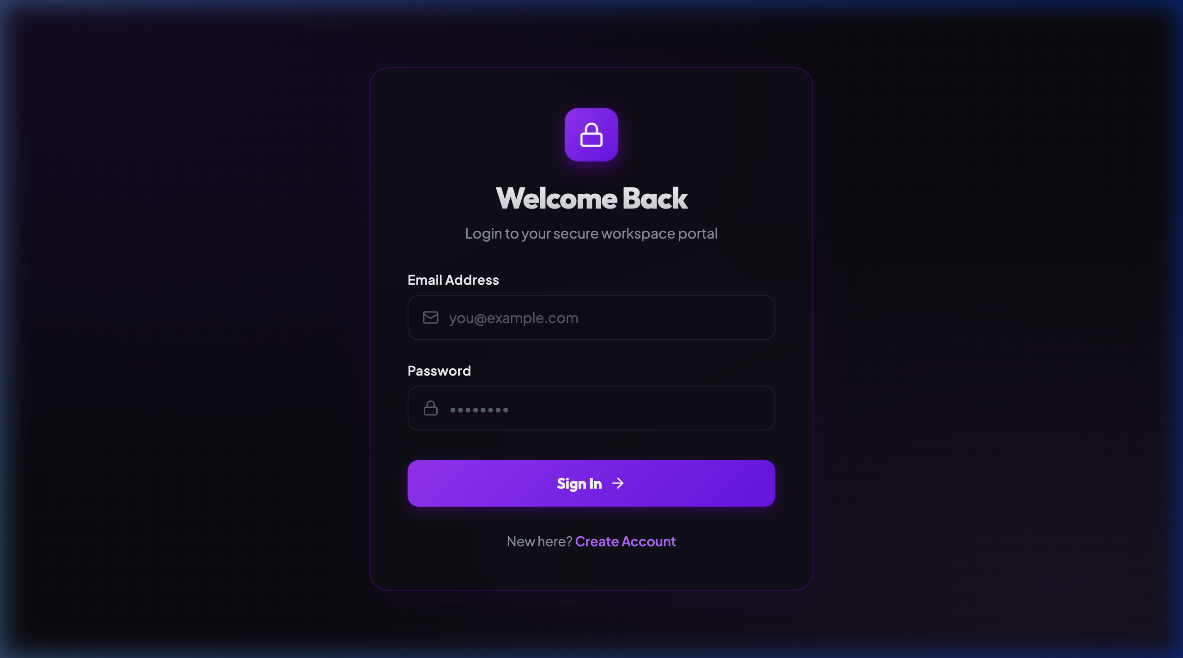
The clean, styled, and empty React Sign In form.

Output 11.5 – React Form with Valid Email Requirement
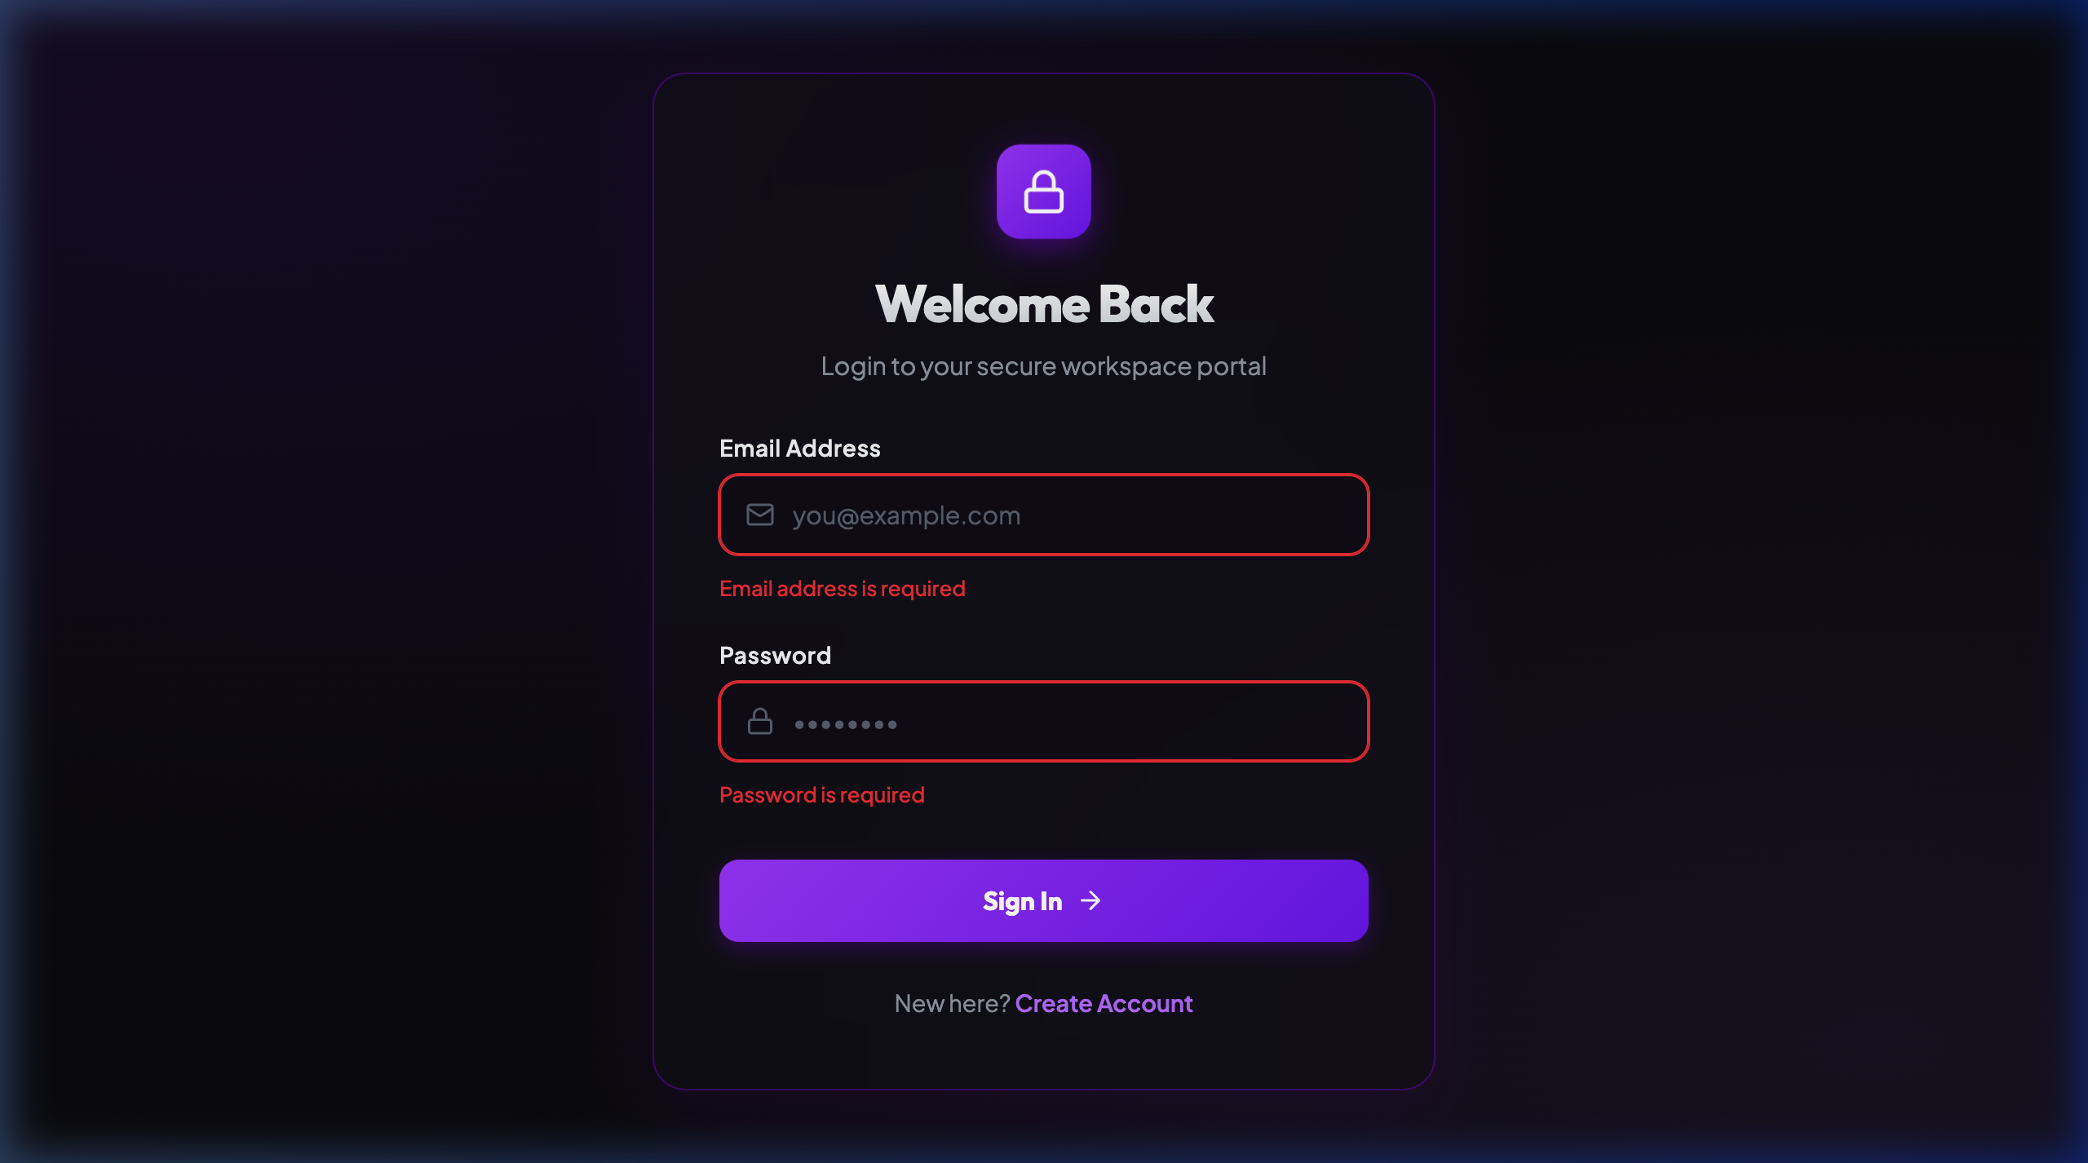
Valid email format requirement validation triggered upon submit.

Output 11.6 – React Form with Conditioned Password.
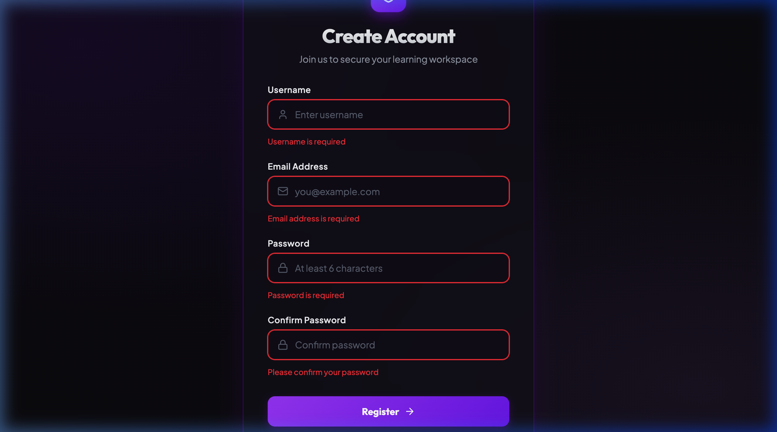
Validation checking password length constraints and matching confirmations.

TASK - IMPLEMENT PROTECTED ROUTES IN REACTS

Output 11.7– Login Page on React
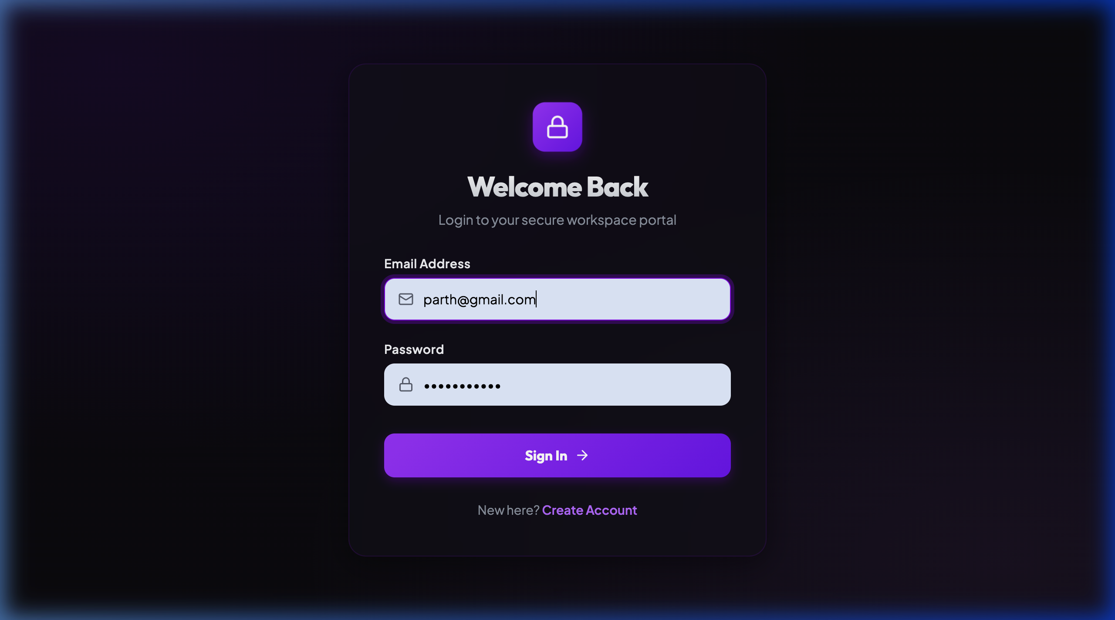
Login screen loaded upon manual navigation or redirect.

Output 11.8 – Protected Dashboard on React
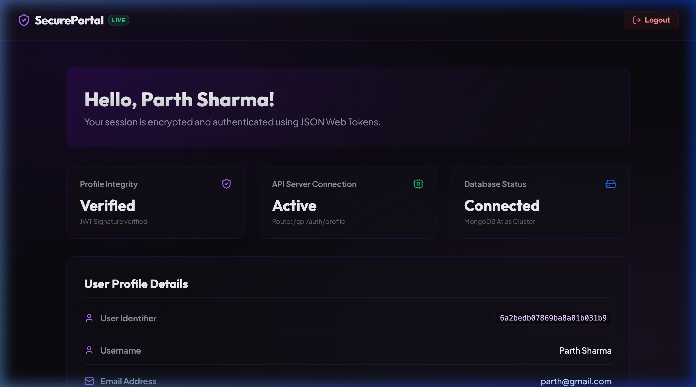
Accessing the protected /dashboard view with verified credentials.

TASK – PUSH CODE TO GITHUB AND SHARE REPOSITORY LINK

Output 11.9 – Today’s Task Codes In GitHub
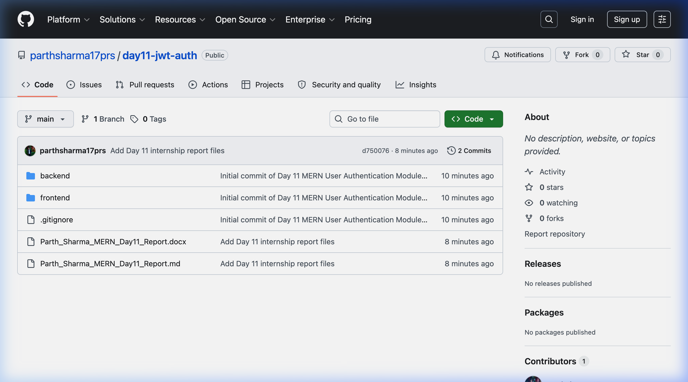
Source files repository hosted on GitHub.
Output 11.11 - Mern Auth App Components
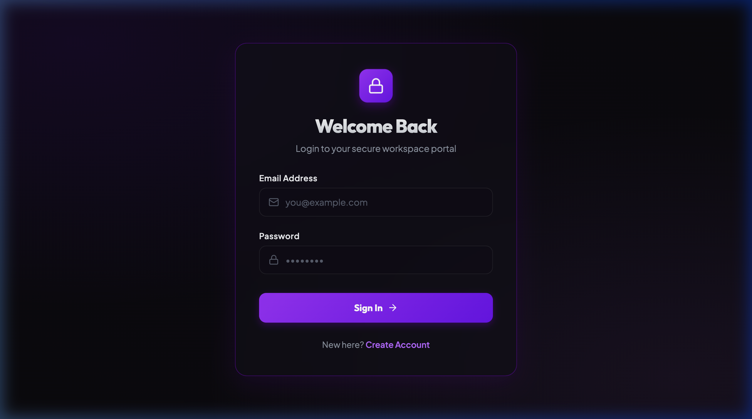
MERN Authentication App components structure representation.

Output 11.12 – Task4 Protected Routes Components
import React from 'react';
import { Navigate } from 'react-router-dom';
const ProtectedRoute = ({ children }) => {
const token = localStorage.getItem('token');
if (!token) {
return <Navigate to='/login' replace />;
}
return children;
};
export default ProtectedRoute;
The ProtectedRoute.jsx component blocks unauthorized access to secure pages.

OUTPUTS LIST BASED ON 5 TASKS –
TASK - USER AUTHENTICATION MODULE USING JWT
Output 11.1 – Server and Mongo DB Connection
Output 11.2 – API auth Login
TASK - LOGIN AND REGISTRATION APIs USING Express.js
Output 11.3 – API Auth Registration
TASK – REACT FORMS WITH VALIDATION
Output 11.4 – React Form
Output 11.5 – React Form with Valid Email Requirement
Output 11.6 – React Form with Conditioned Password.
TASK - IMPLEMENT PROTECTED ROUTES IN REACTS
Output 11.7– Login Page on React
Output 11.8 – Protected Dashboard on React
TASK – PUSH CODE TO GITHUB AND SHARE REPOSITORY LINK
Output 11.9 – Today’s Task Codes In GitHub
Output 11.10 – My GitHub Repositories.
Output 11.11 - Mern Auth App Components
Output 11.12 – Task4 Protected Routes Components

FINAL CONCLUSION
This MERN internship project provided hands-on experience in full-stack web development. It covered authentication, backend API development, frontend form validation, route protection, and version control using GitHub. These tasks strengthened understanding of real-world application development using the MERN stack.

THANK YOU!

