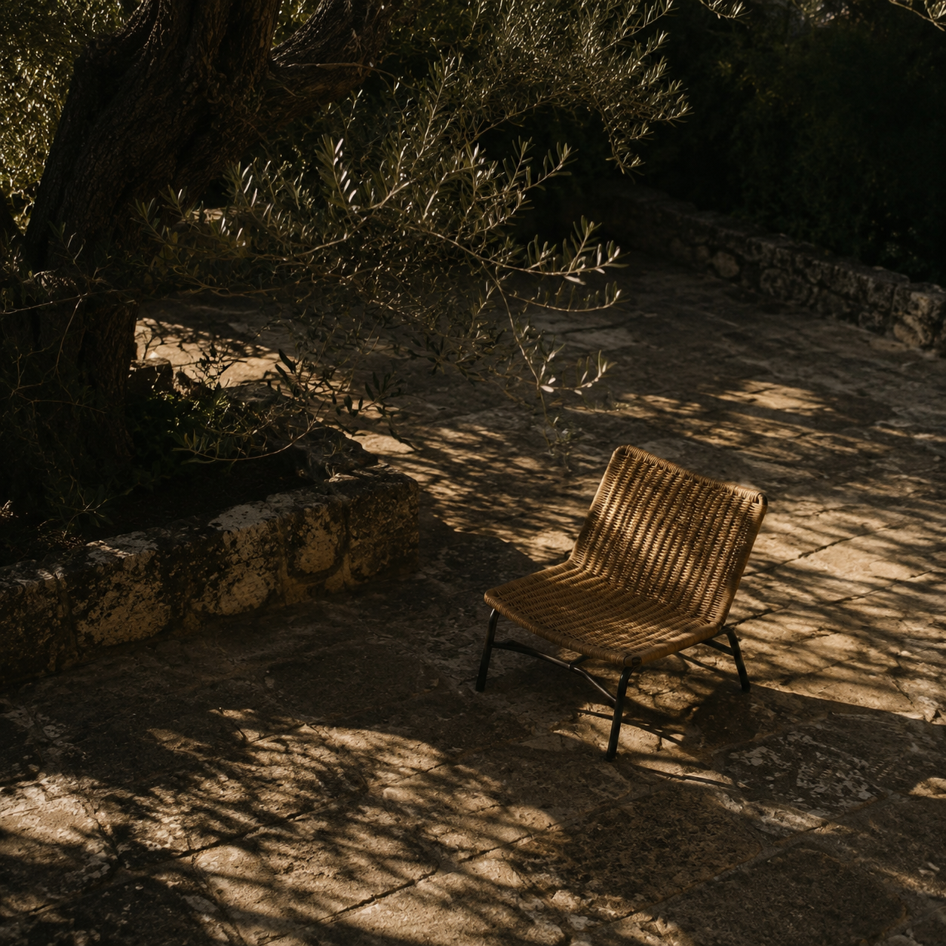

Runes AI website redesign research
Light mode landing page and product UI direction |  | Prepared for Runes AI  October 2026

Contents

Executive summary 2
At a glance 2
Introduction 2
Key findings 3
Context and conditions 3
Patterns in the evidence 3
Implications 3
Recommendations 4
Conclusion 4
Appendix 5
Notes 5
Sources 5

Executive summary
Runes AI should lead with the document a person can finish: write in Markdown or LaTeX, review a suggested prose change, and export a PDF. The current landing page leads with LaTeX and a feature inventory, while the product already supports both formats. The strongest references make the job and next action clear before explaining the machinery. This report translates those patterns into a light mode direction for the site and the editor.
The proposed identity is quiet and editorial: warm white canvas, dark ink, one deep green action color, and actual product footage. The hero should show a real source-to-review-to-PDF sequence. Use trust proof from the product itself until Runes has verified customer evidence. External examples are current page observations, not evidence that a pattern improves conversion.

At a glance
- Lead with one promise: write a document, review AI edits, and leave with a PDF.
- Show the three states in one honest demo: selected prose, diff approval, and current PDF.
- Build light mode across landing, dashboard, and editor from shared tokens and controls.

Introduction
Runes AI is a source editor with Markdown and LaTeX documents, AI prose completion, a controlled paraphrase review, and PDF compilation. The existing page already uses a real editor screenshot and concrete feature copy. Its hero says "Write LaTeX with reviewed AI edits" and the page uses a charcoal token system. These are solid raw materials, but the page underrepresents Markdown and the full document workflow. The dashboard and editor also contain hard-coded dark surfaces outside the central tokens.
I reviewed live product pages on 24 October 2026 and checked YC listings for Anara, Extend, Reducto, and Drafted [1-4]. Granola and Notion are adjacent editorial references [5-6]. The comparison is qualitative. It covers page hierarchy, product demonstration, trust cues, calls to action, and transferable component patterns.

Key findings
Each reference names a job before listing features. Anara promises research with verifiable citations; Extend names its document tasks; Reducto says "Turn documents into data"; Drafted names the output, house plans [1-4]. Their pages show the product doing that job. Runes can use the same clarity with its own language and visuals.

Context and conditions
The current page has a real screenshot, a clear primary button, and a differentiator: users review AI suggestions as diffs before changing source. Keep those. Markdown is absent from the headline and several sections. Marketing has dark-only tokens, while dashboard and editor files use separate charcoal hex values. Two Button implementations and several modal patterns make a full light redesign harder to keep consistent.

Patterns in the evidence
Anara and Granola start with a concise promise, then show work inside the product [1,5]. Extend and Reducto place examples and evidence near claims [2,3]. Drafted shows an artifact and how to make it [4]. Runes should show a readable PDF beside editable source and the approval step, near the first call to action.

Key takeaway. Make editorial control visible. Runes suggests prose changes, shows the exact diff, and waits for approval before the source or PDF changes.

Implications
Define light-mode roles for canvas, surface, text, border, action, focus, status, and code. Carry them through navigation, search, document cards, editor chrome, diff review, preview, and dialogs. Use color and labels together for changed, stale, saved, and error states. A landing page and product UI should share the same visual language.
Theme | Observed pattern | Runes implication
Promise | Specific outcome before feature list | Name document, review, PDF
Proof | Real UI and finished artifact | Show diff beside source and PDF
Trust | Claim next to evidence | Use verifiable behavior, not fake logos

Recommendations
Build the landing page around the task: arrive, understand, inspect the workflow, then start a document. The first release should use screenshots or a short recording captured from the redesigned app. Avoid invented testimonials, decorative analytics, abstract 3D blobs, and a wall of equal-sized feature cards.
- Set the story. Test a hero such as "Write the document. Review every AI edit." Explain Markdown and LaTeX, diff approval, and PDF export in one sentence. Keep one dominant "Start writing" button and a lower-emphasis "See the workflow" link. On mobile, put the product proof directly after this copy.
- Build the system. Use a warm paper canvas (#FAFAF7), white work surfaces, ink (#17201B), and deep green (#1D5A43) for the main action. Treat these as proposed tokens and check rendered contrast before release. Keep Geist for UI; let document content carry any editorial type accent. Consolidate buttons, fields, tabs, badges, dialogs, and empty states into one component contract.
- Validate the work. Prototype the landing page and one complete light-mode path through document creation, a proposed edit, approval, and PDF preview. Test at desktop and narrow mobile widths. Ask new users what Runes does after five seconds, then observe whether they can create a document and find the review step. Track completion and confusion, not just button clicks.

Conclusion
A useful first build has a quiet header, a task-led hero, a real three-state product demonstration, a short explanation of controlled AI edits, format-specific examples, and a final start action. The feature section should show meaningful transitions between source, review, and output. Secondary capabilities such as outline navigation and ghost text can appear after the main loop is understood.
Start by aligning the product screens and shared controls, then capture new product visuals for the page. This order keeps the marketing evidence accurate. The visual direction should feel like a writing tool: large readable type, generous whitespace around the document, precise borders, and deliberate states. Its character comes from the actual work shown, not stock AI effects.

Appendix

Notes
Scope: live pages were reviewed on 24 October 2026. YC profile pages verify the four company selections. The visual recommendations are design judgments based on those pages and the Runes repository; they are not measured usability findings. Competitor claims and metrics were not independently tested.
Release checks: body text should meet WCAG 2.2 AA contrast of at least 4.5:1, and large text at least 3:1. Pointer targets should meet the 24 by 24 CSS pixel minimum or its spacing exceptions [7]. Check keyboard focus, reduced motion, mobile line lengths, empty/error states, and product imagery after the light theme is applied.

Sources
- [1] Anara, homepage and YC company profile. anara.com; ycombinator.com/companies/anara. Accessed 24 Oct 2026.
- [2] Extend, homepage and YC company profile. extend.ai; ycombinator.com/companies/extend. Accessed 24 Oct 2026.
- [3] Reducto, homepage and YC company profile. reducto.ai; ycombinator.com/companies/reducto. Accessed 24 Oct 2026.
- [4] Drafted, homepage and YC company profile. drafted.ai; ycombinator.com/companies/drafted. Accessed 24 Oct 2026.
- [5] Granola, homepage. granola.ai. Accessed 24 Oct 2026.
- [6] Notion, AI product page. notion.com/product/ai. Accessed 24 Oct 2026.
- [7] W3C WAI, WCAG 2.2 Understanding 1.4.3 Contrast Minimum and 2.5.8 Target Size Minimum. w3.org/WAI/WCAG22/Understanding/. Accessed 24 Oct 2026.

Method note. Runes product and implementation observations come from the project README, landing components, global tokens, dashboard, and editor files reviewed on 24 Oct 2026.

