import pandas as pd
import matplotlib.pyplot as plt

# 1. Create the CSV file
data = {
'Grade': ['F', 'E', 'D', 'C', 'B', 'A', 'S'],
'Number_of_Students': [3, 4, 5, 8, 9, 7, 4]
}

df = pd.DataFrame(data)
df.to_csv('student_grades.csv', index=False)

print("CSV file created successfully.")

# 2. Read the CSV file using Pandas
df = pd.read_csv('student_grades.csv')

print("\nStudent Grade Data:")
print(df)

# 3. Validate the data
required_grades = ['F', 'E', 'D', 'C', 'B', 'A', 'S']

if (df['Grade'].tolist() != required_grades
or df['Grade'].nunique() != 7
or df['Number_of_Students'].isnull().any()
or (df['Number_of_Students'] < 0).any()
or not (df['Number_of_Students'] % 1 == 0).all()
or df['Number_of_Students'].sum() != 40):

print("\nInvalid data! Check grades and student counts.")

else:
print("\nData validation successful.")

# 4. Calculate percentages
total = df['Number_of_Students'].sum()

df['Percentage'] = (
df['Number_of_Students'] / total
) * 100

# 5. Display number and percentage for each grade
print("\nGrade-wise Student Performance:")
print(df.to_string(
index=False,
formatters={'Percentage': '{:.2f}%'.format}
))

# 6. Generate pie chart
plt.figure(figsize=(8, 6))

plt.pie(
df['Number_of_Students'],
labels=df['Grade'],
autopct='%1.1f%%',
startangle=90
)

plt.title('Percentage Distribution of Student Grades')
plt.legend(df['Grade'], title='Grades')
plt.tight_layout()
plt.savefig('grade_pie_chart.png')
plt.show()

# 7. Generate bar chart
plt.figure(figsize=(8, 6))

bars = plt.bar(
df['Grade'],
df['Number_of_Students'],
label='Number of Students'
)

plt.xlabel('Grades')
plt.ylabel('Number of Students')
plt.title('Number of Students in Each Grade')
plt.legend()

# Display exact values above bars
for bar in bars:
height = bar.get_height()
plt.text(
bar.get_x() + bar.get_width() / 2,
height + 0.1,
str(int(height)),
ha='center',
va='bottom'
)

plt.tight_layout()
plt.savefig('grade_bar_chart.png')
plt.show()

# 8. Find highest and lowest grades
highest = df['Number_of_Students'].max()
lowest = df['Number_of_Students'].min()

highest_grades = df.loc[
df['Number_of_Students'] == highest, 'Grade'
].tolist()

lowest_grades = df.loc[
df['Number_of_Students'] == lowest, 'Grade'
].tolist()

print("\nHighest number of students:", highest)
print("Grade(s) with highest count:", highest_grades)

print("\nLowest number of students:", lowest)
print("Grade(s) with lowest count:", lowest_grades)

print("\nCharts saved successfully:")
print("grade_pie_chart.png")
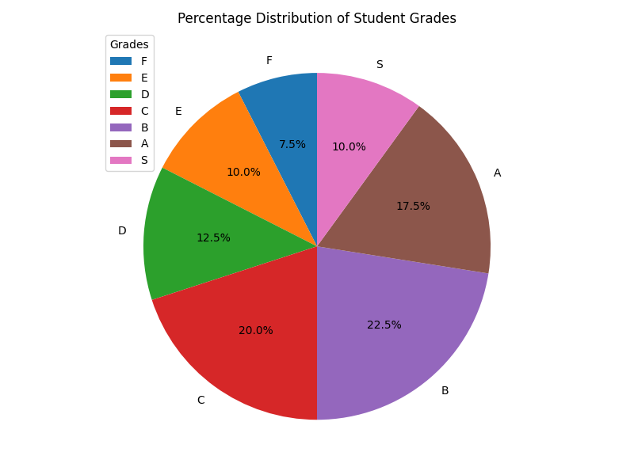
print("grade_bar_chart.png")

