PipeScout

Consolidated local training-run evidence
Generated 15 October 2026 from the local dataset_crack run folders. 35 training-attempt folders inventoried.
Scope: dataset_crack/runs/pipe_proto, dataset_crack/runs/detect/runs/pipe_proto, and dataset_crack/notebook/runs. This is an artifact inventory, not a new evaluation or a ranking across different data splits.

Reading notes
- YOLO validation figures use the best results.csv row by mAP50-95; RF-DETR validation figures use saved best_validation_metrics.json. Validation and held-out test scores are not interchangeable.
- YOLO GFLOPs are nominal forward-pass estimates measured with Ultralytics get_flops/THOP at each checkpoint's saved image size. RF-DETR GFLOPs are unavailable because no verified comparable measurement is stored; checkpoint byte size is not FLOPs.
- YOLO training time is the last cumulative results.csv time. RF-DETR did not log wall-clock duration; where shown, its time is only the approximate local timestamp window from experiment metadata creation to final config write.
- Parameter counts and model size refer to the saved checkpoint where available. Missing values are marked unavailable. Incomplete and resumed runs are not presented as fully trained independent models.
- All saved top-level plot images (training chart, label distribution, F1/PR/P/R curves and confusion matrices) are embedded for each attempt and linked evaluation folder. Train/validation batch example photos and individual false-positive/false-negative crops are not plots and are excluded.

Performance overview
Run | State | Epochs | Dataset | Val P | Val R | Val mAP50 | Val mAP50-95
rfdetr_nano_v5_normal_512_seed0_20261001_181318_e7e98d | partial / resumed | 1–21 / 40 | final_dataset_v5 | 87.50% | 79.12% | 86.62% | 69.58%
rfdetr_nano_v5_normal_512_seed0_20261002_193202_f6bd13 | complete continuation | 22–40 / 40 | final_dataset_v5 | 87.82% | 84.55% | 89.56% | 74.84%
rfdetr_nano_v5_normal_512_seed0_20261003_193042_66b2b7 | complete continuation | 41–50 / 50 | final_dataset_v5 | 89.90% | 84.81% | 90.65% | 76.51%
yolo26n_v4_pipe_cctv_clahe | interrupted / partial | 19 / 100 | final_dataset_v4_clahe | 33.58% | 20.52% | 16.49% | 8.58%
yolo26n_v4_pipe_cctv_clahe-2 | initialized only | Unavailable | final_dataset_v4_clahe | Unavailable | Unavailable | Unavailable | Unavailable
yolo26n_v4_pipe_cctv_clahe-3 | interrupted / partial | 98 / 100 | final_dataset_v4_clahe | 39.20% | 29.23% | 25.86% | 13.38%
yolo26s_v5_cctv | complete | 80 / 80 | final_dataset_v5 | 80.27% | 76.13% | 82.54% | 65.61%
yolo26s_v5_clahe_cbam | complete | 80 / 80 | final_dataset_v5_clahe | 76.85% | 77.94% | 82.66% | 63.50%
yolo26s_v5_clahe_se | complete | 80 / 80 | final_dataset_v5_clahe | 77.47% | 76.48% | 82.24% | 62.82%
yolo26s_v5_clahe_simam | complete | 80 / 80 | final_dataset_v5_clahe | 81.49% | 74.55% | 82.45% | 64.47%
yolo26s_v5_parallel_simam_cbam_se | complete | 80 / 80 | final_dataset_v5 | 79.86% | 73.50% | 82.13% | 63.88%
yolo26s_v6_normal_error_filtered_diagnostic_seed0_20260929_184244_3e235d15 | complete | 80 / 80 | final_dataset_v6 | 80.27% | 76.13% | 82.54% | 65.61%
yolo26s_v6_normal_error_filtered_diagnostic_seed0_20260930_185252_27442ffa | interrupted / partial | 4 / 80 | final_dataset_v6 | 19.52% | 18.48% | 9.80% | 4.15%
yolo26s_v6_normal_error_filtered_diagnostic_seed0_20260930_190356_a5b23911 | complete | 80 / 80 | final_dataset_v6 | 82.00% | 64.24% | 65.61% | 52.63%
yolo26n_cbam_v1 | initialized only | Unavailable | sewer_remapped | Unavailable | Unavailable | Unavailable | Unavailable
yolo26n_cbam_v1-2 | complete | 80 / 80 | sewer_remapped | 49.55% | 31.46% | 33.85% | 18.76%
yolo26n_cbam_v1_140ep | complete | 140 / 140 | sewer_remapped | 43.60% | 33.09% | 32.00% | 18.72%
yolo26n_final_merged | initialized only | Unavailable | final_dataset | Unavailable | Unavailable | Unavailable | Unavailable
yolo26n_final_merged-2 | initialized only | Unavailable | final_dataset | Unavailable | Unavailable | Unavailable | Unavailable
yolo26n_final_merged-3 | complete | 80 / 80 | final_dataset | 34.54% | 40.73% | 32.79% | 18.69%
yolo26n_final_merged-4 | initialized only | Unavailable | final_dataset_v2 | Unavailable | Unavailable | Unavailable | Unavailable
yolo26n_final_merged-5 | interrupted / partial | 72 / 80 | final_dataset_v2 | 77.02% | 71.81% | 77.12% | 59.38%
yolo26n_final_merged-6 | complete | 80 / 80 | final_dataset_v2 | 78.29% | 70.04% | 77.57% | 58.85%
yolo26n_final_merged-7 | complete | 80 / 80 | final_dataset_v3 | 50.70% | 39.19% | 33.64% | 20.12%
yolo26n_simam_v1 | initialized only | Unavailable | sewer_remapped | Unavailable | Unavailable | Unavailable | Unavailable
yolo26n_simam_v1-2 | complete | 140 / 140 | sewer_remapped | 39.01% | 32.00% | 32.66% | 18.73%
yolo26n_simam_v1-3 | initialized only | Unavailable | sewer_remapped_ clahe | Unavailable | Unavailable | Unavailable | Unavailable
yolo26n_simam_v1-4 | complete | 80 / 80 | sewer_remapped_clahe | 33.09% | 36.51% | 29.44% | 16.24%
yolo26n_v1 | initialized only | Unavailable | sewer_remapped | Unavailable | Unavailable | Unavailable | Unavailable
yolo26n_v1-2 | initialized only | Unavailable | sewer_remapped | Unavailable | Unavailable | Unavailable | Unavailable
yolo26n_v1-3 | initialized only | Unavailable | sewer_remapped | Unavailable | Unavailable | Unavailable | Unavailable
yolo26n_v1-4 | complete | 80 / 80 | sewer_remapped | 46.00% | 42.78% | 36.19% | 20.76%
yolo26n_v1-5 | complete | 80 / 80 | sewer_remapped | 46.00% | 42.78% | 36.19% | 20.76%
E5_directional_v5_normal_seed0_20260928_185759_471e27 | complete | 80 / 80 | dataset | 80.64% | 73.57% | 82.02% | 63.72%
E6_E3_single_simam_v5_normal_seed0_20260928_225358_f163f4 | interrupted / partial | 4 / 80 | dataset | 18.77% | 13.23% | 9.80% | 4.38%
The RF-DETR 50-epoch run is a 10-epoch continuation of earlier local RF-DETR runs; its final best checkpoint has 90.65% validation mAP50 and 89.04% held-out test mAP50. The three RF-DETR filesystem time windows total approximately 18.0 h, but this is not a logged GPU-time measurement. Do not cite validation as test performance.

Compute and storage overview
Run | Parameters | GFLOPs | Input | Checkpoint | Training time
rfdetr_nano_v5_normal_512_seed0_20261001_181318_e7e98d | 30,333,500 | Unavailable | 512 | 121.6 MB | 7.33 h*
rfdetr_nano_v5_normal_512_seed0_20261002_193202_f6bd13 | 30,333,500 | Unavailable | 512 | 121.6 MB | 6.75 h*
rfdetr_nano_v5_normal_512_seed0_20261003_193042_66b2b7 | 30,333,500 | Unavailable | 512 | 121.6 MB | 3.93 h*
yolo26n_v4_pipe_cctv_clahe | 2,508,090 | 5.914 | 640 | 20.8 MB | 0.10 h
yolo26n_v4_pipe_cctv_clahe-2 | Unavailable | Unavailable | 640 | Unavailable | Unavailable
yolo26n_v4_pipe_cctv_clahe-3 | 9,956,378 | 22.783 | 640 | 20.3 MB | 0.79 h
yolo26s_v5_cctv | 9,951,734 | 22.757 | 640 | 20.3 MB | 3.19 h
yolo26s_v5_clahe_cbam | 9,953,880 | 22.760 | 640 | 20.3 MB | 3.29 h
yolo26s_v5_clahe_se | 9,953,918 | 22.758 | 640 | 20.3 MB | 3.18 h
yolo26s_v5_clahe_simam | 9,951,734 | 22.757 | 640 | 20.3 MB | 3.46 h
yolo26s_v5_parallel_simam_cbam_se | 10,021,857 | 23.607 | 640 | 20.5 MB | 3.59 h
yolo26s_v6_normal_error_filtered_diagnostic_seed0_20260929_184244_3e235d15 | 9,951,734 | 22.757 | 640 | 20.3 MB | 3.20 h
yolo26s_v6_normal_error_filtered_diagnostic_seed0_20260930_185252_27442ffa | 9,951,734 | 22.757 | 640 | 80.4 MB | 0.13 h
yolo26s_v6_normal_error_filtered_diagnostic_seed0_20260930_190356_a5b23911 | 9,951,734 | 22.757 | 640 | 20.3 MB | 2.50 h
yolo26n_cbam_v1 | Unavailable | Unavailable | 640 | Unavailable | Unavailable
yolo26n_cbam_v1-2 | 2,510,008 | 5.903 | 640 | 5.4 MB | 0.52 h
yolo26n_cbam_v1_140ep | 2,510,008 | 5.903 | 640 | 5.4 MB | 0.84 h
yolo26n_final_merged | Unavailable | Unavailable | 640 | Unavailable | Unavailable
yolo26n_final_merged-2 | Unavailable | Unavailable | 640 | Unavailable | Unavailable
yolo26n_final_merged-3 | 2,505,750 | 5.901 | 640 | 5.4 MB | 1.78 h
yolo26n_final_merged-4 | Unavailable | Unavailable | 640 | Unavailable | Unavailable
yolo26n_final_merged-5 | 2,505,750 | 5.901 | 640 | 20.8 MB | 3.12 h
yolo26n_final_merged-6 | 2,505,750 | 5.901 | 640 | 5.4 MB | 2.99 h
yolo26n_final_merged-7 | 2,505,750 | 5.901 | 640 | 5.4 MB | 1.08 h
yolo26n_simam_v1 | Unavailable | Unavailable | 640 | Unavailable | Unavailable
yolo26n_simam_v1-2 | 2,505,750 | 5.901 | 640 | 5.4 MB | 0.84 h
yolo26n_simam_v1-3 | Unavailable | Unavailable | 640 | Unavailable | Unavailable
yolo26n_simam_v1-4 | 2,505,750 | 5.901 | 640 | 5.4 MB | 0.48 h
yolo26n_v1 | Unavailable | Unavailable | 640 | Unavailable | Unavailable
yolo26n_v1-2 | Unavailable | Unavailable | 640 | Unavailable | Unavailable
yolo26n_v1-3 | Unavailable | Unavailable | 640 | Unavailable | Unavailable
yolo26n_v1-4 | 2,505,750 | 5.901 | 640 | 5.4 MB | 0.54 h
yolo26n_v1-5 | 2,505,750 | 5.901 | 640 | 5.4 MB | 0.48 h
E5_directional_v5_normal_seed0_20260928_185759_471e27 | 9,986,551 | 23.206 | 640 | 20.4 MB | 3.26 h
E6_E3_single_simam_v5_normal_seed0_20260928_225358_f163f4 | 11,319,447 | 39.137 | 640 | 91.7 MB | 2.93 h
* RF-DETR time is an approximate filesystem timestamp window, not a recorded training-time metric. Checkpoint MB uses decimal megabytes (1 MB = 1,000,000 bytes).

1. rfdetr_nano_v5_normal_512_seed0_20261001_181318_e7e98d
Field | Recorded value
Family | RF-DETR Nano
State | partial / resumed
Epochs observed / target | 1–21 / 40
Dataset | final_dataset_v5
Image size | 512
Source folder | dataset_crack/runs/pipe_proto/rfdetr_nano_v5_normal_512_seed0_20261001_181318_e7e98d
Checkpoint | dataset_crack/runs/pipe_proto/rfdetr_nano_v5_normal_512_seed0_20261001_181318_e7e98d/checkpoint_best_ema.pth
Checkpoint size | 121.65 MB
Parameters | 30,333,500
GFLOPs | Unavailable
Training time | 7.33 h (approx. filesystem timestamp window, not measured GPU time)
Best validation | P 87.50%, R 79.12%, mAP50 86.62%, mAP50-95 69.58%
Held-out test artifact: mAP50 84.33%, mAP50-95 67.15%, P 85.15%, R 75.12%.

Saved and reconstructed plots
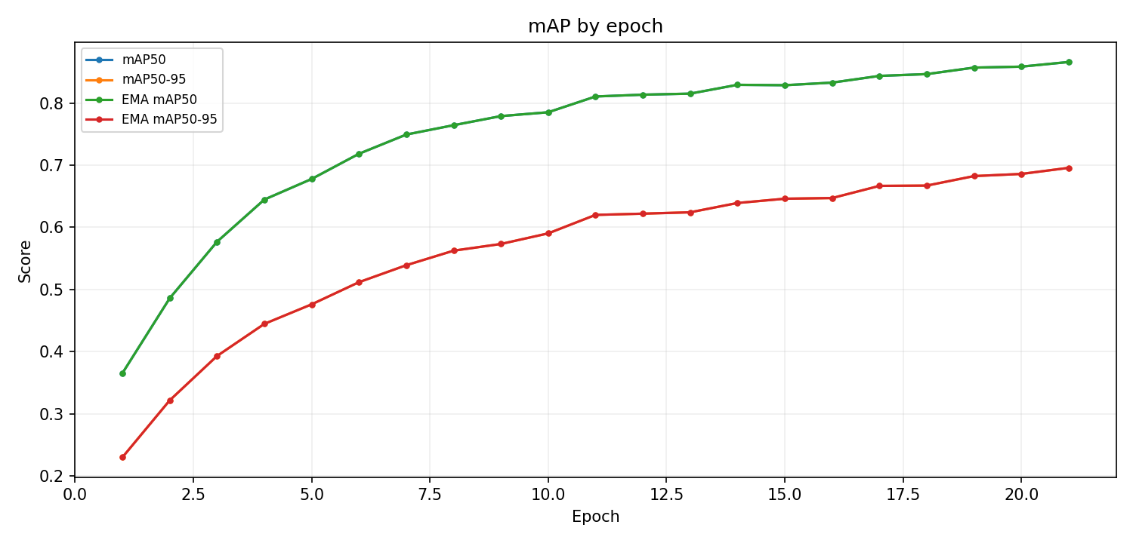
rf map — Reconstructed from dataset_crack/runs/pipe_proto/rfdetr_nano_v5_normal_512_seed0_20261001_181318_e7e98d/metrics.csv
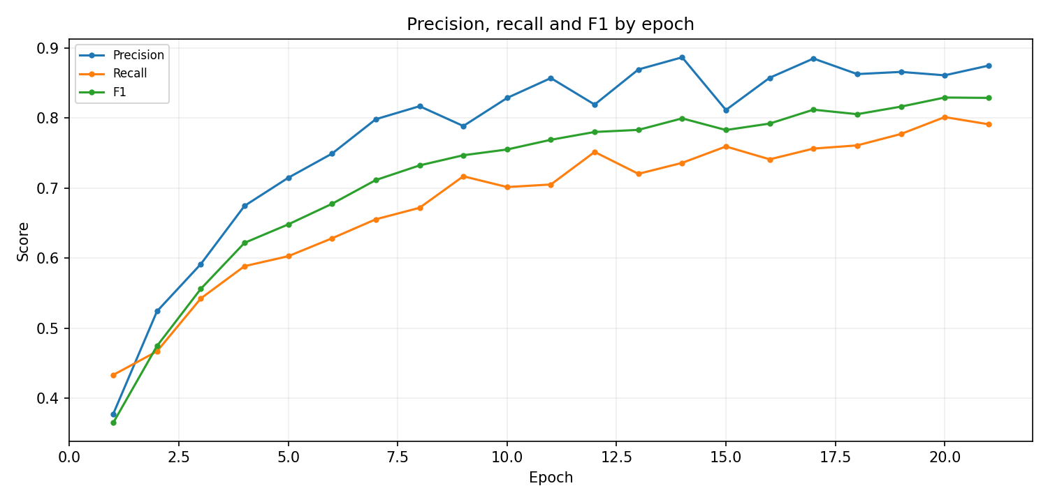
rf prf — Reconstructed from dataset_crack/runs/pipe_proto/rfdetr_nano_v5_normal_512_seed0_20261001_181318_e7e98d/metrics.csv
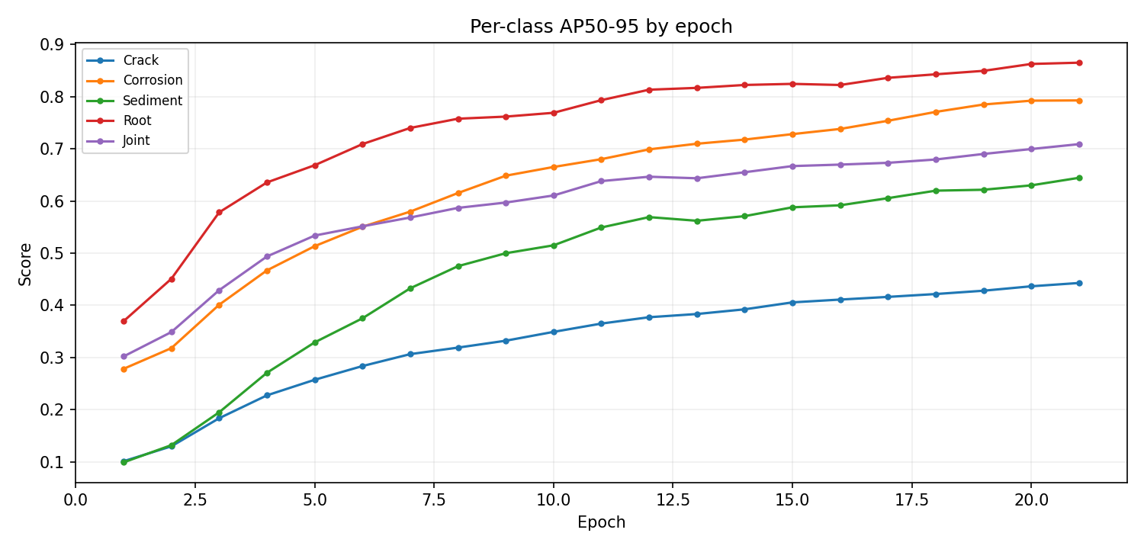
rf class ap — Reconstructed from dataset_crack/runs/pipe_proto/rfdetr_nano_v5_normal_512_seed0_20261001_181318_e7e98d/metrics.csv
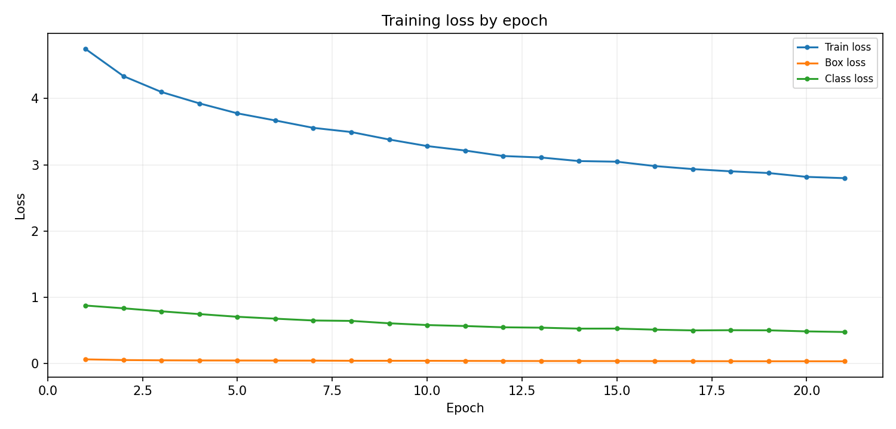
rf loss — Reconstructed from dataset_crack/runs/pipe_proto/rfdetr_nano_v5_normal_512_seed0_20261001_181318_e7e98d/metrics.csv

2. rfdetr_nano_v5_normal_512_seed0_20261002_193202_f6bd13
Field | Recorded value
Family | RF-DETR Nano
State | complete continuation
Epochs observed / target | 22–40 / 40
Dataset | final_dataset_v5
Image size | 512
Source folder | dataset_crack/runs/pipe_proto/rfdetr_nano_v5_normal_512_seed0_20261002_193202_f6bd13
Checkpoint | dataset_crack/runs/pipe_proto/rfdetr_nano_v5_normal_512_seed0_20261002_193202_f6bd13/checkpoint_best_total.pth
Checkpoint size | 121.64 MB
Parameters | 30,333,500
GFLOPs | Unavailable
Training time | 6.75 h (approx. filesystem timestamp window, not measured GPU time)
Best validation | P 87.82%, R 84.55%, mAP50 89.56%, mAP50-95 74.84%
Held-out test artifact: mAP50 87.21%, mAP50-95 71.77%, P 87.26%, R 80.25%.

Saved and reconstructed plots
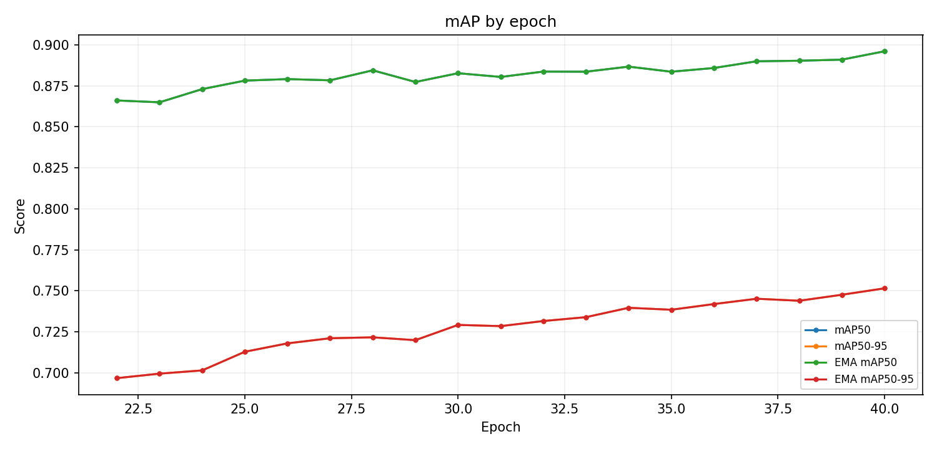
rf map — Reconstructed from dataset_crack/runs/pipe_proto/rfdetr_nano_v5_normal_512_seed0_20261002_193202_f6bd13/metrics.csv
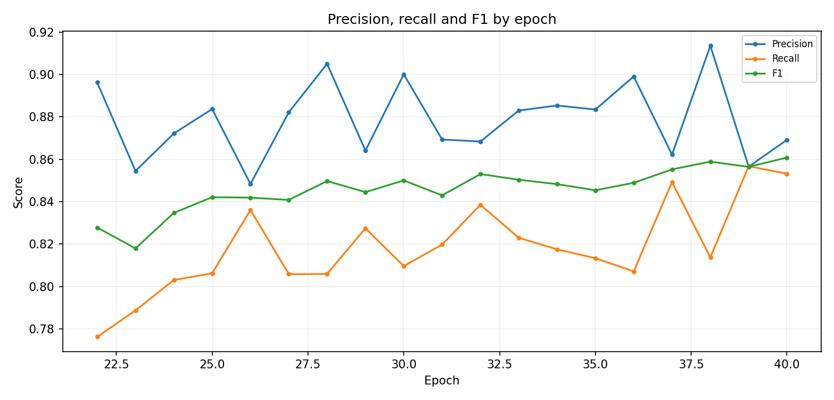
rf prf — Reconstructed from dataset_crack/runs/pipe_proto/rfdetr_nano_v5_normal_512_seed0_20261002_193202_f6bd13/metrics.csv
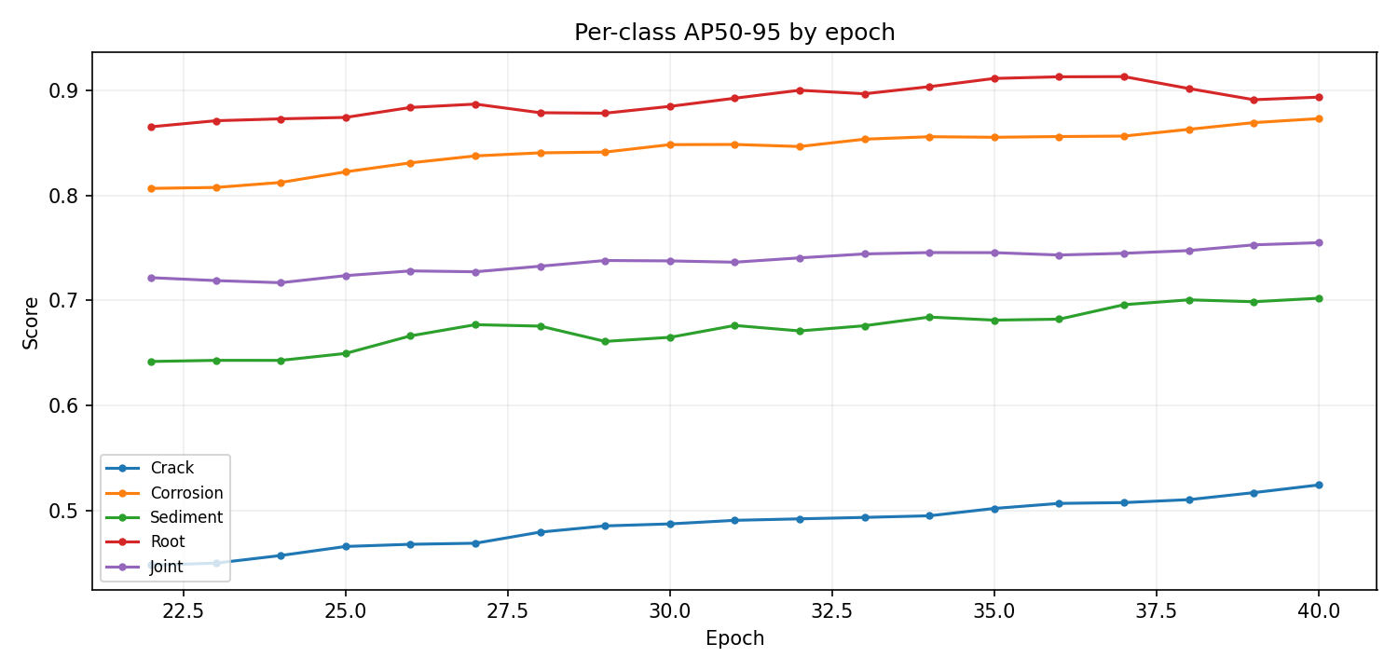
rf class ap — Reconstructed from dataset_crack/runs/pipe_proto/rfdetr_nano_v5_normal_512_seed0_20261002_193202_f6bd13/metrics.csv
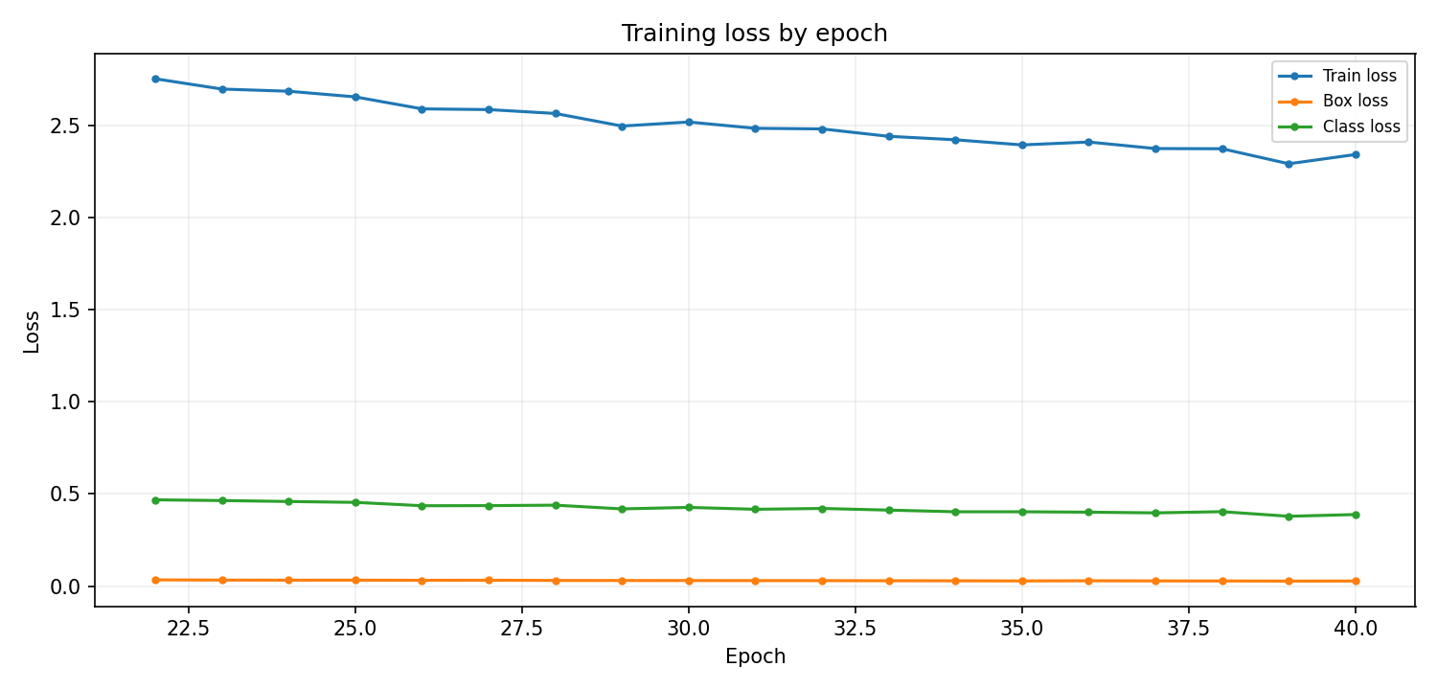
rf loss — Reconstructed from dataset_crack/runs/pipe_proto/rfdetr_nano_v5_normal_512_seed0_20261002_193202_f6bd13/metrics.csv

3. rfdetr_nano_v5_normal_512_seed0_20261003_193042_66b2b7
Field | Recorded value
Family | RF-DETR Nano
State | complete continuation
Epochs observed / target | 41–50 / 50
Dataset | final_dataset_v5
Image size | 512
Source folder | dataset_crack/runs/pipe_proto/rfdetr_nano_v5_normal_512_seed0_20261003_193042_66b2b7
Checkpoint | dataset_crack/runs/pipe_proto/rfdetr_nano_v5_normal_512_seed0_20261003_193042_66b2b7/checkpoint_best_total.pth
Checkpoint size | 121.64 MB
Parameters | 30,333,500
GFLOPs | Unavailable
Training time | 3.93 h (approx. filesystem timestamp window, not measured GPU time)
Best validation | P 89.90%, R 84.81%, mAP50 90.65%, mAP50-95 76.51%
Held-out test artifact: mAP50 89.04%, mAP50-95 73.85%, P 86.34%, R 83.89%.

Saved and reconstructed plots
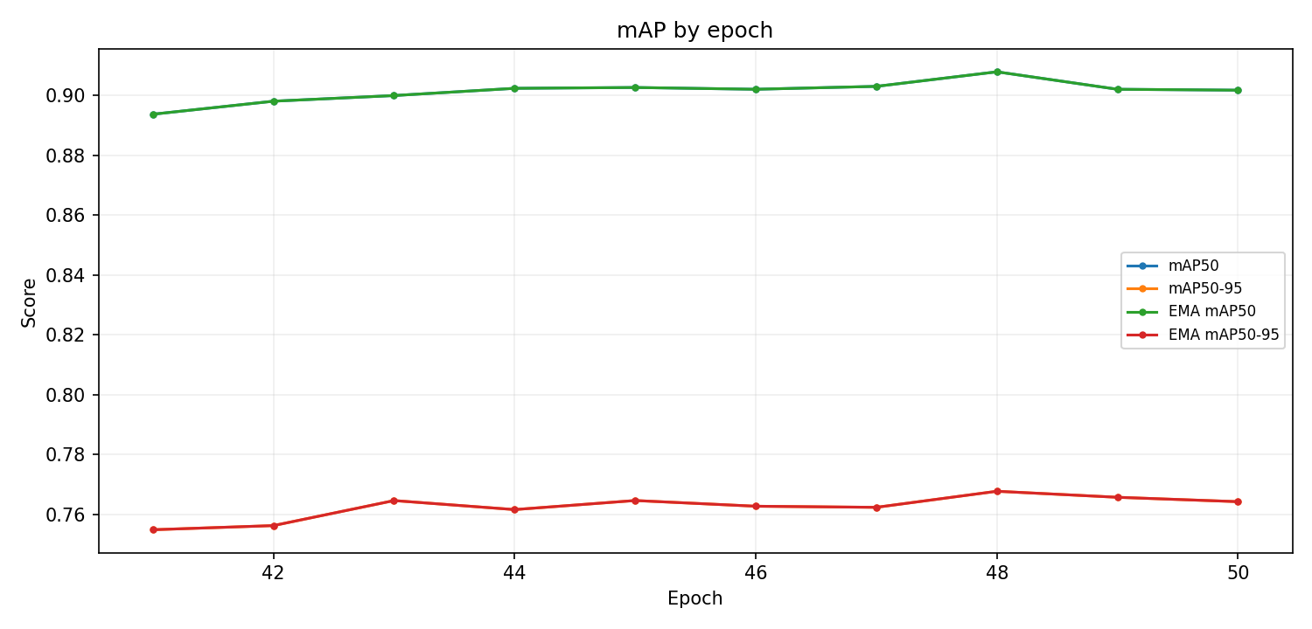
rf map — Reconstructed from dataset_crack/runs/pipe_proto/rfdetr_nano_v5_normal_512_seed0_20261003_193042_66b2b7/metrics.csv
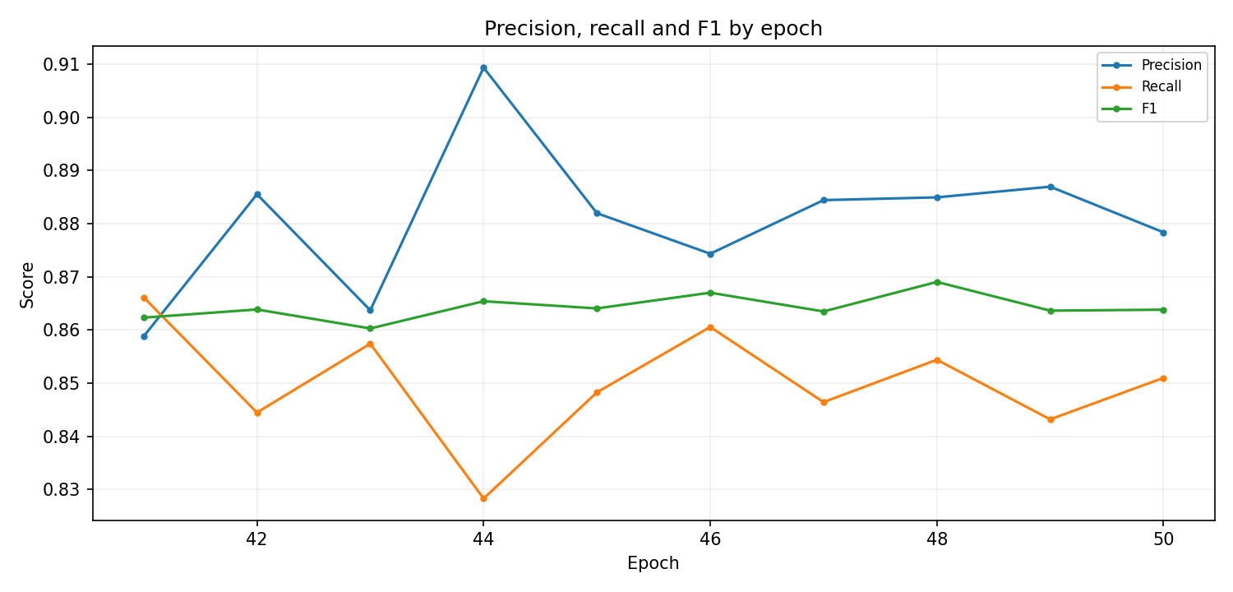
rf prf — Reconstructed from dataset_crack/runs/pipe_proto/rfdetr_nano_v5_normal_512_seed0_20261003_193042_66b2b7/metrics.csv
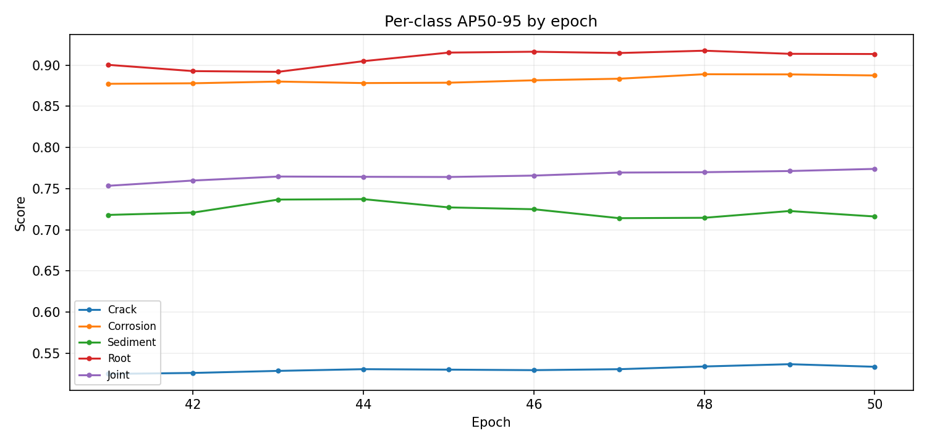
rf class ap — Reconstructed from dataset_crack/runs/pipe_proto/rfdetr_nano_v5_normal_512_seed0_20261003_193042_66b2b7/metrics.csv
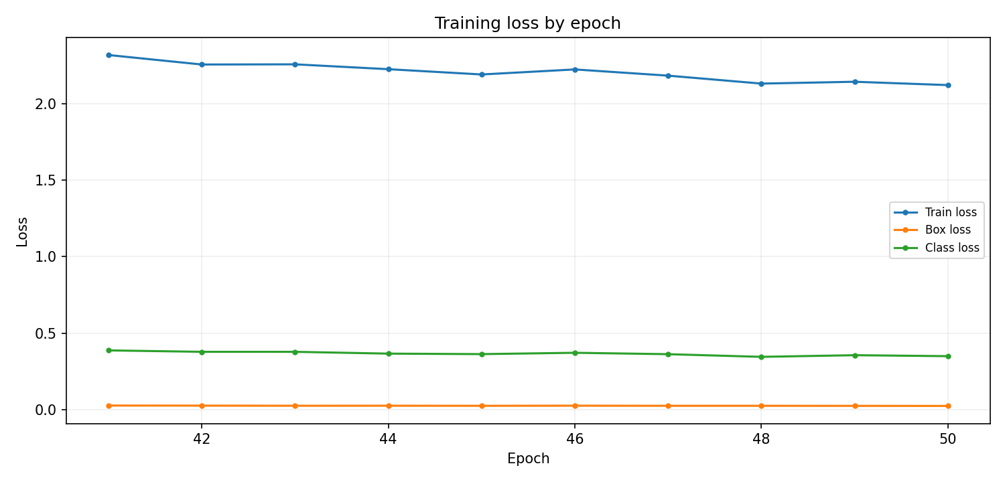
rf loss — Reconstructed from dataset_crack/runs/pipe_proto/rfdetr_nano_v5_normal_512_seed0_20261003_193042_66b2b7/metrics.csv

4. yolo26n_v4_pipe_cctv_clahe
Field | Recorded value
Family | YOLO
State | interrupted / partial
Epochs observed / target | 19 / 100
Dataset | final_dataset_v4_clahe
Image size | 640
Source folder | dataset_crack/runs/pipe_proto/yolo26n_v4_pipe_cctv_clahe
Checkpoint | dataset_crack/runs/pipe_proto/yolo26n_v4_pipe_cctv_clahe/weights/best.pt
Checkpoint size | 20.79 MB
Parameters | 2,508,090
GFLOPs | 5.914
Training time | 0.10 h (Ultralytics cumulative results.csv time)
Best validation | P 33.58%, R 20.52%, mAP50 16.49%, mAP50-95 8.58%

Saved and reconstructed plots
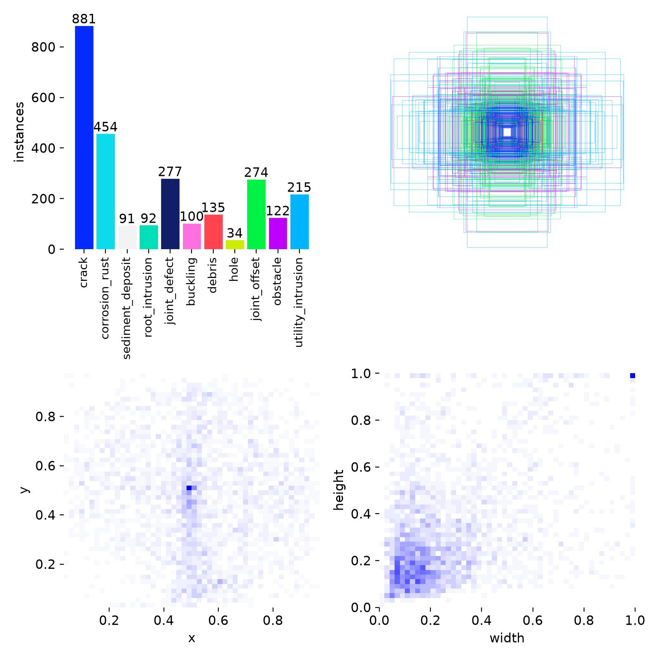
labels — dataset_crack/runs/pipe_proto/yolo26n_v4_pipe_cctv_clahe/labels.jpg

5. yolo26n_v4_pipe_cctv_clahe-2
Field | Recorded value
Family | YOLO
State | initialized only
Epochs observed / target | Unavailable
Dataset | final_dataset_v4_clahe
Image size | 640
Source folder | dataset_crack/runs/pipe_proto/yolo26n_v4_pipe_cctv_clahe-2
Checkpoint | Unavailable
Checkpoint size | Unavailable
Parameters | Unavailable
GFLOPs | Unavailable
Training time | Unavailable (not logged)
Best validation | P Unavailable, R Unavailable, mAP50 Unavailable, mAP50-95 Unavailable

Saved and reconstructed plots
labels — dataset_crack/runs/pipe_proto/yolo26n_v4_pipe_cctv_clahe-2/labels.jpg

6. yolo26n_v4_pipe_cctv_clahe-3
Field | Recorded value
Family | YOLO
State | interrupted / partial
Epochs observed / target | 98 / 100
Dataset | final_dataset_v4_clahe
Image size | 640
Source folder | dataset_crack/runs/pipe_proto/yolo26n_v4_pipe_cctv_clahe-3
Checkpoint | dataset_crack/runs/pipe_proto/yolo26n_v4_pipe_cctv_clahe-3/weights/best.pt
Checkpoint size | 20.33 MB
Parameters | 9,956,378
GFLOPs | 22.783
Training time | 0.79 h (Ultralytics cumulative results.csv time)
Best validation | P 39.20%, R 29.23%, mAP50 25.86%, mAP50-95 13.38%

Saved and reconstructed plots
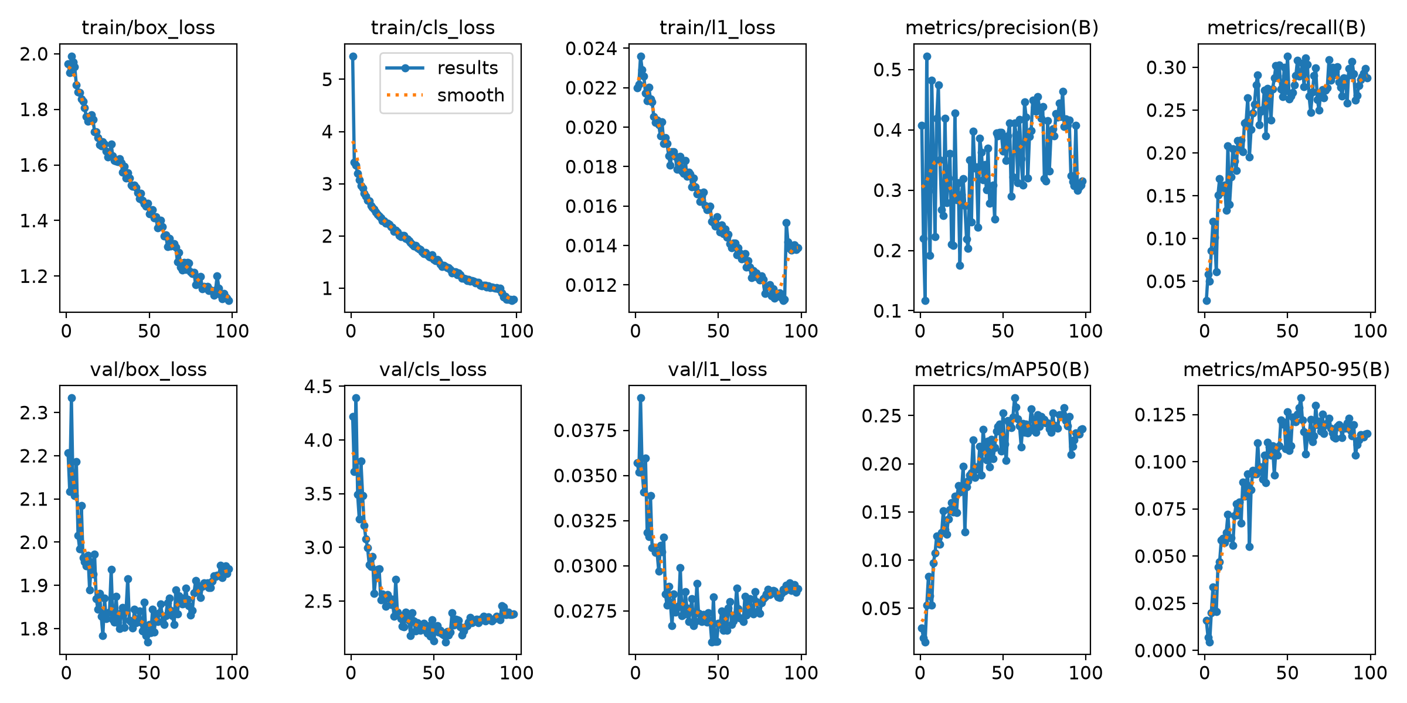
results — dataset_crack/runs/pipe_proto/yolo26n_v4_pipe_cctv_clahe-3/results.png
labels — dataset_crack/runs/pipe_proto/yolo26n_v4_pipe_cctv_clahe-3/labels.jpg
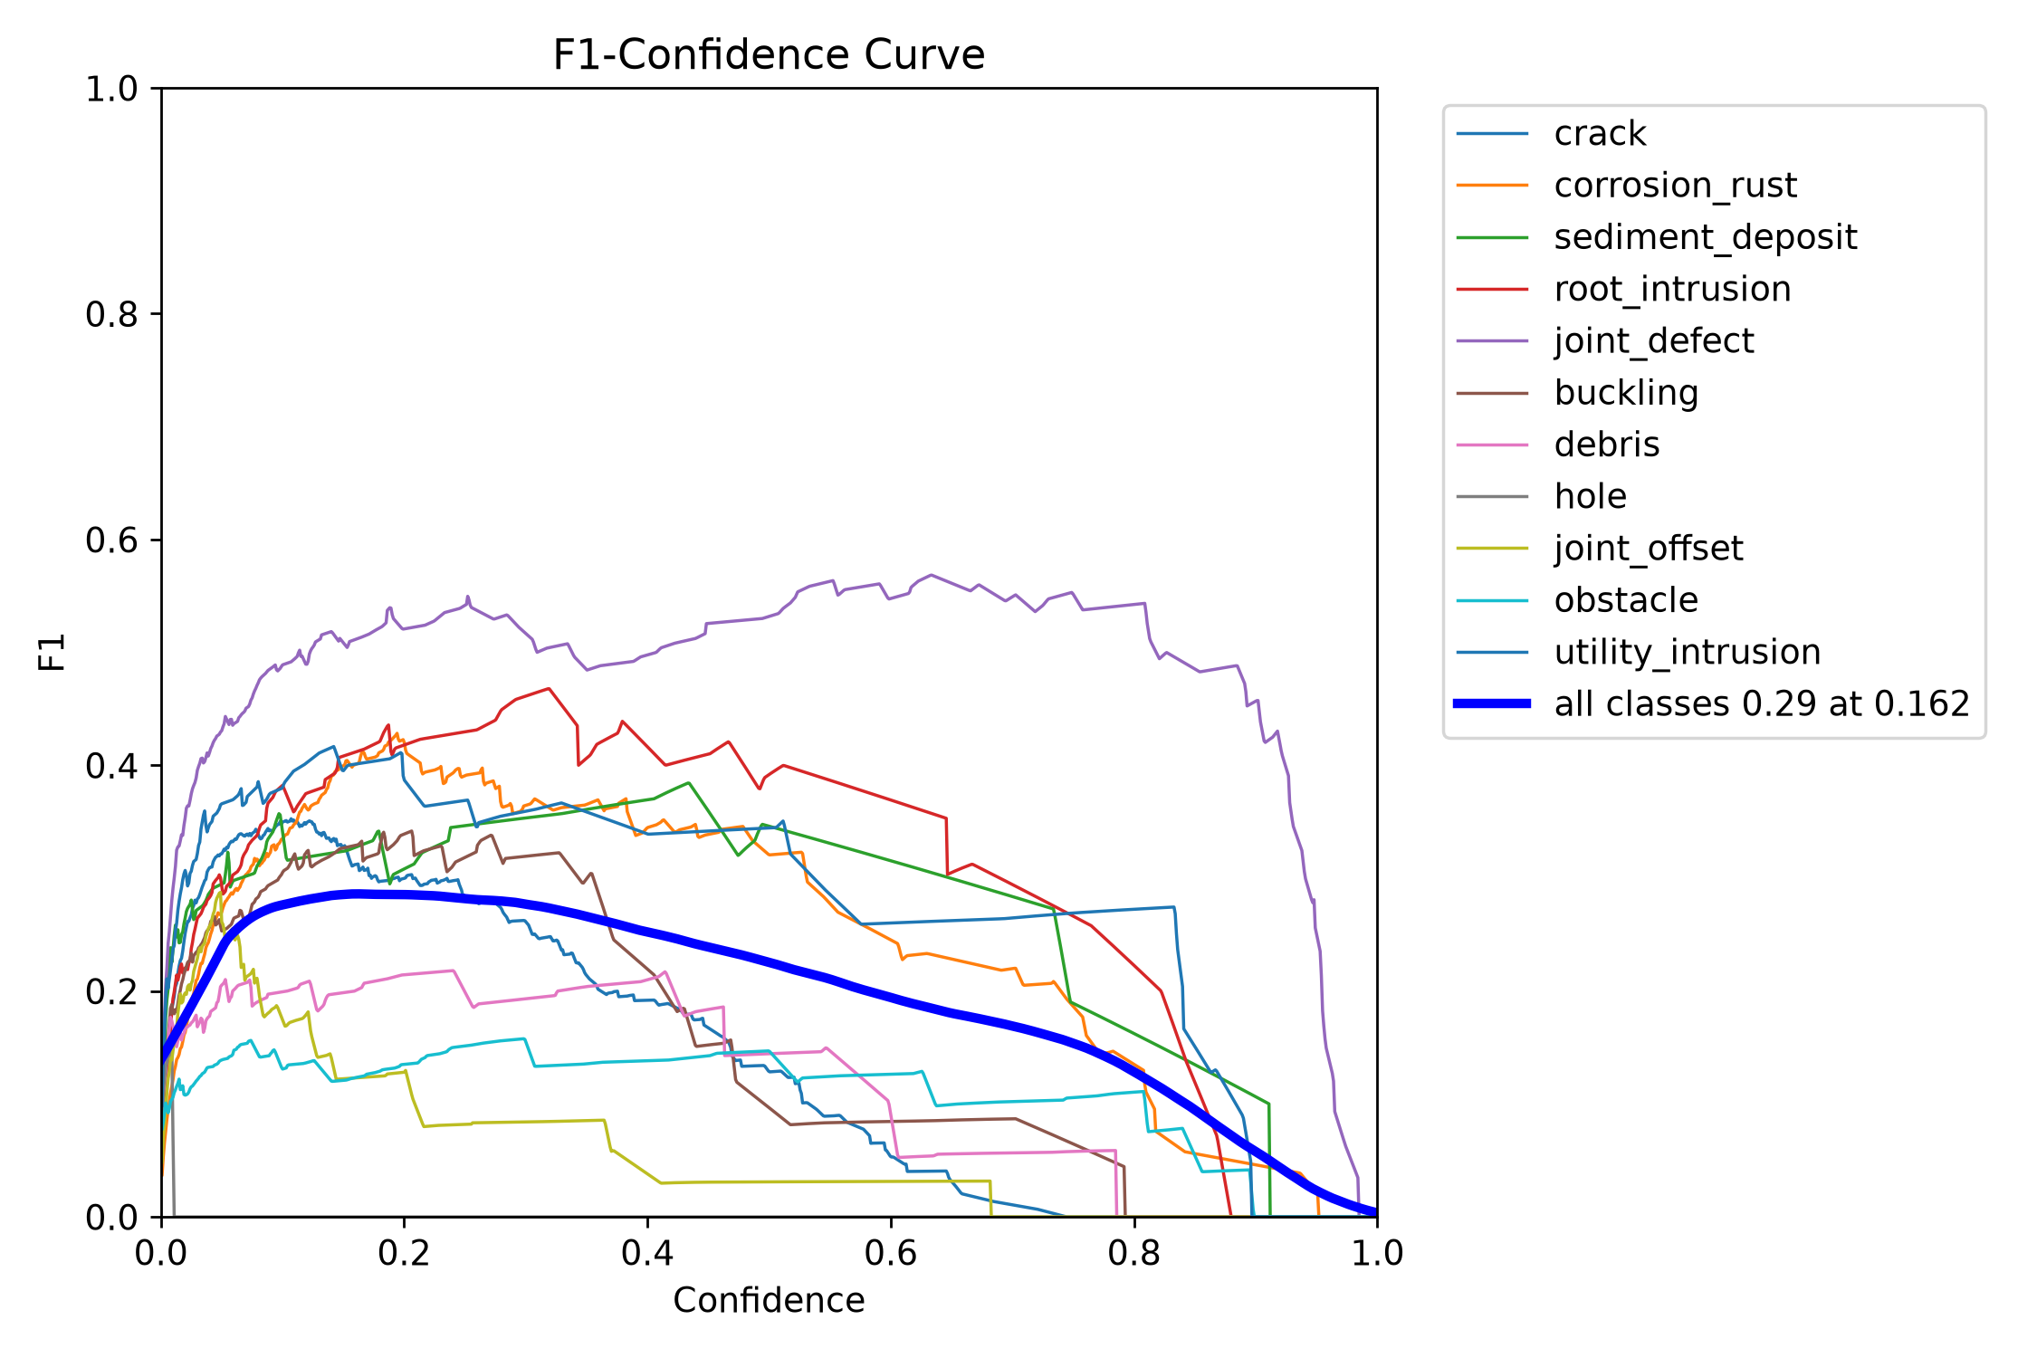
BoxF1 curve — dataset_crack/runs/pipe_proto/yolo26n_v4_pipe_cctv_clahe-3/BoxF1_curve.png
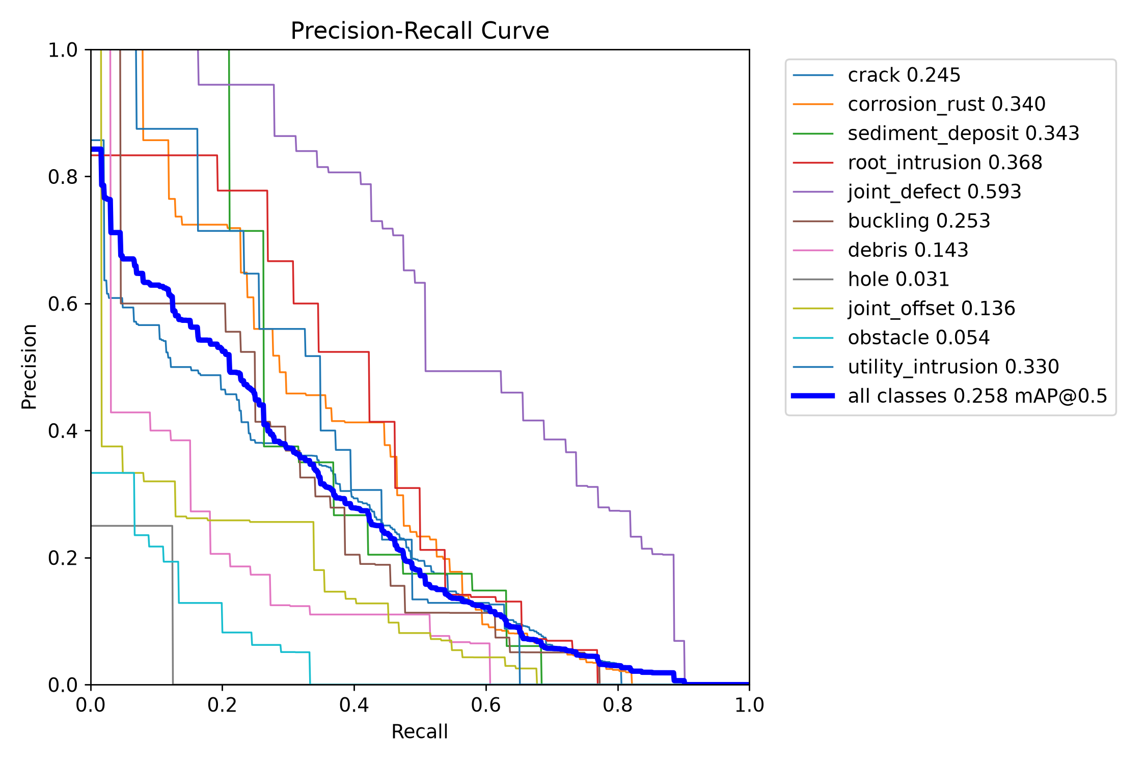
BoxPR curve — dataset_crack/runs/pipe_proto/yolo26n_v4_pipe_cctv_clahe-3/BoxPR_curve.png
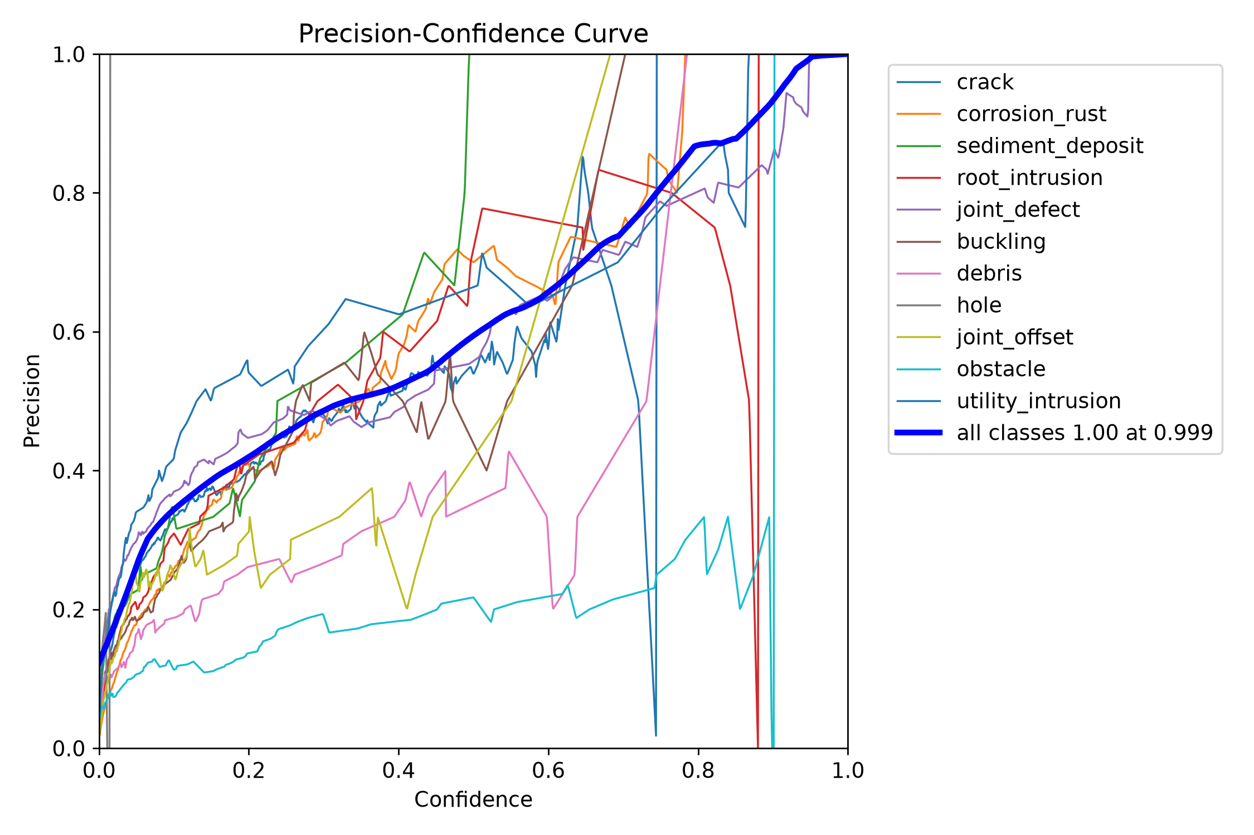
BoxP curve — dataset_crack/runs/pipe_proto/yolo26n_v4_pipe_cctv_clahe-3/BoxP_curve.png
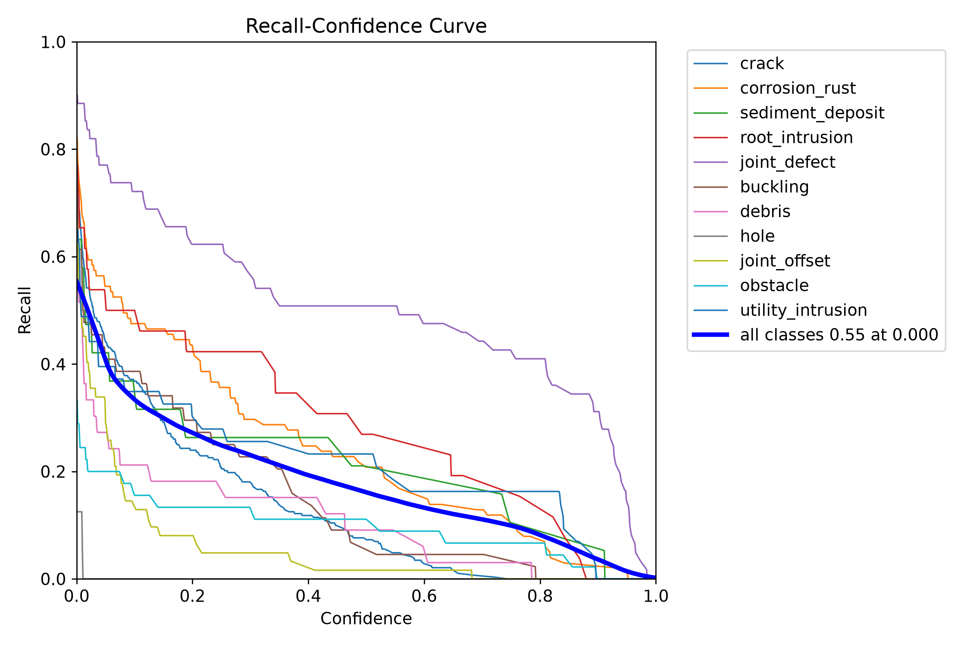
BoxR curve — dataset_crack/runs/pipe_proto/yolo26n_v4_pipe_cctv_clahe-3/BoxR_curve.png
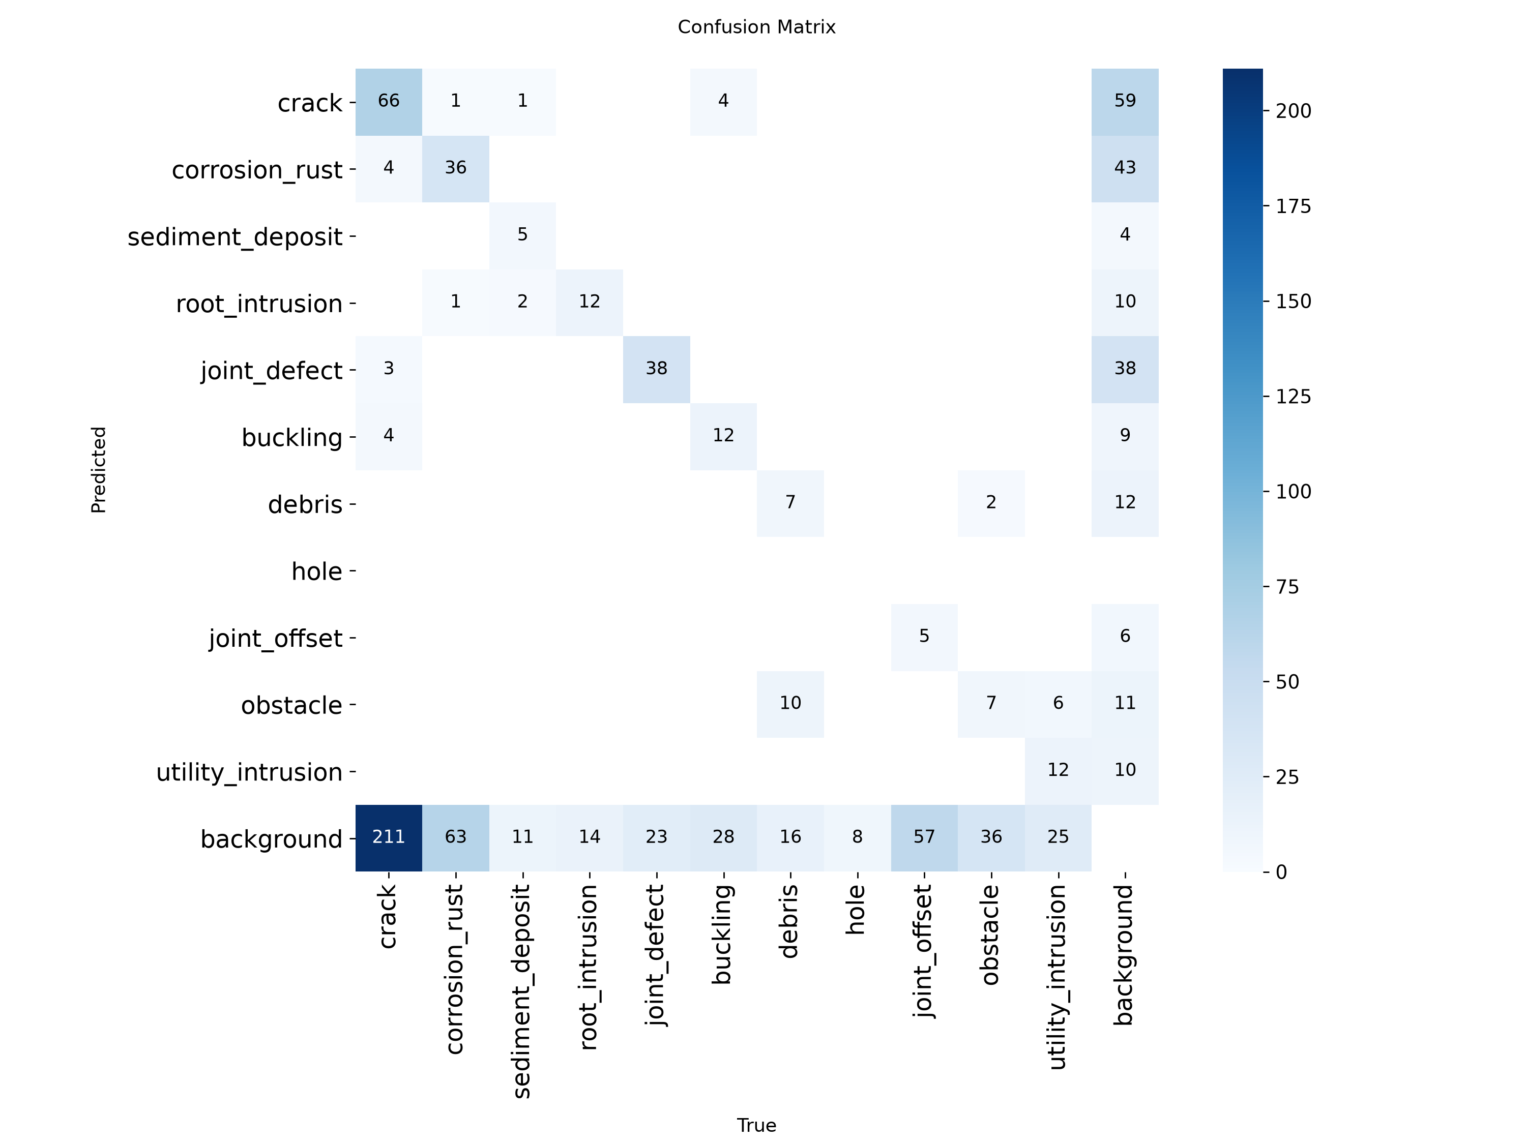
confusion matrix — dataset_crack/runs/pipe_proto/yolo26n_v4_pipe_cctv_clahe-3/confusion_matrix.png
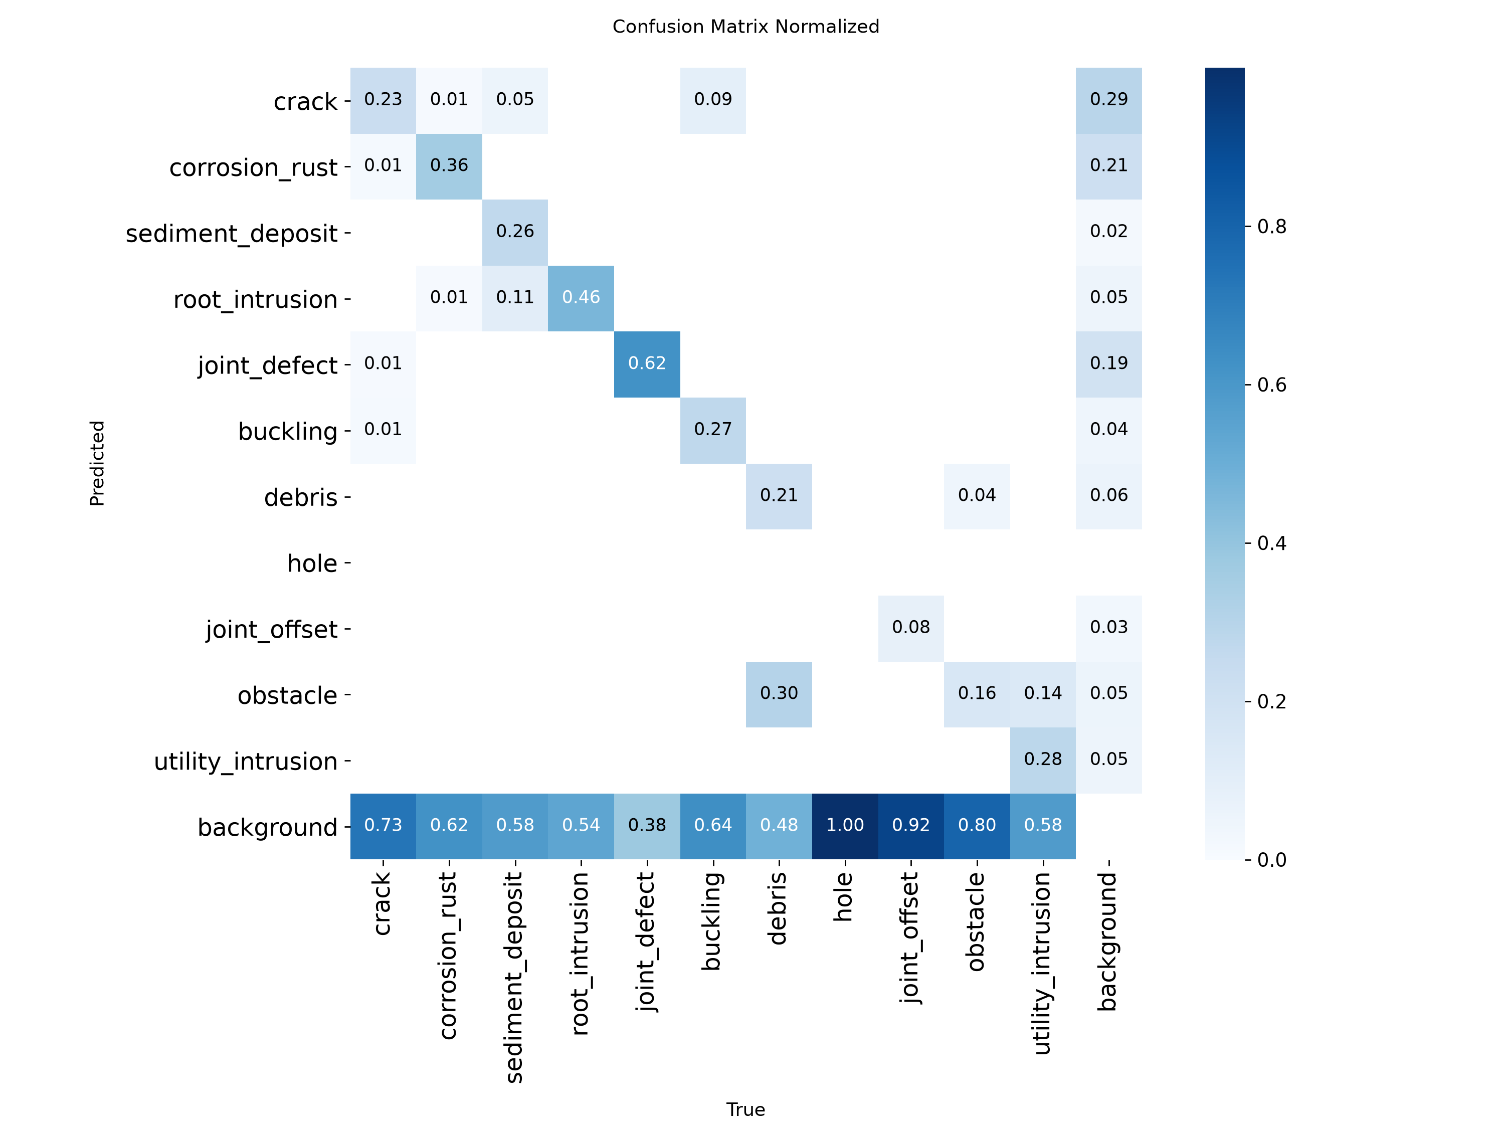
confusion matrix normalized — dataset_crack/runs/pipe_proto/yolo26n_v4_pipe_cctv_clahe-3/confusion_matrix_normalized.png

7. yolo26s_v5_cctv
Field | Recorded value
Family | YOLO
State | complete
Epochs observed / target | 80 / 80
Dataset | final_dataset_v5
Image size | 640
Source folder | dataset_crack/runs/pipe_proto/yolo26s_v5_cctv
Checkpoint | dataset_crack/runs/pipe_proto/yolo26s_v5_cctv/weights/best.pt
Checkpoint size | 20.32 MB
Parameters | 9,951,734
GFLOPs | 22.757
Training time | 3.19 h (Ultralytics cumulative results.csv time)
Best validation | P 80.27%, R 76.13%, mAP50 82.54%, mAP50-95 65.61%

Saved and reconstructed plots
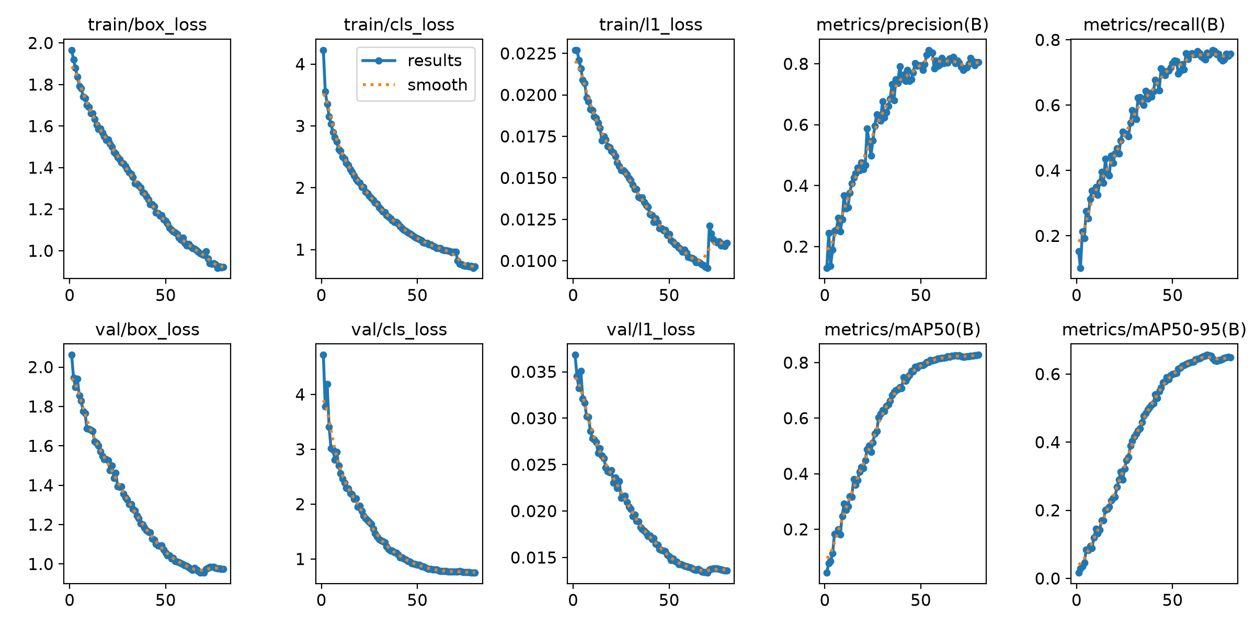
results — dataset_crack/runs/pipe_proto/yolo26s_v5_cctv/results.png
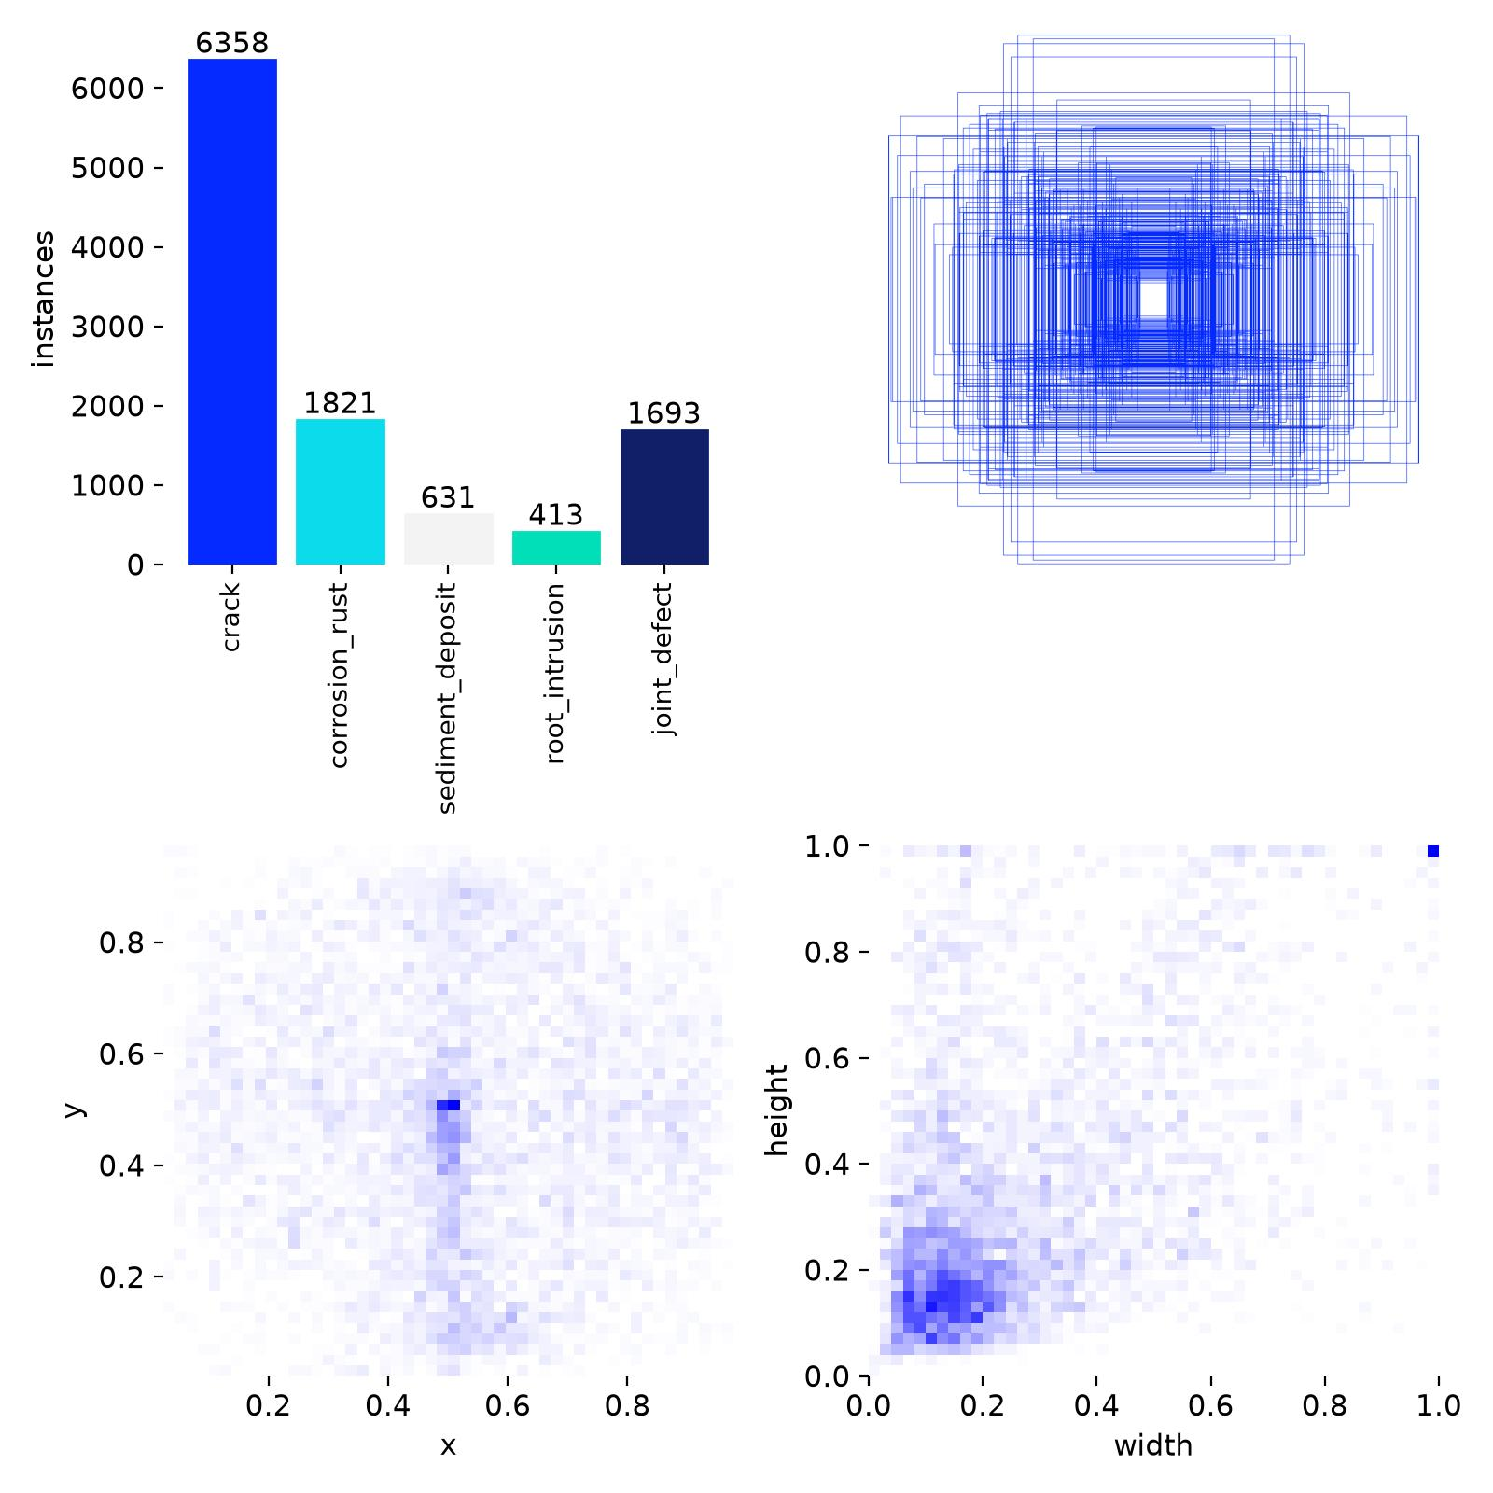
labels — dataset_crack/runs/pipe_proto/yolo26s_v5_cctv/labels.jpg
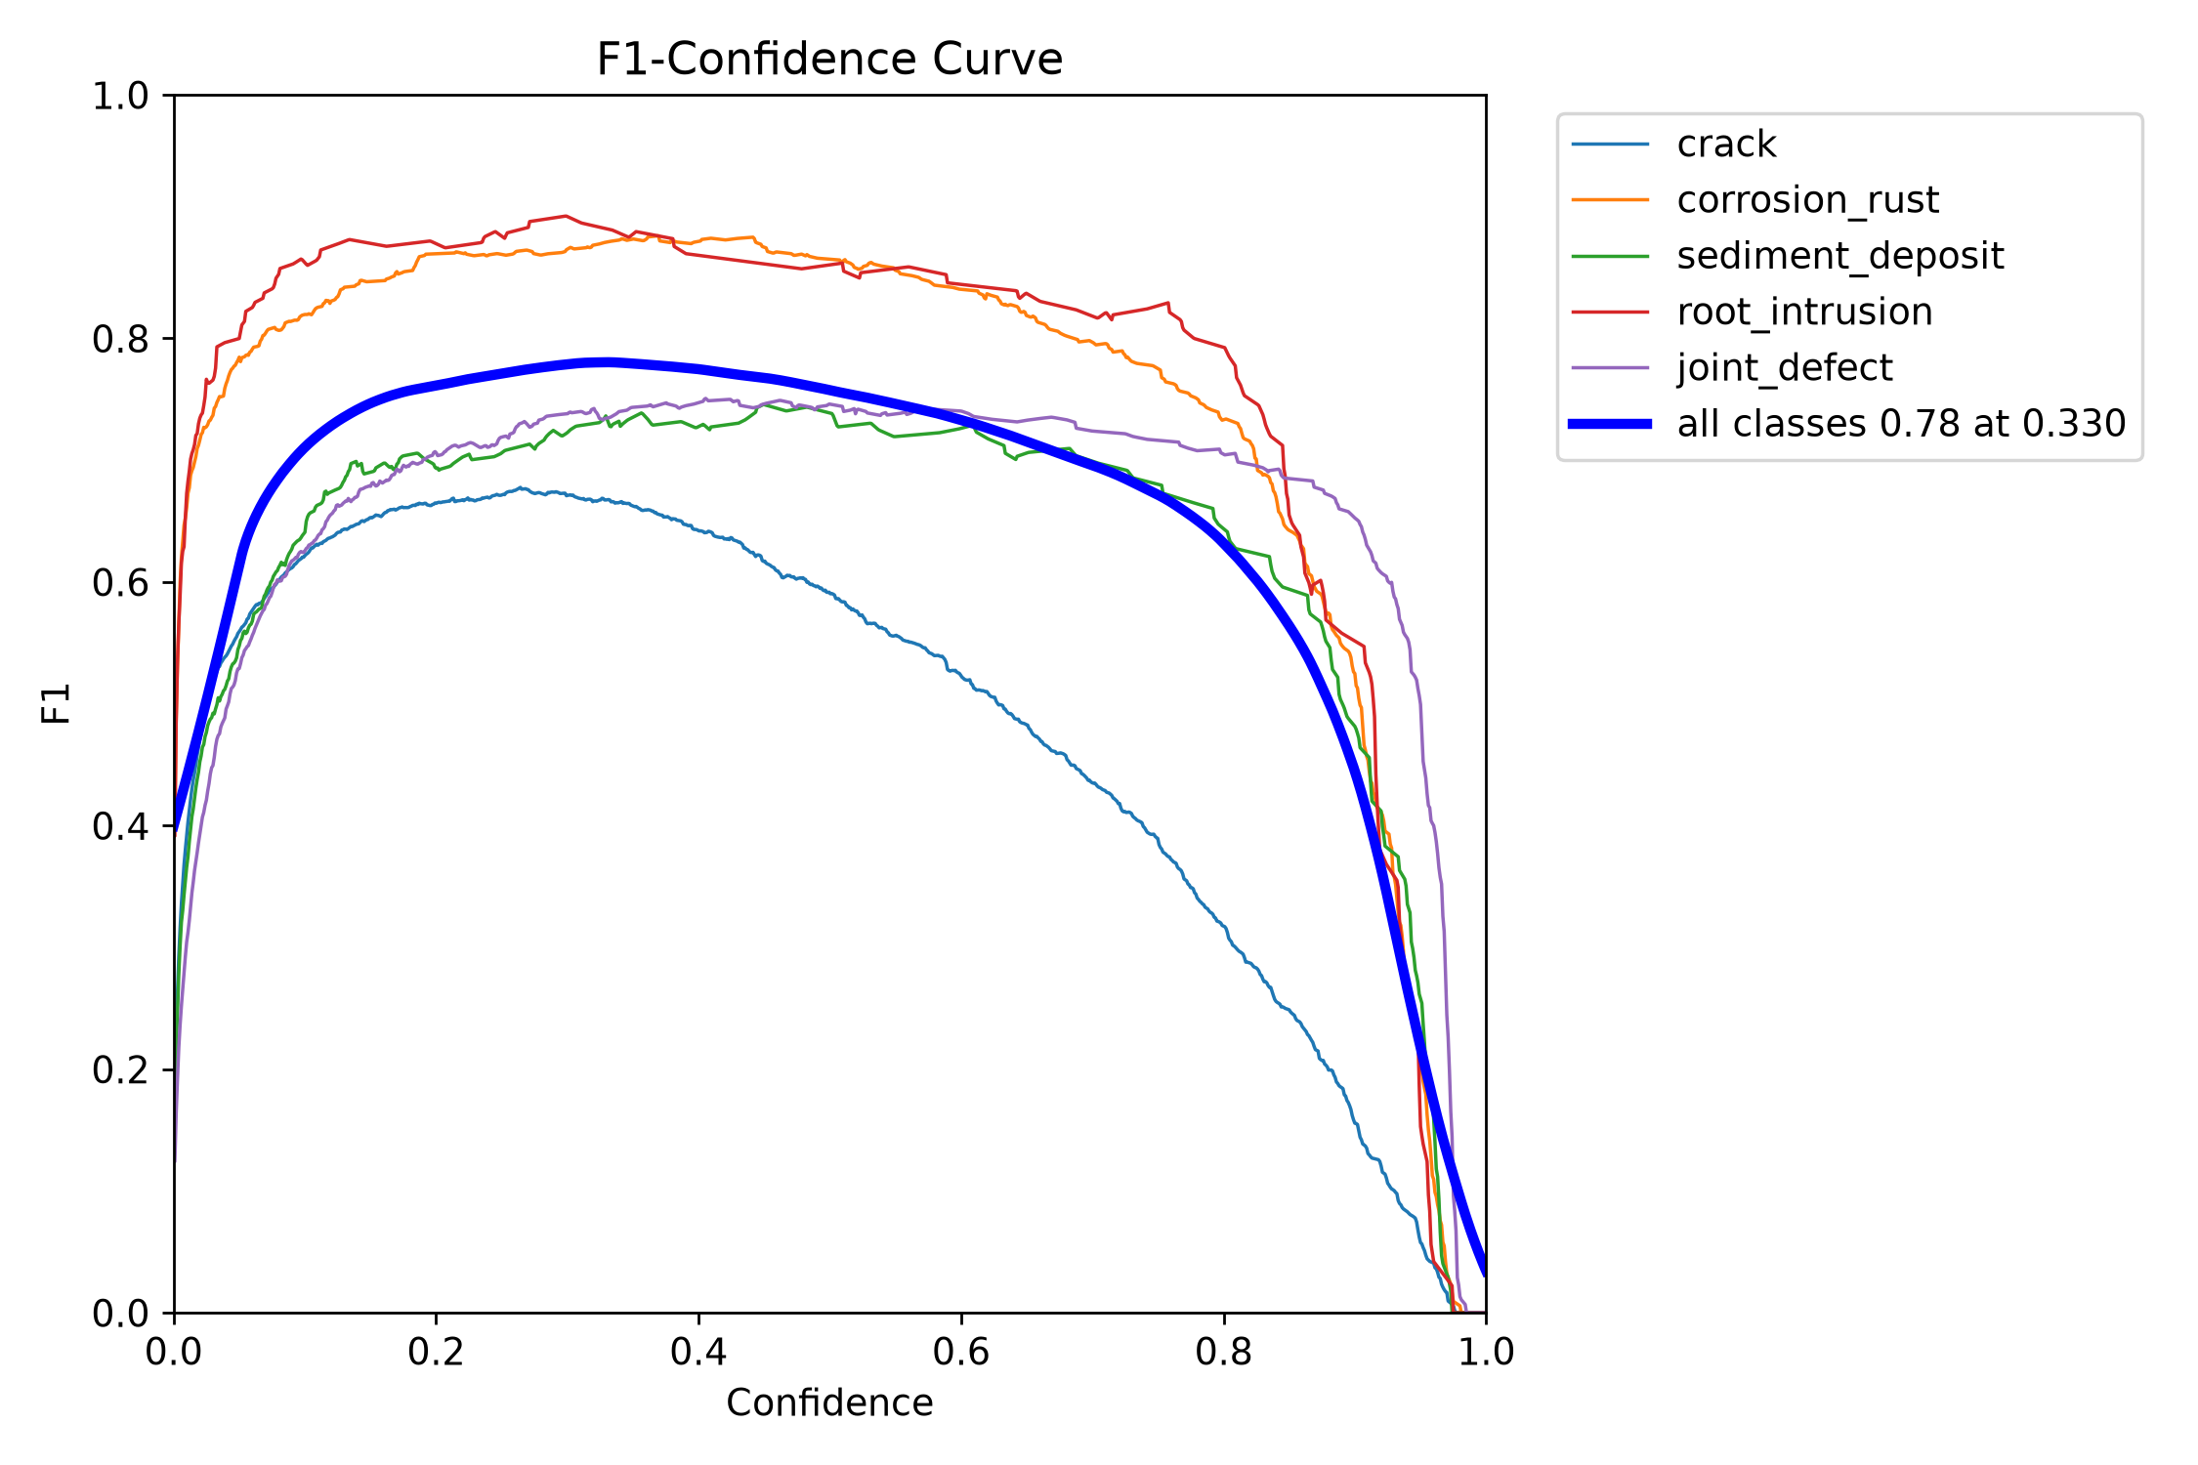
BoxF1 curve — dataset_crack/runs/pipe_proto/yolo26s_v5_cctv/BoxF1_curve.png
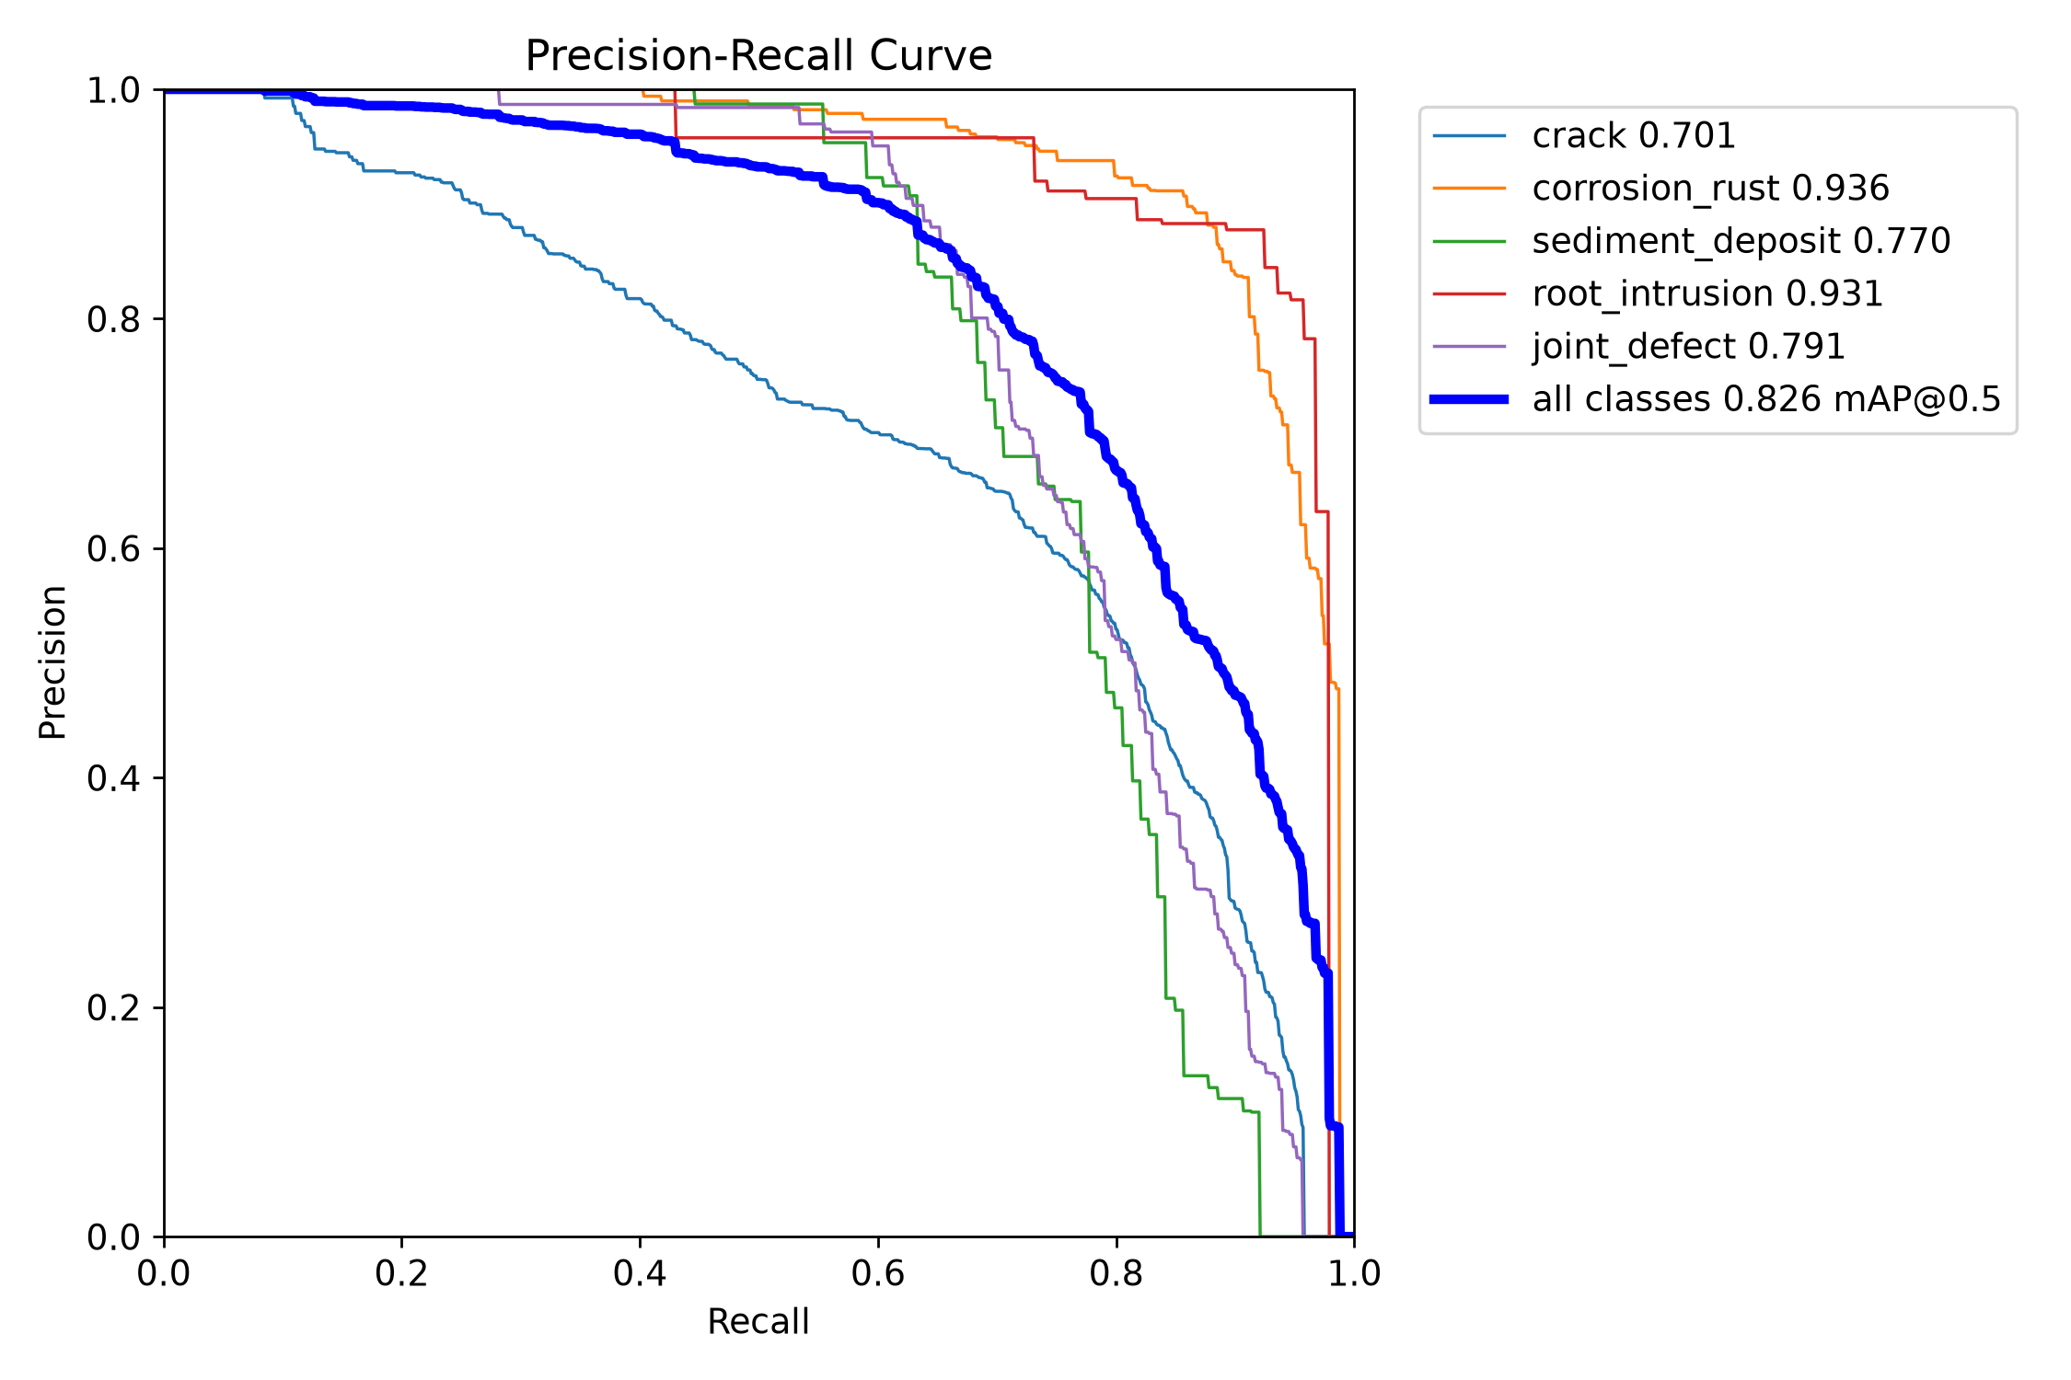
BoxPR curve — dataset_crack/runs/pipe_proto/yolo26s_v5_cctv/BoxPR_curve.png
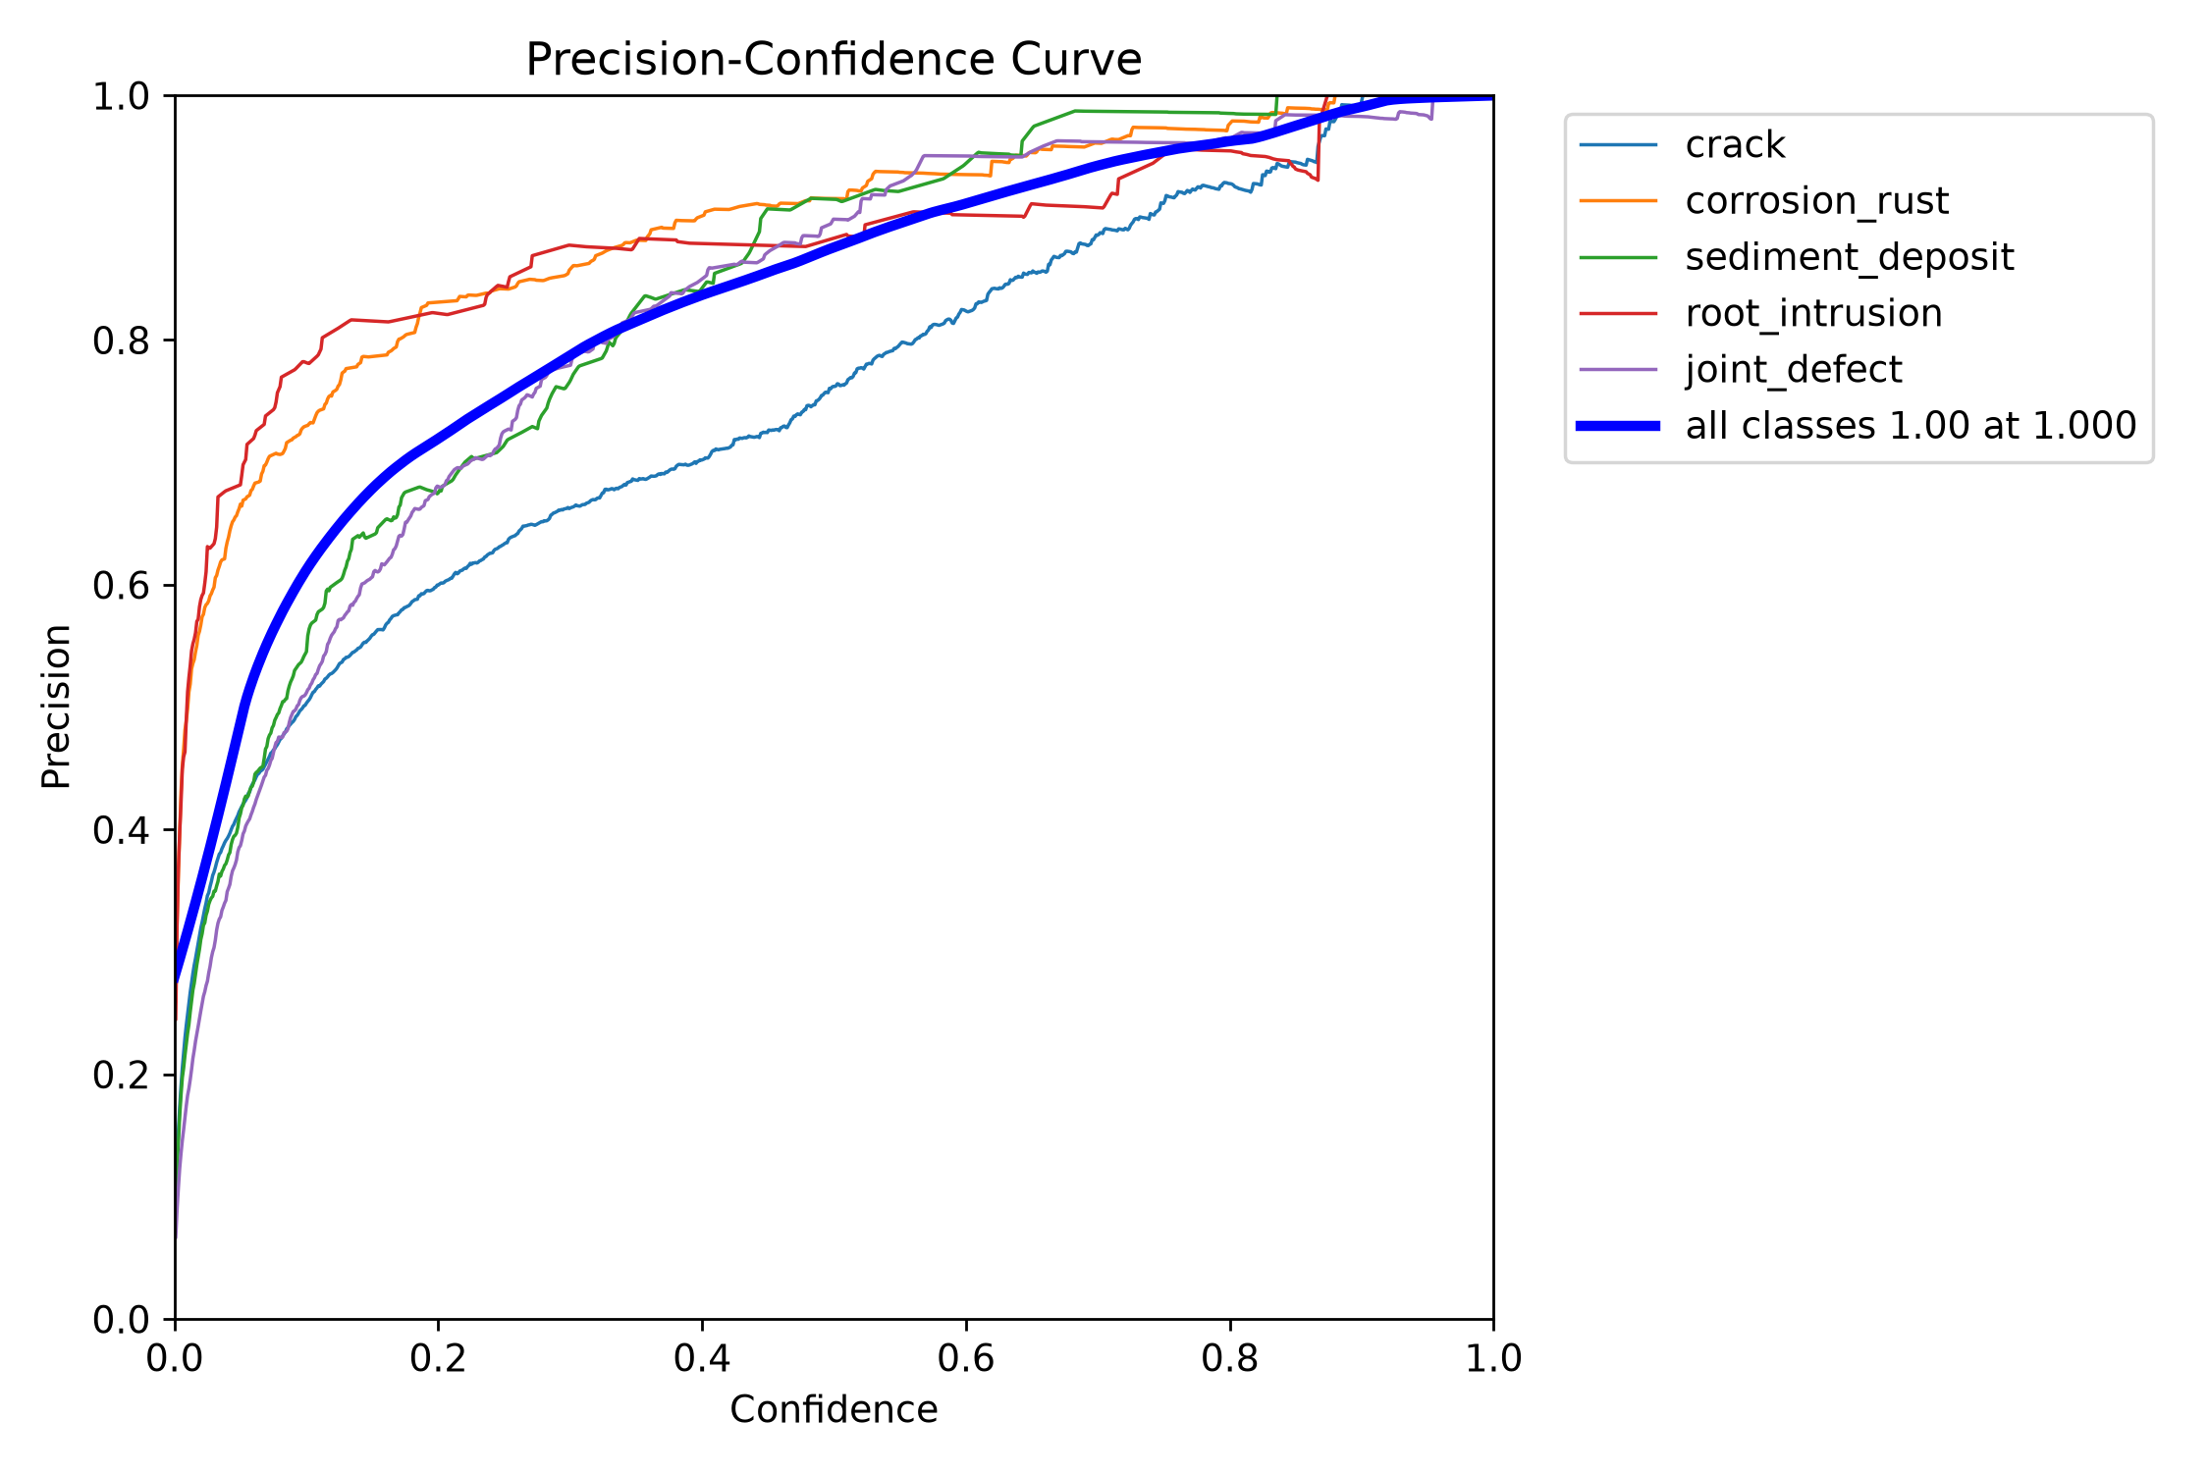
BoxP curve — dataset_crack/runs/pipe_proto/yolo26s_v5_cctv/BoxP_curve.png
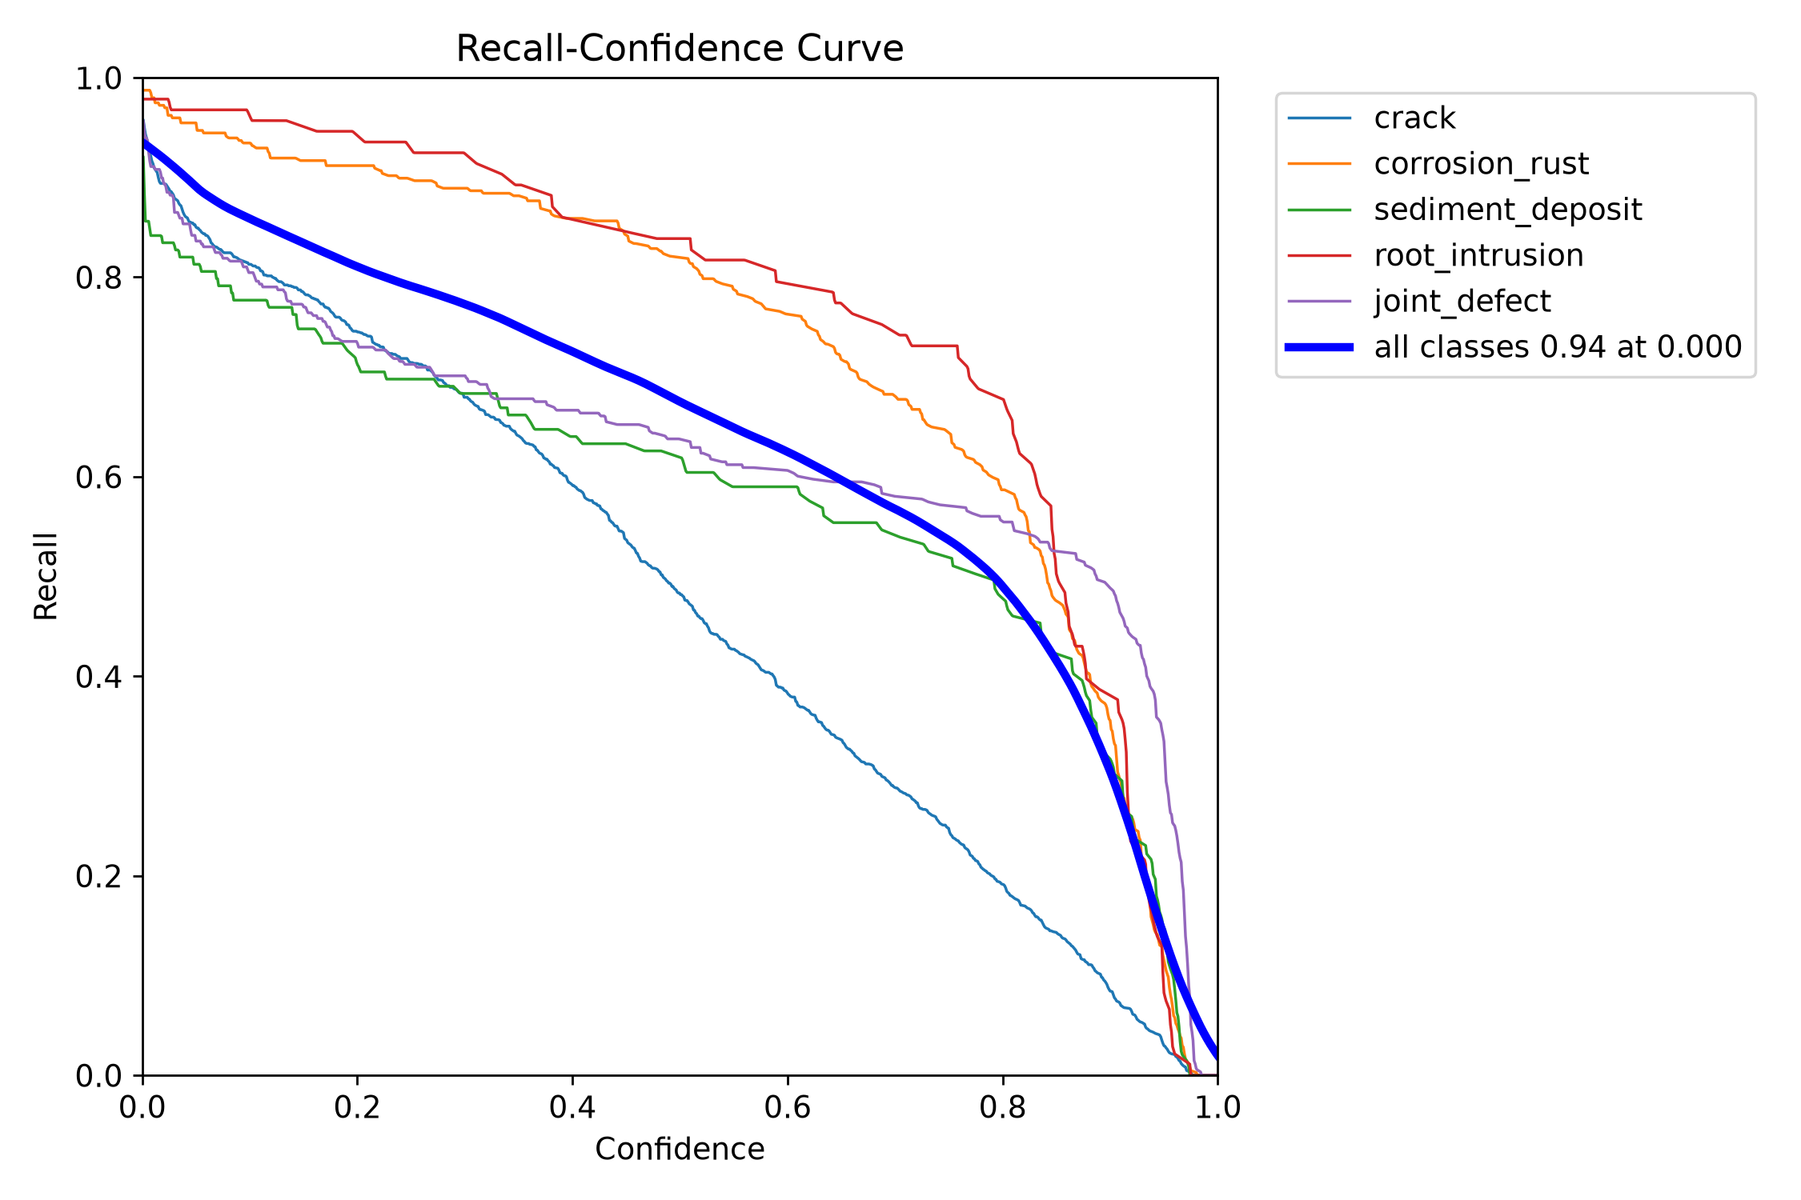
BoxR curve — dataset_crack/runs/pipe_proto/yolo26s_v5_cctv/BoxR_curve.png
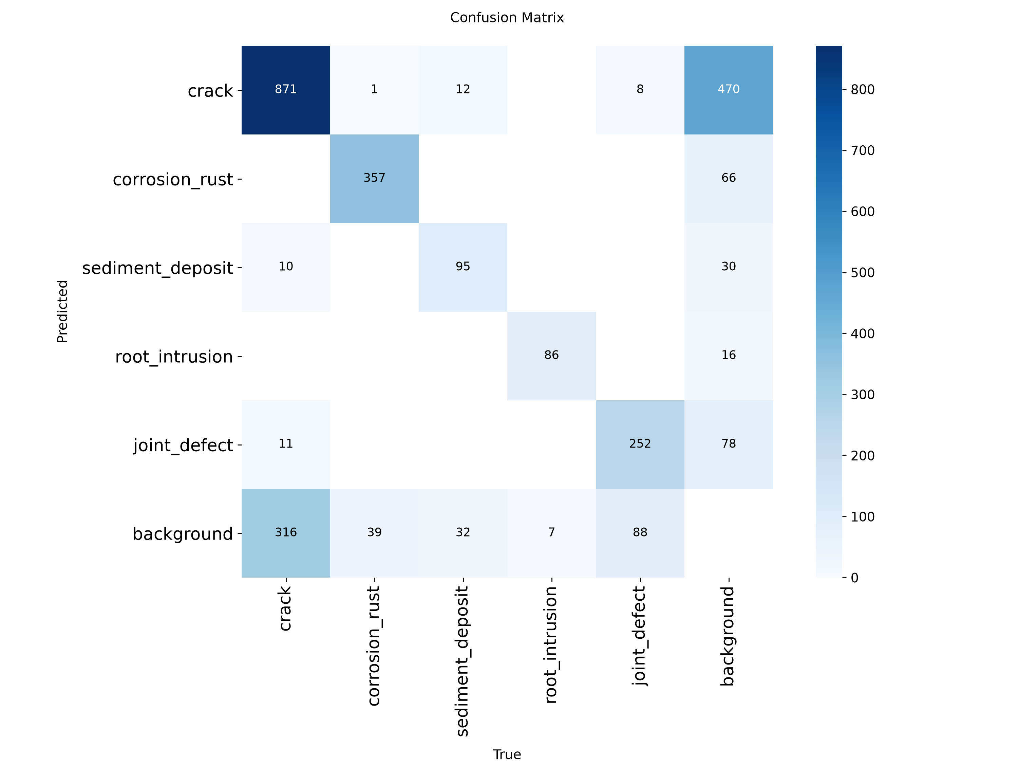
confusion matrix — dataset_crack/runs/pipe_proto/yolo26s_v5_cctv/confusion_matrix.png
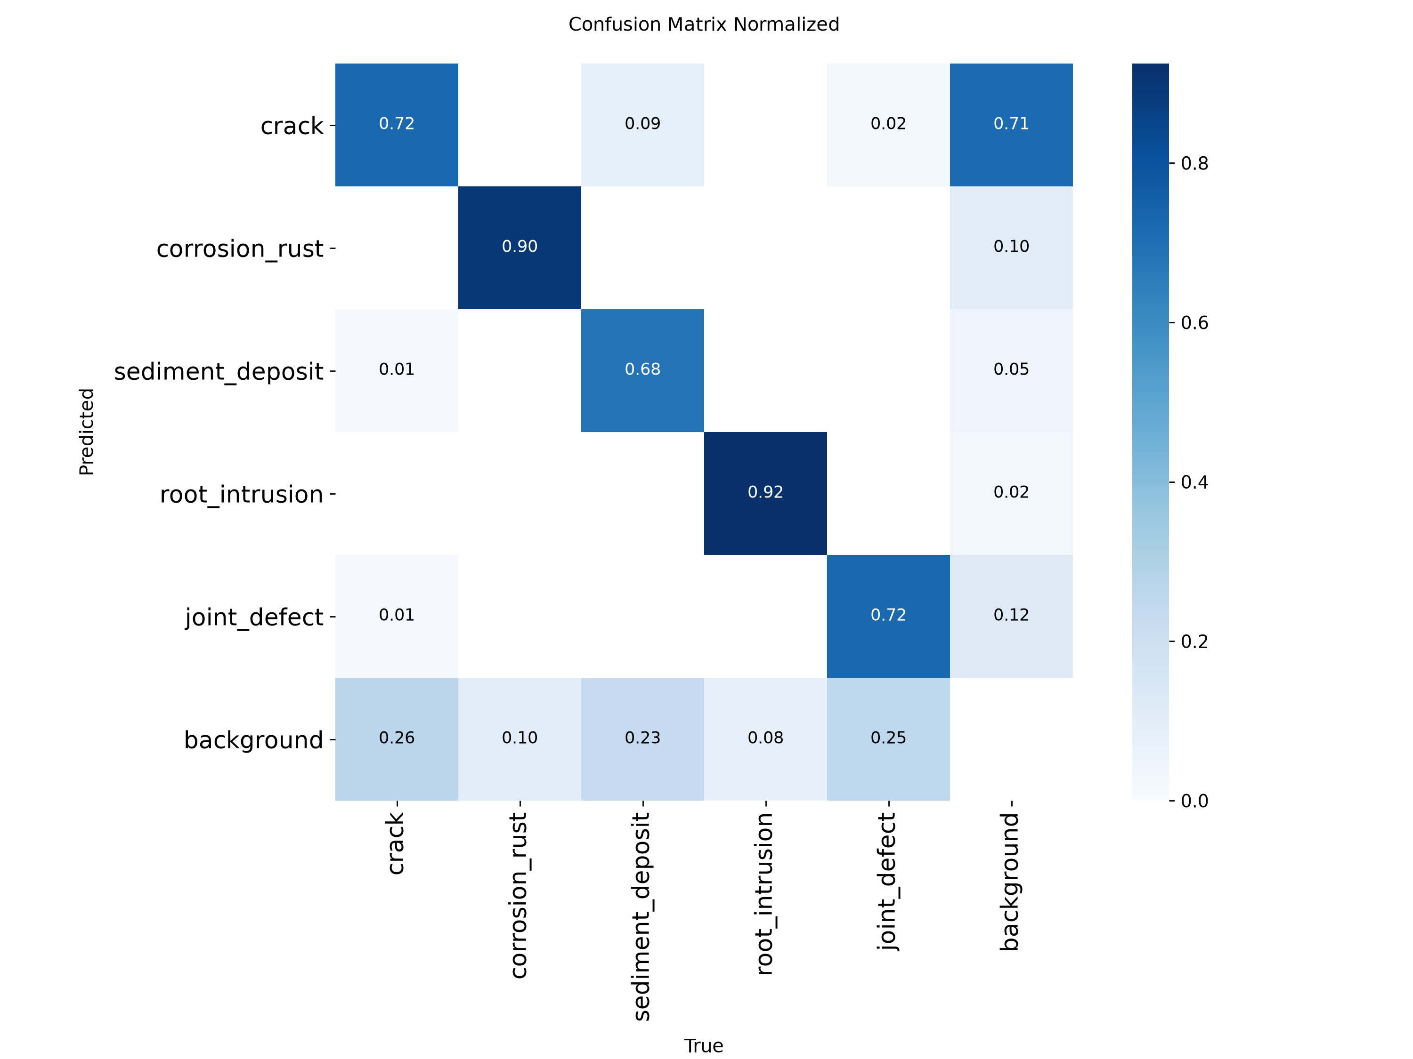
confusion matrix normalized — dataset_crack/runs/pipe_proto/yolo26s_v5_cctv/confusion_matrix_normalized.png

Evaluation artifact: yolo26s_v5_cctv_test
This is a separate evaluation folder, not another training run. Its plots are reproduced below; scores are not inferred solely from the images.
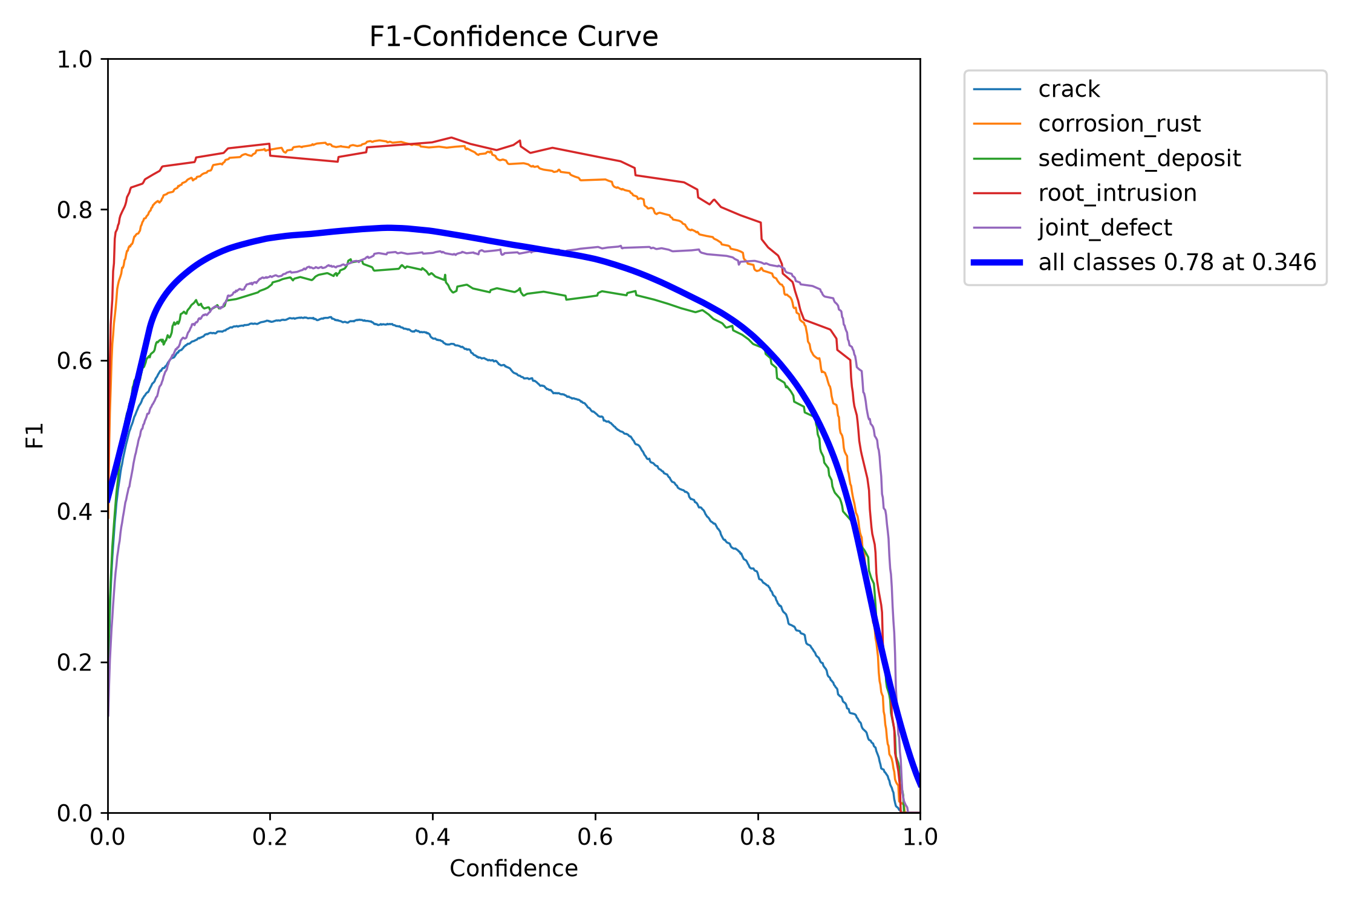
BoxF1 curve — dataset_crack/runs/pipe_proto/yolo26s_v5_cctv_test/BoxF1_curve.png
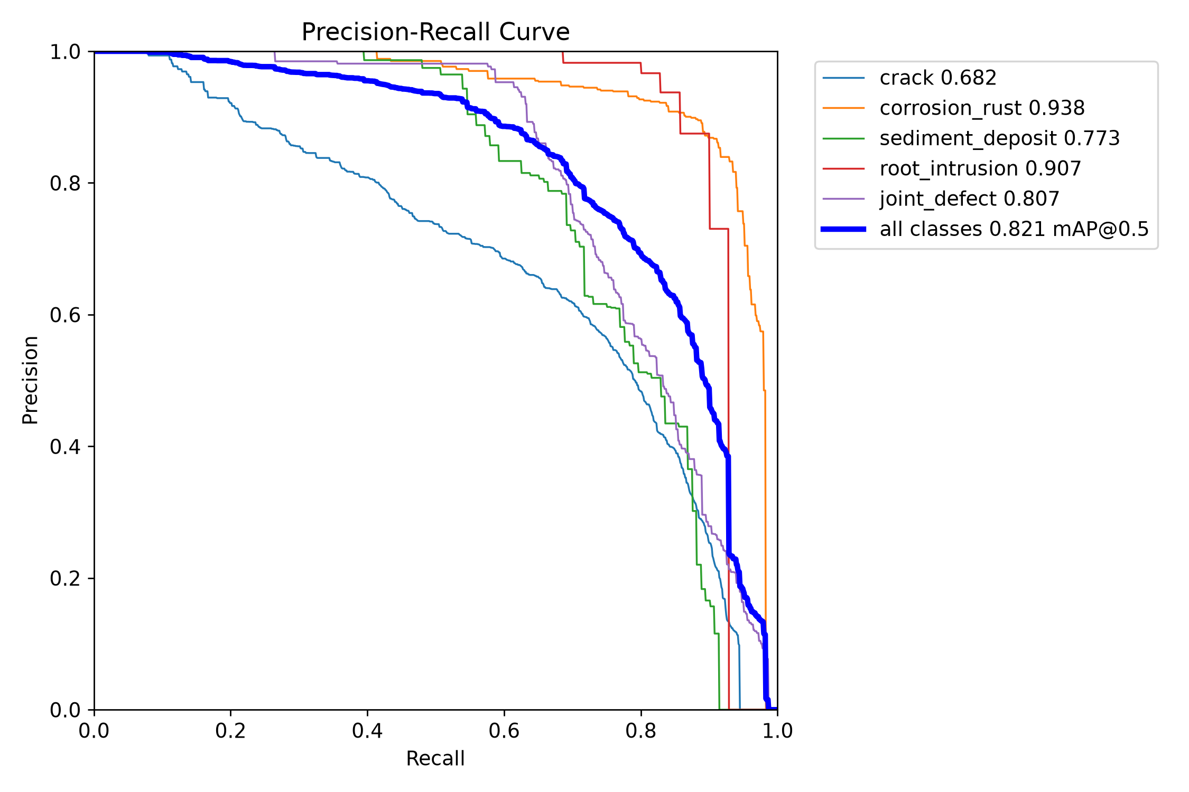
BoxPR curve — dataset_crack/runs/pipe_proto/yolo26s_v5_cctv_test/BoxPR_curve.png
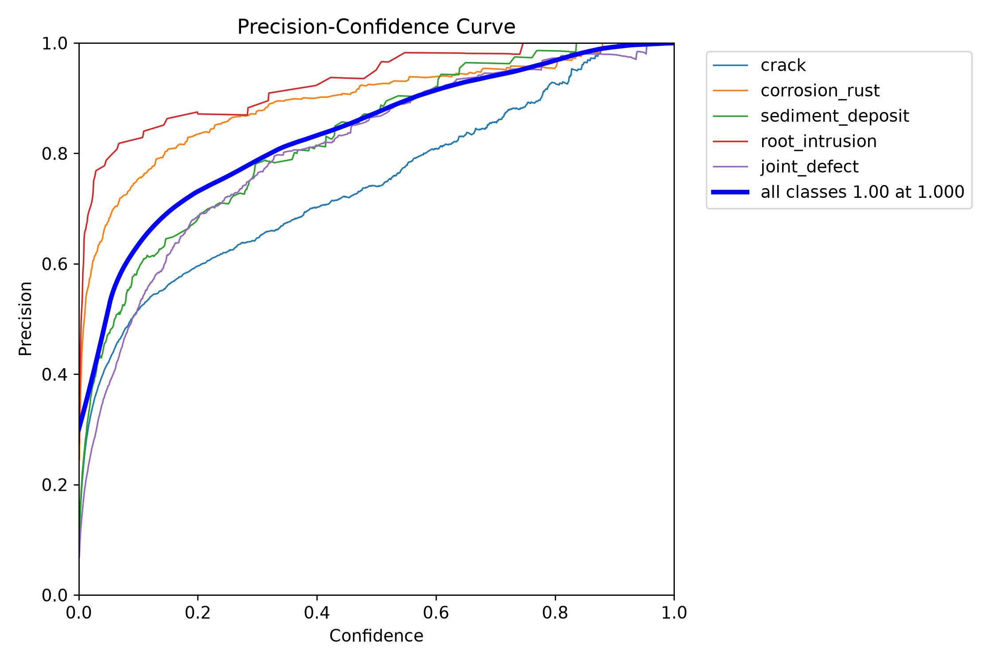
BoxP curve — dataset_crack/runs/pipe_proto/yolo26s_v5_cctv_test/BoxP_curve.png
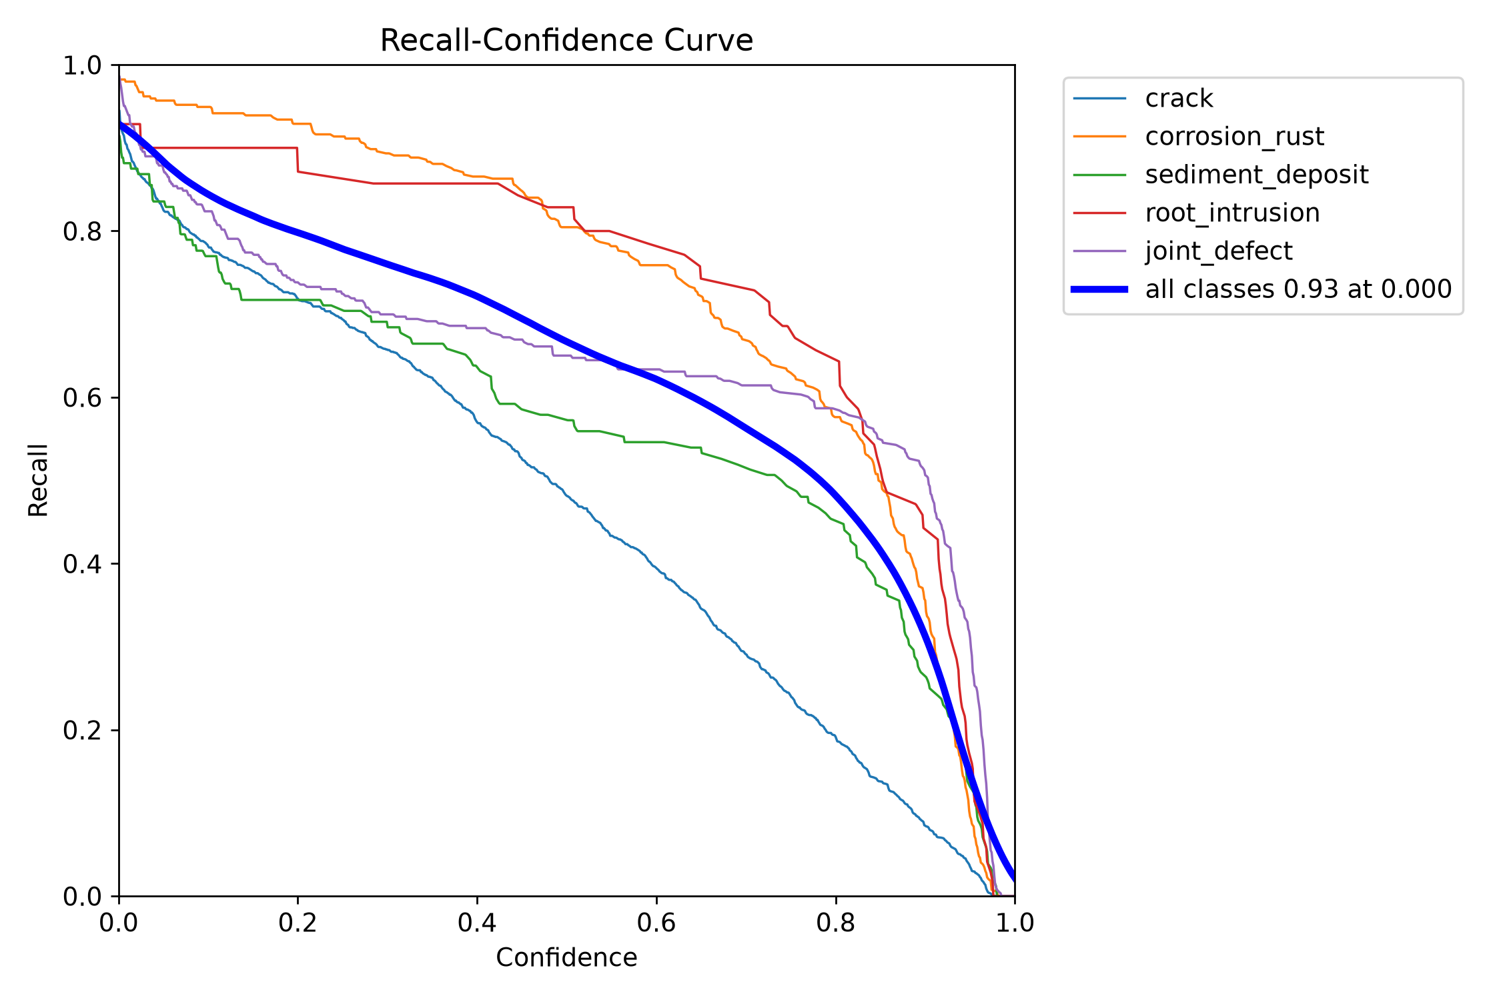
BoxR curve — dataset_crack/runs/pipe_proto/yolo26s_v5_cctv_test/BoxR_curve.png
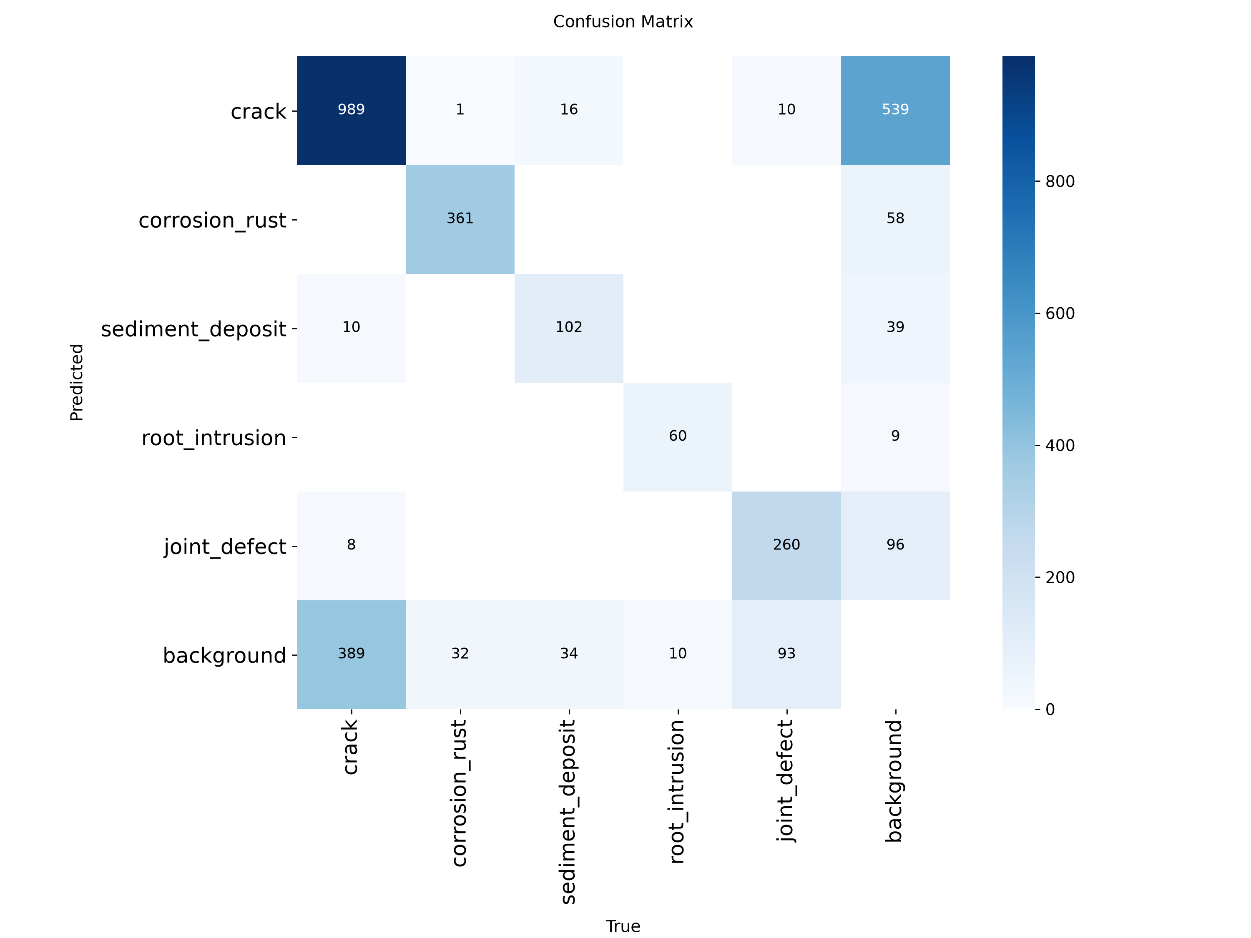
confusion matrix — dataset_crack/runs/pipe_proto/yolo26s_v5_cctv_test/confusion_matrix.png
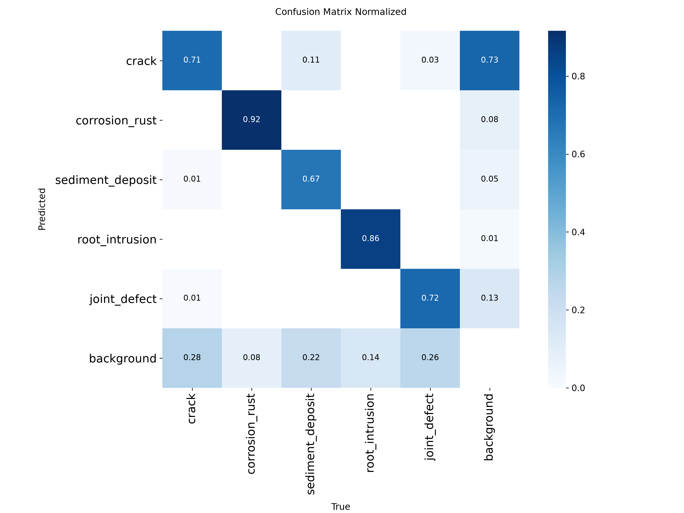
confusion matrix normalized — dataset_crack/runs/pipe_proto/yolo26s_v5_cctv_test/confusion_matrix_normalized.png

8. yolo26s_v5_clahe_cbam
Field | Recorded value
Family | YOLO
State | complete
Epochs observed / target | 80 / 80
Dataset | final_dataset_v5_clahe
Image size | 640
Source folder | dataset_crack/runs/pipe_proto/yolo26s_v5_clahe_cbam
Checkpoint | dataset_crack/runs/pipe_proto/yolo26s_v5_clahe_cbam/weights/best.pt
Checkpoint size | 20.33 MB
Parameters | 9,953,880
GFLOPs | 22.760
Training time | 3.29 h (Ultralytics cumulative results.csv time)
Best validation | P 76.85%, R 77.94%, mAP50 82.66%, mAP50-95 63.50%

Saved and reconstructed plots
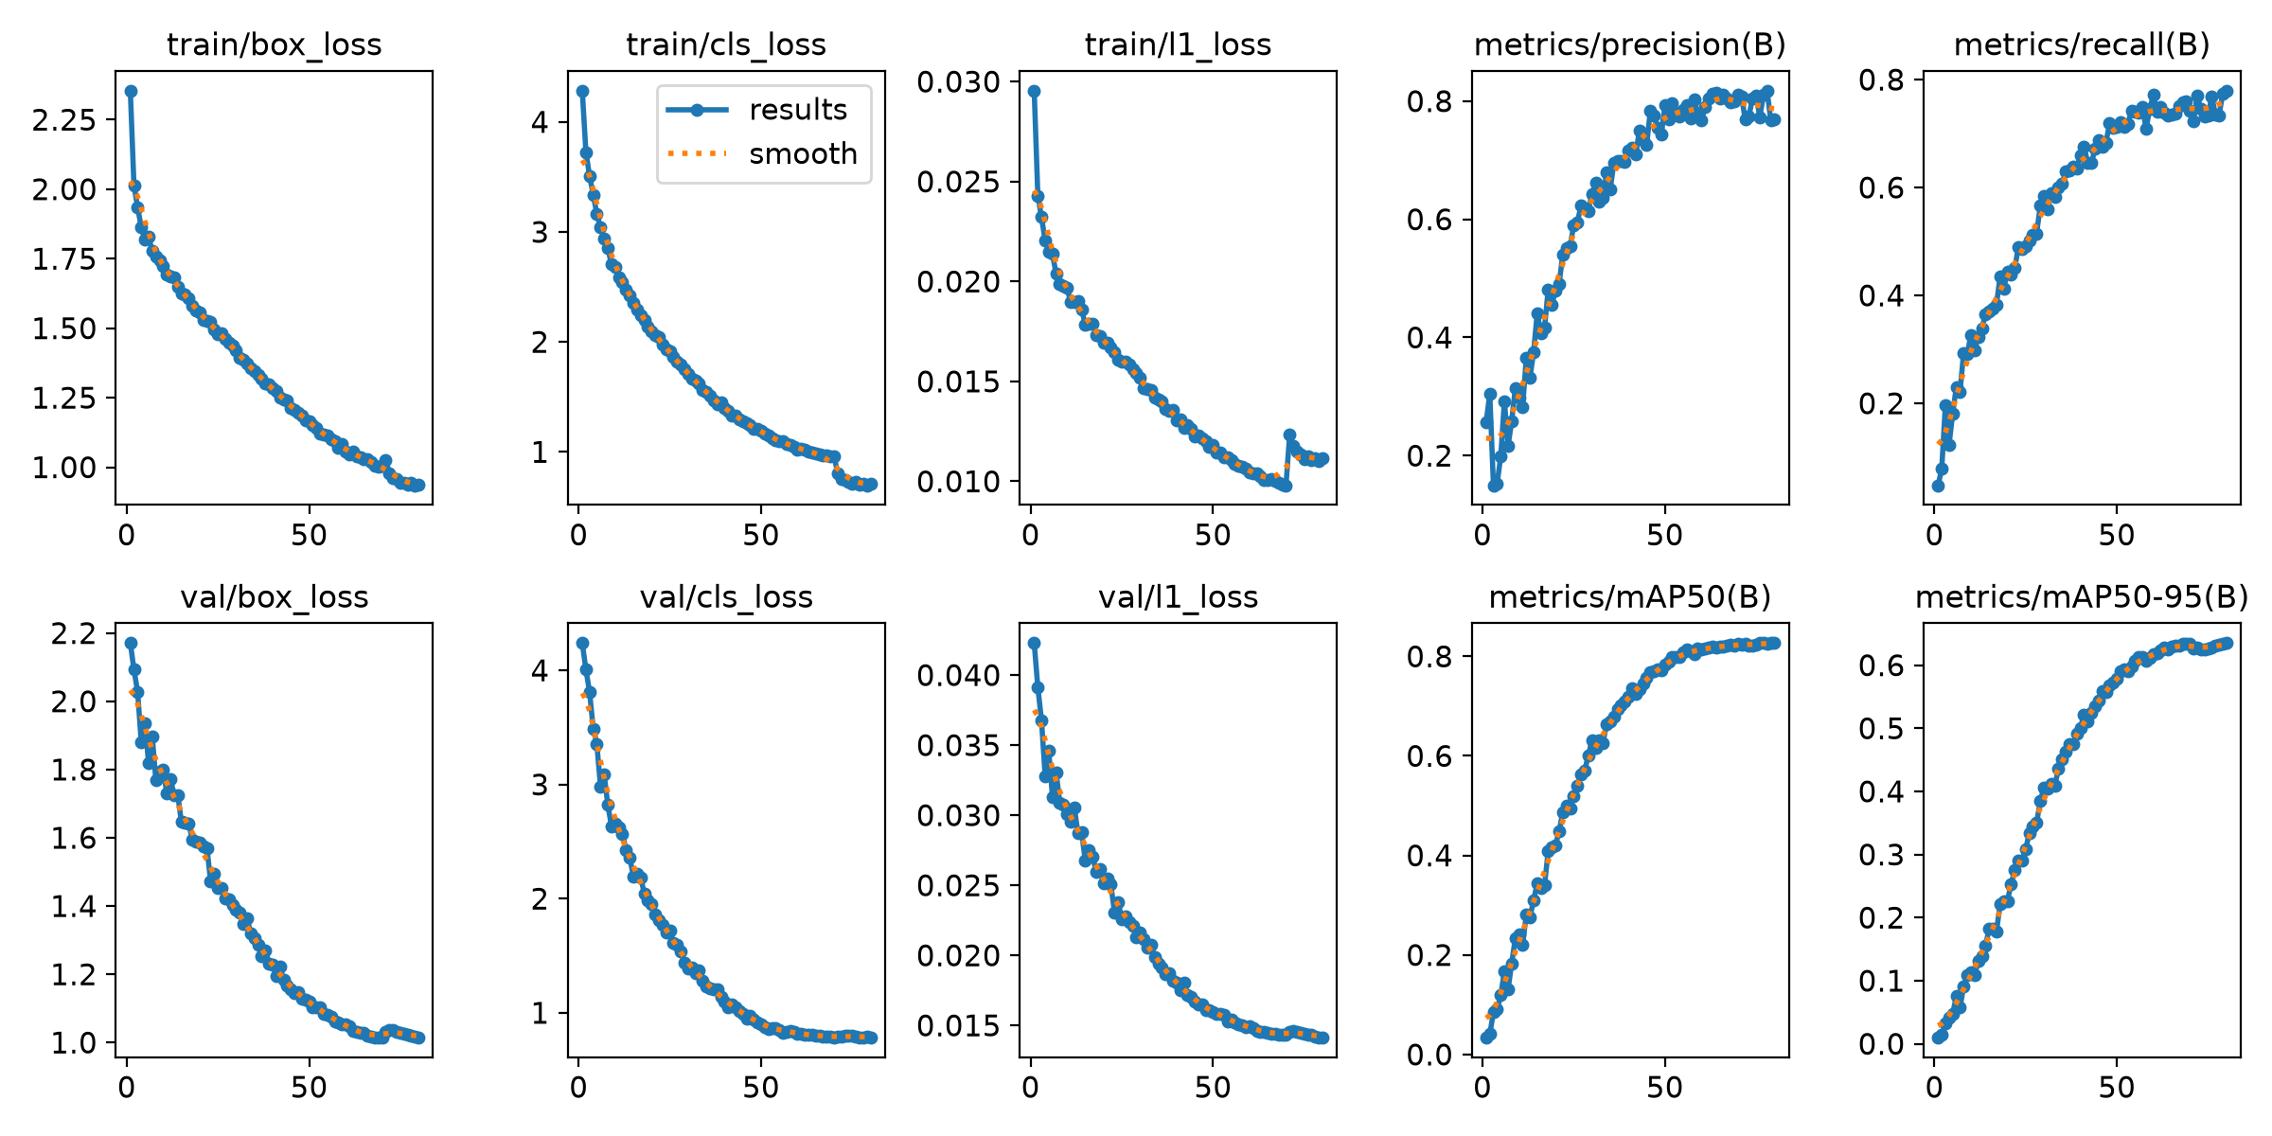
results — dataset_crack/runs/pipe_proto/yolo26s_v5_clahe_cbam/results.png
labels — dataset_crack/runs/pipe_proto/yolo26s_v5_clahe_cbam/labels.jpg
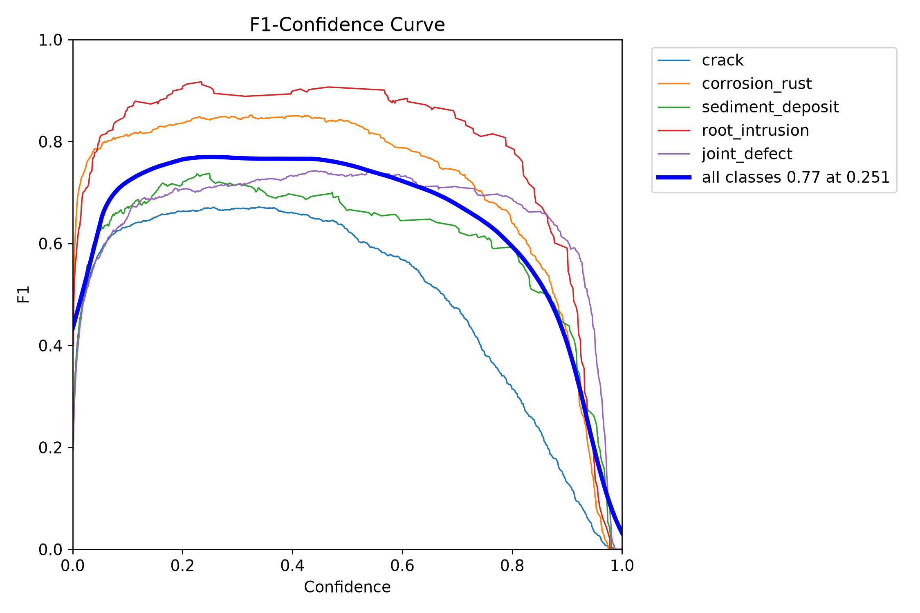
BoxF1 curve — dataset_crack/runs/pipe_proto/yolo26s_v5_clahe_cbam/BoxF1_curve.png
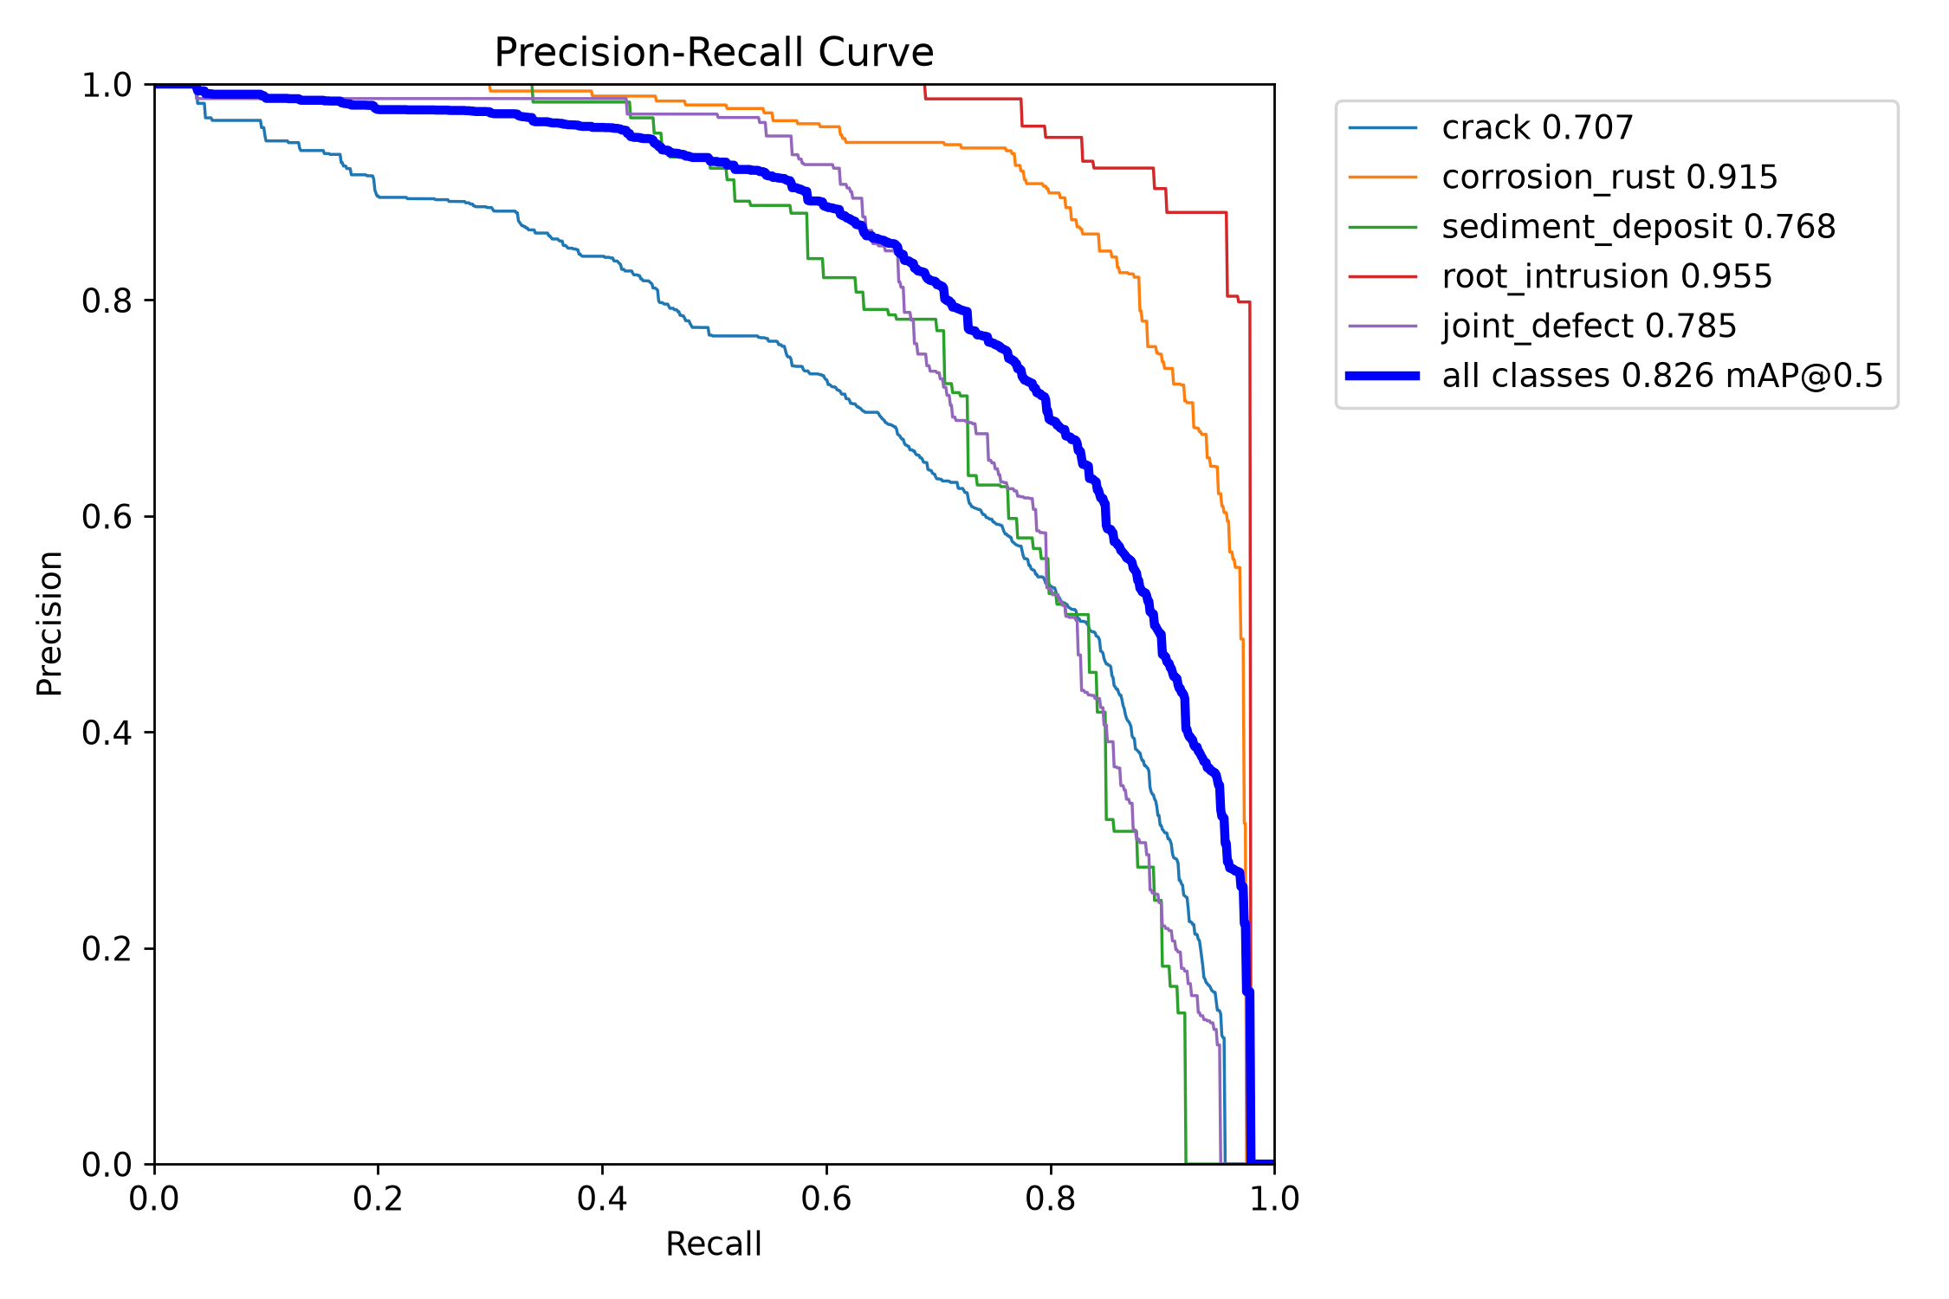
BoxPR curve — dataset_crack/runs/pipe_proto/yolo26s_v5_clahe_cbam/BoxPR_curve.png
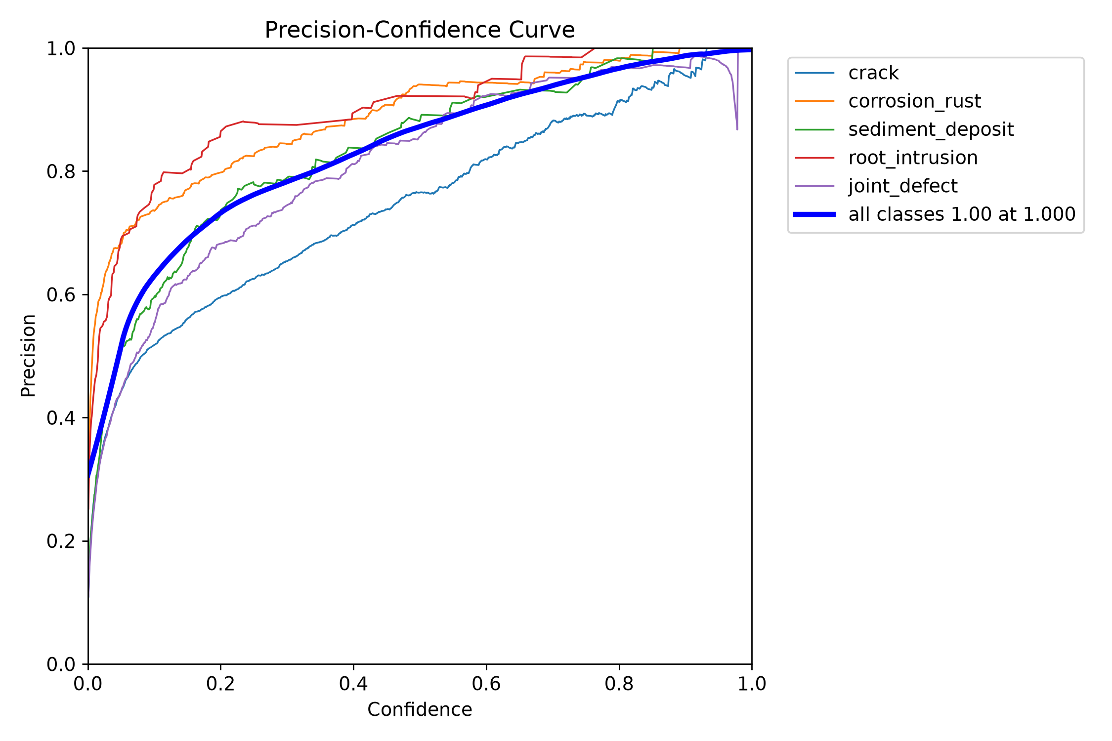
BoxP curve — dataset_crack/runs/pipe_proto/yolo26s_v5_clahe_cbam/BoxP_curve.png
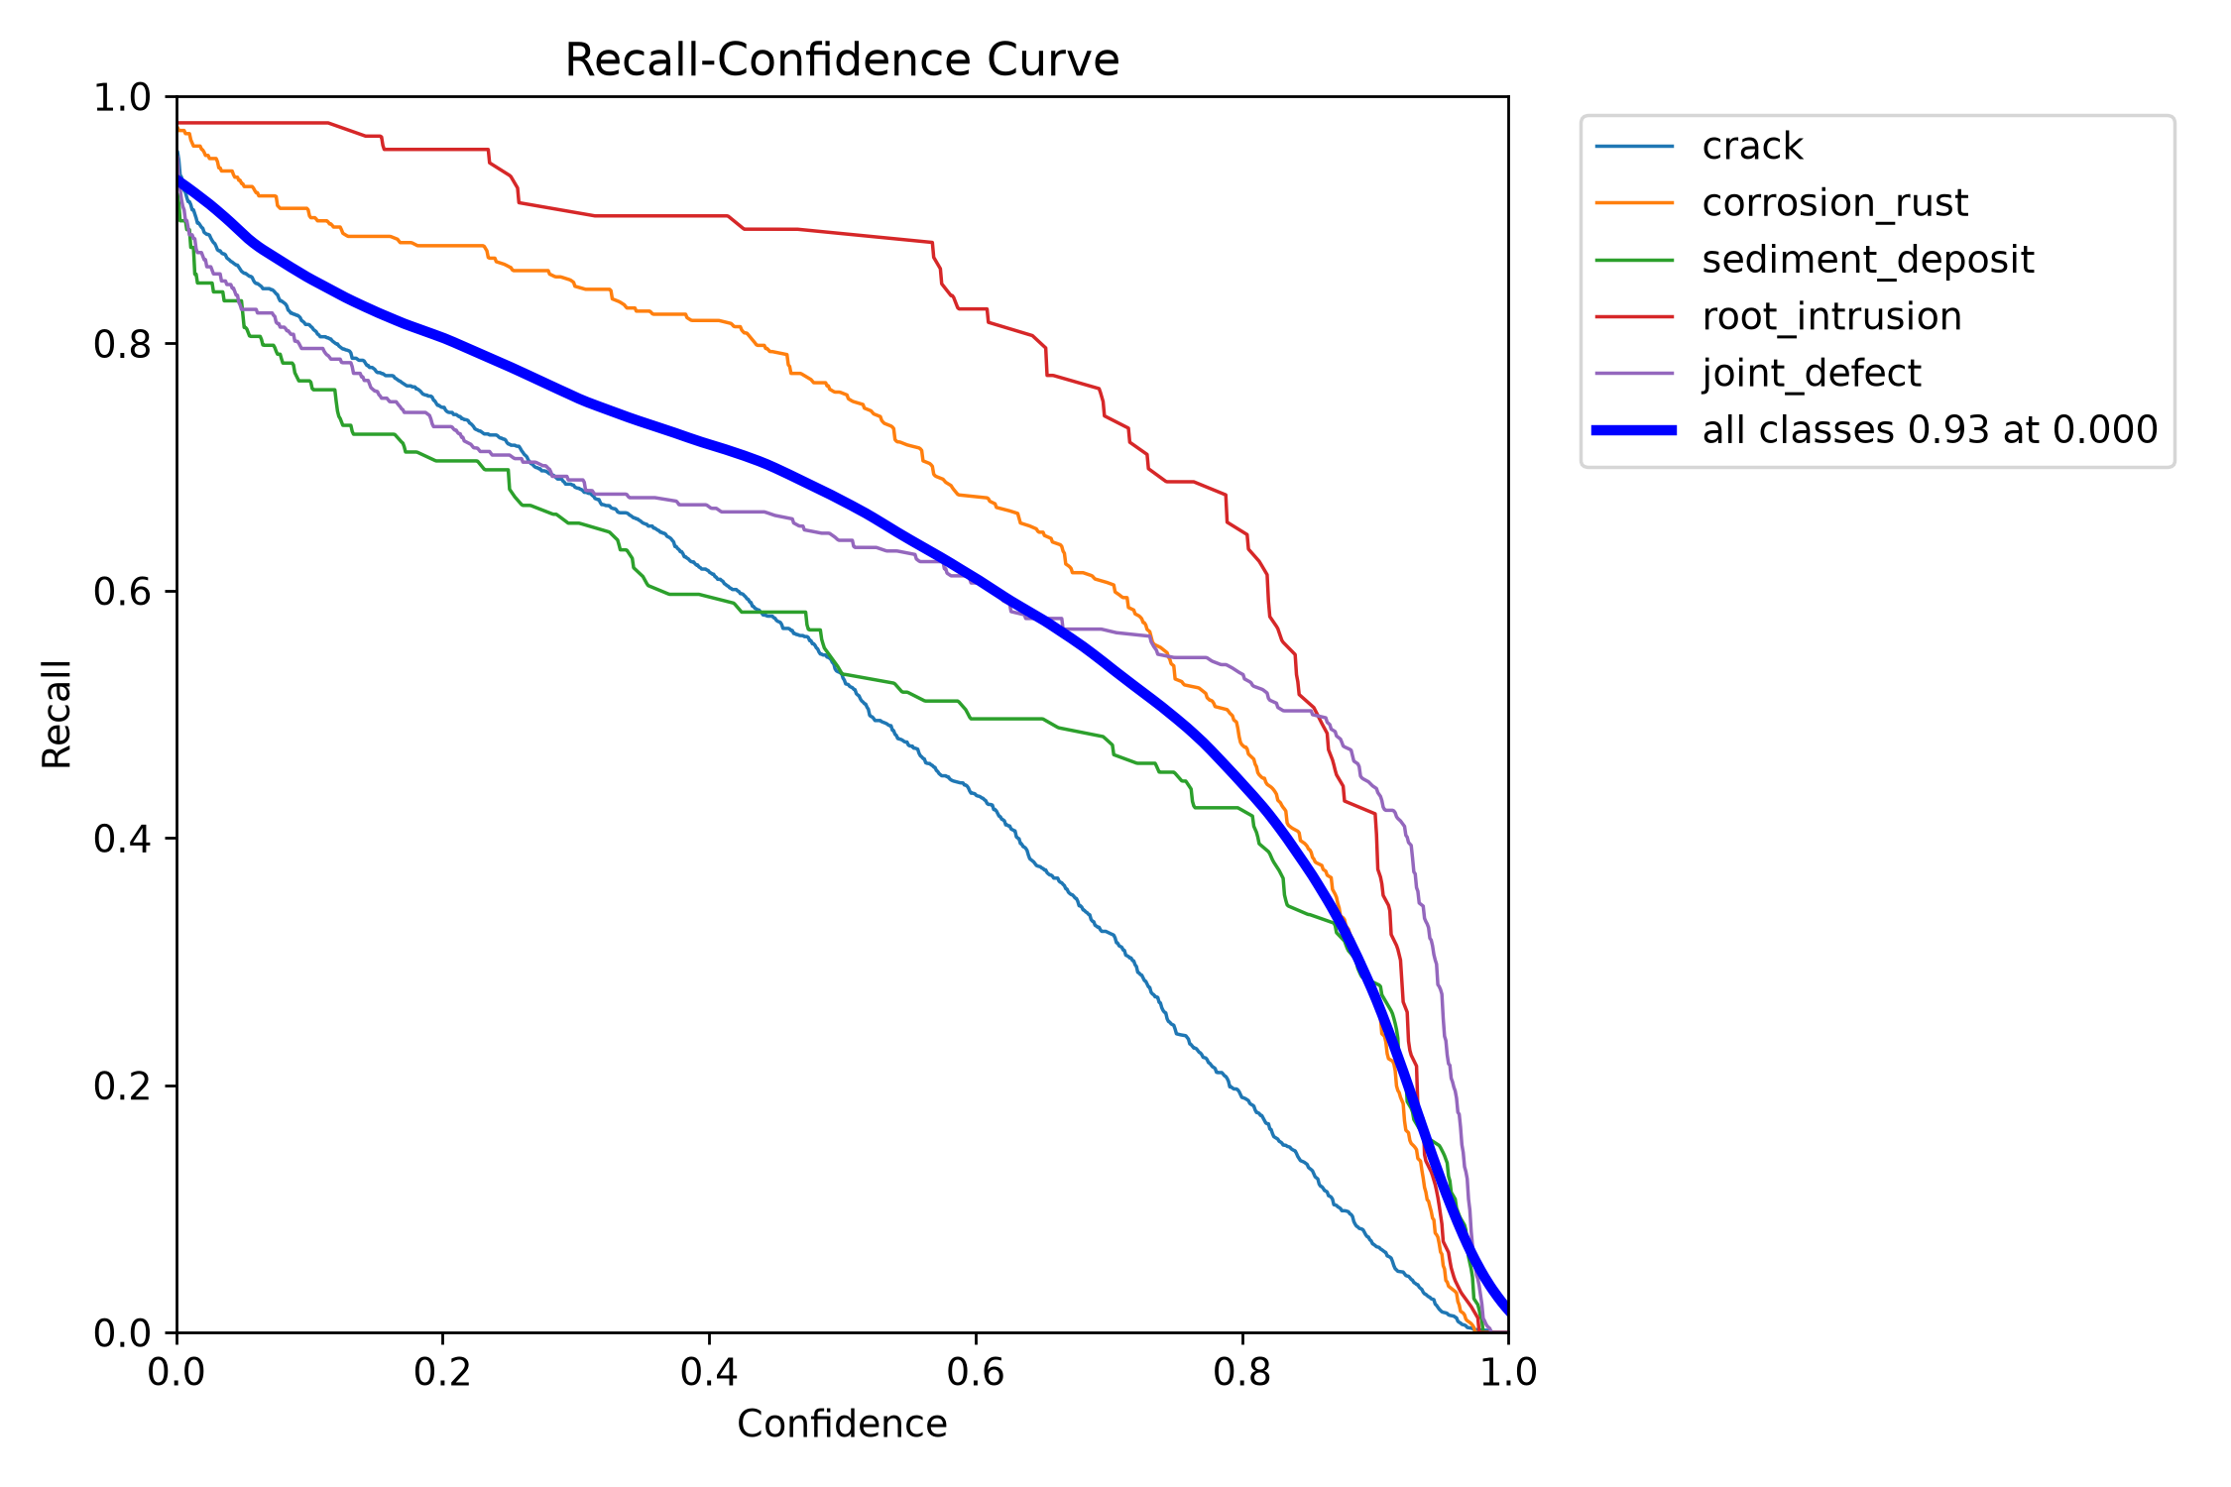
BoxR curve — dataset_crack/runs/pipe_proto/yolo26s_v5_clahe_cbam/BoxR_curve.png
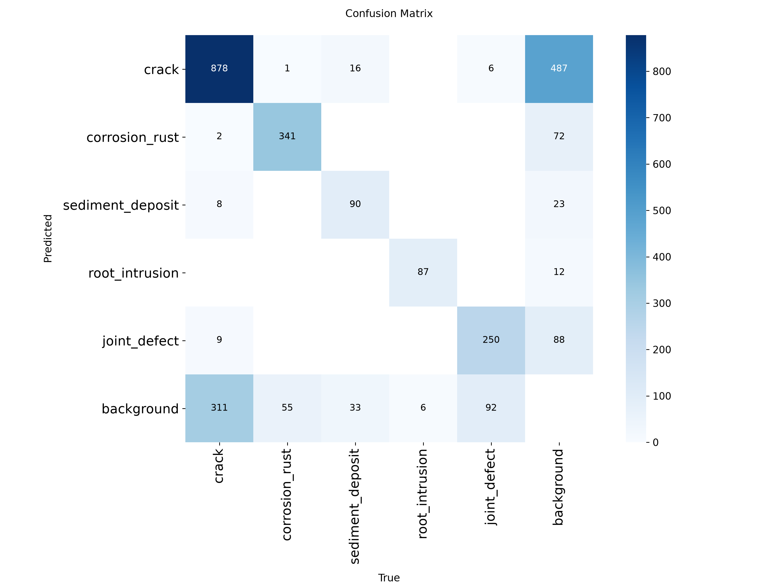
confusion matrix — dataset_crack/runs/pipe_proto/yolo26s_v5_clahe_cbam/confusion_matrix.png
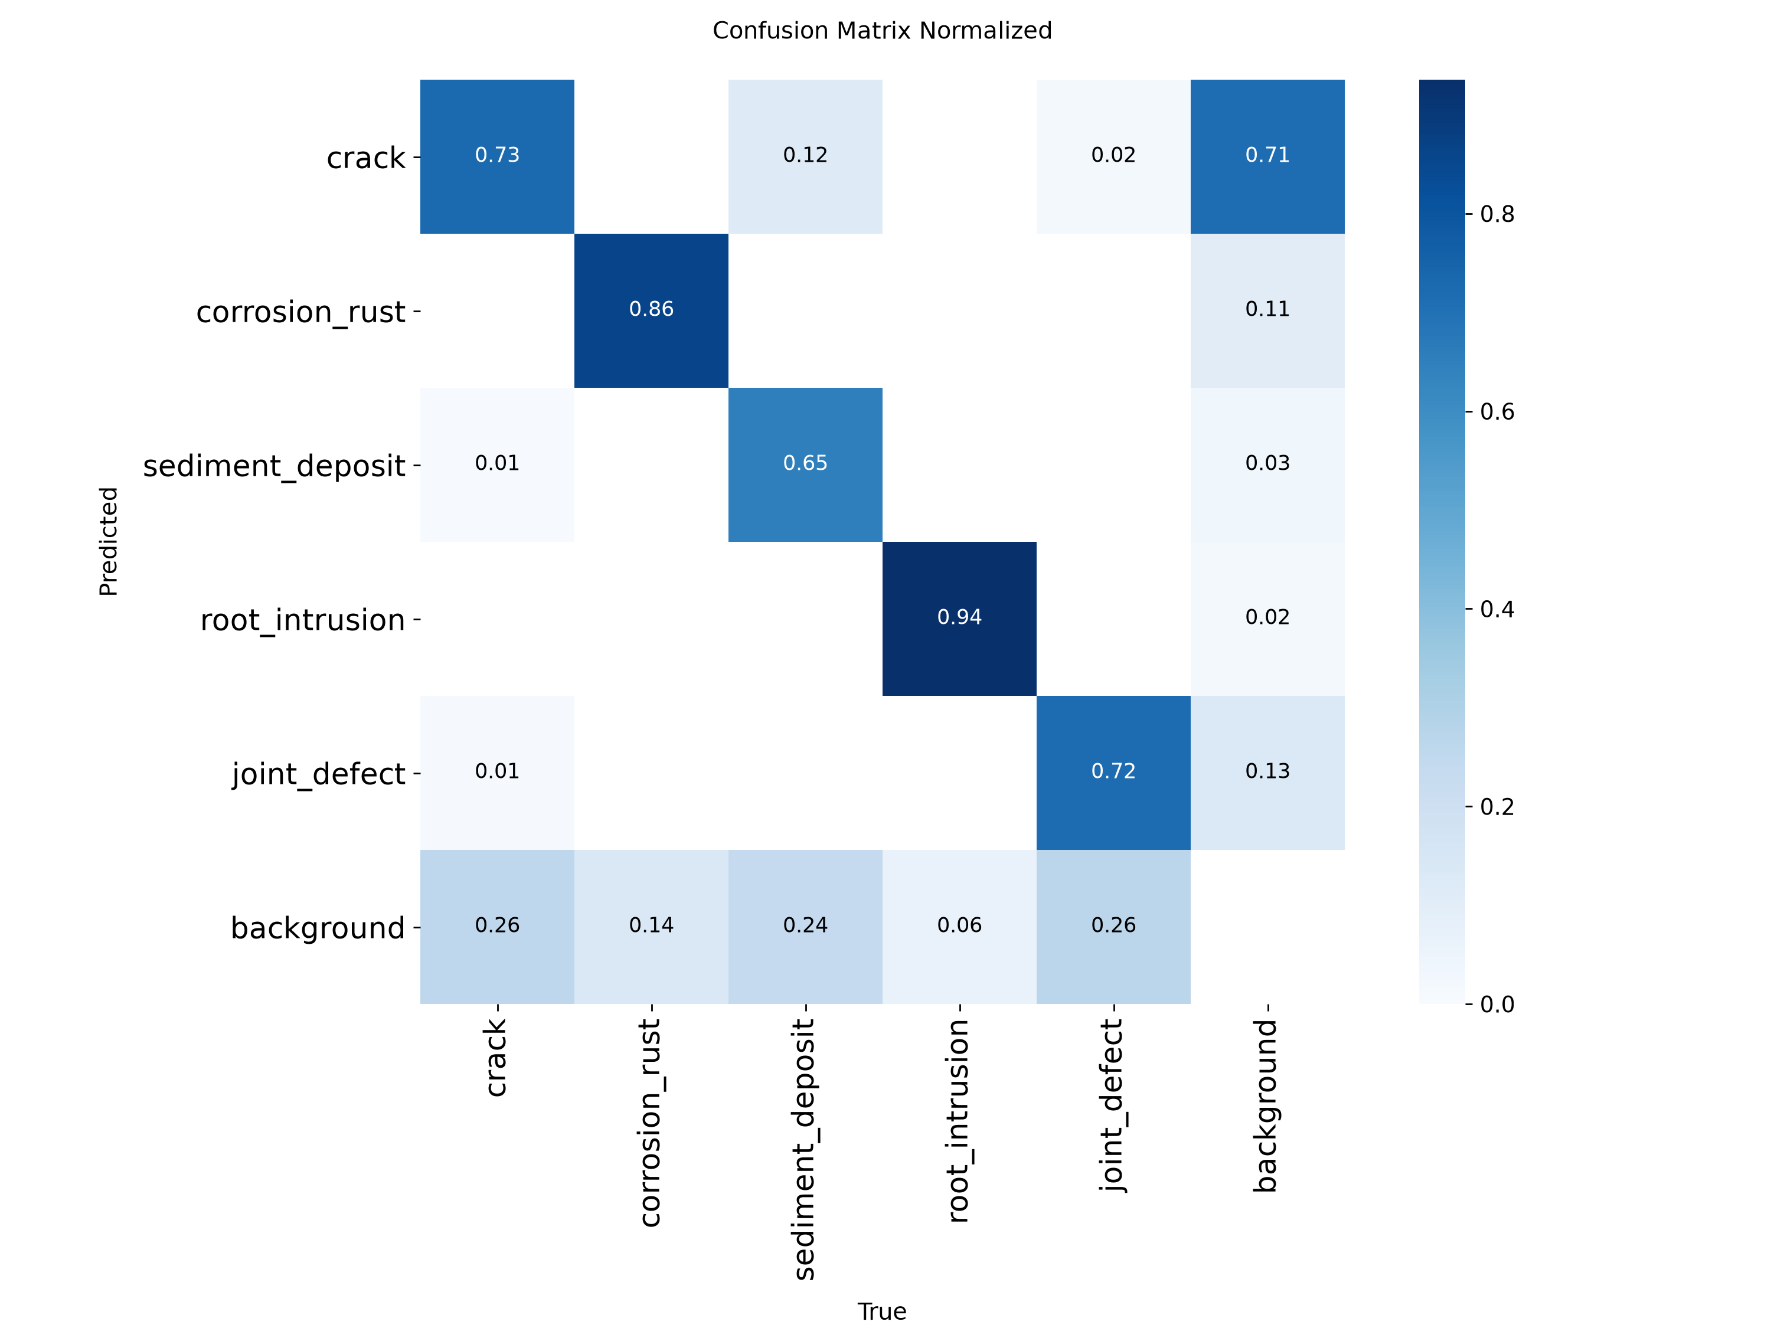
confusion matrix normalized — dataset_crack/runs/pipe_proto/yolo26s_v5_clahe_cbam/confusion_matrix_normalized.png

Evaluation artifact: yolo26s_v5_clahe_cbam_test
This is a separate evaluation folder, not another training run. Its plots are reproduced below; scores are not inferred solely from the images.
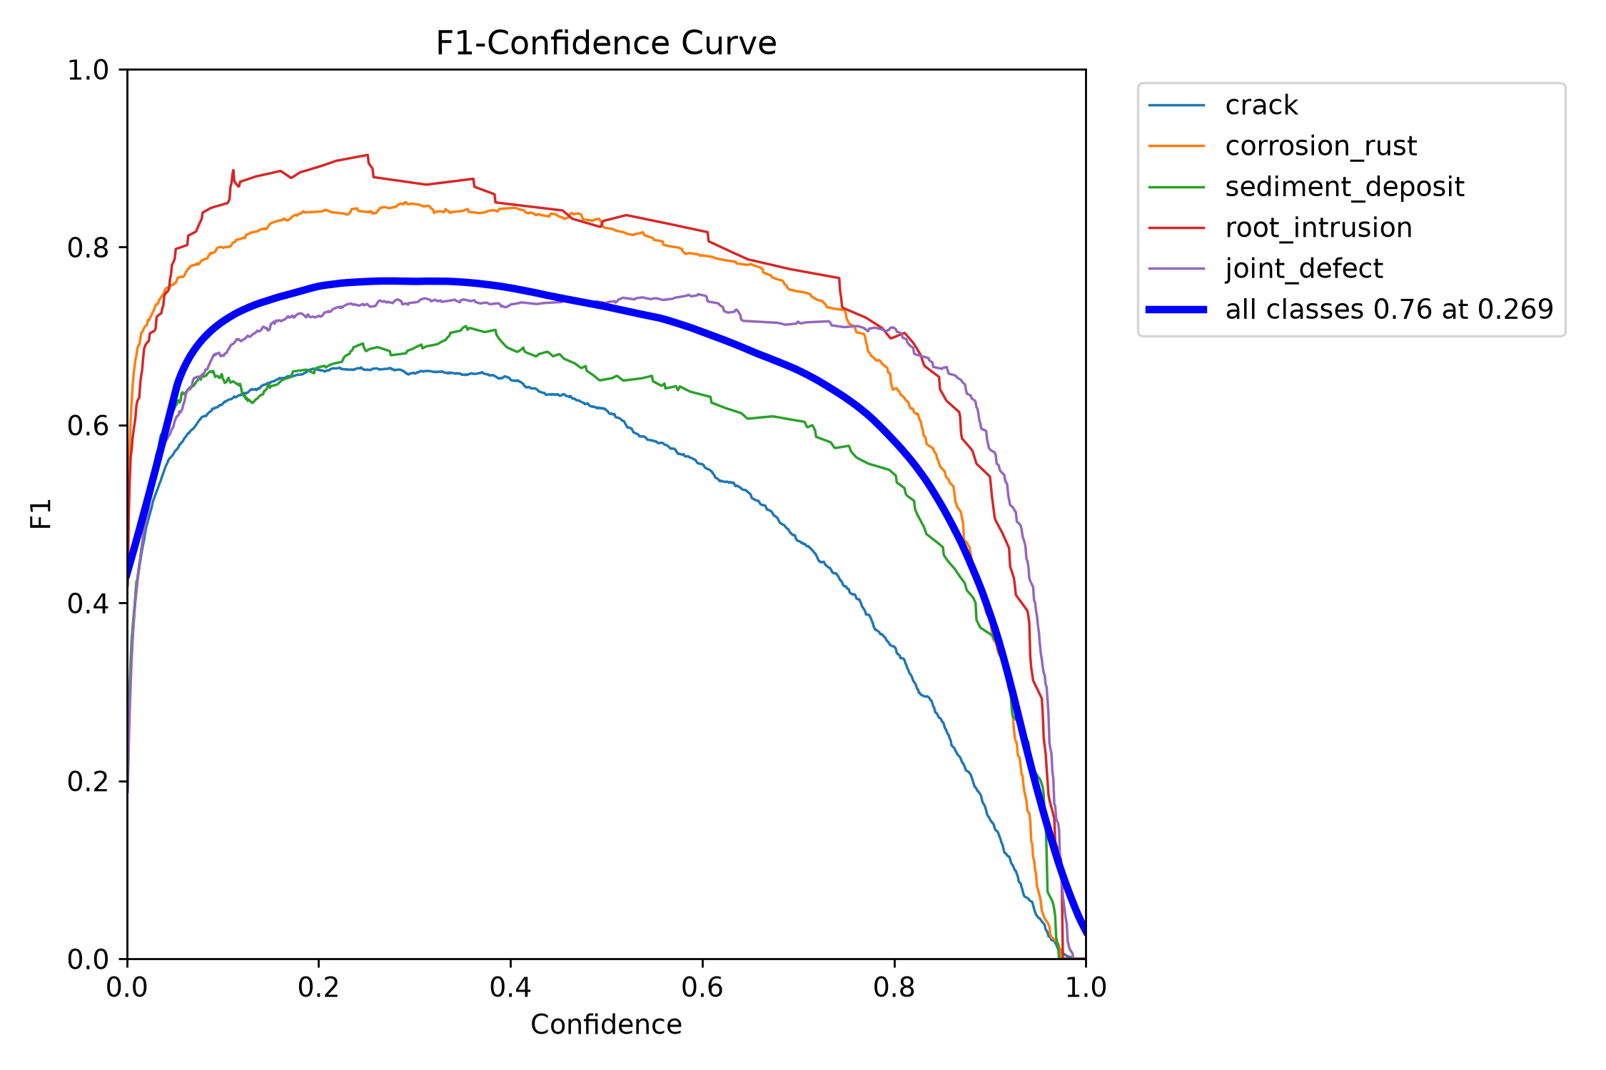
BoxF1 curve — dataset_crack/runs/pipe_proto/yolo26s_v5_clahe_cbam_test/BoxF1_curve.png
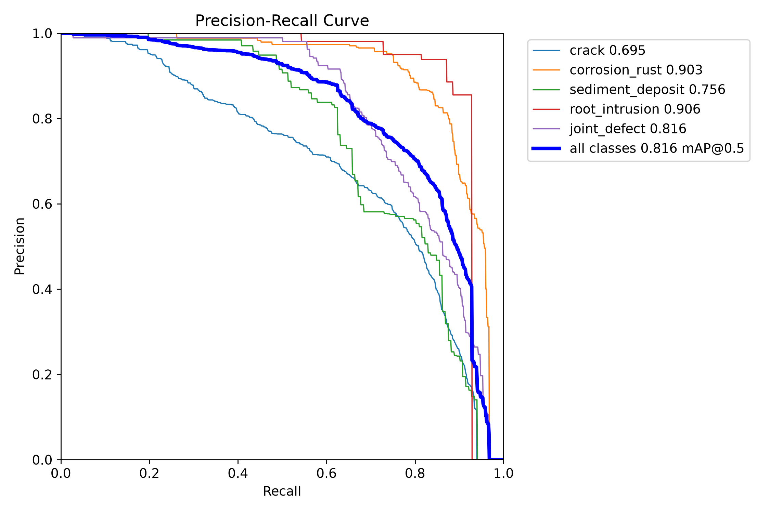
BoxPR curve — dataset_crack/runs/pipe_proto/yolo26s_v5_clahe_cbam_test/BoxPR_curve.png
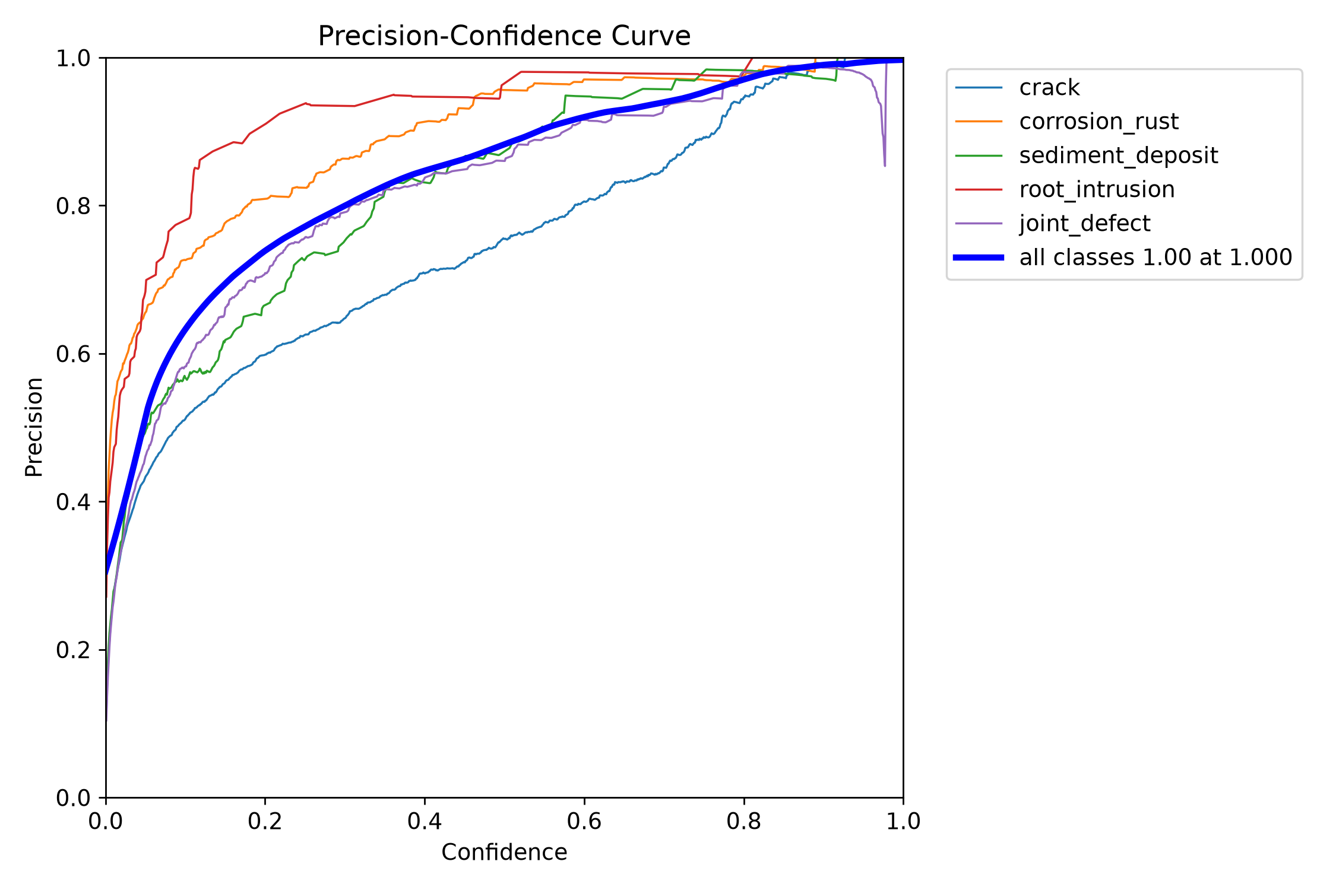
BoxP curve — dataset_crack/runs/pipe_proto/yolo26s_v5_clahe_cbam_test/BoxP_curve.png
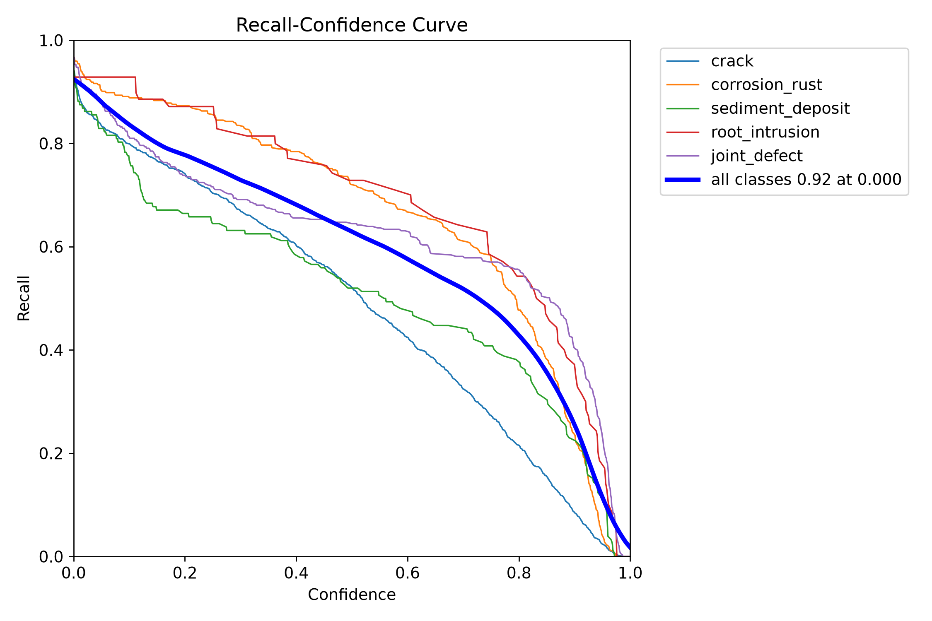
BoxR curve — dataset_crack/runs/pipe_proto/yolo26s_v5_clahe_cbam_test/BoxR_curve.png
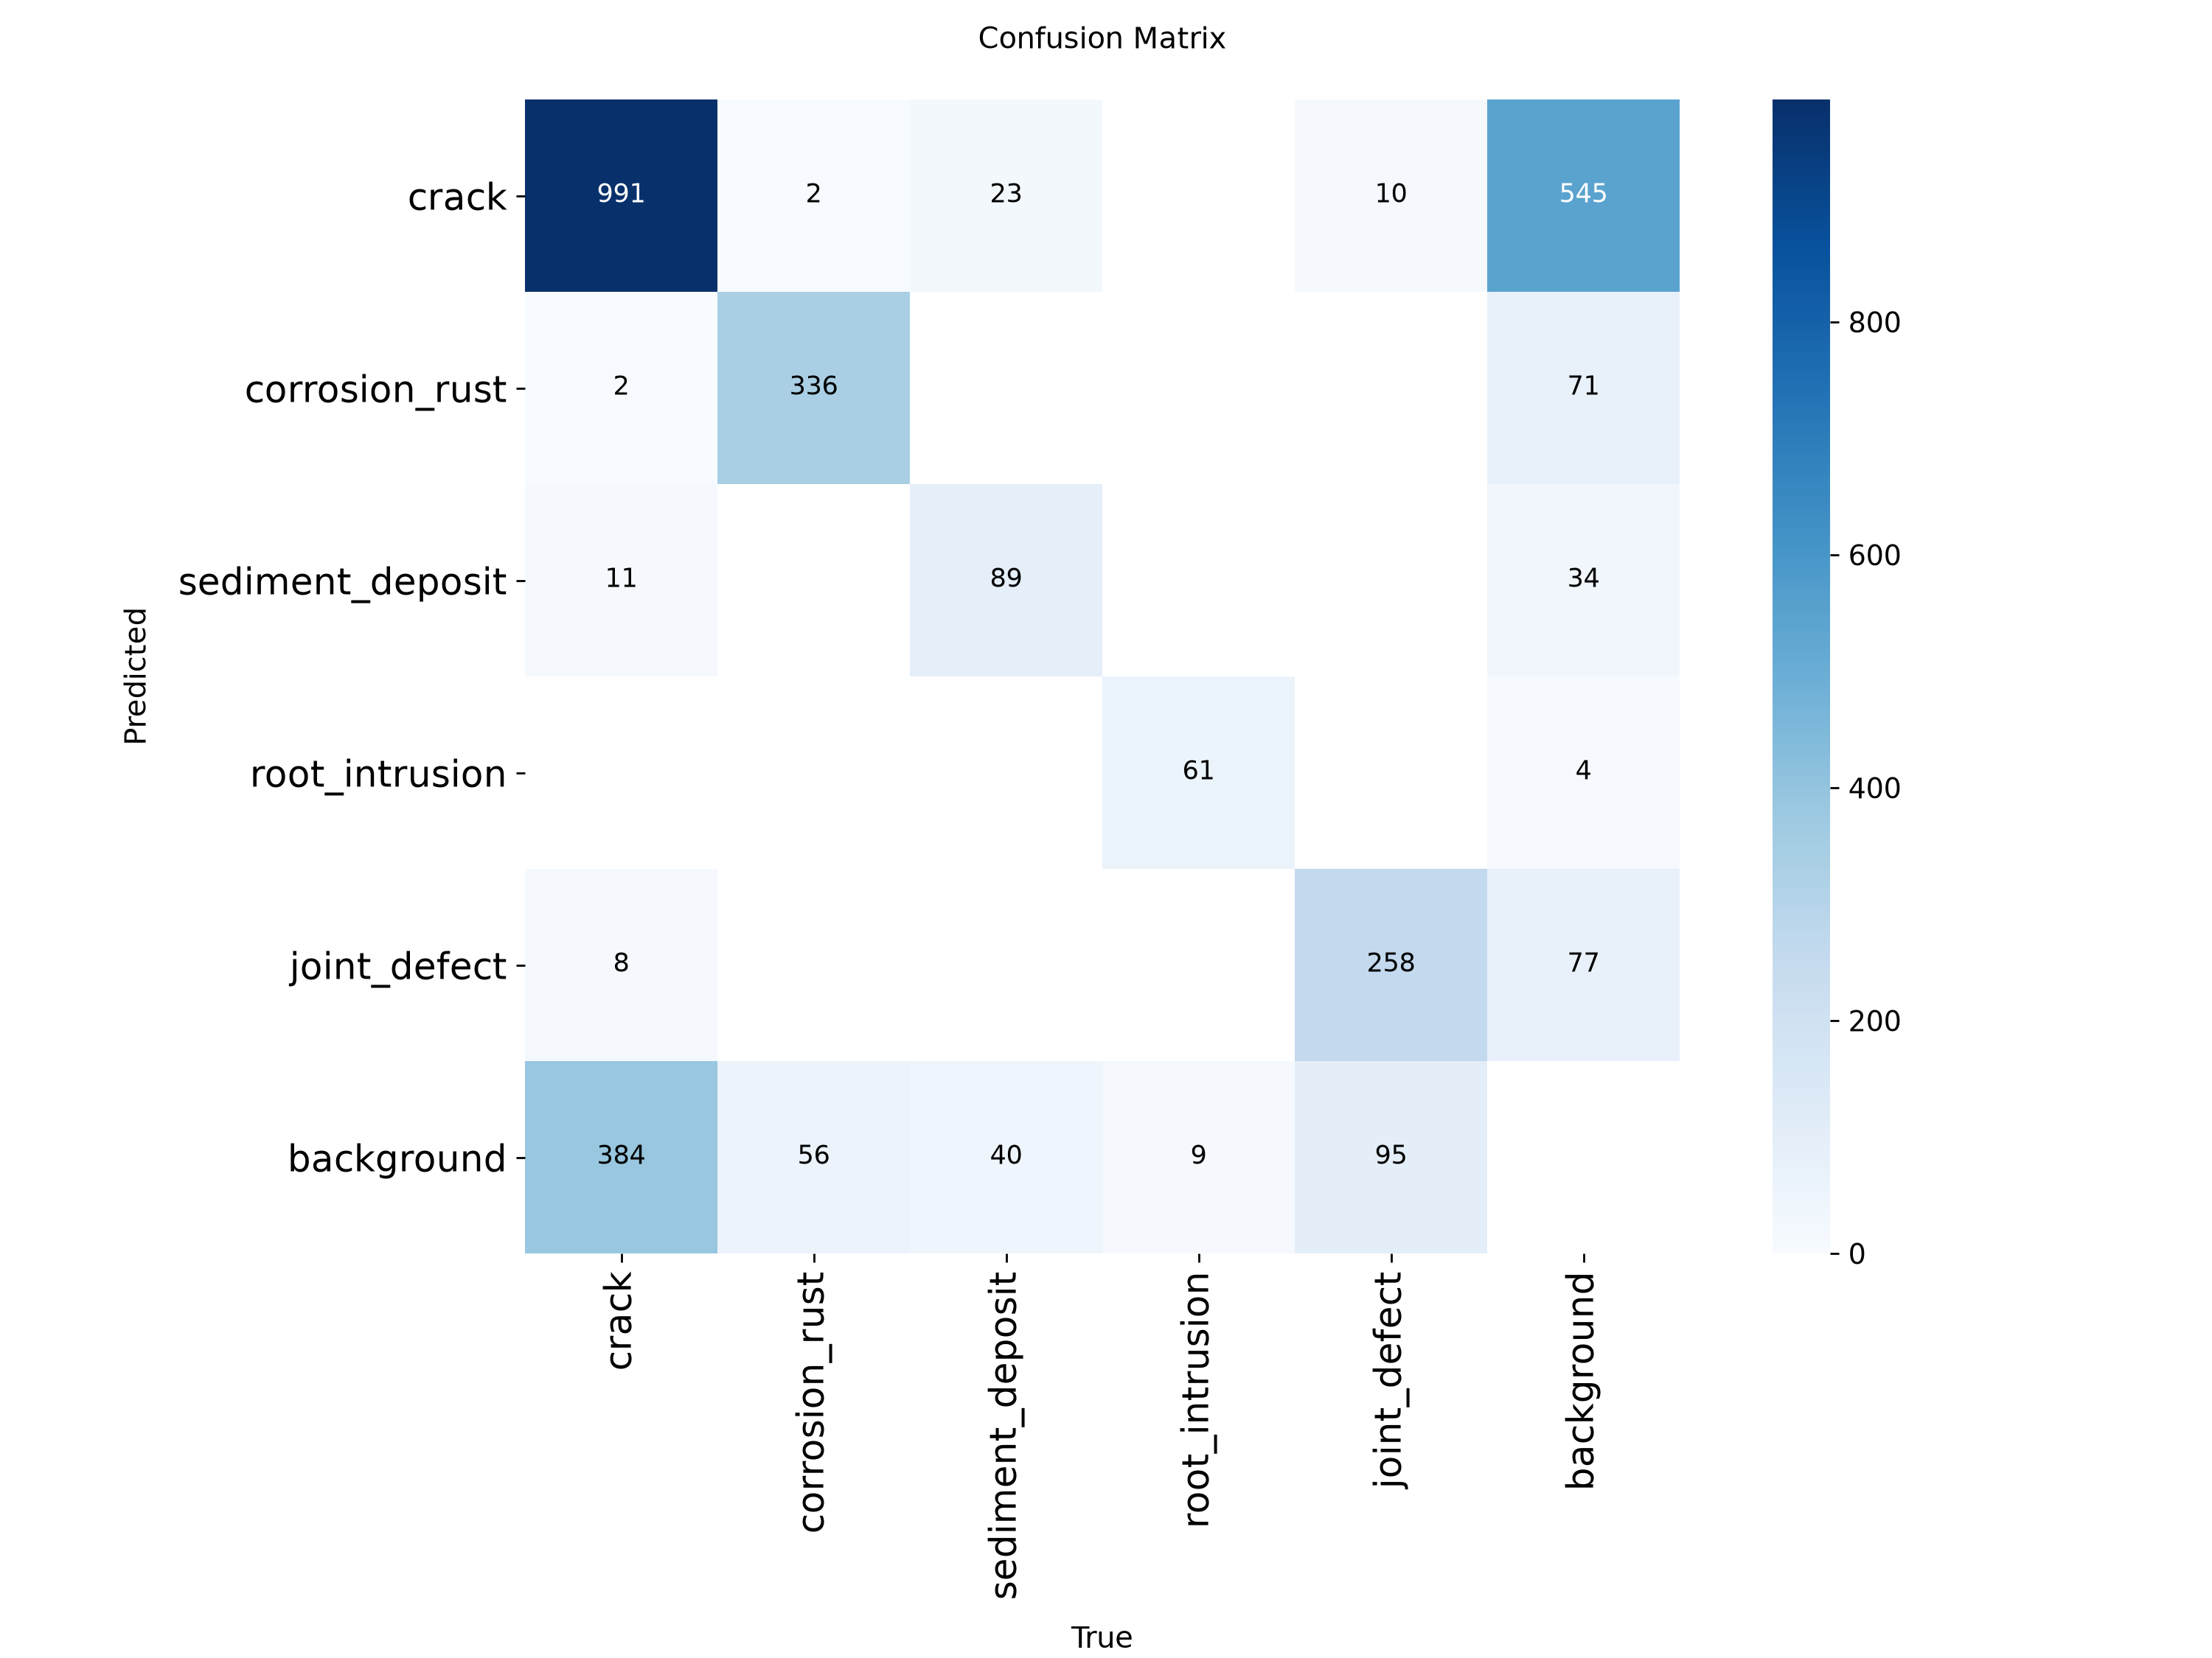
confusion matrix — dataset_crack/runs/pipe_proto/yolo26s_v5_clahe_cbam_test/confusion_matrix.png
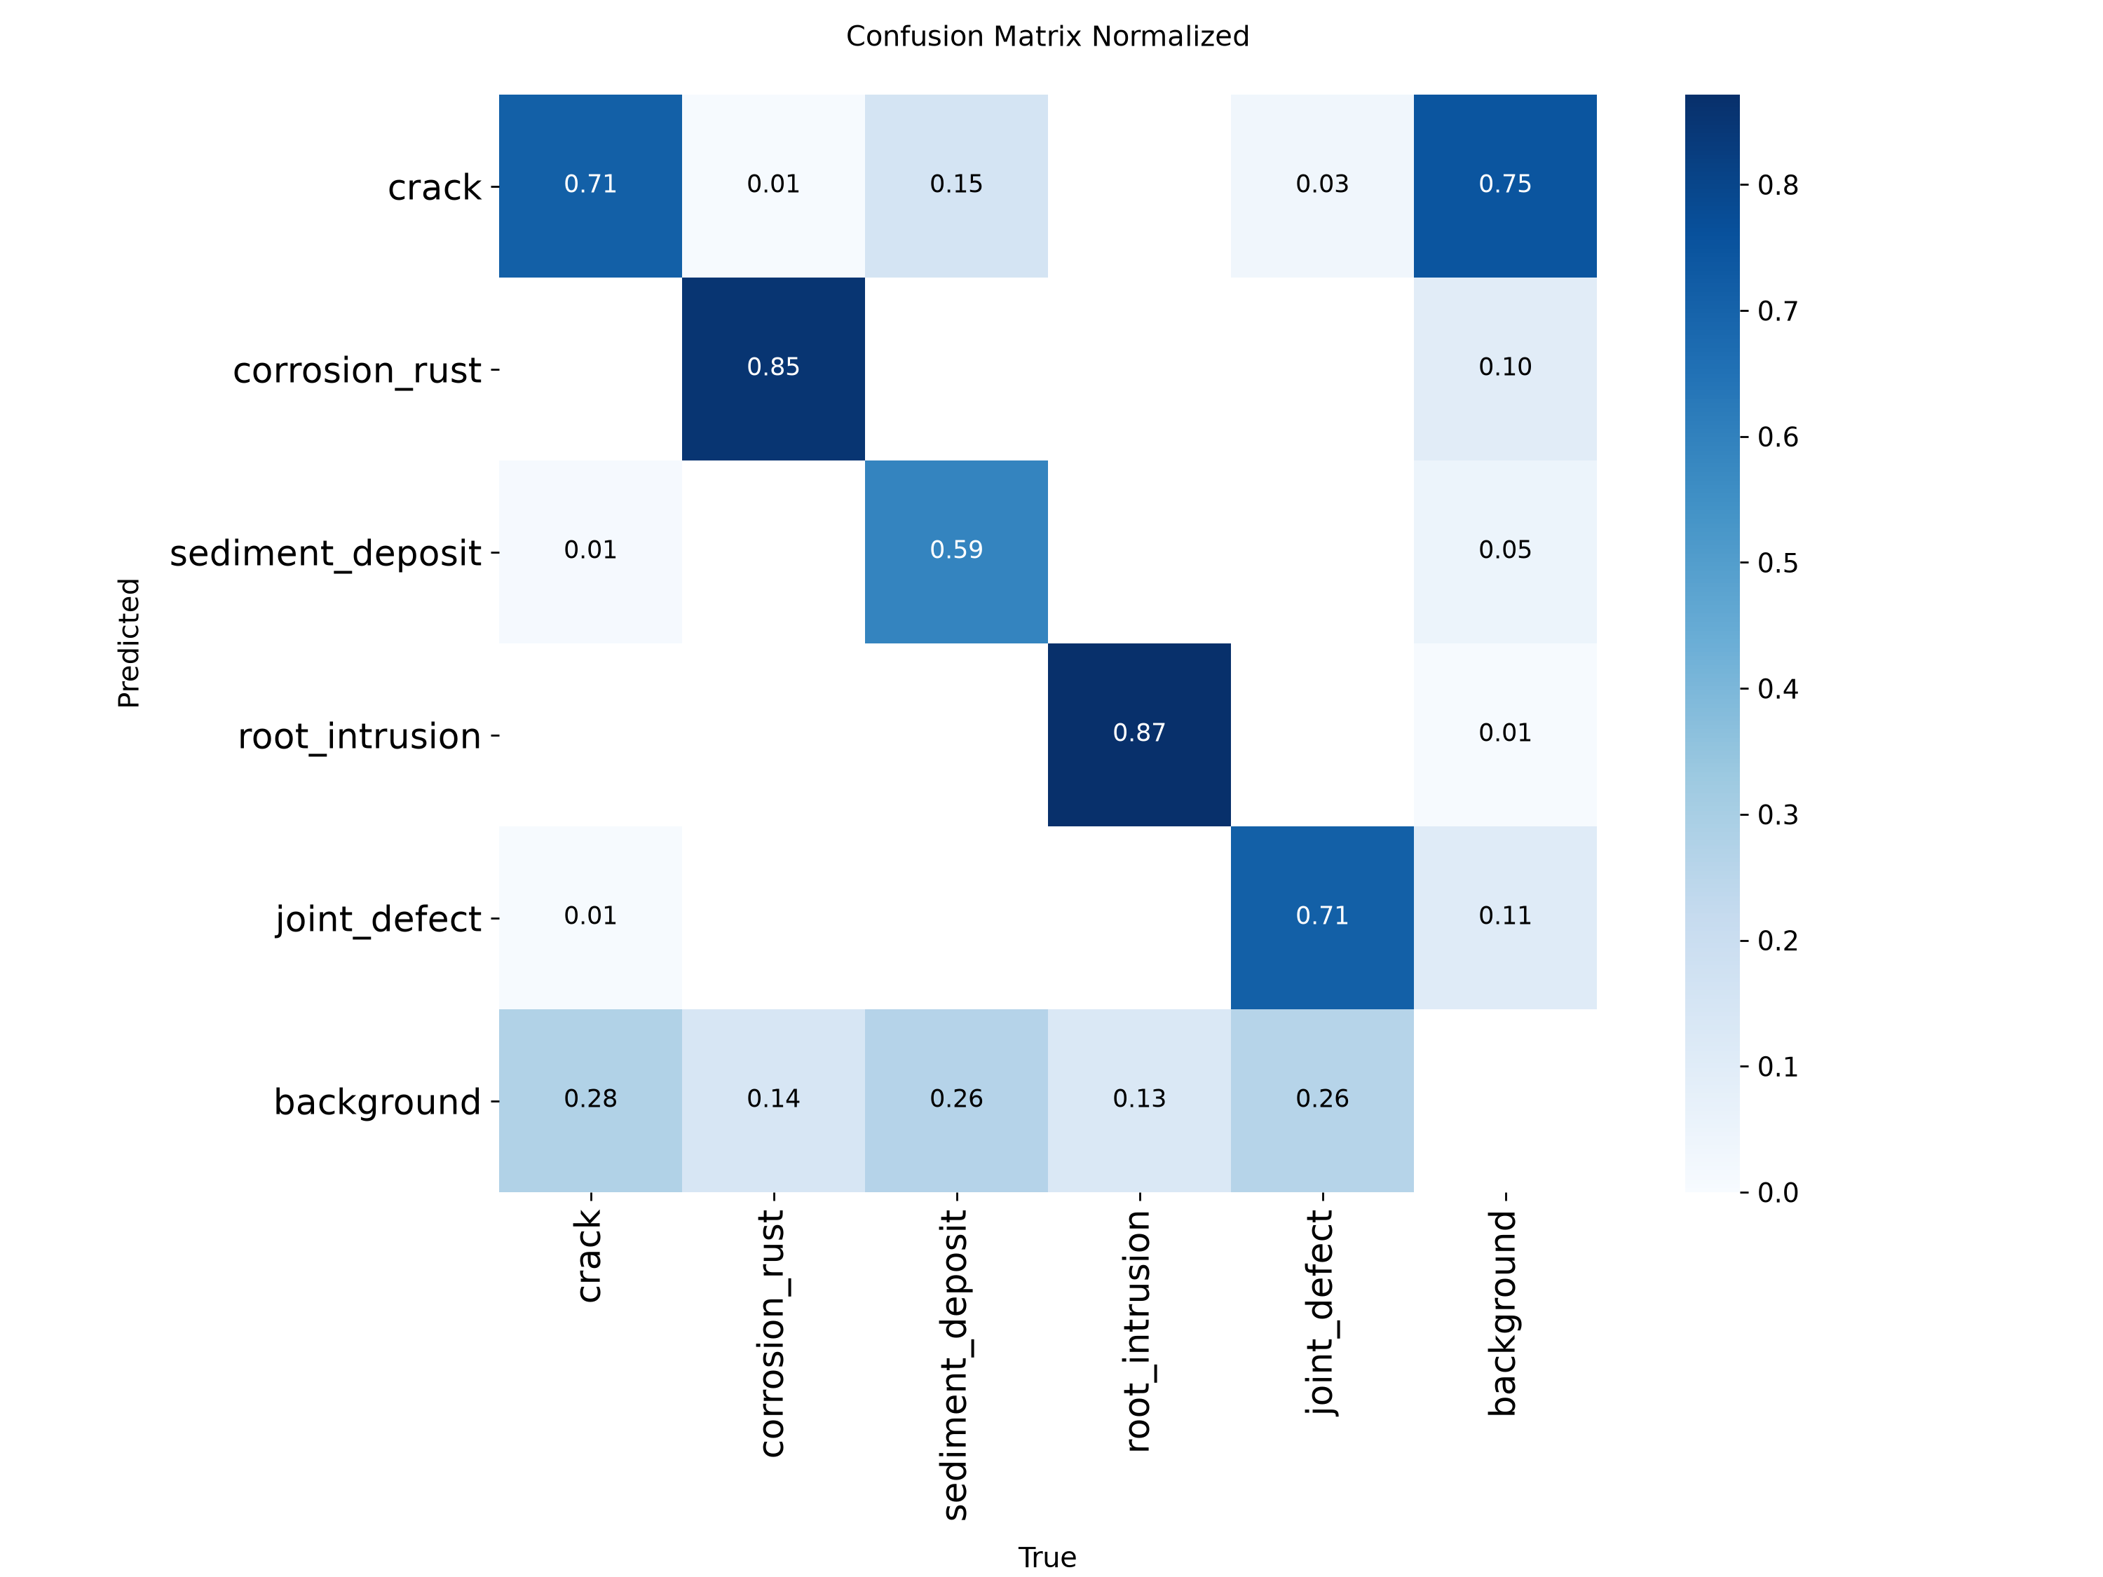
confusion matrix normalized — dataset_crack/runs/pipe_proto/yolo26s_v5_clahe_cbam_test/confusion_matrix_normalized.png

9. yolo26s_v5_clahe_se
Field | Recorded value
Family | YOLO
State | complete
Epochs observed / target | 80 / 80
Dataset | final_dataset_v5_clahe
Image size | 640
Source folder | dataset_crack/runs/pipe_proto/yolo26s_v5_clahe_se
Checkpoint | dataset_crack/runs/pipe_proto/yolo26s_v5_clahe_se/weights/best.pt
Checkpoint size | 20.33 MB
Parameters | 9,953,918
GFLOPs | 22.758
Training time | 3.18 h (Ultralytics cumulative results.csv time)
Best validation | P 77.47%, R 76.48%, mAP50 82.24%, mAP50-95 62.82%

Saved and reconstructed plots
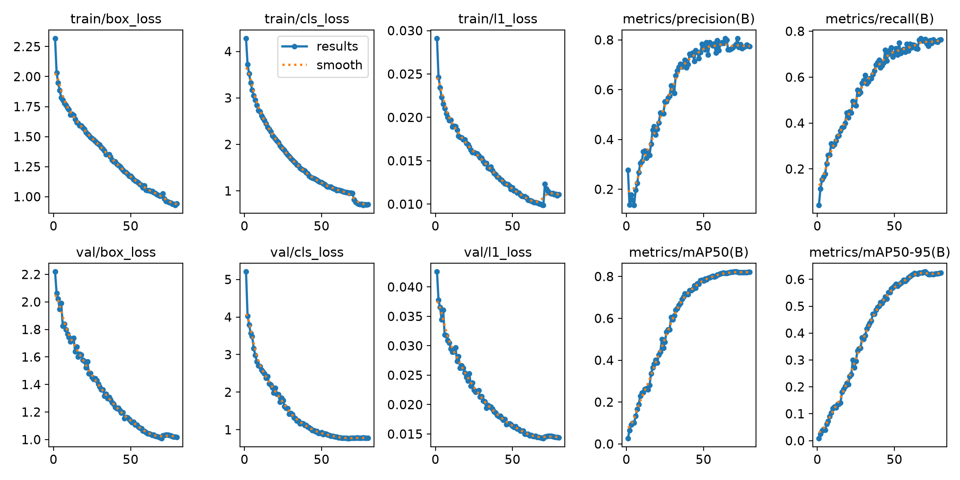
results — dataset_crack/runs/pipe_proto/yolo26s_v5_clahe_se/results.png
labels — dataset_crack/runs/pipe_proto/yolo26s_v5_clahe_se/labels.jpg
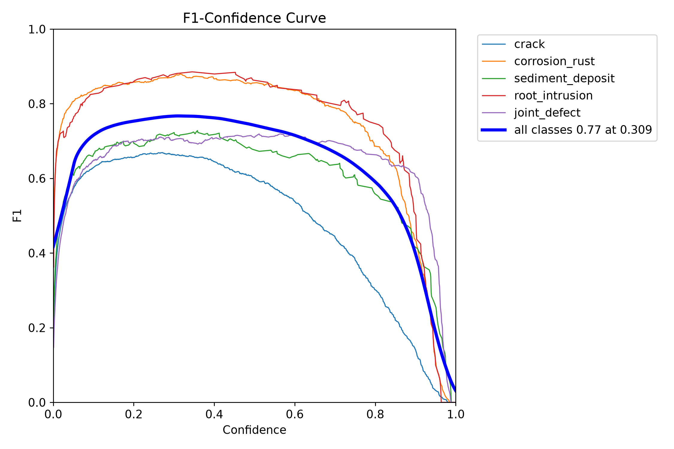
BoxF1 curve — dataset_crack/runs/pipe_proto/yolo26s_v5_clahe_se/BoxF1_curve.png
BoxPR curve — dataset_crack/runs/pipe_proto/yolo26s_v5_clahe_se/BoxPR_curve.png
BoxP curve — dataset_crack/runs/pipe_proto/yolo26s_v5_clahe_se/BoxP_curve.png
BoxR curve — dataset_crack/runs/pipe_proto/yolo26s_v5_clahe_se/BoxR_curve.png
confusion matrix — dataset_crack/runs/pipe_proto/yolo26s_v5_clahe_se/confusion_matrix.png
confusion matrix normalized — dataset_crack/runs/pipe_proto/yolo26s_v5_clahe_se/confusion_matrix_normalized.png

Evaluation artifact: yolo26s_v5_clahe_se_test
This is a separate evaluation folder, not another training run. Its plots are reproduced below; scores are not inferred solely from the images.
BoxF1 curve — dataset_crack/runs/pipe_proto/yolo26s_v5_clahe_se_test/BoxF1_curve.png
BoxPR curve — dataset_crack/runs/pipe_proto/yolo26s_v5_clahe_se_test/BoxPR_curve.png
BoxP curve — dataset_crack/runs/pipe_proto/yolo26s_v5_clahe_se_test/BoxP_curve.png
BoxR curve — dataset_crack/runs/pipe_proto/yolo26s_v5_clahe_se_test/BoxR_curve.png
confusion matrix — dataset_crack/runs/pipe_proto/yolo26s_v5_clahe_se_test/confusion_matrix.png
confusion matrix normalized — dataset_crack/runs/pipe_proto/yolo26s_v5_clahe_se_test/confusion_matrix_normalized.png

10. yolo26s_v5_clahe_simam
Field | Recorded value
Family | YOLO
State | complete
Epochs observed / target | 80 / 80
Dataset | final_dataset_v5_clahe
Image size | 640
Source folder | dataset_crack/runs/pipe_proto/yolo26s_v5_clahe_simam
Checkpoint | dataset_crack/runs/pipe_proto/yolo26s_v5_clahe_simam/weights/best.pt
Checkpoint size | 20.32 MB
Parameters | 9,951,734
GFLOPs | 22.757
Training time | 3.46 h (Ultralytics cumulative results.csv time)
Best validation | P 81.49%, R 74.55%, mAP50 82.45%, mAP50-95 64.47%

Saved and reconstructed plots
results — dataset_crack/runs/pipe_proto/yolo26s_v5_clahe_simam/results.png
labels — dataset_crack/runs/pipe_proto/yolo26s_v5_clahe_simam/labels.jpg
BoxF1 curve — dataset_crack/runs/pipe_proto/yolo26s_v5_clahe_simam/BoxF1_curve.png
BoxPR curve — dataset_crack/runs/pipe_proto/yolo26s_v5_clahe_simam/BoxPR_curve.png
BoxP curve — dataset_crack/runs/pipe_proto/yolo26s_v5_clahe_simam/BoxP_curve.png
BoxR curve — dataset_crack/runs/pipe_proto/yolo26s_v5_clahe_simam/BoxR_curve.png
confusion matrix — dataset_crack/runs/pipe_proto/yolo26s_v5_clahe_simam/confusion_matrix.png
confusion matrix normalized — dataset_crack/runs/pipe_proto/yolo26s_v5_clahe_simam/confusion_matrix_normalized.png

Evaluation artifact: yolo26s_v5_clahe_simam_test
This is a separate evaluation folder, not another training run. Its plots are reproduced below; scores are not inferred solely from the images.
BoxF1 curve — dataset_crack/runs/pipe_proto/yolo26s_v5_clahe_simam_test/BoxF1_curve.png
BoxPR curve — dataset_crack/runs/pipe_proto/yolo26s_v5_clahe_simam_test/BoxPR_curve.png
BoxP curve — dataset_crack/runs/pipe_proto/yolo26s_v5_clahe_simam_test/BoxP_curve.png
BoxR curve — dataset_crack/runs/pipe_proto/yolo26s_v5_clahe_simam_test/BoxR_curve.png
confusion matrix — dataset_crack/runs/pipe_proto/yolo26s_v5_clahe_simam_test/confusion_matrix.png
confusion matrix normalized — dataset_crack/runs/pipe_proto/yolo26s_v5_clahe_simam_test/confusion_matrix_normalized.png

11. yolo26s_v5_parallel_simam_cbam_se
Field | Recorded value
Family | YOLO
State | complete
Epochs observed / target | 80 / 80
Dataset | final_dataset_v5
Image size | 640
Source folder | dataset_crack/runs/pipe_proto/yolo26s_v5_parallel_simam_cbam_se
Checkpoint | dataset_crack/runs/pipe_proto/yolo26s_v5_parallel_simam_cbam_se/weights/best.pt
Checkpoint size | 20.47 MB
Parameters | 10,021,857
GFLOPs | 23.607
Training time | 3.59 h (Ultralytics cumulative results.csv time)
Best validation | P 79.86%, R 73.50%, mAP50 82.13%, mAP50-95 63.88%

Saved and reconstructed plots
results — dataset_crack/runs/pipe_proto/yolo26s_v5_parallel_simam_cbam_se/results.png
labels — dataset_crack/runs/pipe_proto/yolo26s_v5_parallel_simam_cbam_se/labels.jpg
BoxF1 curve — dataset_crack/runs/pipe_proto/yolo26s_v5_parallel_simam_cbam_se/BoxF1_curve.png
BoxPR curve — dataset_crack/runs/pipe_proto/yolo26s_v5_parallel_simam_cbam_se/BoxPR_curve.png
BoxP curve — dataset_crack/runs/pipe_proto/yolo26s_v5_parallel_simam_cbam_se/BoxP_curve.png
BoxR curve — dataset_crack/runs/pipe_proto/yolo26s_v5_parallel_simam_cbam_se/BoxR_curve.png
confusion matrix — dataset_crack/runs/pipe_proto/yolo26s_v5_parallel_simam_cbam_se/confusion_matrix.png
confusion matrix normalized — dataset_crack/runs/pipe_proto/yolo26s_v5_parallel_simam_cbam_se/confusion_matrix_normalized.png

Evaluation artifact: yolo26s_parallel_filtered_diagnostic_test
This is a separate evaluation folder, not another training run. Its plots are reproduced below; scores are not inferred solely from the images.
BoxF1 curve — dataset_crack/runs/pipe_proto/yolo26s_parallel_filtered_diagnostic_test/BoxF1_curve.png
BoxPR curve — dataset_crack/runs/pipe_proto/yolo26s_parallel_filtered_diagnostic_test/BoxPR_curve.png
BoxP curve — dataset_crack/runs/pipe_proto/yolo26s_parallel_filtered_diagnostic_test/BoxP_curve.png
BoxR curve — dataset_crack/runs/pipe_proto/yolo26s_parallel_filtered_diagnostic_test/BoxR_curve.png
confusion matrix — dataset_crack/runs/pipe_proto/yolo26s_parallel_filtered_diagnostic_test/confusion_matrix.png
confusion matrix normalized — dataset_crack/runs/pipe_proto/yolo26s_parallel_filtered_diagnostic_test/confusion_matrix_normalized.png

Evaluation artifact: yolo26s_parallel_full_v5_test
This is a separate evaluation folder, not another training run. Its plots are reproduced below; scores are not inferred solely from the images.
BoxF1 curve — dataset_crack/runs/pipe_proto/yolo26s_parallel_full_v5_test/BoxF1_curve.png
BoxPR curve — dataset_crack/runs/pipe_proto/yolo26s_parallel_full_v5_test/BoxPR_curve.png
BoxP curve — dataset_crack/runs/pipe_proto/yolo26s_parallel_full_v5_test/BoxP_curve.png
BoxR curve — dataset_crack/runs/pipe_proto/yolo26s_parallel_full_v5_test/BoxR_curve.png
confusion matrix — dataset_crack/runs/pipe_proto/yolo26s_parallel_full_v5_test/confusion_matrix.png
confusion matrix normalized — dataset_crack/runs/pipe_proto/yolo26s_parallel_full_v5_test/confusion_matrix_normalized.png

Evaluation artifact: yolo26s_parallel_full_v5_test-2
This is a separate evaluation folder, not another training run. Its plots are reproduced below; scores are not inferred solely from the images.
BoxF1 curve — dataset_crack/runs/pipe_proto/yolo26s_parallel_full_v5_test-2/BoxF1_curve.png
BoxPR curve — dataset_crack/runs/pipe_proto/yolo26s_parallel_full_v5_test-2/BoxPR_curve.png
BoxP curve — dataset_crack/runs/pipe_proto/yolo26s_parallel_full_v5_test-2/BoxP_curve.png
BoxR curve — dataset_crack/runs/pipe_proto/yolo26s_parallel_full_v5_test-2/BoxR_curve.png
confusion matrix — dataset_crack/runs/pipe_proto/yolo26s_parallel_full_v5_test-2/confusion_matrix.png
confusion matrix normalized — dataset_crack/runs/pipe_proto/yolo26s_parallel_full_v5_test-2/confusion_matrix_normalized.png

12. yolo26s_v6_normal_error_filtered_diagnostic_seed0_20260929_184244_3e235d15
Field | Recorded value
Family | YOLO
State | complete
Epochs observed / target | 80 / 80
Dataset | final_dataset_v6
Image size | 640
Source folder | dataset_crack/runs/pipe_proto/yolo26s_v6_normal_error_filtered_diagnostic_seed0_20260929_184244_3e235d15
Checkpoint | dataset_crack/runs/pipe_proto/yolo26s_v6_normal_error_filtered_diagnostic_seed0_20260929_184244_3e235d15/weights/best.pt
Checkpoint size | 20.32 MB
Parameters | 9,951,734
GFLOPs | 22.757
Training time | 3.20 h (Ultralytics cumulative results.csv time)
Best validation | P 80.27%, R 76.13%, mAP50 82.54%, mAP50-95 65.61%

Saved and reconstructed plots
results — dataset_crack/runs/pipe_proto/yolo26s_v6_normal_error_filtered_diagnostic_seed0_20260929_184244_3e235d15/results.png
labels — dataset_crack/runs/pipe_proto/yolo26s_v6_normal_error_filtered_diagnostic_seed0_20260929_184244_3e235d15/labels.jpg
BoxF1 curve — dataset_crack/runs/pipe_proto/yolo26s_v6_normal_error_filtered_diagnostic_seed0_20260929_184244_3e235d15/BoxF1_curve.png
BoxPR curve — dataset_crack/runs/pipe_proto/yolo26s_v6_normal_error_filtered_diagnostic_seed0_20260929_184244_3e235d15/BoxPR_curve.png
BoxP curve — dataset_crack/runs/pipe_proto/yolo26s_v6_normal_error_filtered_diagnostic_seed0_20260929_184244_3e235d15/BoxP_curve.png
BoxR curve — dataset_crack/runs/pipe_proto/yolo26s_v6_normal_error_filtered_diagnostic_seed0_20260929_184244_3e235d15/BoxR_curve.png
confusion matrix — dataset_crack/runs/pipe_proto/yolo26s_v6_normal_error_filtered_diagnostic_seed0_20260929_184244_3e235d15/confusion_matrix.png
confusion matrix normalized — dataset_crack/runs/pipe_proto/yolo26s_v6_normal_error_filtered_diagnostic_seed0_20260929_184244_3e235d15/confusion_matrix_normalized.png

Evaluation artifact: yolo26s_v6_normal_error_filtered_diagnostic_seed0_20260929_184244_3e235d15_filtered_test
This is a separate evaluation folder, not another training run. Its plots are reproduced below; scores are not inferred solely from the images.
BoxF1 curve — dataset_crack/runs/pipe_proto/yolo26s_v6_normal_error_filtered_diagnostic_seed0_20260929_184244_3e235d15_filtered_test/BoxF1_curve.png
BoxPR curve — dataset_crack/runs/pipe_proto/yolo26s_v6_normal_error_filtered_diagnostic_seed0_20260929_184244_3e235d15_filtered_test/BoxPR_curve.png
BoxP curve — dataset_crack/runs/pipe_proto/yolo26s_v6_normal_error_filtered_diagnostic_seed0_20260929_184244_3e235d15_filtered_test/BoxP_curve.png
BoxR curve — dataset_crack/runs/pipe_proto/yolo26s_v6_normal_error_filtered_diagnostic_seed0_20260929_184244_3e235d15_filtered_test/BoxR_curve.png
confusion matrix — dataset_crack/runs/pipe_proto/yolo26s_v6_normal_error_filtered_diagnostic_seed0_20260929_184244_3e235d15_filtered_test/confusion_matrix.png
confusion matrix normalized — dataset_crack/runs/pipe_proto/yolo26s_v6_normal_error_filtered_diagnostic_seed0_20260929_184244_3e235d15_filtered_test/confusion_matrix_normalized.png

Evaluation artifact: yolo26s_v6_normal_error_filtered_diagnostic_seed0_20260929_184244_3e235d15_full_v5_test
This is a separate evaluation folder, not another training run. Its plots are reproduced below; scores are not inferred solely from the images.
BoxF1 curve — dataset_crack/runs/pipe_proto/yolo26s_v6_normal_error_filtered_diagnostic_seed0_20260929_184244_3e235d15_full_v5_test/BoxF1_curve.png
BoxPR curve — dataset_crack/runs/pipe_proto/yolo26s_v6_normal_error_filtered_diagnostic_seed0_20260929_184244_3e235d15_full_v5_test/BoxPR_curve.png
BoxP curve — dataset_crack/runs/pipe_proto/yolo26s_v6_normal_error_filtered_diagnostic_seed0_20260929_184244_3e235d15_full_v5_test/BoxP_curve.png
BoxR curve — dataset_crack/runs/pipe_proto/yolo26s_v6_normal_error_filtered_diagnostic_seed0_20260929_184244_3e235d15_full_v5_test/BoxR_curve.png
confusion matrix — dataset_crack/runs/pipe_proto/yolo26s_v6_normal_error_filtered_diagnostic_seed0_20260929_184244_3e235d15_full_v5_test/confusion_matrix.png
confusion matrix normalized — dataset_crack/runs/pipe_proto/yolo26s_v6_normal_error_filtered_diagnostic_seed0_20260929_184244_3e235d15_full_v5_test/confusion_matrix_normalized.png

13. yolo26s_v6_normal_error_filtered_diagnostic_seed0_20260930_185252_27442ffa
Field | Recorded value
Family | YOLO
State | interrupted / partial
Epochs observed / target | 4 / 80
Dataset | final_dataset_v6
Image size | 640
Source folder | dataset_crack/runs/pipe_proto/yolo26s_v6_normal_error_filtered_diagnostic_seed0_20260930_185252_27442ffa
Checkpoint | dataset_crack/runs/pipe_proto/yolo26s_v6_normal_error_filtered_diagnostic_seed0_20260930_185252_27442ffa/weights/best.pt
Checkpoint size | 80.38 MB
Parameters | 9,951,734
GFLOPs | 22.757
Training time | 0.13 h (Ultralytics cumulative results.csv time)
Best validation | P 19.52%, R 18.48%, mAP50 9.80%, mAP50-95 4.15%

Saved and reconstructed plots
labels — dataset_crack/runs/pipe_proto/yolo26s_v6_normal_error_filtered_diagnostic_seed0_20260930_185252_27442ffa/labels.jpg

14. yolo26s_v6_normal_error_filtered_diagnostic_seed0_20260930_190356_a5b23911
Field | Recorded value
Family | YOLO
State | complete
Epochs observed / target | 80 / 80
Dataset | final_dataset_v6
Image size | 640
Source folder | dataset_crack/runs/pipe_proto/yolo26s_v6_normal_error_filtered_diagnostic_seed0_20260930_190356_a5b23911
Checkpoint | dataset_crack/runs/pipe_proto/yolo26s_v6_normal_error_filtered_diagnostic_seed0_20260930_190356_a5b23911/weights/best.pt
Checkpoint size | 20.32 MB
Parameters | 9,951,734
GFLOPs | 22.757
Training time | 2.50 h (Ultralytics cumulative results.csv time)
Best validation | P 82.00%, R 64.24%, mAP50 65.61%, mAP50-95 52.63%

Saved and reconstructed plots
results — dataset_crack/runs/pipe_proto/yolo26s_v6_normal_error_filtered_diagnostic_seed0_20260930_190356_a5b23911/results.png
labels — dataset_crack/runs/pipe_proto/yolo26s_v6_normal_error_filtered_diagnostic_seed0_20260930_190356_a5b23911/labels.jpg
BoxF1 curve — dataset_crack/runs/pipe_proto/yolo26s_v6_normal_error_filtered_diagnostic_seed0_20260930_190356_a5b23911/BoxF1_curve.png
BoxPR curve — dataset_crack/runs/pipe_proto/yolo26s_v6_normal_error_filtered_diagnostic_seed0_20260930_190356_a5b23911/BoxPR_curve.png
BoxP curve — dataset_crack/runs/pipe_proto/yolo26s_v6_normal_error_filtered_diagnostic_seed0_20260930_190356_a5b23911/BoxP_curve.png
BoxR curve — dataset_crack/runs/pipe_proto/yolo26s_v6_normal_error_filtered_diagnostic_seed0_20260930_190356_a5b23911/BoxR_curve.png
confusion matrix — dataset_crack/runs/pipe_proto/yolo26s_v6_normal_error_filtered_diagnostic_seed0_20260930_190356_a5b23911/confusion_matrix.png
confusion matrix normalized — dataset_crack/runs/pipe_proto/yolo26s_v6_normal_error_filtered_diagnostic_seed0_20260930_190356_a5b23911/confusion_matrix_normalized.png

15. yolo26n_cbam_v1
Field | Recorded value
Family | YOLO
State | initialized only
Epochs observed / target | Unavailable
Dataset | sewer_remapped
Image size | 640
Source folder | dataset_crack/runs/detect/runs/pipe_proto/yolo26n_cbam_v1
Checkpoint | Unavailable
Checkpoint size | Unavailable
Parameters | Unavailable
GFLOPs | Unavailable
Training time | Unavailable (not logged)
Best validation | P Unavailable, R Unavailable, mAP50 Unavailable, mAP50-95 Unavailable

Saved and reconstructed plots
labels — dataset_crack/runs/detect/runs/pipe_proto/yolo26n_cbam_v1/labels.jpg

16. yolo26n_cbam_v1-2
Field | Recorded value
Family | YOLO
State | complete
Epochs observed / target | 80 / 80
Dataset | sewer_remapped
Image size | 640
Source folder | dataset_crack/runs/detect/runs/pipe_proto/yolo26n_cbam_v1-2
Checkpoint | dataset_crack/runs/detect/runs/pipe_proto/yolo26n_cbam_v1-2/weights/best.pt
Checkpoint size | 5.40 MB
Parameters | 2,510,008
GFLOPs | 5.903
Training time | 0.52 h (Ultralytics cumulative results.csv time)
Best validation | P 49.55%, R 31.46%, mAP50 33.85%, mAP50-95 18.76%

Saved and reconstructed plots
results — dataset_crack/runs/detect/runs/pipe_proto/yolo26n_cbam_v1-2/results.png
labels — dataset_crack/runs/detect/runs/pipe_proto/yolo26n_cbam_v1-2/labels.jpg
BoxF1 curve — dataset_crack/runs/detect/runs/pipe_proto/yolo26n_cbam_v1-2/BoxF1_curve.png
BoxPR curve — dataset_crack/runs/detect/runs/pipe_proto/yolo26n_cbam_v1-2/BoxPR_curve.png
BoxP curve — dataset_crack/runs/detect/runs/pipe_proto/yolo26n_cbam_v1-2/BoxP_curve.png
BoxR curve — dataset_crack/runs/detect/runs/pipe_proto/yolo26n_cbam_v1-2/BoxR_curve.png
confusion matrix — dataset_crack/runs/detect/runs/pipe_proto/yolo26n_cbam_v1-2/confusion_matrix.png
confusion matrix normalized — dataset_crack/runs/detect/runs/pipe_proto/yolo26n_cbam_v1-2/confusion_matrix_normalized.png

17. yolo26n_cbam_v1_140ep
Field | Recorded value
Family | YOLO
State | complete
Epochs observed / target | 140 / 140
Dataset | sewer_remapped
Image size | 640
Source folder | dataset_crack/runs/detect/runs/pipe_proto/yolo26n_cbam_v1_140ep
Checkpoint | dataset_crack/runs/detect/runs/pipe_proto/yolo26n_cbam_v1_140ep/weights/best.pt
Checkpoint size | 5.40 MB
Parameters | 2,510,008
GFLOPs | 5.903
Training time | 0.84 h (Ultralytics cumulative results.csv time)
Best validation | P 43.60%, R 33.09%, mAP50 32.00%, mAP50-95 18.72%

Saved and reconstructed plots
results — dataset_crack/runs/detect/runs/pipe_proto/yolo26n_cbam_v1_140ep/results.png
labels — dataset_crack/runs/detect/runs/pipe_proto/yolo26n_cbam_v1_140ep/labels.jpg
BoxF1 curve — dataset_crack/runs/detect/runs/pipe_proto/yolo26n_cbam_v1_140ep/BoxF1_curve.png
BoxPR curve — dataset_crack/runs/detect/runs/pipe_proto/yolo26n_cbam_v1_140ep/BoxPR_curve.png
BoxP curve — dataset_crack/runs/detect/runs/pipe_proto/yolo26n_cbam_v1_140ep/BoxP_curve.png
BoxR curve — dataset_crack/runs/detect/runs/pipe_proto/yolo26n_cbam_v1_140ep/BoxR_curve.png
confusion matrix — dataset_crack/runs/detect/runs/pipe_proto/yolo26n_cbam_v1_140ep/confusion_matrix.png
confusion matrix normalized — dataset_crack/runs/detect/runs/pipe_proto/yolo26n_cbam_v1_140ep/confusion_matrix_normalized.png

18. yolo26n_final_merged
Field | Recorded value
Family | YOLO
State | initialized only
Epochs observed / target | Unavailable
Dataset | final_dataset
Image size | 640
Source folder | dataset_crack/runs/detect/runs/pipe_proto/yolo26n_final_merged
Checkpoint | Unavailable
Checkpoint size | Unavailable
Parameters | Unavailable
GFLOPs | Unavailable
Training time | Unavailable (not logged)
Best validation | P Unavailable, R Unavailable, mAP50 Unavailable, mAP50-95 Unavailable
No saved plot artifact or usable RF-DETR epoch series is available for this attempt.

19. yolo26n_final_merged-2
Field | Recorded value
Family | YOLO
State | initialized only
Epochs observed / target | Unavailable
Dataset | final_dataset
Image size | 640
Source folder | dataset_crack/runs/detect/runs/pipe_proto/yolo26n_final_merged-2
Checkpoint | Unavailable
Checkpoint size | Unavailable
Parameters | Unavailable
GFLOPs | Unavailable
Training time | Unavailable (not logged)
Best validation | P Unavailable, R Unavailable, mAP50 Unavailable, mAP50-95 Unavailable

Saved and reconstructed plots
labels — dataset_crack/runs/detect/runs/pipe_proto/yolo26n_final_merged-2/labels.jpg

20. yolo26n_final_merged-3
Field | Recorded value
Family | YOLO
State | complete
Epochs observed / target | 80 / 80
Dataset | final_dataset
Image size | 640
Source folder | dataset_crack/runs/detect/runs/pipe_proto/yolo26n_final_merged-3
Checkpoint | dataset_crack/runs/detect/runs/pipe_proto/yolo26n_final_merged-3/weights/best.pt
Checkpoint size | 5.40 MB
Parameters | 2,505,750
GFLOPs | 5.901
Training time | 1.78 h (Ultralytics cumulative results.csv time)
Best validation | P 34.54%, R 40.73%, mAP50 32.79%, mAP50-95 18.69%

Saved and reconstructed plots
results — dataset_crack/runs/detect/runs/pipe_proto/yolo26n_final_merged-3/results.png
labels — dataset_crack/runs/detect/runs/pipe_proto/yolo26n_final_merged-3/labels.jpg
BoxF1 curve — dataset_crack/runs/detect/runs/pipe_proto/yolo26n_final_merged-3/BoxF1_curve.png
BoxPR curve — dataset_crack/runs/detect/runs/pipe_proto/yolo26n_final_merged-3/BoxPR_curve.png
BoxP curve — dataset_crack/runs/detect/runs/pipe_proto/yolo26n_final_merged-3/BoxP_curve.png
BoxR curve — dataset_crack/runs/detect/runs/pipe_proto/yolo26n_final_merged-3/BoxR_curve.png
confusion matrix — dataset_crack/runs/detect/runs/pipe_proto/yolo26n_final_merged-3/confusion_matrix.png
confusion matrix normalized — dataset_crack/runs/detect/runs/pipe_proto/yolo26n_final_merged-3/confusion_matrix_normalized.png

21. yolo26n_final_merged-4
Field | Recorded value
Family | YOLO
State | initialized only
Epochs observed / target | Unavailable
Dataset | final_dataset_v2
Image size | 640
Source folder | dataset_crack/runs/detect/runs/pipe_proto/yolo26n_final_merged-4
Checkpoint | Unavailable
Checkpoint size | Unavailable
Parameters | Unavailable
GFLOPs | Unavailable
Training time | Unavailable (not logged)
Best validation | P Unavailable, R Unavailable, mAP50 Unavailable, mAP50-95 Unavailable

Saved and reconstructed plots
labels — dataset_crack/runs/detect/runs/pipe_proto/yolo26n_final_merged-4/labels.jpg

22. yolo26n_final_merged-5
Field | Recorded value
Family | YOLO
State | interrupted / partial
Epochs observed / target | 72 / 80
Dataset | final_dataset_v2
Image size | 640
Source folder | dataset_crack/runs/detect/runs/pipe_proto/yolo26n_final_merged-5
Checkpoint | dataset_crack/runs/detect/runs/pipe_proto/yolo26n_final_merged-5/weights/best.pt
Checkpoint size | 20.78 MB
Parameters | 2,505,750
GFLOPs | 5.901
Training time | 3.12 h (Ultralytics cumulative results.csv time)
Best validation | P 77.02%, R 71.81%, mAP50 77.12%, mAP50-95 59.38%

Saved and reconstructed plots
labels — dataset_crack/runs/detect/runs/pipe_proto/yolo26n_final_merged-5/labels.jpg

23. yolo26n_final_merged-6
Field | Recorded value
Family | YOLO
State | complete
Epochs observed / target | 80 / 80
Dataset | final_dataset_v2
Image size | 640
Source folder | dataset_crack/runs/detect/runs/pipe_proto/yolo26n_final_merged-6
Checkpoint | dataset_crack/runs/detect/runs/pipe_proto/yolo26n_final_merged-6/weights/best.pt
Checkpoint size | 5.40 MB
Parameters | 2,505,750
GFLOPs | 5.901
Training time | 2.99 h (Ultralytics cumulative results.csv time)
Best validation | P 78.29%, R 70.04%, mAP50 77.57%, mAP50-95 58.85%

Saved and reconstructed plots
results — dataset_crack/runs/detect/runs/pipe_proto/yolo26n_final_merged-6/results.png
labels — dataset_crack/runs/detect/runs/pipe_proto/yolo26n_final_merged-6/labels.jpg
BoxF1 curve — dataset_crack/runs/detect/runs/pipe_proto/yolo26n_final_merged-6/BoxF1_curve.png
BoxPR curve — dataset_crack/runs/detect/runs/pipe_proto/yolo26n_final_merged-6/BoxPR_curve.png
BoxP curve — dataset_crack/runs/detect/runs/pipe_proto/yolo26n_final_merged-6/BoxP_curve.png
BoxR curve — dataset_crack/runs/detect/runs/pipe_proto/yolo26n_final_merged-6/BoxR_curve.png
confusion matrix — dataset_crack/runs/detect/runs/pipe_proto/yolo26n_final_merged-6/confusion_matrix.png
confusion matrix normalized — dataset_crack/runs/detect/runs/pipe_proto/yolo26n_final_merged-6/confusion_matrix_normalized.png

24. yolo26n_final_merged-7
Field | Recorded value
Family | YOLO
State | complete
Epochs observed / target | 80 / 80
Dataset | final_dataset_v3
Image size | 640
Source folder | dataset_crack/runs/detect/runs/pipe_proto/yolo26n_final_merged-7
Checkpoint | dataset_crack/runs/detect/runs/pipe_proto/yolo26n_final_merged-7/weights/best.pt
Checkpoint size | 5.40 MB
Parameters | 2,505,750
GFLOPs | 5.901
Training time | 1.08 h (Ultralytics cumulative results.csv time)
Best validation | P 50.70%, R 39.19%, mAP50 33.64%, mAP50-95 20.12%

Saved and reconstructed plots
results — dataset_crack/runs/detect/runs/pipe_proto/yolo26n_final_merged-7/results.png
labels — dataset_crack/runs/detect/runs/pipe_proto/yolo26n_final_merged-7/labels.jpg
BoxF1 curve — dataset_crack/runs/detect/runs/pipe_proto/yolo26n_final_merged-7/BoxF1_curve.png
BoxPR curve — dataset_crack/runs/detect/runs/pipe_proto/yolo26n_final_merged-7/BoxPR_curve.png
BoxP curve — dataset_crack/runs/detect/runs/pipe_proto/yolo26n_final_merged-7/BoxP_curve.png
BoxR curve — dataset_crack/runs/detect/runs/pipe_proto/yolo26n_final_merged-7/BoxR_curve.png
confusion matrix — dataset_crack/runs/detect/runs/pipe_proto/yolo26n_final_merged-7/confusion_matrix.png
confusion matrix normalized — dataset_crack/runs/detect/runs/pipe_proto/yolo26n_final_merged-7/confusion_matrix_normalized.png

25. yolo26n_simam_v1
Field | Recorded value
Family | YOLO
State | initialized only
Epochs observed / target | Unavailable
Dataset | sewer_remapped
Image size | 640
Source folder | dataset_crack/runs/detect/runs/pipe_proto/yolo26n_simam_v1
Checkpoint | Unavailable
Checkpoint size | Unavailable
Parameters | Unavailable
GFLOPs | Unavailable
Training time | Unavailable (not logged)
Best validation | P Unavailable, R Unavailable, mAP50 Unavailable, mAP50-95 Unavailable
No saved plot artifact or usable RF-DETR epoch series is available for this attempt.

26. yolo26n_simam_v1-2
Field | Recorded value
Family | YOLO
State | complete
Epochs observed / target | 140 / 140
Dataset | sewer_remapped
Image size | 640
Source folder | dataset_crack/runs/detect/runs/pipe_proto/yolo26n_simam_v1-2
Checkpoint | dataset_crack/runs/detect/runs/pipe_proto/yolo26n_simam_v1-2/weights/best.pt
Checkpoint size | 5.39 MB
Parameters | 2,505,750
GFLOPs | 5.901
Training time | 0.84 h (Ultralytics cumulative results.csv time)
Best validation | P 39.01%, R 32.00%, mAP50 32.66%, mAP50-95 18.73%

Saved and reconstructed plots
results — dataset_crack/runs/detect/runs/pipe_proto/yolo26n_simam_v1-2/results.png
labels — dataset_crack/runs/detect/runs/pipe_proto/yolo26n_simam_v1-2/labels.jpg
BoxF1 curve — dataset_crack/runs/detect/runs/pipe_proto/yolo26n_simam_v1-2/BoxF1_curve.png
BoxPR curve — dataset_crack/runs/detect/runs/pipe_proto/yolo26n_simam_v1-2/BoxPR_curve.png
BoxP curve — dataset_crack/runs/detect/runs/pipe_proto/yolo26n_simam_v1-2/BoxP_curve.png
BoxR curve — dataset_crack/runs/detect/runs/pipe_proto/yolo26n_simam_v1-2/BoxR_curve.png
confusion matrix — dataset_crack/runs/detect/runs/pipe_proto/yolo26n_simam_v1-2/confusion_matrix.png
confusion matrix normalized — dataset_crack/runs/detect/runs/pipe_proto/yolo26n_simam_v1-2/confusion_matrix_normalized.png

27. yolo26n_simam_v1-3
Field | Recorded value
Family | YOLO
State | initialized only
Epochs observed / target | Unavailable
Dataset | sewer_remapped_ clahe
Image size | 640
Source folder | dataset_crack/runs/detect/runs/pipe_proto/yolo26n_simam_v1-3
Checkpoint | Unavailable
Checkpoint size | Unavailable
Parameters | Unavailable
GFLOPs | Unavailable
Training time | Unavailable (not logged)
Best validation | P Unavailable, R Unavailable, mAP50 Unavailable, mAP50-95 Unavailable
No saved plot artifact or usable RF-DETR epoch series is available for this attempt.

28. yolo26n_simam_v1-4
Field | Recorded value
Family | YOLO
State | complete
Epochs observed / target | 80 / 80
Dataset | sewer_remapped_clahe
Image size | 640
Source folder | dataset_crack/runs/detect/runs/pipe_proto/yolo26n_simam_v1-4
Checkpoint | dataset_crack/runs/detect/runs/pipe_proto/yolo26n_simam_v1-4/weights/best.pt
Checkpoint size | 5.38 MB
Parameters | 2,505,750
GFLOPs | 5.901
Training time | 0.48 h (Ultralytics cumulative results.csv time)
Best validation | P 33.09%, R 36.51%, mAP50 29.44%, mAP50-95 16.24%

Saved and reconstructed plots
results — dataset_crack/runs/detect/runs/pipe_proto/yolo26n_simam_v1-4/results.png
labels — dataset_crack/runs/detect/runs/pipe_proto/yolo26n_simam_v1-4/labels.jpg
BoxF1 curve — dataset_crack/runs/detect/runs/pipe_proto/yolo26n_simam_v1-4/BoxF1_curve.png
BoxPR curve — dataset_crack/runs/detect/runs/pipe_proto/yolo26n_simam_v1-4/BoxPR_curve.png
BoxP curve — dataset_crack/runs/detect/runs/pipe_proto/yolo26n_simam_v1-4/BoxP_curve.png
BoxR curve — dataset_crack/runs/detect/runs/pipe_proto/yolo26n_simam_v1-4/BoxR_curve.png
confusion matrix — dataset_crack/runs/detect/runs/pipe_proto/yolo26n_simam_v1-4/confusion_matrix.png
confusion matrix normalized — dataset_crack/runs/detect/runs/pipe_proto/yolo26n_simam_v1-4/confusion_matrix_normalized.png

29. yolo26n_v1
Field | Recorded value
Family | YOLO
State | initialized only
Epochs observed / target | Unavailable
Dataset | sewer_remapped
Image size | 640
Source folder | dataset_crack/runs/detect/runs/pipe_proto/yolo26n_v1
Checkpoint | Unavailable
Checkpoint size | Unavailable
Parameters | Unavailable
GFLOPs | Unavailable
Training time | Unavailable (not logged)
Best validation | P Unavailable, R Unavailable, mAP50 Unavailable, mAP50-95 Unavailable
No saved plot artifact or usable RF-DETR epoch series is available for this attempt.

30. yolo26n_v1-2
Field | Recorded value
Family | YOLO
State | initialized only
Epochs observed / target | Unavailable
Dataset | sewer_remapped
Image size | 640
Source folder | dataset_crack/runs/detect/runs/pipe_proto/yolo26n_v1-2
Checkpoint | Unavailable
Checkpoint size | Unavailable
Parameters | Unavailable
GFLOPs | Unavailable
Training time | Unavailable (not logged)
Best validation | P Unavailable, R Unavailable, mAP50 Unavailable, mAP50-95 Unavailable
No saved plot artifact or usable RF-DETR epoch series is available for this attempt.

31. yolo26n_v1-3
Field | Recorded value
Family | YOLO
State | initialized only
Epochs observed / target | Unavailable
Dataset | sewer_remapped
Image size | 640
Source folder | dataset_crack/runs/detect/runs/pipe_proto/yolo26n_v1-3
Checkpoint | Unavailable
Checkpoint size | Unavailable
Parameters | Unavailable
GFLOPs | Unavailable
Training time | Unavailable (not logged)
Best validation | P Unavailable, R Unavailable, mAP50 Unavailable, mAP50-95 Unavailable

Saved and reconstructed plots
labels — dataset_crack/runs/detect/runs/pipe_proto/yolo26n_v1-3/labels.jpg

32. yolo26n_v1-4
Field | Recorded value
Family | YOLO
State | complete
Epochs observed / target | 80 / 80
Dataset | sewer_remapped
Image size | 640
Source folder | dataset_crack/runs/detect/runs/pipe_proto/yolo26n_v1-4
Checkpoint | dataset_crack/runs/detect/runs/pipe_proto/yolo26n_v1-4/weights/best.pt
Checkpoint size | 5.38 MB
Parameters | 2,505,750
GFLOPs | 5.901
Training time | 0.54 h (Ultralytics cumulative results.csv time)
Best validation | P 46.00%, R 42.78%, mAP50 36.19%, mAP50-95 20.76%

Saved and reconstructed plots
results — dataset_crack/runs/detect/runs/pipe_proto/yolo26n_v1-4/results.png
labels — dataset_crack/runs/detect/runs/pipe_proto/yolo26n_v1-4/labels.jpg
BoxF1 curve — dataset_crack/runs/detect/runs/pipe_proto/yolo26n_v1-4/BoxF1_curve.png
BoxPR curve — dataset_crack/runs/detect/runs/pipe_proto/yolo26n_v1-4/BoxPR_curve.png
BoxP curve — dataset_crack/runs/detect/runs/pipe_proto/yolo26n_v1-4/BoxP_curve.png
BoxR curve — dataset_crack/runs/detect/runs/pipe_proto/yolo26n_v1-4/BoxR_curve.png
confusion matrix — dataset_crack/runs/detect/runs/pipe_proto/yolo26n_v1-4/confusion_matrix.png
confusion matrix normalized — dataset_crack/runs/detect/runs/pipe_proto/yolo26n_v1-4/confusion_matrix_normalized.png

33. yolo26n_v1-5
Field | Recorded value
Family | YOLO
State | complete
Epochs observed / target | 80 / 80
Dataset | sewer_remapped
Image size | 640
Source folder | dataset_crack/runs/detect/runs/pipe_proto/yolo26n_v1-5
Checkpoint | dataset_crack/runs/detect/runs/pipe_proto/yolo26n_v1-5/weights/best.pt
Checkpoint size | 5.38 MB
Parameters | 2,505,750
GFLOPs | 5.901
Training time | 0.48 h (Ultralytics cumulative results.csv time)
Best validation | P 46.00%, R 42.78%, mAP50 36.19%, mAP50-95 20.76%

Saved and reconstructed plots
results — dataset_crack/runs/detect/runs/pipe_proto/yolo26n_v1-5/results.png
labels — dataset_crack/runs/detect/runs/pipe_proto/yolo26n_v1-5/labels.jpg
BoxF1 curve — dataset_crack/runs/detect/runs/pipe_proto/yolo26n_v1-5/BoxF1_curve.png
BoxPR curve — dataset_crack/runs/detect/runs/pipe_proto/yolo26n_v1-5/BoxPR_curve.png
BoxP curve — dataset_crack/runs/detect/runs/pipe_proto/yolo26n_v1-5/BoxP_curve.png
BoxR curve — dataset_crack/runs/detect/runs/pipe_proto/yolo26n_v1-5/BoxR_curve.png
confusion matrix — dataset_crack/runs/detect/runs/pipe_proto/yolo26n_v1-5/confusion_matrix.png
confusion matrix normalized — dataset_crack/runs/detect/runs/pipe_proto/yolo26n_v1-5/confusion_matrix_normalized.png

34. E5_directional_v5_normal_seed0_20260928_185759_471e27
Field | Recorded value
Family | YOLO
State | complete
Epochs observed / target | 80 / 80
Dataset | dataset
Image size | 640
Source folder | dataset_crack/notebook/runs/E5_directional_v5_normal_seed0_20260928_185759_471e27
Checkpoint | dataset_crack/notebook/runs/E5_directional_v5_normal_seed0_20260928_185759_471e27/weights/best.pt
Checkpoint size | 20.40 MB
Parameters | 9,986,551
GFLOPs | 23.206
Training time | 3.26 h (Ultralytics cumulative results.csv time)
Best validation | P 80.64%, R 73.57%, mAP50 82.02%, mAP50-95 63.72%

Saved and reconstructed plots
results — dataset_crack/notebook/runs/E5_directional_v5_normal_seed0_20260928_185759_471e27/results.png
labels — dataset_crack/notebook/runs/E5_directional_v5_normal_seed0_20260928_185759_471e27/labels.jpg
BoxF1 curve — dataset_crack/notebook/runs/E5_directional_v5_normal_seed0_20260928_185759_471e27/BoxF1_curve.png
BoxPR curve — dataset_crack/notebook/runs/E5_directional_v5_normal_seed0_20260928_185759_471e27/BoxPR_curve.png
BoxP curve — dataset_crack/notebook/runs/E5_directional_v5_normal_seed0_20260928_185759_471e27/BoxP_curve.png
BoxR curve — dataset_crack/notebook/runs/E5_directional_v5_normal_seed0_20260928_185759_471e27/BoxR_curve.png
confusion matrix — dataset_crack/notebook/runs/E5_directional_v5_normal_seed0_20260928_185759_471e27/confusion_matrix.png
confusion matrix normalized — dataset_crack/notebook/runs/E5_directional_v5_normal_seed0_20260928_185759_471e27/confusion_matrix_normalized.png

Evaluation artifact: E5_directional_v5_normal_seed0_20260928_185759_471e27_val
This is a separate evaluation folder, not another training run. Its plots are reproduced below; scores are not inferred solely from the images.
BoxF1 curve — dataset_crack/notebook/runs/E5_directional_v5_normal_seed0_20260928_185759_471e27_val/BoxF1_curve.png
BoxPR curve — dataset_crack/notebook/runs/E5_directional_v5_normal_seed0_20260928_185759_471e27_val/BoxPR_curve.png
BoxP curve — dataset_crack/notebook/runs/E5_directional_v5_normal_seed0_20260928_185759_471e27_val/BoxP_curve.png
BoxR curve — dataset_crack/notebook/runs/E5_directional_v5_normal_seed0_20260928_185759_471e27_val/BoxR_curve.png
confusion matrix — dataset_crack/notebook/runs/E5_directional_v5_normal_seed0_20260928_185759_471e27_val/confusion_matrix.png
confusion matrix normalized — dataset_crack/notebook/runs/E5_directional_v5_normal_seed0_20260928_185759_471e27_val/confusion_matrix_normalized.png

35. E6_E3_single_simam_v5_normal_seed0_20260928_225358_f163f4
Field | Recorded value
Family | YOLO
State | interrupted / partial
Epochs observed / target | 4 / 80
Dataset | dataset
Image size | 640
Source folder | dataset_crack/notebook/runs/E6_E3_single_simam_v5_normal_seed0_20260928_225358_f163f4
Checkpoint | dataset_crack/notebook/runs/E6_E3_single_simam_v5_normal_seed0_20260928_225358_f163f4/weights/best.pt
Checkpoint size | 91.73 MB
Parameters | 11,319,447
GFLOPs | 39.137
Training time | 2.93 h (Ultralytics cumulative results.csv time)
Best validation | P 18.77%, R 13.23%, mAP50 9.80%, mAP50-95 4.38%

Saved and reconstructed plots
labels — dataset_crack/notebook/runs/E6_E3_single_simam_v5_normal_seed0_20260928_225358_f163f4/labels.jpg

Artifact coverage
35 training-attempt folders included; 25 contain a selected checkpoint; 225 plot images embedded, including derived RF-DETR charts. Evaluation-only folders are attached to their matching training attempt rather than double-counted as trained models.
The cloud E3 P2 weighted-fusion checkpoint and partner-run E1/E2/E4 are not in these local run folders; no local plots or measurements were invented for them. If those artifacts are added later, rerun this generator.

