Pipeline Inspection Mobile Robot for AI-enabled Crowd Management and Smart City Infrastructure Monitoring System
A Project Proposal Submitted in Partial Fulfillment of the Requirements for the Degree of
Bachelor of Technology in Robotics and Automation and
Artificial Intelligence and Machine Learning
By
Aryan Sil (23070127011) Ashmit Katale (23070127012) Priyansh Pacheriwala (23070127044)
Parth Ubhe (23070126086) Rajat Dwivedi (23070126100)
Department of Robotics and Automation
SYMBIOSIS INSTITUTE OF TECHNOLOGY,
A Constituent of Symbiosis International (Deemed University), Pune-412115
2026-27


Abstract
There are many obstacles for effective functioning of subsurface municipal utility networks and
densely populated urban areas because of unaccounted structural weaknesses, environmental and
crowd safety dangers. Conventional techniques for monitoring operations are still reactive, time-
consuming, and potentially hazardous. Thus, this project aims to create an AI-driven mobile
robotic system that will be capable of conducting inspection of pipelines and performing AI-
supported urban infrastructure control. The proposed methodology suggests an incorporation of
locomotion device for moving inside narrow pipes along with a real-time multi-sensing telemetry
system which includes visual cameras, ultrasonic sensors and crack detection devices. Computer
vision models, including You Only Look Once (YOLO) deep learning algorithm, optimized for
object detection will be used to perform automatic recognition of defects such as structural cracks,
pipe blockages and real-time analysis of pipelines in smart city urban infrastructure. In the new
framework of AI, the use of YOLO26s baseline as well as Controlled Attention with SimAM,
CBAM, and SE is employed, with CLAHE preprocessing for better visibility under non-uniform
pipeline illumination. Streams of data will be processed through an Internet of Things (IoT)
communication technology to a central monitoring system that will enable risk mapping and
predictive maintenance. Experimental demonstrations prove that this robotic system is highly
accurate in classification of subsurface flaws and ensures high stability of tracking system during
movement. By integrating pipeline diagnostics data with monitoring reports, the combined
platform reduces infrastructure failures, improves human safety protocol methods and provides
an economical backbone for smart city infrastructure maintenance.

Chapter 1 - Introduction

1.1 Background/Rationale
Underground pipeline networks are an essential part to build modern city infrastructure. They help
in transporting water, sewage, gas and other processes. However, these pipelines are always getting
damaged because of the environment and the way they are structured. They can crack, corrode and
get blocked, causing severe problems. If we do not monitor these pipelines, they can leak gas like
hydrogen sulphide, methane and contaminate water. It can also lead to sewage issues, allowing
them to back up and create sink holes in the ground. The traditional manual method of inspecting
these pipelines is not very useful as it usually involves an individual to go inside the pipeline or
using a camera module. Both of these methods have certain limitations. When someone goes
inside, they can suffer from health problems due to toxic gases, harmful chemicals and unstable
structure. The camera method is also inefficient because it is a time-consuming process and not
much accurate. When we look at certain research papers, we see that there are gaps, in their
findings. Some robots move around in the pipelines but not precise enough, while other robots can
perform real-time video analysis but they do not have an efficient way to automatically decide and
identify issues. Some computers detect cracks but are not used in real-time hardware robotic
platforms. Moreover, low-cost inspection robots fail to integrate navigation, live video streaming,
crack detection and report generation into a single platform. This project aims to develop a low-
cost mobile robot that combines ESP32-CAM video analysis, crack detection using YOLO deep
learning algorithm, obstacle navigation and inspection reporting.

1.2 Motivation of the Study
The main goal of this study is to prevent health dangers at work, especially in underground areas.
It aims to replace traditional inspection techniques with a smart AI-enabled intelligence ecosystem
for public safety and process longevity. Modern smart city systems require real-time, dynamic
monitoring tools that can find problems and track the origin.

1.3 Major Technologies
1. Embedded Processing & Locomotion Hardware: The main motor control and sensor
processing is carried out by an Arduino Mega 2560 board. This is interfaced through a motor driver to four DC Geared Motors mounted on a custom Aluminium or 3D-printed robot chassis powered by a 12V Li-ion battery pack.
2. Telemetry Module: The module consists of an ESP32-CAM module that transmits the live
video feed of the interior of the pipeline via wireless IoT networks. Ultrasonic and proximity sensors are used to detect obstacles and measure distance in real time.
3. Deep Learning and Computer Vision Architecture: Utilizes the YOLO deep learning object
detection model on a Python and OpenCV framework to extract video frames, detect structural cracks, and generate bounding boxes with confidence scores in real time.

1.4 Key Advantages
1. Occupational Hazard Reduction:
Removes human maintenance personnel from toxic and confined pipe environments.
2. Automated Real-Time AI Detection:
Live, frame-by-frame YOLO crack detection and classification with no manual post-processing of videos.
3. Obstacle Avoidance & Live Telemetry:
Safely navigate inside pipelines with ultrasonic distance monitoring and low-latency ESP32- CAM IoT network video streaming.
4. Actionable Maintenance Reporting:
Automatically generates structured inspection reports of pipeline crack severity to enable timely maintenance decisions.

1.5 Recent Trends
Current trends in the smart city infrastructure and field robotics indicate some important technological shifts as stated below –
1. Micro-robotics shift:
From bulky and manual crawlers to micro-robots having obstacle avoidance systems and
adaptive mechanics.
2. Deployment of next generation vision frameworks:
Evolution from traditional computer vision algorithms to highly efficient deep learning models
such as YOLO for accurate crack detection and segmentation.
3. Affordable Embedded Vision Streaming:
Transmission of live video streams via wireless IoT networks to the server using
microcontrollers such as the ESP32-CAM.

1.6 Significance of Study
This project makes important technical, economical and practical contributions to the management of municipal infrastructure. The significances include –
1. Academic & Technological Development:
Bridging knowledge gaps in the current literature by merging embedded hardware control system (Arduino Mega, ESP32-CAM) and object detection algorithm (YOLO) on a single unified platform
2. Human Safety & Worker Wellbeing:
Ensures protection of municipal workers from entering toxic sewers and drainage channels.
3. Economic and Infrastructural Sustainability:
Early detection of cracks results in averting pipe bursts, sewage leakages and formation of
sinkholes, thereby increasing infrastructural durability.
4. Smart City Governance Integration:
Provides a scalable, cost-effective data collection layer that integrates with smart city
monitoring dashboards and predictive maintenance workflows.

Chapter 2 - Review of Relevant Literature

2.1 Previous Research/Work
Research on the management of underground infrastructure has evolved from dangerous manual human inspections to autonomous robotic monitoring in recent decades. The literature of the early days was focused on mechanical kinematics and structural locomotion. A wide taxonomy of wheeled, tracked and inchworm crawlers aimed at traversing variable pipe geometries was presented. Comparative studies indicate that commercial systems are too costly to use for routine municipal utility audits. Conventional visual inspection crawlers are without onboard perceptual intelligence and provide only passive video feeds for time-consuming and error-prone manual evaluation by human operators after inspection.
Recent academic research has been moving toward automated computer vision architecture for structural flaw classification to overcome the subjective inefficiencies of manual video review. Comparative studies of successive YOLO generations (YOLOv5, YOLOv8 and YOLOv11) reveal significant performance improvements for real-time concrete crack identification and defect segmentation. A systematic synthesis of these AI vision studies shows that deep learning backbones are tested almost exclusively on static high-resolution offline image repositories. This exposes a clear gap in deploying these algorithms on motion-degraded video feeds streamed live from moving physical robots.
New research on Internet of Things (IoT) field robotics supports the feasibility of low-cost, low- power embedded microcontrollers for field operations along with the progress of artificial intelligence. Empirical performance and thermal evaluations show that modules such as ESP32- CAM and Arduino platforms are capable of sustaining stable, low-latency video streaming and obstacle navigation over wireless protocols reliably. However, previous implementations simply treated these low-cost IoT vision setups as passive remote surveillance cameras, with no integration to intelligent automated diagnostic engines. Therefore, current literature highlights an imminent requirement of a unified framework that combines economical robotic locomotion, wireless video streaming and real-time crack detection inference into a scalable and actionable smart city infrastructure monitoring system.

2.2 Key Findings
1. Traditional Pipe Crawlers Fail Real-Time AI Perception:
The current pipeline inspection robots are mainly designed for physical mobility and navigation, but they lack automated visual intelligence to detect and classify structural defects in real-time.
2. Low-cost IoT microcontrollers can be vision devices:
Small embedded camera modules can stream stable, low-latency video over Wi-Fi, showing that low-cost hardware can be used reliably as the visual stream for a diagnostic robot.

3. Industrial Inspection Systems Are Too Expensive:
Commercial non-destructive testing equipment (ultrasonic or magnetic flux leakage sensors) is very precise, but too expensive for everyday municipal pipeline audits, creating the need for cheap optical AI substitute.
4. Gap between artificial intelligence algorithms and live hardware:
Highly efficient deep learning vision models achieve high accuracy in laboratory and offline tests. However, they are rarely deployed on live video feeds streamed directly from moving mobile micro-robots.
5. YOLOv11 offers the best balance of speed and accuracy:
Existing lightweight deep learning models offer the best compromise between high detection accuracy and low processing latency needed to process real-time video frames.
6. Absence of integrated inspection-to-reporting platforms:
The majority of existing low-cost systems treat navigation, video capture, defect detection, and reporting as individual tasks, rather than consolidating them into a single automated workflow.
7. Manual Inspections Present Significant Occupational Safety Risks:
Traditional maintenance techniques depend on direct human entry or manual CCTV crawlers, leading individuals to suffer from toxic gas emissions, lack of oxygen , and hazardous closed areas.
8. Dynamic Collision Avoidance Using Ultrasonic Distance Sensing:
By integrating an ultrasonic sensor with motor control, micro-robots can operate autonomously and safely inside closed pipe areas with obstacles, restricting physical damage of various parts.

2.3 Research Gaps
• Existing pipeline inspection methods depend largely on manual inspection, making the process
time-consuming, expensive, and unsafe.
• Many traditional systems provide only visual monitoring without automated defect detection.
• Existing inspection solutions often lack AI-based real-time crack detection and accurate defect
classification.
• Most low-cost inspection robots do not integrate navigation, live video streaming, and defect
analytics into a single unified platform.

Chapter 3 – Problem Statement and Objectives

3.1 Research Questions
To bridge the identified issues and solve the operational challenges of smart city infrastructure
management, this report formulates four core research questions –
1. How can a compact, mobile robot chassis be integrated with an Arduino Mega 2560 and
ESP32-CAM to navigate enclosed pipeline geometries while streaming video feeds over an
IoT network?
2. To what measures can the YOLO deep learning model be optimized and implemented with an
ESP32-CAM video stream to achieve real-time crack detection and identification under
realistic pipeline lighting conditions?
3. How can multi-sensor obstacle detection using ultrasonic and proximity sensors be
synchronized for proactive maintenance?
4. Can an end-to-end AI-driven pipeline mobile robot be developed within a low-budget
constraint while maintaining high structural flaw classification reliability?

3.2 Problem Statement
Underground pipelines are prone to cracks, corrosion and structural damage. But manual inspection is slow, expensive and unsafe in confined and dangerous environments. Current inspection methods are often not able to detect defects in real time and to accurately track location. Therefore, there is a need for an autonomous AI-based pipeline inspection system for efficient crack detection, ongoing surveillance, and timely maintenance of pipeline infrastructure.

3.3 Objectives
• Develop a pipeline inspection robot with real-time video capture and live streaming using an
ESP32-CAM module.
• Detect pipeline cracks using the YOLOv11 deep learning model.
• Enabled safe pipeline inspection through obstacle detection, navigation, and automated
inspection report generation for proactive maintenance and infrastructure monitoring.

3.4 Scope and Limitations
Scope –
1. Hardware Assembly & Motion Control: Build a 4-wheeled mobile robot with DC Geared
Motors, a motor driver, an Arduino Mega 2560 microcontroller, an ultrasonic sensor, and a 12V Li-ion battery pack on a 3D-printed chassis.
2. Real-Time Video Capture & Streaming: ESP32-CAM streaming of live pipeline interior
feeds over wireless IoT networks.
3. AI Computer Vision Pipeline: Incorporating the YOLO deep learning model into a Python
and OpenCV environment to detect cracks in real time and assign confidence scores to bounding boxes.
4. Application Domain: Smart city environment; Municipal storm drainage lines, water supply
conduits and dry or partially dry sewage pipelines.
Limitations –
1. Pipe Diameter & Traversal Geometry: The physical chassis prototype is designed for
uniform small to medium pipe diameters. Navigating steep, vertical climbs or completely submerged underwater pipelines falls outside the scope and configurations of this prototype.
2. Wireless Signal Attenuation: The range of Wi-Fi telemetry is restricted by the shielding
effects of concrete and metallic pipe walls, necessitating proximity to pipe access points or the use of local edge data logging for deep underground runs.
3. Dependency on Environment and Illumination: Onboard active LED illumination is
critical for optical classification of cracks. Severe occlusion of the camera lens by thick mud, heavy coating with sludge or lack of visibility in turbulent liquid environment affects the visual AI-based identification accuracy.
4. Battery Autonomy: The operational duration of one mission is about 45-60 minutes of work
on one charge of 12V Li-ion battery requiring continuous charging or battery change.

Chapter 4 - Methodology

4.1 Overview of Methodology
This chapter outlines the development of the Pipeline Inspection Mobile Robot. It gives the
overview of robot fabrication, hardware and software implementation, and application of the
system. It includes wheeled robot chassis with DC motors, ultrasonic obstacle avoidance sensor
and ESP32-CAM video module. The enhanced frame is then processed by YOLOv11-based
crack detection models. Attention-enhanced variants using CBAM, SimAM, and CBAM +
SimAM are trained and compared, and Test-Time Augmentation is applied during inference to
improve detection robustness.
The approach consists of four parts: approach to obstacle avoidance and navigation, materials of
system development, installation and testing process.
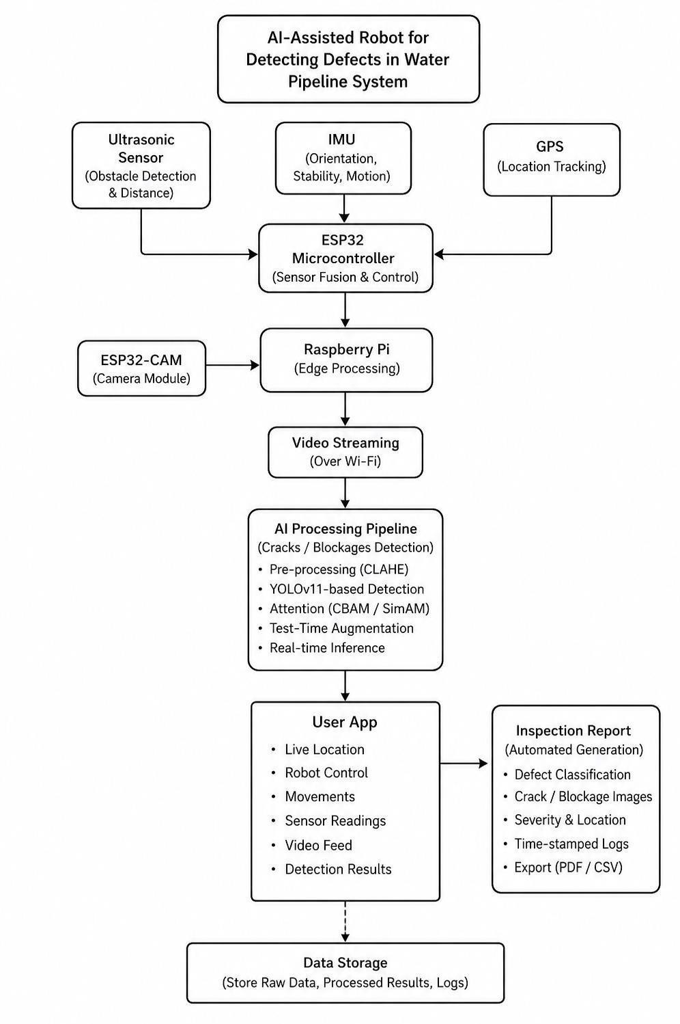

4.2 Design
Motor Specifications: 4 x 12V, 100 RPM geared motors, Holding Torque = 27 kg.cm = 2.65 N.m Power Calculations: ω = 2πN/60 = 2π(100)/60 = 10.47 rad/s, P(motor) = Tω = 2.65 × 10.47 ≈ 27.7 W, P(total) = 4 × 27.7 ≈ 110.8 W Electrical Requirement Assuming 80% overall efficiency, P(electrical) = 110.8/0.8 ≈ 138.5 W Required current at 11.1 V – I = P/V = 138.5/11.1 ≈ 12.48 A Battery Selection Selected battery = 11.1 V, 5000 mAh, 3C Maximum continuous current = 5 × 3 = 15 A Required current = 12.48 A Since 12.48 A < 15 A → Battery is suitable. 11.1 V, 5000 mAh, 3C battery is suitable for the estimated motor load

4.3 Materials and Methods
Materials Table:
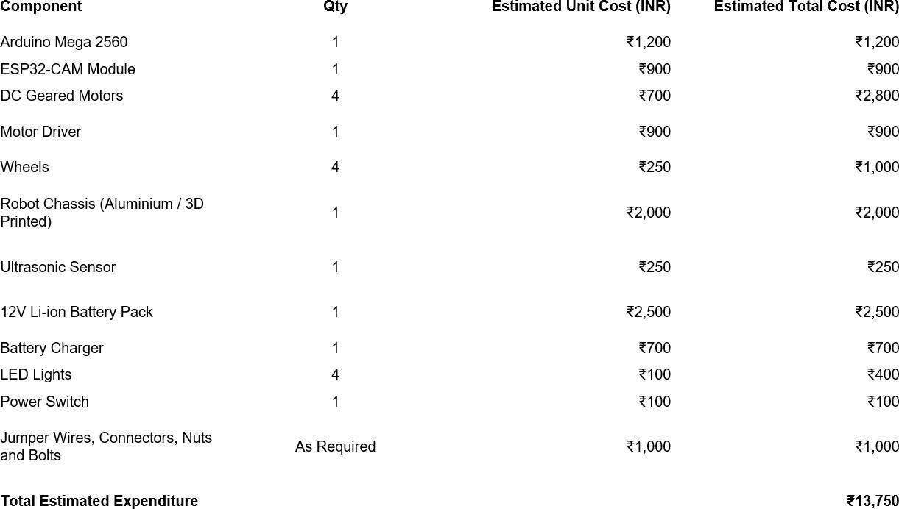

Methods:
Step 1 - Requirement Analysis & System Design:
The functional and non-functional requirements are finalized in this phase and mapped to the three
project objectives and the overall hardware-software architecture is developed.
Step 2 - Hardware Assembly & Embedded Development:
The robot chassis, motors, ultrasonic sensor and ESP32-CAM are assembled and interfaced with
the Arduino Mega which is programmed for motor control, obstacle avoidance and live video
streaming.
Step 3 - AI Model Development:
The crack images are collected, labelled and identified using the YOLO object detection algorithm
for real-time crack detection.
Step 4 - System Integration and Testing: The trained model is integrated with the live ESP32-
CAM feed. The whole unified platform is then tested for accuracy, efficiency and reliability to be
seamlessly operated by maintenance teams.
4.3.1 Image Preprocessing and Attention-Based Model Enhancement To address the uneven illumination present in pipeline CCTV footage, CLAHE is used as a non-neural preprocessing method. It enhances local contrast within small image regions while limiting excessive histogram amplification, helping make fine cracks more visible without aggressively amplifying noise in relatively uniform areas. Attention mechanisms are incorporated into YOLOv11 to improve feature selection. CBAM applies sequential channel and spatial attention to emphasize informative crack regions and suppress background interference. SimAM is a parameter-free attention module that derives three-dimensional attention weights using an energy-based formulation without introducing additional trainable parameters. For inference, Test-Time Augmentation is used by evaluating multiple transformed versions of an input frame, including flipped and differently scaled views, and merging their predictions. TTA does not require retraining and is used to improve robustness against viewpoint and appearance variations. 4.3.2 Image Preprocessing and Augmentation The current v5 dataset was created from the earlier v2 merged dataset to preserve an apples-to-apples comparison. Four remapped source datasets were combined: sewer_o8use, sewage,

sewage_defect_detection, and sewer_defects. The original source labels were mapped into a unified five-class taxonomy: crack, corrosion/rust, sediment deposit, root intrusion, and joint defect. Unsupported categories such as buckling, holes, obstacles and utility intrusion were not forced into incorrect classes; their resulting empty labels were retained rather than aggressively deleting the corresponding images. Two visually mismatched close-up domains, pipeline_crack_detection and pipe_inspection, were removed because they represented close-up surface imagery rather than normal pipe-CCTV point-of-view footage. Source-aware grouping was used to reduce near-duplicate frames crossing train, validation and test splits. Video-derived frames and Roboflow-style duplicates were grouped before splitting. The dataset uses approximately 70% training, 15% validation and 15% testing.
sewer_o8use was oversampled four times in the training split only to reduce source/class imbalance; validation and test images were not oversampled. The final v5 dataset contains 9,486 training images, 2,014 validation images and 1,986 test images, for 13,486 retained entries.
4.3.3 YOLO26 Architecture and Model Novelty Two domains of images are considered for evaluation – normal v5 images and CLAHE processed v5 images. CLAHE is used on offline images in the Luminance channel in CIE-Lab color space with 2.0 clip limit, tile grid of 8×8, and JPEG quality 95. As CLAHE alters local contrast without altering geometry of the image, bounding box labels are used as is. Images are resized to 640×640 pixels during training. The default augmentation pipeline of Ultralytics YOLO is used, which includes mosaic augmentation, horizontal flip, HSV color jittering, scaling, translation, and random erasing. Mosaic augmentation is disabled in the last 10 epochs with close_mosaic = 10.

Chapter 5 - Preliminary Work 5.1 Initial Design
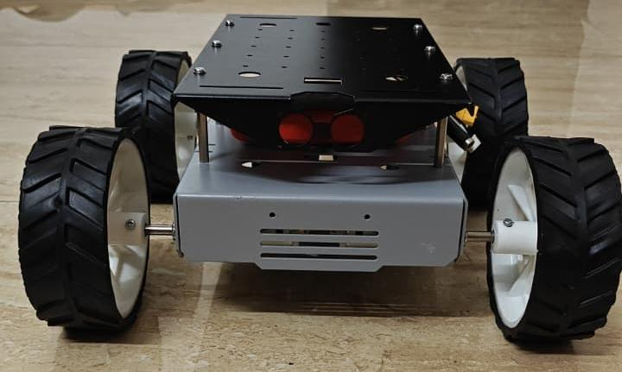

5.2 Experimental Results
Figure 5.2.1: Training and Validation Performance of YOLOv11
Figure 5.2.2 : Recall–Confidence Curve
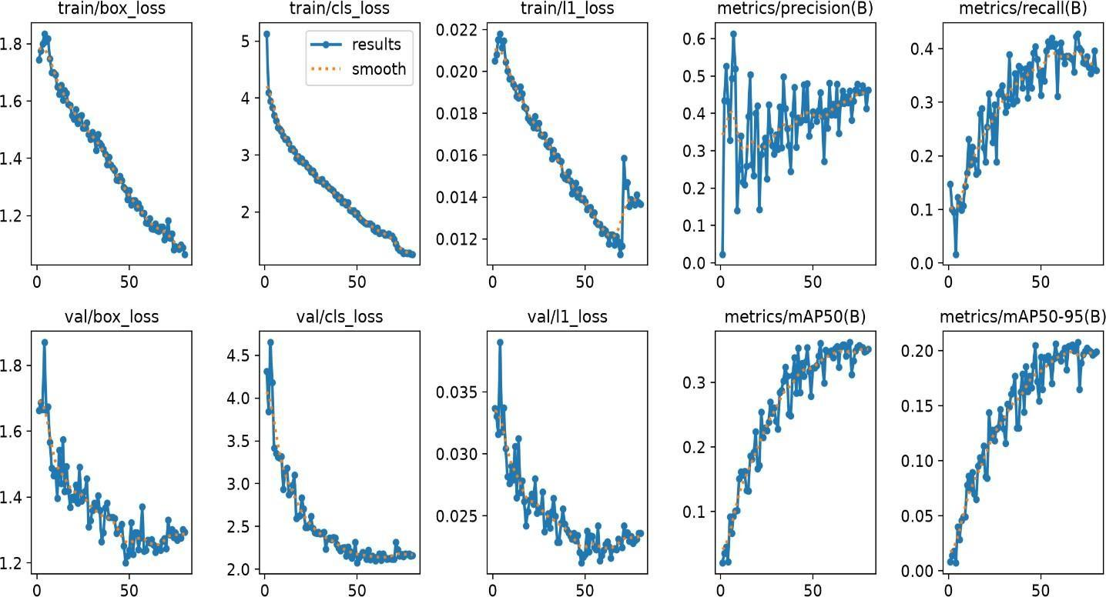
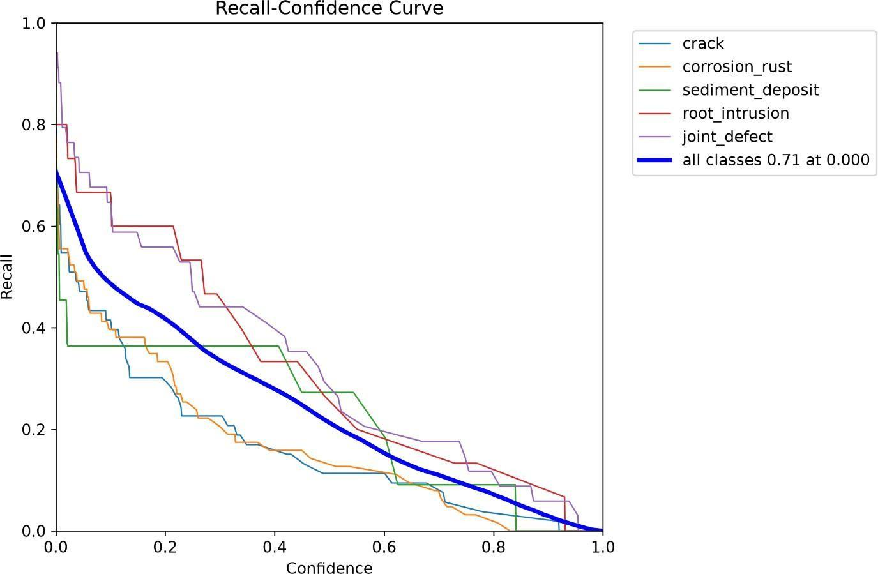

Figure 5.2.3: Precision–Confidence Curve

Chapter 6 - Work to be Done
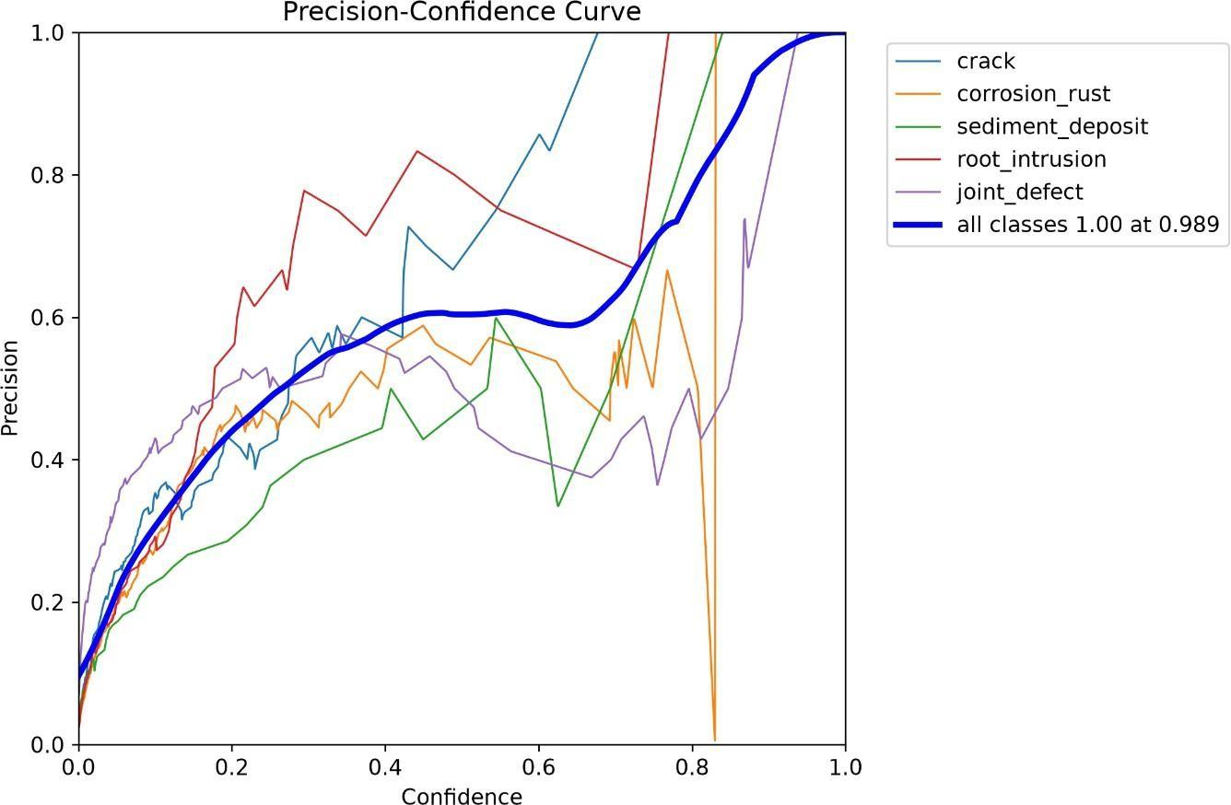
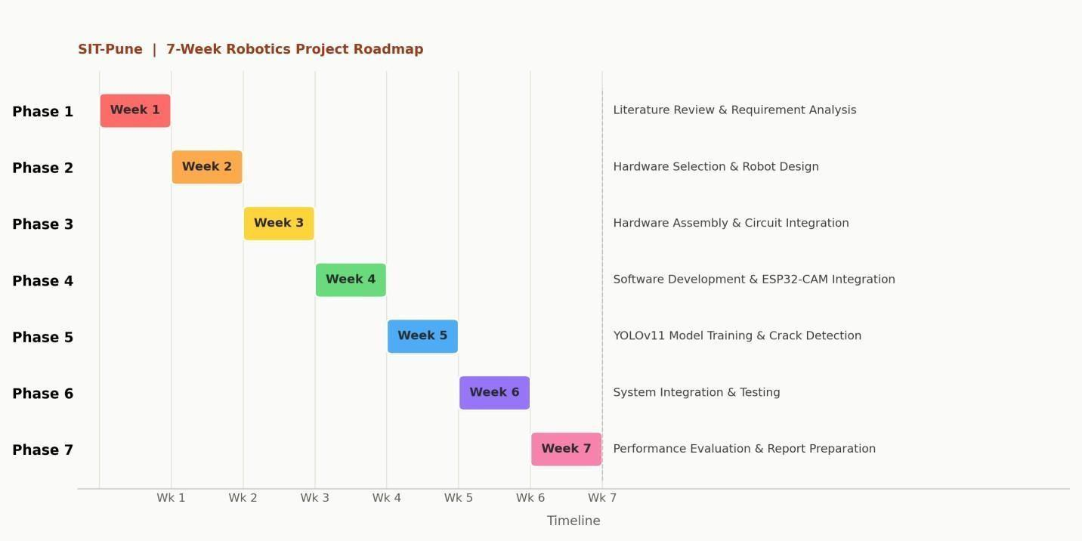

Explanation:
Week 1 – Literature Review and Requirement Analysis
• Focuses on a systematic review of the current literature in robotics and deep learning vision related to pipeline inspections. • The functional requirements for movement, live streaming, real-time crack detection in pipelines and the non-functional requirements for accuracy, low cost and energy efficiency are mapped to the objectives listed above.
Week 2 – Hardware Selection and Robot Development
• The final steps are to finalize the components specification, such as the Arduino Mega 2560, ESP32-CAM, Ultrasonic and proximity sensors, DC geared motors, motor driver, and a 12V Li-ion battery. • Determines the kinematic and geometric constraints on a small four-wheeled 3D-printed chassis for low-center-of-gravity cycling around a cylindrical pipe geometry.
Week 3 – Hardware Assembling and Circuit Integration
• Concentrates on construction of the chassis, mounting the drive motors and wheels, and running power lines through the master power switches and protection circuits. • Interfacing sensors and microcontrollers to maintain signal and power integrity of embedded systems. Week 4 – Software Development and ESP-32 CAM Integration
• C/C++ Embedded firmware programming on the Arduino Mega 2560 for motor control and ultrasonic sensor obstacle avoidance routines. • Configures the ESP32-CAM module to broadcast a low-latency Wi-Fi video telemetry stream of interior pipe camera signals to the host computer.
Week 5 – YOLOv11 Model Training and Crack Detection • Preparation, annotation, and CLAHE-based enhancement of pipeline structural defect image data for computer vision training, with particular attention to unevenly illuminated CCTV footage. • Implements transfer learning and fine-tuning of YOLOv11 to train and compare four configurations: baseline YOLOv11, YOLOv11 + CBAM, YOLOv11 + SimAM, and YOLOv11 + CBAM + SimAM. • Applies Test-Time Augmentation during evaluation using flipped and multi-scale inputs, and compares detection performance using Precision, Recall, mAP@0.5, mAP@0.5:0.95, FPS, and inference latency.

Table Proposed YOLOv11 Model Comparison
Model Variant Attention Module Purpose YOLOv11 Baseline None Reference model for performance comparison.
YOLOv11 + CBAM CBAM Emphasize informative channel and spatial features. YOLOv11 + SimAM SimAM Enhance feature representation with parameter- free attention. YOLOv11 + CBAM + SimAM CBAM + SimAM Evaluate the combined effect of both attention mechanisms.
Week 6 – System Integration and Testing
• Integrates the embedded motion platform, live wireless video stream, and YOLO inference server into a single operational loop. • Conducts dynamic field testing inside pipeline structures to evaluate real-time crack identification accuracy, obstacle collision avoidance, and telemetry system stability.
Week 7 – Performance Evaluation and Report Preparation
• Focuses on evaluating system performance metrics such as detection frame rate (FPS), crack identification accuracy and dynamic response time for obstacles • Finalizes and compiles the research proposal documentation for this study

References
R. Alvarez, M. Gonzalez, and H. Patel, “Low-power embedded systems for autonomous mobile robotics in restricted pipe conduits,” IEEE Trans. Ind. Electron., vol. 71, no. 4, pp. 3845–3856, Apr. 2024, doi: 10.1109/TIE.2023.3289102.
J. Chen, X. Liu, and Y. Zhang, “Deep learning-based concrete crack detection and segmentation for civil infrastructure,” Autom. Constr., vol. 152, p. 104920, Aug. 2023, doi: 10.1016/j.autcon.2023.104920.
Y. Chen, S. Zhou, and H. Wang, “Pipe-finder: Adaptive, lightweight pipe robot integrating origami anisotropic stiffness structure,” in Proc. IEEE Int. Conf. Robot. Biomimetics (ROBIO), Dec. 2023, pp. 112–118, doi: 10.1109/ROBIO58561.2023.10354759.
G. Dobie, C. Peyton, and D. Zhang, “A convex phased-array ultrasonic inspection gauge for small-diameter pipelines,” IEEE Trans. Instrum. Meas., vol. 73, pp. 1–12, Jan. 2026, doi: 10.1109/TIM.2025.3345100.
H. Gupta, R. Sharma, and A. Verma, “Real-time edge computing for object detection in low- bandwidth IoT environments,” IEEE Internet Things J., vol. 11, no. 3, pp. 4512–4523, Feb. 2024, doi: 10.1109/JIOT.2023.3301290.
S. Kwon, M. Wang, J. Yuan, S. Bao, and S. Ma, “Robots for pipeline inspection tasks: A survey of design philosophy and implementation technologies,” IEEE Access, vol. 9, pp. 129480– 129502, Oct. 2021, doi: 10.1109/ACCESS.2021.3112450.
K. Lee, J. Park, and S. Kim, “Comparative evaluation of YOLOv5, YOLOv8, and YOLOv11 object detection backbones for structural flaw classification,” Res. Eng. Struct., vol. 12, no. 2, pp. 145–158, Mar. 2025.
Q. Ma, W. Liang, and P. Zhou, “A review on pipeline in-line inspection technologies,” Sensors, vol. 25, no. 15, p. 4873, Aug. 2025, doi: 10.3390/s25154873.
R. D. Morris and T. Barker, “Hydrogen pipeline in-line inspection case study and real-time image synchronization,” Process Saf. Environ. Prot., vol. 182, pp. 612–624, Feb. 2024, doi: 10.1016/j.psep.2023.12.045.
P. Nguyen and T. H. Kim, “Dynamic design and kinematic analysis of active in-pipe inspection robots for 90-degree bent conduits,” Mech. Mach. Theory, vol. 178, p. 105080, Dec. 2022, doi: 10.1016/j.mechmachtheory.2022.105080.
P. Palanisamy, I. Rajendran, and S. Shanmugasundaram, “Prediction of tool wear using regression and ANN models in end-milling operation,” Int. J. Adv. Manuf. Technol., vol. 37, nos. 1–2, pp. 29–41, Apr. 2008, doi: 10.1007/s00170-007-0948-5.
M. Patel and S. Joshi, “IoT-based ESP32-CAM surveillance robot for low-cost remote monitoring,” J. ISMAC, vol. 8, no. 1, pp. 34–48, Jan. 2026, doi: 10.36596/jismac.v8i1.512.
A. Roy, B. Das, and C. Sen, “A benchmark reference for ESP32-CAM module: Thermal, frame- rate, and power consumption performance,” arXiv preprint arXiv:2502.04892, Feb. 2025.

U. S. Department of Transportation, “Pipeline safety and maintenance standards for municipal utilities,” Federal Railroad Administration, Washington, DC, USA, Tech. Rep. DOT-PHMSA- 2023-004, May 2023.
V. Vasudevan and R. Kumar, “Crowd density analysis and real-time safety monitoring using edge computer vision,” IEEE Trans. Intell. Transp. Syst., vol. 26, no. 5, pp. 5812–5825, May 2025, doi: 10.1109/TITS.2024.3389012.
W. Wang, J. Zhang, and Z. Zhao, “YOLOv11-KW-TA-FP: Real-time concrete crack detection and segmentation on edge accelerators,” arXiv preprint arXiv:2501.09842, Jan. 2025.
X. Wu, Y. Liu, and L. Chen, “PipeMFL-240K: A large-scale dataset and benchmark for object detection in pipeline magnetic flux leakage imaging,” arXiv preprint arXiv:2601.03412, Jan. 2026.
Y. Xu and B. Yang, “Adapting mechanisms for in-pipe inspection robots: A systematic review,” Appl. Sci., vol. 12, no. 12, p. 6191, Jun. 2022, doi: 10.3390/app12126191.
Z. Yu, X. Wang, and M. Wang, “Leakage concentration prediction and interpretable analysis of buried pipelines based on multi-layer perceptron,” Processes, vol. 14, no. 2, p. 312, Feb. 2026, doi: 10.3390/pr14020312.
J. Zhang, H. Zhao, and F. Sun, “An energy-aware adaptive sensor fusion framework for channel robotics in sewer networks,” IEEE Robot. Autom. Lett., vol. 11, no. 1, pp. 892–899, Jan. 2026, doi: 10.1109/LRA.2025.3398120.
L. Zhao, C. Huang, and P. Tan, “Digital twin framework for urban subterranean utility health scoring and risk mapping,” Smart Cities, vol. 8, no. 3, pp. 1102–1120, Jun. 2025, doi: 10.3390/smartcities8030054.

Appendix A
Title: Pipeline Inspection mobile Robot for AI-Enabled Crowd Management and Smart City Infrastructure Monitoring System
Estimated Project Expenditure:

