Pipeline Inspection Mobile Robot for AI-enabled Crowd Management and Smart City Infrastructure Monitoring System
  - Updated research report · sewer defect detection

B.Tech · Robotics and Automation / Artificial Intelligence and Machine Learning
Aryan Sil · Ashmit Katale · Priyansh Pacheriwala · Parth Ubhe · Rajat Dwivedi
Department of Robotics and Automation
Symbiosis Institute of Technology, Pune · 2026–27

Abstract
This project combines a mobile pipeline-inspection prototype with five-class visual defect detection for crack, corrosion/rust, sediment deposit, root intrusion and joint defect. The original proposal described YOLO11 experiments; those historical checkpoints and exact numerical logs are unavailable locally, so they are recorded as archived work rather than assigned invented scores. The reproducible current comparison uses YOLO26s variants and RF-DETR Nano on the v5 CCTV-focused dataset (9,486 train / 2,014 validation / 1,986 held-out test images). RF-DETR Nano after 50 total epochs reached 90.65% validation mAP@0.50 and 89.04% held-out test mAP@0.50, with 73.85% test mAP@0.50:0.95. The prototype photo documents chassis construction; the end-to-end robotic field performance and live-stream FPS still require formal measurement.

1. Introduction and motivation
Underground sewer inspection is often manual, slow and hazardous. Defects can be difficult to distinguish in low light, blur and textured pipe backgrounds. The project aims to combine safe remote viewing, a low-cost mobile platform, obstacle awareness and automated defect localization into one inspection workflow. Its smart-city motivation is faster maintenance triage; crowd-management language in the original proposal is broader context, not a measured function of this detector.
The proposal considers compact field robotics, wireless video, AI-assisted inspection and automated reports. Claimed advantages such as reduced inspection time and autonomous operation are design goals until measured on the assembled system.

2. Literature review
Published studies use different datasets, classes, splits and evaluation protocols. The figures below provide context, not a like-for-like leaderboard. Our 89.04% result is a held-out v5 test mAP@0.50; the 92.3% YOLOv4 paper reports a higher result on its own four-class dataset.
Study | Approach | mAP50 | mAP50:95 | Protocol note
Huang et al., Processes 2023 | YOLOv5s + involution/GSConv/CBAM/distillation | 80.5% | 48.7% | Six classes; 75 FPS reported
Sha et al., PLOS ONE 2025 | Lightweight YOLOv8 cross-scale fusion | 83.6% | — | Different dataset; 1.95 M parameters
Hu et al., Sustainability 2026 | SAW-YOLOv8l | 86.2% | 69.0% | Mixed Sewer-ML/industrial images
Automatic Detection, Appl. Sci. 2023 | YOLOv4 + SPP + DIoU | 92.3% | — | 2,700 images; four classes
https://doi.org/10.3390/pr11082508
https://doi.org/10.1371/journal.pone.0330677
https://doi.org/10.3390/su18083685
https://doi.org/10.3390/app13074589

3. Problem, objectives and scope
Research questions: Can a compact robot obtain useful sewer POV footage? Can five frequent defects be detected robustly in that footage? How should attention and contrast enhancement be evaluated without split leakage? How well does the detector generalize to held-out pipe imagery? The objectives are to assemble a mobile platform, capture video, train and compare defect detectors, and expose inference through a usable interface.
Scope: four-wheel chassis with geared motors, controller, ultrasonic obstacle sensing and an ESP32-CAM-style video path; server-side image/video/live inference; five-class defect localization. Constraints include narrow-pipe mobility, lighting, blur, wireless attenuation, battery endurance and the possibility that images from the same inspection are correlated. GPS/IMU/report-generation elements from the initial block diagram remain proposed unless separately documented as implemented.

4. System and methodology
The source proposal combines locomotion, sensing, video transmission, AI inference, user display and result storage. The current software server accepts images, uploaded videos and live streams, with model selection; this is not proof of real-time robot deployment. The original system block diagram is retained as a proposed architecture.
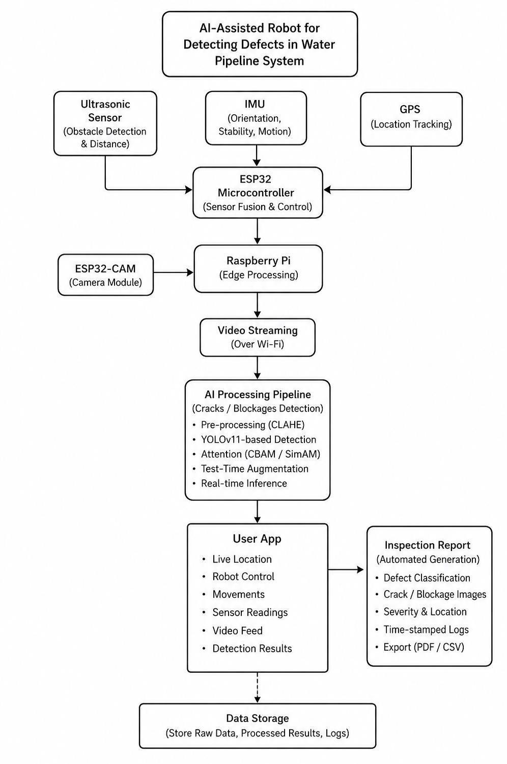

4.1 Prototype and power budget
The photographed prototype uses a four-wheel chassis. The initial materials plan lists four 12 V, 100 RPM geared motors, motor driver, controller, ultrasonic sensing, ESP32-CAM/video components and an 11.1 V, 5,000 mAh battery. The original calculation uses 27 kg·cm ≈ 2.65 N·m per motor and 10.47 rad/s at 100 RPM, giving approximately 27.7 W mechanical per motor and 110.8 W for four. At an assumed 80% efficiency, estimated electrical demand is 138.5 W or 12.48 A at 11.1 V. These are assumptions, not measured current draw or runtime.
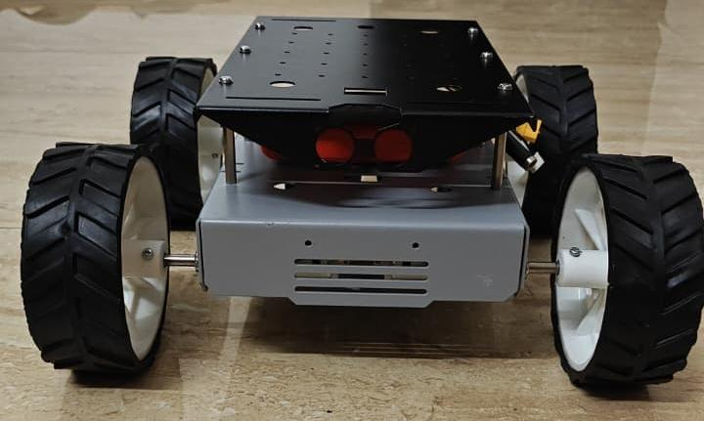
Prototype photo extracted from the source report (same robot shown in the supplied image).
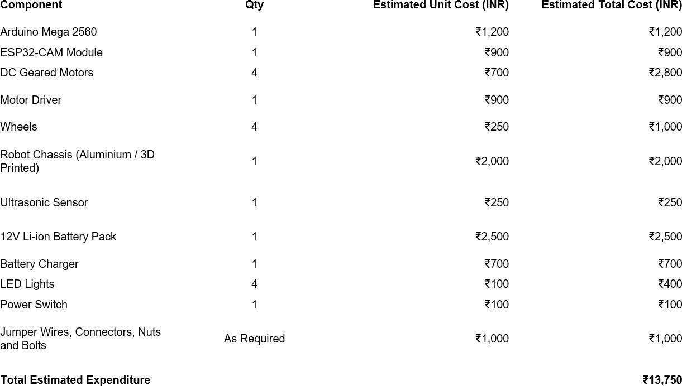
Original estimated expenditure: ₹13,750 (parts table from the source report).

4.2 Dataset construction
The v5 dataset merges sewer_o8use, sewage, sewage_defect_detection and sewer_defects into five labels. Unsupported categories were not forced into another class. Close-up pipeline_crack_detection and pipe_inspection imagery was excluded from the CCTV POV benchmark because it is visually a different domain. V2-style source/group-aware splitting was restored for v5 to reduce near-duplicate frames from an inspection appearing across train and test. This reduces leakage risk but does not certify perfect pipe-identity independence. sewer_o8use was oversampled four times in training only; validation and test were not oversampled. Counts: 9,486 / 2,014 / 1,986.
Class | Held-out test example
crack | sewage_000004.jpg
corrosion_rust | sewer_o8use_000033.jpg
sediment_deposit | sewage_defect_detection_000573.jpg
root_intrusion | sewer_o8use_000154.jpg
joint_defect | sewage_defect_detection_000132.jpg
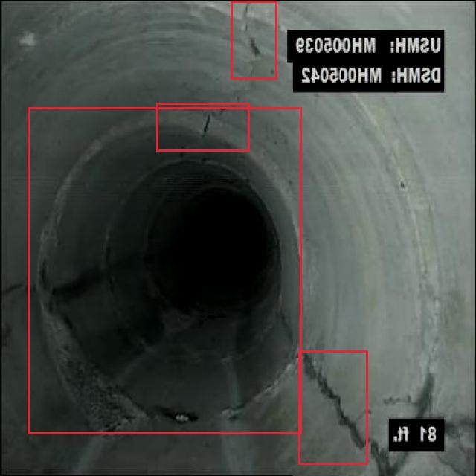
crack: sewage_000004.jpg · 4 ground-truth boxes. Red box = ground-truth label, not model prediction.
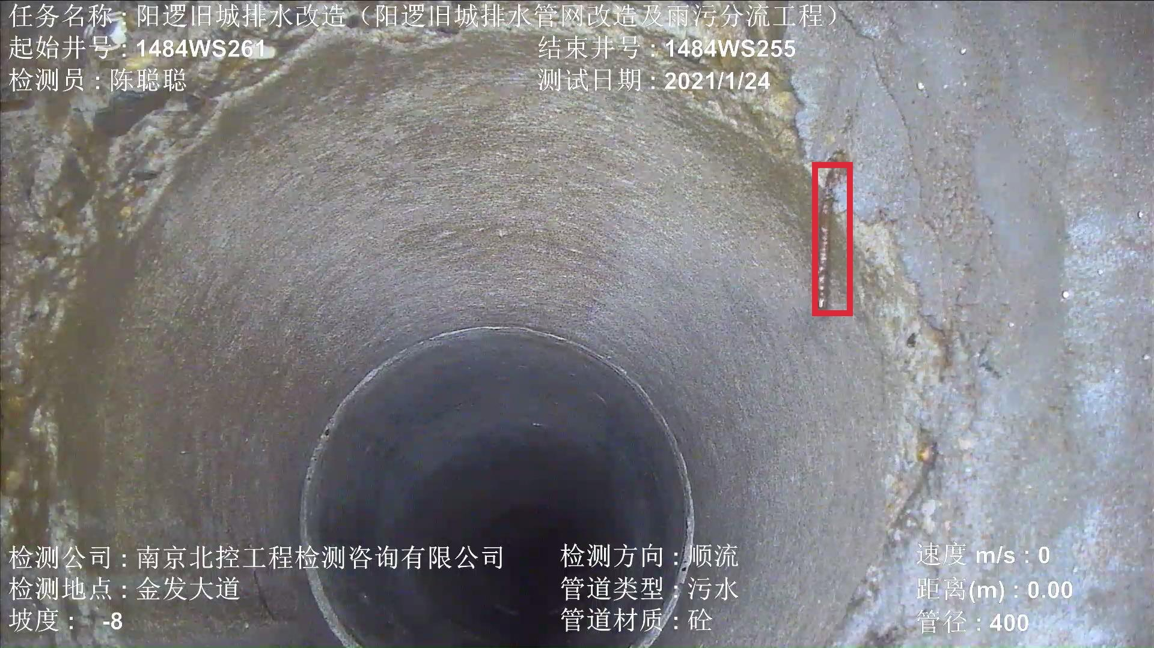
corrosion_rust: sewer_o8use_000033.jpg · 1 ground-truth box. Red box = ground-truth label, not model prediction.
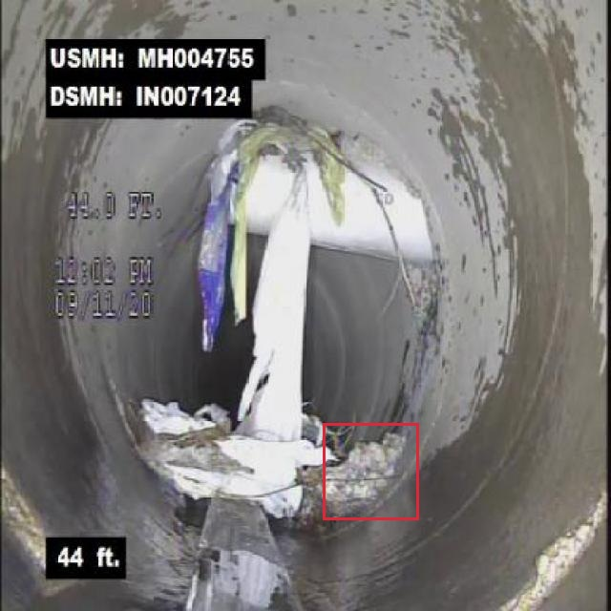
sediment_deposit: sewage_defect_detection_000573.jpg · 1 ground-truth box. Red box = ground-truth label, not model prediction.
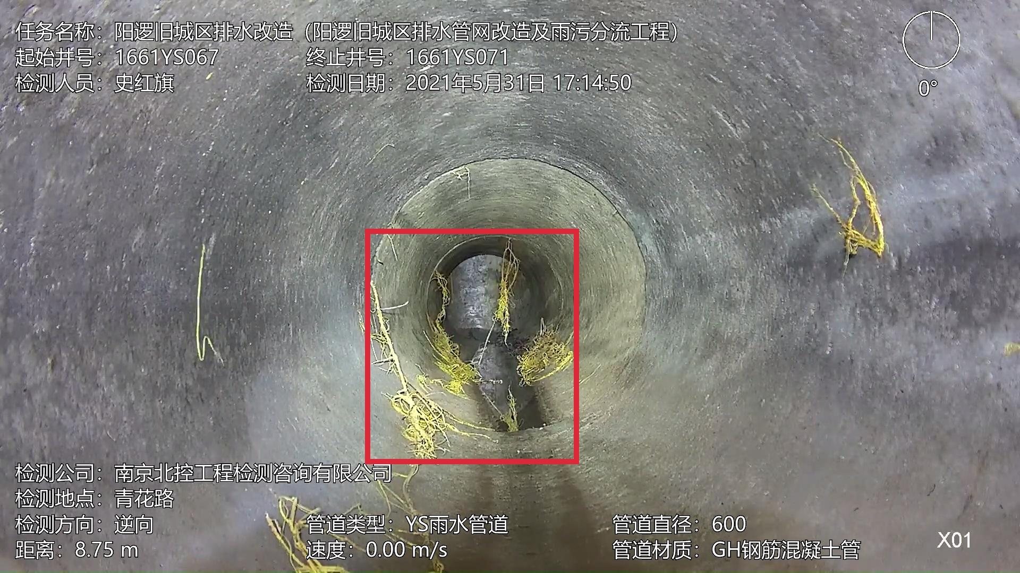
root_intrusion: sewer_o8use_000154.jpg · 1 ground-truth box. Red box = ground-truth label, not model prediction.
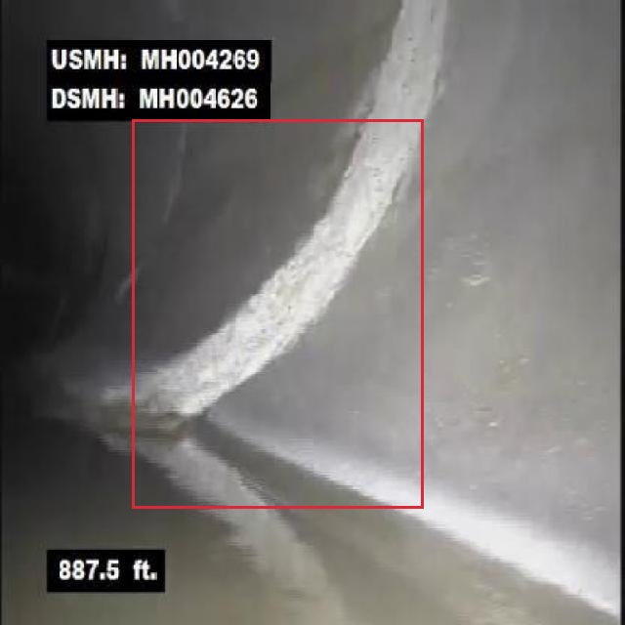
joint_defect: sewage_defect_detection_000132.jpg · 1 ground-truth box. Red box = ground-truth label, not model prediction.

4.3 Preprocessing and training
Normal v5 is compared with a matched offline CLAHE variant. CLAHE operates on CIE-Lab luminance with clip limit 2.0 and an 8×8 tile grid; JPEG quality is 95. The underlying split and label coordinates are unchanged. YOLO26s variants use 640-pixel input, 80 epochs, AdamW, cosine learning-rate schedule, batch 16, seed 0 and standard image-space augmentation (HSV, translation, scaling, flip and mosaic, disabled in the final ten epochs). RF-DETR Nano uses 512-pixel input and 50 total epochs with effective batch 16 by gradient accumulation. Comparison across model families is indicative because input sizes and evaluators differ.
Architecture experiments include CBAM, SimAM, squeeze-and-excitation (SE), their parallel combination, E3 (a P2 head plus weighted PAN fusion), E5 (directional residual P3 block) and an incomplete E6 run that stopped with GPU out-of-memory. SPPF and C2PSA were inherited components, not novel inventions; TTA was described in the old proposal but is not counted as a verified improvement here.

5. Experimental results
The table reports completed validation runs. Historical YOLO11 baseline/CBAM/SimAM/combined variants appear in the original proposal, but their local checkpoints and exact metrics are unavailable. They are deliberately excluded from quantitative rankings.
Model | Dataset | Val mAP50 | Val mAP50:95
YOLO26n v4 + CLAHE | v4 CCTV | 25.86% | 13.38%
YOLO26s baseline | v5 normal | 82.54% | 65.61%
YOLO26s + SimAM | v5 CLAHE | 82.45% | 64.47%
YOLO26s + CBAM | v5 CLAHE | 82.66% | 63.50%
YOLO26s + SE | v5 CLAHE | 82.24% | 62.82%
Parallel SimAM+CBAM+SE | v5 normal | 82.13% | 63.88%
E3 P2 + weighted PAN | v5 normal | 82.19% | 65.01%
E5 directional P3 | v5 normal | 82.01% | 63.82%
RF-DETR Nano 40e | v5 normal | 89.56% | 74.84%
RF-DETR Nano 50e | v5 normal | 90.65% | 76.51%
YOLO26s v6 initial | v6 filtered | 82.54% | 65.61%
YOLO26s v6 hard-image removal | v6 filtered | 65.61% | 52.63%

5.1 Held-out test comparison
Model | Pixels / input | P | R | Test mAP50 | Test mAP50:95
RF-DETR Nano, 50e | normal / 512 | 86.34% | 83.89% | 89.04% | 73.85%
YOLO26s baseline, 80e | normal / 640 | 81.44% | 74.42% | 82.14% | 65.05%
YOLO26s E3, 80e | normal / 640 | 78.40% | 74.66% | 80.78% | 63.83%
YOLO26s + CBAM, 80e | CLAHE / 640 | 78.50% | 74.24% | 81.55% | 62.50%
RF-DETR test precision/recall are 86.34%/83.89%; 90.65% is its validation mAP50, not test accuracy. The best YOLO baseline test mAP50 is 82.14%, a 6.90-point gap on this test split. The difference is not solely attributable to architecture because the input resolution and evaluation backends differ.

5.2 Class-wise analysis and negative experiments
Class | RF-DETR val AP50:95 (epoch 50)
crack | 53.07%
corrosion_rust | 88.91%
sediment_deposit | 70.79%
root_intrusion | 91.83%
joint_defect | 77.52%
Crack is the weakest class. Thin boundaries, ambiguous texture, blur, poor contrast and inconsistent box extent are plausible error sources that need image-level verification. Removing model-selected hard examples from v6 did not improve the scientifically meaningful benchmark: one filtered validation run fell to 65.61% mAP50; a highly inflated 98.37% result came from a model-error-selected test subset and must not be presented as held-out generalization.

6. Integration, limitations and next work
A FastAPI inference interface was built for still images, uploaded video and camera/live stream inputs, with selectable trained models. End-to-end robot field trials, latency/FPS measurements, power draw, battery runtime, navigation reliability and fully independent inspection-site validation remain to be documented. The original seven-week plan covers literature review, design, dataset/model development, integration, testing and reporting; those are planning milestones, not evidence that every feature was completed.
Next steps: freeze the held-out test split; audit cracks and annotations; measure FPS on the target PC and robot video path; repeat leading models across seeds; test an external sewer inspection source; collect robot-native imagery; and report failure cases as well as mAP. Do not optimize on the test set or delete false negatives solely to increase a metric.

References
Huang et al., Processes 2023. https://doi.org/10.3390/pr11082508
Sha et al., PLOS ONE 2025. https://doi.org/10.1371/journal.pone.0330677
Hu et al., Sustainability 2026. https://doi.org/10.3390/su18083685
Automatic Detection, Appl. Sci. 2023. https://doi.org/10.3390/app13074589
Original project proposal: BtechProject_Report.pdf, supplied by the team. Its earlier bibliography and YOLO11 plots are historical source material; individual entries and numerical YOLO11 runs require verification before publication.

Appendix: evidence and status
RF-DETR 50e: dataset_crack/runs/pipe_proto/rfdetr_nano_v5_normal_512_seed0_20261003_193042_66b2b7/{best_validation_metrics.json,full_v5_test_metrics.json}. YOLO test values: dataset_crack/models/README.md and associated test folders. The original PDF has archived YOLO11 training curves but no recoverable checkpoint-level metric table. E1/E2/E4 are pending; E6 is incomplete due to OOM.

