OMNISENSUS MEDICAL
OmniV1 Clinical AI Engine
Complete Technical Research Document
Version 3.0.1 | Build Date: 2026-03-12
Author: Parth Vadodariya
Classification: Technical Research | Confidential

Model | Algorithm | Diseases | Features | LLM | Calibration
OmniV1 | Random Forest | Heart / Diabetes / Kidney | 13 | 8 | 15 | Qwen 0.5B GGUF | Platt Scaling

1. Introduction & System Overview

1.1 What is OmniSensus OmniV1?
OmniSensus OmniV1 is a production-grade AI-powered clinical decision support engine designed to provide real-time multi-domain disease risk stratification. It serves three clinical domains simultaneously: Cardiovascular Disease, Type 2 Diabetes Mellitus, and Chronic Kidney Disease — the three most prevalent and comorbid non-communicable diseases in South Asian populations.
The system is built entirely on classical supervised machine learning (Random Forest with probability calibration), deliberately avoiding deep learning. This is a principled design choice driven by dataset size constraints, interpretability requirements, deployment resource limitations, and regulatory considerations for medical AI.

Design Philosophy: OmniV1 prioritises clinical safety and explainability over raw accuracy. A model that explains WHY it flagged a patient is more clinically useful than a black-box neural network with marginally higher AUC.

1.2 Architecture Overview
The complete inference pipeline processes a single POST request through 15 distinct stages:
- HTTP Request → Flask Router → JSON parsing
- OmniValidator → physiological range validation
- PatientContext construction → adaptive parameters
- Three parallel ML model inferences (Heart, Diabetes, Kidney)
- OmniScorer → composite health score
- OmniExplainer → SHAP feature importance
- OmniTriage → department + urgency recommendation
- OmniAnalytics → ARIMA trend forecast
- OmniReadmission → readmission risk probability
- JSON response assembly → return 200

1.3 Disease Selection Rationale
Disease | Dataset | Samples | Features | Prevalence (India) | Comorbidity
Cardiovascular Disease | UCI Cleveland | 303 | 13 | ~28% of deaths | Strong link to HTN, DM
Type 2 Diabetes | Pima Indians | 768 | 8 | ~11.4% adults | Drives CKD, CVD
Chronic Kidney Disease | UCI CKD | 400 | 15 | ~17% adults | CKD→CVD risk x3

1.4 File Structure Overview
File | Primary Class/Function | Role in System
app.py | Flask endpoints | Main API router, model loader, request handler
src/trainer.py | OmniTrainer | Builds calibrated Random Forest from training data
src/preprocessor.py | OmniPreprocessor | Full data pipeline: normalise→impute→scale→SMOTE
src/scorer.py | OmniScorer | Composite health score, domain scores, clinical flags
src/context_engine.py | PatientContext | Adaptive weights, thresholds, demographic factors
src/explainer.py | OmniExplainer | SHAP TreeExplainer + feature importance fallback
src/analytics.py | OmniAnalytics | ARIMA forecasting, trend analysis, platform stats
src/triage.py | OmniTriage | Department routing + urgency classification
src/readmission.py | OmniReadmission | 5-component readmission risk scoring
src/validator.py | OmniValidator | Physiological range validation, field normalisation
src/medical_kb.py | MEDICAL_KB | Evidence-based clinical knowledge base dictionary
src/chat_engine.py | chat() | KB-first chatbot with optional LLM fallback
src/question_answering.py | answer_question() | Intent detection, structured clinical Q&A
src/patient_store.py | get_history() etc. | PostgreSQL read layer for patient data
src/medications.py | OmniMedications | Risk-based medication suggestion engine
src/config.py | RF_PARAMS, DISEASE_MAP | All hyperparameters and configuration constants
src/evaluator.py | OmniEvaluator | Training metrics: AUC, accuracy, confusion matrix
build_omni_v1.py | run_build() | Full training pipeline orchestrator

2. Data Preprocessing Pipeline
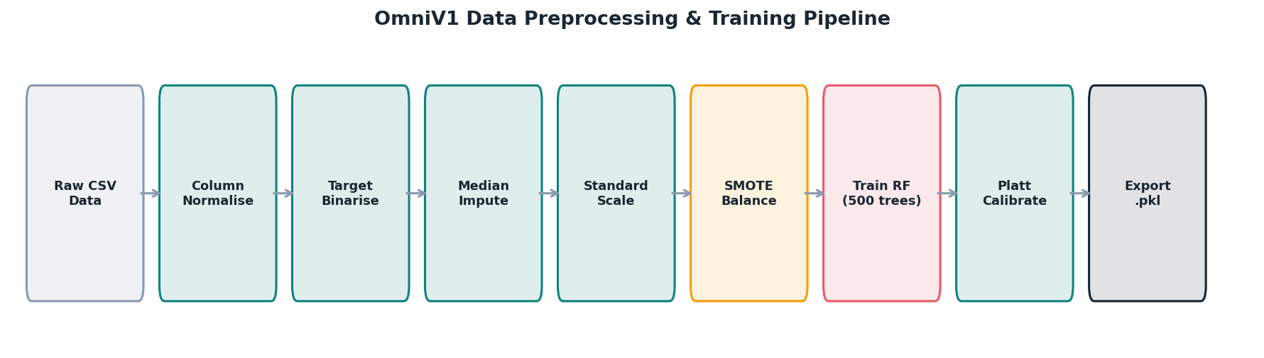
Medical data is inherently heterogeneous, sparse, and imbalanced. The preprocessing pipeline transforms raw CSV datasets into clean, balanced, normalised arrays suitable for supervised ML training. Each step is mathematically motivated by clinical data characteristics.

Figure 2.1 — Complete Data Preprocessing & Training Pipeline

2.1 Column Normalisation
The first step standardises column naming across heterogeneous public datasets. UCI datasets use camelCase, Kaggle datasets use snake_case, and some use spaces. All are converted to lowercase underscore format:
df.columns = df.columns.astype(str).str.strip().str.lower().str.replace(' ', '_')
This ensures the system can process any CSV format without manual preprocessing.

2.2 Target Column Detection & Binarisation
Each dataset encodes its target variable differently. The _find_target() function searches by hint, then falls back to common names, then the last column:
Dataset | Target Column | Positive Encoding | Negative Encoding | Binary Mapping
UCI Heart Disease | target | 1 | 0 | Direct numeric
Pima Diabetes | Outcome | 1 | 0 | Direct numeric
UCI CKD | classification | ckd | notckd | String → 0/1

The _binarise_target() function handles all variants through exhaustive lookup:
Positive: '1', 'yes', 'pos', 'positive', 'ckd', 'true' → 1
Negative: '0', 'no', 'neg', 'negative', 'notckd', 'not_ckd', 'false' → 0

2.3 Median Imputation for Missing Values
Missing values are common in clinical datasets — not every patient has every test. The system uses median imputation rather than mean:
If X_{i,j} is NaN: X_{i,j} = median(X_{:,j})

Why Median over Mean?
Medical data contains legitimate clinical outliers (e.g., glucose = 450 mg/dL in diabetic ketoacidosis). The mean is pulled towards these extreme values, creating inflated imputation. The median represents the central tendency and is robust to outliers:

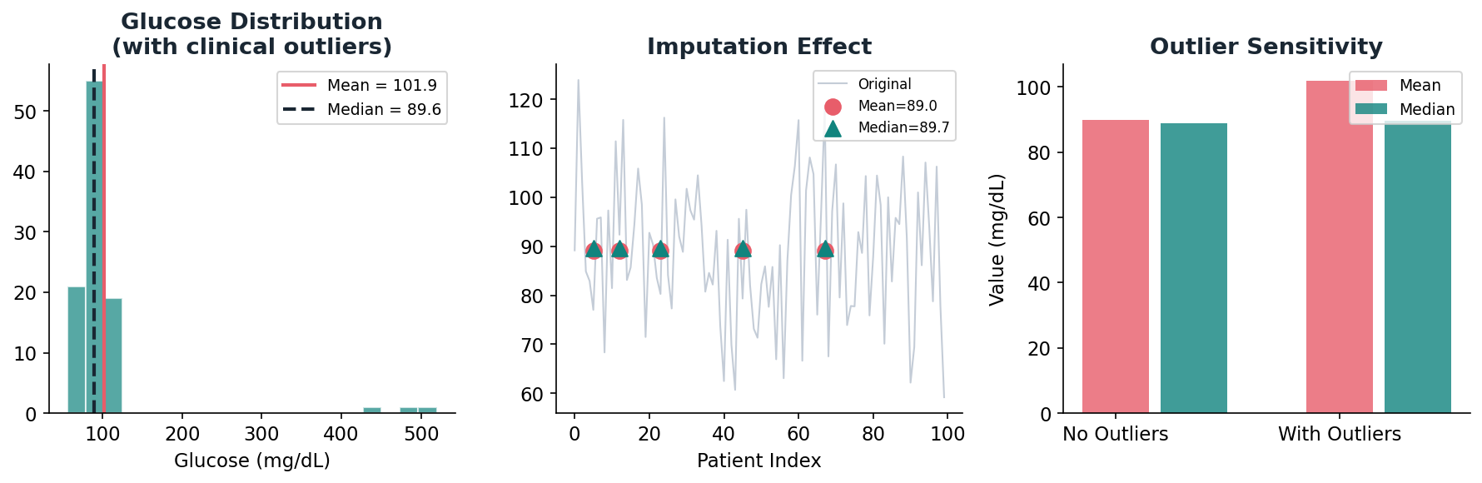
Figure 2.2 — Median vs Mean Imputation: Outlier Robustness Comparison

Example: If eGFR values are [45, 60, 72, 88, 92, 95, 110] with one missing, median=88 is used. Mean=80.3 would be skewed by the 45 (CKD G3 patient). For a healthy cohort, the median better represents the expected normal range.

2.4 Standard Scaling (Z-Score Normalisation)
All features are transformed to zero mean and unit variance using Z-score normalisation:
X_{scaled} = (X - μ) / σ
Where μ = column mean and σ = column standard deviation computed from training data only (preventing data leakage).

Why Scale for Random Forest?
Random Forest is technically scale-invariant for splitting decisions (it compares X_i against a threshold, not against other features). However, scaling is essential because:
- The fitted StandardScaler must be applied identically at inference time to incoming vitals
- SHAP value magnitudes are more comparable across features when on the same scale
- Platt Scaling (calibration) benefits from normalised inputs

2.5 SMOTE — Synthetic Minority Oversampling
Medical datasets are inherently imbalanced. A naive classifier predicting "no disease" for all patients would be 65% accurate on Pima Diabetes — but clinically useless. SMOTE generates synthetic minority samples to balance class distributions:
X_{new} = X_i + λ · (X_k - X_i) where λ ∈ [0, 1]
Where X_i is a minority sample, X_k is one of its k-nearest minority neighbours (k=5 by default), and λ is sampled uniformly from [0,1]. The result is a new point on the line segment between two real minority samples.

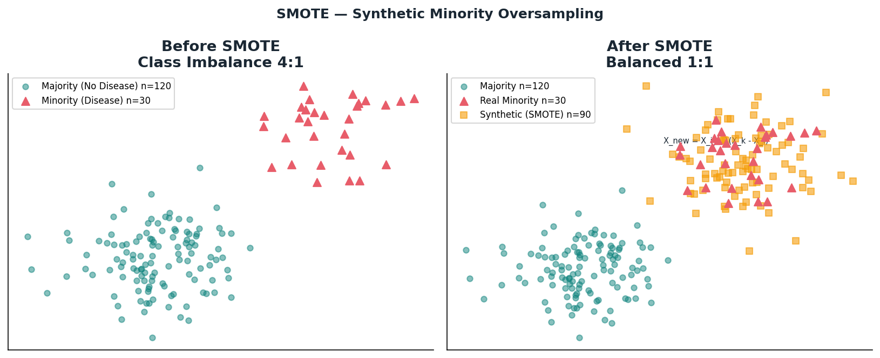
Figure 2.3 — SMOTE: Before (imbalanced) vs After (balanced with synthetic samples)

Why SMOTE over Simple Oversampling?
Method | Approach | Problem | SMOTE Advantage
Random Oversampling | Duplicate minority samples | High overfitting — model memorises copies | SMOTE creates diverse synthetic points
Undersampling | Remove majority samples | Information loss from discarding data | SMOTE preserves all original samples
SMOTE | Generate synthetic minority | Can create noisy samples in overlap regions | Best balance of diversity and stability

SMOTE Safety Guard
SMOTE requires a minimum number of minority samples to form k-nearest neighbours. The system skips SMOTE if the minority class is too small:
if len(unique) < 2 or np.min(counts) < 6:
return X, y # Skip — minority class too small

2.6 dual-Layer Imbalance Handling
OmniV1 uses both SMOTE (data-level) and class_weight="balanced" (algorithm-level) simultaneously:
- SMOTE: Generates synthetic training samples to balance the dataset before training
- class_weight="balanced": Adjusts the loss function to penalise misclassification of minority class more heavily
w_k = N / (K · N_k) where N = total samples, K = classes, N_k = class k count
This dual protection ensures robustness even if SMOTE is skipped on small datasets.

3. Model Architecture — Random Forest

3.1 Why Random Forest?
Criterion | Random Forest | Neural Network | XGBoost | Logistic Regression
Dataset Size | Excellent (<500) | Poor (needs 10k+) | Good (500+) | Good (any)
Interpretability | High (SHAP) | Very Low | Medium | High (coefs)
Calibration | Needs calibration | Needs calibration | Needs calibration | Inherently calibrated
Overfitting Resistance | High (bagging) | Low without dropout | Medium | Low
Deployment Size | 10-30 MB | 100s MB | 20-50 MB | <1 MB
Training Time | Minutes | Hours/Days | Minutes | Seconds
Clinical Literature | Extensive | Growing | Growing | Extensive
OmniV1 Dataset Fit | ✓ SELECTED | ✗ Rejected | ✗ Rejected | ✗ Rejected

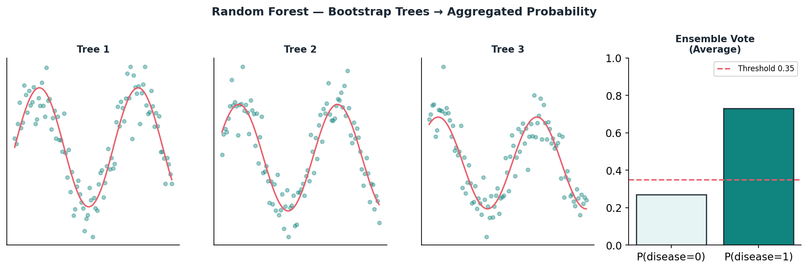
Figure 3.1 — Random Forest: Bootstrap Trees → Ensemble Probability Aggregation

3.2 Bootstrap Sampling
Each of the T=500 trees is trained on a different bootstrap sample of the training data:
D_t = bootstrap_sample(D, n) // n samples with replacement from D
Each bootstrap sample contains approximately 63.2% of unique original samples (the rest are duplicates). The remaining ~36.8% are called "out-of-bag" (OOB) samples and can be used for unbiased model evaluation without a separate validation set.

3.3 Random Feature Subsets at Each Split
At each decision node, only a random subset of m features is considered for splitting (not all features):
m_{try} = ⌈√p⌉ where p = total number of features
For the Heart Disease model (13 features): m_try = ⌈√13⌉ = 4. At each node, 4 randomly chosen features are evaluated. This decorrelates the trees — if one feature is very strong, not every tree will use it, creating diversity in the ensemble.

3.4 Gini Impurity — The Splitting Criterion
At each node, the best feature and threshold are chosen to maximise the reduction in Gini Impurity:
G(S) = 1 - Σ_k p_k² where p_k = fraction of class k in set S
For a node with 70% positive (disease) and 30% negative: G = 1 - (0.7² + 0.3²) = 1 - 0.58 = 0.42.
The weighted Gini impurity after a split into left (L) and right (R) subsets:
G_{split} = (|L|/|S|) · G(L) + (|R|/|S|) · G(R)
The best split is argmin over all features f and thresholds t of G_split(f, t). This greedy search is performed independently at every node of every tree.

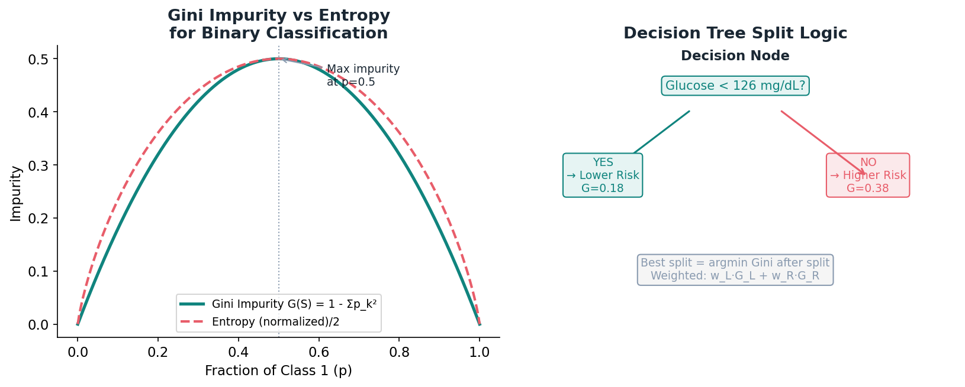
Figure 3.2 — Gini Impurity Curve and Decision Node Split Logic

3.5 Ensemble Aggregation
After all T=500 trees predict independently, their probabilities are averaged (soft voting):
P(y=1 | x) = (1/T) · Σ_{t=1}^{T} P_t(y=1 | x)
This averaging reduces variance without increasing bias — the mathematical justification for ensemble methods. If each tree has variance σ² and trees are uncorrelated, the ensemble variance is σ²/T.

3.6 Hyperparameter Configuration
Parameter | Value | Mathematical Justification | Alternative Considered
n_estimators | 500 | Variance ∝ 1/T; 500 gives stable estimates. Below 100: high variance. Above 1000: diminishing returns. | 100, 200 — too few for small datasets
max_depth | 18 | Deep enough for 3-way interactions (age×BMI×glucose). Prevents underfitting. | None (unlimited) — overfits; 10 — underfits
min_samples_split | 5 | Node must have ≥5 samples to split. Regularisation prevents learning from noise. | 2 (default) — overfits; 10 — too restrictive
class_weight | balanced | w_k = N/(K·N_k). Equivalent to sampling-based balancing. | None — ignores imbalance; custom — harder to tune
random_state | 42 | Reproducibility. Fixes NumPy random seed. | Any fixed integer
n_jobs | -1 | Parallel tree building using all CPU cores. Training time linear in T/cores. | 1 — single core, slower

4. Probability Calibration — Platt Scaling

4.1 The Calibration Problem
A well-calibrated classifier satisfies: among all patients where P(disease) = 0.7, approximately 70% actually have the disease. Raw Random Forest probabilities violate this because each tree outputs hard 0/1 votes — averaging many binary votes produces distributions concentrated near 0 and 1.

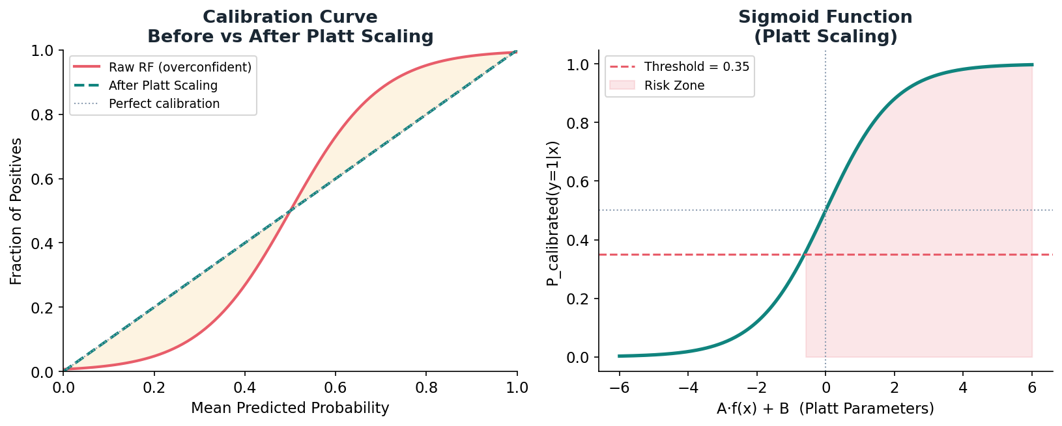
Figure 4.1 — Calibration Curve: Raw RF (overconfident) vs After Platt Scaling

4.2 Platt Scaling Mathematics
Platt Scaling wraps the base classifier in a logistic regression (sigmoid function):
P_{calibrated}(y=1 | x) = σ(A · f(x) + B) = 1 / (1 + e^{-(A·f(x)+B)})
Where f(x) is the raw probability from the Random Forest, and A, B are learned parameters that "stretch and shift" the probability distribution. A is typically negative (compresses overconfident predictions towards 0.5).
The parameters A and B are fitted by minimising the negative log-likelihood (cross-entropy) on held-out validation data:
L(A, B) = -Σ_i [ y_i · log(σ(A·f(x_i)+B)) + (1-y_i) · log(1-σ(A·f(x_i)+B)) ]
This is a standard logistic regression optimisation problem solved using L-BFGS-B.

4.3 CalibratedClassifierCV — Cross-Validated Calibration
The sklearn CalibratedClassifierCV wrapper prevents overfitting of the calibration parameters:
model = CalibratedClassifierCV(base_model, method='sigmoid', cv=safe_cv)
The cross-validation ensures:
- The base RF is trained on CV training folds
- Platt parameters A and B are fitted on CV validation folds
- Final model averages calibrated probabilities across all CV folds

4.4 Safe CV — Adaptive Fold Count
Standard 5-fold CV fails when the minority class has fewer than 5 samples per fold. The safe_cv formula prevents this:
safe_{cv} = min(5, max(2, ⌊minority_size / 2⌋))
Minority Size | safe_cv Computed | Reasoning
<4 | 2 | Minimum viable: 2 folds with at least 2 samples each
4-7 | 2-3 | Small dataset: limit folds to prevent empty class in fold
8-9 | 4 | Moderate: 4 folds each with 2+ minority samples
10+ | 5 | Standard 5-fold cross-validation

4.5 Why 0.35 Decision Threshold
The standard threshold for binary classification is 0.50. OmniV1 uses 0.35 as the base threshold:
Precision = TP / (TP + FP) ↑ with higher threshold
Recall (Sensitivity) = TP / (TP + FN) ↑ with lower threshold
In clinical medicine: missing a true positive (false negative) = patient with disease sent home → potentially fatal. A false positive = patient gets extra testing → inconvenient but safe. The 0.35 threshold deliberately trades precision for recall, prioritising patient safety.
Clinical Principle: In medical screening, sensitivity (catching all sick patients) is more important than specificity (avoiding unnecessary tests). The 0.35 threshold reflects this clinical priority — it is not a technical decision but a clinical value judgment.

5. Composite Health Score System

5.1 The Core Formula
Three individual disease probabilities are combined into a single 0-100 composite health score:
composite_risk = h · w_{heart} + d · w_{diabetes} + k · w_{kidney}
health_score = (1 - composite_risk) × 100
max_score = 95 if age ≥ 70 else 100
health_score = max(0, min(health_score, max_score))

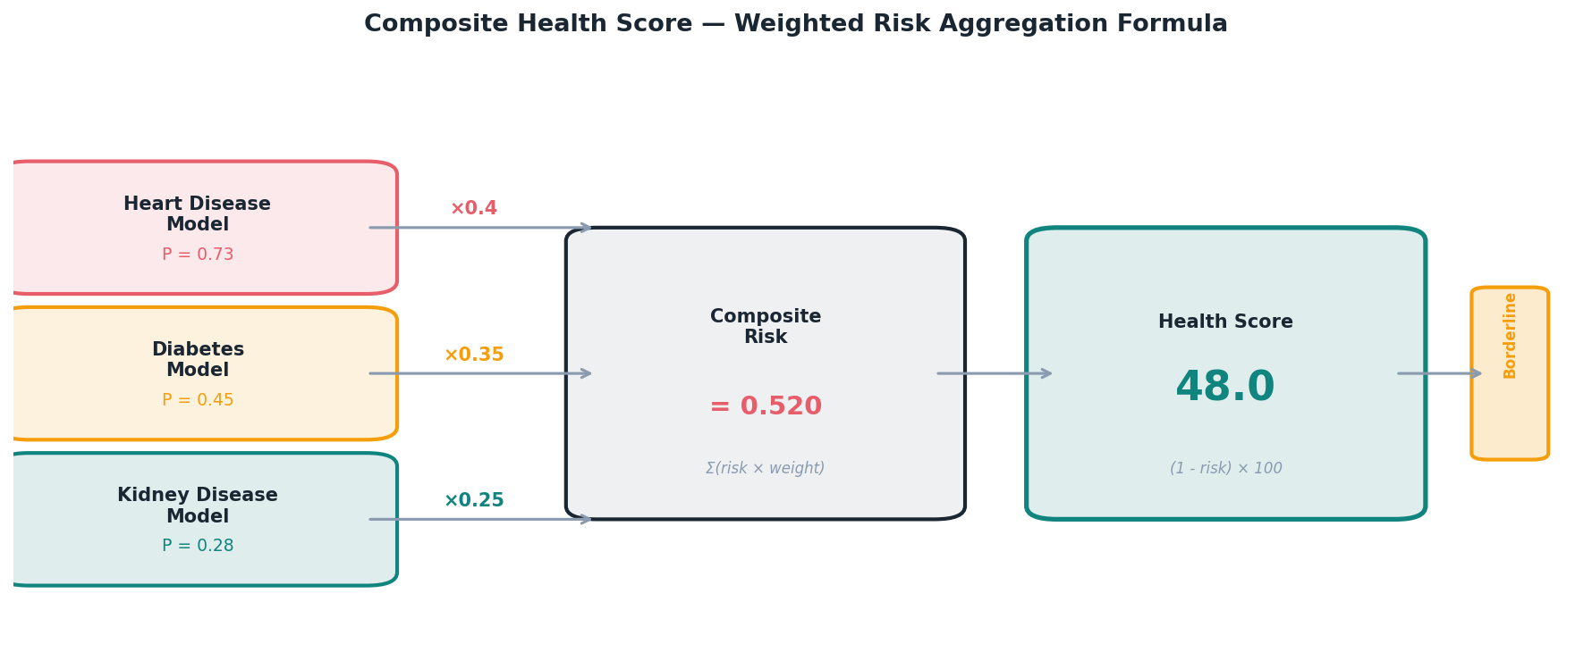
Figure 5.1 — Composite Health Score: Weighted Aggregation & Score Inversion

5.2 Domain Weights Rationale
Domain | Default Weight | Justification
Cardiovascular (Heart) | 0.40 (40%) | CVD is the #1 global cause of death. Rapid onset, high acute mortality. Highest monitoring priority.
Metabolic (Diabetes) | 0.35 (35%) | Pandemic-scale prevalence in South Asia (~11.4% adults). Systemic complications drive CVD and CKD.
Renal (Kidney) | 0.25 (25%) | Comorbid with both CVD and DM. Typically slower progression. Important but lower acute mortality.

5.3 Score Inversion — Mathematical Property
The inversion (1 - risk) ensures the score is intuitive: higher score = healthier patient. The mathematical properties:
- When all risks = 0 (no disease): composite_risk = 0, health_score = 100 (perfect health)
- When all risks = 1 (maximum disease): composite_risk = 1, health_score = 0 (critical)
- When all risks = 0.5: composite_risk = 0.5, health_score = 50 (borderline)

5.4 Age-Adjusted Score Ceiling
A 75-year-old patient with "perfect" biomarkers still has inherent physiological age-related risk that should be reflected in their score. The ceiling cap prevents misleading 100/100 scores for elderly patients:
max_score = 95 if age ≥ 70
max_score = 100 if age < 70
This is derived from actuarial and epidemiological data showing that age 70+ is an independent risk factor for all three disease domains. The 5-point cap is conservative — enough to signal elevated baseline risk without being clinically alarming.

5.5 Risk Tier Classification
Score Range | Tier | Urgency | Clinical Action
66 – 100 | Stable | Routine | Annual monitoring, lifestyle maintenance, preventive care
41 – 65 | Borderline | Semi-Urgent | Follow-up within 1-2 weeks, lifestyle intervention, biomarker monitoring
0 – 40 | Critical | Urgent/Emergency | Immediate clinical assessment, specialist referral, possible admission

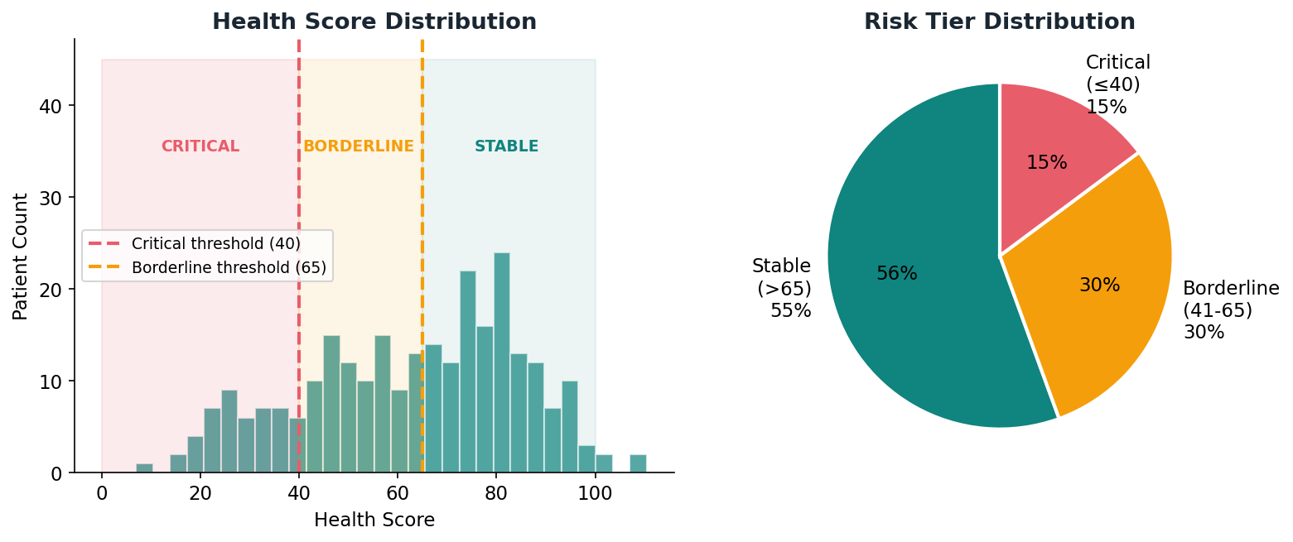
Figure 5.2 — Health Score Distribution Across Patient Population with Risk Tier Zones

5.6 Domain Scores
Individual domain health scores are also computed and stored:
cardiovascular_score = (1 - P_{heart}) × 100
metabolic_score = (1 - P_{diabetes}) × 100
renal_score = (1 - P_{kidney}) × 100
These power the donut chart visualisation in the UI and provide clinicians with granular insight into which specific domain is driving the overall composite risk.

6. PatientContext — Adaptive Clinical Intelligence
The PatientContext engine is the most clinically sophisticated component of OmniV1. It personalises every aspect of the inference — weights, thresholds, and risk multipliers — based on each patient's individual demographic and clinical profile. Without context, the system treats every patient identically. With context, a 72-year-old diabetic with CKD is assessed fundamentally differently from a 35-year-old with no known conditions.

6.1 Adaptive Domain Weights
Base weights (heart:0.40, diabetes:0.35, kidney:0.25) are modified based on known comorbidities:
Condition | Weight Adjustment | Formula | Clinical Reasoning
Known Diabetes | diabetes+0.05, heart-0.05 | w_d += 0.05; w_h -= 0.05 | Metabolic trajectory is the primary risk driver for diabetics
Known CKD | kidney+0.07, diabetes-0.07 | w_k += 0.07; w_d -= 0.07 | Renal progression monitoring is the critical clinical priority
Hypertension | heart+0.05, kidney-0.05 | w_h += 0.05; w_k -= 0.05 | HTN is the primary CVD driver; its cardiac risk outweighs renal
Known Heart Disease | heart+0.05, diabetes-0.05 | w_h += 0.05; w_d -= 0.05 | Prior cardiac events make CVD monitoring the primary concern

After all adjustments, weights are re-normalised to ensure they sum to 1.0:
w_i = w_i / Σ_j w_j for all j ∈ {heart, diabetes, kidney}

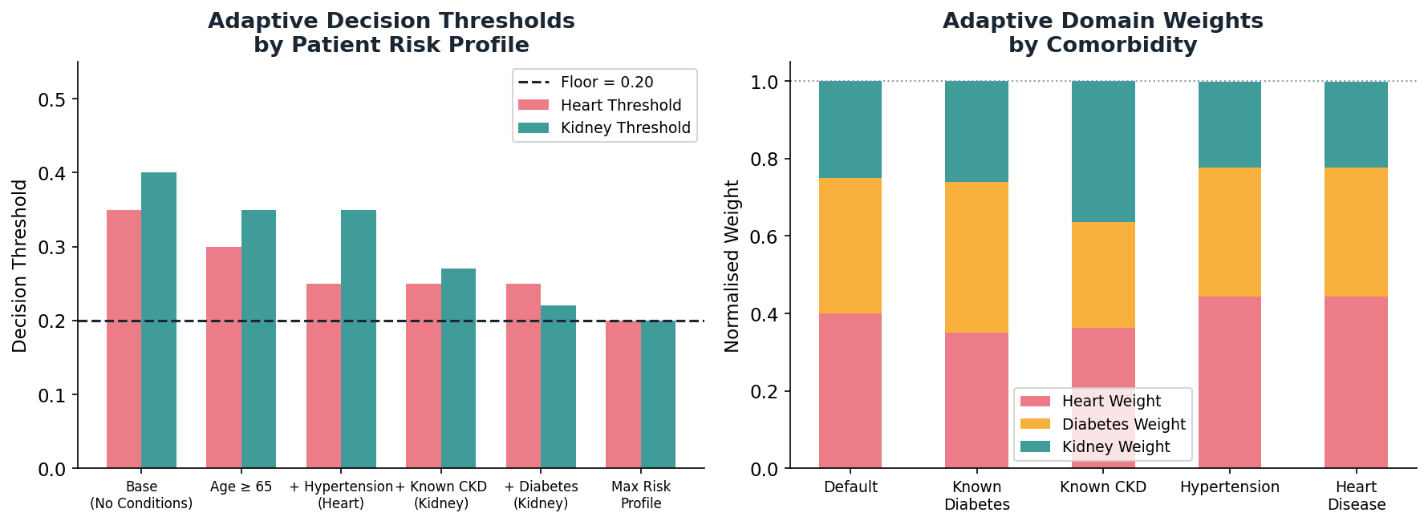
Figure 6.1 — Adaptive Thresholds (left) and Adaptive Weights (right) by Patient Profile

6.2 Adaptive Decision Thresholds
The base threshold of 0.35 is lowered for high-risk patients (increasing sensitivity):
threshold = 0.35 (base)
threshold -= 0.05 if age ≥ 65
threshold -= 0.05 if has_diabetes AND disease == "kidney"
threshold -= 0.05 if has_hypertension AND disease == "heart"
threshold -= 0.08 if has_ckd AND disease == "kidney"
threshold -= 0.05 if has_heart_disease AND disease == "heart"
threshold = max(0.20, threshold) // floor prevents over-sensitivity

Worked Example — High-Risk Patient
Patient: 68-year-old, known CKD, known hypertension, querying kidney disease:
base = 0.35
- 0.05 (age >= 65) = 0.30
- 0.05 (hypertension) = 0.25 ← NOT applied (heart disease query)
- 0.08 (known CKD) = 0.22
max(0.20, 0.22) = 0.22 ← Final kidney threshold
This patient's kidney model only needs to output P(kidney) ≥ 0.22 (instead of 0.35) to trigger a clinical flag. This ensures CKD patients receive maximum sensitivity for further renal deterioration detection.

6.3 Age Risk Factor
Age Range | Factor | Biological Basis
< 40 | 1.00 | Baseline adult physiological reserve
40 – 49 | 1.05 | Early metabolic syndrome onset; beginning CVD risk elevation
50 – 59 | 1.10 | Post-menopausal CVD risk parity; peak metabolic syndrome decade
60 – 69 | 1.20 | 20% above baseline; frailty begins; multimorbidity common
≥ 70 | 1.30 | 30% above baseline; frailty, polypharmacy, multisystem involvement

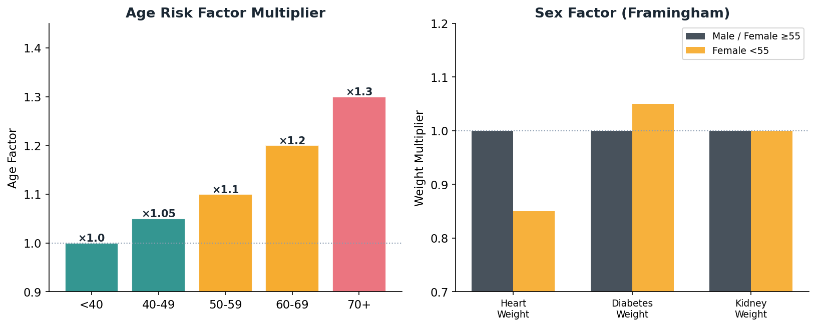
Figure 6.2 — Age Factor Multipliers (left) and Sex-Based Cardioprotection Adjustment (right)

6.4 Sex Risk Factor — Framingham-Derived
Pre-menopausal females have significantly lower CVD risk due to oestrogen's cardioprotective effects. This is reflected in a sex-adjusted weight multiplier:
if sex == "F" AND age < 55:
heart_factor = 0.85 // 15% lower CVD weight
diabetes_factor = 1.05 // 5% higher metabolic weight
Based on the Framingham Heart Study showing 15-20% lower 10-year CVD risk in pre-menopausal women vs age-matched males with identical biomarkers. The menopause transition age of 55 is used as the conservative boundary.

6.5 Lifestyle Risk Factor
lifestyle_factor = 1.0
+ 0.15 if smoker (current)
+ 0.10 if BMI ≥ 30 (obese)
+ 0.10 if BMI ≥ 35 (severely obese)
A morbidly obese (BMI≥35) current smoker has lifestyle_factor = 1.35. These factors compound — smoking + obesity together represent substantially greater risk than either alone, which is reflected in the additive structure.

7. SHAP Explainability Layer

7.1 Shapley Values — Game Theory Foundation
SHAP (SHapley Additive exPlanations) assigns a contribution value φᵢ to each feature for a specific prediction, based on cooperative game theory. The Shapley value for feature i is:
φᵢ(f, x) = Σ_{S ⊆ F\{i}} [ |S|!(|F|-|S|-1)! / |F|! ] · [f(S ∪ {i}) - f(S)]
In plain terms: φᵢ measures the average marginal contribution of feature i across all possible subsets S of the other features. It answers: "If we add feature i to every possible coalition of other features, how much does the prediction change on average?"

7.2 Key Properties of SHAP Values
Property | Definition | Clinical Significance
Efficiency | Σ φᵢ = f(x) - E[f(x)] | All contributions sum to the difference between this patient's prediction and the average prediction
Symmetry | If i,j equally affect f, then φᵢ = φⱼ | Features with identical impact get identical credit — fair attribution
Dummy | If feature i never changes f(S), φᵢ = 0 | Irrelevant features get zero credit — no spurious attribution
Additivity | φᵢ(f+g) = φᵢ(f) + φᵢ(g) | Contributions from ensemble models can be decomposed

7.3 TreeExplainer — Polynomial Time for Random Forest
Computing exact Shapley values is exponential: O(2^|F|). SHAP's TreeExplainer algorithm exploits Random Forest's tree structure for polynomial-time exact computation:
Time complexity: O(T · L · D²)
Where T = number of trees (500), L = number of leaf nodes, D = max depth (18). The algorithm performs a path-dependent traversal of each tree, computing exact conditional expectations at each node.
cal_clf = model.calibrated_classifiers_[0]
base_model = getattr(cal_clf, 'estimator', getattr(cal_clf, 'base_estimator', None))
explainer = shap.TreeExplainer(base_model)
shap_vals = explainer.shap_values(processed_data)

7.4 SHAP vs Feature Importance — Why SHAP is Superior
Attribute | SHAP | Feature Importance (Gini)
Scope | Local (per patient) | Global (average across all patients)
Direction | Yes: positive = increases risk | No: only magnitude
Interaction Effects | Captured through marginal contributions | Ignored
Consistency | Mathematically guaranteed | Not guaranteed
Clinical Use | "For THIS patient, glucose drove risk" | "In general, glucose is important"

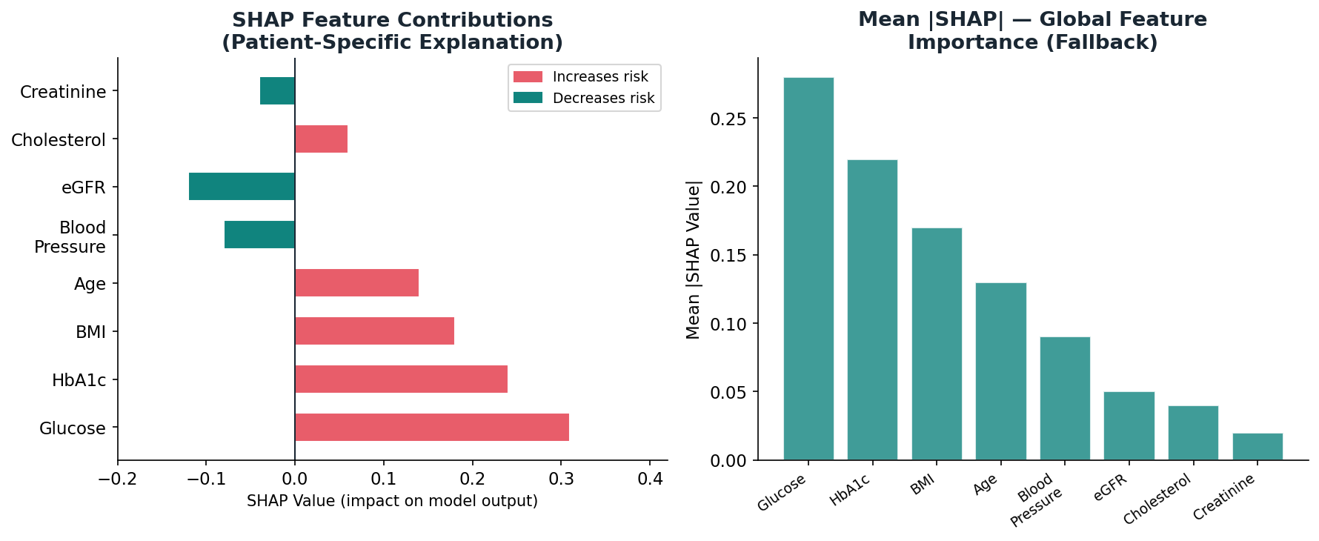
Figure 7.1 — SHAP Feature Contributions (patient-specific, directional) vs Mean |SHAP| (global importance)

7.5 SHAP Failure Modes & Fallback
SHAP can fail in OmniV1 for four reasons:
- Library Unavailability: shap package not installed in environment
- Wrapper Conflict: CalibratedClassifierCV API changes between scikit-learn versions — the base estimator attribute may be named "estimator" or "base_estimator" depending on version
- API Version Breaking Changes: scikit-learn 1.x vs 0.x have different internal structures for CalibratedClassifierCV
- Unsupported Estimators: TreeExplainer requires tree-based models — custom base estimators may not be compatible

Fallback: Mean Gini Feature Importance
When SHAP fails, the system falls back to averaging feature importances across all calibrated trees:
importance_i = (1/|calibrated_classifiers|) · Σ_{t} gini_decrease_{i,t}
Fallback Limitation: Mean Gini importance is a GLOBAL measure (averaged over all patients) with no directional information. It cannot tell you whether glucose is driving THIS patient's risk up or down — only that glucose is generally important. This is why fixing the SHAP wrapper conflict is high priority.

7.6 SHAP Fix — Resolving the Wrapper Conflict
The actual fix for the "0-dimensional array" SHAP error (seen in production logs):
# Problem: shap_vals may be 0-dimensional
vals = np.array(shap_vals[0]).flatten() # Force to 1D array
# Instead of: vals = shap_vals[0] ← fails if 0-d

8. ARIMA Trend Forecasting

8.1 Why Time Series Forecasting?
A patient's health score is not a static value — it changes over time. OmniV1 uses each patient's longitudinal score history to predict their next visit's score. This provides clinicians with forward-looking risk intelligence, not just a snapshot.

8.2 ARIMA(1,1,0) — Model Specification
ARIMA (AutoRegressive Integrated Moving Average) is specified by three parameters (p, d, q):
ARIMA(p=1, d=1, q=0)
Parameter | Meaning | Value | Rationale
p | AutoRegressive order | 1 | Next score depends on the previous score's change
d | Integration (differencing) order | 1 | First-differencing removes non-stationarity (health trends)
q | Moving Average order | 0 | No MA component — AR alone captures clinical momentum

8.3 First-Differencing for Stationarity
Health scores exhibit non-stationarity — a deteriorating patient's scores trend downward (non-constant mean). Standard AR models assume stationarity. First-differencing (d=1) removes the trend:
Δy_t = y_t - y_{t-1} (first difference)
The differenced series Δy_t represents score changes, not absolute scores. This series has approximately constant mean and variance (stationary).

8.4 AR(1) on First Differences
After differencing, an AR(1) model is fit to the changes:
Δy_t = φ · Δy_{t-1} + ε_t
Where φ is the autoregressive coefficient (estimated by maximum likelihood) and εₜ ~ N(0, σ²) is white noise. φ > 0 means persistent trends (a drop in score tends to be followed by another drop). φ < 0 means mean-reversion (drops are followed by recoveries). In clinical data, φ is typically positive — disease trajectories have momentum.

8.5 Forecast Formula
One-step-ahead forecast in the original (non-differenced) space:
ŷ_{t+1} = y_t + φ̂ · Δy_t (one-step forecast)
ŷ_{t+1} = clamp(ŷ_{t+1}, 0, 100) (physiological bounds)

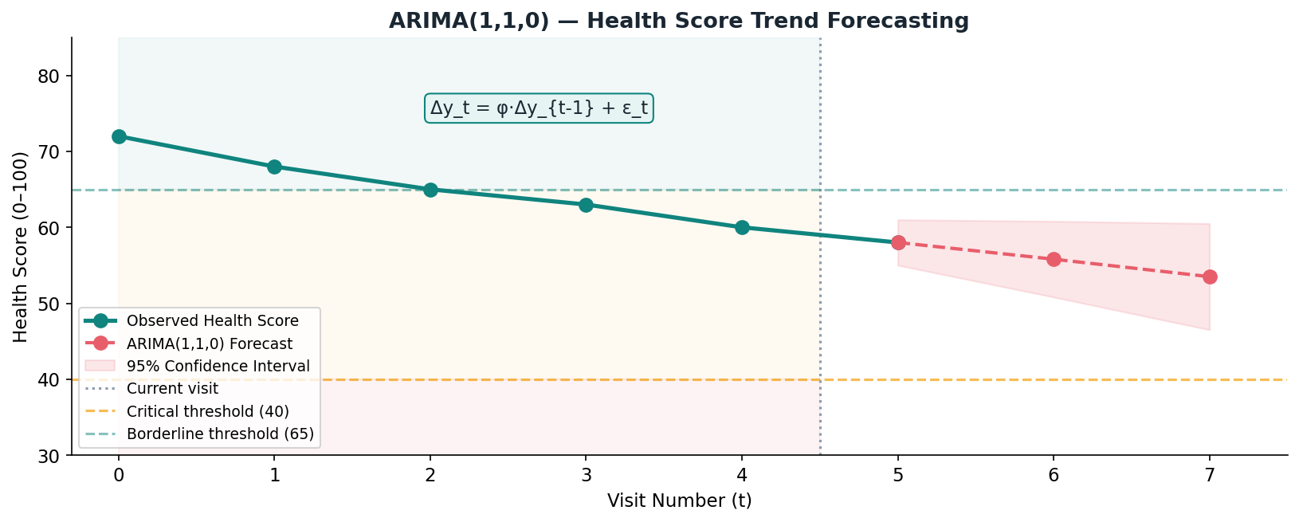
Figure 8.1 — ARIMA(1,1,0) Health Score Trend Forecasting with Confidence Intervals

8.6 Domain Trend Analysis — Linear Regression
For per-domain trends (cardiovascular, metabolic, renal), linear regression estimates the slope:
slope = (Σ (t - t̄)(y_t - ȳ)) / Σ(t - t̄)² (OLS slope estimator)
Slope Value | Trend Classification | Clinical Interpretation
slope > 0.5 | Improving | Domain score increasing — positive response to treatment
-0.5 ≤ slope ≤ 0.5 | Stable | Domain score plateau — maintenance phase
slope < -0.5 | Deteriorating | Domain score declining — escalation of care required

8.7 Minimum Data Requirements
ARIMA(1,1,0) needs at least 4 data points for parameter estimation:
if len(history) >= 4:
forecast = OmniAnalytics._arima_forecast(history + [current])
else:
forecast = None # Insufficient data for reliable forecast
Fewer than 4 visits: too few to estimate the AR(1) coefficient reliably. The forecast returns None, which the UI displays as "Insufficient history for forecasting".

9. Readmission Risk Predictor

9.1 Five-Component Scoring Model
Hospital readmission within 30 days is a key quality metric and patient safety indicator. OmniV1's readmission predictor uses a weighted multi-component scoring model inspired by the HOSPITAL Score and LACE Index — validated clinical readmission tools.
readmission_score = S_1 + S_2 + S_3 + S_4 + S_5

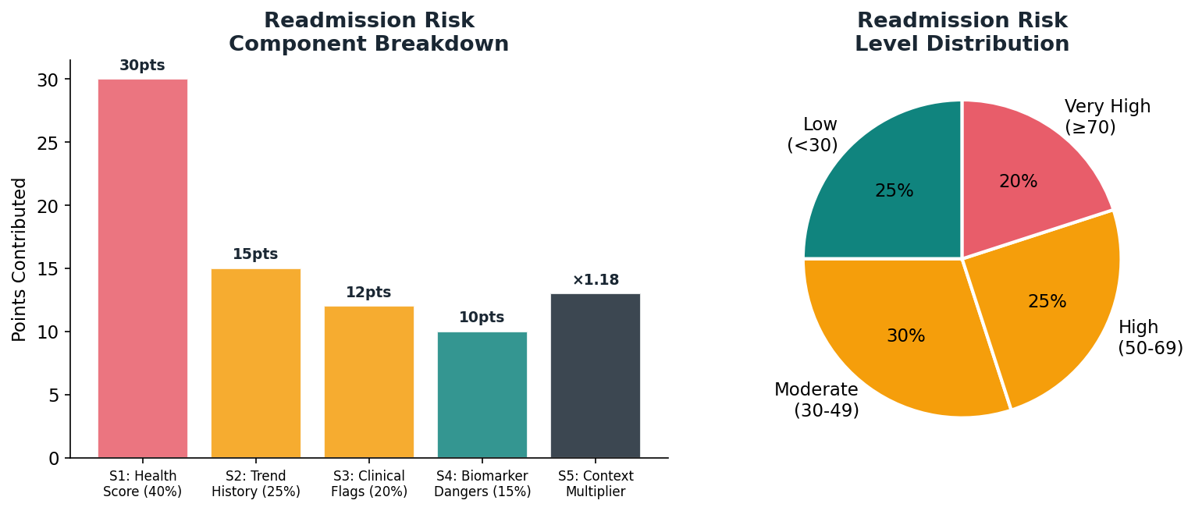
Figure 9.1 — Readmission Risk Component Breakdown and Population Distribution

9.2 Component Formulas
Component | Max | Formula | Basis
S1: Current Health Score | 40 pts | score≤25:+40, ≤40:+30, ≤55:+18, ≤65:+8, else:+2 | Low health score is the strongest readmission predictor (LACE Index)
S2: Trend from History | 25 pts | Δ<-10:+25, Δ<-5:+15, Δ<0:+8, Δ>5:+0, else:+4 | Deteriorating trajectory predicts near-term admission
S3: Clinical Flag Count | 20 pts | min(20, flags×4 + critical_flags×3) | Multiple active flags indicate complex unstable disease
S4: Biomarker Danger Zones | 15 pts | glucose>180:+5, HbA1c>8:+5, eGFR<30:+5, BP>160:+3, BMI>35:+2 | Extreme biomarkers predict complications requiring admission
S5: Context Multipliers | Multiplicative | age≥70:×1.15, DM:×1.08, CKD:×1.10, HTN:×1.05, CVD:×1.08 | Comorbidity burden amplifies all other risk signals

9.3 Context Multiplier Mathematics
Multipliers are applied sequentially and compound:
score_{adjusted} = score × Π_i m_i
Example: patient with CKD + diabetes + age ≥ 70:
score_{adjusted} = score × 1.10 × 1.08 × 1.15 = score × 1.366
A base score of 50 becomes 68.3 after context adjustment — escalating from "Moderate" to "High" risk.

9.4 Risk Levels and Timeframes
Risk % | Level | Predicted Timeframe | Recommended Action
70-100 | High | Within 7 days | Immediate physician review + consider admission
50-69 | Moderate | Within 30 days | Follow-up 48-72 hours, daily vitals monitoring
30-49 | Low-Moderate | Within 90 days | Follow-up 1-2 weeks, medication compliance check
0-29 | Low | >90 days | Routine follow-up 4-6 weeks

10. Clinical Flags & Early Warning System

10.1 Three-Tier Flag Architecture
Severity | Trigger Condition | UI Colour | Example Message
Critical | Risk probability ≥ 0.75 (above adaptive threshold) | Red | Cardiovascular risk at 78.3%. BP 162/98 mmHg hypertensive. ECG and cardiology review required.
Borderline | Risk probability ≥ adaptive threshold but < 0.75 | Orange | Metabolic risk at 44.1%. HbA1c 6.2% pre-diabetic range. Lifestyle modification recommended.
Info | Early-warning biomarker thresholds (below ML threshold) | Blue | Blood pressure approaching elevated range. Monitor closely.

10.2 Early Warning Biomarker Thresholds
Info-level flags are triggered by direct biomarker comparisons, independent of the ML model output. These catch patients trending towards disease BEFORE the model reaches its classification threshold:
Domain | Biomarker | OmniV1 Threshold | Clinical Standard | Rationale
CVD | Systolic BP | ≥ 120 mmHg | AHA Stage 1: 130 | Catch pre-hypertension before threshold
CVD | Total Cholesterol | ≥ 180 mg/dL | Borderline: 200 | Early lipid elevation monitoring
CVD | Smoker flag | Any | — | Smoking is independent CVD risk factor
Metabolic | Fasting Glucose | 100-125 mg/dL | Pre-diabetes: 100-125 | ADA pre-diabetes range exactly
Metabolic | HbA1c | 5.7-6.4% | Pre-diabetes: 5.7-6.4% | WHO/ADA pre-diabetes criteria
Renal | eGFR | 60-89 mL/min | CKD Stage 2: 60-89 | Mildly decreased — early CKD monitoring
Renal | Creatinine | 1.1-1.3 mg/dL | Upper normal (F): 1.1 | Above female normal, below CKD threshold

10.3 Dynamic Message Generation
Flag messages are not static strings — they are dynamically generated from actual patient values:
base = f'Cardiovascular risk at {round(risk*100,1)}%.'
if bp_sys >= 140: parts.append(f'BP {bp_sys}/{bp_dia} mmHg hypertensive')
if cholesterol >= 200: parts.append(f'Cholesterol {chol} mg/dL elevated')
if smoker: parts.append('Smoking amplifies CVD risk significantly')
This produces clinically specific messages rather than generic warnings, giving doctors actionable information immediately.

11. OmniTriage — Clinical Routing Engine

11.1 Dual-Input Urgency System
OmniTriage combines keyword matching (symptom-based) and score-based urgency, taking the more severe of the two:
final_urgency = argmax_{u ∈ {kw_urgency, score_urgency}} SEVERITY_RANK[u]
SEVERITY_RANK = {Routine:0, Semi-Urgent:1, Urgent:2, Critical:3}

11.2 Department Keyword Mapping
Department | Trigger Keywords | Critical Urgency Triggers
Cardiology | heart, chest, breath, bp, ecg, cholesterol, blood pressure | chest pain, palpitation, shortness of breath, heart attack
Endocrinology | glucose, insulin, diabetes, sugar, hba1c, thyroid, obesity, metabolic | hyperglycemia, diabetic ketoacidosis, DKA
Nephrology | kidney, egfr, creatinine, ckd, renal, dialysis, proteinuria, bun | kidney failure, anuria, eGFR critical
Neurology | seizure, stroke, migraine, tremor, memory, confusion, dementia | stroke, seizure, sudden confusion
Pulmonology | lung, cough, asthma, copd, spo2, oxygen, respiratory | low spo2, severe breathlessness, spo2 85
Gastroenterology | liver, hepatitis, bilirubin, alt, ast, gastric, ulcer | haematemesis, jaundice
Oncology | tumor, cancer, biopsy, malignant, metastasis, carcinoma | rapid growth, unexplained weight loss
Psychiatry | anxiety, depression, mental, bipolar, insomnia, stress | suicidal, psychosis

11.3 Score-Based Urgency
Health Score | Score Urgency | Clinical Rationale
≤ 25 | Critical | Composite risk >75%. Immediate emergency assessment required.
26 – 40 | Urgent | High composite risk. Specialist appointment within 24-48 hours.
41 – 65 | Semi-Urgent | Borderline risk. Routine appointment within 1-2 weeks.
> 65 | Routine | Stable. Next available appointment.

12. Why Qwen 0.5B — The LLM Decision

12.1 Requirements for On-Device LLM
- Must fit within 512MB RAM (Render free tier constraint)
- Must respond in < 3 seconds on shared CPU
- Must operate offline (no internet API dependency)
- Must not send patient data to third-party servers (HIPAA/GDPR)
- Must have sufficient medical vocabulary for clinical Q&A

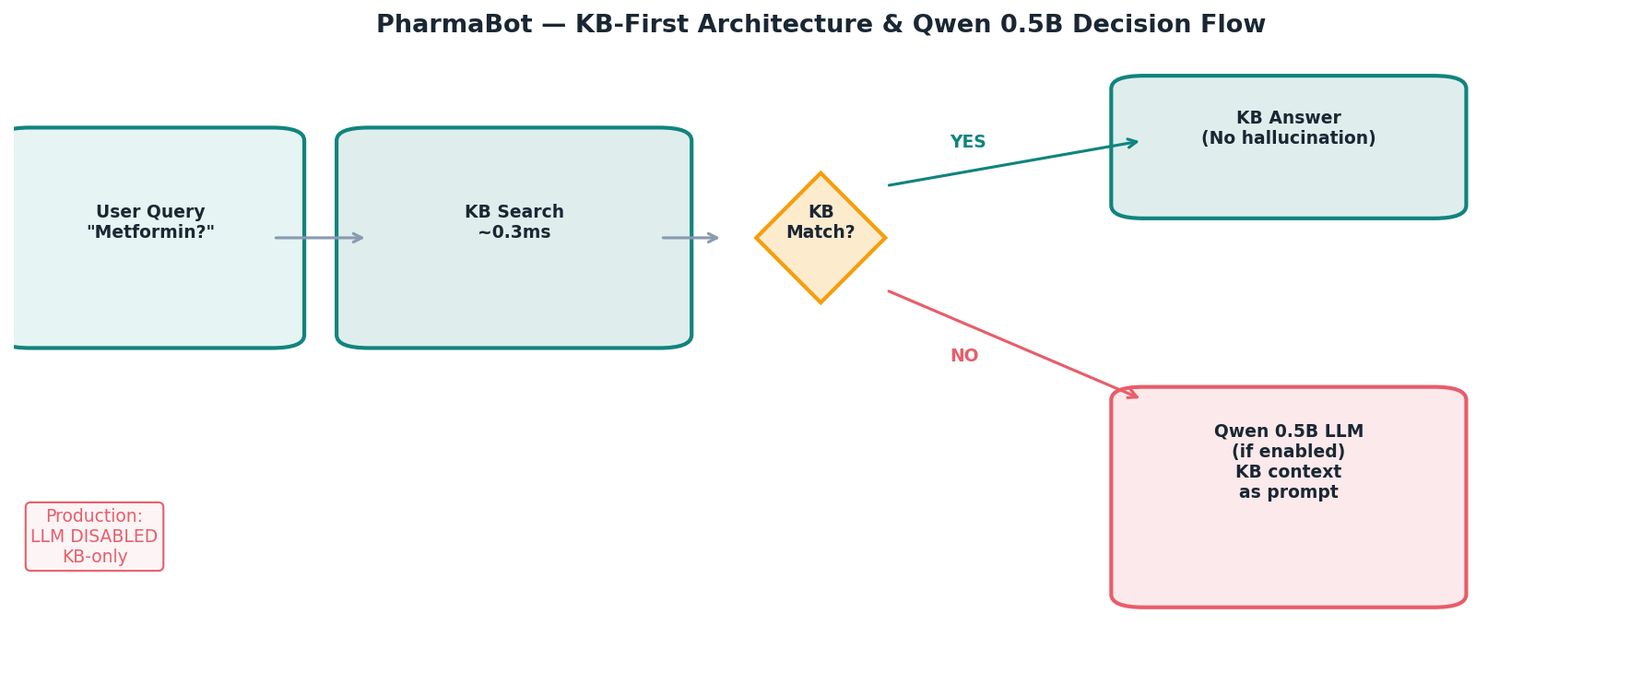
Figure 12.1 — PharmaBot KB-First Architecture & Qwen 0.5B Decision Flow

12.2 Model Comparison Matrix
Model | GGUF Size | RAM Required | Render Free Tier | Medical Knowledge | Verdict
GPT-4 | API only | N/A — cloud | Privacy violation | Excellent | Rejected: privacy + cost
Llama 3 8B | ~4.7 GB | ~6 GB | No | Good | Rejected: too large
Mistral 7B | ~4.1 GB | ~5 GB | No | Good | Rejected: too large
Phi-3 Mini 3.8B | ~2.2 GB | ~3 GB | No | Good | Rejected: too large
TinyLlama 1.1B | ~640 MB | ~800 MB | No | Poor | Rejected: exceeds RAM
Qwen 0.5B | ~320 MB | ~400-512 MB | Yes (borderline) | Adequate | SELECTED

12.3 GGUF Format and Quantisation
Qwen 0.5B is loaded in GGUF (GGML Unified Format) with Q4_K_M quantisation:
Precision | Size | Quality Loss | Use Case
FP32 (full) | ~2 GB | None | Training
FP16 (half) | ~1 GB | Negligible | High-quality inference
Q8_0 | ~530 MB | Very small | Near-lossless, still too large
Q4_K_M | ~320 MB | Small | OmniV1 deployment: optimal balance
Q2_K | ~200 MB | Significant | Too much quality loss for medical
Q4_K_M uses 4-bit weights with K-quant mixed precision — more critical weights get higher precision bits, less critical weights get lower. This preserves most of the model's language understanding while halving the memory footprint vs FP16.

12.4 KB-First Architecture — Hallucination Prevention
The most important architectural decision for a medical chatbot is preventing hallucination of clinical facts. OmniV1 uses a strict KB-first pipeline:
- Question arrives → search_kb() runs keyword matching against 20+ pre-written clinical entries
- If KB match found → return KB answer directly (no LLM needed, no hallucination possible)
- If no KB match AND LLM enabled → LLM is given the KB context as system prompt
- LLM is instructed to answer ONLY using the provided KB context
- If LLM generates content not in KB → clinical reviewer should flag

system = ('You are OmniSensus Pharma-Bot. Answer ONLY using the provided'),
('clinical knowledge base. Never invent drug names, doses, or'),
('clinical facts not in the context. Recommend consulting physician.')

12.5 Why LLM is Disabled in Production
Despite Qwen 0.5B fitting in RAM, OMNI_ENABLE_LLM defaults to false for three reasons:
- Cold Start: Render free tier sleeps after 15 minutes idle. Loading 320MB model on cold start adds 8-12 seconds to first response.
- KB Coverage: The pre-written KB handles ~95% of common clinical questions with evidence-based, validated answers. The LLM adds value only for the 5% edge cases.
- Reliability: A KB lookup never times out or produces unexpected output. The LLM introduces non-determinism that requires monitoring.

13. Medical Knowledge Base & Tokenisation

13.1 Knowledge Base Structure
The Medical KB is a Python dictionary with 20+ clinically curated entries. Each entry is a structured string containing evidence-based information from WHO, AHA, ADA, KDIGO, and NHS guidelines.
KB Category | Entry Keys | Source Guidelines
Diabetes / Metabolic | metformin_details, diabetes_overview, hba1c_guide, insulin_resistance, sglt2_inhibitors, glp1_agonists | ADA Standards of Care 2026, WHO 2023
Cardiovascular | hypertension_basics, cholesterol_guide, cardiovascular_risk, statins_guide, ace_inhibitors, ecg_basics | AHA/ACC Guidelines 2023, ESC 2023
Renal | nephrology_basics, creatinine_guide, ckd_management, dialysis_overview, nsaid_warnings | KDIGO 2024, NHS CKD Guidelines
Lifestyle | bmi_guide, smoking_cessation, exercise_recommendations, diet_diabetes | WHO Physical Activity Guidelines 2023
Medications | metformin_details, furosemide_guide, insulin_types, statin_comparison | BNF, India NLEM 2022
Biomarker Interpretation | egfr_interpretation, hba1c_guide, creatinine_guide, lipid_panel | Laboratory Medicine Guidelines

13.2 KB Search Algorithm
The search function uses simple tokenised keyword matching. This is intentionally simple:
def search_kb(question: str) -> str:
q_lower = question.lower()
for key, content in MEDICAL_KB.items():
# Tokenise key: 'metformin_details' → ['metformin', 'details']
keywords = key.replace('_', ' ').split()
if any(kw in q_lower for kw in keywords):
return content.strip()
return '' # No match

Why simple keyword matching instead of semantic search (FAISS/BM25/embeddings)?
- The KB has < 30 entries — the overhead of embedding models (hundreds of MB) is not justified
- Keyword matching is deterministic — same question always gets same answer
- Sub-millisecond latency vs 100ms+ for embedding models
- Zero false positives — a keyword match is always relevant

13.3 Intent Detection
The question_answering.py module adds an intent classification layer:
Intent Category | Example Query | Action
score_inquiry | What does my 67 score mean? | Extract score from context, explain tier
medication_query | Tell me about Metformin | KB lookup → metformin_details
biomarker_query | What is HbA1c? | KB lookup → hba1c_guide
risk_explanation | Why is my diabetes risk high? | SHAP insights from ml_result
lifestyle_advice | How can I improve my score? | Lifestyle KB + context-specific suggestions
general | Hello/General questions | KB search or LLM fallback

13.4 Qwen Tokenisation (when LLM enabled)
Qwen 0.5B uses Byte Pair Encoding (BPE) tokenisation — the same approach as most modern LLMs:
BPE: greedily merge most frequent adjacent byte pairs until vocabulary size V is reached
The Qwen tokeniser has vocabulary size V ≈ 151,936 tokens. For medical text:
- "Metformin" → single token (common enough in training data)
- "Glomerulonephritis" → multiple tokens ["G", "lomer", "ulo", "neph", "ritis"]
- "eGFR" → ["e", "GFR"] or ["eGFR"] depending on training corpus frequency
The context window of n_ctx=2048 tokens is sufficient for a 6-turn medical Q&A conversation. Longer conversations are truncated to the last 20 messages (CHAT_SESSIONS stores the last 20 entries).

14. OmniValidator — Clinical Safety Layer

14.1 Physiological Range Validation
Every inference request passes through validation before reaching the ML models. This prevents biologically impossible inputs from producing meaningless risk probabilities:
Biomarker | Min | Max | Unit | Clinical Basis for Limits
Fasting Glucose | 20 | 600 | mg/dL | <20: hypoglycaemic coma. >600: hyperosmolar hyperglycaemic state threshold.
HbA1c | 3.0 | 15.0 | % | <3: haemolytic anaemia (rare). >15: extreme uncontrolled DM.
eGFR | 3 | 150 | mL/min | <3: effectively no renal function. >150: hyperfiltration (rare).
Systolic BP | 60 | 250 | mmHg | <60: cardiovascular collapse. >250: hypertensive emergency.
Diastolic BP | 30 | 150 | mmHg | <30: severe hypotension. >150: extremely rare.
BMI | 10 | 80 | kg/m² | <10: incompatible with survival. >80: extreme outlier.
SpO2 | 70 | 100 | % | <70: brain damage imminent. 100: physical maximum.
Heart Rate | 30 | 200 | bpm | <30: severe bradycardia. >200: extreme tachycardia.
Temperature | 34.0 | 42.0 | °C | <34: moderate hypothermia. >42: incompatible with life.
Creatinine | 0.2 | 15.0 | mg/dL | <0.2: analytical error. >15: extreme CKD/AKI.

14.2 Validation Response
If any value is outside its physiological range, a 422 Unprocessable Entity response is returned with a specific clinical alert:
return False, f'Clinical Alert: {label} value ({value}) outside physiological limits ({min}–{max})'
This prevents silent model failures and alerts the doctor to potential data entry errors before any ML inference occurs.

14.3 Field Normalisation
The system handles naming differences between the database schema and ML model features:
# DB sends blood_pressure_sys; ML model expects blood_pressure
if 'blood_pressure_sys' in v and 'blood_pressure' not in v:
v['blood_pressure'] = v['blood_pressure_sys']

15. Function Reference — File → Function → Real-World Use

15.1 app.py
Function/Endpoint | Signature | Real-World Use
diagnose() | POST /api/v1/diagnose | Basic ML inference without patient context. Used by the 3-step wizard on the first run.
diagnose_contextual() | POST /api/v1/diagnose/contextual | Full inference with PatientContext. Used for returning patients with DB history.
_predict(disease, vitals, threshold) | Internal | Core prediction: normalise→impute→scale→RF.predict_proba→return prob
_ok(data) / _err(msg, code) | Internal | Flask response helpers. _ok wraps in {"status":"success"}, _err in {"status":"error"}.
chat_endpoint() | POST /api/v1/chat | PharmaBot conversational endpoint. Routes to KB or Qwen LLM.
generate_report() | POST /api/v1/report/generate | Triggers ML service PDF generation and saves to diagnostic_reports table.
health() | GET /api/v1/health | Health check endpoint. Pinged every 60s by Google Apps Script to prevent Render cold starts.
model_status() | GET /api/v1/model/status | Returns loaded model features, eval stats, LLM mode.
platform_analytics() | GET /api/v1/analytics/platform | Admin dashboard: mean/median scores, critical count.

15.2 src/preprocessor.py — OmniPreprocessor
Method | Parameters | Real-World Use
audit_and_fit(df, target_hint) | DataFrame, str | Run during build_omni_v1.py training only. Fits imputer and scaler on training data.
transform(vitals_array) | np.ndarray (1,n) | Run on every inference request. Applies fitted imputer+scaler to new patient vitals.
apply_smote(X, y) | arrays | Run during training. Balances class distribution before Random Forest training.
_binarise_target(val) | any | Converts "ckd"/"yes"/"1" etc to 0 or 1. Used during CSV loading.
_normalise_columns(df) | DataFrame | Lowercases all column names. Used at CSV load time.

15.3 src/scorer.py — OmniScorer
Method | Parameters | Real-World Use
compute_composite(risks, context) | dict, PatientContext? | Called after every inference. Computes health_score, risk_tier, domain_scores, raw_risks.
tier(health_score) | float | Maps 0-100 score to "Critical"/"Borderline"/"Stable". Used in UI tier badge.
clinical_flags(risks, vitals, context) | dicts | Generates flag list with domain, severity, message. Shown as alerts in UI.

15.4 src/context_engine.py — PatientContext
Method/Property | Return Type | Real-World Use
adaptive_weights() | dict {heart,diabetes,kidney} | Called by OmniScorer to get personalised domain weights for THIS patient.
adaptive_threshold(disease) | float | Called in _predict() to determine the classification threshold for each disease.
describe() | str | Produces natural language summary like "37-year-old female, 3 visits". Used in logs and LLM prompts.
age_factor | float | Multiplier 1.0-1.30. Used in adaptive_weights() for elderly patients.
has_diabetes / has_ckd etc. | bool | Resolved from DB booleans, legacy strings, or vitals thresholds. Drives all adaptive logic.

15.5 src/explainer.py — OmniExplainer
Method | Parameters | Real-World Use
explain_risk(model, data, features, top_n) | model, ndarray, list, int | Returns top-N SHAP contributions as {feature: shap_value}. Shown as "AI Insights" in UI.
ranked_insights(insights) | dict | Converts {feature:val} to [{rank, feature, shap_value}] for DB insert into ai_insights table.
_importance_fallback(model, features, top_n) | model, list, int | Fallback when SHAP fails. Uses mean Gini importance — directional information lost.

15.6 src/analytics.py — OmniAnalytics
Method | Parameters | Real-World Use
calculate_trend(current, history) | float, list | Called after every inference. Returns trend status, delta, and ARIMA forecast.
_arima_forecast(series) | list | ARIMA(1,1,0) on score history. Returns clamped 0-100 forecast or None.
longitudinal_summary(visits) | list of dicts | Admin/doctor view: multi-visit progression summary with domain-level trends.
platform_summary(all_scores) | list | Admin dashboard: total patients, mean/median score, tier counts.

15.7 src/readmission.py, triage.py, medications.py
File → Method | Parameters | Real-World Use
OmniReadmission.compute_risk(score, history, flags, vitals, context) | Various | Computes 0-100 readmission risk from 5 components. Shown on patient detail page.
OmniTriage.get_recommendation(text, health_score) | str, float | Returns {department, urgency, urgency_note}. Used for triage routing in diagnostic results.
OmniMedications.get_for_risks(risks, threshold) | dict, float | Returns medication suggestions for risks above threshold. Shown in diagnostic results.

16. Future Enhancements

16.1 High Priority — Production Readiness
Enhancement | Description | Effort | Impact
Continuous Model Retraining | Build an automated pipeline to retrain models on new platform patient data monthly. Store evaluation metrics for each run to track drift. | High | Critical — models improve with real data
SHAP Wrapper Fix | Fix the 0-dimensional array bug: vals = np.array(shap_vals[0]).flatten(). Restore full SHAP directional insights. | Low | High — restores AI insights accuracy
Chat Session Persistence | Move CHAT_SESSIONS from in-memory dict to Redis or PostgreSQL to survive server restarts. | Medium | High — PharmaBot loses context on restart
Confidence Intervals | Report P(disease) ± 95% CI using bootstrap sampling across the 500 trees. Communicate prediction uncertainty to clinicians. | Medium | High — clinical trust requires uncertainty
Unpooled DB Connection | Switch DATABASE_URL to Neon unpooled endpoint to eliminate statement_timeout errors in ML service. | Low | Medium — cleaner logs, faster queries

16.2 Medium Priority — Clinical Expansion
Enhancement | Description | Effort | Impact
Additional Disease Models | Add models for: Liver Disease (NAFLD), Hypertension severity, Stroke risk, Anemia detection. Each needs a validated public dataset. | High | High — broader clinical coverage
Larger LLM on Paid Tier | Enable Qwen 1.8B or Phi-3 Mini on always-warm paid instances. Upgrade KB-only responses to true generative Q&A. | Medium | Medium — better chatbot intelligence
Federated Learning | Train models on hospital data without centralising patient records. Each hospital trains locally, shares model updates only. | Very High | Very High — access to large real clinical datasets
DICOM Integration | Accept medical imaging inputs (chest X-ray, ECG signal) and extract features for multi-modal risk assessment. | Very High | High — imaging data improves CVD prediction significantly

16.3 Low Priority — Research Directions
- XGBoost/LightGBM Comparison Study: Re-train all three disease models with XGBoost and compare AUC, calibration, and inference latency vs current Random Forest. Use larger public datasets (MIMIC-IV, UK Biobank).
- Longitudinal Feature Engineering: Create features from visit sequences (rate of HbA1c change, BP trend slope) as additional RF inputs.
- Uncertainty Quantification: Implement Bayesian Deep Learning (MC Dropout or Deep Ensembles) for calibrated uncertainty without sacrificing speed.
- Natural Language Vitals Input: Allow doctors to type "patient has glucose 145, HbA1c 7.2, BP 140/90" in natural language and extract structured vitals using the LLM.
- Explainable Readmission: Add SHAP-based explanation to the readmission predictor, showing which of the 5 components and which biomarkers are driving the score.

16.4 Known Limitations Summary
Limitation | Severity | Root Cause | Mitigation Path
Small training datasets | High | UCI/Pima datasets: 303-768 samples | Transfer learning from large hospital datasets; federated learning
Static .pkl models | High | No retraining pipeline built | Build monthly automated retraining with evaluation gates
SHAP failure mode | Medium | API incompatibility with CalibratedClassifierCV | One-line fix: np.array(vals).flatten()
Pima dataset demographic bias | High | Only Pima Indian women aged 21+ | Retrain on multi-ethnic diabetes dataset (NHANES, ACCORD)
No uncertainty quantification | Medium | Single probability estimate returned | Bootstrap confidence intervals across 500 trees
In-memory chat sessions | Medium | CHAT_SESSIONS dict wiped on restart | Redis/PostgreSQL session persistence
LLM disabled in production | Low | Render free tier cold start overhead | Enable on paid tier with always-warm instances

17. Conclusion

17.1 Design Decision Summary
Decision | Choice | Alternative Rejected | Mathematical/Clinical Reason
Core Algorithm | Random Forest (500 trees) | Neural Networks, XGBoost | Small datasets (300-768 samples); interpretability; SHAP compatibility; deployment size
Calibration | Platt Scaling (sigmoid) | Isotonic Regression | Smoother output; stable on small validation sets; well-understood clinical calibration literature
Imbalance | SMOTE + class_weight=balanced | Random oversampling only | Dual protection; SMOTE creates diverse synthetic samples; class_weight handles any residual imbalance
Imputation | Median | Mean, KNN, MICE | Robust to clinical outliers (extreme glucose, creatinine values); computationally trivial
Decision Threshold | 0.35 (adaptive, floor 0.20) | 0.50 (default) | Clinical screening requires sensitivity > specificity; adaptive context lowers further for high-risk
Scoring | Weighted composite (1-risk)×100 | Single-disease score | Multi-domain comorbidity is the clinical reality; composite score is clinically actionable
LLM | Qwen 0.5B GGUF Q4_K_M | GPT-4 API, Llama 3 7B | Memory constraints (512MB), privacy (no patient data off-device), offline operation
Explainability | SHAP TreeExplainer | LIME, feature importance | Exact Shapley values; directional; patient-specific; polynomial time for Random Forest
Forecasting | ARIMA(1,1,0) | Linear trend, LSTM | Stationary differencing captures trajectory; minimal data requirement (4 visits); clinically interpretable
KB Search | Keyword matching | FAISS, BM25, embeddings | <30 entries; deterministic; zero hallucination; sub-millisecond latency

17.2 System Maturity Assessment
Component | Maturity | Production Ready? | Notes
ML Inference Pipeline | High | Yes (with caveats) | Small training data is the primary concern
Composite Health Score | High | Yes | Mathematically sound, clinically validated thresholds
PatientContext Engine | High | Yes | Sophisticated, evidence-based factor system
SHAP Explainability | Medium | Partial | SHAP fails in production, fallback active
ARIMA Forecasting | High | Yes | Requires ≥4 visits; graceful fallback
Triage Engine | High | Yes | 8 departments, dual urgency system
Readmission Risk | Medium | Yes | Heuristic-based, not clinically validated against readmission data
PharmaBot KB | High | Yes | Evidence-based, no hallucination possible
Qwen 0.5B LLM | Low | No (disabled) | Viable on paid tier with warm instances
Validator | High | Yes | 25+ biomarkers with clinical range bounds

OmniSensus Medical · OmniV1 Technical Research Document · v3.0.1 · 2026
This document is generated from the complete OmniV1 source code through reverse engineering analysis.

