**A**

**Project Report**

**On**

**"Online Food App"**

**Prepared by**

Parth Vasoya (18DCS134)

**Under the guidance of**

Prof. Mohammed Bohara

A Report Submitted to

Charotar University of Science and Technology

For Partial Fulfillment of the Requirements for the

5th Semester Summer Internship-I (CS343)

**Submitted at**



**Department of Computer Science & Engineering**

**Devang Patel Institute of Advance Technology and Research**

**At: Changa, Dist.: Anand – 388421**

**June 2020**



**CERTIFICATE**

This is to certify that the report entitled “**Online Food App**” is a bonafide work carried out by **Mr. Parth R. Vasoya (18dcs134)** under the guidance and supervision of **Prof. Mohammed Bohara** for the subject **CS343 Summer Internship-I** of 5th Semester of Bachelor of Technology in **Department of Computer Science & Engineering,** **DEPSTAR** at Faculty of Technology & Engineering – CHARUSAT, Gujarat.

To the best of my knowledge and belief, this work embodies the work of candidate, has duly been completed, and fulfills the requirement of the ordinance relating to the B.Tech. Degree of the University and is up to the standard in respect of content, presentation and language for being referred to the examiner.

|  |  |
| --- | --- |
| Prof. Mohammed Bohara  Assistant Professor  Department of Computer Science & Engineering  DEPSTAR, CHARUSAT, Changa, Gujarat. |  |
| Prof. Parth Goel  I/C Head of Department  Department of Computer Science & Engineering  DEPSTAR, CHARUSAT, Changa, Gujarat | Dr. Amit Ganatra  Principal, DEPSTAR  Dean, FTE  CHARUSAT, Changa, Gujarat. |

**Devang Patel Institute of Advance Technology And Research At: Changa, Ta. Petlad, Dist. Anand, PIN: 388 421. Gujarat**

**ACKNOWLEDGEMENT**

The developer of a Dynamic flutter application namely “Online Food Delivery”, with immense pleasure and commitment would like to present the Project. The development of this project has given us wide opportunity to think, implement and interact with various aspects of management skills as the new emerging technologies.

Every work that I completes successfully stands on the constant encouragement, good will and support of people around. We hereby avail this opportunity to express my gratitude to number of people who extended their valuable time, full support and cooperation in developing the project.

We express deep sense of gratitude towards our project guide Assistant Professor Mohammed Bohara for the support during the whole session of study and development. It is because of them, that we were prompted to do hard work, adopting new technologies.

Thanks,

Parth Vasoya

**ABSTRACT**

Making dynamic application, for restaurant.In this application, I will create two module one for admin, who can add products and get all information about application and other for users,

In that users can add products into cart and after that they can get final bill and buy product and track their product.

**TABLE OF CONTENTS**

**ACKNOWLEDGEMENT......................................................................................i**

**ABSTRACT.............................................................................................................ii**

**TABLE OF CONTENTS.......................................................................................iii**

**Chapter 1: project Definition .................................................................................1**

1.1 Definition ........................................................................................................1

1.2 Objective ........................................................................................................1

1.3 Scope ...............................................................................................................1

1.4 Tools and Technologies...................................................................................1

**Chapter 2: Project Description……………...........................................................2**

2.1 Description of the Project …………………………………………………...2

**Chapter 3: Software and Hardware Requirements.............................................4**

3.1 Software and hardware requirements for making the Project……………….4

3.2 Software requirements for running the applications…………………..…….4

3.3 Hardware requirements for running the applications………………..………4

**Chapter 4: Major Functionality……….................................................................5**

4.1 Functionality for User……………………………………………………….5

4.2 Functionality for Admin…………………………………………………….5

**Chapter 5: Flow Chart …………….......................................................................6**

5.1 Flow Diagram for User and Admin…….………………………………….6

**Chapter 6: Screenshots …………….......................................................................7**

6.1 Screenshots of Application………………….………………………………7

**Chapter 7: Limitations & Future Enhancement of project……………..............11**

7.1 Limitations…………………..……………………………………………….11

7.2 Future Enhancement ………..……………………………………………….11

**Chapter 8: Outcome…………….............................................................................12**

8.1 Our Application outcome…………………………………………………....12

8.2 Expected outcome……………………………………………………………12

**Chapter 9: References……………..........................................................................13**

9.1 References………………..………………………………………………...13

**Chapter 1: Project Definition**

* 1. **Definition**
* Making dynamic application, for restaurant. In this application, I will create two module one for admin, who can add products and get all information about application and other for users,
* In that users can add products into cart and after that they can get final bill and buy product and track their product.
  1. **Objective**
* After development of this project, Travel Agency can Grow their business online
* Basically this platform provide any Travel Agency to bring their business online
  1. **Scope**
* Mobile apps playing the role as a key lifestyle factor for majority of population..
* A variety of popular cuisines and cosmopolitan tastes to try different food delicacies.
* A thriving food scene with a variety of quality restaurants serving delicacies with different price tags.
* Increasing demand for faster and timely food delivery.
* Competitive pricing aggravated by promotional offers and discounts being a key motivation for the customers.
  1. **Tools and Technologies**
     + VS CODE
     + Flutter SDK
     + Dart Extension
     + Firebase
     + Many flutter plugins like shared preferences,firebase_auth,etc.

**Chapter 2: Project Description**

* 1. **Description**
* As Project Definition states that “Online Food App” is an online marketplace that connects a Foodies to multiple local Restaurants.
* There are mainly two users :-
* Restaurant(Admin)
* People who order online food(Foodies)
* Both the App modules are build using Flutter.

**Why Flutter?**

* Flutter is an open-source UI software development kit created by Google. It is used to develop applications for Android, iOS, Windows, Mac, Linux, Google Fuchsia. and the web.
* The first version of Flutter was known as codename "Sky" and ran on the Android operating system. It was unveiled at the 2015 Dart developer summit, with the stated intent of being able to render consistently at 120 frames per second. During the keynote of Google Developer Days in Shanghai, Google announced Flutter Release Preview 2 which is the last big release before Flutter 1.0. On December 4th, 2018, Flutter 1.0 was released at the Flutter Live event, denoting the first "stable" version of the Framework.
* The major components of Flutter include:

Dart platform

Flutter engine

Foundation library

Design-specific widgets

* **Dart Programming Language**
* Dart is a client-optimized programming language for apps on multiple platforms. It is developed by Google and is used to build mobile, desktop, backend and web applications.
* Dart is an object oriented, class defined, garbage-collected language using a C-style syntax that trans compiles optionally into JavaScript. It supports interfaces, mixins, abstract classes,reified generics, static typing, and a sound type system.
* Google has introduced Flutter for native mobile app development on both Android and iOS. Flutter is a mobile app SDK, complete with framework, widgets, and tools, that gives developers a way to build and deploy mobile apps, written in Dart. Flutter works with Firebase and other mobile app SDKs, and is open source.
* **Firebase**
* It is an online tool that helps to manage the firebase services.
* It provides services like cloud storage, authentication, database, web hosting, etc.
* It also provides analysis of the application to improve its quality.
* These include crash reports, performance monitoring, testing, etc.

**Chapter 3: Software and Hardware Requirements**

**3.1 Software and hardware requirements for making the Project:**

* Operating System:
* Microsoft Windows 7, 64-bit
* Microsoft Windows 8.1, 64-bit
* Microsoft Windows 10, 64-bit
* Hardware:
* Intel® Core i5 4th generation (or an equivalent AMD processor)
* 2 GB Ram
* Software
* VS CODE
* Flutter SDK
* Dart Extensions
* Emulator iOS/Android

**3.2 Software requirements for running the App:**

* I Android 6.0 Marshmallow or Above
* IOS 10
* Internet Accessibility

**3.3 Hardware requirements for running the App:**

* The absolute minimum requirements for our project were a 1 GB of RAM.
* 45 MB of storage is required minimum.

**Chapter 4: Major Functionality**

In this project there are two modules based on the users of the app.

**4.1 Functionality for User**

* Pages : home page, food page, cart page, status page, admin page,admin order page
* In Homepage, I created all items category list widgets ,frequently bought foods, drawer menu,etc.
* In Item pages, I add all foods which have same category, in this all food items fetch from firebase database. In I create 4 category pages like pizza,burger,sandwich and dessert.
* In food page, when user click on any food item card then navigate to food page. In that food page I include food name,photo,description,price,add to cart button and cart icon where we can check cart.
* In Cart Page, when user add item into cart all item shows in this cart page. This all data fetch from firebase. In this I add one checkout button when user click on that order is placed.
* In Status page, user can show their order status like order placed, order received at admin site, order prepared and order delivered.

**4.2 Functionality for Admin**

* In Admin page, in this page admin can add items in database via this page or directly in firebase.
* In Admin order page, when user click on checkout button admin can show all user order in this page.
* In Admin order item page, when user click on user email show in admin order page admin can get all information about that user order like all items name and no. of each items. In this page two buttons are their which are one prepared button and one delivered button, when click on that button user status will update.

**Chapter 5: Flow Chart**

**5.1 Flow Diagram for User and Admin**

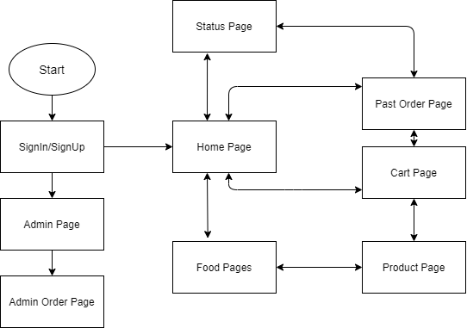

**Figure 1.1**

**Chapter 6: Screenshots**

**6.1 Screenshots of Application**

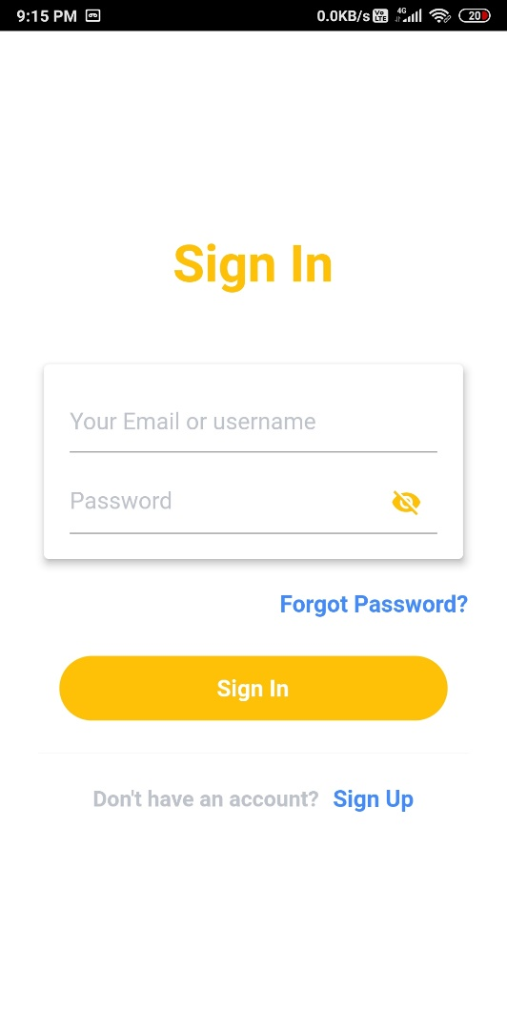 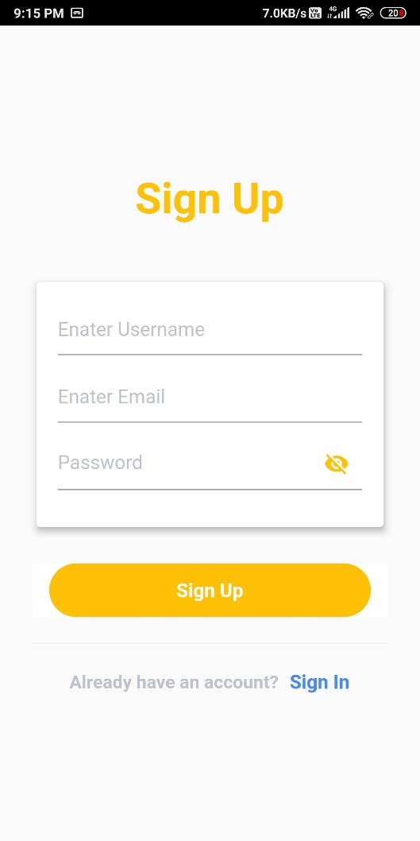

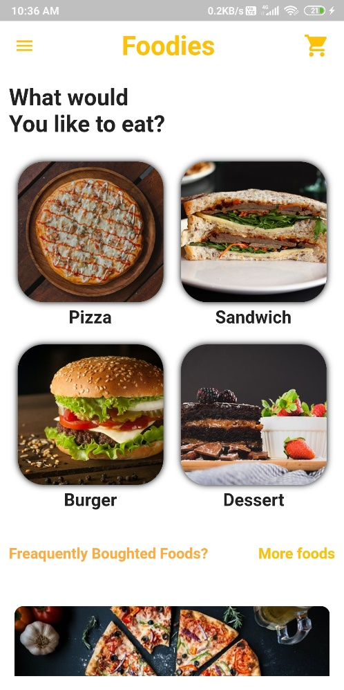 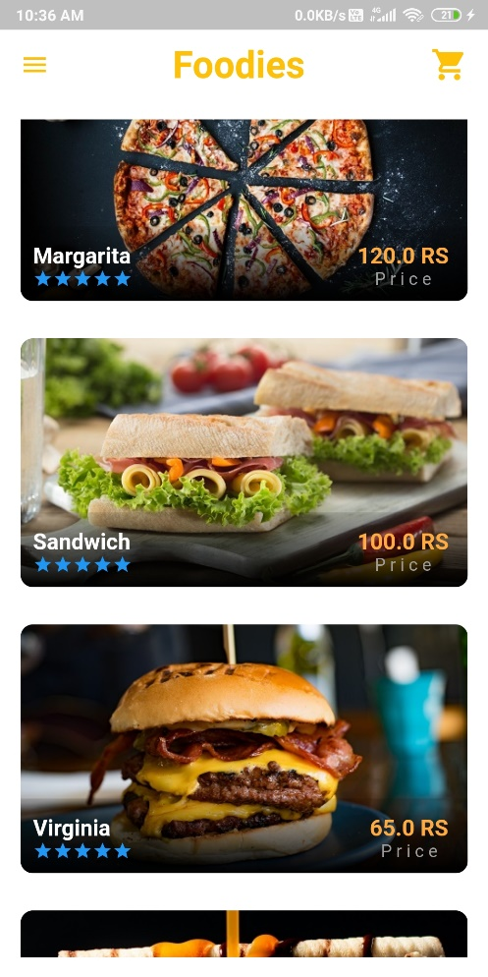

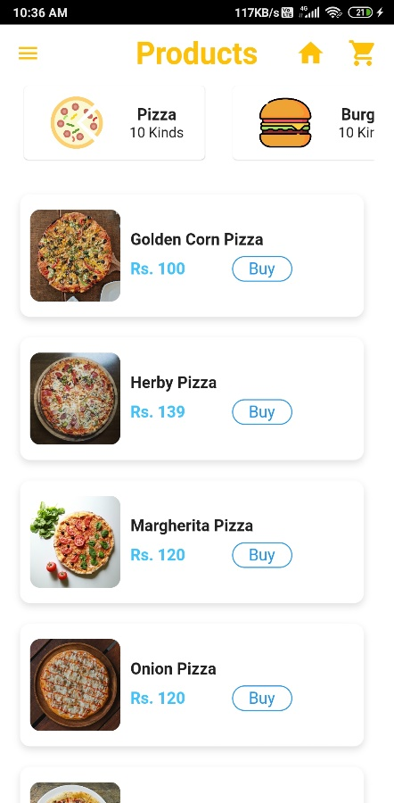 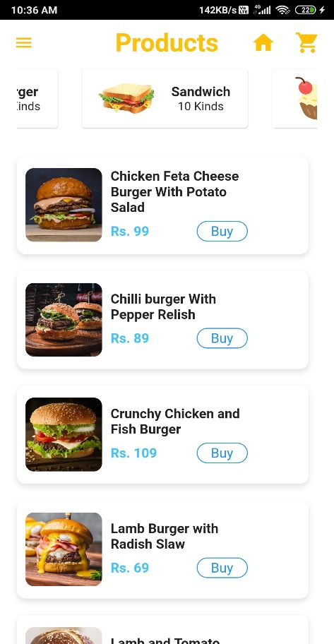

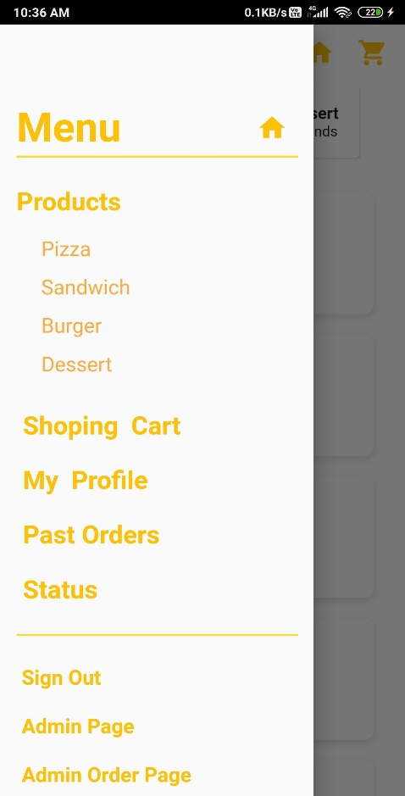 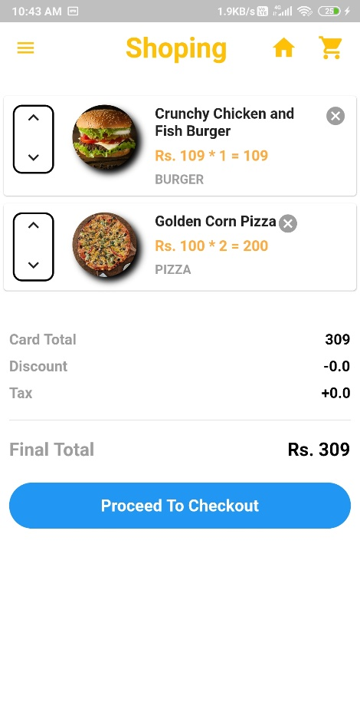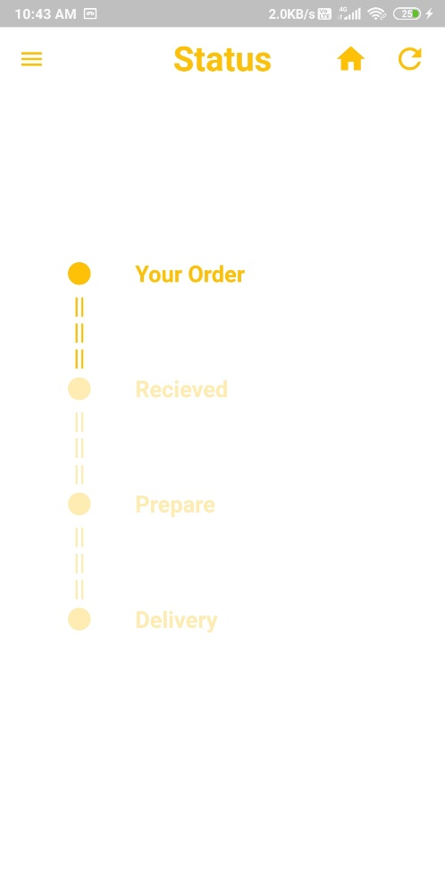 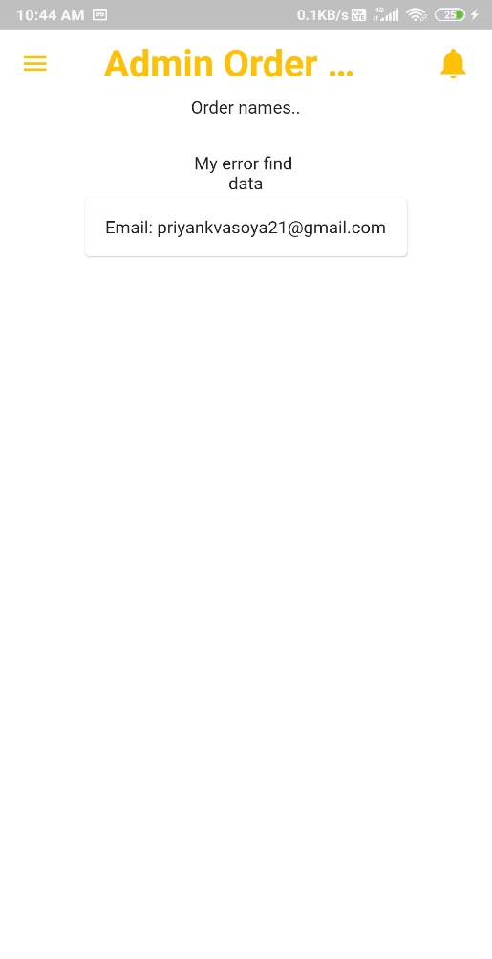

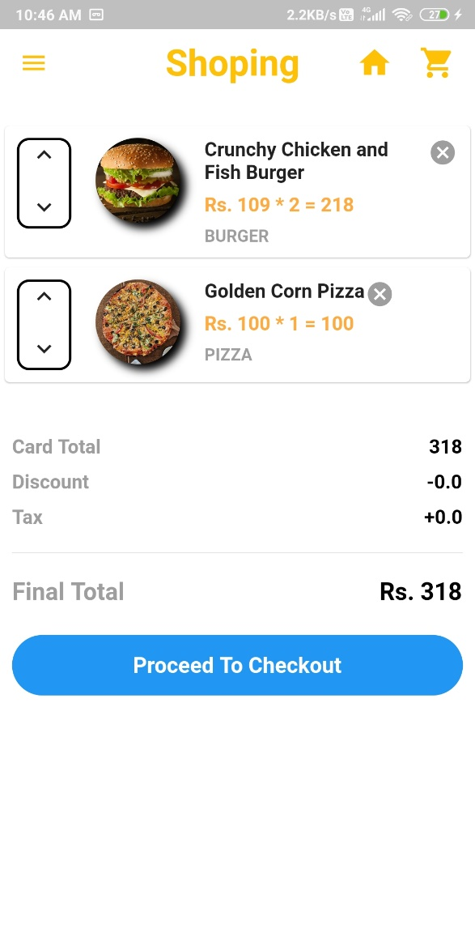 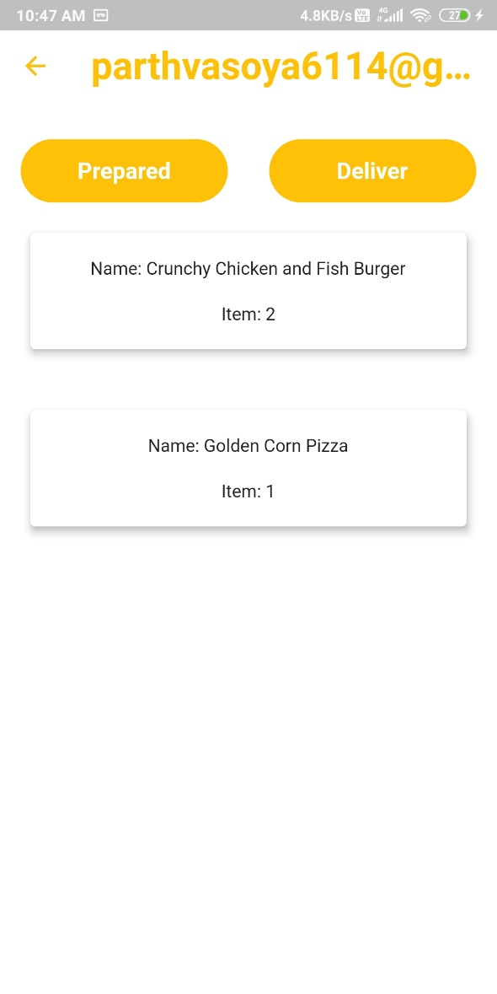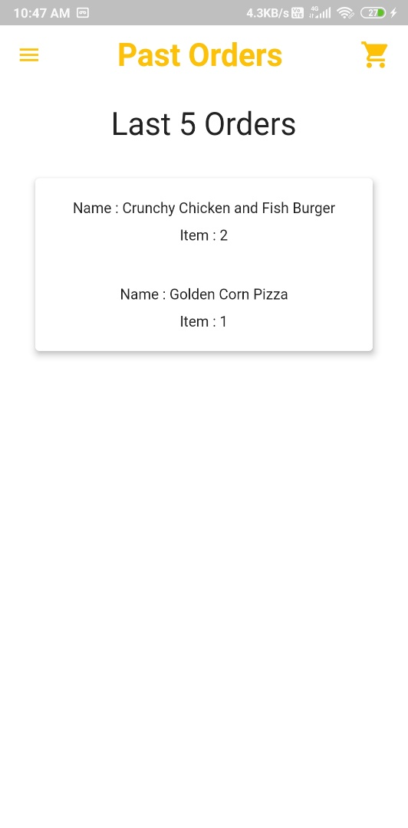

**Chapter 7: Limitations of project & Future Enhancement**

**7.1 Limitations**

* Lack of cookies – Many devices do not support storage of cookies, which are now widely used in most application to enhance user experience, facilitating the validation of data entered by the page visitor.
* Integration of payment gateway with online payment service is still pending.
* Some of the functionality still some improvement (they need to be more dynamic) like a user can only edit his profile photo or his other detail one at a time.
  1. **Future Enhancement**
* Integrating of payment gateway with banks
* More Dynamic UI
* Google Map Integration

**Chapter 8: Outcome**

**8.1 Our Application outcome**

* “Online Food App” is Able to connect local Restaurant, In which restaurant can register themselves through admin and they can add their products description,price,photo,etc.
* User create their account and they will choose different products on app and they place order check their order status and checkout.
* Admin check different order that will place by customer and admin can change user order status when order place, baked and delivered.
  1. **Expected outcome**
* We expect that users can easily use application on android as well as on iOS both.
* Restaurant can grow their business online and Increasing demand for faster and timely food delivery.

**Chapter 9: References**

* 1. **References:**
* <https://pub.dev/packages/cloud_firestore>
* <https://pub.dev/packages/firebase_auth>
* <https://pub.dev/packages/shared_preferences>
* <https://firebase.google.com/>
* <https://stackoverflow.com/questions/49764905/how-to-assign-future-to-widget-in-flutter>
* <https://stackoverflow.com/questions/51473292/flutter-project-when-run-showing-error-invalid-arguments-the-source-must-not>
* <https://flutter.dev/docs/get-started/install/windows>
* [https://console.firebase.google.com](https://console.firebase.google.com/)
* <https://flutter.dev/docs/development/tools/sdk/upgrading>
* <https://code.visualstudio.com/download>
* [https://flutter.dev](https://flutter.dev/)
* <https://stackoverflow.com/questions/tagged/flutter>