LIFE EXPECTANCY DASHBOARD REPORT



**Submitted By:** Name: Parth Vohra

Roll no.: 102016044

**Submitted To:**

Archana Singh

July 2022 – December 2022

# Dashboard:

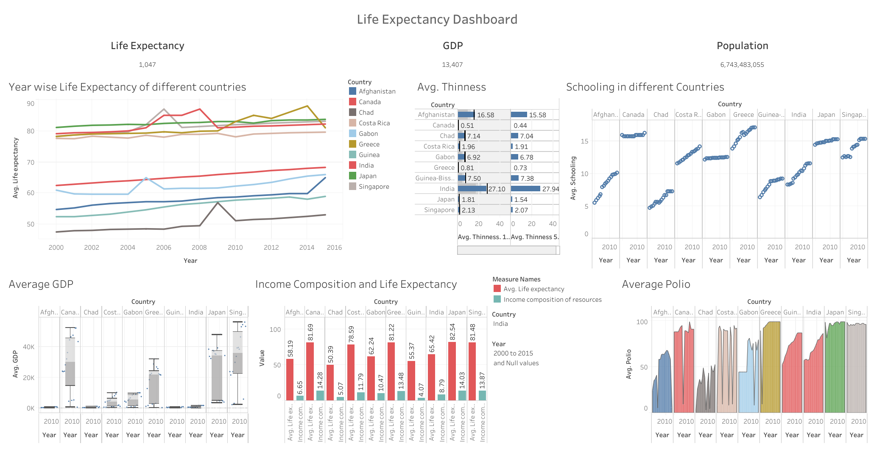

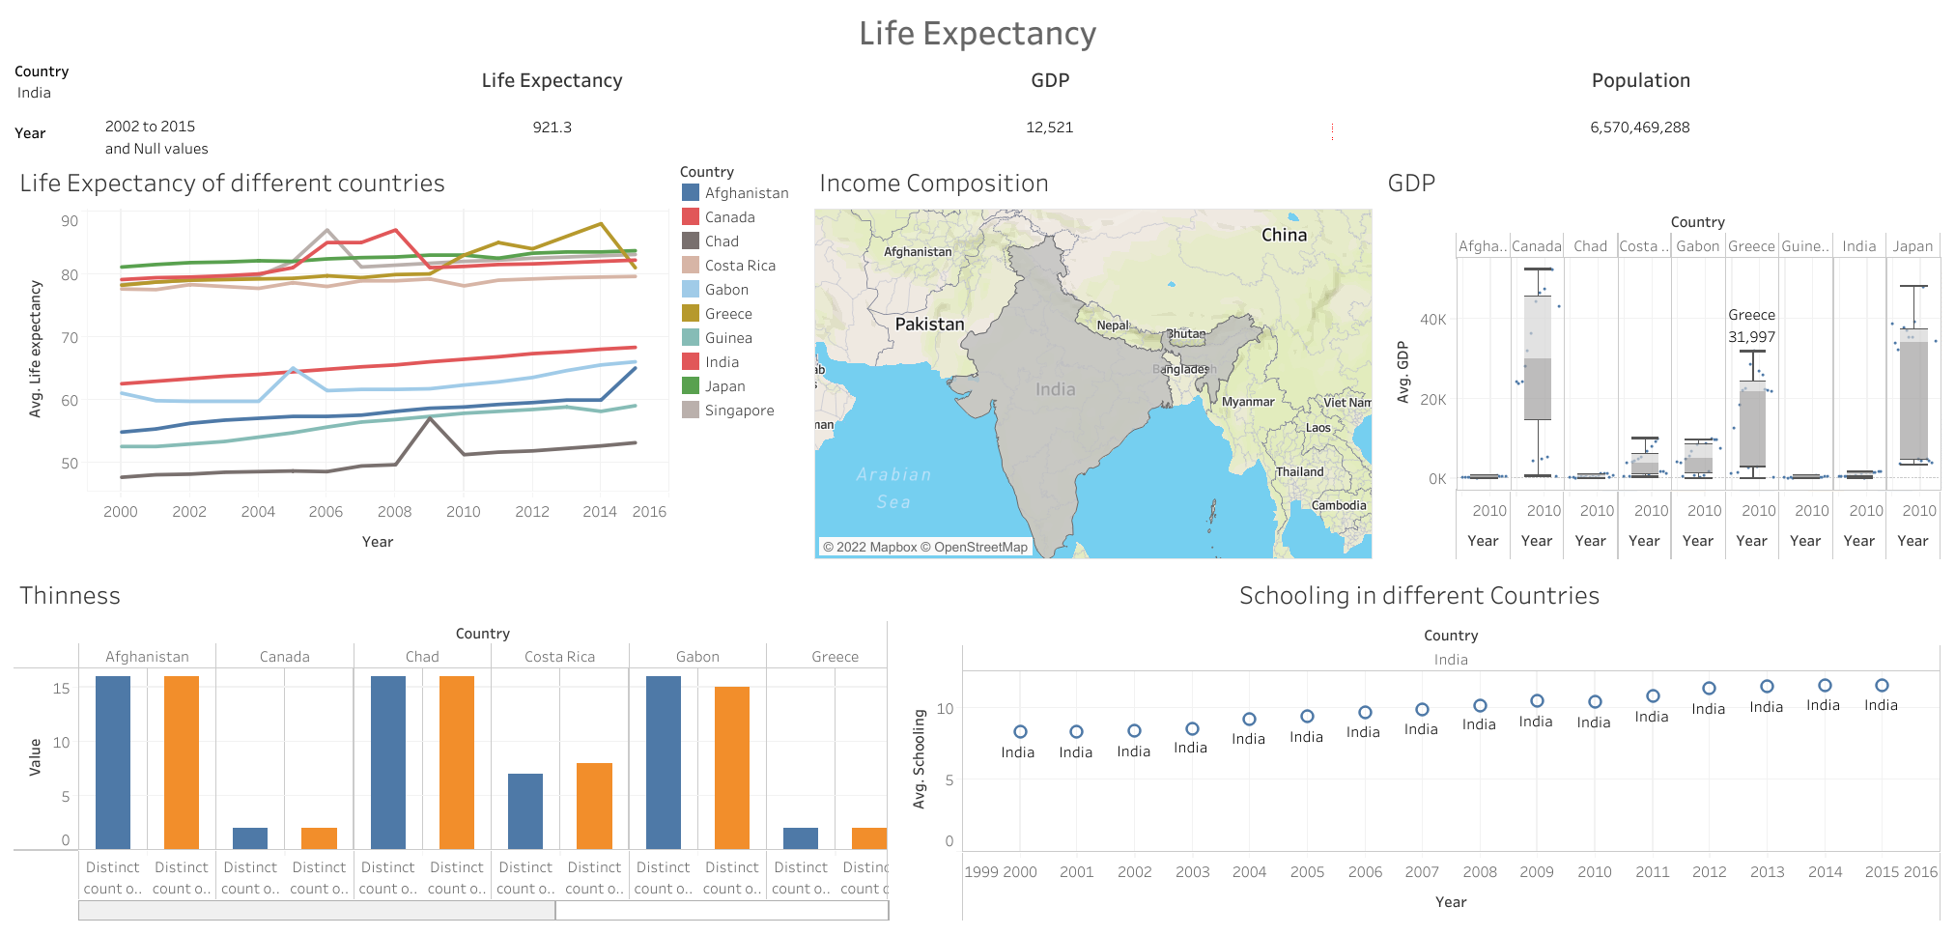

1. Dataset used:

The dataset is related to Life Expectancy ,Health factors for 193 countries.

The original dataset is with NULL values.

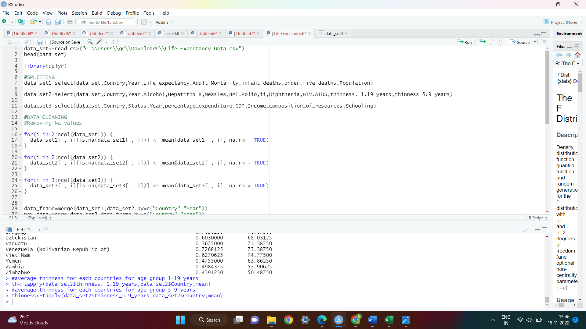

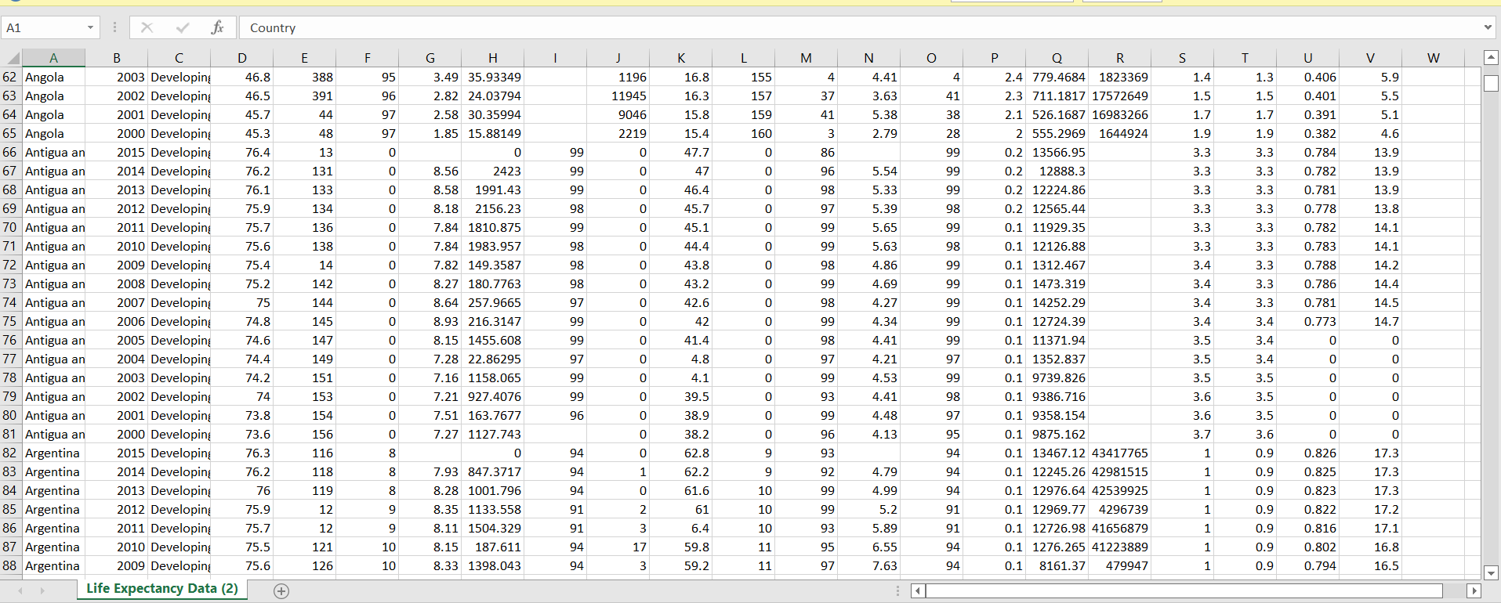

# Splitting The Dataset:

The dataset was splitted into Three Dataframes.



Outputs:

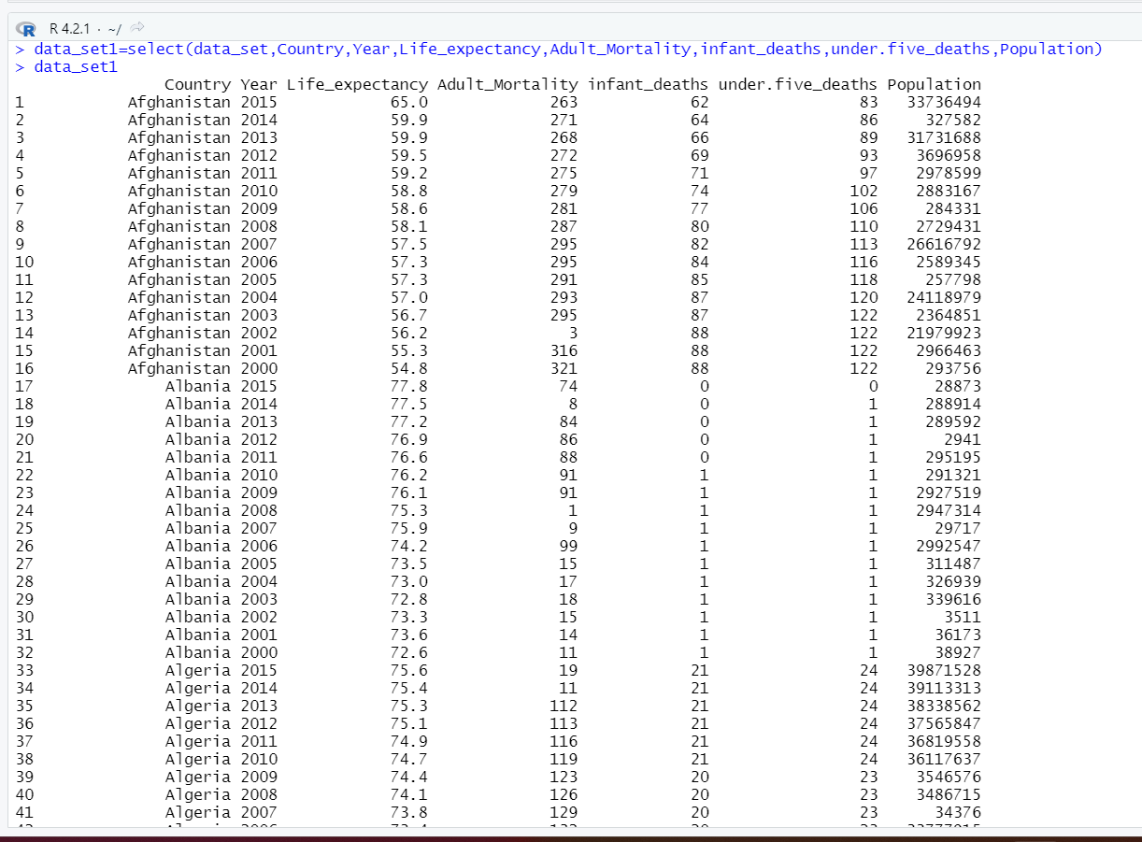

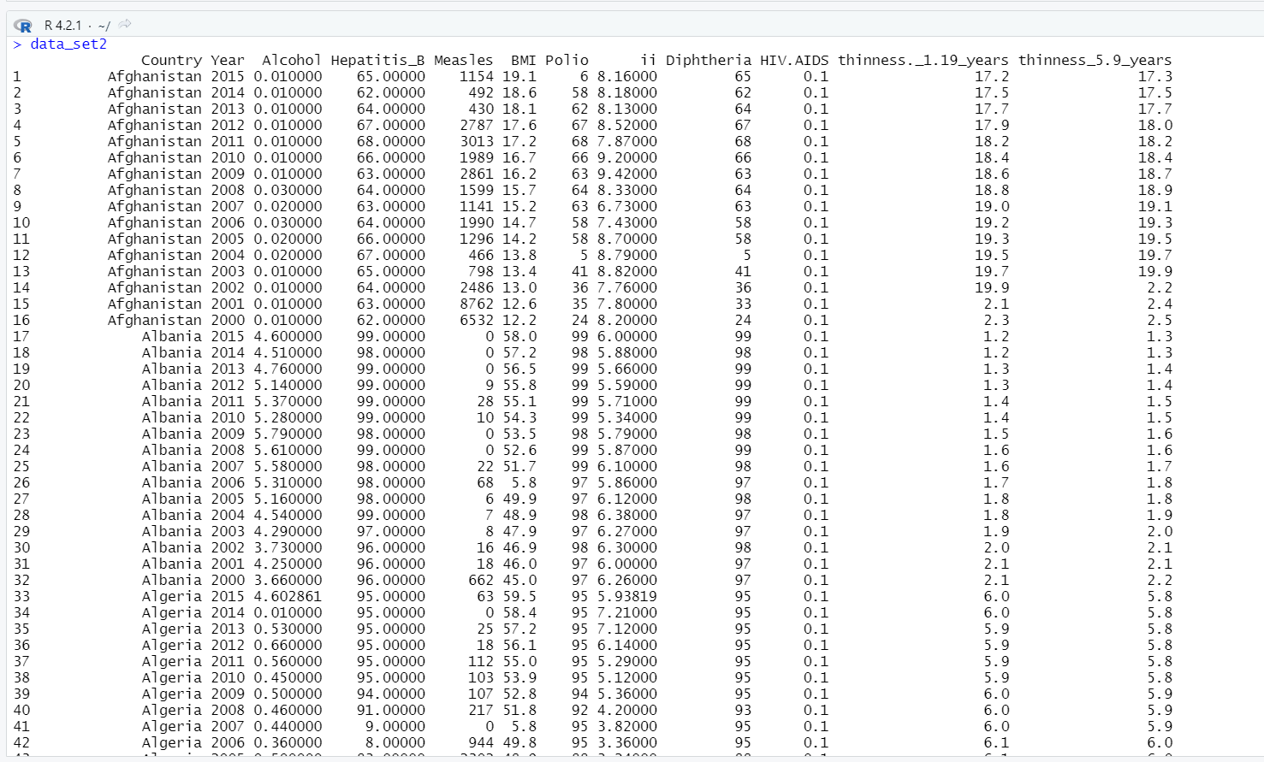

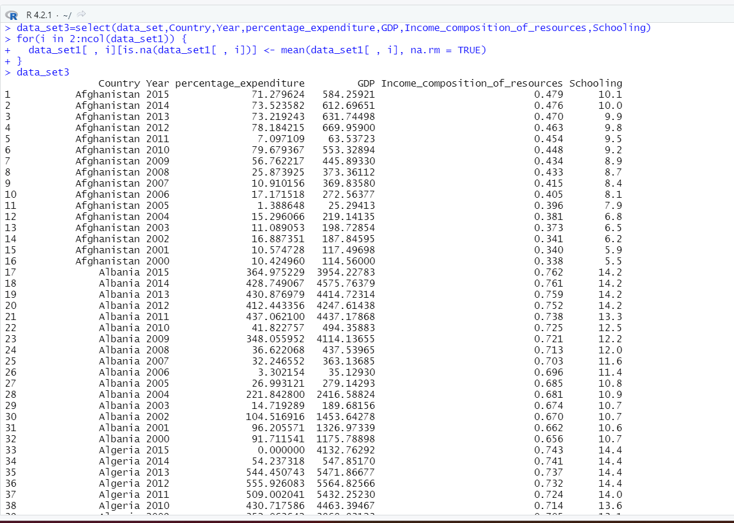

# Data Cleaning:

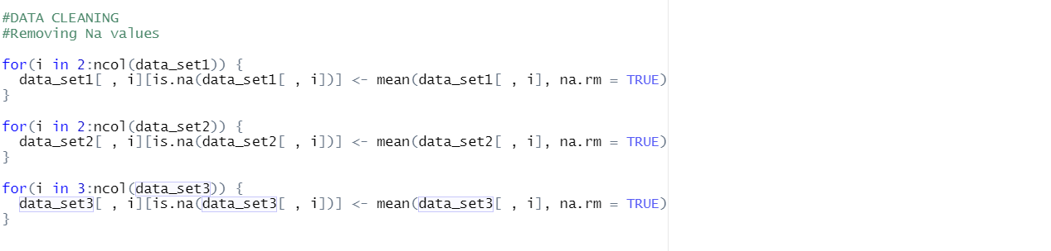

Output:

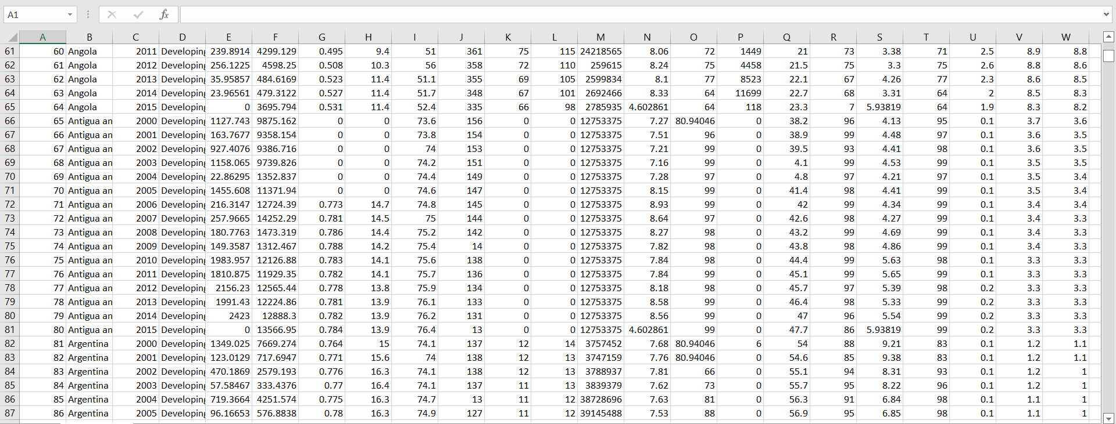

After splitting the dataset, they have been merged based on the primary keys. Code ->

Merged dataset:

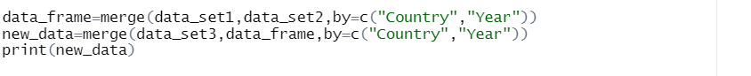

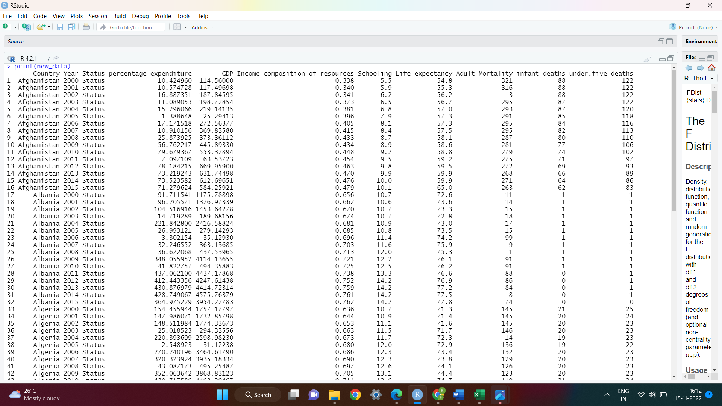

# Queries and outputs:

1. Year wise Life Expectancy of different countries



Output:

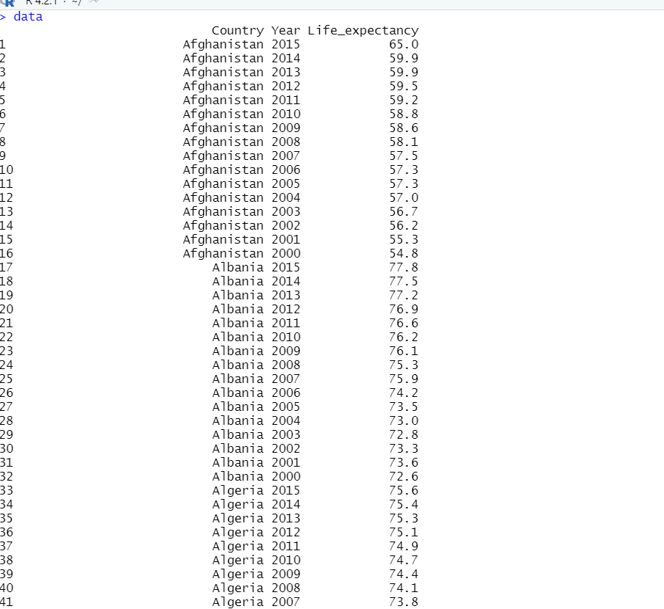

2. average thinness for each country for age group 1-19 years



Output:

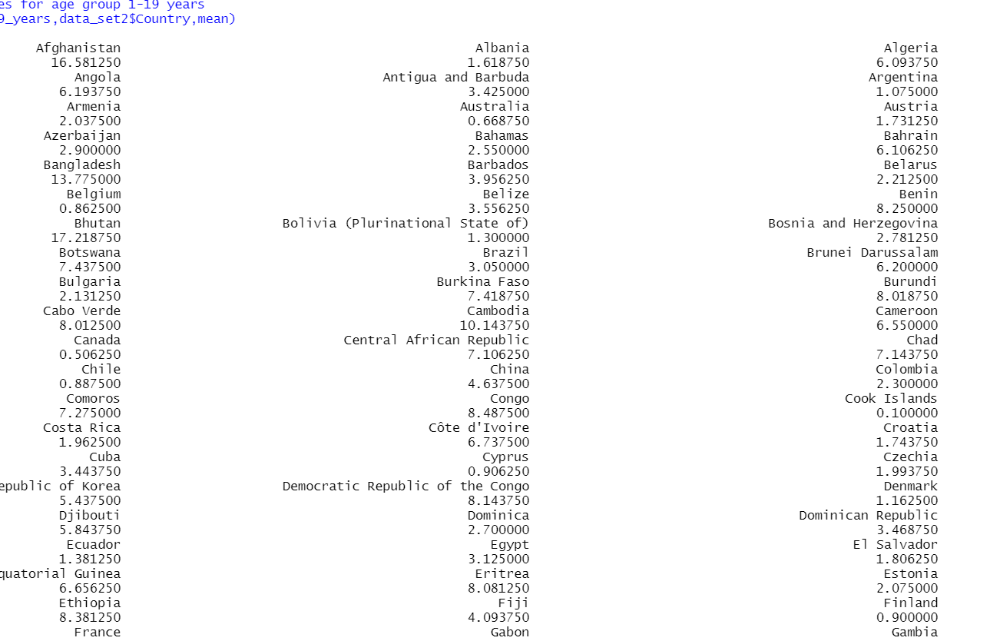

3. average thinness for each country for age group 5-9 years



Output:

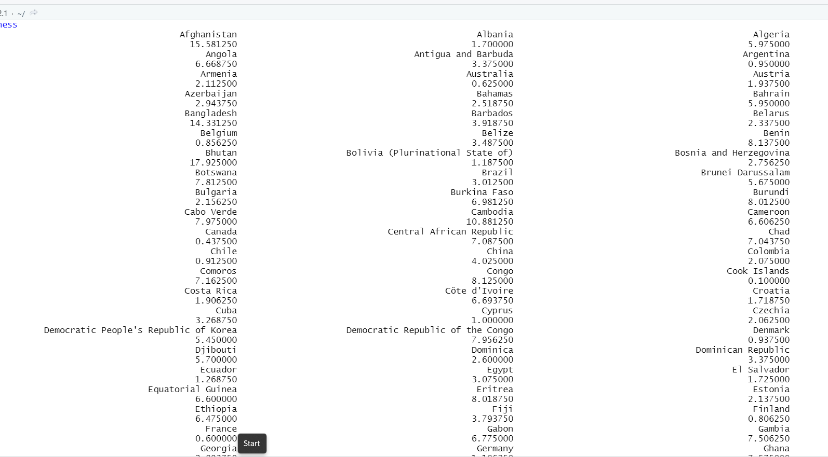

4. Average Schooling in different countries

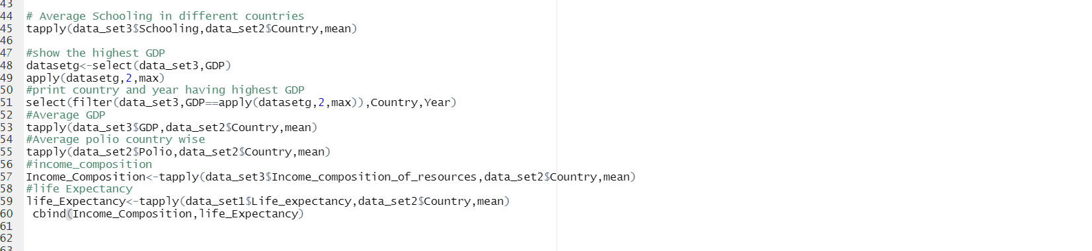

Output:

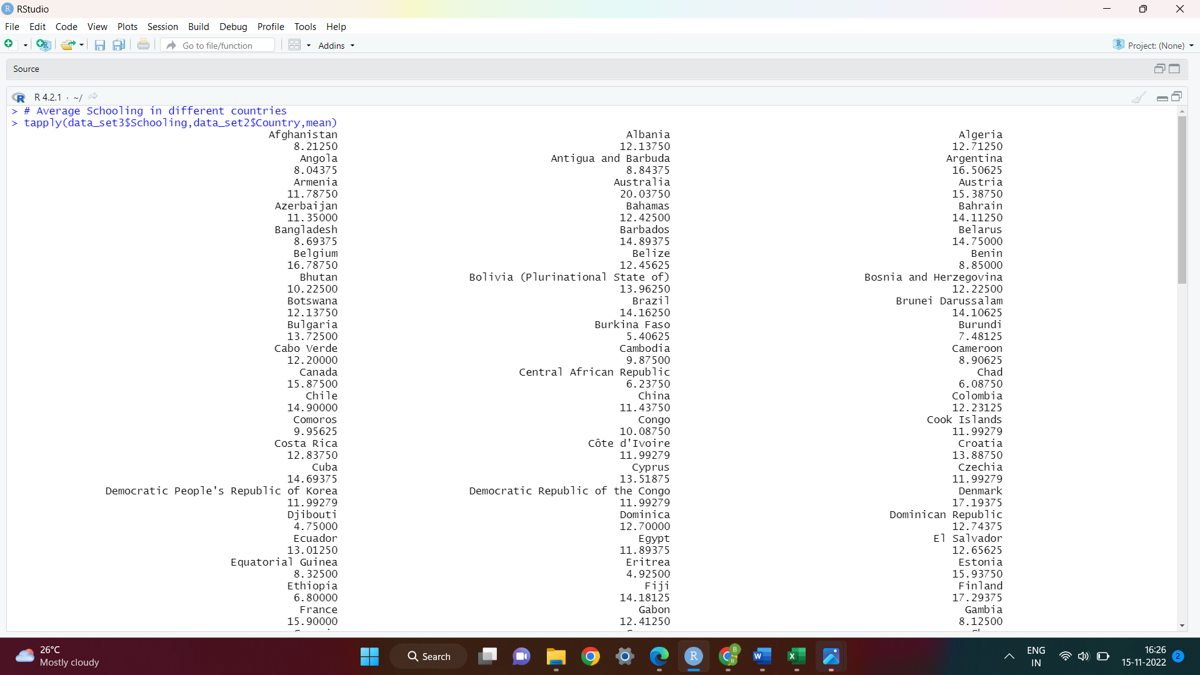

1. show the highest GDP



Output:

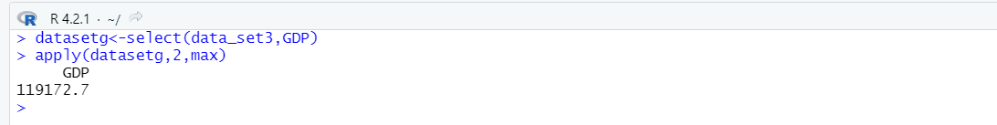

1. print country and year having highest GDP



Output:

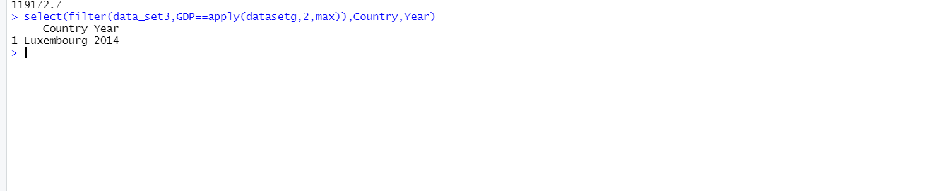

1. Average GDP



Output:

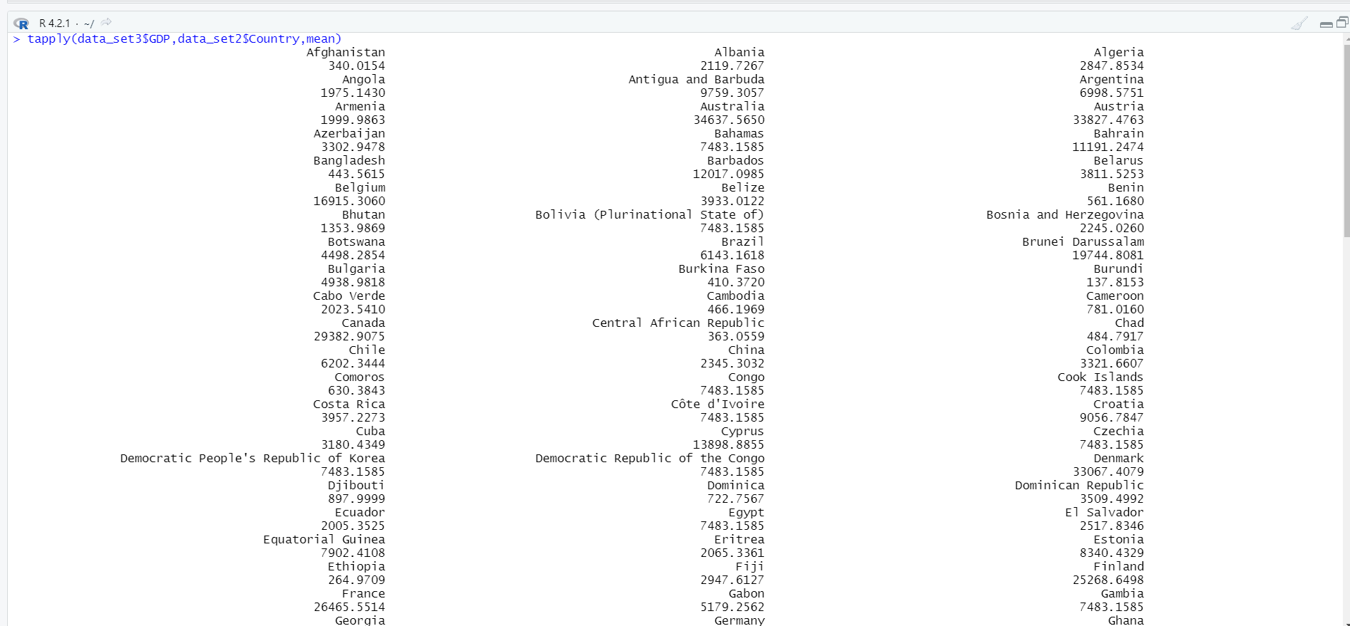

9.Average Polio



Output:

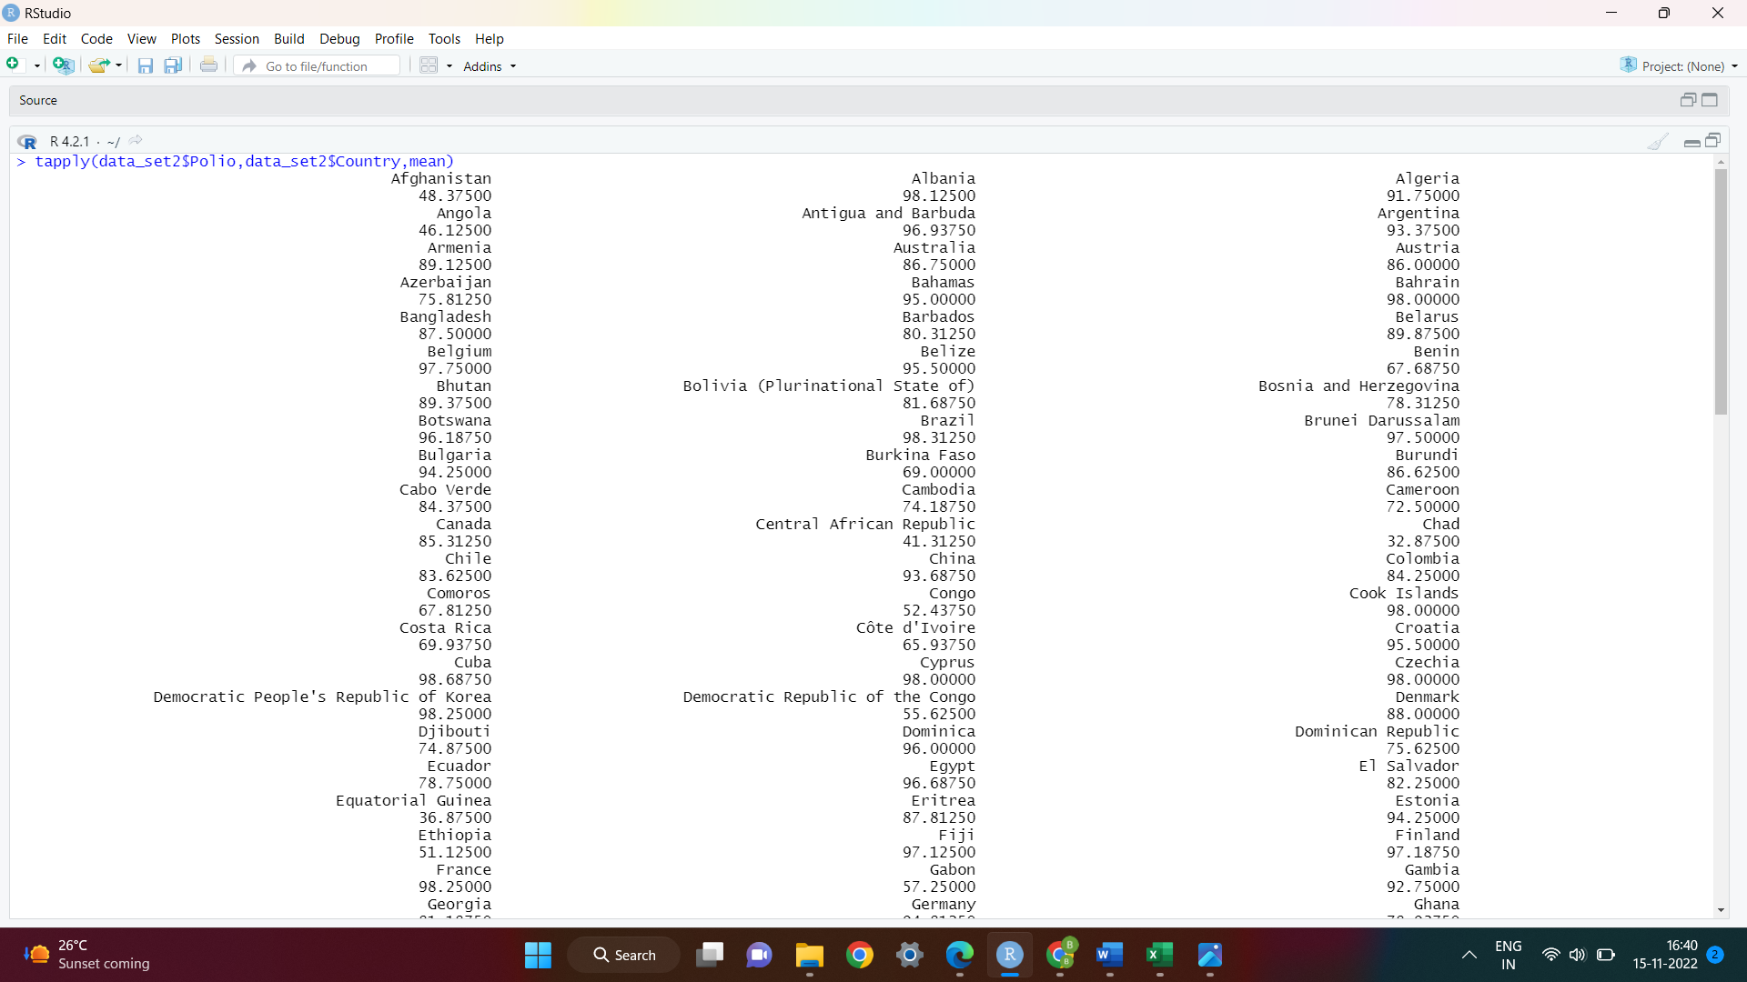

10.Average Income and Life Expectancy



