Assignment – 5

# Parth Vohra 102016044 3CS10

1. Consider that X is the time (in minutes) that a person has to wait in order to take a flight. If each flight takes off each hour X ~ U (0, 60). Find the probability that

(a) waiting time is more than 45 minutes, and

(b) waiting time lies between 20 and 30 minutes.

**Code:**

x<-punif(45, min=0, max=60,lower.tail = FALSE)

print(x)

y<-punif(30, min=0, max=60,lower.tail = TRUE)-punif(20, min=0, max=60,lower.tail = TRUE)

print(y)

**Ans:**

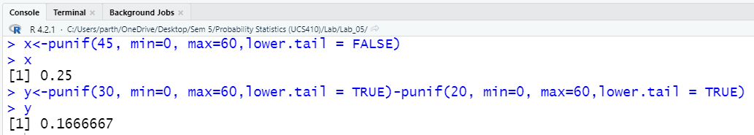

2.The time (in hours) required to repair a machine is an exponential distributed random variable with parameter λ = 1/2.

(a) Find the value of density function at x = 3.

(b) Plot the graph of exponential probability distribution for 0 ≤ x ≤ 5.

(c) Find the probability that a repair time takes at most 3 hours.

(d) Plot the graph of cumulative exponential probabilities for 0 ≤ x ≤ 5.

(e) Simulate 1000 exponential distributed random numbers with λ = ½ and plot the simulated data.

**Code:**

#Ques_2(a)

result1 <- dexp(3,rate=1/2)

result1

**Ans:**

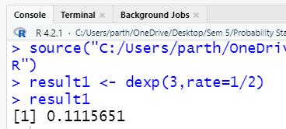

**Code:**

#Ques_2(b)

x<-seq(0,5)

y <- dexp(x,rate=1/2)

plot(x,y,type="l")

**Ans:**

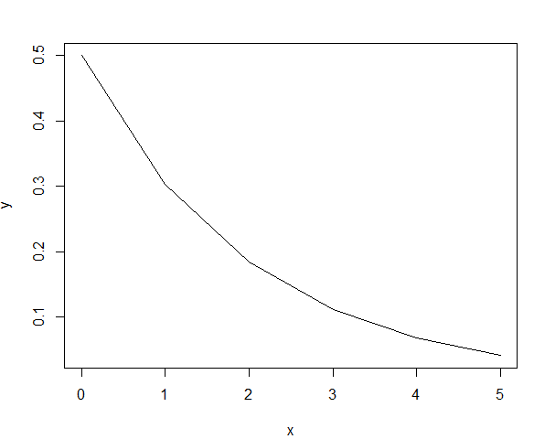

**Code:**

#Ques_2(c)

result2 <- pexp(3,rate=1/2)

result2

**Ans:**

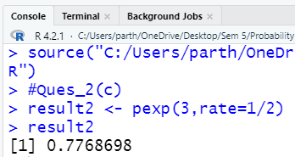

**Code:**

#Ques_2(d)

z <- pexp(x,rate=1/2)

plot(x,z,type="l")

**Ans:**

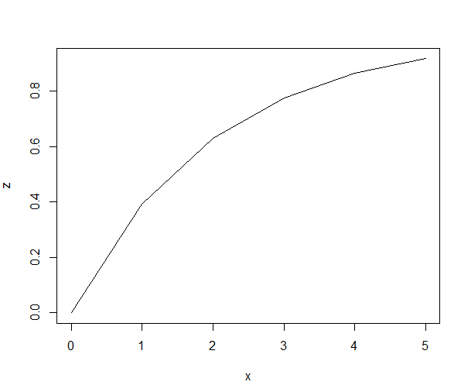

**Code:**

#Ques_2(e)

x_sim <- rexp(1000,rate=1/2)

plot(density(x_sim))

**Ans:**

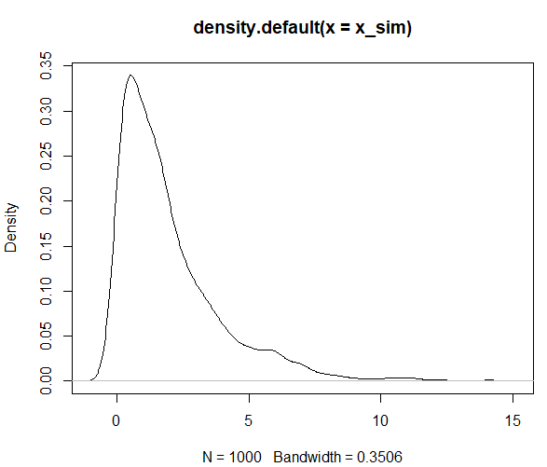

3. The lifetime of certain equipment is described by a random variable X that follows Gamma distribution with parameters α = 2 and β = 1/3.

(a) Find the probability that the lifetime of equipment is (i) 3 units of time, and (ii) at least 1 unit of time.

(b) What is the value of c, if P(X ≤ c) ≥ 0.70? (Hint: try quantile function qgamma())

**Code:**

#Ques_3(a(ii))

p<-pgamma(1,2,scale=1/3, lower.tail=FALSE)

p

**Ans:**

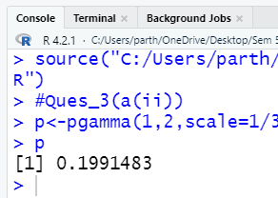

**Code:**

#Ques_3(b)

c<-qgamma(0.7,2,scale=1/3)

c

**Ans:**

