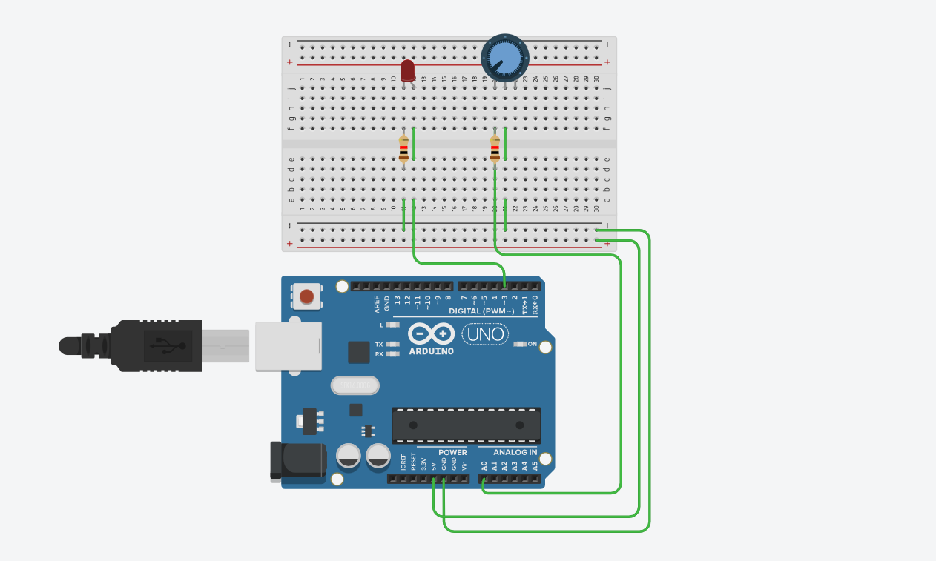
#define pinLed 3 // Define LED pin
#define pinFoto A0 // Define photoresistor pin

void setup() {
pinMode(pinLed, OUTPUT);
pinMode(pinFoto, INPUT);
}

void loop() {
int fotoValue = analogRead(pinFoto); // Read sensor (0–1023)
int ledValue = fotoValue / 4; // Convert to 0–255 range
analogWrite(pinLed, ledValue); // Adjust LED brightness
delay(100);
}

