Experiment 7
Name – Parth Wankhede PRN - 25070521159

Algorithm
Step 1: Start

Step 2: Read an integer value n from the user.

Step 3: Initialize a loop from i = n down to 1 (decreasing by 1 each time).

Step 4: For each value of i, print i number of * (stars).

Step 5: Repeat Step 4 until the loop ends (when i becomes 0).

Step 6: Stop

Flowchart:
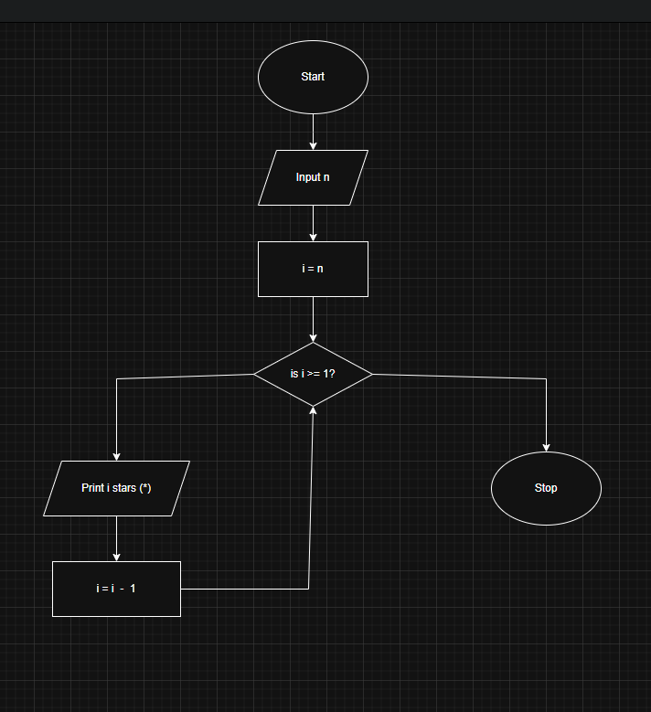

Execution:
