Curriculum Vitae
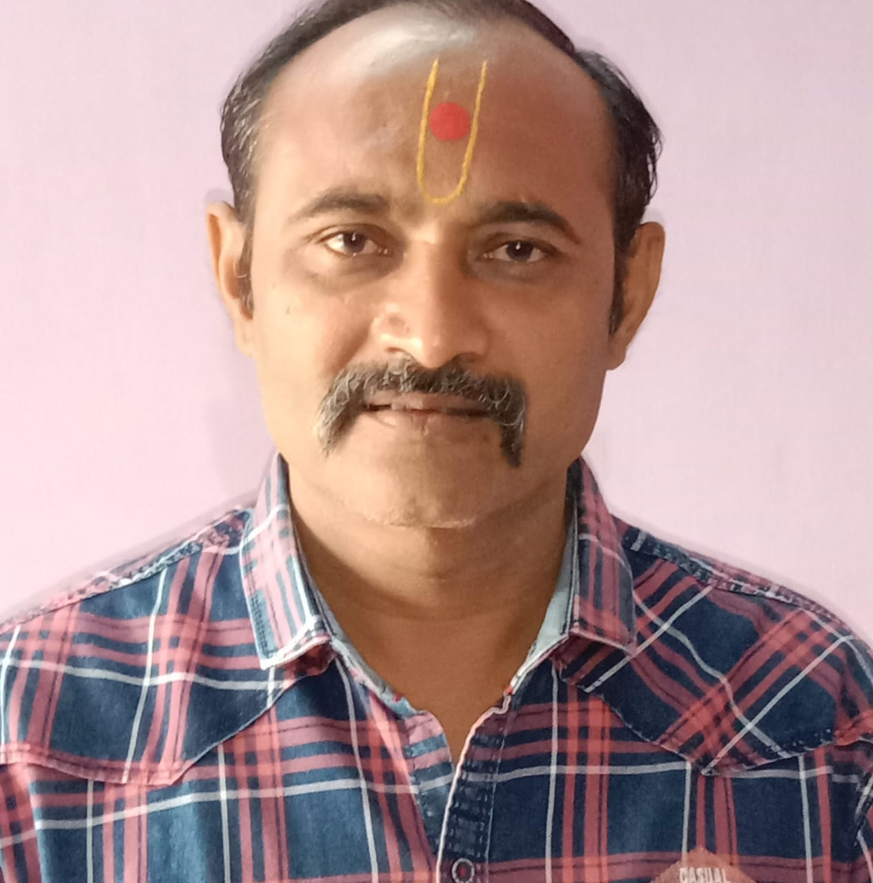
Vyas Shreekant jitendrabhai
Mob: +91 99047 31413
E-mail:– shreekantvyas1976@gmail.com

OBJECTIVE :-
Seeking a career in a challenging environment that would give me the opportunity to bring out the best in me.
EDU. QUALIFICATION :-
- 10th-passed +ITI (Fitter)
TECHNICAL QUALIFICATION:-
- ITI (Fitter)

EXPERIENCE:-
- Total 20 years of experience in general maintenance (Fitter) & store purchase.
- Worked for 4 years as General Maintenance (Fitter) executive at Deco Gold Ceramic Industries, Morbi.
- Worked for 2 years as General Maintenance Engineer at Gokul Ceramics, Morbi.
- Worked for 2 years as Sr. General Maintenance executive at Italica Ceramics, Morbi.
- Worked for 10 years as Store & Plant Purchase Manager at Simola Virified Tiles, Morbi.
- Current working at Simola Tiles Llp as Store & Plant Purchase Manager from last 2 years.
Most recent experience:
- Plant maintenance tools & components purchase.
- Maintain relationship with plant components supplier.
- Purchase process handling for plant components & tools.
- Plant tools & components stock control & management.
- Maintain partner relationship.
- Regular interaction with plant components & tools supplier.

PERSONAL DETAILS

Name - Vyas Shreekant

Father’s Name - Vyas Jitendrabhai

Sex - Male

Date of Birth - 29th August 1976

Nationality - Indian

Cellph No - 9904731413

STRENGTH
smart work, confident, self-disciplined and sincere.

PERSONAL
Basically optimistic & positive in nature with a lot of self-
confidence, flexibility and good team spirit.

Expected Salary: As per industrial standard.

DECLARATION
I hereby declare that the statement furnished above is true to the
best of my knowledge and belief.

Place :Rajkot.

Date : 21/11/2022 Your’s Faithfully,
Shreekant J. Vyas.

