CURRICULUM –VITAE

Khaja Nawaz

N0.29/1, Perembur high road 2nd Street,
Jamalia,
Chennai – 600 012
nawaztiles@yahoo.com
Cell : 9884091809

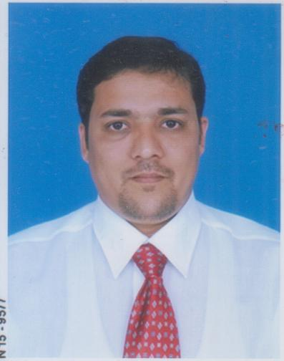

Education : B.Com
Date of Birth : 04th March 1976
Father’s name : Mr. Habeeb Nawaz.
Nationality : Indian.
Mother tongue : Urdu
Langauge Known : English Hindi Tamil
Personality : Pleasing and Hardworking

Presently Working:-

Organization : M/s. Maps Granito Pvt Ltd
Designation : Asst General Manager
Duration : From April 2017 - Present
Job Description : Heading TN market & Team
Appoint Dealers
Promote Double Charge & Full Body Slabs
To Meet Sales & Collection Targets
Handling Projects

(B)
Organization : M/s. ORIENT Bell Limited
Designation : Regional Manger
Duration : From Jan 2nd 2012 till March 2017
Job Description : Heading ORIENT Tiles Division.
Handling a team.
Maintaining a track on payments.
Make subordinates achieve their target.

Professional Achievements : Increased Wall tiles Sales from Nil to 56000smt
Opened five ORIENT Franchisee outlets

(C)

Organization : M/s. Asian Granito India Ltd,
Designation : Regional Manger
Duration : From May 2008 to Jan 1st 2012
Job Description : Heading Asian - Wall Tiles Division.
Handling a team.
Maintaining a track on payments.
Make subordinates achieve their target.

Professional Achievements : Increased Wall tiles Sales from 3000 to 48000smt
just in the first two months of joining.
Achieved the highest figures in sales in the company.
Promoted as Regional Manager
(D)

Organization : M/s. Nitco Tiles Limited
Designation : Sr. Area Manager -Sales
Duration : From November 23rd 2005 to April 30 2008
Job Description : Handling Chennai & Pondicherry Market.
Meeting Architects, Builders, Dealers, Sub-Dealers.
Visiting Projects for orders.
To Make subordinates achieve their target.

Professional Achievements : Increased Pondicherry Sales by 94%.
Increased Chennai Sales by 42%.
Increased sales by appointed new dealers and
Adding sub- dealers.
Promoted from Area Manager to Sr. Area Manger

(E)

Organization : M/s. Intex Designer Tiles Pvt. Ltd.,
(Manufacturer, DURACRETE TILES.)
Designation : Senior Sales Officer
Duration : 3yrs 5 mnth .May 13th 2000 to Nov 15th 2005
Job Description : Meeting Architects & Individual Clients for orders.
Visiting Projects
To attend to complaints made by the customer
Collecting payments from Dealers

Professional Achievements : Increased Sales by introducing new architects.
Appointed Dealers and sub- dealers by breaking competitor’s Dealership.
Achieved orders by higher price than competitor.

CAREER OBJECTIVES & PLAN

Short Term > to gain considerable experience in a challenging environment.
Long Term > to head the department in an Industry.

REFERENCE. Mr. F. Sajid
Managing Director,
M/s. Shanoo Leather Garments Pvt. Ltd.
4/4, Sheik Mohideen Subdar Street,
Dasahmakkan , Chennai .

Mr. Amir
Managing Director,
M/s. IZA Exports
Perimet, Chennai.

Khaja Nawaz

