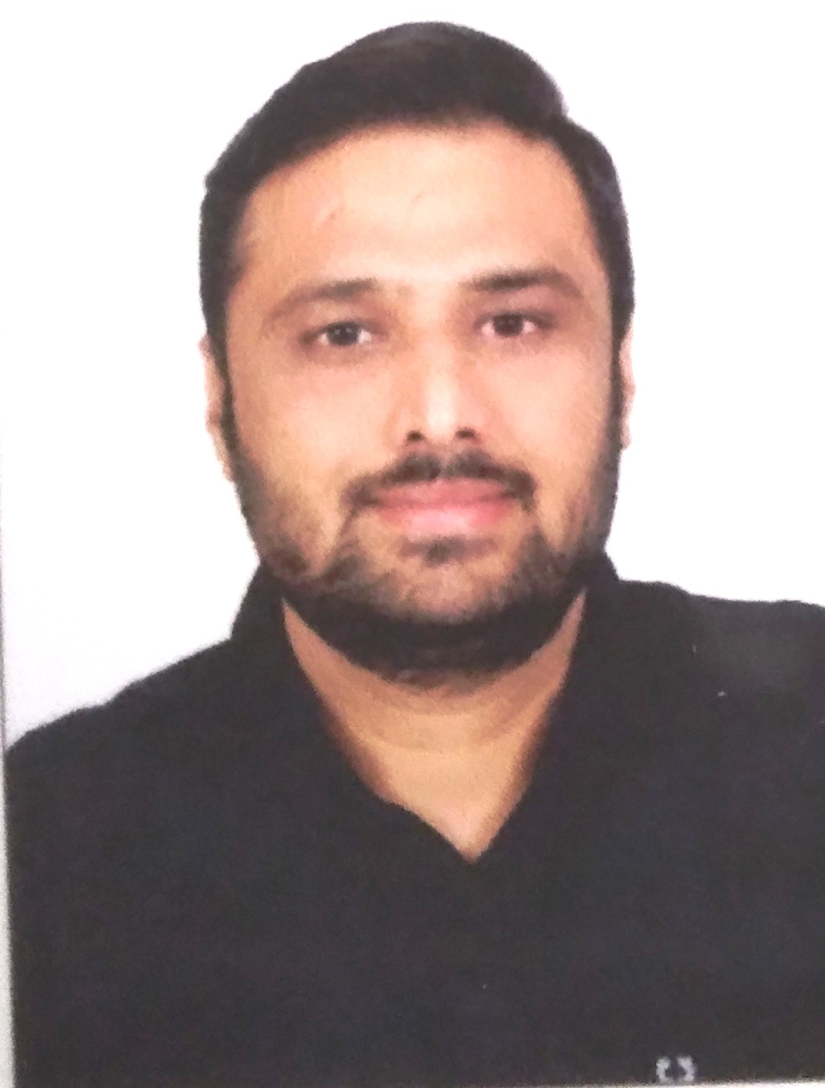 | HARDEEK YADAVH  Flat No :- A-603  Sagar Samrat  Near Shivrajani,  Radio Mirchi Tower Road,  Satellite  Ahmadabad - 380051  Cell : +91 9099056847  email : hardik.yadav87@gmail.com
Career objective :
To contribute the organization with fullest potential.

Educational Qualifications:
- BA from Bhavnagar University
- SSC (std-10) Pass with First Class
- HSC (std-12) Pass
- I.T & E.S.M From Bhavnagar

WORK EXPERIENCE:

Esense learning pvt.ltd.1/1/2012 till Date.

Joined Esense learning pvt.ltd (Navneet Education India ltd.)As a Territory Sales Manager.
- I have covering All Saurashtra and Kutch and Half Gujarat.
- My job profile is to handling team and sale educational product and . hardware product.
- I handling direct sales and also Primary Secondary Market.
- Taking Care of existing and new dealers
- Also taking care of Order execution and on time payment collection
- Liquidate slow moving and non moving product with high contribution
- Regular Follow Up and type with new schemes and company awareness with dealer
- Identifying gap between Non performer and Non active dealers and putting him to on channel performers.
- Making Healthy relation with end-users by services
- Also working in a government, NGO, and CSR order.
- Pidilite Industry CSR Project.
- Jaquar Foundation CSR Project.
- Adani Foundation CSR Project.
- Amreli Rural school Government Project.
- GMDC School Project.
- Kutch Government School Project.
- Ajanta Orpat CSR project .

Since 1/12/2015 I have been Promoted as a Area sales manager to till Date.
- And I have covering All Saurashtra and kutchh and half Gujarat.
Achievements:
- Highest contribution product sale in west zone 2012 to till date
- Got awarded for high performers in Gujarat every year.
- Best increments and incentive Achievers in Gujarat every year.
- Government order

CE INFO SYSTEMS (P) LTD:Dec-2009 toDec-2011.
- My job profile is to sell GPS NAVIGATION SYATEM to Primary and Secondary.
- Was handling costal area of Saurashtra.
- Maintaining relation between dealers and end users
- Branding And Marketing done on time
- On time MIS report to The Company
- Taking lead from reference and converted in to sale

MAHER ENTERPRIZES: From Aug-2008to Nov-2009.
- My job profile is to sell Medimix Soap to retailer and stockiest.
- Was Handling three district and 25 dealers
- On time report to management regarding sale
- Collecting Money and Sale from dealers
- Servicing dealer regarding any issue of Product.
- Assign new territory for healthy business of Distributors
- Product display at dealer shop to generate more business

EUREKA FORBES LTD. – (Bhavnagar) April-2006 to July-2008.
- Joined Eureka Forbes Ltd In April 2006 As Sales Representative
- Was handling B2B market in Bhavnagar Territory
- Making 40 house call in a day and identifying
- Per day three Demonstrate regarding product and close the sale from identifying customer
- Upgraded as A Confirm Customer Sales Specialist and Promoted As Senior Customer Representative.
- Leading three Representatives under my self & motivated them and took business from them.
.

PERSONAL PARTICULARS:
Physical detail :  Date of Birth : 15 Oct ,1987  Sex : Male  Martial Status : married  Category : OBC  Height : 165 cm  Weight : 81 Kg  Nationality : Indian  Religion : Hinduism | Family Background :  Father : Government Employ.  Mother : House wife  Wife : House wife  Brother :Working In Vodafone

languages KNOWN:
1. Gujarati (Mother tongue)
2. Hindi
3. English

COMPUTER AWARNESS:
- Internet surfing and e-mail  - Dos  - MS – Office | - Auto Cad  - Tally  - Photo-shop

Psychographics Details:

Personal Value : Hard work, Sincerity, Self confidence
Attitude : Where there is a will, there is a way.
Hobbies : Music, Sports, Journey.

Declarations: Here I declared that above all information is correct.

HARDEEK YADAVH
09099056847

