RESUME
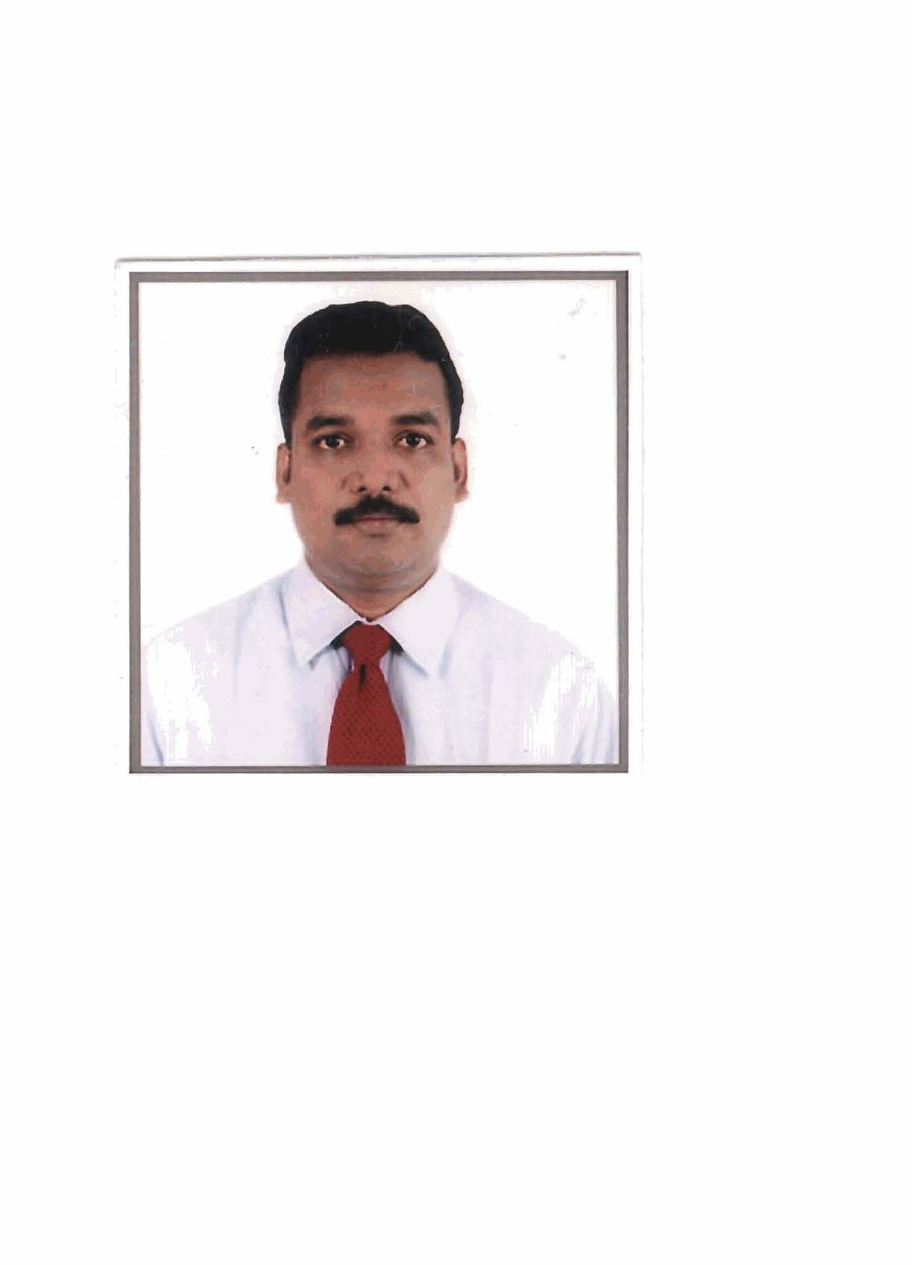
DINECHE COUMAR.J

Career Objective:
To Pursue a career with a Progressive organization playing an

Active role in management tasks and helping in achieving organizational goals.

Educational Qualification: B.Tech.,MBA

Specialization : Civil Engineering

Year of Passing : May 2000

Class : First Class

College : Pondicherry Engineering College

University : Pondicherry University

Post Graduation:

Specialization : Marketing Management

Year of Passing : May 2005

University : Annamalai University

Computer Knowledge:

Languages : C, C++, Java, HTML, DHTML, JSP, Servlets, JDBC,

Scripting Languages : V.B Script, Java Script

Database : Oracle 8i, JDBC, ASP

Operating System : MS-Dos, Windows 2000

Current Job: Currently working as Sales Head- in Paschal Form works (India ) Pvt Ltd
( German MNC) leaders in scaffolding and Form works.

Responsibilities:

1. Regular updates to the management on the business trends and actions plans for India.

2. Responsible for overall sales of the scaffolding and Form works Division for the branch.

3. Market survey and establishing new branch offices at potential places.

4. Ensuring maximum ROI of the branch.

5. Market intelligence and developing Strategies.

6. Order forecasting, planning and budgeting for the branches.

7. Optimisation of manpower and motivating the team.

8. Price positioning of the product, coordinating with the production department ensuring

Liquidity as per the schedule mutually accepted.
.
9. Brand promotion and increasing the brand equity of the product.

10. Conducting seminars to engineers and contractors on a regular basis.

11. Motivating and training second level managers.

12. Ensuring the customer satisfaction and find innovative methods for servicing them.

13. Ensuring max output form Channel partners.

14. Maintaining relationship with corporate companies.

15. Ensuring collections on time and reducing the old outstanding.

Major Project Won In India

1.KNR CONSTRUCTION

2.TATA PROJECTS

3.GODREJ INFRA

4.APARNA CONSTRUCTION

5.NAVAYUGA CONST

6.CDS

7.SHAPOORJI AND POOLANJI

8.DELEEP INFRA

9.NCC CONSTRUCTIONS

10.MEGA CONSTRUCTION

11.VISWASAMUDRA CONST

12.HCC

Major Project Won In Middle East

1. SATORP-(Saudi Total refinery Project)

2. SADARA- (Saudi Dow refinery Project)

3. WASIT REFINERY PROJECT

4. FADHELLI POWER PLANT

5. MADEN ALUMINIUM REFINERY PROJECT

6. JALMUDHA HOUSING PROJECT

7. SABIC HOUSING PROJECT

8. ARAMCO AJAL HOUSING PROJECT

9. MADEN HOUSING PROJECT

10. MADEN AMMONIUM PROJECT

11. JIZAN REFINARY PROJECT

SCAFFOLDING/FORMWORK SYSTEM EXPERIENCE:

1. CUP LOCK SYSYTEM

2. KWIK STAGE SYSTEM

3. RING LOCK SYSTEM

4. TUBES AND COUPLER SYSTEM

5. SOLDIER FORM WORK SYSTEM

6. ISCHE BECK FORM WORK SYSTEM

7. MEVA FORM WORK SYSTEM

8. HYUNDAI ALUMINIUM WORK SYTEM

9. COSMA FORM WORK SYSTEM

10.PASCHAL FORMWORK

Previous job experience:

1.Worked as Sales Manager- for SSF- (Building Materials Division of

XENEL-ABT GROUP) in SAUDI ARABIA

Responsibilities:

1. Regular updates to the management on the business trends and actions plans.

2. Responsible for overall sales of the scaffolding Division for the branch.

3. Market survey and establishing new branch offices at potential places.

4. Ensuring maximum ROI of the branch.

5. Market intelligence and developing Strategies.

6. Order forecasting, planning and budgeting for the branches.

7. Optimization of manpower and motivating the team.

8. Price positioning of the product, coordinating with the production department ensuring

Liquidity as per the schedule mutually accepted.
.
9. Brand promotion and increasing the brand equity of the product.

10. Conducting seminars to engineers and contractors on a regular basis.

11. Motivating and training second level managers.

12. Ensuring the customer satisfaction and find innovative methods for servicing them.

13. Ensuring max output form Channel partners.

14. Maintaining relationship with corporate companies.

15. Ensuring collections on time and reducing the old outstanding.

2. Worked as Sales Head-Construction Equipments for

HYUNDAI EAST AFRICA LTD in TANZANIA (East Africa).

Responsibilities:

1. Responsible for overall sales of the construction Equipment division.

2. Preparing sales plan and ensuring the achievements.

3. Market trend analysis and formulating new strategies.

4. New product development.

5. Planning and implementation of Brand Building activities.

6. Planning and Budgeting for the Department.

7. Price positioning of the product.

8. Ensuring max ROI for the company..

9. Optimisation Of man power and minimizing of cost.

10. Market survey and identifying potential places.

11. Motivating and training second level managers.

12. Ensuring the customer satisfaction and find innovative methods for servicing them.

13. Ensuring max output form Channel partners.

14. Responsible for the smooth function of the C & F department.

15. Identifying potential places for opening retail outlets.

3. Senior manager Marketing - Construction Division for Ameya
Dye chem. Pvt.ltd (India).

Responsibilities:

1. Responsible for all India sales of the division.

2. Planning and budgeting for the year.

3. New product development.

4. Competitor analysis of the product.

5. Developing and implementation of Strategy for the product.

6. Price positioning.

7. Pilot running of the product in a particular geography.

8. Finding the gaps and derive solutions.

9. Planning and implementation of brand promotional activities.

10. Tracking the progress and feed back from customers.

11. Market Intelligence and Competitor Activities.

12. Optimisation Of man power and minimizing of cost.

13. Market survey and identifying potential places.

14. Motivating and training second level managers.

15. Ensuring max ROI to the company.

4. MANAGER –Retail Steel Business for ESSAR STEELS LTD in Tamil Nadu (INDIA)

Responsibilities:

1. Opening of new Retail outlets in potential places there by creating more

Revenue to the company.

2. Achieving Business targets and ensuring smooth running of each Retail

Outlets.

3. Planning and budgeting for each outlet.

4. Motivating and Training of sales people.

5. Coordinating with factory and Handling logistics issues.

6. Ensuring Maximum ROI from each retail outlet.

7. Responsible for customer relation management.

8. Market Intelligence and Competitor Activities.

9. Optimisation Of man power and minimizing of cost.

10. Conducting Brand promotional activities.

11. Market survey and identifying potential places.

5. ASSISTANT MANAGER- Key Accounts Marketing in ADITHYA BIRLA GROUP handling corporate sales for Karnataka and Goa state (INDIA).

Responsibilities:

1. As a Team leader for two states planning, achieving sales target and motivating sales team.

2. Meeting corporate clients, engineers and architects, getting business for the company.

3. Planning and conducting brand promotional activities and technical meets.

4. Responsible for customer relationship management and project relation ship management.

5. Market intelligence on competitor activities.

6. As a technical person handling customer complaints and guiding the
Customer service executives.

7. Handling logistics and C&F issues.

8. Contributing maximum realization to the company.

9. Minimising cost and optimization of man power.

6. Area in Charge-The Associated cement companies ltd (INDIA)

Responsibilities:

1. Meeting engineers and architects, getting business for the company.

2. Planning and conducting brand promotional activities in developed and under developed markets.

3. Expanding network in under represented areas.

4. As a technical person handling customer complaints and guiding the customer service executives.

5. Handling logistics and C&F issues.

6. Contributing maximum realization to the company.

Training Attended:

1. Proffesional selling skills-Archieve Global India.

2. Communication and Analytical Skills–Dale Carnagie.

3. How to achieve corporate goals-Boston consultancy.

4. Workshop on customer handling-NIS-Bangalore.

5. Marketing and Management skills – Liba – Chennai.

6. Handling customer complaints-Paradigm Power.

Languages Known: English, Tamil, Hindi, Malayalam

French and Japanese.

Extra-Curricular Activities:

1. As a Basket ball Player represented state 3 times in national level tournaments.

2. Playing Badminton and table tennis.

3. Playing Guitar and Keyboard.

Personal Data:

Name : DINECHE COUMAR.J

Fathers Name : V.JeyaKumar

Date of Birth : 25-10-1977

Sex : Male

Nationality : Indian

Marital Status : Married

Permanent Address : No.25, Nainiappa Pillai Street,

Pondicherry-605 001.

Telephone Number (India)) : 0413-2228269

Mobile Number (Saudi Arabia) : + 916385561533

Passport Number : B2778265

Address for Communication : No.25, Nainiappa Pillai Street,

Pondicherry-605 001.

INDIA

E-mail : dineshcoumar@rediffmail.com

Yours Truly,

DINECHE COUMAR, J

