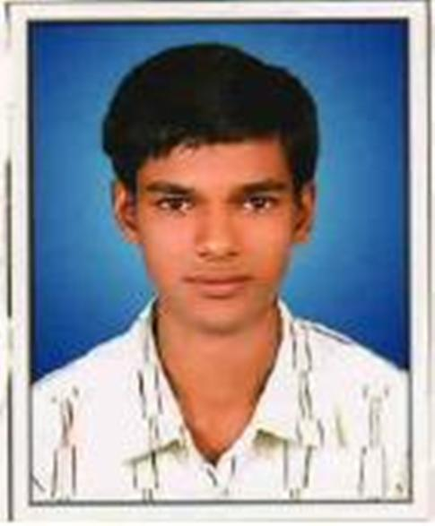
CIRRICULUM VITAE

PANKAJ KUMAR SETHIYA
Subhash Colony
Ramganjmandi  326519
Distt. - Kota (Rajasthan)
E-mail : pankaj.sethiya2@gmail.com
Cell: 09214484123
__________________________________________________________

CAREER OBJECTIVE

Learn from every experience, understanding and implementing the feasible and best solutions in my work. Achievement of personal and professional goals in my final objective in life.

Working Experience:-

1) Cheer Sagar, Jaipur (Raj.)
(A Garment mfg. & Export Company)
Designation:- Assistant (Fabric Deptt.)
Duration :- Jan. 2019 to Jan. 2020

2) PBM Polytex Ltd. , Petlad ( Gujarat)
(A Unit of Patodia Eurotex Group)
Designation:- Office Assistant (Cotton/Purchase Deptt.)
Duration :- Nov. 2021 to July. 2022

EDUCATIONAL QUALIFICATION :-

COURCES /  CLASS | SCHOOL / COLLEGE | BOARD / UNIVERCITY | YEAR | MARKS %
8th | Govt. Sr. Sec.  School , R.mandi | Kota Diet Board, Kota | 2003 | 69.83
10th | Govt. Sr. Sec.  School ,  Ramganjmandi | Board Of Sec.  Edu. Ajmer  (Raj.) | 2005 | 53.33
12th | Govt. Sr. Sec.  School,  Ramganjmandi | Board of Sec. Educ. Ajmer  (Raj.) | 2007 | 58.00
B.COM. | Govt. College Ramganjmandi | University of Kota, Kota | 2010 | 53.94
M.COM.(ABST) | Govt. Commerce College, Kota | University of Kota, Kota | 2013 | 58.33

Certifications:
RS-CIT By 68 % From Vardhman Mahaveer Open University , Kota
(I know Hindi & English typing also)

PERSONAL INFORMATION

Date of Birth: 2 Sept. 1989
Fathers name: Mr. Kishor kumar sethiya
Residential Address: Subhash Colony ,
Kherabad Road,
Ramganjmandi-326519, Distt. Kota (Raj)
Gender: Male
Marital Status: Single.
Languages Known: English, Hindi.
Hobbies: Playing & Dancing when need to present

REFERENCES

I hereby declare that all information provided is true and if provided a chance of work, I will work with my all capabilities.

Place:
Date:
Pankaj Kumar Sethiya

