**CURRICULUM – VITAE.** 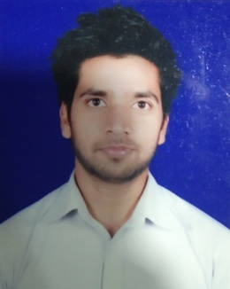

**RAKESH KUMAR**

F-178, Gali No. 7 Hari Nagar Part-2,

Badarpur, New Delhi-110044

Mobile No. **7053950441**

E-mail ID – [**rakeshrathor784@gmail.com**](mailto:rakeshrathor784@gmail.com)

**Career objective**

To dish up the society through scientific perspective, to contribute in formulating solutions to the problems of the society and maintain the dynamics of my personality to achieve my potential at professional level.

**Academic Qualification**

1. Passed **10th**in **2010** from **C.B.S.E Board,**Delhi.
2. Passed **12th** in **2012**from **C.B.S.E Board**, Delhi.
3. Passed **B.A** in 2016 from **Moti Lal college eve.** (**Delhi University**.)

**Professional Qualification**

1. I have done Certification in **Retail** form softdot.
2. Ihave done certification in NISM mutual fund series-5
3. **Packages:** Microsoft Office, MS Excel etc.

**Working experience**

**Share khan limited From 24 October, 2016 to 01 November 2019.**

**Sales Executive**

**1. Opening Demat account.**

**2. Selling Mutual fund**

**3. Making the calls and fixing the appointment**

**4. Providing client services after account opening.**

**5. Converting the assigned lead into sales and maintaining a healthy relationship with clients.**

**Trustline Securities limited From 10 August, 2020 to 05 April, 2021.**

**Customer service Executive**

**1. Resolving customer query.**

**2. Providing solutions to them by mail and phone calls.**

**3. Resolving customer queries regarding ledger, profit and loss, capital gain, and trade.**

**4. Processing client's refund.**

**Icici Securities limited From 06 April, 2021 to 15 Jan, 2022.**

**Sr. Sales Manager**

**1. Acquiring new customers.**

**2. Opening Demat account.**

**3. Selling Mutual funds and in-house investment products.**

**4. Helping customer to achieve their future goals and requirement.**

**5. Providing client services after account opening.**

**Hobbies**

1. Reading on Internet.
2. Listen music.
3. Roaming on new places.

**SKILLS**

1. Active listening
2. Computer skills
3. Customer service skills

**PersonalDetails**

Father’s Name : Mr. Suresh Rathor

Mother’s Name : Ms. Haridesh

Date of Birth : 02nd June 1994

Nationality : Indian

Gender : Male

Marital status : Single

Language Known : English & Hindi

**Declaration**

I hereby affirm that the information in the document is accurate and true best of my knowledge.

**Date:**

**Place: (RAKESH KUMAR)**