CURRICULUM

-

VITAE

VIVEK JEE

Mahadevi Path Road No:

-

7

Shiv Nagar,Kamre,

Near Birsa Ashahey Bal Vikas

School,

Ranchi: 835222, Jharkhand

.

MOBILE:

09155032777.

E

-

mail

:

jee.vivek55@gmail.com

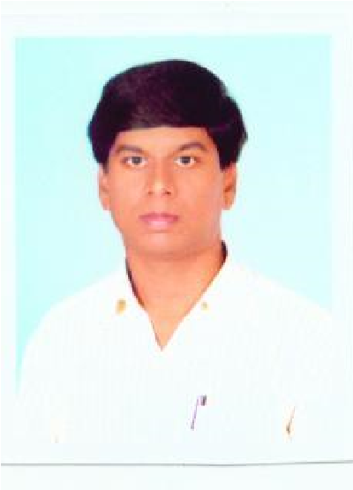

Objective:

Take challenging assignments in multifaceted function of ‘Sales & Marketing’ to enhance my skill and discharge my duties efficiently.

Experience:

From 07th June 2004 to 20th May 2013 of experience sales and marketing, Business Development, Dealer Management and General Management in Datax Omeda Pvt. Ltd. (June 2004 to April 2006), H & R JOHNSON (I) LTD. (May 2006 to Oct.2008), Future Groups (Nov. 2008 to Sep. 2009), Western India Ceramics Pvt. Ltd.(Oct. 2009 to Jul. 2011), H & R JOHNSON (INDIA) (Aug. 2011 to Feb. 2012),White House Tiles Pvt. Ltd.(March 2012 to May 2013) Swastik Ceracon Ltd.(June 2013 to Oct.2018) And Gabon Seramik Pvt.Ltd (Nov.2018 to Jan.2022).

Current Job Status: AREA SALES MANAGER

AMBANI VITRIFIED PVT.LTD

(From February 2022 to till date in Jharkhand)

Job Profile:-

* To identify potential Dealer
* To support the Dealer in brand promotional activities.
* Ensuring that the order & supply of materials was in accordance to the customer requirements.
* To arrange exhibition and camps for sales promotional activities.
* To fulfill the company’s target.
* Keep view on Revenue collection.
* Give proper knowledge of the various products of the company to the Dealer that which would help them to sell the product, easily & also satisfy customer quires.
* Taking customer feedback and keeping a track of competitors’ activity from the market.
* Creating a friendly atmosphere between the Channel Partner & the Company.
* Contacting and convincing to builders, Contractors, Engineers and Architects to increase the sale.

Academic Qualification:

* B.A. (Eco. – Hons.) from St. Xavier’s College, Ranchi with Ranchi University in 2000.
* I. A. From St. Xavier’s College, Ranchi with B.I.E.C. (Patna) in 1997.
* Matriculation from Gauri Dutt Mandelia High School, Ranchi with B.S.E.B. (Patna) in 1995.

Other Qualification:

* Diploma in Computer Application

|  |  |  |
| --- | --- | --- |
| ● REM, SAP & Internet Personal Profile: |  |  |
| Father’s Name | : | Late Murlidhar Verma |
| Date of Birth | : | 06.03.1980 |
| Marital Status | : | Married |
| Language Known | : | Hindi & English |
| Hobbies | : | Travelling, Cricket & Making Friends |

Reference:

Mr.Vikas Barnwal R. S. M.

Sales & marketing

Jaquar & Co Pvt. Ltd.

Ranchi, Jharkhand.

Mobile No: 09709122225.

The all above are designed because I can work as marketing customer care executive, sales manager, and many more.

Place: Ranchi

Date: Vivek Jee